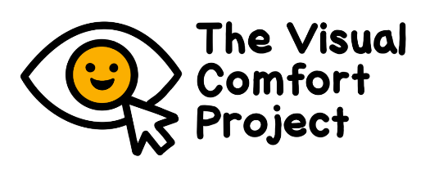
PARENT/GUARDIAN INFORMATION SHEET

Visual comfort levels in autistic and
non-autistic children

Overview
- We are running a study to find out what children find comfortable and uncomfortable to look at.
- The findings will be used to make places (like schools) and materials more accessible.
- We are inviting autistic and non-autistic children aged 6-14 years to take part.
- Autistic children who take part must have a diagnosis. Non-autistic children who take part cannot have any developmental conditions (e.g., ADHD, dyslexia).
- Children with migraine or epilepsy cannot take part, for safety reasons.
- Children will be seen at the University of Birmingham.
- Children will see images and videos in a game. They will be asked to say how comfortable they are to look at.
- Parents will fill in some questionnaires.
- Everything will take under 2 hours.
- Families will be given a £10 voucher for taking part, and a report of what the child finds comfortable and uncomfortable to look at. We will pay back travel costs.
- We may invite children and parents to take part in another part of the study, up to 2 years later.

Part 1: Autistic and non-autistic children’s ratings of images and videos

We would like to invite you and your child to take part in a two-part study at the University of Birmingham. We are looking at how children respond to different visual information. We know that there is a lot of information here. This is because we want you to understand why the research is being done and what it involves. Then you can decide whether to take part. Please read this information carefully and discuss it with your child. Please ask us if you have any questions.
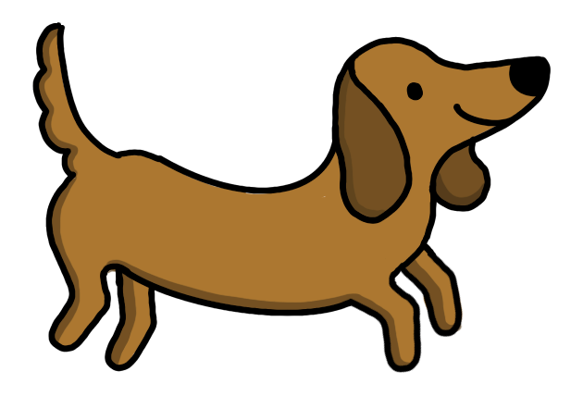

If you need this information in another format, please ask us.

What is this study about? Why is it important?
Autistic people often process sensory information differently than non-autistic people. Sometimes autistic children can be more reactive to the visual environment (like lights, colours or patterns). This can make looking at certain things, or going certain places, uncomfortable.

We are running a two-part study. This information sheet is about Part 1. In Part 1, we will find out exactly which visual features of images and videos are comfortable and uncomfortable for autistic children and non-autistic children. This will tell us whether autistic children differ from non-autistic children in what causes them discomfort - or if they differ only in how much discomfort they feel from the same visual information. Our findings will be used in future to make visual materials and environments more accessible for autistic children.

Up to 2 years after Part 1, we may invite you and your child to take part in Part 2. In Part 2, we will use child-friendly techniques to look at how your child’s brain, heart and eyes respond to visual information. This will help us to understand why there are visual reactivity differences in autism.

Who can take part?
We are inviting children aged 6-14 years and their parents/guardians to take part. Your child can take part if either:
- They have a diagnosis of autism
OR
- They have no diagnosed developmental conditions (e.g., autism, ADHD, dyslexia) and they are not on the neurodevelopmental pathway.
Your child cannot take part if they have diagnosed or suspected migraines or epilepsy. This is to avoid seizures and migraines.

Children cannot wear coloured lenses during the computer activities, because they change the visual information at the eyes. Please contact us if your child wears coloured lenses.

What can we expect if my child and I take part?
You and your child will be invited to the University of Birmingham. This can be after school, at a weekend, or during the school holidays.

For your child:

- Your child will be shown images and videos on the computer (e.g. striped patterns, flickering patterns, pictures of scenes). They will be asked to rate how comfortable they find them to look at on a thermometer-type scale. We are interested in what children think, so there are no right or wrong answers. This activity will be part of a child-friendly game, with cat and dog characters.
- Your child will be asked to do some language and reasoning tasks.
- Your child will be asked some questions about their visual reactivity in everyday life.
- We will check your child’s vision with eye charts. Your child should wear their glasses if they need them.
- All of these activities will take up to 2 hours in total. We can split the activities up into separate sessions if you like.

For you:

- We will ask you to fill out some questionnaires about your child’s development (including autism traits) and sensory processing.
- These will take around 1 hour to complete.
- You can complete the questionnaires while your child is taking part at the University. Or you can complete them at another time and return them to the researcher within a week. If you are posting the questionnaires to us, please use recorded delivery.

We are doing these activities for research – it is not a test. No judgment will be put on children or parents.

What would happen after we take part?
- Children will be given a personalised certificate
- Families will be given a £10 gift voucher for taking part after the activities and questionnaires are finished.
- We will pay back your travel costs.
- We will give you a summary of the overall results of the study
- We will give you a report of the types of visual information that your child found comfortable or uncomfortable. You may use this for your child’s benefit.
- Note, if you and your child start taking part but choose to stop taking part before finishing the study, we will give you a voucher for a reduced amount (£5). We will still pay back your travel costs.
- If we think that your child may have problems with their eyesight, we will advise you to take your child to an optician. We will publish the overall findings in a scientific journal. We will present the findings at conferences.
- We may contact you again to invite you and your child to take part in Part 2. In Part 2, we will measure heart, brain and eye responses when children look at images. This could be up to 2 years later. You will be given a new information sheet and consent form at that stage. We will invite families based on our research requirements. If you are not selected, it isn’t because you or your child did anything ‘wrong’.

Do my child and I have to take part?
No – you and your child can choose whether to take part. If you decide to take part, both you and your child will be asked to sign a form. If you later decide you no longer want to take part, you can take away your consent at any time by contacting the researchers. You do not need to give a reason. It is important that children know they can stop taking part, or take a break, at any time.

What are the possible risks of taking part? How will my child be kept safe and comfortable?
This study involves showing images, like striped and flickering patterns, which may be uncomfortable for some children. The study has been designed with input from autism community consultants. It has also been found to be acceptable for children. However, there is a chance that some children may feel distress, boredom or tiredness. We will do all we can to avoid this. Child safety and comfort is very important to us.
- We will watch children carefully for signs of distress. If there are any signs for your child that we should know about, please tell us.
- Children will be told that they can take a break or stop taking part at any time.
- Children will be able to choose to look at something they find comfortable whenever they need.
- You can stay with your child throughout the session.
- Children can bring sensory supports (e.g., fidget toys) that might help them. We will have some too.
- We will end the session if children show any signs of distress. We would follow-up with you to check you and your child are OK. We would point you to further support if needed.
- The research team is available to address concerns.
- Researchers are trained in working with children.
- All researchers have DBS checks.

What are the benefits of taking part?
- Children normally enjoy taking part.
- Children will get a personalised certificate.
- You will be given information about what your child finds comfortable or uncomfortable to look at.
- Families will be given a £10 voucher. Although we cannot fully pay for your time, this is a token of our thanks.
- The findings will help children in the future, by showing what types of visual information are comfortable or uncomfortable. This information can be used in designing resources, schools and public spaces.

Who is involved in the study?
This study is being run by Dr Cathy Manning (Principal Investigator), Dr Sam Tyler (post-doctoral researcher) and research assistants (Lily Herbert and Aneesa Begum). It is funded by the Medical Research Council. The study was designed with input from autistic children and adults, parents of autistic children and professionals working with autistic children.

What happens to our information?
- The personal information we collect about you and your child is kept fully confidential.
- Information collected about your child is stored with a code number, not their name.
- We ask for your child’s date of birth so we can see how children of different ages respond. We also use this to check that they are in the right age range for our study.
- However, no identifying information (e.g., name, date of birth) will be shared with anyone outside of the research team..
- All information and results will be stored securely on password protected computers and University servers or in locked filing cabinets within the University.
- Your contact details will only be used for this study and will be deleted after the study. However, if you tell us you are interested in hearing about future studies from us, or other researchers at the Centre for Developmental Science at the University of Birmingham, we will keep your details on a secure database.
- Any hard copies of data will be kept until we have inputted and checked the data digitally.
- Consent records will be kept for 5 years after the project ends. Then they will be destroyed.
- Anonymised information from this study will be shared with other researchers who apply to use it, so that it can be of greater scientific benefit.
- You can remove your and your child’s data before data analysis begins. This will be around 2 weeks after we have seen the last child. Please contact us if you would like your data to be removed.
- You can ask for your contact details to be removed at any time.
- More information about data protection is at the end of this information sheet.

Who has reviewed the study?
This project has passed an ethical review from the STEM Ethics Committee at the University of Birmingham (ref: ERN_3515-Feb2025). All researchers on this project have had criminal record (DBS) checks. We have designed this study with input from autistic children and adults, parents of autistic children, and teachers and professionals who work with autistic children.

What if I have a concern?
If you have any concern about this project, please contact Dr Sam Tyler (s.l.tyler@bham.ac.uk) or Dr Cathy Manning (c.manning@bham.ac.uk).. They will get back to you within 10 working days about how they will deal with your concerns. If you are still unhappy, or want to make a formal complaint, please contact the secretary to the Research Committee (Elizabeth Westlake; e.westlake@bham.ac.uk).

What should I do next?
- If you would like to discuss the research, or if you have any questions, please contact Dr Sam Tyler (s.l.tyler@bham.ac.uk) or Dr Cathy Manning (c.manning@bham.ac.uk; 0121 41 45517).
- We also have a list of frequently asked questions (FAQs).
- If you would like to take part, please fill in the consent form and return it to the researcher (in person, or by secure email or post).

GDPR information
The organisation responsible for protection of your personal information is the University of Birmingham (the Data Controller). Queries regarding data protection and your rights should be directed to
dataprotection@contacts.bham.ac.uk, or in writing to: The Information Compliance Manager, Legal Services, The University of Birmingham, Edgbaston, Birmingham, B15 2TT.

The University of Birmingham collects, analyses, uses, shares, and retains personal data for the purposes of research in the public interest. Under data protection law, we are required to inform you that this use of the personal data we may hold about you is on the lawful basis of being a public task in the public interest and where it is necessary for scientific or historical research purposes. If you withdraw from a research study, which processes your personal data, dependant on the stage of withdrawal, we may still rely on this lawful basis to continue using your data if your withdrawal would be of significant detriment to the research study aims. We will always have in place appropriate safeguards to protect your personal data.

If we have included any additional requests for use of your data, for example adding you to a registration list for the purposes of inviting you to take part in future studies, this will be done only with your consent where you have provided it to us and should you wish to be removed from the register at a later date, you should contact Dr Cathy Manning by email c.manning@bham.ac.uk) or by phone (0121 41 45517).

You have certain rights under data protection law which are:
- Withdraw your consent, for example if you opted in to be added to a participant register
- Access your personal data or ask for a copy
- Rectify inaccuracies in personal data that we hold about you
- For your details to be removed from systems that we use to process your personal data
- Restrict uses of your data
- Object to uses of your data, e.g., retention after you have withdrawn from a study

Some restrictions apply to the above rights where data is collected and used for research purposes.
You can find out more about your rights on the website of the Information Commissioners Office (ICO) at https://ico.org.uk

You also have a right to complain the ICO if you are unhappy with how your data has been handled. Please contact dataprotection@contacts.bham.ac.uk in the first instance.

Thank you for your interest in this study.

By ‘diagnosis’, we mean a formal recognition or identification of autism by a qualified healthcare professional. We know that some people prefer these other terms.
If traveling to the University is a problem for you, please contact us. We may be able to come up with other arrangements.

