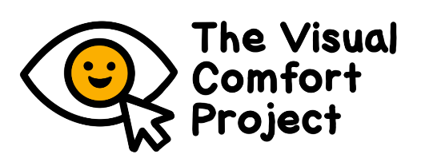
PARENT/GUARDIAN INFORMATION SHEET

Visual comfort levels in autistic and non-autistic children

Autistic and non-autistic children’s ratings of everyday images online

Overview
- We are running a study to find out what children find comfortable and uncomfortable to look at.
- The findings will be used to make places (like schools) and materials more accessible.
- We are inviting autistic and non-autistic children aged 9-14 years to take part in their school.
- Autistic children who take part must have a diagnosis. Non-autistic children who take part cannot have any developmental conditions.
- Children with migraine or epilepsy cannot take part, for safety reasons.
- Children will see images and videos in an online game. They will be asked to say whether they are comfortable or uncomfortable to look at.
- Parents will fill in short questionnaires.
- Everything will take under 40 minutes.
- You will have the chance to win a £25 voucher after taking part.

We would like to invite you and your child to take part in an online study run by the University of Birmingham. We are looking at how children respond to everyday images. We know that there is a lot of information here. This is because we want you to understand why the research is being done and what it involves. Then you can decide whether to take part. Please read the following information carefully and discuss it with your child. Please ask us if you have any questions.
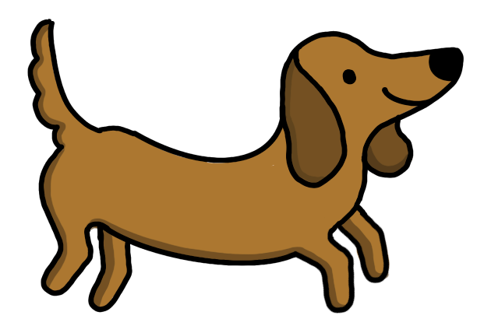

What is this study about? Why is it important?
Autistic people often process sensory information differently than non-autistic people. Sometimes autistic children can be more reactive to the visual environment like lights, colours or patterns). This can make looking at certain things, or going to certain places, uncomfortable.

In this online study, we will find out exactly which features of everyday images (e.g. buildings, wallpaper patterns) are comfortable and uncomfortable for autistic children and non-autistic children. This will tell us whether autistic children differ from non-autistic children in what causes them discomfort. Our findings will be used in future to make visual materials and environments more accessible for autistic children.

Who can take part?
We are inviting children aged 9-14 years and their parents/guardians to take part. Your child can take part if either:

- They have a diagnosis of autism
OR
- They have no diagnosed developmental conditions (e.g., autism, ADHD, dyslexia) and they are not on the neurodevelopmental pathway.

Your child cannot take part if they have diagnosed or suspected migraines or epilepsy. This is to avoid seizures and migraines.

Children cannot wear coloured lenses during the computer activities, because they change the visual information at the eyes. Please contact us if your child wears coloured lenses.
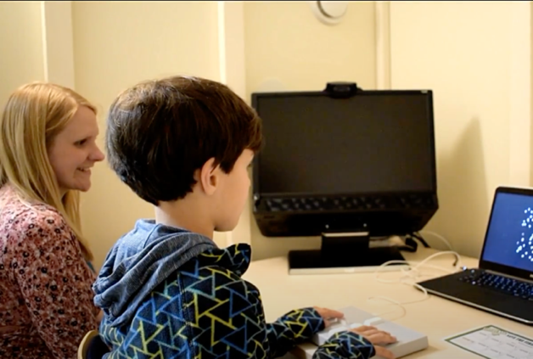
What can we expect if my child and I take part?
Your child will be invited to take part in some activities at their school.

For your child:
- Your child will be shown a range of everyday images (e.g. pictures of buildings, wallpaper patterns, and scenes). They will be asked to rate if they find each image comfortable or uncomfortable to look at. We are interested in what children think, so there are no right or wrong answers. This activity will be part of a child-friendly game, with cat and dog characters.
- Your child will be asked to do a quick reasoning activity (puzzles).
- Your child should wear their glasses if they need them.
- All of these activities will take around 20 minutes in total for your child.
For you:
- We will ask for you to fill in some questionnaires about your child’s development (including autism traits) and sensory processing
- These will take under 20 minutes for you to complete.

We are doing these activities for research – it is not a test. No judgment will be put on children, parents or schools.

What would happen after we take part?
- You can choose to be entered into a prize draw to win one of 10 £25 gift vouchers once the tasks and questionnaires are finished.
- If you would like a summary of the overall results of the study, we will send this to you once the study has finished. We will ask for your email address so that we can send this to you at the end of the study.
- We will publish the overall findings in a scientific journal. We will present the findings at conferences.

Do my child and I have to take part?
No – you and your child can choose whether to take part. If you decide to take part, both you and your child will be asked to sign a form. If you later decide you no longer want to take part, you can take away your consent at any time by telling the researchers. You do not need to give a reason. It is important that children know they can stop taking part, or take a break, at any time.

Who is involved in the study?
This study is being run by Dr Cathy Manning (Principal Investigator), Dr Sam Tyler (post-doctoral researcher) and research assistants (Lily Herbert, Aneesa Begum). It is funded by the Medical Research Council. The study was designed with input from autistic children and adults, parents of autistic children and professionals working with autistic children.
What are the possible risks of taking part? How will my child be kept safe and comfortable?
This study involves seeing everyday images, like wallpaper patterns or buildings, which may be uncomfortable for some children. The study has been designed with input from autism community consultants. It has also been found to be acceptable for children. However there is a chance that some children may experience distress, boredom or tiredness. We will do all we can to avoid this. Child safety and comfort is very important to us.

- Researchers will discuss with you and/or your child’s teacher before the study to make sure the environment is suitable for your child. Sensory triggers and distractions will be minimised.
- Researchers and teachers who are there will watch your child carefully for signs of distress.
- Children will be told that they can take a break or stop taking part at any time.
- Children may use sensory supports (e.g., fidget toys, headphones)
- If there are any signs of distress, we will stop the study. Children can also choose to stop taking part.
- The research team is available to address concerns.
- Researchers are trained in working with children
- All researchers have DBS checks.

What are the benefits of taking part?
- Children normally enjoy taking part.
- Children will get a certificate.
- Families will have the chance to win a £25 voucher.
- The findings will help children in the future, by showing what types of visual information are comfortable or uncomfortable. This information can be used in designing resources, schools and public spaces.

What happens to our information?
* The personal information we collect about you and your child is kept fully confidential.
- Information collected about your child is stored with a code number, not their name.
- We ask for your child’s date of birth so we can see how children of different ages respond. We also use this to check that they are in the right age range for our study. However, no identifying information (e.g., name, date of birth) will be shared with anyone outside of the research team.
- All information and results will be stored securely on password protected computers and University servers or in locked filing cabinets within the University.
- Your contact details will only be used for this study. They will be deleted after we have sent a report of the results and completed the prize draw. However, if you tell us you are interested in hearing about future studies from us, or other researchers at the Centre for Developmental Science at the University of Birmingham, we will keep your details on a secure database.
- Consent records will be kept for 5 years after the project ends. Then they will be destroyed.
- Anonymised information from this study will be shared with other researchers who apply to use it, so that it can be of greater scientific benefit. You can remove your and your child’s data before data analysis begins. This will be around 2 weeks after we have seen the last child. Please contact us if you would like your data to be removed.
- You can ask for your contact details to be removed at any time.
- More information about data protection is at the end of this information sheet.

Who has reviewed the study?
This project has passed an ethical review from the STEM Ethics Committee at the University of Birmingham (ref: ERN_3515-Feb2025). All researchers on this project have had criminal record (DBS) checks. We have designed this study with input from autistic children and adults, parents of autistic children, and teachers and professionals who work with autistic children.

What if I have a concern?
If you have any concern about this project, please contact Dr Sam Tyler (s.l.tyler@bham.ac.uk) or Dr Cathy Manning (c.manning@bham.ac.uk). They will get back to you within 10 working days about how they will deal with your concerns. If you are still unhappy, or want to make a formal complaint, please contact the secretary to the Research Committee (Elizabeth Westlake; e.westlake@bham.ac.uk).

What should I do next?
- If you would like to discuss the research, or if have any questions, please contact Dr Sam Tyler (s.l.tyler@bham.ac.uk) or Dr Cathy Manning (c.manning@bham.ac.uk; 0121 41 45517).
- If you would like to take part, please fill out the consent form and return it to the [school or researcher] (in person, or by secure email or post).

GDPR information
The organisation responsible for protection of your personal information is the University of Birmingham (the Data Controller). Queries regarding data protection and your rights should be directed to dataprotection@contacts.bham.ac.uk, or in writing to: The Information Compliance Manager, Legal Services, The University of Birmingham, Edgbaston, Birmingham, B15 2TT.

The University of Birmingham collects, analyses, uses, shares, and retains personal data for the purposes of research in the public interest. Under data protection law, we are required to inform you that this use of the personal data we may hold about you is on the lawful basis of being a public task in the public interest and where it is necessary for scientific or historical research purposes. If you withdraw from a research study, which processes your personal data, dependant on the stage of withdrawal, we may still rely on this lawful basis to continue using your data if your withdrawal would be of significant detriment to the research study aims. We will always have in place appropriate safeguards to protect your personal data.

If we have included any additional requests for use of your data, for example adding you to a registration list for the purposes of inviting you to take part in future studies, this will be done only with your consent where you have provided it to us and should you wish to be removed from the register at a later date, you should contact Dr Cathy Manning by email (c.manning@bham.ac.uk) or by phone (0121 41 45517).

You have certain rights under data protection law which are:
- Withdraw your consent, for example if you opted in to be added to a participant register
- Access your personal data or ask for a copy
- Rectify inaccuracies in personal data that we hold about you
- For your details to be removed from systems that we use to process your personal data
- Restrict uses of your data
- Object to uses of your data, e.g. retention after you have withdrawn from a study

Some restrictions apply to the above rights where data is collected and used for research purposes. You can find out more about your rights on the website of the Information Commissioners Office (ICO) at https://ico.org.uk.

You also have a right to complain to the ICO if you are unhappy with how your data has been handled. Please contact dataprotection@contacts.bham.ac.uk in the first instance.

Thank you for your interest in this study.

By ‘diagnosis’, we mean a formal recognition or identification of autism by a qualified healthcare professional. We know that some people prefer these other terms.

