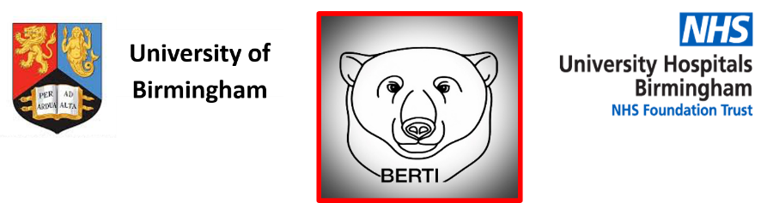
Brain tumour Education and Research paTient and public Involvement group
West Midlands
Are you affected by a brain tumour?
BERTI is a group for people affected by brain tumours in any way.
Join us, as we explore key questions such as:

- ‘What is a brain tumour?’

- ‘How will it affect me’

- ‘Can I do anything to make it better?’

- ‘Will new research help me?’

We include patients, friends and family, health professionals and researchers who are committed to improving the care of people with a brain tumour.
It is run between the University Hospitals Birmingham NHS Foundation Trust (UHB) and the University of Birmingham (UoB).
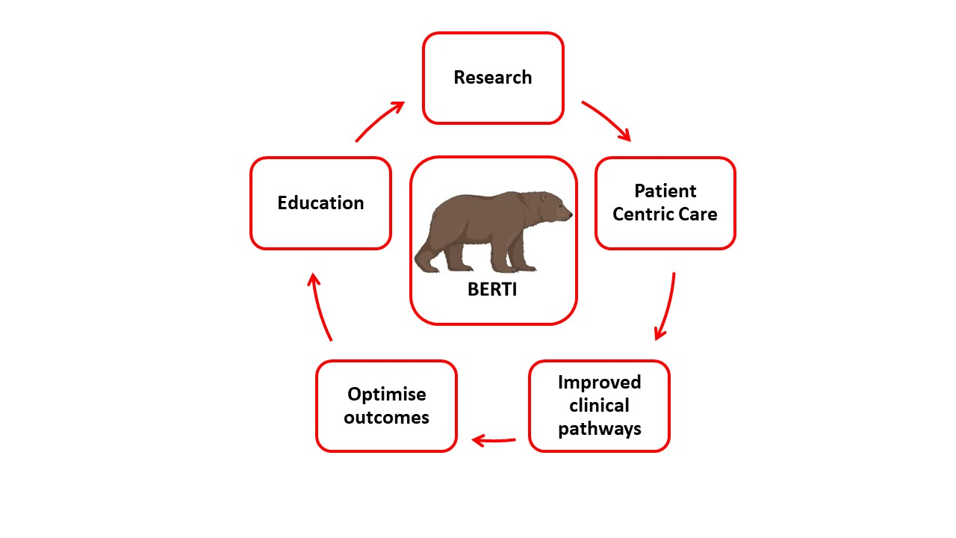
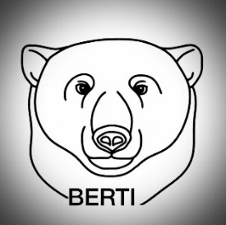
BERTI provides a forum to
- Meet with other people affected by brain tumours and share experiences
- Understand the condition better
- Work with clinical staff and researchers to improve clinical care and facilitate research for people living with brain tumours.

Together we can make a difference for people with brain tumours

-We meet three times per year (virtually at the moment), but when we are able we will meet at the Queen Elizabeth Hospital, Birmingham.
-We will have a formal talk explaining an aspect of brain tumour or a research idea, and will always prioritise time for discussion both as a whole group and smaller informal chats.
-There is no cost and no commitment – come along, join in and let us know what you think!

For more information or if you would like to attend the next meeting please contact:
Berti@uhb.nhs.uk

