Stitched Voices 2017
Event: ‘Bozambique’: Where healing meets remembrance

Event organized by Samara Guimarães and Louis Monroy Santander
Bozambique, as a visual encounter with processes of remembrance and trauma healing, aimed at observing non-judicial approaches of post-conflict reconstruction as a way of contrasting possibilities and difficulties in the practice of transitional justice.
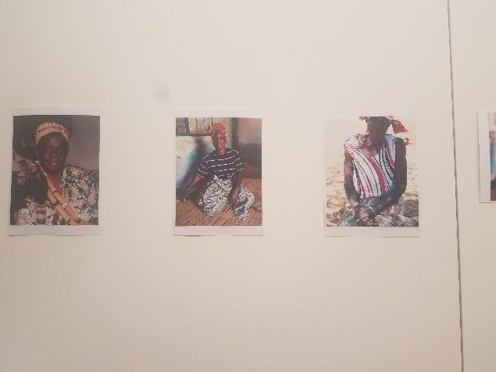
Starting as a photographic gallery, Bozambique showed a contrast between the different projects done for remembrance in Bosnia-Herzegovina and the work of healers in Mozambique. Participants were initially asked to look at the pictures and define the concept of ‘transitional justice’ based on the messages they received by looking at the different photographs. Ideas of forgiveness, of dealing with the past, of seeking peaceful relations after conflict and addressing issues of truth, justice and reconciliation. Critical insights from participants focused on the contrast between Mozambique’s individuality in reconciliation and Bosnia’s institutionalised approaches to remembrance, concerned with the presence and absence of the state in processes of post-war reconstruction.

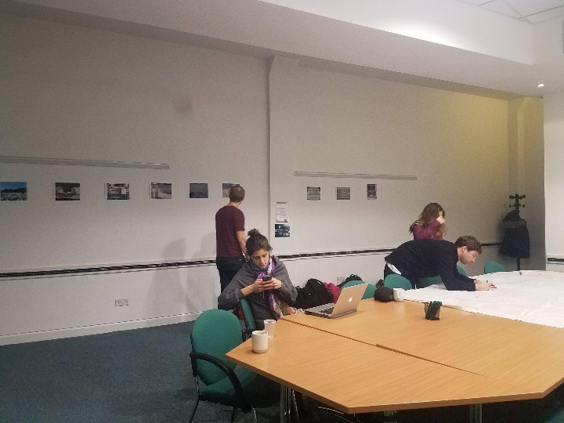
A ‘visual’ analysis between audience and presenters allowed for a contrasting of themes and definitions on the importance of forgiveness, remembrance, and reconciliation. Once these initial themes were made explicit, the event flowed into the presentation of two different case studies that helped create a contrasting visualization of two different approaches to transitional justice. The first presentation saw Louis Monroy Santander describe his fieldwork journey in Bosnia-Herzegovina making a series of stops on sites that allowed for memorialization of the 1992-1995 Balkan conflict. The presentation showcased the work done by museums, memorials, commemoration of events and activities geared towards combating genocide denial in the country.
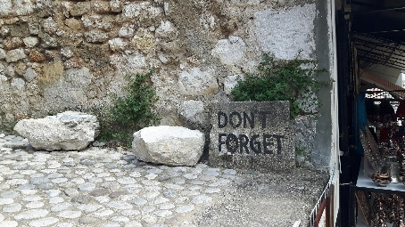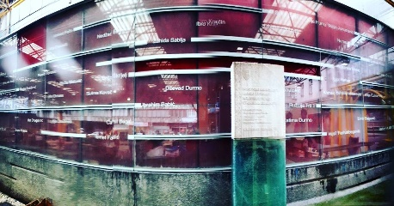
A second presentation, focused on Samara Guimarães’ experience with local healers in different areas of Mozambique, looking at their connections with trauma-healing, health work, and as a particular indigenous take on state-building. Samara’s presentation brought in a more human, individual and personal account of post-war reconstruction work, explaining how trauma healers have organized around communities, whose work can be identified as more organic and culturally appropriate for the context of Mozambique, to the point where they can be seen as more legitimate actors for peacebuilding-orientated work.
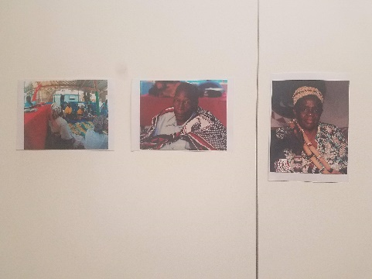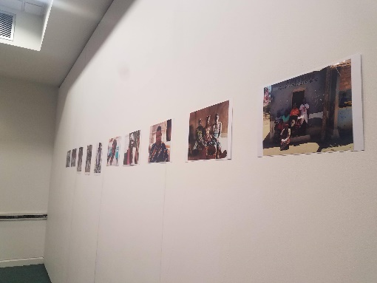

After the two presentations allowed for a contrast between Bosnia and Mozambique’s experiences of transitional justice work, the event was open for attendees to express their views, opinions and questions about both case studies. Many noted the value of contrasting two very different settings, their dilemmas, possibilities and barriers to processes of reconciliation, state-building and trauma-healing. The highly institutionalized process of memorialization in the Bosnian experience led to questioning the legitimacy and acceptance of such processes by communities on the ground and the politicisation of remembrance and its narratives of the past. In the case of Mozambique, the healer’s role is marked by their authentic, indigenous and grounded nature, yet a clear absence of strong state structures marked the potential difficulties in promoting a post-liberal form of peacebuilding.

