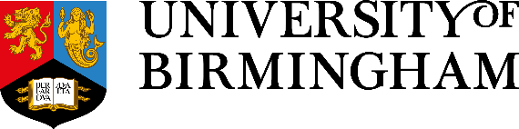

Sustainable Approaches to Business Travel
  - Case Studies
Edward Shelley, Sustainable Travel Officer
October 2025
We advance
We activate
birmingham.ac.uk

Contents

Executive summary 4
Case Study 1: Major International Conferences 5
Case Study 2: Careers Project in Dubai 7
Case Study 3: Go Global 9
Case Study 4: A Global Engineering Network 11

Executive summary

Business travel is a major source of our University’s carbon emissions, evaluated at 19.5 Mt in the academic year 2023-2024 and nearly half of the emissions from gas, fuels and electricity we use on our estate.
Reducing emissions from business travel is a key milestone on the road to net zero. As we look to the horizon of 2045, adjusting how, when and why we choose to travel is key, in the absence of major technological advances to decarbonise overseas trips.
Through four case studies, we look at how colleagues across our University have adapted their approach to carbon-intensive business travel, while leading outstanding global collaboration and engagement.

Case Study 1: Major International Conferences
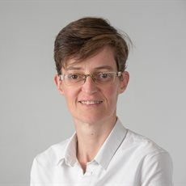
Figure 1
Dr Christel McMullan.
Our department’s sustainability lead once explained how reducing flying is a major sustainability action for individual academics and the university. I remember being struck by her words.
In my field, there is a major annual conference that alternates between Europe and the US. It is massive: a five-day conference bringing together quality of life researchers from around the world. It is the place to be to present work, listen to latest research, and meet colleagues in formal and social settings.

When I saw that it was taking place in Cologne, I thought back to my colleague’s words, and I checked to see if the journey was feasible by rail. As it happened, the journey was nearly as quick by train, because there were no direct flights from Birmingham. The cost was similar too, when you factored in a connection to Heathrow or Manchester.
It’s an important conference for our whole team, and my colleagues were surprised when I told them how I would be getting there. Most of them automatically assumed flying was the only option. Some were concerned that I would be delayed, but flights get cancelled too! There is a mindset that cross-channel travel only means flying. But I did inspire one other colleague to join me on the overland journey and our administrator sorted out the booking.
The journey went really well. The trains ran on time and I got a lot of work done on the way. I find it easier to concentrate in a train carriage compared to a departures lounge with updating screens and tannoy announcements.

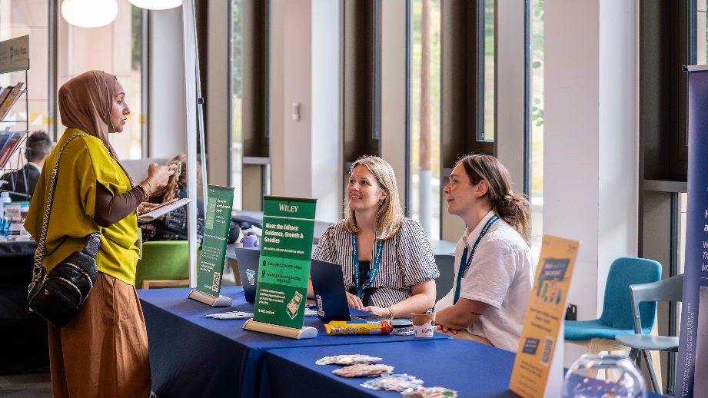
Figure 2.Conference scene.
I have reflected a lot on my assumptions and past practices, and the sustainability impact of how I carry out my work. For example, in the past, I would have flown to places such as Edinburgh for face-to-face meetings but now I only consider the train. The carbon emissions are so much less and, on the practical side, the rail journey gives me time to focus.
As a department we work together to minimise the number of trips we take, while extracting maximum value from such an important conference. This year I won’t be going to the States for our annual conference as I don’t have anything to present and it is costly to attend conferences, besides the climate impact. One of my colleagues will deliver a talk, so will be there. She’s taking another colleague’s poster and will be able to answer questions on their behalf.
When we get back from conferences like this, we share slides of the best presentations we have seen and update each other on developments in the field. So global engagement for us is as much about good teamwork and internal communication as frequent international travel for all.

Dr Christel McMullan
Research Fellow
Centre for Patient-Reported Outcomes Research
Department of Applied Health Sciences

The journey was nearly as quick by train, because there were no direct flights from Birmingham. The cost was similar too, when you factored in a connection to the airport.

Case Study 2: Careers Project in Dubai
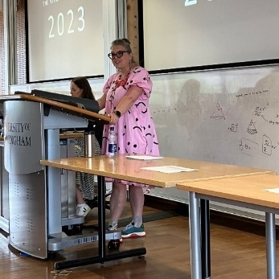
Figure 3
Dr Sarah Hall.
The Birmingham Project is an intense, week-long, employability programme for first-year undergraduates. We task them with solving a real-world challenge for one of our partner employers, who offer feedback and judge the results. It is a major part of the careers network programme and the gateway for many of our undergraduate students into all the careers support we offer. We know that sustainability will feature in every sector of the economy in decades to come, so every one of our challenges has a sustainability dimension.

I’ve been part of The Birmingham Project for 12 years and for the first time this year we were tasked with making it a project truly for our whole institution by running an edition for Dubai students.
We were clear from the beginning that we wanted our Dubai students to have an experience that was just as rich and effective as the programme we run on our Edgbaston campus.
This threw up some practical challenges. We are a small team of four who deliver the project; we are all based in Birmingham and we had to make the most of the precious time and budget that we have available.
I decided to split my team in two. Bob and Jane travelled to Dubai to support the students in person for the week, and Robin and I stayed at home. We joined the groups online to support them. Our employer partner Siemens did the same, with some of their representatives dialling in from the UK and Germany. Bob and Jane also delivered other Careers Network programmes when they were there, including the Birmingham Award, so we made the most of their trip.

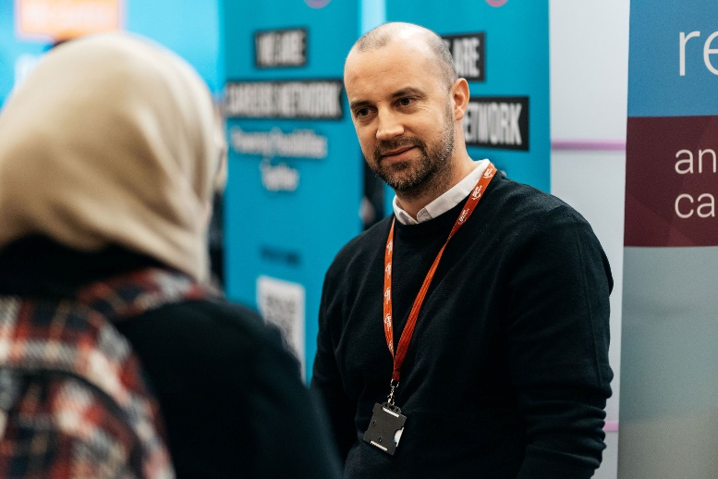
Figure 4 Bob Lee of the Birmingham Project team.
In planning this hybrid delivery mode, we quickly realised having some team members support the project from the UK was not an obstacle but a core attribute of the programme. From a pedagogical point of view, we were conscious that we are preparing students for the world of work, and today companies like Siemens have international teams collaborating from all over the globe. Our students aspire to careers in global businesses and the skills required to generate and present ideas effectively online are different from what is needed when working in person, and the project helped students work on those skills. The students themselves loved that the project had an international dimension and felt like they were working in an international network.
As an educator, I reflected a lot on how to include all members of the student teams on the calls and adapted my style to ensure that all students contributed. We gave feedback on final presentations via video messages. Some people say that online work is impersonal, but this was a really effective way of providing detailed assessment with that human touch, and the students appreciated that a lot.
Practically, we were also a lot less reliant on room bookings so we could be flexible and agile in supporting the students.
Overall, the Dubai edition of the Birmingham Project went really well, and we plan to use the same format with a second employer and increased student numbers.

Dr Sarah Hall
Lead of The Birmingham Project
Reader in Religious Education
Director of Postgraduate Taught Programmes
College of Social Sciences

In planning this hybrid delivery mode, we quickly realised that it was not an obstacle but a core attribute of the programme. Our students aspire to careers in global businesses and the skills required to generate and present ideas effectively online are different from what is needed when working in person, and the project helped students work on those skills.

Case Study 3: Go Global
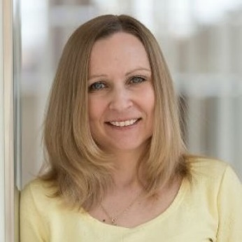
Figure 5
Maggie Wootton.
I head up the Go Global Team at the University of Birmingham, coordinating international mobility opportunities for students across a range of programmes - from short-term summer experiences to full academic years abroad. This includes the Year and Semester Abroad programme, as well as Go Global Summer, which offers international summer schools, language programmes, research placements, volunteering, and internships. Most opportunities involve physical travel, with growing options for virtual international experiences.

Students are very excited about the range of opportunities we offer, and the University has an ambition that 50% of each graduating cohort of undergraduate students will benefit from an international experience (physical and virtual) by 2030.
Many students who went abroad as part of their university experience rate their experience among the very best in their career at the University. They also get better grades, are more employable and earn higher salaries - trends that are particularly pronounced among our students from disadvantaged backgrounds. As one year abroad student put it, “this experience expanded my horizons and helped me grow on so many levels”.
For all the amazing benefits that going abroad gives our students, we are very conscious of the climate impact of facilitating long distance travel en masse on an annual basis, so we are working to integrate sustainability into our work.

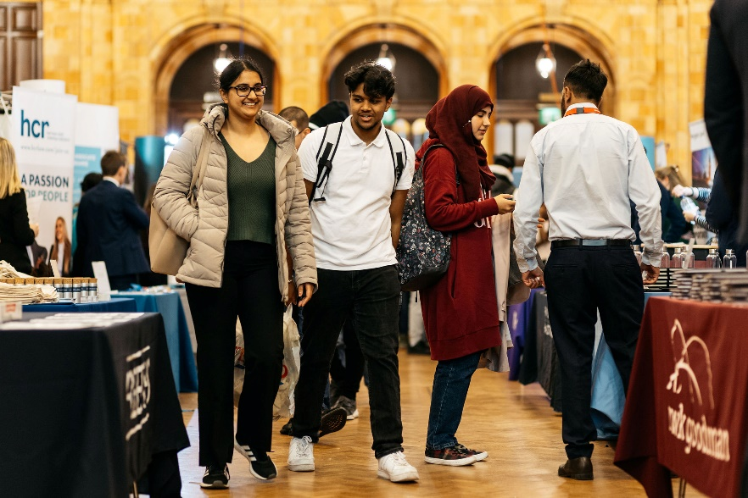
Figure 6 Fair in the Great Hall.
We appreciate that this is a once in a lifetime opportunity for many, but that prospective year, semester or summer abroad students often care the most about the world we live in. We seek to educate them and provide as much context and information so that they can decide how to pursue the opportunities of going abroad in sustainable ways. Working with the Sustainable Travel Team, we have put together a pre-departure Canvas page for students. There’s lots of practical advice on the choice of destination, mode of travel, frequency of return journeys or lifestyle choices when there. We also invite the Sustainable Travel Team to deliver this message at our termly fairs as students are exploring the opportunities available to them.

Maggie Wootton
Head of International Mobility (Outgoing Students)
Go Global Team
Student Services

We have put together a pre-departure sustainability page on Canvas for students. There’s lots of practical advice on the choice of destination, mode of travel, frequency of return journeys or lifestyle choices when studying abroad.

Case Study 4: A Global Engineering Network
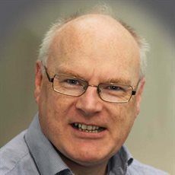
Figure 7
Ian Jefferson.
I am a member of the International Society for Soil Mechanics and Geotechnical Engineering Technical Committee, a global committee of engineering experts and practitioners seeking to influence the sustainable development of infrastructure and civil societies in a significant way. The purpose of the network is to monitor, contribute to and disseminate information on sustainability related issues in geotechnical engineering and active connection - collaboration with stakeholders across industry and academia is essential.

Face-to-face collaboration is important to build and strengthen relationships, but we only meet every 2 years in person; we maintain regular connection and drive progress through virtual meetings and conference, reducing the need for global committee members to travel. We have adapted our approach to ensure we achieve the goals and purpose of the committee, have impact across industry but reduce the environmental impact of our work, where we can.

Professor Ian Jefferson, BEng (Hons), DIS, PhD, FGS
Professor in Geotechnical Engineering
Department of Civil Engineering
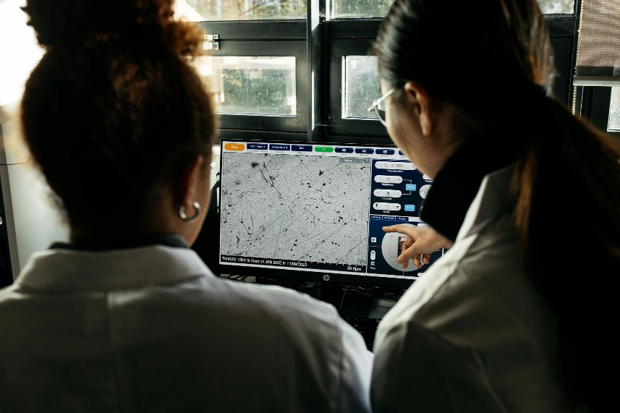
Figure 8 Researchers in a lab.
We maintain regular connection and drive progress through virtual meetings and conferences, reducing the need for global committee members to travel.
With thanks to:
- Dr Christel McMullan
- Dr Sarah Hall
- Maggie Wootton
- Professor Ian Jefferson

We advance
We activate
birmingham.ac.uk

