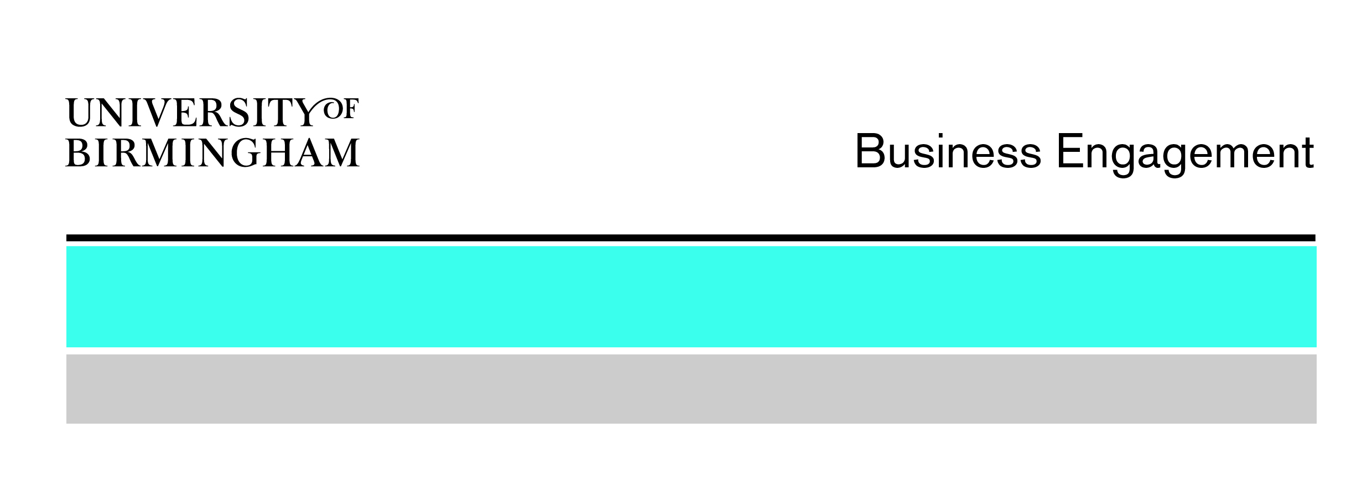
Knowledge Transfer Secondment (KTS) Scheme

Fact sheet

Updated: July 2017

A KTS provides funding to help exploit research through the movement of skilled people both into, and out of, the University of Birmingham through secondments.
The benefits to your organisation
- The services of a highly qualified researcher, technical officer and/or direct access to senior academic expertise to work on a project of mutual interest
- Access to the very latest technological advances emerging from the research base
- The opportunity to develop a long-term partnership with the University of Birmingham and find out more about the wide range of services available for business
The objective
The KTS scheme supports projects in the engineering, physical, biological, biotechnology and biomedical sciences, looking to:
- progress the results of previous/current research towards application
- address an organisation’s challenges through collaborative research
- access specialist equipment and/or skilled technicians
Secondment and funding models
Secondments OUT of the University | Secondments INTO the University
The KTS will provide:  - up to 50% of the outward secondees’ salaries, superannuation and NI contributions  - reasonable travel and subsistence costs as necessary to support the secondee(s)  - up to 50% of the costs of consumables | The KTS will provide:  - up to 50% of the inward secondees’ salaries, exclusive of pension and NI contributions  - reasonable travel and subsistence costs as necessary to support the secondee(s)  - reasonable research consumables
You should provide:  - 50% or more of the secondees’ salaries, superannuation and NI contributions  - appropriate infrastructure and equipment to enable the secondees’ project work  - 50% or more of the cost of consumables | You should provide:  - 50% or more of the secondees’ salaries, and 100% of their pension and NI contributions

  - Eligibility and rules
- Companies, government departments, NHS, charities and other not- for-profit organisations are eligible
- Projects will run from between 6 weeks and 2 years and may have one or multiple secondees
- Secondments may be full or part-time, with a minimum 10% FTE (part time secondments will receive pro-rata funding)
- Commercial and secondment agreements must be in place before secondments can commence
- Deadlines occur quarterly

Funding range

- Projects funded to date have ranged from £10k - £50k.

Learn more
- Contact: Anthony Khan E: a.khan.7@bham.ac.uk T: 0121 414 7093

