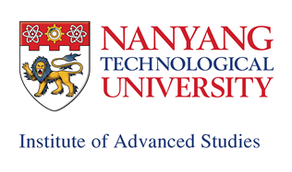
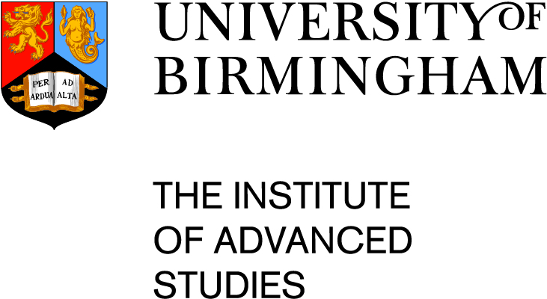
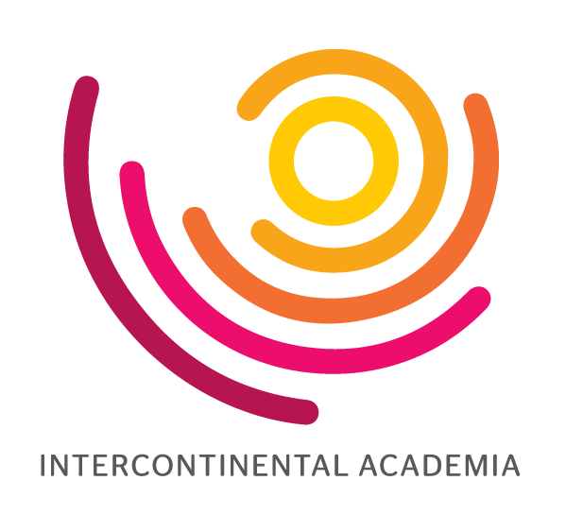

Intercontinental Academia Singapore March 19-27 2018
Orchid Room, NTU Campus Clubhouse, 50 Nanyang View, Singapore 639667

Sunday 18 March | 18:30 Welcome Reception @ Cosmo
Monday 19 March | Morning | Afternoon |  | Evening
Fellows  All Fellows  Mentors  Professor Michal Feldman  Professor David Gross  Professor Patrick Geary  Professor Gil Kalai  Professor Michel Spiro  Directors  Professor Lars Brink  Professor Kwek Leong Chuan  Professor Michael J Hannon  Professor Phua Kok Khoo  Professor Eliezer Rabinovici  Birmingham Organising Group  Professor Damien Walmsley  (University of Birmingham)  Guests  Professor Nargiza Amirova  (IAR Nagoya University) | Welcome  09:00-09:30  Phua Kok Khoo  Michael J Hannon  Eliezer Rabinovici  Kwek Leong Chuan  Sue Gilligan  Briefing on:  Mentor talks responses  1:1s with Mentors  Thematic Panels  Projects and outcomes  Presentation to Brazil  09:30-12:00  Fellows introductions to each other  Mind-mapping and planning  Includes 10:30 Refreshments break  12:00 Morning wrap up | Mentor talks and responses  Chair - Eliezer Rabinovici  13:30-15:30 Michal Feldman  Algorithmic Game Theory: the Crossroad of Computer Science, Game Theory, and Economics  Response and discussion  Michel Spiro + two fellows  15:30 Refreshments  15:45-17:45 Patrick Geary  Laws of History and Laws in History  Response and discussion  David Gross + two fellows |  | Dinner  Catering @ Orchid Room  18:30  20:00-21:00 Evening discussion  All fellows  Michal Feldman  Patrick Geary
Tuesday 20 March | Morning
Fellows  All Fellows  Mentors  Professor Penny Andrews  Professor Michal Feldman  Professor Patrick Geary  Professor David Gross  Professor Gil Kalai  Professor Atul Parikh  Professor Michel Spiro  Directors  Professor Lars Brink  Professor Kwek Leong Chuan  Professor Michael J Hannon  Professor Phua Kok Khoo  Professor Eliezer Rabinovici  Birmingham Organising Group  Professor Damien Walmsley  (University of Birmingham)  Guests  Professor Nargiza Amirova  (IAR Nagoya University) | Fellows’ 6 minute Presentations  09:00-09:30  Dr Vahid Aryadoust  Why aren’t there any “Scientific Laws” in Applied Linguistics?”  Dr VV Binoy  Determinants of Social Decision-making: a Tale of Two Vertebrates  Dr Anupam Chattopadhyay  Laws of Digital Evolution  09:30-10:00  Dr Willem Gravett  The Legal System's Uneasy Relationship with Social Science: Can Rigidity Make Way for a Dynamic?  Dr Dr Hanjo Hamann  Why European Lawyers Call Their Trade a "Science", and What That Tells Us About Their Dynamical Systems Perspective  Dr Uli Heisserer  Industrial Research in Materials Science: Doing Meaningful Things where Laws of Nature (science), Laws of Society (legislation, ethics) and Market Laws Interplay  10:00-10:40  Dr Wai-Yip Ho  Rigidity and Dynamics: Considering Islamic Law  Dr Nkatha Kabira  Commissions as Technologies of Law and Governance  Dr Isabel Kusche  Legal Rules: Content versus Meaning  Dr Irina Kuznetsova  Law, Mobility and Bodies: Developing an Interdisciplinary Theoretical and Methodological Approach to Studying the Outcomes of Displacement |  | 10:40-11:00 Refreshments  11:00-11:30  Dr Petra Liedl  Laws and Sustainability- How do Laws Support Transformation Processes?  Dr Kenneth Lim  Intuitions and Learning, and (very) early musings on Intuitions and Laws  Dr David Maimon  Regulating Computer Users’ Online Behaviors: Online and Offline Architectures of Control  11:30-12:00  Professor Yoh Matsuo  Two Concepts of Law: Legal and Scientific  Dr Katrien Pype  Mobile Phones: the Matter of Communication  Dr Tom Schonberg  New Paradigms, Open Science and Neuroethics of "mind-reading"  12:00-12:30  Dr Michal Smolkin  Law through the Lens of Physics  Dr Carla Aparecida Arena Ventura  International Law and International Human Rights Law: Exploring Interrelationships, Rigidity and Dynamics in the areas of Health and Mental Health  Dr Al Wilson  Laws of Nature: Unity and Variety
Tuesday 20 March (cont.) | Afternoon |  | Evening
Fellows  All Fellows  Mentors  Professor Penny Andrews  Professor Michal Feldman  Professor Patrick Geary  Professor David Gross  Professor Gil Kalai  Professor Atul Parikh  Professor Michel Spiro  Directors  Professor Lars Brink  Professor Kwek Leong Chuan  Professor Michael J Hannon  Professor Phua Kok Khoo  Professor Eliezer Rabinovici  Birmingham Organising Group  Professor Damien Walmsley  (University of Birmingham)  Guests  Professor Nargiza Amirova  (IAR Nagoya University) | Mentor talks and responses  Chair - Nargiza Amirova  13:30-15:30  Penny Andrews  The “Casserole Constitution”: The South African Constitution and International Laws  Response and discussion  Gil Kalai + two fellows  15:30 Refreshments  Chair - Lars Brink  15:45-17:45  Gil Kalai  The Laws of Physics vs. the Laws of Computation – Laws and Errors in the Case of Quantum Computers  Response and discussion  Atul Parikh + two fellows |  | Dinner  Catering @ Orchid Room  18:30  20:00-21:00 Evening discussion  All fellows  Penny Andrews  Gil Kalai
Wednesday 21 March | Morning | Afternoon |  | Evening
Fellows  All Fellows  Mentors  Professor Penny Andrews  Professor Suzanne Blier  Professor Sir Partha Dasgupta  Professor Michal Feldman  Professor Patrick Geary  Professor David Gross  Professor Gil Kalai  Professor Atul Parikh  Professor Michel Spiro  Directors  Professor Lars Brink  Professor Kwek Leong Chuan  Professor Michael J Hannon  Professor Phua Kok Khoo  Professor Eliezer Rabinovici  Birmingham Organising Group  Professor Damien Walmsley  (University of Birmingham)  Guests  Professor Robin Mason  (PVC International,  University of Birmingham) | Mentor talks and responses  Chair - Robin Mason  09:00-11:00 Partha Dasgupta  A Matter of Trust: Laws and Norms  Response and discussion  David Gross + two fellows  11:00-11:15 Refreshments  Chair - KK Phua  11:15-13:15 David Gross  The Nature of Laws and Principles in Physics  Response and discussion  Patrick Geary + two fellows | Mentor talks and responses  Chair - Mike Hannon  14:15-16:15 Michel Spiro  CERN a Collective Machinery to Test  Laws against Nature  Response and discussion  Michal Feldman + two fellows  16:15-16:30 Refreshments  16:30-18:30 Suzanne Blier  From Fair Use to Zoning Ordinance: Challenging the Law for Public Benefit  Response and discussion  Partha Dasgupta + two fellows  Dinner transport leaves at 19:00 |  | Dinner  20:00  Tanglin Club  Churchill Room  5 Stevens Rd, Singapore 257814  http://www.tanglinclub.org.sg/about/club-history.html
Thursday 22 March | Morning and Afternoon |  |  | Evening
Fellows  All Fellows  Mentors  Professor Penny Andrews  Professor Suzanne Blier  Professor Sir Partha Dasgupta  Professor Michal Feldman  Professor David Gross  Professor Patrick Geary  Professor Gil Kalai  Professor Atul Parikh  Professor Michel Spiro  Directors  Professor Lars Brink  Professor Kwek Leong Chuan  Professor Michael J Hannon  Professor Phua Kok Khoo  Professor Eliezer Rabinovici  Birmingham Organising Group  Professor Damien Walmsley  University of Birmingham  Guests  Professor Robin Mason  (PVC International  University of Birmingham) | Thematic panel day - to be planned by Fellows  09:00-10:30 SESSION 1  10:30-11:00 Refreshments  11:00-13:00 SESSION 2  13:00-14:00 Lunch  Lunchtime discussion  All fellows  David Gross  Michel Spiro  14:00-16:00 SESSION 3  Includes 15:00 Refreshments break  Transport to leave at 17:00 |  |  | Dinner hosted by  Professor Robin Mason  (PVC International  University of Birmingham)  #06-01 National Gallery Singapore 1 St. Andrew's Road  Singapore 178957  Tel: +65 9234 8122  Fax: +65 63845575  18:00 Welcome Drink  Smoke and Mirrors  18:30-20:30  Dinner, Yan  Nanyang Executive Centre  23:00 – 23:30  (12:00 Sao Paulo Time)  Link with  UBIAS Directors’ Meeting  Session UBIAS programs:  Results of ICA 1 and 2  Contact with ongoing ICA 3
Friday 23 March | Morning | Afternoon |  | Evening
Fellows  All Fellows  Mentors  Professor Penny Andrews  Professor Suzanne Blier  Professor Sir Partha Dasgupta  Professor Patrick Geary  Professor Wang Gungwu  Professor Gil Kalai  Professor Atul Parikh  Professor Ernst Rank  Professor Ada Yonath  Directors  Professor Lars Brink  Professor Kwek Leong Chuan  Professor Michael J Hannon  Professor Phua Kok Khoo  Professor Eliezer Rabinovici  Birmingham Organising Group  Professor Damien Walmsley  (University of Birmingham) | Mentor talks and responses  Chair - Mike Hannon  09:00-11:00 Ernst Rank  Laws and Beauty – a view from Computational Sciences  Response and discussion  Penny Andrews + two fellows  11:00-11:15 Refreshments  Chair - KK Phua  11:15-13:15 Wang Gungwu  Chinese Historiography, on History as a Mirror of Government  Response and discussion  Ada Yonath + two fellows | Project and outcomes challenge  14:15-16:00 Fellows planning project outcomes  16:00 Refreshments  16:15-17:45 Presentation of projects |  | Dinner  18:30  BBQ outside Orchid Room  20:00-21:00 Evening discussion  All fellows  Suzanne Blier  Partha Dasgupta
Saturday 24 March | Morning | Afternoon |  | Evening
Fellows  All Fellows  Mentors  Professor Suzanne Blier  Professor Sir Partha Dasgupta  Professor Patrick Geary  Professor Atul Parikh  Professor Ernst Rank  Professor Ada Yonath  Directors  Professor Lars Brink  Professor Kwek Leong Chuan  Professor Michael J Hannon  Professor Phua Kok Khoo  Professor Eliezer Rabinovici | Chair - Kwek Leong Chuan  09:00-11:00 Atul Parikh  At the Limits of Laws of Thermodynamics: From Single Molecules to Living Matter  Response and discussion  Suzanne Blier + two fellows  11:00-11:15 Refreshments  Chair - Eliezer Rabinovici  11:15-13:15 Ada Yonath  Thoughts about Functional Flexibility and Origin of Life: The Creation of Multi Tasks Complex Systems  Response and discussion  Ernst Rank + two fellows | Transport leaves at 14:30  15:30-17:30  ArtScience Museum  6 Bayfront Ave, Singapore 018974  Gather at 17:30 for dinner transport |  | Dinner  18:30  Buffet dinner  Hotel Jen @ Orchardgateway  277 Orchard Rd, Singapore 238858  Return transport to NEC at 20:30
Sunday 25 March | Morning | Afternoon |  | Evening
Fellows  All Fellows  Mentors Directors  Suzanne Blier Kwek L Chuan  Patrick Geary Michael J Hannon  Atul Parikh Phua Kok Khoo  Ernst Rank Eliezer Rabinovici  Ada Yonath Lars Brink | 08:00 Depart from NEC  Pulau Ubin and Chek Jawa  Lunch at Pulau Ubin  14:30 Return to Singapore main island | 15:00-15:45 Changi Museum  16:15-17:00 Sun Yat Sen Nanyang Memorial Hall |  | Dinner  17:30 Satay by the Bay  18 Marina Gardens Drive #01-19 Singapore 018953  Return transport to NEC at 20:30
Monday 26 March | Morning | Afternoon |  | Evening
Fellows  All Fellows  Mentors  Professor Patrick Geary  Professor Atul Parikh  Professor Ernst Rank  Professor Ada Yonath  Directors  Professor Lars Brink  Professor Kwek Leong Chuan  Professor Michael J Hannon  Professor Phua Kok Khoo  Professor Eliezer Rabinovici | Fellows-led programme  09:00-10:30 SESSION 1  10:30-11:00 Refreshments  11:00-13:00 SESSION 2  13:00-14:00 Lunch | Fellows-led programme  14:00-15:30 SESSION 3  15:30-15:45 Refreshments  15:45-17:30 SESSION 4 |  | Dinner  Catering @ Orchid Room  18:30  20:00-21:00 Evening discussion  All fellows  Atul Parikh  Ernst Rank  Ada Yonath
Tuesday 27 March | Morning | Afternoon |  | Evening
Fellows  All Fellows  Mentors  Professor Atul Parikh  Professor Ernst Rank  Professor Ada Yonath  Directors  Professor Kwek Leong Chuan  Professor Michael J Hannon  Professor Phua Kok Khoo  Professor Eliezer Rabinovici | Fellows-led programme  09:00-10:30 SESSION 1  10:30-11:00 Refreshments  11:00-13:00 SESSION 2  13:00-14:00 Lunch | Plenary and close  14:00-15:00

