

The economic, social, and cultural impact of the University of Birmingham



June 2024

About London Economics
London Economics is one of Europe's leading specialist economics and policy consultancies headquartered in London. We advise clients in both the public and private sectors on economic and financial analysis, policy development and evaluation, business strategy, and regulatory and competition policy.
Our consultants are highly-qualified economists with experience in applying a wide variety of analytical techniques to assist our work, including cost-benefit analysis, multi-criteria analysis, policy simulation, scenario building, statistical analysis and mathematical modelling. We are also experienced in using a wide range of data collection techniques including literature reviews, survey questionnaires, interviews and focus groups.
Head Office: Somerset House, New Wing, Strand, London, WC2R 1LA, United Kingdom.
w: londoneconomics.co.uk e: info@londoneconomics.co.uk : @LondonEconomics
t: +44 (0)20 3701 7700

Acknowledgements
We would like to acknowledge the useful data, guidance and feedback provided by the University of Birmingham throughout this research, with particular thanks to Zoe Waliszewska, Kathryn Hobbs, Jo Kite, Cathy Gilbert, Rebecca Riley, Neil Hanley, Gavin Maggs, Cate Linforth, Amy Hayes, Matthew Wildig, Muhammad Tarajia, Duncan Smith, Helen Howitt, Chris East, Caleb Wright, Mark Clayton, Ravinder Chall, Hollie Moore, David Coleman, Matthew Home, Simon Jephcott, Lauren Deere, Andy Allford, Charmaine Morrell, Edward Shelley, and Julia Myatt. We would also like to thank the members of the Steering Group, Academic Advisory Panel and Regional Engagement Group for their helpful input throughout the project. Responsibility for the contents of this report remains with London Economics.

Authors
James Cannings, Senior Economic Consultant, jcannings@londecon.co.uk
Katharina Knuth, Economic Consultant, kknuth@londecon.co.uk
Jack Booth, Economic Consultant, jbooth@londecon.co.uk
Philip Hagelberg, Economic Consultant, phagelberg@londecon.co.uk
Dr Gavan Conlon, Partner, gconlon@londecon.co.uk
Alice Battiston, Senior Economic Consultant, abattiston@londecon.co.uk
Maike Halterbeck, Partner, mhalterbeck@londecon.co.uk
Picture credits: Microsoft Office. Source of icons: Palsur / Shutterstock.com; Microsoft PowerPoint

Executive Summary iii
The aggregate economic impact of the University of Birmingham iii
The impact of the University of Birmingham’s research and knowledge exchange activities iv
The impact of the University of Birmingham’s teaching and learning activities v
The impact of the University of Birmingham’s educational exports vi
The impact of the University of Birmingham’s expenditure viii
The impact of the University of Birmingham’s contribution to tourism ix
1 Introduction 1
2 The impact of the University of Birmingham’s research and knowledge exchange activities 3
2.1 Economic impact of the University of Birmingham’s research 3
2.2 Economic impact of the University of Birmingham’s knowledge exchange activities 9
2.3 Total impact of the University of Birmingham’s research and knowledge exchange activities 13
3 The impact of the University’s teaching and learning activities 15
3.1 The 2021-22 cohort of domestic University of Birmingham students 15
3.2 Methodology 19
3.3 Impact of the University’s teaching and learning activities 21
3.4 Analysis of earnings and employment outcomes of the University of Birmingham’s graduates 23
4 The impact of the University of Birmingham’s educational exports 27
4.1 The 2021-22 cohort of international University of Birmingham students 28
4.2 Changes in the number of international students at the University of Birmingham 31
4.3 Direct impact 32
4.4 Total economic impact associated with the University of Birmingham’s educational exports 34
5 The impact of the University of Birmingham’s expenditures 37
5.1 Direct impact of the University’s expenditures 37
5.2 Indirect and induced impacts of the University’s expenditures 41
5.3 Aggregate impact of the University of Birmingham’s spending 42
6 The University of Birmingham’s contribution to tourism 44
6.1 Estimating the number of visitors associated with the University’s activities 44
6.2 Direct impact associated with visitor expenditure 46
6.3 Indirect and induced impacts associated with visitor expenditure 46
6.4 Total impact associated with visitor expenditure 47
7 The social and cultural impact of the University of Birmingham 49
7.1 Wider economic and societal benefits of the University of Birmingham for students and graduates 49
7.2 Cultural impact 54
7.3 Staff volunteering 55
7.4 Environmental impact 56
8 The total economic impact of the University of Birmingham on the UK economy in 2021-22 57
8.1 Total impact by region and sector (where available) 58
Index of Tables, Figures and Boxes 61
Annexes 66
Annex 1 References 67
Annex 2 Technical annex 71
A2.1 Multi-regional Input-Output tables 71
A2.2 Impact of the University’s research and knowledge exchange activities 73
A2.3 Impact of the University’s teaching and learning activities 79
A2.4 Impact of the University’s educational exports 96

Executive Summary


The aggregate economic impact of the University of Birmingham
The total economic impact on the UK economy associated with the University of Birmingham’s activities in 2021-22 was estimated at approximately £4.4 billion (see Table 1). In terms of the components of this impact, the value of the University’s research and knowledge exchange activities stood at £1.4 billion (32% of total), while the impact associated with the University’s teaching and learning activities accounted for £1.3 billion (31%). The impact generated by the operating and capital expenditures of the University was estimated to be £908 million (21%), and the impact of the University’s international students accounted for £690 million (16%). The remaining 1% of economic impact (£46 million) was from the impact of tourism activities associated with the University.
The total economic impact associated with the University of Birmingham's activities in 2021-22 stood at £4.4 billion.
There is also a wide range of social and cultural impacts arising from the University and its members. We present some of these wider societal benefits of the University for students and graduates (identified via an alumni survey), its cultural impact (through hosting public events), supporting the local community (through volunteering), and the University’s environmental impact.
- Total economic impact of the University of Birmingham’s activities in the UK in 2021-22 (£m and % of total)
Type of impact |  | £m | %
 | Impact of research and knowledge exchange | £1,399m | 32%
 | Research activities | £1,051m | 24%
 | Knowledge exchange activities | £348m | 8%
 | Impact of teaching and learning | £1,346m | 31%
 | Students | £674m | 15%
 | Exchequer | £671m | 15%
 | Impact of international students | £690m | 16%
 | Tuition fee income | £363m | 8%
 | Non-tuition fee income | £327m | 7%
 | Impact of the University's spending | £908m | 21%
 | Direct impact | £398m | 9%
 | Indirect and induced impact | £510m | 12%
 | Impact of tourism | £46m | 1%
 | Direct impact | £19m | 0%
 | Indirect and induced impact | £26m | 1%
 | Total economic impact | £4,388m | 100%
Note: All estimates are presented in 2021-22 prices, rounded to the nearest £1m, and may not add up precisely to the totals indicated. The percentage figures in the brackets represent the proportion of total impact in that region associated with the strand/sub-strand of analysis. Source: London Economics' analysis
In terms of the number of full-time equivalent (FTE) jobs supported, the analysis indicates that the total impact generated by the University’s activities supported a total of 19,885 FTE jobs across the UK economy in 2021-22, of which 13,295 were located in the West Midlands.
Compared to the University’s relevant operational costs of approximately £769 million in 2021-22, the total impact of the University of Birmingham’s activities on the UK economy was estimated at £4.4 billion, which corresponds to a benefit to cost ratio of 5.7:1.
In addition to assessing the total impact of £4.4 billion on the UK economy as a whole, it is also possible to estimate the economic impact of a number of strands of the University’s activities on the West Midlands. Specifically, we estimated the economic impact associated with direct, indirect and induced impacts of the University’s research and knowledge exchange activities, the impact of international students, the impact of the University’s expenditure, and the impact of tourism activities associated with the University on the West Midlands.
Following this approach the analysis identified that approximately £2.2 billion (50%) of the University of Birmingham’s total impact of £4.4 billion can be disaggregated geographically (see Section 8.1 for more information), of which approximately £1.4 billion (63%) occurred in the West Midlands.


The impact of the University of Birmingham’s research and knowledge exchange activities
To estimate the economic impact associated with the University of Birmingham’s research activity, we used information on the total research-related income received from Research England and other sources of research grants and contract income (e.g. UK Research Councils, central and local government, charities etc.) in 2021-22, which stood at £271 million.
The estimated impact of University of Birmingham’s research and knowledge exchange activities in 2021-22 stood at £1.40 billion.
We assessed the direct, indirect, and induced economic impacts associated with the University’s research activity using economic multipliers derived from a (multi-regional) Input-Output model. After taking into account a total of £177 million of Exchequer costs, the net direct, indirect, and induced research impact is estimated at £192 million.
Existing academic literature suggests strong evidence of productivity spillovers from public investment in university research. Applying estimates from the academic literature, our analysis implies a spillover multiplier such that every £1 invested in the University’s research activities generates additional annual economic output of £5.30 across the UK economy in terms of positive productivity spillovers to the UK private sector, totalling £858 million.
In addition to the University of Birmingham’s research, the analysis estimated the impact associated with knowledge exchange activities at the university, including the activities of associated spinout and start-up companies; contract research and consultancy services provided by the university; business and community courses; facilities and equipment hire; and licensing of university IP to other organisations. The analysis estimates that the University of Birmingham’s knowledge exchange activities generated a total of £348 million of impact across the UK economy in 2021-22.
The combined economic impact associated with the University of Birmingham’s research and knowledge exchange activities in 2021-22 was therefore estimated at £1,399 million (see Figure 1).
In terms of gross value added (GVA) and full-time equivalent (FTE) employment measures, the analysis estimates that the University of Birmingham’s R&D activities generated £324 million in GVA and supported approximately 6,880 FTE jobs, of which 3,875 are located in the West Midlands.
- Total economic impact of the University of Birmingham’s research and knowledge exchange activities in 2021-22, £m
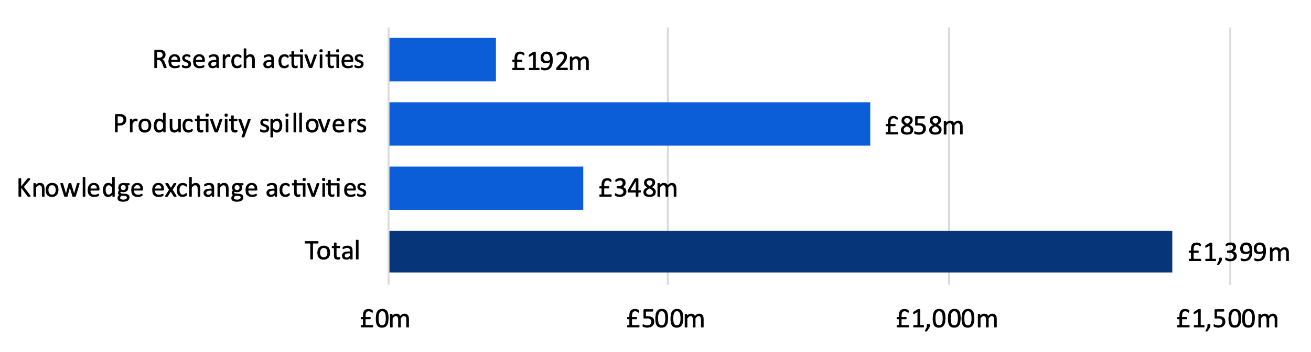
Note: All values are presented in 2021-22 prices, rounded to the nearest £1 million, and may not add up precisely to the totals indicated.
Source: London Economics’ analysis


The impact of the University of Birmingham’s teaching and learning activities
The analysis of the impact of the University of Birmingham’s teaching and learning activities estimates the enhanced employment and earnings benefits to graduates, and, separately, the additional taxation receipts to the public purse associated with higher education qualification attainment at the University. The analysis is adjusted for the characteristics of the 10,830 UK domiciled students who started a qualification at the University of Birmingham in the 2021-22 academic year.
Incorporating both the expected costs associated with qualification attainment and the labour market benefits expected to be accrued by students/graduates over their working lives, the analysis suggests that the net graduate premium achieved by representative UK domiciled students in the 2021-22 cohort completing a full-time first degree (with a Level 3 qualification as their highest level of prior attainment) stands at approximately £79,000 (in 2021-22 money terms). Separately, taking account of the benefits and costs to the public purse, the analysis indicates that the corresponding net Exchequer benefit associated with these students stands at £78,000.
The net graduate premiums and net Exchequer benefits were combined with information on the number of students starting each qualification at the University of Birmingham in the 2021-22 academic year and expected completion rates. The aggregate economic impact generated by the teaching and learning activities associated with the 2021-22 cohort stood at approximately £1,346 million (see Table 2). This is split evenly between the Exchequer and students/graduates: £674 million (50%) of the total economic benefit generated is accrued by students/graduates undertaking qualifications at the University of Birmingham, while the remaining £671 million (50%) is accrued by the Exchequer.
The total economic impact of teaching and learning generated by the 2021-22 cohort of University of Birmingham students stood at £1.35 billion.

- Aggregate impact of the University of Birmingham’s teaching and learning activities associated with the 2021-22 cohort (£m), by type of impact, domicile, and level of study
Beneficiary and study level | Domicile
Beneficiary and study level | England | Wales | Scotland | Northern Ireland | Total
Students | £649m | £20m | £2m | £3m | £674m
Undergraduate | £500m | £15m | £1m | £2m | £518m
Postgraduate | £149m | £5m | £1m | £1m | £156m
Exchequer | £646m | £20m | £3m | £3m | £671m
Undergraduate | £478m | £14m | £1m | £2m | £495m
Postgraduate | £168m | £6m | £2m | £1m | £177m
Total | £1,295m | £40m | £5m | £5m | £1,346m
Undergraduate | £978m | £29m | £2m | £4m | £1,013m
Postgraduate | £317m | £11m | £3m | £1m | £333m
Note: All estimates are presented in 2021-22 prices, discounted to reflect net present values, rounded to the nearest £1m, and may not add up precisely to the totals indicated.
Source: London Economics’ analysis


The impact of the University of Birmingham’s educational exports
With the University of Birmingham being an attractive destination for many international students, the University’s higher education offer represents a tradeable activity with imports and exports like any other tradeable sector. The economic impact of the University of Birmingham’s contribution to educational exports is based on the direct injection of tuition fee and non-tuition fee income from international students. As with the University’s knowledge exchange activities, this income generates indirect and induced impacts throughout the UK economy, through supply chain and wage income effects. The analysis focuses on the cohort of 5,080 non-UK domiciled students who started qualifications at the University of Birmingham in the 2021-22 academic year. Of these students, 175 (3%) were EU-domiciled, and 4,905 (97%) were from non-EU jurisdictions.
Combining the estimates of tuition fee income (net of the University of Birmingham’s cost of fee waivers and bursaries for international students) and non-tuition fee income associated with international students in the 2021-22 cohort, the total export income (i.e. direct impact) generated by this cohort stood at £278 million. Over half of this income (£151 million) was generated from international students’ (net) tuition fee expenditure accrued by the University of Birmingham, while just under a half (£127 million) was generated from international students’ non-tuition fee expenditure (e.g. including costs related to accommodation, subsistence, course-related purchases, and travel).
The total (direct, indirect, and induced) economic impact associated with this income was again estimated using relevant economic multipliers, identifying the extent to which the direct export income generates additional activity throughout the UK economy. We thus estimate that the total economic impact on the UK generated by the (net) tuition fee income and non-tuition fee income associated with international students in the 2021-22 University of Birmingham cohort amounts to £690 million. Of this total, £363 million was associated with international students’ (net) tuition fees, and £327 million was associated with these students’ non-tuition fee expenditures over the duration of their studies at the University of Birmingham (see Figure 2).
The impact of the export income generated by the 2021-22 University of Birmingham cohort of international student starters stood at £690 million.
The University’s activities with respect to educational exports supported an estimated 6,355 full-time equivalent jobs across the UK as a whole, of which 4,465 jobs were located in the West Midlands. This is in addition to the number of jobs supported as a result of the impact associated with the University of Birmingham’s institutional expenditures or the impact associated with the University’s knowledge exchange activities.
- Impact of the University of Birmingham’s educational exports associated with international students in the 2021-22 cohort (£m), by domicile and type of income
Note: All estimates are presented in 2021-22 prices, discounted to reflect net present values, rounded to the nearest £1m, and may not add up precisely to the totals indicated.
Source: London Economics’ analysis

The impact of the University of Birmingham’s expenditure

The University of Birmingham’s physical footprint supports jobs and promotes economic growth throughout the UK. This is captured by the direct, indirect, and induced impact associated with the expenditures of the institution. The direct impact of the University’s physical footprint was based on its operating and capital expenditures. In the 2021-22 academic year, the University of Birmingham incurred a total of £872 million of expenditure (including £769 million of operating expenditure and £103 million of capital expenditure). From this total, we deducted £474 million to avoid double-counting, which resulted in a net direct impact of £398 million.
The impact of the University of Birmingham’s expenditure on the UK economy in the 2021-22 academic year stood at £908 million.
Again, the direct increase in economic activity resulting from the expenditures of the University of Birmingham generates additional rounds of spending throughout the economy (through the University’s supply chains, and the spending of staff). Applying the relevant economic multipliers, the total direct, indirect, and induced impact associated with the University’s expenditures in the 2021-22 academic year was estimated at £908 million (see Figure 3).
Almost two-thirds of this impact (£596 million, 66%) occurred in the West Midlands, while the remainder (£312 million, 34%) was accrued across the rest of the UK. In addition to the impacts occurring in the government, health, and education sector itself (£449 million, 49%), there are also large impacts felt within other sectors, including the distribution, transport, hotel, and restaurant sector (£115 million, 13%), the production sector (£105 million, 12%), and the real estate sector (£73 million, 8%).
- Impact associated with the University of Birmingham’s expenditure in the 2021-22 academic year (£m)
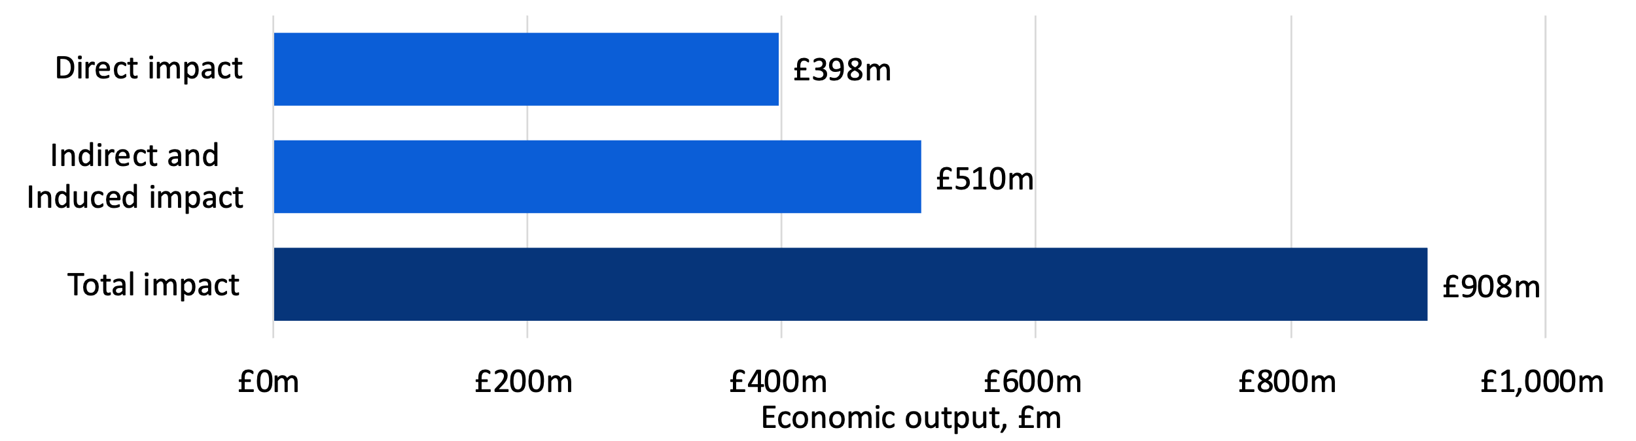
Note: All estimates are presented in 2021-22 prices, rounded to the nearest £1m, and may not add up precisely to the totals indicated.
Source: London Economics’ analysis
In terms of the number of FTE jobs supported, the University of Birmingham’s expenditure supported a total of 6,200 FTE jobs across the UK economy in the 2021-22 academic year of which 4,620 (75%) were based in the West Midlands. The remaining 1,580 jobs supported by the University’s activities are located across the rest of the UK.


The impact of the University of Birmingham’s contribution to tourism
As a final strand of impact, the University attracts a range of visitors to Birmingham, including business visitors, friends and family visiting the University’s staff and students, and participants in study trips to the University.
To understand the economic impact associated with the University’s contribution to tourism through the attraction of these visitors, we estimated the number of visitors to Birmingham in 2021-22 that were associated with the University’s presence. The analysis focuses only on visits to Birmingham that involved overnight stays by visitors from overseas, as it is assumed that any domestic (day or overnight) visits to Birmingham would have displaced activity from other regions of the UK (and should not be considered ‘additional’ to the UK economy). Out of a total of 803,000 overnight visits from overseas visitors to Birmingham, we estimate that approximately 26,000 resulted from the University’s activities. Combined with information on the average trip expenditure per visitor, the direct impact of the University’s contribution to tourism was estimated at £19 million.
As with the University’s research and knowledge exchange activities, educational exports, and the spending of the University, this visitor expenditure results in subsequent rounds of expenditure throughout the UK economy. Again, this is measured by the indirect, and induced impacts associated with these expenditures, estimated by applying relevant economic multipliers to the direct impact. Using this approach, the analysis indicates that the total direct, indirect, and induced impact of the visitor expenditure generated by the University of Birmingham stood at approximately £46 million (see Figure 4).
The impact of the University’s contribution to tourism in 2021-22 stood at
£46 million.
The University’s contribution to tourism activities supported an estimated 455 full-time equivalent jobs across the UK as a whole, with 340 jobs of these jobs supported in the West Midlands.
- Impact associated with the University of Birmingham’s contribution to tourism in 2021-22 (£m)
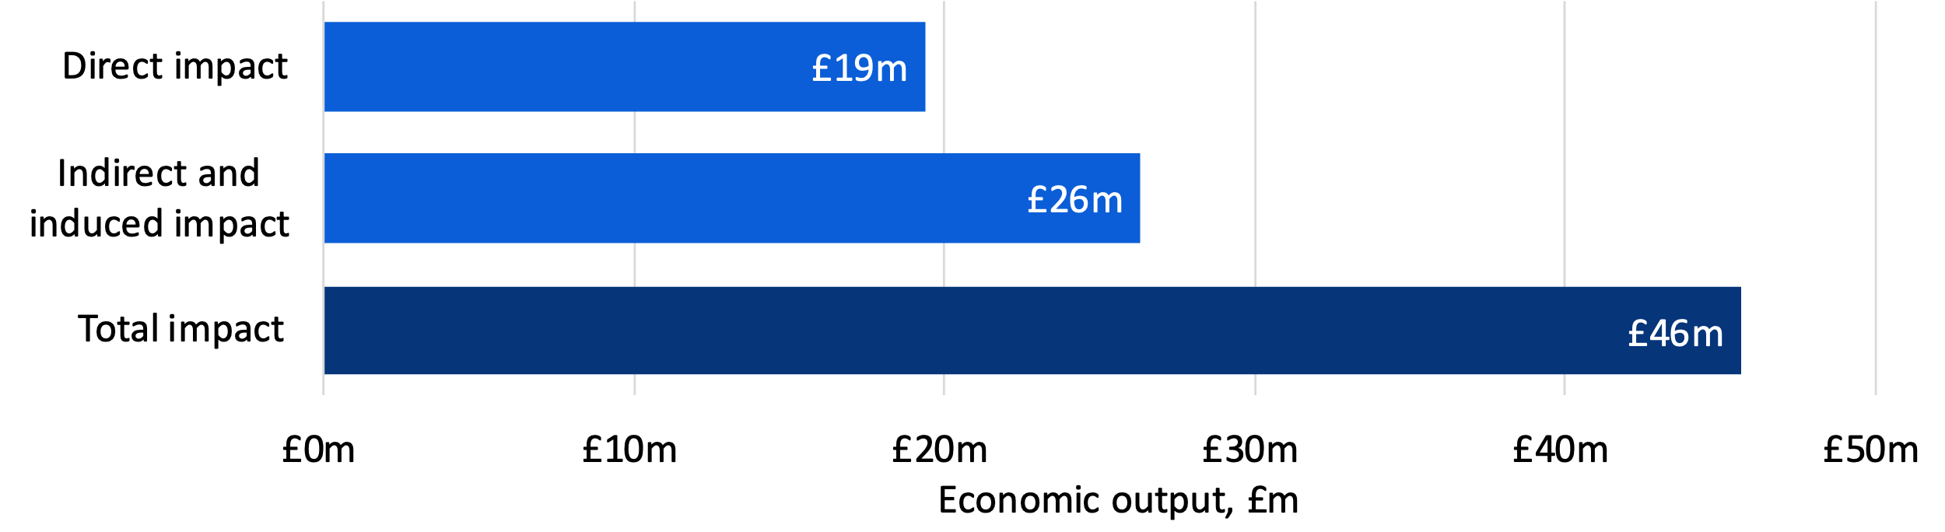
Note: All estimates are presented in 2021-22 prices, rounded to the nearest £1m, and may not add up precisely to the totals indicated.
Source: London Economics’ analysis

Introduction
London Economics were commissioned to assess the economic, social and cultural impact of the University of Birmingham to the United Kingdom, focusing on the 2021-22 academic year. The University of Birmingham contributes to the UK’s national prosperity through a range of activities and channels, and the analysis is split into:
- The impact of the University of Birmingham’s research and knowledge exchange activities;
- The economic contribution of the University of Birmingham’s provision of teaching and learning;
- The impact of the University of Birmingham’s contribution to educational exports;
- The impact of the University of Birmingham’s operating and capital expenditures;
- The impact of the tourism activity associated with the University of Birmingham; and
- The social and cultural impact of the University of Birmingham.
The analysis builds upon previous work undertaken by London Economics for the University of Birmingham assessing the University’s economic and social impact, which focused on the 2014-15 academic year. Alongside a number of methodological improvements, this report focuses on a wider range of impacts than the previous study, including knowledge exchange activities and tourism. As such, the direct comparison of results between the current analysis and the results presented in the previous report should be treated with caution.
Reflecting these channels of impact, the remainder of this report is structured as follows.
In Section 2, we outline our estimates of the impact of the University of Birmingham’s research and knowledge exchange activities. To estimate the impact of the research undertaken at the University, we combine information on the research-related income accrued in the 2021-22 academic year with estimates from the wider economic literature on the extent to which public investment in research activity results in additional private sector productivity (i.e. positive ‘productivity spillovers’). In addition, the analysis estimates the direct, indirect, and induced impact associated with the University’s research and knowledge exchange activities, including the commercialisation activities of associated spinout and start-up companies; contract research provided by the University; consultancy services provided by the University; business and community courses; facility and equipment hire; and licensing of the University’s intellectual property (IP) to other organisations.
In Section 3, we assess the improved labour market earnings and employment outcomes associated with higher education attainment at the University of Birmingham. Through an assessment of the expected lifetime benefits and costs associated with educational attainment, we estimate the net economic benefits of the University’s teaching and learning activity to its graduates and the public purse (through enhanced taxation receipts), focusing on the cohort of 10,830 UK domiciled students who started higher education qualifications at the University in the 2021-22 academic year. In addition, we provide evidence on the average earnings and employment outcomes of the University’s graduates as well as the role that the University plays in attracting graduates to the West Midlands. We also demonstrate the University’s role in training public sector workers in the West Midlands and its role in facilitating apprenticeships.
In addition to these UK domiciled students, there were a further 5,080 international students commencing their studies in the 2021-22 cohort of University of Birmingham students. These students contribute to the value of UK educational exports through their tuition fees as well as their non-fee (i.e. living cost) expenditures during their studies. Section 4 assesses the direct, indirect, and induced economic impacts generated by this fee and non-fee income associated with the University’s 2021-22 cohort of international students.
Given that the University of Birmingham is a major employer and supports its core activities through significant expenditures, the University’s substantial physical footprint supports jobs and promotes economic growth throughout the West Midlands and the wider UK economy. Section 5 presents our estimates of the direct, indirect, and induced economic impacts associated with the operating and capital expenditures incurred by the University of Birmingham in the 2021-22 academic year.
The University also attracts a range of visitors to Birmingham, including business visitors, friends and family visiting the University’s staff and students, and participants in study trips to the University. The impact of these visitors on the UK economy is estimated in Section 6.
In addition to the economic impacts associated with the University, there is a wide range of further social and cultural impacts associated with the University. In Section 7, we present the wider economic and societal benefits of the University of Birmingham for students and graduates (evidenced through a survey of the University’s alumni), its cultural impact through hosting public events, the contribution of the University’s staff to the local community through volunteering, and the University’s environmental impact.
Finally, Section 8 of this report summarises our main findings.

The impact of the University of Birmingham’s research and knowledge exchange activities
In this section, we outline our estimates of the economic impact of the University of Birmingham’s research and knowledge exchange activities. To achieve this, we first consider the impact of the University’s expenditure on research and wider knowledge exchange activities through the direct, indirect and induced effects of that spending. Secondly, we consider the wider productivity spillovers that are generated through the University’s research activities as well as the economic impact generated by spinout and start-up companies that are linked to the University. The section first considers the impact of the University’s research (Section 2.1), followed by the impact of the University’s knowledge exchange activities (Section 2.2).

Economic impact of the University of Birmingham’s research
In this section, we outline our analysis of the economic impact of the University of Birmingham’s research activities. We estimate both the direct, indirect, and induced effects of the University of Birmingham’s research (captured by the research income accrued by the University of Birmingham and the subsequent rounds of spending this income generates across the economy), as well as the productivity spillover effects from the University’s research activities.

The University of Birmingham’s research income in 2021-22
To estimate the direct impact generated by the University of Birmingham’s research activities, we used information from the Higher Education Statistics Agency (HESA) on the total research-related income accrued by the University in the 2021-22 academic year, including:
- Income from research grants and contracts provided by:
  - UK sources, including the UK Research Councils; UK-based charities; central government bodies, local authorities, and health and hospital authorities; industry and commerce; and other UK sources;
  - EU sources, including government bodies, charities, industry and commerce, and other sources; and
  - Non-EU sources, including charities, industry and commerce, and other sources; and
- Recurrent research funding allocated to the University by Research England.
Aggregating across these sources, the total research-related income accrued by the University of Birmingham in the 2021-22 academic year stood at £271 million (see Figure 5).
Approximately 21% (£56 million) of the research income in 2021-22 was received through recurrent research grant funding from Research England, with an additional 28% (£76 million) received from the UK Research Councils, 13% (£34 million) from UK charities, and 23% (£63 million) from other UK sources. In addition, in terms of funding from international sources, 9% (£26 million) of the University’s research-related income was derived from EU research grants and contracts, and the remaining 6% (£16 million) was from non-EU sources.
- Research income received by the University of Birmingham in 2021-22, £m by source of income
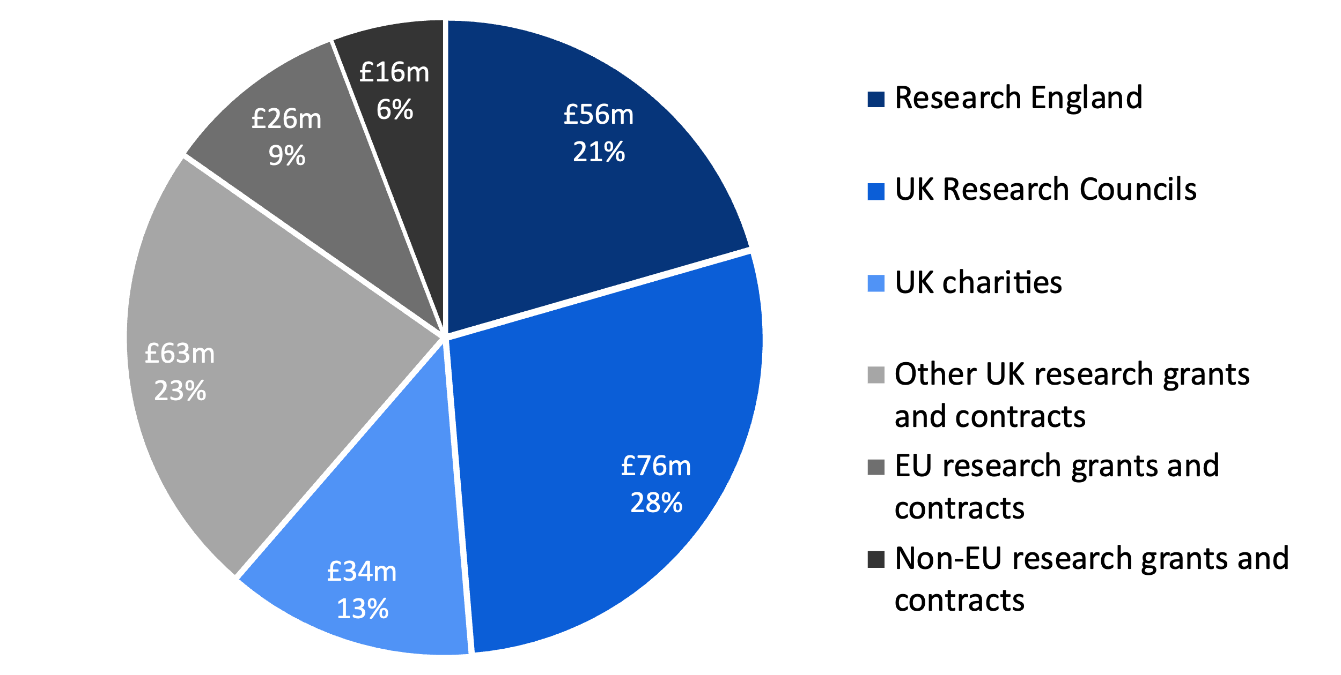
Note: All values are presented in 2021-22 prices and rounded to the nearest £1 million.
Source: London Economics’ analysis based on data provided by the Higher Education Statistics Agency (HESA, 2023d)

Adjustment for double counting with knowledge exchange activities
The £271 million of research income received by the University of Birmingham in 2021-22 includes income associated with a whole range of research activities. In particular, the University’s collaborative research and contract research activities are included within this aggregate total. However, the income from these two activities is also recorded separately within the Higher Education Business and Community Interaction Survey (HE-BCI) data, which we use to separately estimate the economic impact associated with the University’s wider knowledge exchange activities (described in further detail in Section 2.2).
Given that the income from these sources is included in both the data on the University’s research-related income as well as the HE-BCI data on the University’s wider knowledge exchange activities, to avoid any double counting between the estimated impact of the University of Birmingham’s research activity (described in this section) and wider knowledge exchange activities (described in Section 2.2), we made the following adjustments:
- In terms of the University’s impact from collaborative research, we implicitly account for publicly funded and cash income from collaborative research within the impact of the University’s research in this section. We therefore do not take collaborative research income into account in the analysis of wider knowledge exchange activities. This income represents £15 million out of the £271 million of total research income received by the University of Birmingham in 2021-22.
- In terms of contract research, we account for this activity within the impact of the University of Birmingham’s wider knowledge exchange activities (see Section 2.2). Therefore, to avoid double counting, the analysis of the impact of the University of Birmingham’s research activities here is adjusted to deduct the £109 million of contract research income from the above total research-related income (£271 million). We thus estimated that the gross direct impact (before deducting public costs) associated with the University of Birmingham’s research activity in the 2021-22 academic year stands at £162 million.
A schematic overview of the methodological approach adopted including the adjustments for double counting is provided in Annex A2.2.1.

Total direct, indirect, and induced impact of the University of Birmingham’s research activity
The analysis assesses the direct, indirect, and induced economic impacts associated with the University of Birmingham’s research activity in 2021-22 on the UK economy. While the direct impact reflects the research income that the University of Birmingham received in the 2021-22 academic year, the indirect and induced effects reflect the chain reaction of subsequent rounds of spending throughout the economy, often referred to as a ‘ripple effect’. These are defined as follows:
- Indirect effect (‘supply chain impacts’): The University of Birmingham spends its research income on purchases of goods and services from suppliers, who in turn spend this revenue purchasing inputs to meet demand from the University. This results in a chain reaction of subsequent rounds of spending across industries, often referred to as a ‘ripple effect’.
- Induced effect (‘wage spending impacts’): The employees of the University of Birmingham (supported by their research income) use their wages to purchase consumer goods and services within the economy. This in turn generates wage income for employees within the industries producing these goods and services, again leading to subsequent rounds of spending, i.e. a further ‘ripple effect’ throughout the economy as a whole.
The total of the direct, indirect, and induced effects constitutes the gross economic impact of the University of Birmingham’s research activities. An analysis of the net economic impact ideally needs to account for two additional factors potentially reducing the size of any of the above effects:
- Leakage into other geographical areas, by taking account of how much of the additional economic activity actually occurs in the area of consideration (i.e. the United Kingdom); and
- Displacement of economic activity within the region of analysis, i.e. taking account of the possibility that the economic activity generated might result in the reduction of activity elsewhere within the region.
The direct, indirect, and induced impacts are measured in terms of monetary economic output, gross value added (GVA), and full-time equivalent (FTE) employment supported. In addition to measuring these impacts on the UK economy as a whole, the analysis is broken down by geographic region and sector.
These impacts of the University of Birmingham’s research activities were estimated using economic multipliers derived from Input-Output tables, which measure the total production output of each industry in the UK economy, and the inter-industry (and intra-industry) flows of goods and services consumed and produced by each sector. In other words, these tables capture the degree to which different sectors within the UK economy are connected, i.e. the extent to which changes in the demand for the output of any one sector impact all other sectors of the economy. To be able to achieve a breakdown of the analysis by region, we developed a multi-regional Input-Output model, combining UK-level Input-Output tables (published by the Office for National Statistics) with a range of regional-level data to achieve a granular breakdown by sector and region.
To estimate the total direct, indirect, and induced impact, we apply the relevant economic multipliers (derived from our above-described Input-Output analysis) associated with organisations in the government, health, and education sector in the West Midlands. These multipliers (for the impact on the West Midlands and the UK economy as a whole) are presented in Table 3.
Based on these estimates, in terms of economic output, we assume that every £1 million of research income accrued by the University of Birmingham generates a total of £2.28 million of impact throughout the UK economy on average, of which £1.50 million is accrued in the West Midlands. In terms of employment, again we base our assumptions on the Input-Output tables. We therefore assume that, for every 1,000 FTE staff employed directly by the University of Birmingham, a total of 1,790 staff are supported throughout the UK, of which 1,330 are supported in the West Midlands.
- Economic multipliers associated with the University of Birmingham’s research activities
Location of impact | Output | GVA | FTE employment
West Midlands | 1.50 | 1.43 | 1.33
Total UK | 2.28 | 2.07 | 1.79
Note: All multipliers constitute Type II multipliers, defined as [Direct + indirect + induced impact]/[Direct impact].
Source: London Economics’ analysis
In addition to the impacts associated with the University of Birmingham’s research activity, a similar methodology is applied to estimate the direct, indirect, and induced economic effects associated with the University’s knowledge exchange activities (see Section 2.2), export income (see Section 4), operational and capital expenditures (see Section 5) and tourism impact (see Section 6).

Adjusting for public costs
To arrive at the total impact of the University of Birmingham’s research activities on the UK economy, net of public costs, we deducted the costs to the public purse of funding the University of Birmingham’s research activities. These public costs include the funding provided by the UK Research Councils (£76 million), recurrent research grants provided by Research England (£56 million), and other research income from UK central government bodies, local authorities, and health and hospital authorities (£46 million). These total public purse costs (£177 million) are deducted from the direct, indirect, and induced impacts of research activity estimated using the multipliers outlined above. We estimated that the resulting direct, indirect, and induced impact (net of public costs) associated with the University of Birmingham’s research activity in the 2021-22 academic year stood at £192 million, where the direct research impact stood at £84 million (see Figure 6).
The estimated impact of the University of Birmingham’s research activities in 2021-22 stood at £192 million.
In terms of GVA and FTE employment, the total direct, indirect, and induced impact associated with the University of Birmingham’s research was estimated at £118 million and 1,965 FTE jobs, respectively.
- Net direct, indirect, and induced impacts associated with University of Birmingham research income in 2021-22 by activity, £m
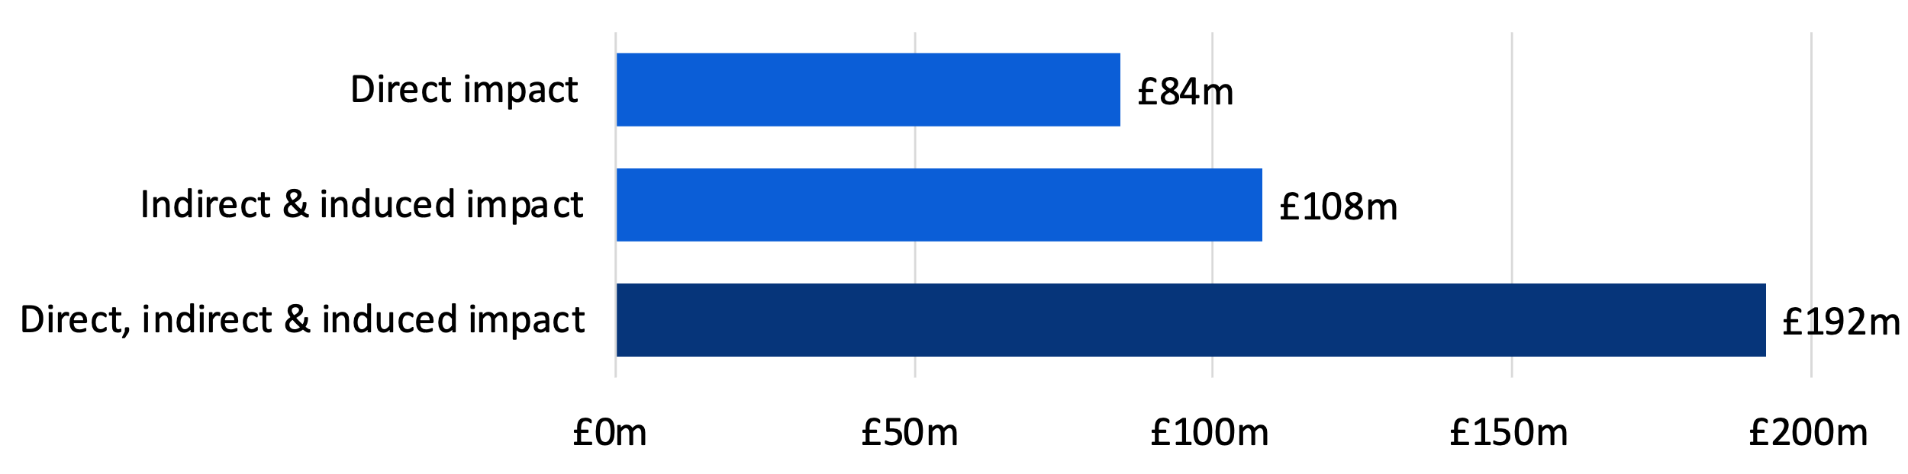
Note: Monetary estimates are presented in 2021/22 prices, rounded to the nearest £1 million, and may not add up precisely to the totals indicated.
Source: London Economics’ analysis

Productivity spillovers
In addition to the direct, indirect, and induced impact of research, the wider academic literature indicates that investments in research & development (R&D) and other intangible assets may induce positive externalities. Economists refer to the term ‘externality’ to describe situations in which the activities of one ‘agent’ in the market induces (positive or negative) external effects on other agents in that market (which are not reflected in the price mechanism). In the context of the economic impact of research activities, existing academic literature assesses the existence and size of positive productivity and knowledge spillovers, where knowledge generated through the research activities of one agent enhances the productivity of other organisations.
There are many ways in which research generated at universities can induce such positive spillover effects to the private sector. For example, spillovers are enabled through direct R&D collaborations between universities and firms (such as Knowledge Transfer Partnerships), the publication and dissemination of research findings, or through university graduates entering the labour market and passing on their knowledge to their employers.

What are the estimates of the productivity spillovers?
In order to estimate the productivity spillovers associated with the University of Birmingham’s research activities, we apply these productivity spillover multipliers from the existing literature to the different types of research-related income received by the University in 2021-22 (again see Figure 5). Specifically, assigning the multiplier of 12.7 to the research funding that the University of Birmingham received from UK Research Councils and UK charities in 2021-22 (amounting to £110 million), and assigning the multiplier of 0.2 to all other research funding received by the University in that academic year (amounting to £160 million). More detailed summaries of these papers and further studies on this topic are presented in Annex A2.2.2.
Therefore, we infer a weighted average spillover multiplier associated with the University of Birmingham’s research activities of approximately 5.30 – i.e. every £1 invested in the University’s research activities generates additional annual economic output of £5.30 across the UK economy. This captures the impact of the research undertaken by the University in 2021-22 within that same academic year (but excludes any additional (and likely substantial) impacts in subsequent years).
Applying this weighted average multiplier to the direct impact of research (i.e. excluding contract research, which is £109 million), we estimate that the research conducted by the University of Birmingham in 2021-22 resulted in total market sector productivity spillovers of £858 million.

Aggregate impact of the University of Birmingham’s research
Combining the direct, indirect, and induced economic impact of the University of Birmingham’s research (£192 million) with the estimated productivity spillovers associated with this research (£858 million), we estimate that the total economic impact associated with the University’s research activities in 2021-22 stands at approximately £1,051 million (see Figure 7).
The estimated impact of University of Birmingham’s research activities in 2021-22 stood at £1.05 billion.
Comparing the £177 million of publicly funded research income received by the University of Birmingham in 2021-22 to the £1,051 million impact from research activities, this suggests that for each £1 million of publicly funded research income, the University of Birmingham’s research activities generated an estimated total of £5.93 million in economic impact across the UK.
- Total impact of the University of Birmingham’s research activities in 2021-22, £m
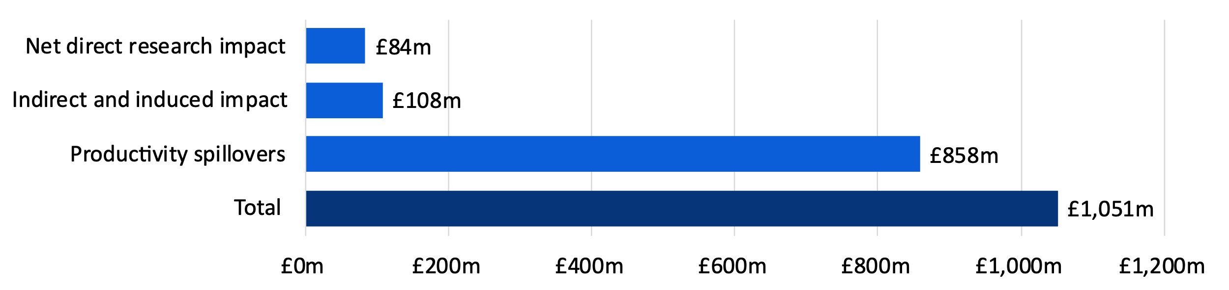
Note: All values are presented in 2021-22 prices, rounded to the nearest £1 million, and may not add up precisely to the total indicated
Source: London Economics’ analysis
- The University of Birmingham’s performance in the 2021 Research Excellence Framework
In addition to the monetary estimates of the impact of the University of Birmingham’s research activities, the results from the 2021 Research Excellence Framework further highlight the University’s world-leading research. Overall, over half (52%) of the University’s submissions were rated as 4* (world-leading) and 41% were rated as 3* (internationally excellent), compared to the average of 41% and 43% respectively across all UK institutions.
The University’s strength in certain areas was highlighted by being ranked in the top 5 in the UK in 9 units of assessment (based on the proportion of 4* submissions). The University ranked 1st for Physics; 2nd for Earth Systems and Environmental Sciences; 3rd for Computer Science and Informatics; Philosophy; Theology and Religious Studies; Area Studies; 4th for Education; and 5th for Public Health, Health Services and Primary Care; Sport and Exercise Sciences, Leisure and Tourism.
In addition, the University was ranked top in the UK for research impact (again, based on the proportion of 4* submissions) for 4 units of assessment: Computer Science and Informatics; Public Health, Health Services and Primary Care; Education; and Theology and Religious Studies.

Economic impact of the University of Birmingham’s knowledge exchange activities
In addition to its research activities, the University of Birmingham generates significant economic impacts through a range of knowledge exchange activities. The methodology of this section focuses on the impact of spinout and start-up companies linked to the University of Birmingham and the wider knowledge exchange activities undertaken at the University, including:
- Contract research provided by the University of Birmingham;
- Consultancy services provided by the University of Birmingham;
- Licensing of University IP to other organisations;
- The business and community courses provided by the University of Birmingham; and
- Facilities and equipment hire, and related activities.
Specifically, the analysis captures the direct, indirect, and induced economic impacts associated with a range of these knowledge exchange activities using economic multipliers derived from Input-Output tables, as described in Section 2.1.3.

Economic impact of the University of Birmingham’s spinout and start-up companies
To assess the direct impact associated with the University of Birmingham’s UK-based spinout and start-up companies, we made use of information on turnover or investment funding data (as a measure of economic output) and FTE employment associated with a total of 41 spinout companies and 310 start-ups that were active and based in the UK in 2021-22, where available. The information on each company’s turnover and employment was based on data from Bureau van Dijk’s FAME database (based on Companies House information). The direct GVA generated was estimated by multiplying the turnover of each firm by the average ratio of GVA to output among organisations within the given company’s industry and region,.
Considering spinout and start-up companies in turn, we adopt the approach outlined above to estimate the direct impact associated with the activities of all the University of Birmingham spinout companies for which data was available. For the academic year 2021-22, the total direct impact of the University of Birmingham’s spinout companies was estimated at £13 million in economic output (i.e. turnover) terms, 455 FTE staff, and £7 million of GVA. Similarly, the direct impact associated with the activities of the University of Birmingham’s start-up companies in 2021-22 was estimated at £17 million in economic output terms, 360 FTE staff, and £9 million of GVA.
We applied relevant economic multipliers (derived from our above-described Input-Output analysis) to estimate the total direct, indirect, and induced economic impacts of spinout and start-up companies associated with the University of Birmingham. Specifically, we assigned relevant economic multipliers to each active spinout and start-up company in 2021-22, based on each firm’s industry classification and the region of its main registered office address.
Applying these multipliers to the above direct impacts, the total economic impact associated with the activities of the University’s spinout companies in the 2021-22 academic year was estimated to be £33 million across the UK economy, of which £1.4 million (4%) occurred in the West Midlands (see Table 4). The estimated total number of FTE jobs supported stood at 1,275 (of which 205 (or 16%) were located in the West Midlands). The corresponding estimate in terms of GVA stood at £18 million (of which £0.7 million (or 4%) occurred in the West Midlands).
- Economic impact associated with the University of Birmingham’s spinout companies in 2021-22
Location of impact | Output, £m | GVA, £m | # of FTE employees
West Midlands | £1.4m | £0.7m | 205
Total UK | £33m | £18m | 1,275
Note: All monetary values are presented in 2021-22 prices and rounded to the nearest £1 million. The employment figures are rounded to the nearest 5.
Source: London Economics’ analysis
The total economic impact associated with the activities of the University’s start-up companies was estimated to be £49 million across the UK economy, of which £1.5 million (3%) occurred in the West Midlands (see Table 5). The estimated total number of FTE jobs supported stood at 915 (of which 175 or 19% were located in the West Midlands). The corresponding estimate in terms of GVA stood at £24 million (of which £0.8 million or 3% occurred in the West Midlands).
- Economic impact associated with the University of Birmingham’s start-ups in 2021-22
Location of impact | Output, £m | GVA, £m | # of FTE employees
West Midlands | £1.5m | £0.8m | 175
Total UK | £49m | £24m | 915
Note: All monetary values are presented in 2021-22 prices and rounded to the nearest £1 million. The employment figures are rounded to the nearest 5.
Source: London Economics’ analysis

Total impact of the University of Birmingham’s spinout and start-up companies
The total direct impact of spinout and start-up companies associated with the University of Birmingham is therefore £30 million in economic output (i.e. turnover) terms, 815 FTE staff, and £16 million of GVA.
This led to a total direct, indirect and induced economic impact of £82 million across the UK economy. The estimated total number of FTE jobs supported stood at 2,190 and the corresponding estimate in terms of GVA stood at £42 million. This total impact is likely to be underestimated significantly given the limitations to the data that were available on the companies’ turnover and employment.

Economic impact of the University of Birmingham’s wider knowledge exchange activities
In this section, we estimate the economic impact of the University of Birmingham’s wider knowledge exchange activities, which are measured in HE-BCI, but are distinct from the spinout and startup companies created by the University of Birmingham’s staff and students. These wider knowledge exchange activities include:
- Contract research provided by the University of Birmingham;
- Consultancy services provided by the University of Birmingham;
- Licensing of University IP to other organisations;
- The business and community courses provided by the University of Birmingham; and
- Facilities and equipment hire, and related activities.
The publicly funded and cash income from collaborative research is not included in this section, but implicitly accounted for in the impact of the University’s research (see Section 2.1). Although the income from collaborative research is likely to contain funding related to wider knowledge exchange activities, it is difficult to attribute it with certainty to a specific knowledge exchange activity. As such, we retain collaborative research within the research impact category (see Section 2.1.2 for more details on the adjustment for double counting).
In addition to the direct impact in economic output terms associated with each of the wider knowledge exchange activities, we estimate the impact in GVA and FTE employment terms. To arrive at these comparable estimates, we multiply the direct output by the average ratios of GVA to output and of FTE employees to output among organisations within the government, health, and education sector located in the West Midlands.
The direct impact of the University of Birmingham’s wider knowledge exchange activities is made up of £109 million in income from contract research activities, £6 million in revenues associated with consultancy services, £1.3 million of IP licensing income, £0.7 million of income generated from business and community courses, as well as £0.1 million of income associated with the hire of the University of Birmingham’s research facilities. The total direct impact therefore stood at £117 million in the 2021-22 academic year. The associated impact in GVA terms stood at £79 million while supporting 1,525 FTE employment.
To estimate the total direct, indirect, and induced impacts associated with the University of Birmingham’s income from each of the wider knowledge exchange activities, we then multiplied these direct impacts by the estimated average economic multipliers associated with organisations in the government, health, and education sector in the West Midlands. These multipliers (for the impact on the West Midlands and the UK economy as a whole) are the same as those presented in Table 3 in Section 2.1.3.
Combining the economic impacts generated by the University of Birmingham’s contract research, consultancy services, IP licensing, business and community courses, and facilities and equipment lease and hire, Table 6 presents the aggregate impact associated with the University of Birmingham’s wider knowledge exchange activities in the 2021-22 academic year.
Therefore, the analysis estimates that, in 2021-22, wider knowledge exchange activities generated an estimated total of £267 million of economic output across the UK economy. The total GVA impact is estimated at £164 million and an estimated 2,725 FTE jobs are supported across the UK economy.
- Economic impact associated with the University of Birmingham’s wider knowledge exchange activities in 2021-22
Type of impact | Output, £m | GVA, £m | # of FTE employees
Direct impact | £117m | £79m | 1,525
Indirect and induced impact | £150m | £85m | 1,200
Total impact | £267m | £164m | 2,725
Note: All monetary values are presented in 2021-22 prices and rounded to the nearest £1 million. The employment figures are rounded to the nearest 5.
Source: London Economics’ analysis

Total economic impact of the University of Birmingham’s knowledge exchange activities
The combined knowledge exchange and commercialisation activities of the University of Birmingham in 2021-22 directly generated an estimated £147 million in terms of economic output across the UK economy. The corresponding value in terms of GVA stood at £95 million and the activities supported 2,340 FTE jobs across the UK economy. When accounting for the indirect and induced impacts of these knowledge exchange activities, the total impact stood at £348 million (Figure 8).
Of the total value of £348 million, contract research contributes 71% (£248 million), followed by 14% (£49 million) from the University of Birmingham’s active UK-based start-up companies and 9% (£33 million) from spinout companies.
- Total economic impact associated with the University of Birmingham’s knowledge exchange activities in 2021-22 by activity, £m
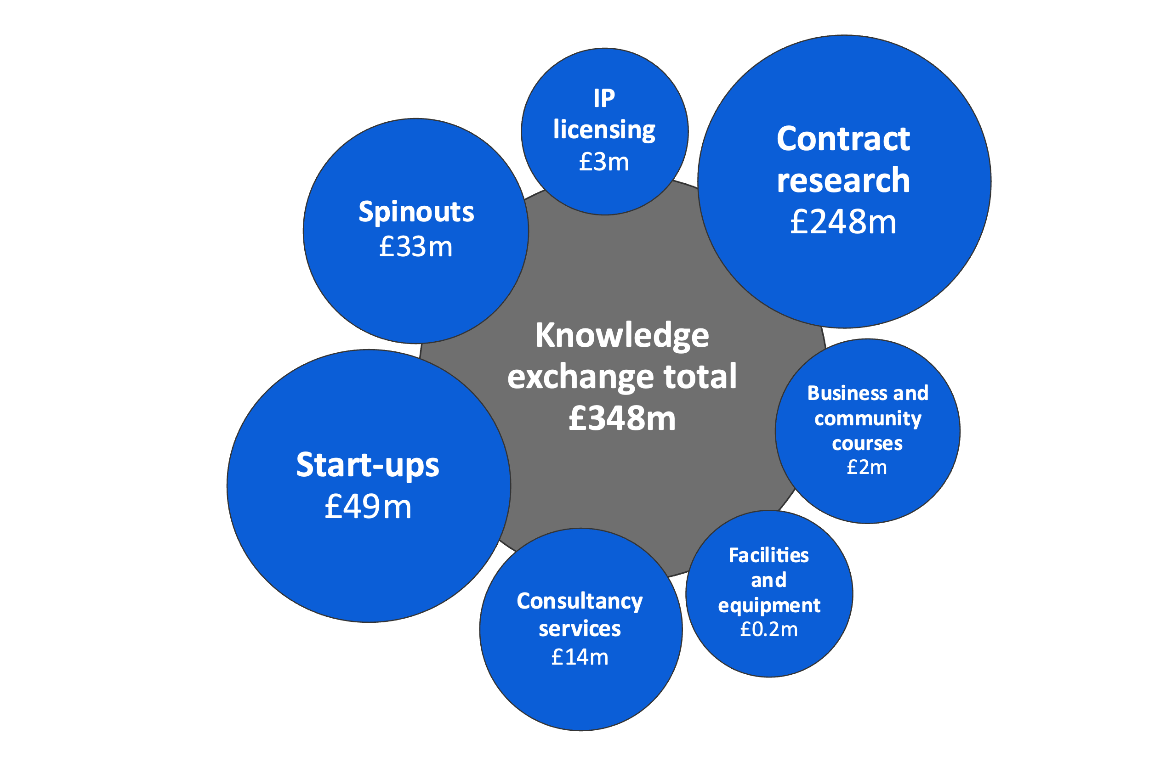
Note: Monetary estimates are presented in 2021-22 prices, rounded to the nearest £1 million, and may not add up precisely to the totals indicated. Bubbles not to scale.
Source: London Economics’ analysis

Total impact of the University of Birmingham’s research and knowledge exchange activities
The total economic impact on the UK economy associated with the University of Birmingham’s research and knowledge exchange activities in 2021-22 was estimated to be approximately £1.4 billion (Figure 9). A breakdown by region and sector, where available, is presented in Annex A2.2.3. In terms of the components of this impact:
- University of Birmingham’s research activities accounted for £192 million;
- The associated productivity spillovers to the wider UK economy stood at £858 million; and,
- The impact associated with the University of Birmingham’s knowledge exchange activities is estimated to be £348 million, including:
  - Spinout and start-up companies (£82 million);
  - Contract research provided by the University of Birmingham (£248 million);
  - Consultancy services provided by the University of Birmingham (£14 million);
  - Licensing of University IP to other organisations (£3 million);
  - The business and community courses provided by the University (£2 million); and
  - Facilities and equipment hire, and related activities (£0.2 million).
- Total impact of the University of Birmingham’s research and knowledge exchange activities in 2021-22, £m
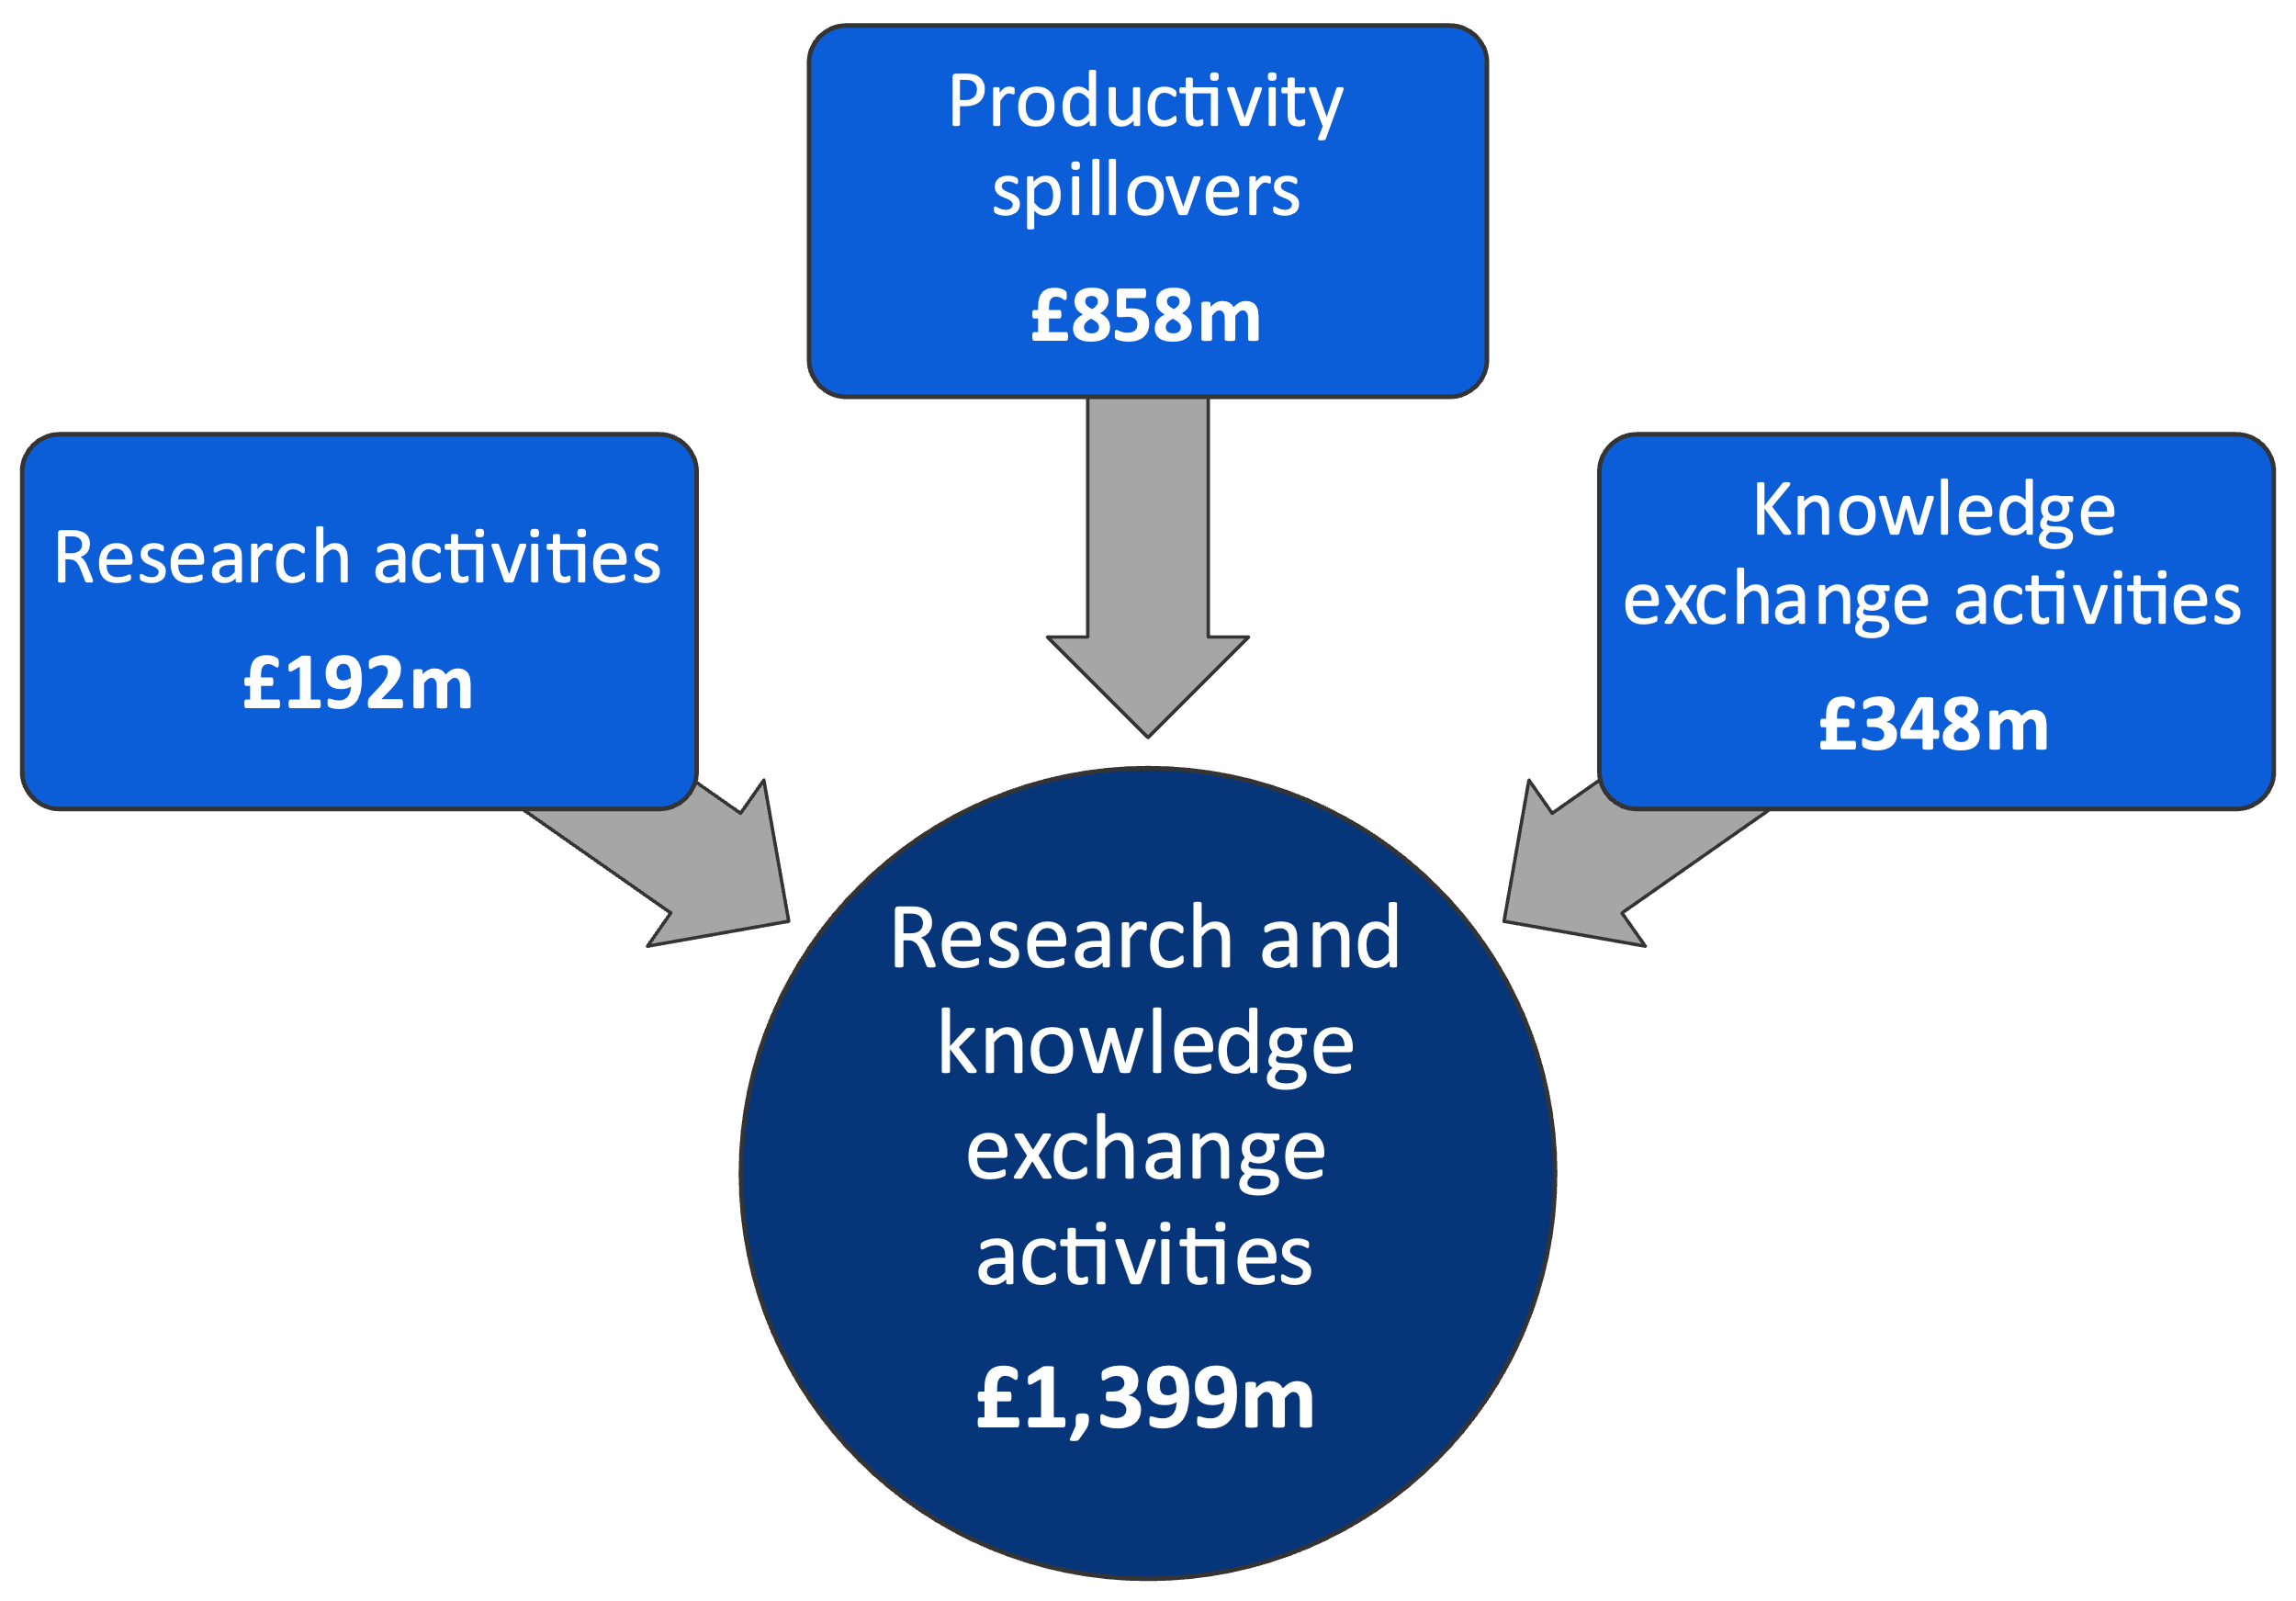
Note: All values are presented in 2021-22 prices, rounded to the nearest £1 million, and may not add up precisely to the totals indicated.
Source: London Economics’ analysis

The impact of the University’s teaching and learning activities
Teaching and learning activities are one of the University of Birmingham’s primary activities and provide major benefits to the UK economy through improving the labour market productivity of graduates. In this section of the report, we detail our estimates of the economic impact of the teaching and learning activities undertaken at the University of Birmingham, by considering the labour market benefits associated with enhanced qualification attainment and skills acquisition – to both the individual and the public purse.
In addition, we provide evidence on the average earnings and employment outcomes of the University’s graduates as well as the role that the University plays in attracting graduates to the West Midlands. We also demonstrate the University’s role in training public sector workers in the West Midlands and its role in facilitating apprenticeships.

The 2021-22 cohort of domestic University of Birmingham students
The analysis of the economic impact of the teaching and learning activities of the University of Birmingham is based on the 2021-22 cohort of UK domiciled students. In other words, instead of the University’s entire student body of 37,990 students in the 2021-22 academic year (irrespective of when these individuals may have started their studies), the analysis in this section focuses on the 10,830 UK domiciled students starting higher education qualifications (or standalone modules/credits) in the 2021-22 academic year.
In terms of level of study (Figure 10), 60% (6,455 students) of this cohort of UK domiciled students were undertaking first degrees, with a further 2,085 students (19%) undertaking postgraduate taught degrees, and 1,390 students (13%) enrolled in other postgraduate degrees. An additional 575 (5%) students were undertaking postgraduate research degrees, while the remaining 325 (3%) students were enrolled in other undergraduate qualifications.
- UK domiciled students in the 2021-22 cohort of University of Birmingham students, by level of study
Note: All numbers are rounded to the nearest 5, and the total values may not add up due to this rounding. ‘Other undergraduate’ learning includes Certificates of Higher Education, Foundation Degrees, other undergraduate-level certificates, diplomas and qualifications and undergraduate-level credits. ‘Other postgraduate’ learning includes taught work for credit at postgraduate level, Postgraduate Certificates or Professional Graduate Diplomas in Education, and other diplomas and qualifications at postgraduate level.
Source: London Economics’ analysis based on University of Birmingham Higher Education Statistics Agency (HESA) data
In relation to mode of study (Figure 11), 8,560 (79%) students in the cohort were undertaking their studies with the University of Birmingham on a full-time basis, while the remaining 2,270 (21%) were enrolled on a part-time basis. As shown in Table 7, most full-time students were undertaking first degrees (75% of full-time students), while part-time students in the cohort were predominantly enrolled in higher degree (taught) qualifications (41% of part-time students) or other postgraduate qualifications (41% of part-time students).
- UK domiciled students in the 2021-22 cohort of University of Birmingham students, by mode of study |  | - UK domiciled students in the 2021-22 cohort of University of Birmingham students, by domicile
Note: All numbers are rounded to the nearest 5, and the total values may not add up due to this rounding.  Source: London Economics’ analysis based on University of Birmingham HESA data |  | Note: All numbers are rounded to the nearest 5, and the total values may not add up due to this rounding.  Source: London Economics’ analysis based on University of Birmingham HESA data
In terms of domicile (Figure 12), almost all students (10,420, 96%) in the cohort were domiciled in England. A further 315 (3%) students were domiciled in Wales, and the remainder were domiciled in Scotland (60) and Northern Ireland (40).
- UK domiciled students in the 2021-22 cohort of University of Birmingham students, by level of study, mode, and domicile
Level and mode of study | Domicile
Level and mode of study | England | Wales | Scotland | Northern Ireland | Total
Full-time
Other undergraduate | 10 | 0 | 0 | 0 | 10
First degree | 6,250 | 175 | 10 | 15 | 6,455
Other postgraduate | 450 | 10 | 5 | 0 | 465
Higher degree (taught) | 1,105 | 45 | 5 | 0 | 1,160
Higher degree (research) | 450 | 15 | 10 | 0 | 475
Total | 8,265 | 245 | 30 | 20 | 8,560
Part-time
Other undergraduate | 285 | 20 | 5 | 10 | 315
First degree | 0 | 0 | 0 | 0 | 0
Other postgraduate | 900 | 15 | 10 | 0 | 925
Higher degree (taught) | 875 | 30 | 15 | 10 | 925
Higher degree (research) | 95 | 0 | 0 | 0 | 105
Total | 2,155 | 70 | 30 | 20 | 2,270
Total
Other undergraduate | 295 | 20 | 5 | 10 | 325
First degree | 6,250 | 175 | 10 | 15 | 6,455
Other postgraduate | 1,350 | 20 | 15 | 5 | 1,390
Higher degree (taught) | 1,980 | 80 | 20 | 10 | 2,085
Higher degree (research) | 545 | 15 | 10 | 0 | 575
Total | 10,420 | 315 | 60 | 40 | 10,830
Note: All numbers are rounded to the nearest 5, and the total values may not add up due to this rounding. ‘Other undergraduate’ learning includes Certificates of Higher Education, Foundation Degrees, other undergraduate-level certificates, diplomas and qualifications and undergraduate-level credits. ‘Other postgraduate’ learning includes taught work for credit at postgraduate level, Postgraduate Certificates or Professional Graduate Diplomas in Education, and other diplomas and qualifications at postgraduate level.
Source: London Economics’ analysis based on University of Birmingham HESA data
Figure 13 presents the distribution of the University of Birmingham’s 2021-22 cohort of student starters by domicile at the Local Authority level. This map illustrates the University’s appeal to prospective students in the West Midlands, with 40% of UK domiciled students starters coming from the West Midlands and 16% from Birmingham. Elsewhere in the West Midlands, there were at least 200 students from each of Sandwell, Dudley, Walsall, Wolverhampton and Solihull. However, the map also shows the geographical draw of students from across the entire UK, with 13% of UK domiciled student starters originating from the South East, 12% from London, 8% from the East of England, 7% from the East Midlands and 7% from the South West.
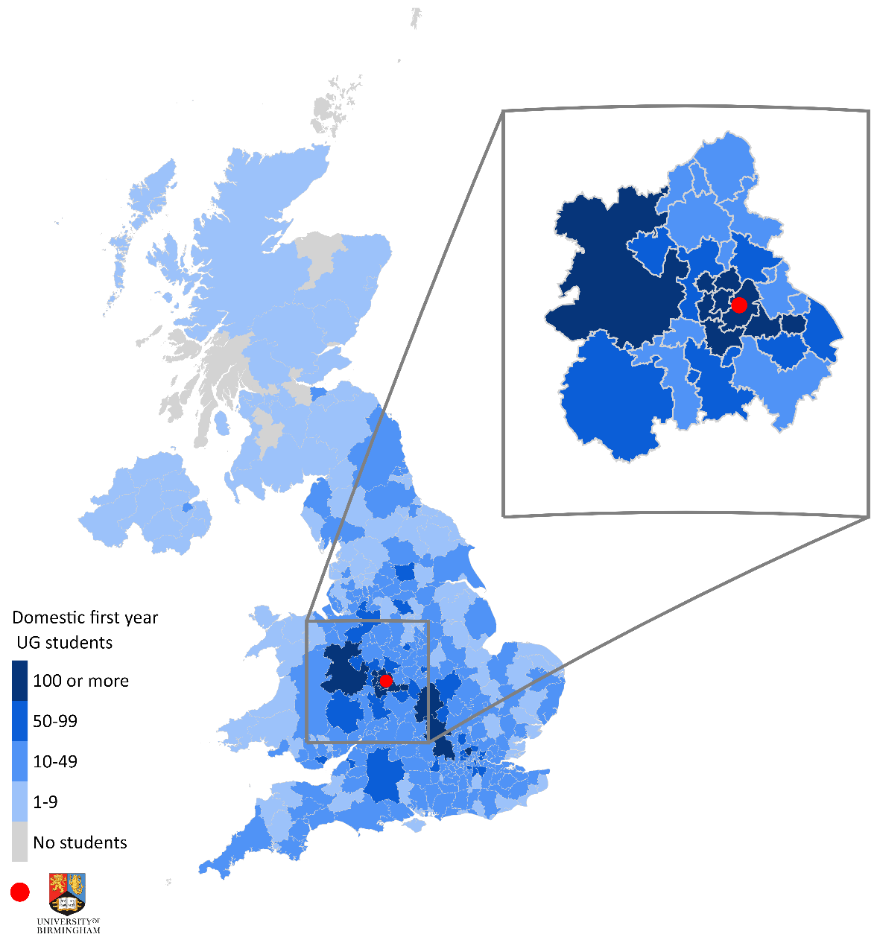
- UK domiciled first-year students in the 2021-22 cohort, by Local Authority of domicile
Note: We received HESA data on 10,870 first year undergraduate students from the University of Birmingham. We excluded 80 students from Guernsey, Jersey and the Isle of Man or those with an unspecified domicile, resulting in this map being based on 10,790 students. Domicile refers to a student’s home address before starting their qualification at the University of Birmingham.
Source: London Economics’ analysis based on data from the University of Birmingham and the Office for National Statistics. Contains National Statistics, OS, Royal Mail, Gridlink, ONS, NISRA, NRS and Ordnance Survey data © Crown copyright and database right 2024.
- The University’s role in training public sector workers in the West Midlands
The University of Birmingham has an important role in training public sector workers in the West Midlands. To demonstrate this, we analysed HESA data relating to student enrolments at higher education providers in the West Midlands in 2021-22 by subject. As Figure 14 shows, the University of Birmingham had a total of 5,380 students studying teacher training, social work, nursing, or medicine and dentistry in 2021-22 (across all years of study), which represented 16% of all higher education enrolments in the West Midlands in those subjects. In particular, the University trained nearly half (47%) of those studying medicine at higher education providers in the West Midlands, 89% of those studying dentistry, 16% of those studying social work, and 15% of those undertaking teacher training. While it is not guaranteed that these individuals will remain in the West Midlands, or in the professions for which they are studying, it highlights the University’s role in securing a domestic pipeline of public sector workers in key professions.
- Enrolments at the University of Birmingham and other higher education providers in the West Midlands across selected subjects, 2021-22
Note: Based on all study levels, study modes, domiciles and years of study (i.e. not limited to first year students). Classifications are based on the following Common Aggregation Hierarchy (CAH) level 3 classification: Medicine (01-01-01 medical sciences (non-specific), 01-01-02 medicine (non-specific) and 01-01-03 medicine by specialism); Dentistry (01-01-04 dentistry); Nursing (02-04-01 nursing (non-specific), 02-04-02 adult nursing, 02-04-03 community nursing, 02-04-05 children's nursing, 02-04-07 mental health nursing, 02-04-08 learning disabilities nursing, 02-04-09 others in nursing); Social work (15-04-01 social work); Teacher training (22-01-02 teacher training).
Source: London Economics’ analysis based on HESA data (HESA, 2023k).

Methodology
The analysis of the impact of the University’s teaching and learning captures the enhanced labour market benefits and taxation receipts (minus the costs of attendance/provision) associated with students in the above cohort completing qualifications at the University of Birmingham. Specifically, the fundamental objective of the analysis is to estimate the gross and net graduate premium to the individual and the gross and net public purse benefit to the Exchequer associated with higher education qualification attainment, defined as follows (and presented in Figure 15):
- The gross graduate premium associated with qualification attainment is defined as the present value of enhanced after-tax earnings (i.e. after income tax, National Insurance and VAT are removed, and following the deduction of any foregone earnings during study) relative to an individual in possession of the counterfactual qualification;
- The gross benefit to the public purse is defined as the present value of enhanced taxation (i.e. income tax, National Insurance and VAT, following the deduction of the costs of foregone tax earnings during study) relative to an individual in possession of the counterfactual qualification;
- The net graduate premium is defined as the gross graduate premium minus the present value of the direct costs associated with qualification attainment; and
- Similarly, the net benefit to the public purse is defined as the gross public purse benefit minus the direct Exchequer costs of provision during the period of attainment.
The analysis examines the benefits of a single cohort of students (i.e. the cohort of the 2021-22 starters) across their lifetimes in present value terms (i.e. in today’s money). A detailed methodology is presented in Annex A2.3.
- Overview of gross and net graduate premium, and gross and net Exchequer benefit
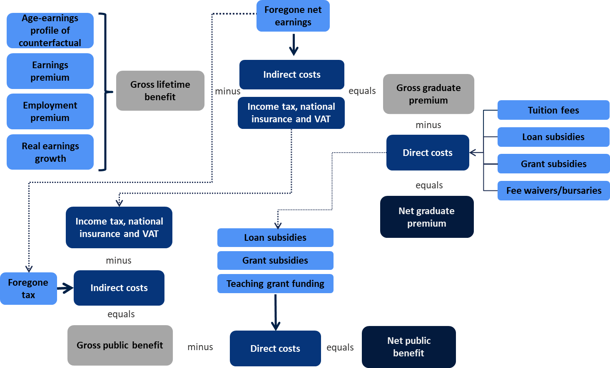
Source: London Economics’ analysis based on Department for Business, Innovation and Skills (2011a)
- The University’s role in facilitating apprenticeships
As a large employer, the University of Birmingham pays the Apprenticeship Levy to support apprentices. Based on a contribution of 0.5% on its total pay bill above £3 million, in the next 12 months, the University's planned expenditure from its ongoing Levy contributions is around £930,000, with around one-third of that going to facilitate apprenticeships in other organisations in the West Midlands Combined Authority. The University itself had 86 apprentices in 2022, with 89% of new entrants progressing into jobs at the University in 2022. In total, the University has hosted 423 apprentices since the introduction of the Levy in 2016, with half of these being new entrants and half being existing staff.

Impact of the University’s teaching and learning activities

Estimated net graduate premium and net Exchequer benefit per student
Table 8 presents the net graduate premiums and net Exchequer benefits achieved by UK domiciled students starting qualifications at the University of Birmingham in the 2021-22 academic year (by study mode, on average across men and women, and on average across students from all domiciles).
The net graduate premium for a representative full-time first degree student stands at £79,000.
The analysis indicates that the estimated net graduate premium achieved by a representative student in the 2021-22 cohort completing a full-time first degree at the University of Birmingham (with an RQF Level 3 qualification as their highest level of prior attainment) is approximately £79,000 in today’s money terms. At postgraduate level, the net (post)graduate premiums for a representative student completing a full-time postgraduate taught or postgraduate research degree at the University of Birmingham (relative to a first degree) stand at approximately £59,000 and £109,000, respectively.
- Net graduate premium and net Exchequer benefit per UK domiciled student at the University of Birmingham, by study level and mode
Level of study | Net graduate premium |  | Net public purse benefit
Level of study | Full-time  students | Part-time students | Full-time  students | Part-time students
Other undergraduate¹ | £67,000 | £86,000 | £57,000 | £68,000
First degree¹ | £79,000 | - | £78,000 | -
Other postgraduate² | £22,000 | £23,000 | £31,000 | £25,000
Higher degree (taught)² | £59,000 | £45,000 | £67,000 | £47,000
Higher degree (research)² | £109,000 | £62,000 | £108,000 | £60,000
Note: All estimates constitute weighted averages across men and women (weighted by the estimated number of student completers in the 2021-22 cohort) and are presented in 2021-22 prices, discounted to reflect net present values, and rounded to the nearest £1,000.
We assume that the gross graduate premium / Exchequer benefit associated with any HE qualification attainment can never be negative – i.e. students will never incur a wage/employment penalty from achieving additional qualifications. In instances where this would be the case, we instead assume a £0 gross graduate premium / Exchequer benefit (while the costs of qualification attainment would still be incurred). Gaps may arise where there are no students in the 2021-22 University of Birmingham cohort expected to complete the given qualification (with the given characteristics).
¹ Net graduate premiums and net public purse benefits associated with qualifications at ‘other undergraduate’ and first degree level are estimated relative to possession of Level 3 qualifications (see Annex A2.3.3 for further detail).
² Net graduate premiums and net public purse benefits associated with qualifications at ‘other postgraduate’, higher degree (taught) and higher degree (research) level are estimated relative to the possession of first degrees.
Source: London Economics’ analysis
There are also substantial net graduate premiums for part-time students. For instance, for a representative part-time student in the cohort completing a postgraduate taught degree, the estimated net graduate premium stands at approximately £45,000. The fact that part-time students tend to complete their studies later in life (resulting in fewer years spent in the labour market post-graduation) results in a relative reduction in the net graduate premiums for part-time students compared to full-time students. However, it is assumed that part-time students are able to combine work with their academic studies and thus do not incur any opportunity costs in the form of foregone earnings. In the case of postgraduate taught qualifications, part-time net graduate premiums tend to be lower than the corresponding premiums for full-time students, suggesting that the former effect likely dominates the latter in this case.
The net public purse benefit associated with a representative full-time first degree student stands at £78,000.
In terms of the benefits to the public purse, the net Exchequer benefit for a representative full-time first degree student (again with a Level 3 qualification as their highest level of prior attainment) stands at approximately £78,000 in 2021-22 money terms. The net Exchequer benefits for a representative student completing a full-time postgraduate taught or postgraduate research degree (relative to a first degree) were estimated at approximately £67,000 and £108,000, respectively.
Again, there are also substantial net Exchequer benefits associated with part-time students. For instance, the net Exchequer benefits for a representative part-time student undertaking a postgraduate taught or postgraduate research degree (relative to a first degree) stand at approximately £47,000 and £60,000 (respectively).

Total impact of teaching and learning activities at the University of Birmingham
Combining the information on the number of UK domiciled students in the 2021-22 University of Birmingham cohort, expected completion rates, and the net graduate and public purse benefits associated with the different qualification levels (relative to students’ specific prior attainment), the analysis estimates that the aggregate economic benefit of the University of Birmingham’s teaching and learning activities associated with the 2021-22 cohort amounts to approximately £1,346 million (see Table 9).
This total impact is split evenly between the Exchequer and students, with £671 million of the economic benefit accrued by the Exchequer, and the remaining £674 million accrued by students. In terms of study level, 75% (£1,013 million) of the estimated economic impact is generated by the University of Birmingham’s undergraduate students, with the remaining 25% (£333 million) generated by the University’s postgraduate students. In terms of domicile, 96% (£1,295 million) of the estimated economic impact is associated with students from England.
The total economic impact of teaching and learning generated by the 2021-22 cohort of University of Birmingham students stood at £1.35 billion.
- Aggregate impact of the University of Birmingham’s teaching and learning activities associated with the 2021-22 cohort (£m), by type of impact, domicile, and level of study
Beneficiary and study level | Domicile
Beneficiary and study level | England | Wales | Scotland | Northern Ireland | Total
Students | £649m | £20m | £2m | £3m | £674m
Undergraduate | £500m | £15m | £1m | £2m | £518m
Postgraduate | £149m | £5m | £1m | £1m | £156m
Exchequer | £646m | £20m | £3m | £3m | £671m
Undergraduate | £478m | £14m | £1m | £2m | £495m
Postgraduate | £168m | £6m | £2m | £1m | £177m
Total | £1,295m | £40m | £5m | £5m | £1,346m
Undergraduate | £978m | £29m | £2m | £4m | £1,013m
Postgraduate | £317m | £11m | £3m | £1m | £333m
Note: All estimates are presented in 2021-22 prices, discounted to reflect net present values, rounded to the nearest £1m, and may not add up precisely to the totals indicated.
Source: London Economics’ analysis

Analysis of earnings and employment outcomes of the University of Birmingham’s graduates
In addition to the analysis above of the economic impact of the University’s teaching and learning activities, we analysed the Longitudinal Education Outcomes (LEO) dataset to examine the labour market outcomes of the University’s graduates in terms of average earnings, employment outcomes and graduate mobility.

Underlying data from the Longitudinal Education Outcomes (LEO) dataset
The LEO dataset is a matched individual level dataset produced by the Department for Education combining information from multiple educational data sources with information on earnings and employment outcomes. The data provides disaggregated information based on tax year, graduation cohort, qualification level, subject area of study, sex of the individual and higher education provider.
For this analysis, we used the latest data release from the Department for Education, covering different graduating cohorts observed in the tax year 2020-21. The graduating cohorts include the academic years 2018-19 (at 1 year after graduation), 2016-17 (at 3 years after graduation), and 2014-15 (at 5 years after graduation). All earnings information has been rebased to 2020-21 prices using average consumer price index (CPI) inflation for the relevant tax year and constructed using a weighted average (using the number of graduates in each cell as weights). Only UK-domiciled graduates have been retained in the sample.
Specifically, we look at the following measures for all graduation cohorts:
- The median earnings after graduation by region, subject, and sex, weighted by the number of graduates;
- The proportion of graduates in sustained employment, further study, or both, during the tax year; and
- The movement of graduates by region.
Importantly, and unlike the analysis presented elsewhere in this section, this analysis of the LEO data does not control for graduate characteristics (e.g. subject composition), nor does it account for any counterfactual (i.e. a graduate’s potential earnings if they had not undertaken a given qualification).

Earnings and employment outcomes from graduates of the University of Birmingham
Figure 16 presents the weighted median earnings of UK first degree graduates of the University of Birmingham by graduating cohort and sex. Across all graduating cohorts, the University of Birmingham has consistently placed among the top 25% of all higher education institutions (HEIs) in Great Britain in terms of median earnings for graduates of all sexes. Medicine and Dentistry is the subject grouping with the highest median earnings amongst the University’s graduates for all graduation cohorts and regardless of the sex of graduates. This subject grouping also represents the highest proportion of graduates of any subject grouping at the University with 9%, 10%, and 11% of graduates at 1, 3, and 5 years after graduation respectively.
- Weighted median earnings of UK first degree graduates of the University of Birmingham
Note: All estimates are presented in 2020-21 prices.
Source: London Economics’ analysis using Longitudinal Education Outcomes data
In addition, the LEO data provides information on the proportion of University of Birmingham graduates in sustained employment, further study, or both. The University of Birmingham ranked highest out of all Russell Group institutions in Great Britain at 5 years after graduation (with 90% of UK domiciled graduates in sustained employment, further study or both), ranking 4th (90%) and 8th (90%) at 3 years and 1 year after graduation respectively.
Considering graduate mobility, Figure 17, Figure 18 and Figure 19 demonstrate the extent to which UK domiciled University of Birmingham graduates remain in the West Midlands after study. In total, approximately 33% of University of Birmingham graduates remained in the West Midlands one year after graduation, with the figure standing at 33% and 30% at 3 years and 5 years respectively. While this figure is lower than many other HEIs in the West Midlands, it in fact represents a net migration to the West Midlands. This is because almost all graduates with West Midlands as their home region (93% one year post-study) remained in the region post-study, while some graduates from outside the West Midlands (15% one year post-study) remained in the region post-study. This resulted in net migration to the West Midlands of 9% of the total cohort size one year post-study, falling to 6% and 4% at 3 and 5 years respectively, which was a larger net migration to the West Midlands than any other HEI in Birmingham.
- Location of UK domiciled University of Birmingham graduates in the 2018-19 graduating cohort, before and 1 year after study
Note: Totals may not sum due to rounding. Pre-study location refers to a graduate’s ‘home’ region before study (based on HESA postcode data).
Source: London Economics’ analysis using Longitudinal Education Outcomes data and SankeyMATIC.
- Location of UK domiciled University of Birmingham graduates in the 2016-17 graduating cohort, before and 3 years after study
Note: Totals may not sum due to rounding. Pre-study location refers to a graduate’s ‘home’ region before study (based on HESA postcode data).
Source: London Economics’ analysis using Longitudinal Education Outcomes data and SankeyMATIC.
- Location of UK domiciled University of Birmingham graduates in the 2014-15 graduating cohort, before and 5 years after study
Note: Totals may not sum due to rounding. Pre-study location refers to a graduate’s ‘home’ region before study (based on HESA postcode data).
Source: London Economics’ analysis using Longitudinal Education Outcomes data and SankeyMATIC.

The impact of the University of Birmingham’s educational exports
With the United Kingdom, and the University of Birmingham in particular, being an attractive destination for many overseas students, the higher education sector is a tradeable industry with imports and exports like any other tradeable sector.
In this part of the analysis, we focus on the impact of educational exports through the injection of overseas funding into the UK generated by the University. Specifically, we analyse overseas income in the form of tuition fee spending (net of any fee waivers and other bursaries provided by the University) and non-tuition fee (off-campus) expenditures by international (EU and non-EU domiciled) students in the 2021-22 cohort of the University of Birmingham students, over the entire course of their studies. The analysis estimates the direct, indirect, and induced economic impacts associated with this export income, defined as follows:
- Direct effect: This is captured by the level of (net) fee income (accrued by the University of Birmingham itself) and non-fee income (accrued by other organisations providing goods and services to international students) associated with non-UK students in the 2021-22 cohort.
- Indirect effect (‘supply chain impacts’): The University and local businesses providing other goods and services to international students spend their income on purchases of goods and services from their suppliers, which in turn use this revenue to buy inputs (including labour) to meet these demands. This results in a chain reaction of subsequent rounds of spending across industries, often referred to as a ‘ripple effect’.
- Induced effect (‘wage spending impacts’): The employees of the University of Birmingham (supported by its tuition fee income) and of companies providing goods and services to the University’s international students use their wages to buy consumer goods and services. This in turn generates wage income for employees within the industries producing these goods and services, again leading to subsequent rounds of spending, i.e. a further ‘ripple effect’ throughout the economy as a whole.
The analysis of the impacts associated with the University of Birmingham’s educational exports follows a similar methodology to the one used to estimate the direct, indirect, and induced economic effects associated with the University’s research and knowledge exchange activities (see Section 2), operational and capital expenditures (see Section 5) and tourism impact (see Section 6).

The 2021-22 cohort of international University of Birmingham students
Figure 20, Figure 21, and Figure 22 present information on the number of non-UK domiciled students in the 2021-22 cohort of University of Birmingham students (by domicile, mode of study, and level of study, respectively).
In terms of domicile (Figure 20), of the total of 5,080 international students starting higher education qualifications at the University of Birmingham in 2021-2022, 175 (3%) were domiciled within the European Union, while 4,905 (97%) were from non-EU countries. In terms of study mode (Figure 21), the majority of international students in the cohort (4,905, 97%) were undertaking their qualifications on a full-time basis, with the remaining 175 (3%) studying on a part-time basis.
In terms of study level (Figure 22), in contrast to UK domiciled students (see Section 3.1), the majority of non-UK domiciled students in the cohort were undertaking postgraduate qualifications (3,495, 69%), including 3,140 students (62%) enrolled in postgraduate taught degrees, 295 (6%) undertaking postgraduate research degrees, and 60 (1%) undertaking other postgraduate qualifications. At undergraduate level, there were 1,435 (28%) students undertaking first degrees, while the remaining 150 (3%) students were enrolled in other undergraduate learning.
Figure 23 presents more detailed information on the country of domicile of international students in the 2021-22 cohort.
- Non-UK domiciled students in the 2021-22 cohort of University of Birmingham students, by domicile |  | - Non-UK domiciled students in the 2021-22 cohort of University of Birmingham students, by study mode
Note: All numbers are rounded to the nearest 5, and the total values may not add up precisely due to this rounding.  Source: London Economics’ analysis based on University of Birmingham HESA data. |  | Note: All numbers are rounded to the nearest 5, and the total values may not add up precisely due to this rounding.  Source: London Economics’ analysis based on University of Birmingham HESA data.
- Non-UK domiciled students in the 2021-22 cohort of University of Birmingham students, by level of study
Note: All numbers are rounded to the nearest 5, and the total values may not add up precisely due to this rounding.
‘Other undergraduate’ learning relates to undergraduate-level diplomas and certificates. ‘Other postgraduate’ learning includes postgraduate-level diplomas and other qualifications, as well as taught work for credit at postgraduate level.
Source: London Economics’ analysis based on University of Birmingham HESA data.

- Non-UK domiciled students in the 2021-22 cohort of University of Birmingham students, by country of domicile
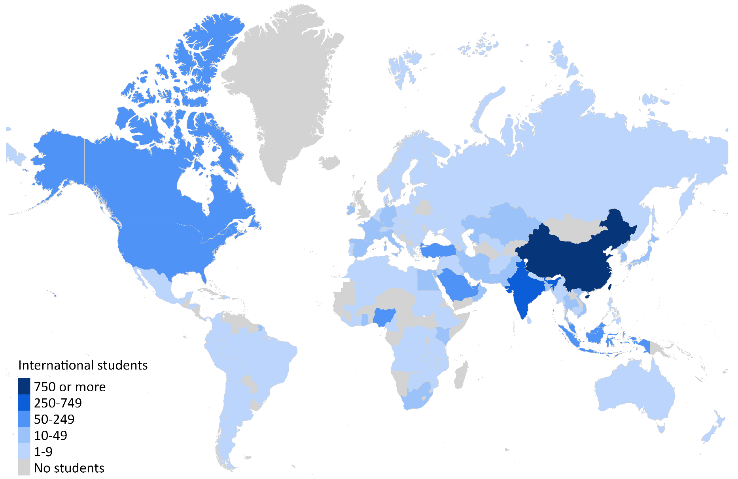
Note: Based on data provided by the University of Birmingham on 5,060 first year overseas domiciled students from the University of Birmingham in 2021-22. Of these students, 50 were excluded as they could not be matched to a country within the World Bank data.
Source: London Economics’ analysis based on University of Birmingham and World Bank data.

Changes in the number of international students at the University of Birmingham
Alongside the analysis of the 2021-22 cohort of non-UK domiciled first-year students, we have also examined the trends in the University of Birmingham’s entire non-UK student body over the past twelve years (i.e. academic years 2010-11 to 2021-22).
With the University of Birmingham being an increasingly popular destination for international students, there has been a significant increase in the number of non-UK domiciled students enrolled at the University of Birmingham over the last decade, increasing from 6,390 students in 2010-11 to 9,555 students in the 2021-22 academic year (a 50% increase). With the number of UK domiciled students having increased at a slower rate across the period (by 17%), the proportion of the University’s students that are from non-UK domiciles has increased from 21% in 2010-11 to 25% in the 2021-22 academic year (see Figure 24). In 2021-22, the University of Birmingham accounted for nearly 1 in 5 (19%) of all international students at higher education providers (HEPs) in the West Midlands and over half (51%) of those studying at HEPs in Birmingham.
The overall increase in international students was predominantly driven by an increase in students from non-EU domiciles, with an increase in the number of non-EU domiciled students as a proportion of the total non-UK domiciled student population, from 79% in 2010-11 to 89% in the 2021-22 academic year. The increase in the number of international students studying at the University of Birmingham occurred across both undergraduate and postgraduate students, with the number of non-UK undergraduate students more than doubling, increasing from 2,005 in 2010-11 to 4,710 in the 2021-22 academic year, and the number of non-UK postgraduate students rising from 4,385 in 2010-11 to 4,845 in the 2021-22 academic year.
- Total number of students at the University of Birmingham, 2010-11 to 2021-22, by domicile
Note: All numbers are rounded to the nearest 5, and the total values may not add up precisely due to this rounding.
Source: London Economics’ analysis based on HESA (2011, 2012, 2013, 2014, 2015, and 2023f)

Direct impact

Methodology

Net tuition fee income
To assess the level of gross tuition fee income associated with international students in the 2021-22 cohort, we made use of data on the average tuition fees per student charged by the University of Birmingham in the 2021-22 academic year (by study level, mode, and domicile). Assuming the same average study durations as in the analysis of the impact of the University of Birmingham’s teaching and learning activities provided to UK-domiciled students (see Annex A2.3), we calculated the resulting tuition fee income per international student in the cohort from the start of a student’s learning aim until completion. Expressing the total fee income until completion in 2021-22 prices and using the HM Treasury Green Book real discount rate of 3.5% (see HM Treasury, 2022), we arrived at an estimate of the gross tuition fee income per student (in present value terms over the total study duration).
To calculate the net tuition fee income per student, we then deducted any fee waivers and bursaries paid to international students by the University of Birmingham. These costs were again calculated over students’ total study duration and estimated in present value terms. These estimates per student were combined with information on the number of non-UK students in the 2021-22 cohort and used the same assumptions on completion rates as for UK domiciled students (as part of the analysis of the impact of teaching and learning (see Annex A2.3).

Non-fee income
In addition to tuition fees, the UK economy benefits from export income from overseas students’ non-tuition fee (i.e. living cost) expenditures incurred during their studies at the University of Birmingham. These costs include:
- Accommodation costs (e.g. rent costs, council tax, household bills etc.);
- Subsistence costs (e.g. food, entertainment, personal items, non-course travel etc.);
- Direct course costs (e.g. course-related books, subscriptions, computers etc.);
- Facilitation costs (e.g. course-related travel costs); and
- Spending on children (including childcare that is not related to students’ course participation).
To analyse the level of non-tuition fee expenditure associated with the 2021-22 cohort of international students studying at the University of Birmingham, we used estimates from the 2021-22 Student Income and Expenditure Survey (SIES). The survey provides estimates of the average expenditures of English domiciled undergraduate students (studying in England or Wales) on living costs, housing costs, participation costs (including tuition fees) and spending on children, separately for full-time and part-time students. For the purpose of this analysis, we made the following adjustments to the SIES estimates:
- We excluded estimates of tuition fee expenditure (to avoid double-counting with the analysis presented in Section 4).
- We deducted any on-campus expenditure that students might incur (to avoid double-counting with the analysis of the impacts of the expenditure of the University of Birmingham itself (see Section 5)).
- Since the SIES results do not provide expenditure estimates for non-UK domiciled students, our analysis implicitly assumes that non-tuition fee expenditure levels do not vary significantly between UK and international students. We do however adjust the SIES estimates for the longer average stay durations in the UK of non-EU students compared to EU students.
Similar to tuition fees, we then calculated the non-tuition fee expenditure over the entire duration of students’ higher education courses (and discounted to reflect present values). The resulting estimates provide the total average (off-campus) non-fee expenditure per student in 2021-22 prices, by level of study, mode, and domicile. Again, the estimated non-tuition fee income per student was combined with the number of international students in the 2021-22 cohort expected to complete qualifications (or credits/modules) at the University of Birmingham.

Total direct impact
The total direct economic impact of the expenditures of international students in the 2021-22 University of Birmingham cohort (in economic output terms) was estimated at £278 million (Figure 25). Over half of this total (£151 million, 54%) was generated from international students’ tuition fees accrued by the University of Birmingham (net of any fee waivers or bursaries provided by the University), while the remaining £127 million (46%) was generated from international students’ non-tuition fee spending. In terms of student domicile, most of this impact (£267 million, 96%) was generated by non-EU domiciled students, while £11 million (4%) was associated with EU students (not presented graphically here).
In addition to economic output (i.e. export income), it was possible to convert the above estimates into gross value added and the number of full-time equivalent jobs supported. We thus estimate that the export income generated by international students in the 2021-22 University of Birmingham cohort directly generates £183 million in GVA (£102 million from international (net) fee income and £81 million from non-fee income) and supports 3,015 FTE jobs (1,975 from (net) tuition fee income and 1,040 from non-tuition fee income).
- Total direct impact associated with non-UK students in the 2021-22 University of Birmingham entrant cohort, by type of impact
Output, £m
GVA, £m
Employment, FTE
Note: All monetary estimates are presented in 2021-22 prices, discounted to reflect net present values, and rounded to the nearest £1m. The employment figures are rounded to the nearest 5. Values may not add up precisely to the totals due to rounding.
Source: London Economics’ analysis

Total economic impact associated with the University of Birmingham’s educational exports
To estimate the total (direct, indirect, and induced) economic impact associated with the export income generated by international students studying at the University of Birmingham, we used economic multipliers derived from the above-described multi-regional Input-Output model (see Section 2.1), estimating the extent to which the direct export income generates additional activity throughout the UK economy. Specifically, we applied two types of multipliers to the above-described tuition fee and non-tuition fee income associated with international students in the 2021-22 cohort, including:
- Multipliers relating to international tuition fee income (accrued by the University of Birmingham itself): The multipliers used to estimate the impact of the University of Birmingham’s international tuition fee income were calculated based on the inter- and intra-industry flows of goods and services for the West Midlands’s government, health, and education sector as a whole.
- Multipliers relating to income from international students’ (off-campus) non-tuition fee expenditures: These were calculated based on the final consumption expenditure patterns of households located in the West Midlands, and subsequently applied to the estimated off-campus non-tuition fee expenditures of overseas students in the 2021-22 cohort of the University of Birmingham students.
Again, these multipliers are expressed in terms of economic output, gross value added, and (full-time equivalent) employment, and are calculated as total multipliers, capturing the aggregate impact on all industries in the UK economy arising from an initial injection relative to that initial injection.
Table 10 presents the economic multipliers applied to the income generated by international students at the University of Birmingham (in terms of the impact on the West Midlands and the UK economy as a whole).
- Economic multipliers associated with the income from international student entrants in the 2021-22 cohort of University of Birmingham students
Location of impact and type of income | Output | GVA | FTE employment
Tuition fee income
West Midlands | 1.50 | 1.43 | 1.33
Total UK | 2.28 | 2.07 | 1.79
Non-fee income
West Midlands | 1.63 | 1.61 | 1.66
Total UK | 2.57 | 2.45 | 2.58
Note: All multipliers constitute Type II multipliers, defined as [Direct + indirect + induced impact]/[Direct impact].
Source: London Economics' analysis
Applying these multipliers to the above direct economic impacts, we estimate that the total economic impact on the UK generated by the (net) tuition fee income and non-tuition fee income associated with international students in the 2021-22 University of Birmingham cohort amounts to £690 million of economic output (see top panel of Figure 29):
- In terms of the breakdown by type of income from international sources, £363 million of this impact was associated with international students’ (net) tuition fees, and £327 million was associated with these students’ non-tuition fee expenditures over the duration of their studies at the University of Birmingham.
The impact of the export income generated by the 2021-22 University of Birmingham student cohort stood at £690 million.
- In terms of the breakdown by region, most of this impact (£446 million, 65%) was generated in the West Midlands, with the remaining £244 million (35%) occurring in other regions across the UK.
- In terms of sector, the tuition fee and non-tuition fee income generated from the University of Birmingham’s international students generated particularly large impacts within the government, health, and education sector (£205 million (30%), given that the cohort’s tuition fee income is accrued as income by the University of Birmingham itself). In addition, there are relatively large impacts felt within the distribution, transport, hotel, and restaurant sector (£124 million, 18%), and the production industry (£100 million, 14%).
The impact in terms of gross value added was estimated at £420 million across the UK economy as a whole (with £284 million generated within the West Midlands), while the corresponding estimates in terms of employment stood at 6,355 full-time equivalent jobs across the UK as a whole, with 4,465 jobs supported across the West Midlands.

The impact of the University of Birmingham’s expenditures
In this section, we outline our estimates of the direct, indirect, and induced impacts associated with the operational and capital expenditures of the University of Birmingham. Analyses of these impacts consider universities as economic units creating output within their local economies by purchasing products and services from their suppliers and hiring employees. Similar to the impact associated with the University’s research and knowledge exchange activities (see Section 2), educational exports (see Section 4) and tourism impact (see Section 6), the direct, indirect, and induced economic impacts of a university’s expenditures are defined as follows:
- Direct effect: This considers the economic output generated by the University of Birmingham itself, by purchasing goods and services (including labour) from the economy in which it operates.
- Indirect effect: The University of Birmingham’s purchases generate income for the supplying industries, which they in turn spend on their own purchases from suppliers to meet the University’s demands. This again results in a chain reaction of subsequent rounds of spending across industries, also referred to as a ‘ripple effect’.
- Induced effect: The employees of the University of Birmingham and of businesses operating in the University’s supply chain use their wages to buy consumer goods and services within the economy. This in turn generates wage income for employees within the industries producing these goods and services, who then spend their own income on goods and services – leading to a further ‘ripple effect’ throughout the economy as a whole.
In line with the other strands of impact, the analysis focuses on the 2021-22 academic year. As with the direct, indirect and induced impact of the University’s research and knowledge exchange activities, educational exports and tourism, these impacts can be measured in terms of economic output, gross value added, and FTE employment.

Direct impact of the University’s expenditures

Gross direct impact of the University’s expenditures
To measure the direct economic impact of the purchases of goods, services, and labour by the University of Birmingham, we used information on the University’s operational expenditures (including staff and non-staff spending), capital expenditures, as well as the number of staff employed (in terms of full-time equivalent employees), for the 2021-22 academic year.
Based on this, in terms of monetary economic output (measured in terms of expenditure), the gross direct economic impact associated with the University of Birmingham’s expenditures stood at approximately £872 million in the 2021-22 academic year (see Figure 26). This includes £440 million of operating expenditure on staff related costs, £329 million of expenditure on other (non-staff) operating expenses, as well as £103 million of capital expenditure incurred in that academic year.
- Gross direct economic impact (in terms of output) of the University of Birmingham’s expenditure in the 2021-22 academic year, by type of expenditure
Note: We exclude a total of £71 million of non-staff costs associated with depreciation, and £203 million of staff costs associated with movements in pension provisions, as it is assumed that these are not relevant from a procurement perspective (i.e. these costs are not accounted for as income by other organisations). All estimates are presented in 2021-22 prices and rounded to the nearest £1m.
Source: London Economics’ analysis based on HESA (2023a), HESA (2023j) and the University of Birmingham’s annual accounts (University of Birmingham, 2022).

Net direct impact of the University’s expenditures
Before arriving at the net direct impact associated with the University of Birmingham’s expenditure, it is necessary to deduct a number of income and expenditure items to avoid double-counting, and to take account of the ‘netting out’ of the costs and benefits associated with the University between different agents in the UK economy. Specifically, we deducted a total of £474 million:
- The total research income received by the University in the 2021-22 academic year (£162 million), to avoid double-counting with the estimated impact of the University’s research activities (Section 2.1);
- The direct impact associated with the University’s knowledge exchange activities, excluding the impact of spinouts and startups (£117 million in economic output terms), to avoid double-counting with the impact of the University’s wider knowledge exchange activities (Section 2.2);
- £29 million in bursary spending for UK domiciled students, as this was included (as a benefit) in the analysis of the University’s teaching and learning activities (Section 3); and
- The direct impact generated by the University’s (gross) international fee income associated with the 2021-22 cohort of non-UK students (£166 million), to avoid double-counting with the impact of the University’s educational exports (Section 4).
Having accounted for these deductions, the net direct impact of the University’s expenditure in 2021/22 stood at £398 million.

The University’s geographical footprint
In addition to these total expenditures, we investigated the geographical breakdown of the University’s procurement expenditures and the number of staff, to demonstrate the University of Birmingham’s impact across the West Midlands and the rest of the UK.
Figure 27 presents the distribution of the University of Birmingham’s UK procurement expenditure (based on invoice data for 2021-22) by Local Authority. The map illustrates a concentration of procurement expenditure in the West Midlands (approximately 45% of expenditure), with 24% of all UK procurement expenditure taking place in Birmingham. Elsewhere in the West Midlands, the University of Birmingham spent approximately £25 million in Rugby, £12 million in Coventry, £12 million in Solihull and £5 million in North Warwickshire. The University also spent significant amounts on goods and services from suppliers in other regions, such as the South East (15% of UK procurement expenditure), London (13%), the North West (8%), the East Midlands (5%), and Yorkshire and the Humber (5%).
In addition, Figure 28 illustrates the distribution of the University’s staff headcount by Local Authority (based on the postcode district of employees’ home addresses). As expected, the maps show a particularly strong concentration of staff and staff expenditure in the area immediately surrounding the University, with approximately 88% of UK staff based in the West Midlands and nearly half (47%) living in Birmingham.
- Distribution of the University of Birmingham’s procurement expenditure in the 2021-22 academic year by Local Authority (of invoice address)
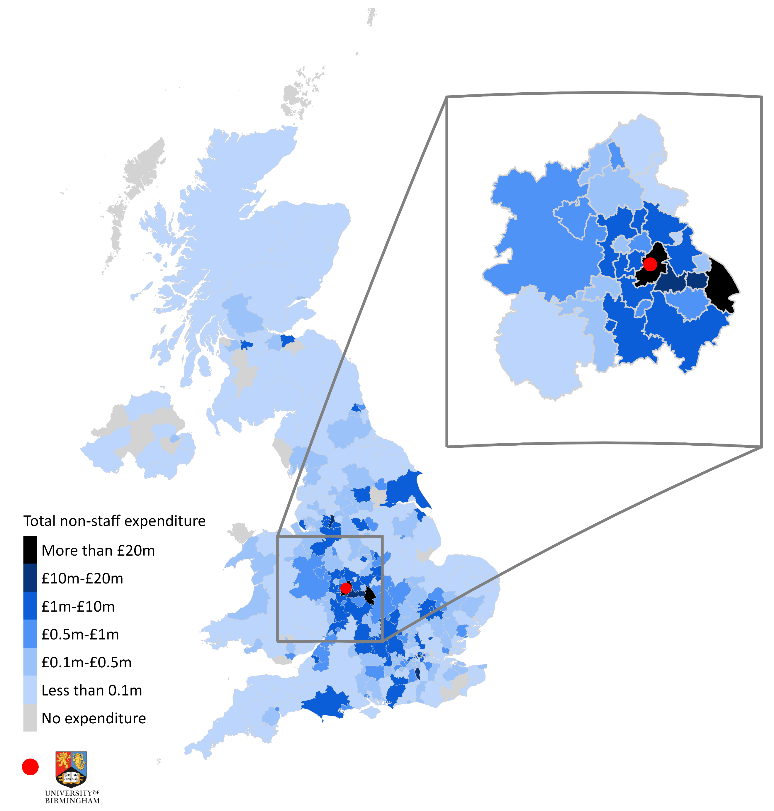
Note: We received data on the invoice postcodes associated with £361 million of non-staff expenditure by the University of Birmingham. Of this total, we excluded expenditure records with invalid postcodes (38 records). As a result of these exclusions, this figure is based on a total of £355 million of non-staff expenditure.
Source: London Economics’ analysis based on data from the University of Birmingham and the Office for National Statistics. Contains National Statistics, OS, Royal Mail, Gridlink, ONS, NISRA, NRS and Ordnance Survey data © Crown copyright and database right 2024

- Distribution of the University of Birmingham’s staff (in headcount) by Local Authority (of home address) in the 2021-22 academic year
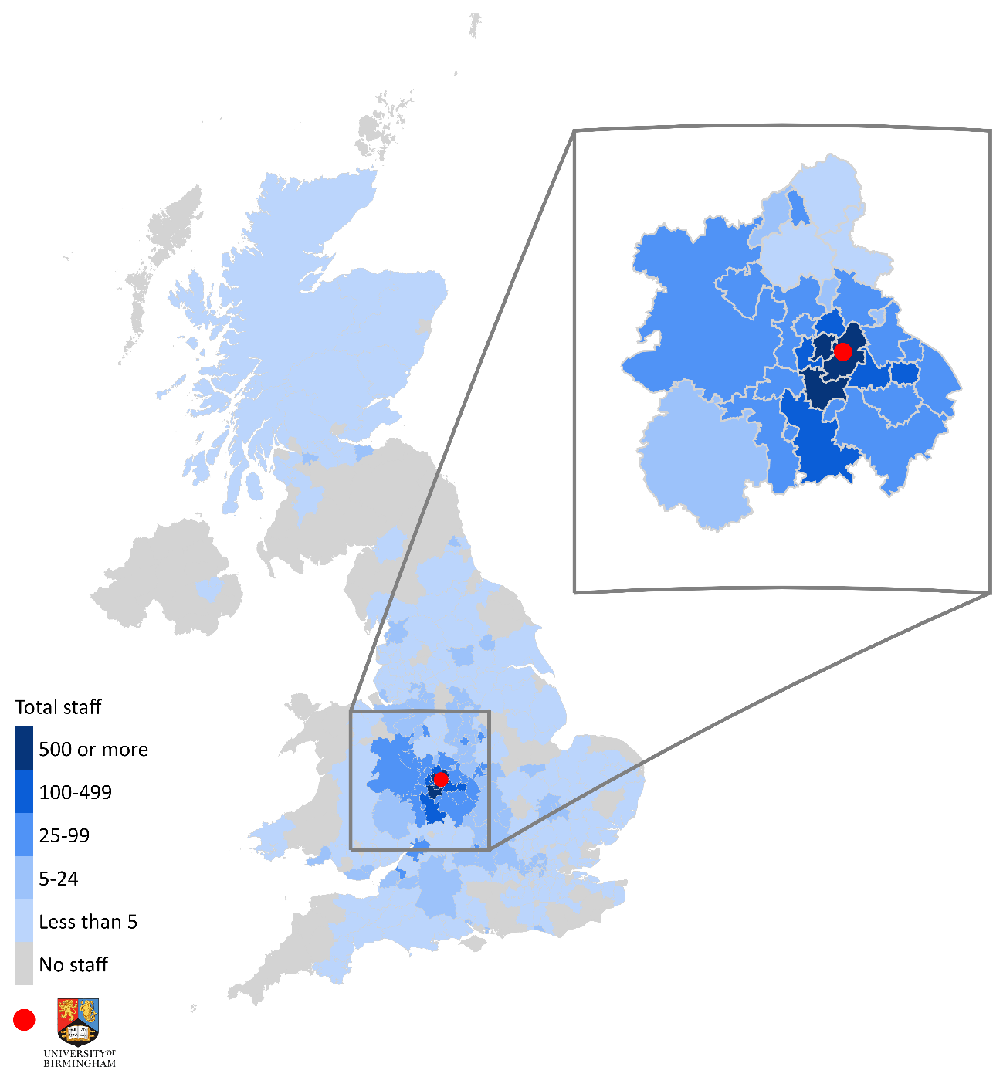
Note: We received data on home address postcode district for a total of 9,985 staff (in headcount) from the University of Birmingham. Of this total, we excluded staff records with invalid postcode districts (550 in total). This figure is therefore based on the home addresses of 9,435 staff. Staff associated with postcode districts that are spread across multiple Local Authorities have been apportioned equally across them.
Source: London Economics’ analysis based on data from the University of Birmingham and the Office for National Statistics. Contains National Statistics, OS, Royal Mail, Gridlink, ONS, NISRA, NRS and Ordnance Survey data © Crown copyright and database right 2024

Indirect and induced impacts of the University’s expenditures
As with the economic impact of the University of Birmingham’s research and knowledge exchange activities (see Section 2), educational exports (see Section 4) and tourism (see Section 6), the assessment of the indirect and induced economic impacts associated with the expenditures of the University is based on economic multipliers derived from the above-discussed multi-regional Input-Output model. We applied the estimated average economic multipliers associated with organisations in the West Midlands’s government, health, and education sector, which mirrors the approach used to assess the impact of the University’s international tuition fee income and the income derived from its research and wider knowledge exchange activities, since this income was accrued (and subsequently spent) by the University of Birmingham itself. Again, this approach asserts that the spending patterns of the University reflect the average spending patterns across organisations operating in the West Midlands’s government, health, and education sector. These multipliers are applied to the net direct impact of the University of Birmingham’s expenditures of £398 million. These multipliers (for the impact on the West Midlands and the UK economy as a whole) are the same as those presented in Table 3 in Section 2.1.3.

Aggregate impact of the University of Birmingham’s spending
Figure 29 presents the estimated total direct, indirect, and induced impacts associated with the expenditures incurred by the University of Birmingham in the 2021-22 academic year (after the above-described adjustments have been made). The aggregate impact of these expenditures was estimated at approximately £908 million in economic output terms (see top panel of Figure 29):
The impact of the University of Birmingham’s expenditure on the UK economy in 2021-22 stood at £908 million.
- In terms of region, the majority of this impact (£596 million, 66%) was generated in the West Midlands, with the remaining £312 million (34%) occurring in other regions across the UK.
- In terms of sector, in addition to the impacts occurring in the government, health, and education sector itself (£449 million, 49%), there are also large impacts felt within other sectors, including the distribution, transport, hotel, and restaurant sector (£115 million, 13%), the production sector (£105 million, 12%), and the real estate sector (£73 million, 8%).
In terms of the number of jobs supported (in FTE), the results indicate that the University of Birmingham’s spending supported a total of 6,200 FTE jobs across the UK economy in the 2021-22 academic year (of which 4,620 were located in the West Midlands). In addition, the impact in terms of gross value added was estimated at £531 million across the UK economy as a whole (with £367 million accrued within the West Midlands).
- Total economic impact associated with the University of Birmingham’s expenditures in the 2021-22 academic year, by region and sector
Note: Monetary estimates are presented in 2021-22 prices, rounded to the nearest £1 million, and may not add up precisely to the totals indicated. Employment estimates are rounded to the nearest 5, and again may not add up precisely to the totals indicated. Source: London Economics’ analysis

The University of Birmingham’s contribution to tourism
As a final strand of economic contribution, this chapter outlines the analysis of the University’s role in attracting a range of visitors to Birmingham, including business visitors, friends and family visiting the University’s staff and students, and visitors participating in study trips to the University.
To understand the economic impact of tourism associated with the University, we combine information on the number of visits to Birmingham associated with the University with information on the average expenditure per visitor. As with the University’s research and knowledge exchange activities (see Section 2), educational exports (see Section 4), and operational and capital expenditures (see Section 5), these visitors’ expenditures result in subsequent rounds of spending and economic activity within the local economy, captured by the direct, indirect, and induced impacts associated with these expenditures. Again, these impacts are estimated using economic multipliers, and are measured in terms of the contribution to economic output, gross value added, and (full-time equivalent) employment in 2021-22.

Estimating the number of visitors associated with the University’s activities
Data from the International Passenger Survey (IPS) by the Office for National Statistics estimated that, in 2022, there were a total of approximately 803,000 overseas overnight visits to Birmingham. Domestic visits are not considered in the analysis as they do not contribute additionally to the UK economy. As a result, the remainder of this analysis focuses only on the 803,000 trips to Birmingham involving overnight stays by visitors from overseas.
In addition to the total number of these overseas overnight visits, a key element of the analysis involves understanding the specific reason for these visits. Using information from the IPS (VisitBritain, 2023b), of the total of 803,000 overnight trips to Birmingham by overseas visitors, approximately 47% (374,000) were for business trips, 36% (286,000) were for the purposes of visiting friends and family, 14% (110,000) were holiday visits, 1% (8,000) were study trips to Birmingham, and the remaining 3% (26,000) were trips for other purposes. Using this breakdown by purpose of visit to estimate the impact of the University of Birmingham’s contribution to tourism in a typical academic year, we made the following assumptions in relation to the number of overseas overnight visits to Birmingham that resulted from the University’s presence:
- With respect to trips to visit family and friends, data from the University of Birmingham indicates that there were approximately 2,420 non-UK nationals employed by the University (representing 0.2% of the resident population of Birmingham), as well as 9,560 non-UK domiciled students attending the University (representing around 0.8% of the resident population). Based on London Economics’ previous analysis assessing the economic impact of international students on the UK economy, it is assumed that, on average, there were 0.8 visits from overseas per non-EU domiciled student or non-EU member of staff and 3.1 visits from overseas per EU domiciled student or EU member of staff in 2021-22, which represents a weighted average of 1.1 visits per non-UK student and 1.9 visits per non-UK staff. Based on a 2022 population estimate for the city of Birmingham of 1,157,600, it is therefore assumed that approximately 5% of all overseas visits to Birmingham to visit family or friends were visits to the University’s students and staff (equivalent to approximately 15,000 trips in 2021-22).
- A similar approach was adopted in relation to business trips. The University employed approximately 9,955 staff in 2021-22, accounting for around 2% of the total employed population of Birmingham in 2021-22. Based on this, it is assumed that 2% of business trips to Birmingham in 2021-22 were related to the University (corresponding to approximately 7,000 visits/trips).
- In terms of the study trips to Birmingham, it is assumed that all trips were a result of either the University of Birmingham, Aston University, Birmingham City University, Newman University or University College Birmingham. Non-UK domiciled students enrolled at the University of Birmingham accounted for 51% of the total non-UK domiciled student population of these institutions. It is assumed that study trips by international students are made in proportion to the number of international students at each institution and therefore that 51% of study trips to Birmingham in 2021-22 are related to the University of Birmingham. This corresponds to approximately 4,000 visits/trips.
- Finally, it is assumed that none of the remaining trips to Birmingham for holiday visits or other purposes were as a result of the University.
This methodology is likely to underestimate the tourism impact of the University. Firstly, it does not account for the impact the University’s museums and attractions (such as the Barber Institute of Fine Arts, Winterbourne House and Garden, the Lapworth Museum of Geology and the Cadbury Research Library – see Section 7) on overseas overnight visits to Birmingham. Secondly, it only considers the University's tourism impact within Birmingham, whereas the University may generate overseas visitors outside of Birmingham, such as through the Shakespeare Institute in Stratford-upon-Avon. Thirdly, it does not directly account for the University’s role in facilitating the 2022 Commonwealth Games, beyond the overall increase in tourism numbers in Birmingham in 2022. Finally, we only estimate the impact of overseas tourism, given that we focus on the impact of the University on the UK economy. However, the University is likely to bring significant additional impact to the West Midlands economy through domestic tourism, which is not accounted for here.
Table 11 presents the resulting number of trips to Birmingham by overseas visitors in 2021-22 that were due to the University of Birmingham’s activities, which was estimated to total 26,000 in 2021-22 (or 3% of total overseas trips to Birmingham).
- Total number of visits to Birmingham and University-related visits by overseas overnight visitors in 2021-22
Type of trip | Total visits | Visits associated with the University | % associated with the University
Holidays | 110,000 | - | 0%
Study trips | 8,000 | 4,000 | 51%
Business trips | 374,000 | 7,000 | 2%
Trips to visit friends and family | 286,000 | 15,000 | 5%
Other trips | 26,000 | - | 0%
Total visits | 803,000 | 26,000 | 3%
Note: All numbers are rounded to the nearest 1,000, and the total values may not add up due to this rounding.
Source: London Economics’ analysis

Direct impact associated with visitor expenditure
The spend per trip by purpose is calculated using information on the total spend by purpose and the number of visits by purpose to the West Midlands region from VisitBritain (2023a). Using the figures for spend per trip, the direct impact associated with the University’s contribution to tourism in 2021-22 stood at approximately £19 million.
In terms of the breakdown by purpose of trip, the analysis suggests that approximately £9 million (48%) of this total came from study trips; £7 million (38%) was spent during visits to see friends and family associated with the University; and an estimated £3 million (14%) was associated with business trips.

Indirect and induced impacts associated with visitor expenditure
As with the University’s research and knowledge exchange activities (see Section 2), educational exports (see Section 4), and operational and capital expenditures (see Section 5), the assessment of the indirect and induced economic impacts associated with visitor expenditure is again based on economic multipliers derived from the above-described multi-regional Input-Output model. Reflecting the distribution of visitor expenditure in the distribution, transport, hotels, and restaurants sector and the ‘other’ services sector, we applied the estimated average economic multipliers associated with organisations in those sectors located in the West Midlands.
These multipliers (for the West Midlands and the UK as a whole; presented in Table 12) indicate that every £1 million of (overseas overnight) visitor expenditure associated with the University of Birmingham generates an additional £1.36 million of impact throughout the UK economy, of which £0.53 million is generated in the West Midlands. In terms of employment, for every 1,000 (FTE) staff directly supported by this visitor expenditure, an additional 850 staff are supported throughout the United Kingdom, of which 360 are located in the West Midlands.
- Economic multipliers associated with tourism expenditures related to the University of Birmingham
Location of impact | Output | GVA | FTE employment
West Midlands | 1.53 | 1.53 | 1.36
Total UK | 2.36 | 2.31 | 1.85
Note: All multipliers constitute Type II multipliers, defined as [Direct + indirect + induced impact]/[Direct impact]. The multipliers shown are weighted averages across the assumed spend in the distribution, transport, hotels, and restaurants sector and the ‘other’ services sector.
Source: London Economics’ analysis

Total impact associated with visitor expenditure
Figure 30 presents the estimated total direct, indirect, and induced impacts associated with the above visitor expenditures generated by the University’s activities in 2021-22. The analysis indicates that the aggregate impact of these expenditures stood at approximately £46 million in economic output terms (see top panel of Figure 30). In terms of region, the majority of this impact (£30 million, 65%) was generated in the West Midlands, with £16 million (35%) occurring in other regions across the UK.
The impact of the University’s contribution to tourism in 2021-22 stood at
£46 million.
In terms of sector of impact, in addition to the impacts occurring in the distribution, transport, hotels and restaurants sector (£24 million, 53%), there were also impacts within other sectors, such as the production sector (£6 million, 13%), the real estate sector (£4 million, 8%), and the ‘other services’ sector (£4 million, 8%).
In terms of the number of FTE jobs supported, the results indicate that the visitor spending generated by the University’s activities supported a total of 455 FTE jobs across the UK economy in 2021-22, of which 340 were located in the West Midlands (presented in the bottom panel of Figure 30). In addition, the impact in terms of gross value added was estimated at £26 million across the UK economy as a whole, of which £17 million was generated within the West Midlands (see the middle panel of Figure 30).

- Total economic impact associated with the University’s contribution to tourism in 2021-22, by region and sector
By region | By sector
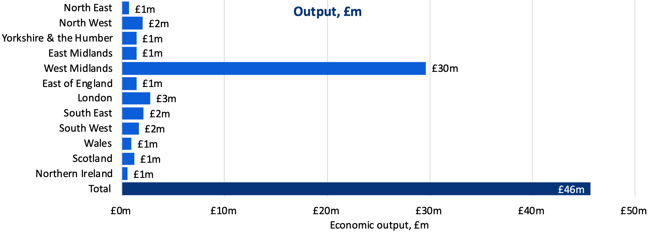 | 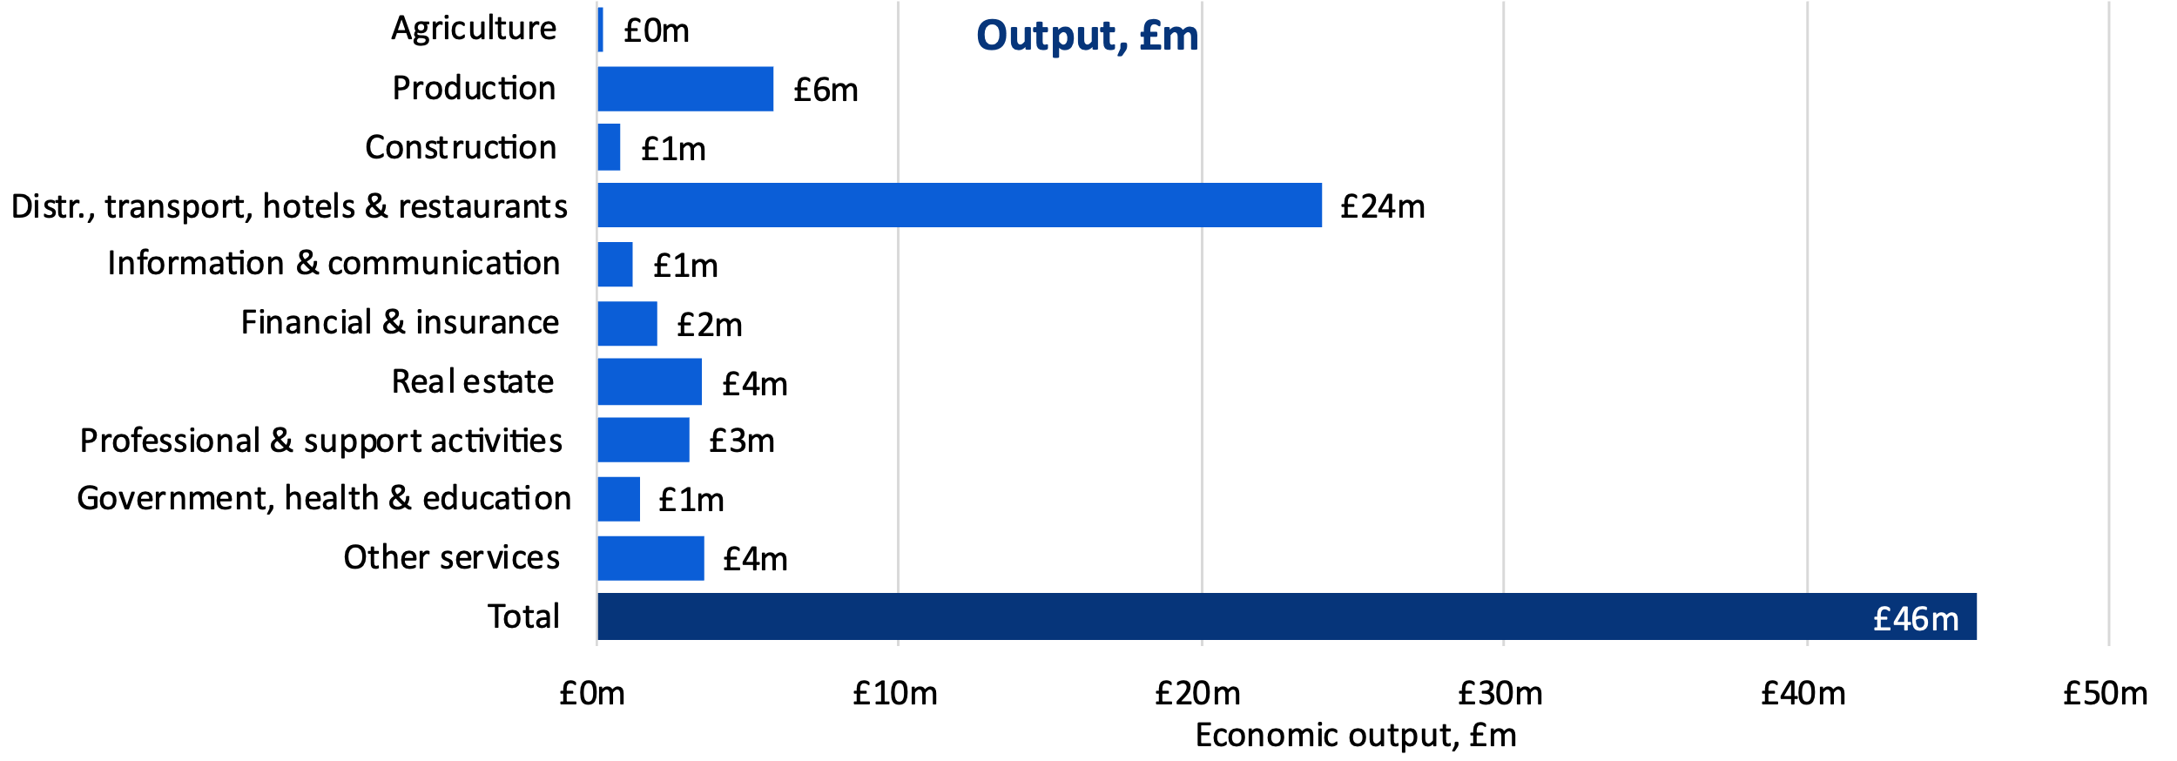
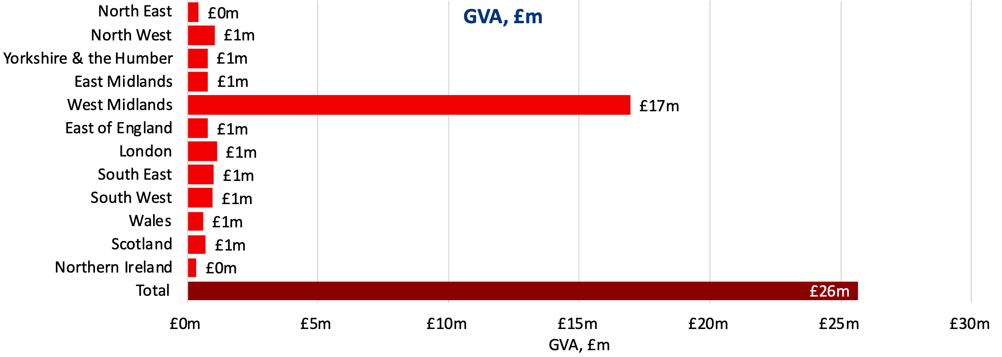 | 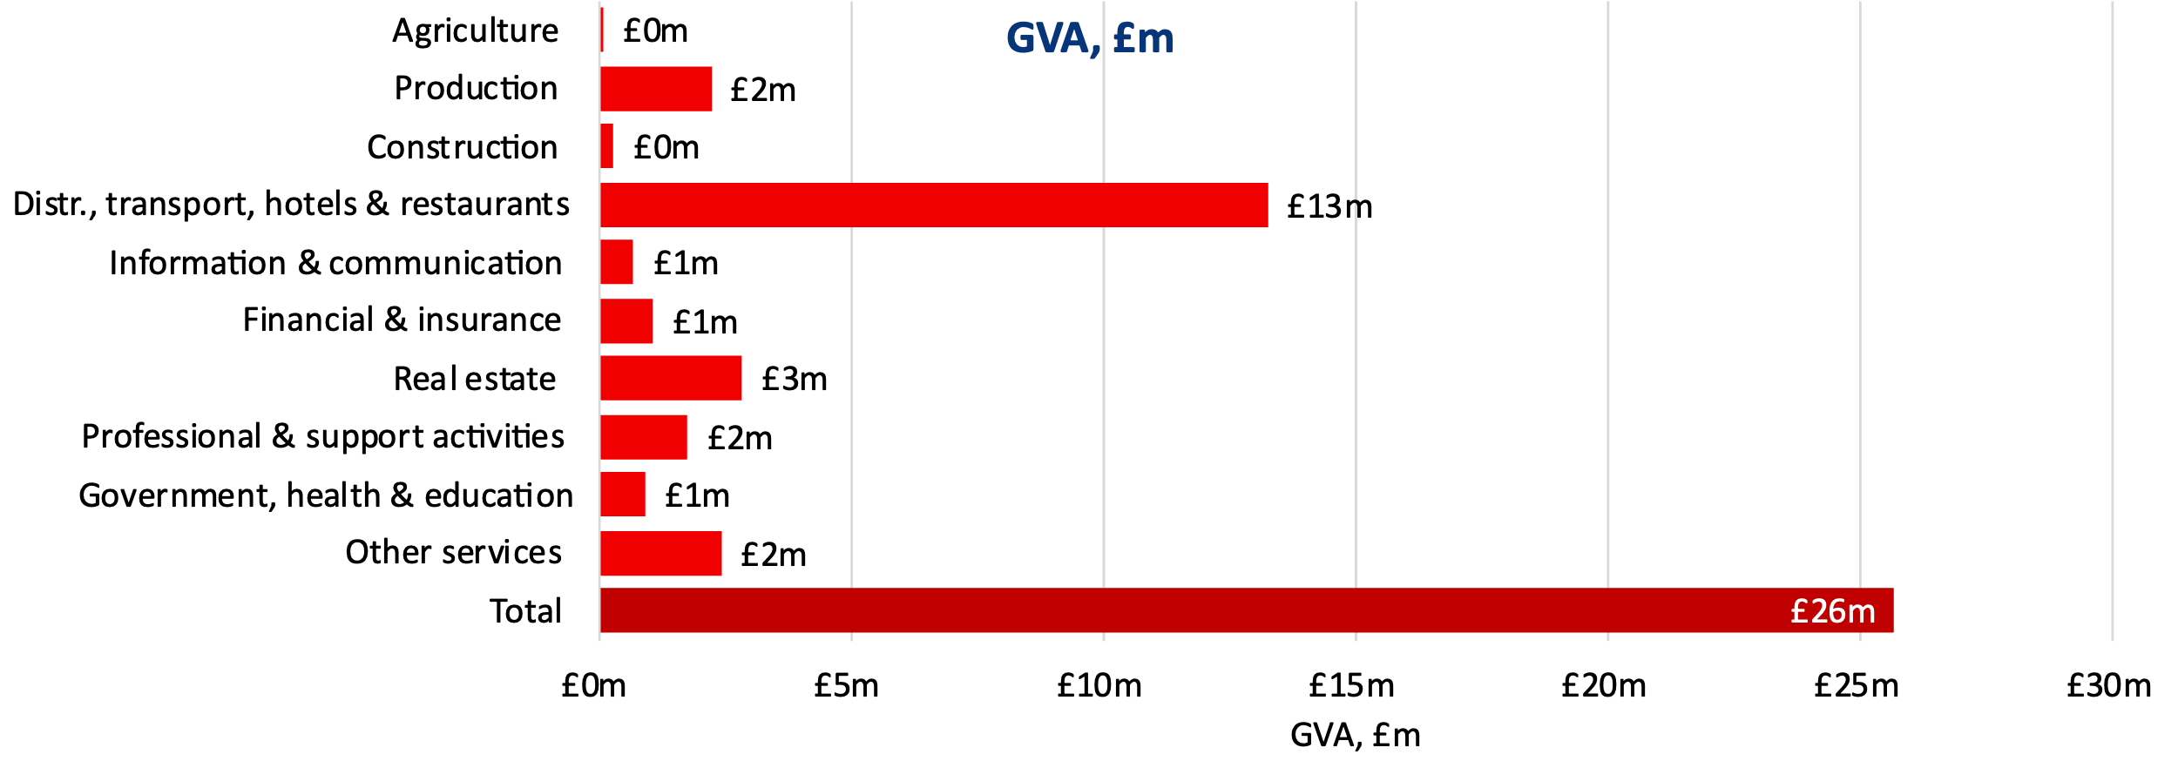
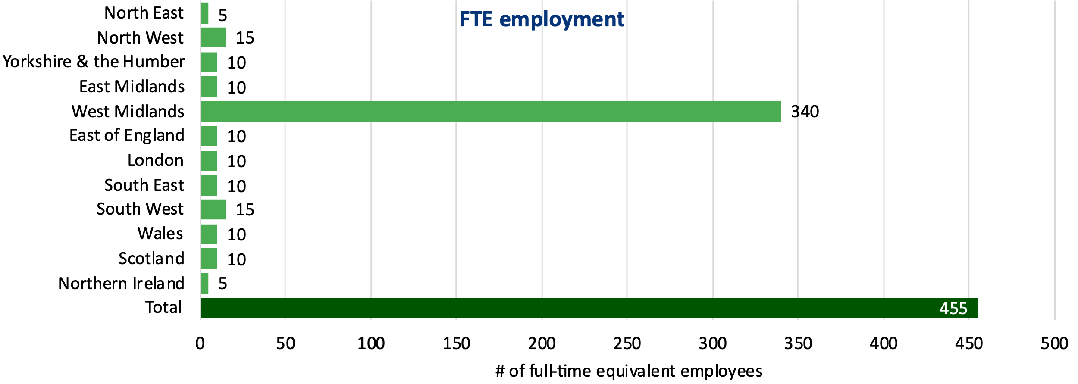 | 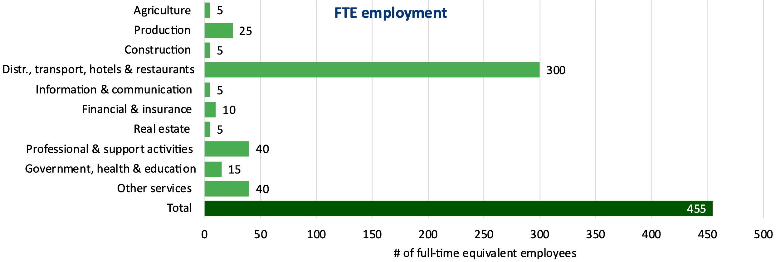
Note: Monetary estimates are presented in 2021-22 prices, rounded to the nearest £1 million, and may not add up precisely to the totals indicated. Employment estimates are rounded to the nearest 5, and again may not add up precisely to the totals indicated. Source: London Economics’ analysis

The social and cultural impact of the University of Birmingham
In addition to the economic impacts associated with the University, there is a wide range of further social and cultural impacts associated with the University. While equally important as those presented previously, these impacts are generally more difficult to monetise, so we have evidenced them through a range of statistics presented within this section.
Within this section, we present the wider economic and societal benefits of the University of Birmingham for students and graduates (evidenced through a survey of the University’s alumni), its cultural impact through hosting public events, the contribution of the University’s staff to the local community through volunteering, and the University’s environmental impact.

Wider economic and societal benefits of the University of Birmingham for students and graduates
There are a multitude of economic and societal benefits that students take forward into their lives after university. To assess the wider economic and social impact of the University of Birmingham on its students and society at large, we conducted an online survey among a group of the University of Birmingham’s alumni (over four weeks in February and March 2024). The associated outcomes have significant societal value, but it is almost impossible to assign a monetary value. As such, we do not attempt to monetise these wider impacts, but instead, demonstrate the impact of learning at the University of Birmingham on graduates’ jobs, lives and prospects.
The survey achieved a total of 496 valid responses, and this section summarises the main survey results in terms of the impacts of University of Birmingham qualifications on graduates’ job-related outcomes, general and job-related skills, personal development, and well-being.

Job-related outcomes
To assess the impact of University of Birmingham qualifications on graduates’ economic outcomes, the survey asked respondents a number of questions in relation to whether certain aspects of their career prospects and working lives had changed following their learning at the University of Birmingham. As presented in Figure 31, approximately 80% of respondents believed that their degree had helped them get a better job; 77% of respondents believed that their degree had better prepared them for their career; and 76% believed their degree helped them advance their career. More than half of respondents indicated that their University of Birmingham degree helped them to obtain a more interesting job, a better paying job, a more secure job, or allowed them to change job or employer.
- ‘Overall, would you say that your degree from the University of Birmingham helped you…?’
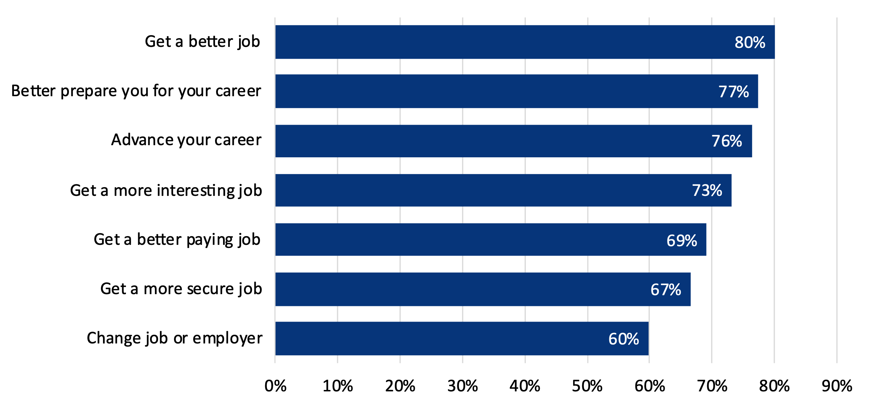
Note: Based on responses from 496 respondents. ‘Don’t know / not applicable’ responses have been excluded (26 to 130 respondents).
Source: London Economics’ analysis of University of Birmingham alumni survey data
To be able to understand the impacts of education at the University of Birmingham it is important to analyse the counterfactual; in other words, what might have happened in the absence of the learning experience with the University of Birmingham. The responses demonstrate the causal impact of learning at the University of Birmingham.
As presented in Figure 32, of those alumni who believed that their degree helped them improve their working lives in any of the above-described ways (Figure 31), 22% indicated that these improvements were a direct result of their qualification from the University of Birmingham, with a further 45% stating that the learning had helped a lot. These results demonstrate the very high degree of additionality associated with attaining qualifications at the University of Birmingham.
- ‘To what extent do you think this improvement was / these improvements were linked to your degree from the University of Birmingham?’
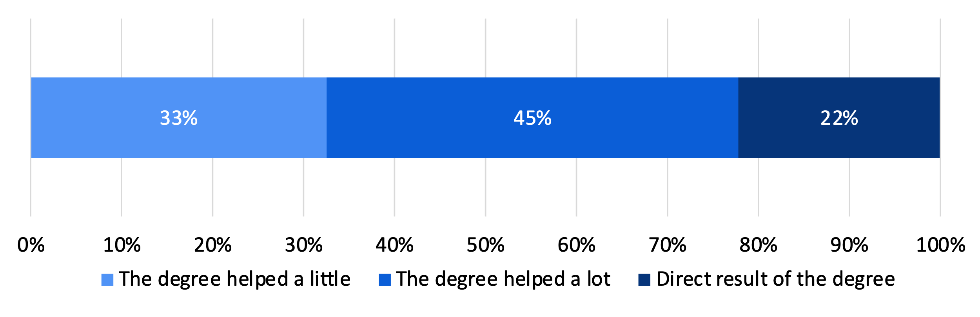
Note: Based on responses from 455 of 496 respondents, excluding 41 respondents that answered ‘don’t know / not applicable’. Percentages may not sum exactly due to rounding.
Source: London Economics’ analysis of University of Birmingham alumni survey data

Impact on skills
Figure 33 presents the impact of obtaining a degree from the University of Birmingham on individuals’ general skills and proficiencies, asking respondents to indicate the extent to which their skills improved following their learning experience at the University of Birmingham. Respondents reported improvements (either by ‘a lot’ or ‘a little’) in a wide array of skills, including their critical thinking skills (94%); analytical skills (93%); writing skills (88%); communication skills (85%); literacy skills (80%); interpersonal skills (78%); presentation skills (78%); and social skills (76%). In addition, respondents also reported improvements in their team working skills (74%), IT skills (55%) and numeracy skills (47%).
- ‘Following completion of your degree from the University of Birmingham, what impact did this have on your general set of skills?’
Note: Based on responses from 496 respondents. ‘Don’t know / not applicable’ responses have been excluded (0 to 16 respondents). Percentages may not sum exactly due to rounding.
Source: London Economics’ analysis of University of Birmingham alumni survey data
Figure 34 presents alumni’s responses in relation to whether they felt that their job-related skills had improved as a result of their degree. Evidencing the impact that the University of Birmingham qualification has had on their employability, the vast majority of respondents (84%) reported that their ability to do their job had increased either by a ‘lot’ or a ‘little’ as a result of their degree; 86% reported that the skills and knowledge they use in their current, previous, or desired area of work had improved by a ‘lot’ or a ‘little’; and 87% reported that their general transferable skills had improved by a ‘lot’ or a ‘little’.
- ‘What impact did your degree from the University of Birmingham have on your job-related set of skills?’
Note: Based on responses from 496 respondents. ‘Don’t know / not applicable’ responses have been excluded (between 12 and 18 respondents). Percentages may not sum exactly due to rounding.
Source: London Economics’ analysis of University of Birmingham alumni survey data

Personal development and wellbeing
In addition to the above-discussed impact of learning on respondents’ working lives and skills, the survey also sought to measure the extent to which learning experiences at the University of Birmingham had an impact on respondents’ personal development, community engagement and well-being.
Figure 35 explores the extent to which alumni agreed with a number of statements relating to their personal interests and aspirations, indicating that 86% of respondents believed that their experience at Birmingham helped them meet new people and make new friends; 78% felt that they had become more enthusiastic about learning; 72% were more likely to undertake further learning or training at any level; 68% reported that their time at Birmingham made them more likely to undertake further learning or training at a higher level; 67% stated that their time at Birmingham made them more innovative; and 67% indicated that their experience gave them a better idea of what they want to do in life.
- ‘In terms of your personal development, to what extent do you agree or disagree that your experience at the University of Birmingham…?’
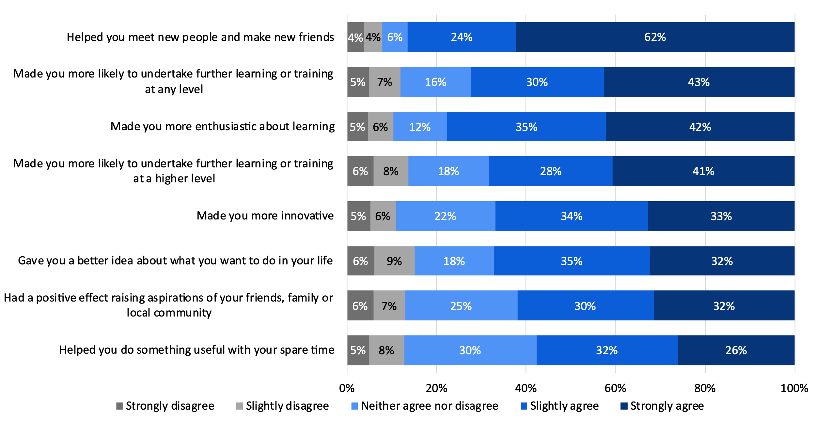
Note: Based on responses from 496 respondents. ‘Don’t know / not applicable’ responses have been excluded (0 to 17 respondents). Percentages may not sum exactly due to rounding.
Source: London Economics’ analysis of University of Birmingham alumni survey data
In relation to wider community engagement and community cohesion (see Figure 36), the analysis indicates that 58% of respondents believed that their experience at the University of Birmingham encouraged them to become a member of a group, club, or association; 43% reported that their time at the University of Birmingham made them more likely to participate in sport or to pursue an active lifestyle; 41% were more likely to take part in voluntary or community activities; 38% of respondents were more likely to become members or visitors of cultural attractions such as museums or galleries; and 31% felt their experience at the University encouraged them to vote.
- ‘In terms of your personal development, to what extent do you agree or disagree that your experience at the University of Birmingham encouraged you to…?’
Note: Based on responses from 496 respondents. ‘Don’t know / not applicable’ responses have been excluded (12 to 24 respondents). Percentages may not sum exactly due to rounding.
Source: London Economics’ analysis of University of Birmingham alumni survey data

Finally, in terms of measures of well-being, Figure 37 shows that 77% of respondents agreed (either ‘strongly’ or ‘slightly’) that they had become more confident as a result of their degree; 74% felt that their degree helped increase their self-esteem; 71% agreed that their degree had improved their quality of life; 65% believed that their emotional intelligence had increased as a result of their degree; and 48% felt that their degree had helped them keep active.
- ‘In terms of your well-being, to what extent do you agree or disagree that the degree which you completed at the University of Birmingham…?’
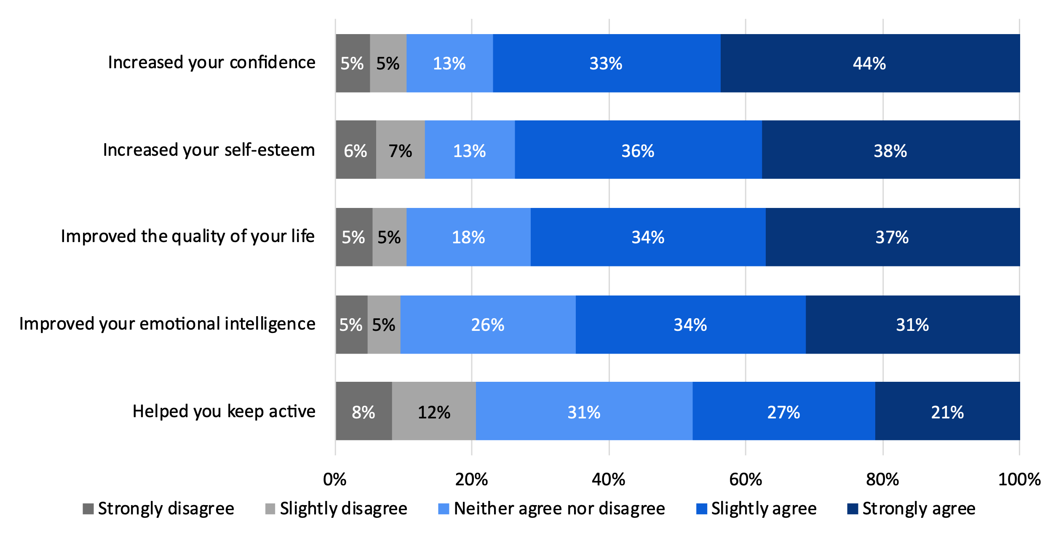
Note: Based on responses from 496 respondents. ‘Don’t know / not applicable’ responses have been excluded (0 to 7 respondents). Percentages may not sum exactly due to rounding.
Source: London Economics’ analysis of University of Birmingham alumni survey data

Cultural impact
An important aspect of the University of Birmingham’s activities relates to its impact on culture and the local community. In particular, the University hosted a range of events and attracted visitors to Birmingham through its cultural institutions.
Figure 38 shows the annual number of attendees for 2021-22 for various public events held by the University of Birmingham. In total, there were 869,817 attendees at public events held by the University for 2021-22. In terms of the total attendees to events, the University of Birmingham ranks 25th out of a total of 220 UK higher education providers (HESA, 2023i). The vast majority (89%) of the University’s cultural attendees engaged with free events held by the University. Considering the type of events, 479,348 visitors attended exhibitions at galleries and museums, while a further 40,849 attended performance arts events, 24,742 attended public lectures, and 6,564 attended museum education events. There were a further 318,314 attendees from ‘other’ event types, which can include viewing and listening figures for television and radio programs produced by the University of Birmingham, and downloads from their websites. In total, at least 921 academic staff days were committed in 2021-22 to deliver these events.
The total number of attendees to events can also be broken down by venue, with 287,530 attendees associated with the Cadbury Research Library, 173,292 with the Exchange and the Research and Cultural Collections, 79,479 with Winterbourne House and Gardens, 63,800 with University Music, 61,857 with the Lapworth Museum of Geology, and 30,113 with the Barber Institute of Fine Arts (3.5%). Lastly, the Festival of Social Science attracted 19,315 visitors.
To some extent, these figures are likely to heavily understate the University’s cultural impact, due to the impact of the COVID-19 pandemic on visitor numbers in 2021-22. For example, there were over 1 million attendees to public events hosted by the University of Birmingham in 2022-23, with over 3,900 academic staff days used to deliver those events.
- Number of attendees to public events at the University of Birmingham in 2021-22, by chargeable and free events
Source: London Economics’ analysis based on University of Birmingham HESA data (HESA, 2023i).

Staff volunteering
The University of Birmingham’s staff generate significant social impact through their work volunteering in the local community. To assess this impact, the University of Birmingham ran an online survey of its staff in January and February 2024 to determine the number of hours spent volunteering. The survey achieved a total of 438 valid responses, which represents approximately 4% of the University’s staff.
Of those respondents, approximately 74% volunteered regularly, with staff who volunteered volunteering an average of 10 hours per month. In total, the respondents to the survey are estimated to volunteer around 39,180 hours of their time each year. This figure is likely to be a vast underestimate of the total volunteering hours by the University’s staff, given the relatively low response rate to the survey.
Staff volunteered in a range of roles and organisations, with 31% of volunteers volunteering at a charity; 18% volunteering as a school governor, 17% as a trustee of a charity, 15% in a sports club, 14% in a youth club and 14% in a faith-based group.

Environmental impact
The University of Birmingham is one of the UK’s largest HEIs, ranking 7th in terms of site area and 14th in terms of number of buildings in 2021-22 (HESA, 2023g). Consequently, the University of Birmingham has substantial carbon emissions, with the 7th largest carbon emissions of all UK HEIs, based on Scope 1 and 2 carbon emissions (HESA, 2023h).
However, the University of Birmingham is making active efforts to reduce its carbon emissions. The University aims to reach net zero carbon emissions for Scope 1 and 2 by 2035 and for Scope 3 by 2045 (University of Birmingham, 2024). The University’s total carbon emissions increased by 5% from 2020-21 to 2021-22, rising from 316,239 tonnes of carbon dioxide equivalent (tCO2e) to 330,991 tCO2e (Hoare Lea, 2023). However, in that period, the University’s Scope 1 and 2 carbon emissions (i.e. those over which the University has the most control) fell by 11%. In particular, the University substantially reduced its emissions associated with natural gas usage, with associated emissions falling by 18%. In addition, HESA data suggests that the University’s Scope 1 and 2 carbon emissions fell by 27% between 2005 and 2021-22 (HESA, 2023h). The overall increase in emissions between 2020-21 and 2021-22 was driven by Scope 3 carbon emissions, which rose due to increased procurement expenditure and increased emissions from international students visiting their home countries (Hoare Lea, 2023). It is also important to note that the baseline year for this comparison was 2020-21, where carbon emissions were likely to be lower due to the impact of the COVID-19 pandemic.

The total economic impact of the University of Birmingham on the UK economy in 2021-22
The total economic impact on the UK economy associated with the University of Birmingham’s activities in the 2021-22 academic year was estimated at approximately £4.4 billion (see Table 13). In terms of the components of this impact:
- The University of Birmingham’s research and knowledge exchange activities accounted for £1.4 billion (32%) of this impact;
The total economic impact associated with the University of Birmingham's activities in 2021-22 stood at £4.4 billion.
- The value of the University of Birmingham’s teaching and learning activities stood at £1.3 billion (31%);
- The impact associated with the University of Birmingham’s international students was estimated at £690 million (16%);
- The impact generated by the operating and capital expenditures of the University stood at £908 million (21%); and
- The impact of tourism activities associated with the University was estimated at £46 million (1%).
- Total economic impact of the University of Birmingham’s activities in the UK in 2021-22 (£m and % of total)
Type of impact |  | £m | %
 | Impact of research and knowledge exchange | £1,399m | 32%
 | Research activities | £1,051m | 24%
 | Knowledge exchange activities | £348m | 8%
 | Impact of teaching and learning | £1,346m | 31%
 | Students | £674m | 15%
 | Exchequer | £671m | 15%
 | Impact of international students | £690m | 16%
 | Tuition fee income | £363m | 8%
 | Non-tuition fee income | £327m | 7%
 | Impact of the University's spending | £908m | 21%
 | Direct impact | £398m | 9%
 | Indirect and induced impact | £510m | 12%
 | Impact of tourism | £46m | 1%
 | Direct impact | £19m | 0%
 | Indirect and induced impact | £26m | 1%
 | Total economic impact | £4,388m | 100%
Note: All estimates are presented in 2021-22 prices, rounded to the nearest £1m, and may not add up precisely to the totals indicated. The percentage figures in the brackets represent the proportion of total impact in that region associated with the strand/sub-strand of analysis. Source: London Economics' analysis
Compared to the University’s total relevant operational costs of approximately £769 million in 2021-22, the total impact of the University of Birmingham’s activities on the UK economy was estimated at £4.4 billion, which corresponds to a benefit to cost ratio of approximately 5.7:1.

Total impact by region and sector (where available)
In addition to the total impact on the UK economy as a whole, it was possible to disaggregate some strands of the University’s economic impact by sector and region (and estimate the impacts in terms of economic output as well as GVA and FTE employment). The strands of impact for which this disaggregation was achievable include:
- The direct, indirect and induced impact of the University’s research activities (estimated at £192 million, see Section 2.1);
- The impact of the University’s knowledge exchange activities (estimated at £348 million, see Section 2.2);
- The impact of the University’s educational exports (£690 million, see Section 4); and
- The impact associated with the operating and capital expenditure of the University (£908 million, see Section 5); and
- The impact associated with the tourism activities associated with the University (£46 million, see Section 6).
Hence, approximately £2.2 billion (50%) of the University of Birmingham’s total impact of £4.4 billion can be disaggregated in this way.
In terms of the breakdown by region, the analysis indicates that of this total of £2.2 billion, approximately £1.4 billion (63%) occurred in the West Midlands, with £809 million (37%) occurring in other regions across the UK (see Figure 39).
In terms of sector, the University’s activities resulted in particularly large impacts within the government, health, and education sector (£902 million, 41%), the distribution, transport, hotel, and restaurant sector (£332 million, 15%), production sector (£275 million, 13%), and the real estate sector (£215 million, 10%) (see Figure 40).
In terms of the number of FTE jobs supported, the results indicate that the total impact generated by the University’s activities supported a total of 19,885 FTE jobs across the UK economy in the 2021-22 academic year, of which 13,295 were located in the West Midlands. In addition, the impact in terms of gross value added was estimated at £1.3 billion across the UK economy as a whole, of which £864 million was generated within the West Midlands.
- Total identifiable economic impact associated with the University’s activities in 2021-22, by region
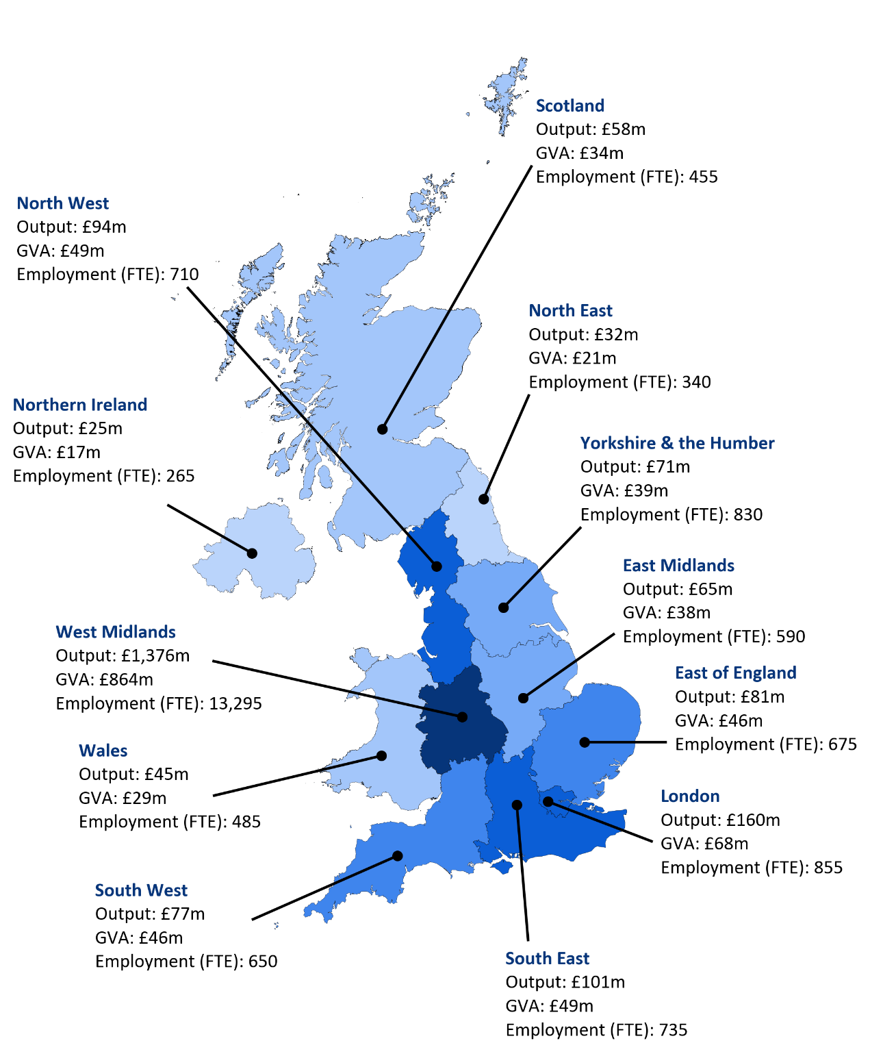
Note: Monetary estimates are presented in 2021-22 prices, discounted to reflect net present values (where applicable), rounded to the nearest £1 million, and may not add up precisely to the totals indicated. Employment estimates are rounded to the nearest 5, and again may not add up precisely to the totals indicated. The map only contains the £2.2 billion (of the University’s total £4.4 billion) of economic impact that can be attributed to a region. Source: London Economics’ analysis
- Total identifiable economic impact associated with the University’s activities in 2021-22, by sector
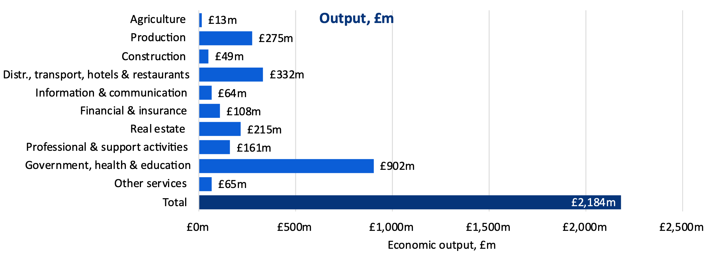
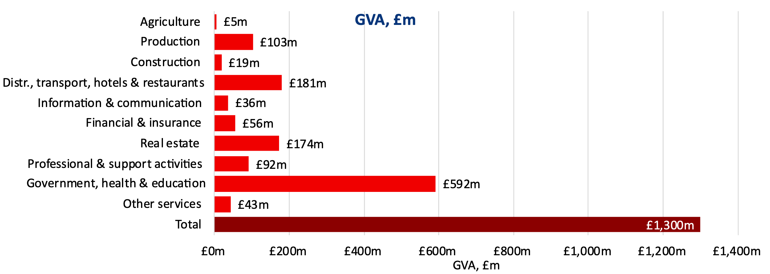
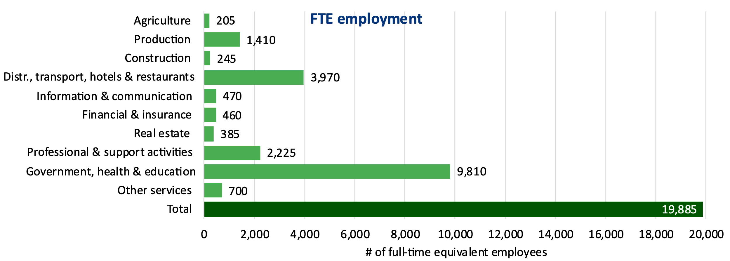
Note: Monetary estimates are presented in 2021-22 prices, discounted to reflect net present values (where applicable), rounded to the nearest £1 million, and may not add up precisely to the totals indicated. Employment estimates are rounded to the nearest 5, and again may not add up precisely to the totals indicated. The map only contains the £2.2 billion (of the University’s total £4.4 billion) of economic impact that can be attributed to a sector. Source: London Economics’ analysis

Index of Tables, Figures and Boxes

Tables
Table 1 Total economic impact of the University of Birmingham’s activities in the UK in 2021-22 (£m and % of total) iii
Table 2 Aggregate impact of the University of Birmingham’s teaching and learning activities associated with the 2021-22 cohort (£m), by type of impact, domicile, and level of study vi
Table 3 Economic multipliers associated with the University of Birmingham’s research activities 6
Table 4 Economic impact associated with the University of Birmingham’s spinout companies in 2021-22 11
Table 5 Economic impact associated with the University of Birmingham’s start-ups in 2021-22 11
Table 6 Economic impact associated with the University of Birmingham’s wider knowledge exchange activities in 2021-22 12
Table 7 UK domiciled students in the 2021-22 cohort of University of Birmingham students, by level of study, mode, and domicile 17
Table 8 Net graduate premium and net Exchequer benefit per UK domiciled student at the University of Birmingham, by study level and mode 21
Table 9 Aggregate impact of the University of Birmingham’s teaching and learning activities associated with the 2021-22 cohort (£m), by type of impact, domicile, and level of study 23
Table 10 Economic multipliers associated with the income from international student entrants in the 2021-22 cohort of University of Birmingham students 35
Table 11 Total number of visits to Birmingham and University-related visits by overseas overnight visitors in 2021-22 46
Table 12 Economic multipliers associated with tourism expenditures related to the University of Birmingham 46
Table 13 Total economic impact of the University of Birmingham’s activities in the UK in 2021-22 (£m and % of total) 57
Table 14 Industry grouping used as part of the multi-regional Input-Output analysis 71
Table 15 Assumed completion rates of University of Birmingham student entrants 80
Table 16 Treatment and comparison groups used to assess the marginal earnings and employment returns to higher education qualifications 83
Table 17 Marginal earnings returns to higher education qualifications (weighted across subjects), in % (following exponentiation), by gender and age band 85
Table 18 Marginal employment returns to higher education qualifications (weighted across subjects), in percentage points, by gender and age band 87
Table 19 Average age at enrolment, study duration, and age at completion for students in the 2021-22 University of Birmingham cohort 88
Table 20 Assumed age decay adjustment factors for students in the 2021-22 University of Birmingham cohort 90
Table 21 Gross graduate premiums and Exchequer benefits per student associated with HE qualification attainment at the University of Birmingham, by study mode, level, gender, and prior attainment 94
Table 22 Net graduate premiums and Exchequer benefits per student associated with HE qualification attainment at the University of Birmingham, by study mode, level, gender, and prior attainment 95
Table 23 Non-UK domiciled students in the 2021-22 cohort of University of Birmingham students, by level of study, mode of study and domicile 97
Table 24 Net tuition fee income per international student in the 2021-22 cohort of University of Birmingham students, by level of study, mode 98
Table 25 Assumed average stay durations (in weeks per year) for non-UK domiciled students, by study level and study mode 98
Table 26 Non-fee income per international student in the 2021-22 cohort of University of Birmingham students, be level of study, mode, and domicile 99

Figures
Figure 1 Total economic impact of the University of Birmingham’s research and knowledge exchange activities in 2021-22, £m v
Figure 2 Impact of the University of Birmingham’s educational exports associated with international students in the 2021-22 cohort (£m), by domicile and type of income vii
Figure 3 Impact associated with the University of Birmingham’s expenditure in the 2021-22 academic year (£m) viii
Figure 4 Impact associated with the University of Birmingham’s contribution to tourism in 2021-22 (£m) ix
Figure 5 Research income received by the University of Birmingham in 2021-22, £m by source of income 4
Figure 6 Net direct, indirect, and induced impacts associated with University of Birmingham research income in 2021-22 by activity, £m 7
Figure 7 Total impact of the University of Birmingham’s research activities in 2021-22, £m 9
Figure 8 Total economic impact associated with the University of Birmingham’s knowledge exchange activities in 2021-22 by activity, £m 13
Figure 9 Total impact of the University of Birmingham’s research and knowledge exchange activities in 2021-22, £m 14
Figure 10 UK domiciled students in the 2021-22 cohort of University of Birmingham students, by level of study 16
Figure 11 UK domiciled students in the 2021-22 cohort of University of Birmingham students, by mode of study 16
Figure 12 UK domiciled students in the 2021-22 cohort of University of Birmingham students, by domicile 16
Figure 13 UK domiciled first-year students in the 2021-22 cohort, by Local Authority of domicile 18
Figure 14 Enrolments at the University of Birmingham and other higher education providers in the West Midlands across selected subjects, 2021-22 19
Figure 15 Overview of gross and net graduate premium, and gross and net Exchequer benefit 20
Figure 16 Weighted median earnings of UK first degree graduates of the University of Birmingham 24
Figure 17 Location of UK domiciled University of Birmingham graduates in the 2018-19 graduating cohort, before and 1 year after study 25
Figure 18 Location of UK domiciled University of Birmingham graduates in the 2016-17 graduating cohort, before and 3 years after study 26
Figure 19 Location of UK domiciled University of Birmingham graduates in the 2014-15 graduating cohort, before and 5 years after study 26
Figure 20 Non-UK domiciled students in the 2021-22 cohort of University of Birmingham students, by domicile 28
Figure 21 Non-UK domiciled students in the 2021-22 cohort of University of Birmingham students, by study mode 28
Figure 22 Non-UK domiciled students in the 2021-22 cohort of University of Birmingham students, by level of study 29
Figure 23 Non-UK domiciled students in the 2021-22 cohort of University of Birmingham students, by country of domicile 30
Figure 24 Total number of students at the University of Birmingham, 2010-11 to 2021-22, by domicile 31
Figure 25 Total direct impact associated with non-UK students in the 2021-22 University of Birmingham entrant cohort, by type of impact 34
Figure 26 Gross direct economic impact (in terms of output) of the University of Birmingham’s expenditure in the 2021-22 academic year, by type of expenditure 38
Figure 27 Distribution of the University of Birmingham’s procurement expenditure in the 2021-22 academic year by Local Authority (of invoice address) 40
Figure 28 Distribution of the University of Birmingham’s staff (in headcount) by Local Authority (of home address) in the 2021-22 academic year 41
Figure 29 Total economic impact associated with the University of Birmingham’s expenditures in the 2021-22 academic year, by region and sector 43
Figure 30 Total economic impact associated with the University’s contribution to tourism in 2021-22, by region and sector 48
Figure 31 ‘Overall, would you say that your degree from the University of Birmingham helped you…?’ 50
Figure 32 ‘To what extent do you think this improvement was / these improvements were linked to your degree from the University of Birmingham?’ 50
Figure 33 ‘Following completion of your degree from the University of Birmingham, what impact did this have on your general set of skills?’ 51
Figure 34 ‘What impact did your degree from the University of Birmingham have on your job-related set of skills?’ 51
Figure 35 ‘In terms of your personal development, to what extent do you agree or disagree that your experience at the University of Birmingham…?’ 52
Figure 36 ‘In terms of your personal development, to what extent do you agree or disagree that your experience at the University of Birmingham encouraged you to…?’ 53
Figure 37 ‘In terms of your well-being, to what extent do you agree or disagree that the degree which you completed at the University of Birmingham…?’ 54
Figure 38 Number of attendees to public events at the University of Birmingham in 2021-22, by chargeable and free events 55
Figure 39 Total identifiable economic impact associated with the University’s activities in 2021-22, by region 59
Figure 40 Total identifiable economic impact associated with the University’s activities in 2021-22, by sector 60
Figure 41 Overview of the analysis of research and wider knowledge exchange activities 74
Figure 42 Estimated total economic impact associated with the University of Birmingham’s research and knowledge exchange activities in 2021-22, by region 77
Figure 43 Estimated total economic impact associated with the University of Birmingham’s research and knowledge exchange activities in 2021-22, by sector 78
Figure 44 Estimating the gross graduate premium and gross Exchequer benefit 81

Boxes
Box 1 The University of Birmingham’s performance in the 2021 Research Excellence Framework 9
Box 2 The University’s role in training public sector workers in the West Midlands 18
Box 3 The University’s role in facilitating apprenticeships 20

Annexes
- References
Callender, C., Wilkinson, D., Gibson, A., and Perkins, C. (2011). ‘The impact of higher education for part-time students’.
http://webarchive.nationalarchives.gov.uk/20s140108090250/http://www.ukces.org.uk/assets/ukces/docs/publications/evidence-report-36-impact-of-he-for-pt-students.pdf
Department for Business, Innovation and Skills (2011a). ‘The returns to Higher Education Qualifications’.
https://www.gov.uk/government/uploads/system/uploads/attachment_data/file/32419/11-973-returns-to-higher-education-qualifications.pdf
Department for Business, Innovation and Skills (2011b). ‘Estimating the value to the United Kingdom of Education Exports’.
http://www.bis.gov.uk/assets/biscore/higher-education/docs/e/11-980-estimating-value-of-education-exports.pdf
Department for Business, Innovation and Skills (2014). ‘Insights from International Benchmarking of the UK Science and Innovation System’. https://assets.publishing.service.gov.uk/government/uploads/system/uploads/attachment_data/file/277090/bis-14-544-insights-from-international-benchmarking-of-the-UK-science-and-innovation-system-bis-analysis-paper-03.pdf
Department for Business, Innovation and Skills (2014). ‘Rates of Return to Investment in Science and Innovation’. https://assets.publishing.service.gov.uk/government/uploads/system/uploads/attachment_data/file/333006/bis-14-990-rates-of-return-to-investment-in-science-and-innovation-revised-final-report.pdf
Department for Education (2022b). ‘Eligibility rules for home fee status and student finance from the 2021/22 academic year following the UK’s exit from the EU’. https://assets.publishing.service.gov.uk/government/uploads/system/uploads/attachment_data/file/1123697/Eligibility_rules_for_home_fee_status_and_student_finance_from_the_2021_to_2022_academic%20_year.pdf
Department for Education (2023). ‘Student loan forecasts for England’.
https://explore-education-statistics.service.gov.uk/find-statistics/student-loan-forecasts-for-england
Destination Coventry & West Midlands Growth Company (2023). ‘The economic impact of the visitor economy in Coventry 2022’.
https://coventry21evaluation.info/wp-content/uploads/2023/09/Coventry-STEAM-Web-Presentation-2022.pdf
Elnasri, A., & Fox, K. J. (2017). ‘The contribution of research and innovation to productivity.’ Journal of productivity analysis, 47, 291-308. https://www.researchgate.net/profile/Kevin-J-Fox/publication/316568973_The_contribution_of_research_and_innovation_to_productivity/links/5a78246945851541ce5aa7d3/The-contribution-of-research-and-innovation-to-productivity.pdf
Haskel, J., & Wallis, G. (2010). 'Public support for innovation, intangible investment and productivity growth in the UK market sector'. https://docs.iza.org/dp4772.pdf
Haskel, J., Hughes, A., and Bascavusoglu-Moreau, E. (2014). 'The economic significance of the UK science base: a report for the Campaign for Science and Engineering'. https://spiral.imperial.ac.uk/bitstream/10044/1/13751/2/Haskel%202014-04.pdf
Higher Education Statistics Agency (2011). ‘Students in Higher Education 2009/10’.
https://www.hesa.ac.uk/data-and-analysis/publications/students-2009-10
Higher Education Statistics Agency (2012). ‘Students in Higher Education 2010/11’.
https://www.hesa.ac.uk/data-and-analysis/publications/students-2010-11
Higher Education Statistics Agency (2013). ‘Students in Higher Education 2011/12’.
https://www.hesa.ac.uk/data-and-analysis/publications/students-2011-12
Higher Education Statistics Agency (2014). ‘Students in Higher Education 2012/13’.
https://www.hesa.ac.uk/data-and-analysis/publications/students-2012-13
Higher Education Statistics Agency (2015). ‘Students in Higher Education 2013/14’.
https://www.hesa.ac.uk/data-and-analysis/publications/students-2013-14
Higher Education Statistics Agency (2023a). ‘Expenditure – breakdown by HE provider 2014/15 to 2021/22’.
https://www.hesa.ac.uk/data-and-analysis/finances/table-8
Higher Education Statistics Agency (2023b). ‘Funding body grants by provider 2015/16 to 2021/22’.
https://www.hesa.ac.uk/data-and-analysis/finances/table-7c
Higher Education Statistics Agency (2023c). ‘Higher Education Provider Data: Business and Community interaction’. https://www.hesa.ac.uk/data-and-analysis/business-community
Higher Education Statistics Agency (2023d). ‘Higher Education Provider Data: Finance’. https://www.hesa.ac.uk/data-and-analysis/finances
Higher Education Statistics Agency (2023e). ‘Student 2021/22 – Domicile’. https://www.hesa.ac.uk/collection/c21051/a/domicile
Higher Education Statistics Agency (2023f). ‘Students in Higher Education 2014/15 to 2021/22’.
https://www.hesa.ac.uk/data-and-analysis/students/table-1
Higher Education Statistics Agency (2023g). ‘Table 1 - Buildings and spaces’.
https://www.hesa.ac.uk/data-and-analysis/estates/table-1
Higher Education Statistics Agency (2023h). ‘Table 3 - Emissions and waste’.
https://www.hesa.ac.uk/data-and-analysis/estates/table-3
Higher Education Statistics Agency (2023i). ‘Table 5 - Social, community and cultural engagement: Designated public events by HE provider 2014/15 to 2021/22’.
https://www.hesa.ac.uk/data-and-analysis/providers/business-community/table-5
Higher Education Statistics Agency (2023j). ‘Table 9 - Capital expenditure’.
https://www.hesa.ac.uk/data-and-analysis/finances/table-9
Higher Education Statistics Agency (2023k). ‘Table 49 - HE student enrolments by HE provider and subject of study 2019/20 to 2021/22’.
https://www.hesa.ac.uk/data-and-analysis/students/table-49
HM Treasury (2022). ‘The Green Book. Central Government Guidance on Appraisal and Evaluation’.
https://assets.publishing.service.gov.uk/government/uploads/system/uploads/attachment_data/file/685903/The_Green_Book.pdf
Imperial College London (2010). ‘University research contributes £45 billion a year to the UK economy, according to new impact study’. http://www3.imperial.ac.uk/newsandeventspggrp/imperialcollege/newssummary/news_16-3-2010-13-6-57
Institute for Employment Studies & National Centre for Social Research (2023). ‘Student income and expenditure survey 2021 to 2022’.
https://www.gov.uk/government/publications/student-income-and-expenditure-survey-2021-to-2022
London Economics (2017), ‘The economic, social, and cultural impact of the University of Birmingham’.
https://www.birmingham.ac.uk/Documents/university/economic-impact-brochure-summary.pdf
London Economics (2018), ‘The economic impact of the Group of Eight in Australia’
https://londoneconomics.co.uk/wp-content/uploads/2018/08/Go8_London-Economics-Report.pdf
London Economics. (2023). 'The benefits and costs of international higher education students to the UK economy.
https://londoneconomics.co.uk/blog/publication/the-benefits-and-costs-of-international-higher-education-students-to-the-uk-economy-analysis-for-the-2021-22-cohort-may-2023/
London Economics (2024). ‘General Election Briefings: Examination of higher education fees and funding across the UK – February 2024’.
https://londoneconomics.co.uk/blog/publication/general-election-briefings-examination-of-higher-education-fees-and-funding-across-the-uk/
Nomis. (2023). ‘Population estimates - local authority based by five year age band’
https://www.nomisweb.co.uk/query/construct/summary.asp?mode=construct&version=0&dataset=31
Office for Budget Responsibility (no date). ‘Tax by tax, spend by spend. VAT’.
http://obr.uk/forecasts-in-depth/tax-by-tax-spend-by-spend/vat/
Office for Budget Responsibility (2023a). ‘Economic and fiscal outlook – November 2023’. https://obr.uk/efo/economic-and-fiscal-outlook-november-2023/
Office for Budget Responsibility (2023b). ‘Economic and fiscal outlook – March 2023’. https://obr.uk/efo/economic-and-fiscal-outlook-march-2023/
Office for National Statistics (2022). ‘UK SIC 2007’.
https://www.ons.gov.uk/methodology/classificationsandstandards/ukstandardindustrialclassificationofeconomicactivities/uksic2007
Office for National Statistics (2023). ‘UK input-output analytical tables - industry by industry’ https://www.ons.gov.uk/economy/nationalaccounts/supplyandusetables/datasets/ukinputoutputanalyticaltablesindustrybyindustry
Office for National Statistics (2024). ‘CPI Index 00: All items, 2015=100’.
https://www.ons.gov.uk/economy/inflationandpriceindices/timeseries/d7bt/mm23
Oxford Economics (2017). ‘The economic impact of universities in 2014-15’.
https://www.oxfordeconomics.com/resource/the-economic-impact-of-universities-in-2014-15/
Salter, A., & Martin, B. (2001). ‘The Economic Benefits of Publicly Funded Basic Research: A Critical Review’. https://doi.org/10.1016/S0048-7333(00)00091-3
Student Awards Agency Scotland (2022). ‘Higher education student support in Scotland 2021-22’.
https://www.saas.gov.uk/files/400/saas-statistics-2021-22.pdf
Student Loans Company (2022a). ‘Student support for higher education in England 2022’.
https://www.gov.uk/government/statistics/student-support-for-higher-education-in-england-2022
Student Loans Company (2022b). ‘Student support for higher education in Wales 2022’.
https://www.gov.uk/government/statistics/student-support-for-higher-education-in-wales-2022
Student Loans Company (2022c). ‘Student support for higher education in Northern Ireland 2022.
https://www.gov.uk/government/statistics/student-support-for-higher-education-in-northern-ireland-2022
University of Birmingham (2022). ‘2021-22 annual report and accounts’.
https://www.birmingham.ac.uk/documents/finance/uob-annual-report-and-accounts-2021-22-accessible.pdf
Walker, I., & Zhu, Y. (2013), ‘The impact of university degrees on the lifecycle of earnings: Some further analysis’’. Department for Business Innovation and Skills Research Report 112.
https://www.gov.uk/government/uploads/system/uploads/attachment_data/file/229498/bis-13-899-the-impact-of-university-degrees-on-the-lifecycle-of-earnings-further-analysis.pdf
VisitBritain (2023a). ‘Inbound visits and spend: annual, regional’
https://www.visitbritain.org/research-insights/inbound-visits-and-spend-annual-regional
VisitBritain (2023b). ‘Inbound visits and spend: trends by UK town’
https://www.visitbritain.org/research-insights/inbound-visits-and-spend-trends-uk-town

- Technical annex
- Multi-regional Input-Output tables
- Derivation of economic multipliers from multi-regional Input-Output tables
This section provides further detail on the economic multipliers utilised in this analysis, as first introduced in Section 2.1.3.
The fundamental idea of the multi-regional Input-Output analysis is that region i’s demand for region j’s output is related to the friction involved in shipments from one region to another (which we proxy by the distance between the two regions), and that cross-regional trade can be explained by the relative gross value added of the sector in all regions. The multi-regional Input-Output model was derived by combining UK-level Input-Output tables with data on geographical distances between regions; GVA and compensation of employees by sector and region (here); employment by sector and region (here); gross disposable household income by region (here); population by region (here); mean weekly total paid hours worked by industry, for full-time vs. part-time employees (here); employed residents by region of usual residence and region of workplace (here); and UK imports into each region and exports by each region, by commodity (here).
In terms of sector breakdown, the original UK Input-Output tables are broken down into 105 relatively granular sectors. However, the wide range of regional-level data required to generate the multi-regional Input-Output model is not available for such a granular sector breakdown. Instead, the multi-regional Input-Output model is broken down into 10 more high-level sector groups (see Table 14 below).
While Input-Output analyses are a useful tool to assess the total economic impacts generated by a wide range of activities, it is important to note several key limitations associated with this type of analysis. Input-Output analyses assume that inputs are complements, and that there are constant returns to scale in the production function (i.e., that there are no economies of scale). The interpretation of these assumptions is that the prevailing breakdown of inputs from all sectors (employees, and imports) is a good approximation of the breakdown that would prevail if total demand (and therefore output) were marginally different. In addition, Input-Output analyses do not account for any price effects resulting from a change in demand for a given industry/output.
- Industry classifications for multi-regional Input-Output analysis
Table 14 provides an overview of the high-level industry classifications used throughout the multi-regional Input-Output analysis.
- Industry grouping used as part of the multi-regional Input-Output analysis
Industries included in original UK Input-Output table | High-level industry group [and UK SIC Codes]
Crop and animal production, hunting and related service activities | Agriculture [1-3]
Forestry and logging | Agriculture [1-3]
Fishing and aquaculture | Agriculture [1-3]
Mining and quarrying | Production [5-39]
Manufacture of food products, beverages, and tobacco products | Production [5-39]
Manufacture of textiles, wearing apparel and leather products | Production [5-39]
Manufacture of wood and of products of wood and cork, except furniture; manufacture of articles of straw and plaiting materials | Production [5-39]
Manufacture of paper and paper products | Production [5-39]
Printing and reproduction of recorded media | Production [5-39]
Manufacture of coke and refined petroleum products | Production [5-39]
Manufacture of chemicals and chemical products | Production [5-39]
Manufacture of basic pharmaceutical products and pharmaceutical preparations | Production [5-39]
Manufacture of rubber and plastic products | Production [5-39]
Manufacture of other non-metallic mineral products | Production [5-39]
Manufacture of basic metals | Production [5-39]
Manufacture of fabricated metal products, except machinery and equipment | Production [5-39]
Manufacture of computer, electronic and optical products | Production [5-39]
Manufacture of electrical equipment | Production [5-39]
Manufacture of machinery and equipment n.e.c. | Production [5-39]
Manufacture of motor vehicles, trailers and semi-trailers | Production [5-39]
Manufacture of other transport equipment | Production [5-39]
Manufacture of furniture; other manufacturing | Production [5-39]
Repair and installation of machinery and equipment | Production [5-39]
Electricity, gas, steam, and air conditioning supply | Production [5-39]
Water collection, treatment and supply | Production [5-39]
Sewerage; waste collection, treatment, and disposal activities; materials recovery; remediation activities and other waste management services | Production [5-39]
Construction | Construction [41-43]
Wholesale and retail trade and repair of motor vehicles and motorcycles | Distribution, transport, hotels, and restaurants [45-56]
Wholesale trade, except of motor vehicles and motorcycles | Distribution, transport, hotels, and restaurants [45-56]
Retail trade, except of motor vehicles and motorcycles | Distribution, transport, hotels, and restaurants [45-56]
Land transport and transport via pipelines | Distribution, transport, hotels, and restaurants [45-56]
Water transport | Distribution, transport, hotels, and restaurants [45-56]
Air transport | Distribution, transport, hotels, and restaurants [45-56]
Warehousing and support activities for transportation | Distribution, transport, hotels, and restaurants [45-56]
Postal and courier activities | Distribution, transport, hotels, and restaurants [45-56]
Accommodation and food service activities | Distribution, transport, hotels, and restaurants [45-56]
Publishing activities | Information and communication [58-63]
Motion picture, video and television programme production, sound recording and music publishing activities; programming and broadcasting activities | Information and communication [58-63]
Telecommunications | Information and communication [58-63]
Computer programming, consultancy and related activities; information service activities | Information and communication [58-63]
Financial service activities, except insurance and pension funding | Financial and insurance [64-66]
Insurance, reinsurance and pension funding, except compulsory social security | Financial and insurance [64-66]
Activities auxiliary to financial services and insurance activities | Financial and insurance [64-66]
Real estate activities excluding imputed rents | Real estate [68.1-2-68.3]
Imputed rents of owner-occupied dwellings | Real estate [68.1-2-68.3]
Legal and accounting activities; activities of head offices; management consultancy activities | Professional and support activities [69.1-82]
Architectural and engineering activities; technical testing and analysis | Professional and support activities [69.1-82]
Scientific research and development | Professional and support activities [69.1-82]
Advertising and market research | Professional and support activities [69.1-82]
Other professional, scientific, and technical activities; veterinary activities | Professional and support activities [69.1-82]
Rental and leasing activities | Professional and support activities [69.1-82]
Employment activities | Professional and support activities [69.1-82]
Travel agency, tour operator reservation service and related activities | Professional and support activities [69.1-82]
Security and investigation activities; services to buildings and landscape activities; office administrative, office support and other business support activities | Professional and support activities [69.1-82]
Public administration and defence; compulsory social security | Government, health & education [84-88]
Education | Government, health & education [84-88]
Human health activities | Government, health & education [84-88]
Social work activities | Government, health & education [84-88]
Creative, arts and entertainment activities; libraries, archives, museums, and other cultural activities; gambling and betting activities | Other services [90-97]
Sports activities and amusement and recreation activities | Other services [90-97]
Activities of membership organisations | Other services [90-97]
Repair of computers and personal and household goods | Other services [90-97]
Other personal service activities | Other services [90-97]
Activities of households as employers; undifferentiated goods- and services-producing activities of households for own use | Other services [90-97]
Note: ‘n.e.c.’ = not elsewhere classified
Source: London Economics’ analysis, based on Office for National Statistics (2023) and UK SIC Codes (see Office for National Statistics, 2022)
- Impact of the University’s research and knowledge exchange activities
- Overview of the analysis of research and wider knowledge exchange activities
Figure 41 provides an overview of the methodological approach adopted to analyse the economic impact of the University of Birmingham’s research and knowledge exchange activities in terms of:
- The direct, indirect, and induced impact of research (Section 2.1.3);
- Productivity spillovers from research (Section 2.1.4); and,
- The direct, indirect, and induced impact of wider knowledge exchange activities (Section 2.2).
- Overview of the analysis of research and wider knowledge exchange activities
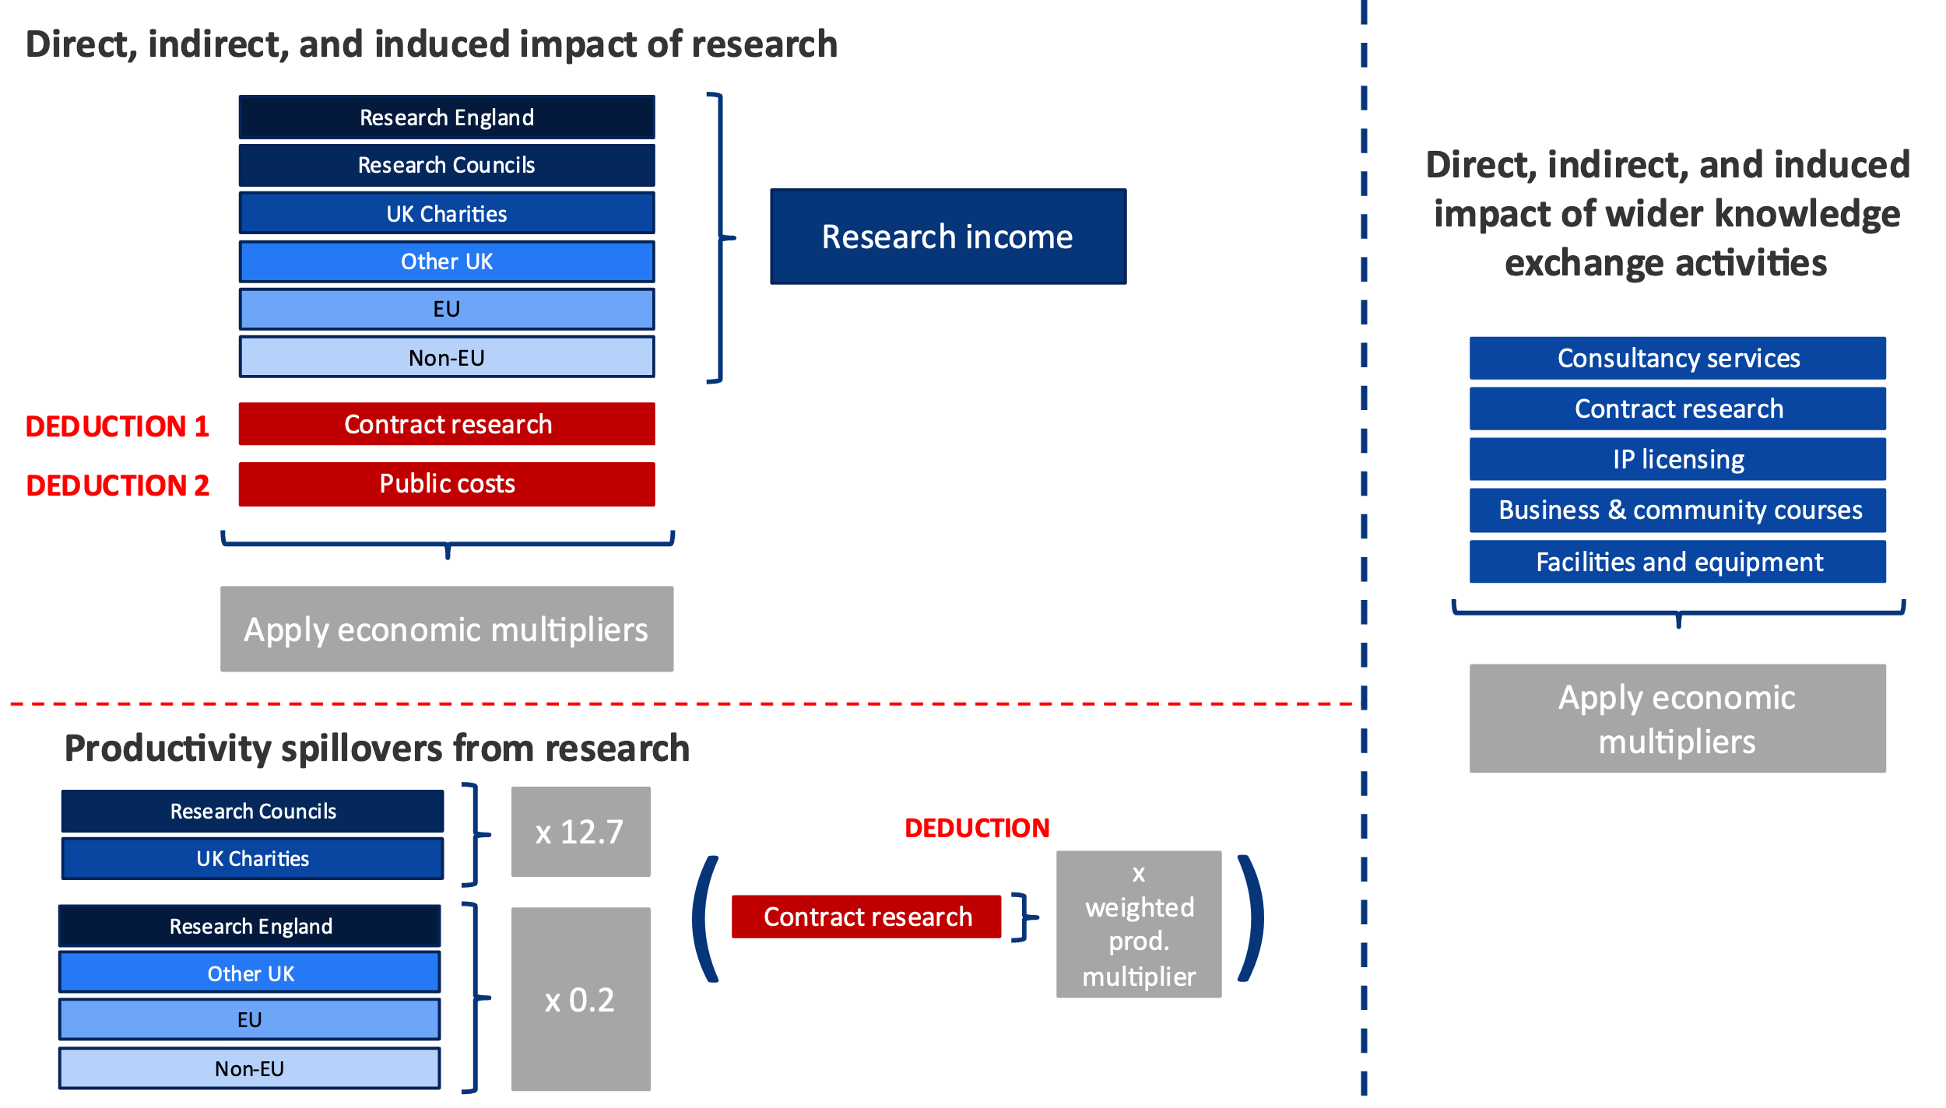
Note: Research funding includes collaborative research funding, which is divided into public, cash and in-kind funding. Cash and public fall under and are included in the research categories. In-kind is excluded from the impact analysis since these contributions do not represent a cash transaction for which we can robustly apply economic multipliers. To avoid double counting, contract research funding is deducted from the impact of research, as this is already included within the impact of wider knowledge exchange activities.
Source: London Economics analysis
- Literature discussing productivity spillovers
This section provides further detail on the literature associated with productivity spillovers, estimated in Section 2.1.4.
Of particular interest in the context of research conducted by universities, a study by Haskel and Wallis (2010) investigates evidence of spillovers from publicly funded research & development activities. The authors analyse productivity spillovers to the private sector from public spending on R&D by the UK Research Councils and public spending on civil and defence-related R&D, , and the relative effectiveness of these channels of public spending in terms of their impact on the ‘market sector’. They find strong evidence of the existence of market sector productivity spillovers from public R&D expenditure originating from the UK Research Councils. Their findings imply that, while there is no spillover effect associated with publicly funded civil and defence R&D, the marginal spillover effect of public spending on research through the Research Councils stands at 12.7 (i.e. every £1 spent on research through the Research Councils results in an additional annual output of £12.70 within the UK private sector).
Another study by Haskel et al. (2014) provides additional insight into the size of potential productivity spillovers from university research. Rather than estimating effects on the UK economy as a whole, the authors analyse the size of spillover effects from public research across different UK industries. The authors investigate the correlation between the combined research conducted by the Research Councils, the higher education sector, and central government itself (e.g. through public research laboratories), interacted with measures of industry research activity, and total factor productivity within the different market sectors. Their findings imply a total rate of return on public sector research of 0.2 (i.e. every £1 spent on public R&D results in an additional annual output of £0.20 within the UK private sector).
It should be noted that much of the existing literature does not assume a rate of depreciation on publicly-funded R&D investments. A standard assumption of the depreciation rate from the literature is around 20-25% per year, which still implies a significant estimate of the productivity spillover.

How do these estimates compare to the wider literature?
While these research spillovers are quantitatively large; they are in line with related findings from the (relatively limited) economic literature. A report for the (former) Department for Business, Innovation and Skills (2014) replicates the Haskel and Wallis (2010) approach, using a different (publicly-available) dataset and a slightly different methodology to explore variation in types of research council R&D investments in terms of their impact on private sector productivity. Despite the difference in data and approach, they find qualitatively similar findings: research council R&D investments yield large returns through their impact on private sector productivity. The comparable research multiplier is estimated at 10.71. Moreover, the report finds much higher returns, depending on the precise approach and sample used. Additionally, research from Australia finds a similar research spillover to Haskel and Wallis (2010), albeit with a slightly lower research multiplier of 9.76, which may be expected given the different country studied (Elnasri and Fox, 2017).
There is more limited research associated with general R&D multipliers (for other research income) although a report published for the Department for Business, Innovation and Skills, looking into the international benchmarking of the UK science and innovation system, notes a rate of return in the range of 20 to 50% (Department for Business, Innovation and Skills, 2014). This demonstrates that researchers using different methods and datasets find similar results with regard to estimates of research spillovers.
- Regional and sectoral impact of research and knowledge exchange activities
The total direct, indirect, and induced impact of the University of Birmingham’s research and knowledge exchange activities can also be broken down by regions across the UK and sectors in the economy, and presented in GVA and FTE employment measures. Figure 42 presents the aggregate impact associated with the University of Birmingham’s research and knowledge exchange activities in the 2021-22 academic year across all regions and in Figure 43 by sector.
- Estimated total economic impact associated with the University of Birmingham’s research and knowledge exchange activities in 2021-22, by region
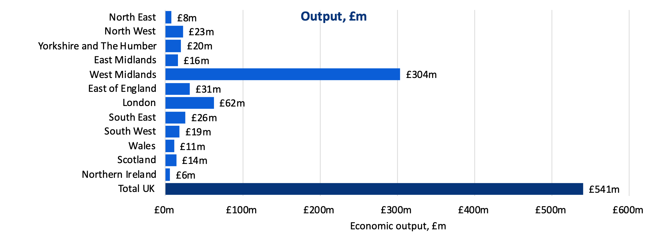
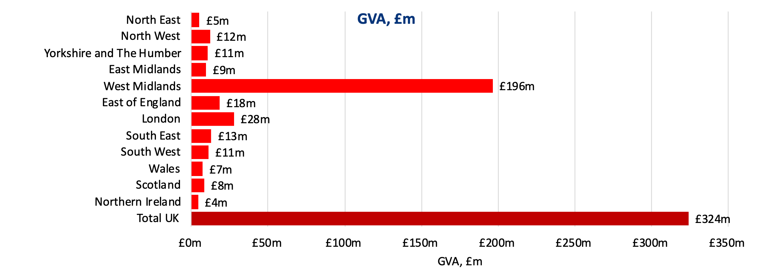
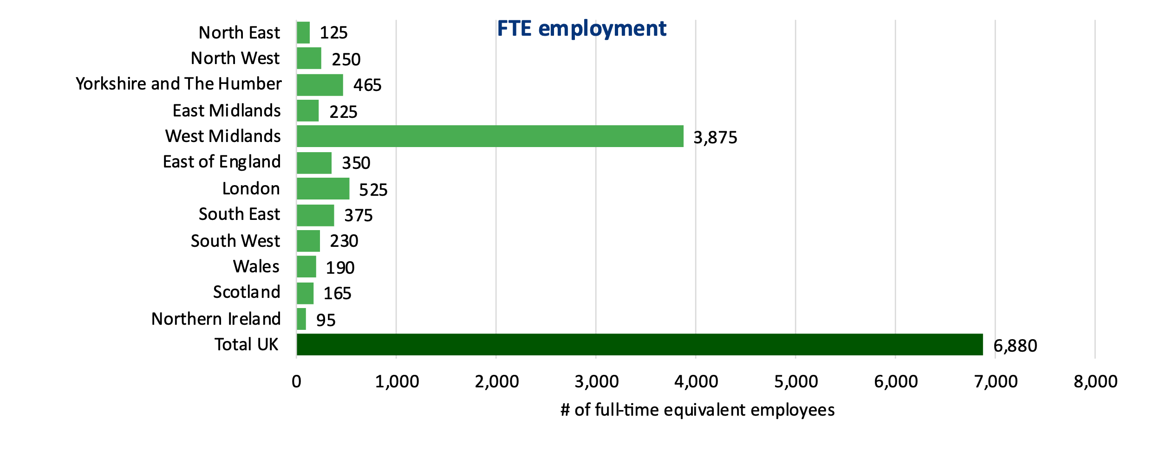
Note: Monetary estimates are presented in 2021-22 prices, rounded to the nearest £1 million, and may not add up precisely to the totals indicated. Employment estimates are rounded to the nearest 5, and again may not add up precisely to the totals indicated.
Source: London Economics’ analysis
Considering the breakdown by region, in terms of economic output (top panel), more than half of the total impact (£541 million) of the University of Birmingham’s research and knowledge exchange activities (£304 million, 56%) occurred in the West Midlands, but there were also significant impacts occurring in other regions across the UK, particularly in London (£62 million, 12%), and the East of England (£31 million, 6%).
Additionally, in terms of GVA (middle panel), the impact was estimated to be approximately £324 million across the UK economy as a whole, of which £196 million occurred in the West Midlands. Finally, of the estimated 6,880 FTE jobs (bottom panel) that were supported by the University’s research and knowledge exchange activities across the UK as a whole, the majority (approximately 3,875) were located within the West Midlands.
- Estimated total economic impact associated with the University of Birmingham’s research and knowledge exchange activities in 2021-22, by sector
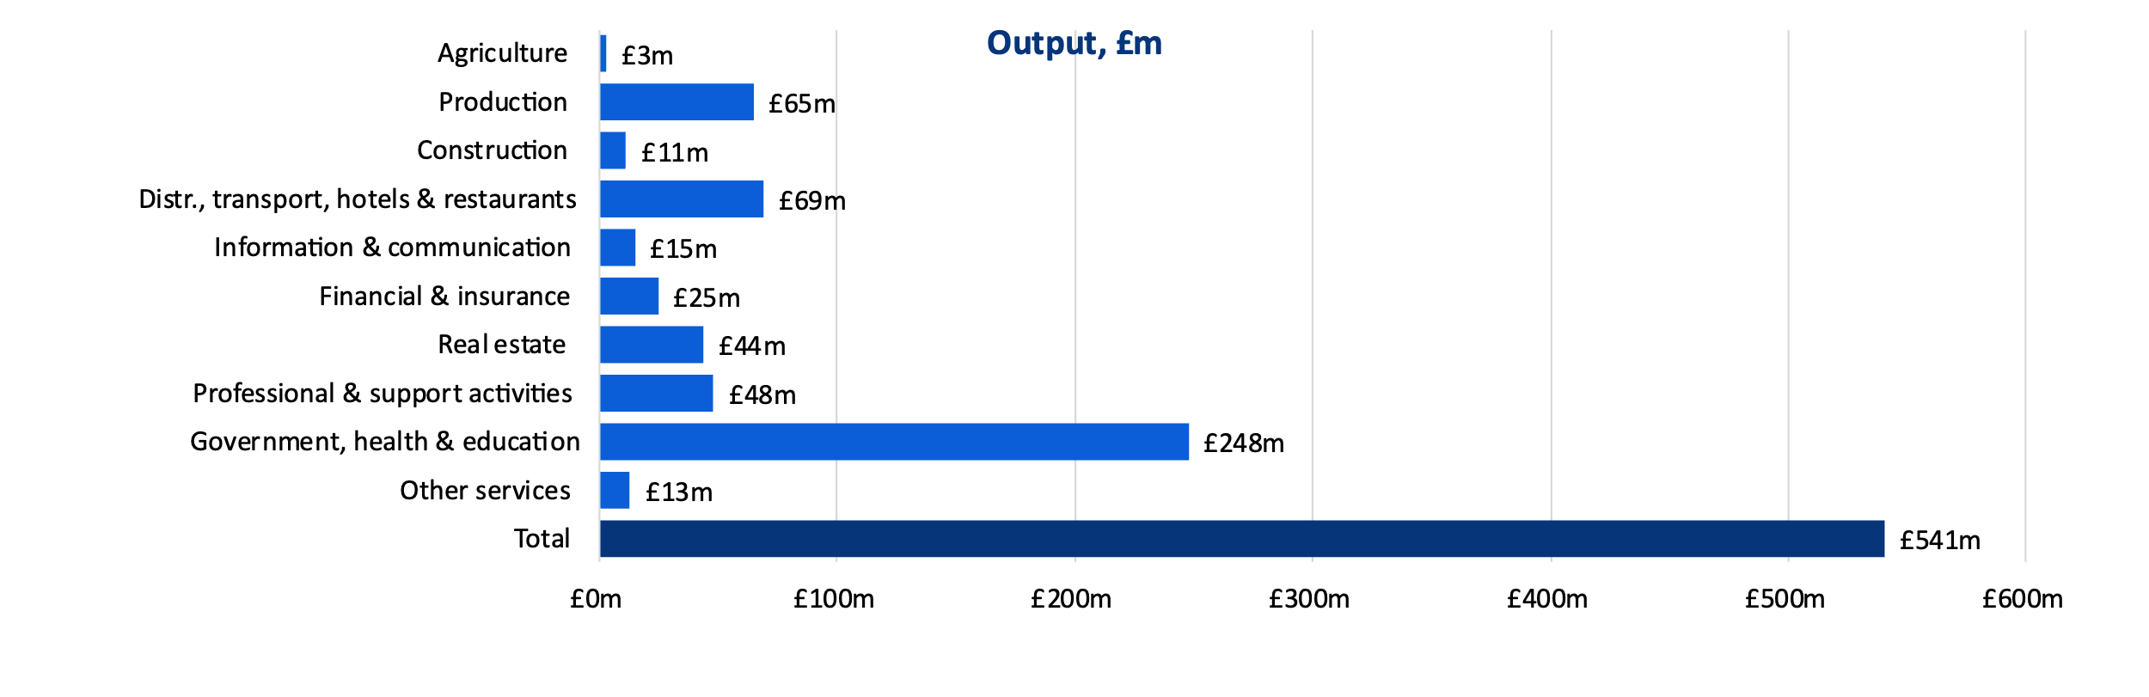
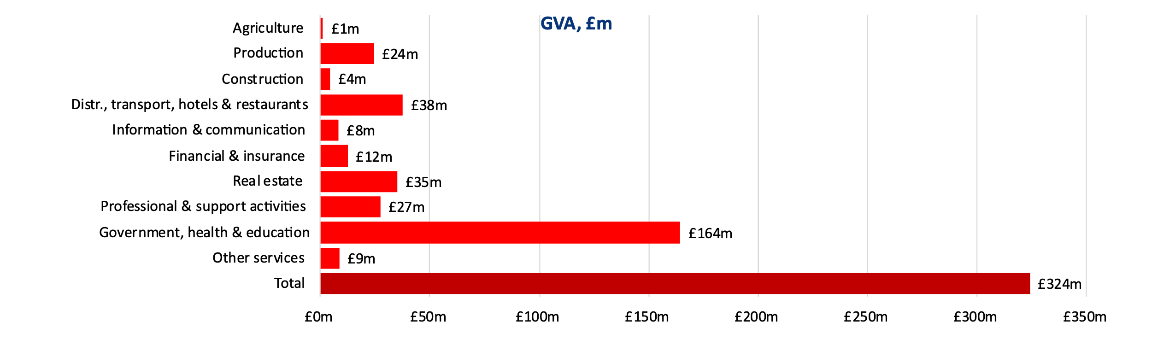
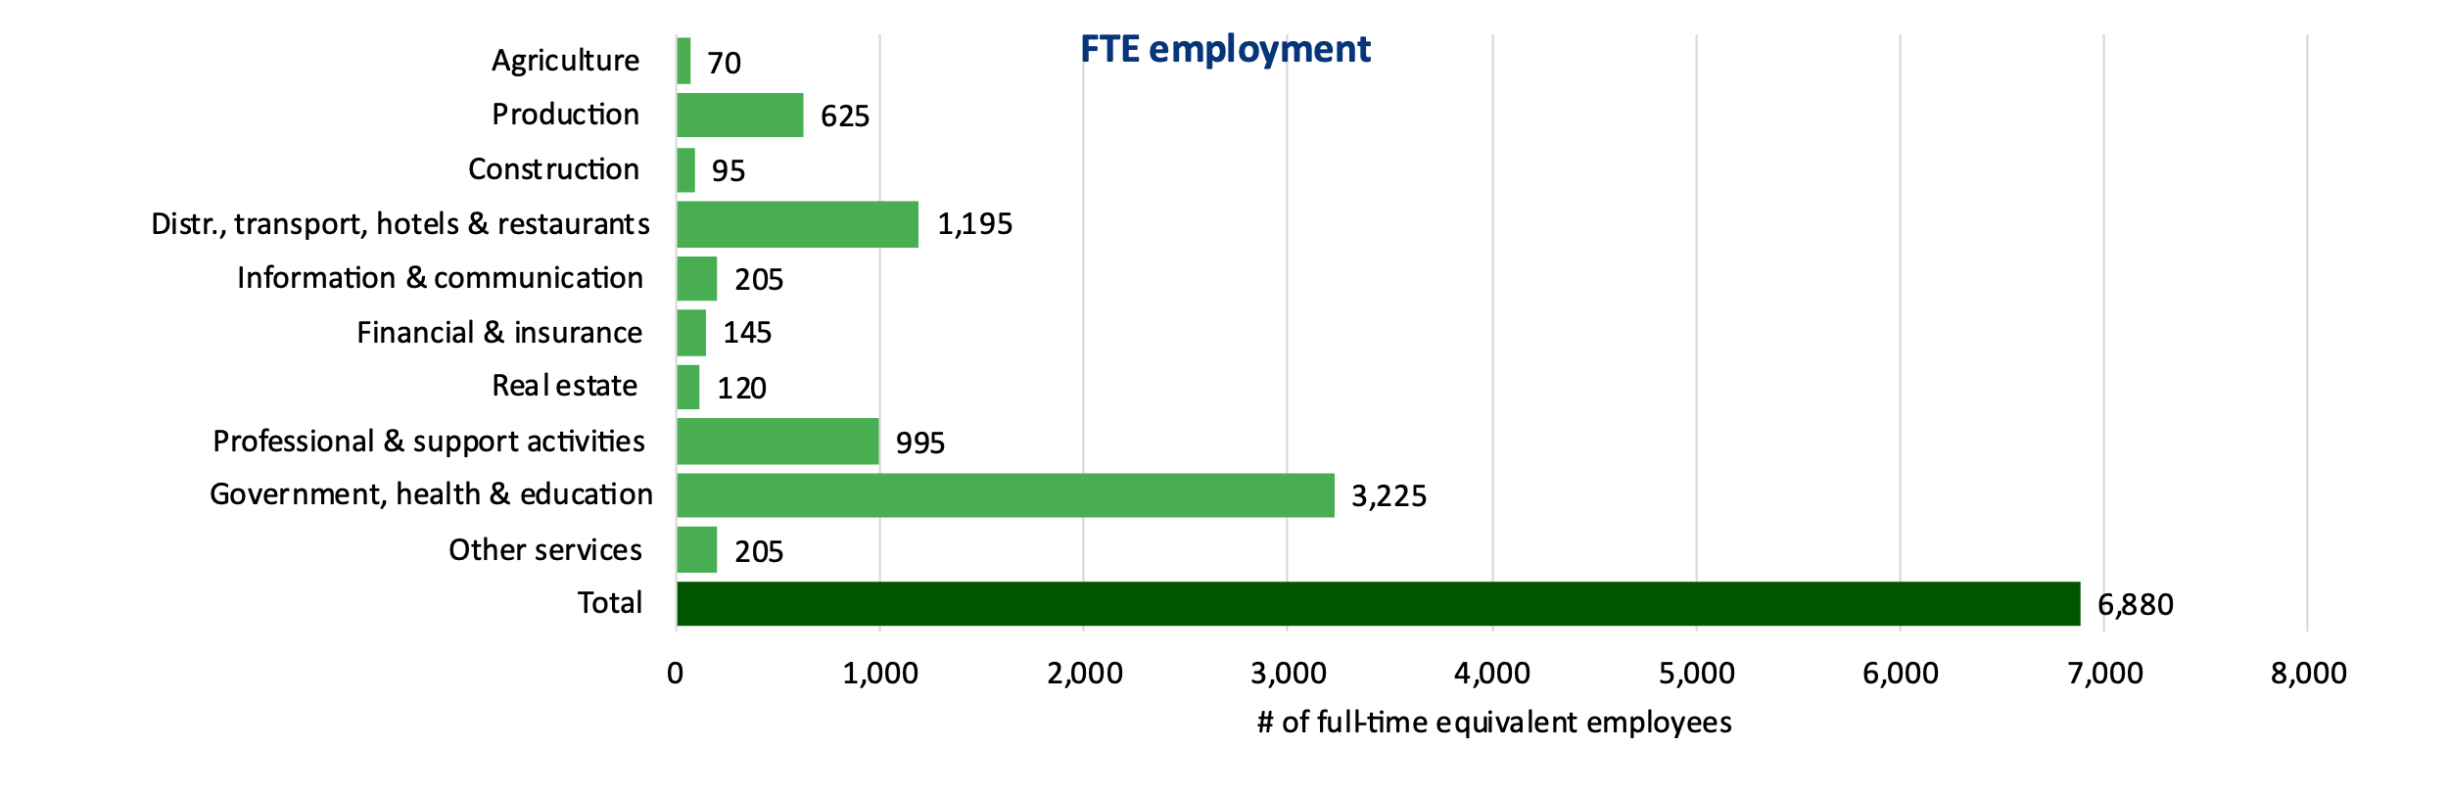
Note: Monetary estimates are presented in 2021-22 prices, rounded to the nearest £1 million, and may not add up precisely to the totals indicated. Employment estimates are rounded to the nearest 5, and again may not add up precisely to the totals indicated.
Source: London Economics’ analysis
In terms of sector, the University’s research and knowledge exchange activities resulted in particularly large impacts within the government, health & education (£248 million, 46%), the distribution, transport, hotels, and restaurant sector (£69 million, 13%), and the production sector (£65 million, 12%).
- Impact of the University’s teaching and learning activities
Section 3 outlined our analysis of the economic impact of teaching and learning activities associated with the cohort of first-year UK domiciled students who started higher education qualifications at the University of Birmingham in the 2021-22 academic year. In the following, we provide further details on the underlying methodological approach used to arrive at our estimates of this impact.
- Adjusting for completion rates
In Section 3.1, we provided an overview of the number of UK domiciled students starting qualifications or modules at the University of Birmingham in the 2021-22 academic year. However, to aggregate individual-level impacts of the University’s teaching and learning activity, it is necessary to adjust the number of ‘starters’ to account for completion rates.
To achieve this, we used information provided by the University of Birmingham on the historical completion outcomes of students from the University – broken down by study mode, study intention, and study completion. In other words, these completion data include the number of students who completed their intended qualification (or module); completed a different (usually lower) qualification; or discontinued their studies without being awarded a qualification (modelled as completion at ‘other undergraduate’ level (for students who originally enrolled in first degrees or other undergraduate qualifications) or ‘other postgraduate’ level (for students who originally intended to complete higher degrees or other postgraduate qualifications)).
Table 15 presents the resulting completion rates applied throughout the analysis. We assume that, of those students starting a full-time first degree at the University of Birmingham in the 2021-22 academic year, 84% complete the first degree as intended, while the remaining 16% undertake one or more of the credits/modules associated with their degree before discontinuing their studies (modelled as completion at ‘other undergraduate’ level). Similarly, at postgraduate level, we assume that of those individuals starting a full-time postgraduate taught degree, 95% complete the qualification as intended, while the remaining 5% complete another (lower) qualification or undertake one or more of the credits/modules associated with the intended degree before dropping out (in this case, modelled as completion at ‘other postgraduate’ level). In all these cases, the analysis of the impact of teaching and learning calculates the estimated returns associated with the completed qualification/standalone module(s).
- Assumed completion rates of University of Birmingham student entrants
Completion outcome | Study intention
Completion outcome | Other undergraduate | First degree | Other postgraduate | Higher degree (taught) | Higher degree (research)
Full-time students
Other undergraduate | 100% | 16% | - | 0% | -
First degree | - | 84% | - | - | -
Other postgraduate | - | - | 100% | 5% | 12%
Higher degree (taught) | - | - | - | 95% | -
Higher degree (research) | - | - | - | - | 88%
Total | 100% | 100% | 100% | 100% | 100%
Part-time students
Other undergraduate | 100% | - | - | - | -
First degree | - | 100% | - | - | -
Other postgraduate | - | - | 100% | 23% | 34%
Higher degree (taught) | - | - | - | 77% | 1%
Higher degree (research) | - | - | - | - | 66%
Total | 100% | 100% | 100% | 100% | 100%
Note: Based on University of Birmingham progression information for the 2021-22 academic year. Totals may not sum due to rounding.
Source: London Economics’ analysis based on information provided by the University of Birmingham
- Defining the gross graduate premium and gross public purse benefit
As summarised in Section 3.2, to measure the economic benefits of higher education qualifications, we estimate the labour market value associated with these qualifications, rather than simply assessing the labour market outcomes achieved by individuals in possession of higher education qualifications. The standard approach to estimating this labour market value is to undertake an econometric analysis where the ‘treatment’ group consists of those individuals in possession of the qualification of interest, and the ‘counterfactual’ group consists of those individuals with comparable personal and socioeconomic characteristics but with the next highest level of qualification. The rationale for adopting this approach is that the comparison of the earnings and employment outcomes of the treatment group and the counterfactual group ‘strips away’ (to the greatest extent possible with the relevant data) those other personal and socioeconomic characteristics that might affect labour market earnings and employment (such as gender, age, or sector of employment), leaving just the labour market gains attributable to the qualification itself (see Figure 44 for an illustration of this). The treatment and counterfactual groups, and details of the econometric approach, are presented in Annex A2.3.3 and Annex A2.3.4, respectively.
- Estimating the gross graduate premium and gross Exchequer benefit
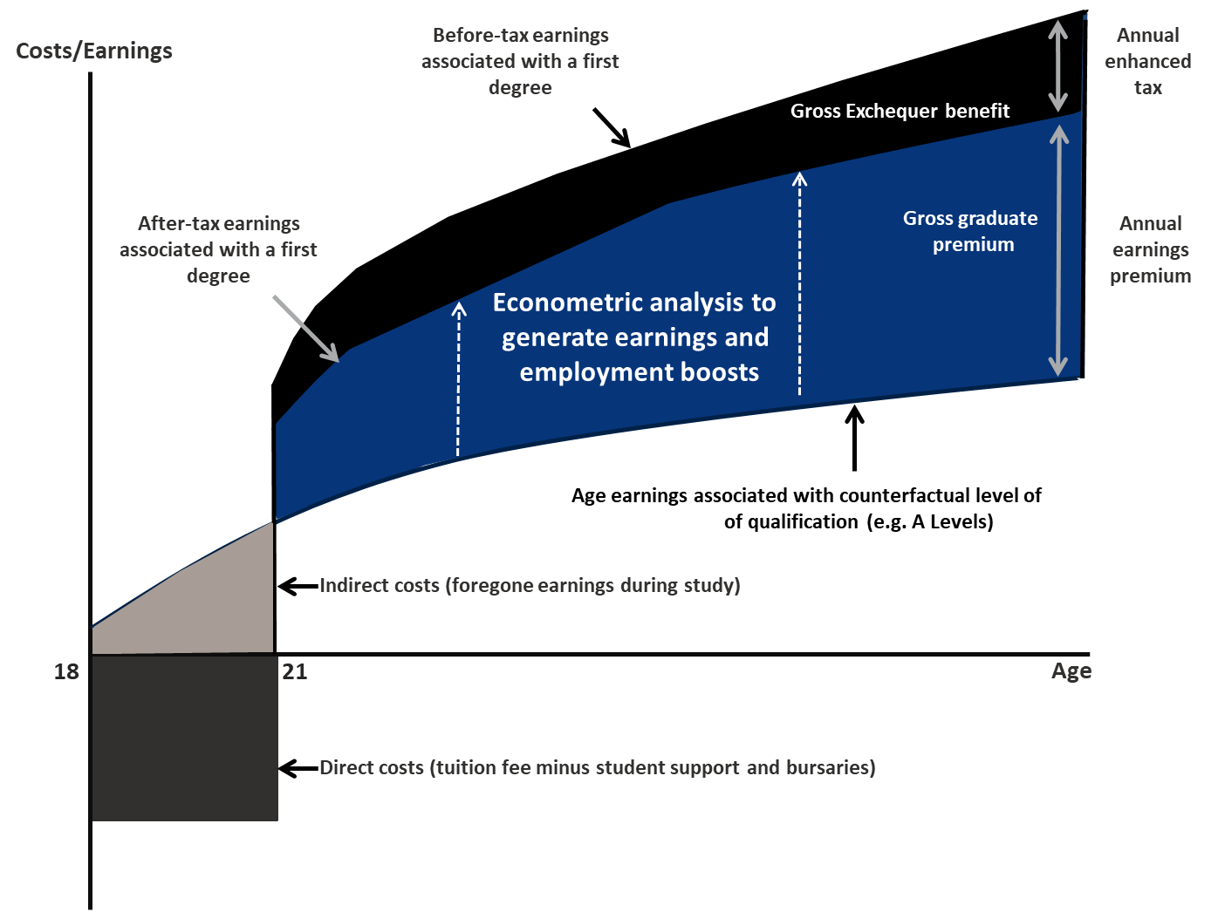
Note: The analysis assumes that the opportunity costs of foregone earnings associated with higher qualification attainment are applicable to full-time students only. For part-time students, we have assumed that these students are able to combine work with their academic studies and as such, do not incur any opportunity costs in the form of foregone earnings. This illustration is based on an analysis of the University of Birmingham’s student cohort data for 2021-22, where the mean age at enrolment for full-time first degree students stands at 18, and the average study duration for full-time first degree students is 3 years.
Source: London Economics
Throughout the analysis, the assessment of earnings and employment outcomes associated with higher education qualification attainment (at all levels) is undertaken separately by gender, reflecting the different labour market outcomes between men and women. Further, the analysis is adjusted for the specific subject composition of students studying at the University of Birmingham, to reflect the fact that there is significant variation in post-graduation labour market outcomes depending on the subject of study. In addition, given the fact that part-time students generally undertake and complete higher education qualifications later in life than full-time students, the analysis for part-time students applies a ‘decay function’ to the returns associated with qualification attainment, to reflect the shorter period of time in the labour market.
To estimate the gross graduate premium, based on the econometric results, we then estimate the present value of the enhanced post-tax earnings of individuals in possession of different higher education qualifications (i.e. after income tax, National Insurance and VAT are removed, and following the deduction of foregone earnings) relative to an individual in possession of the counterfactual qualification (see Annex A2.3.6 for more detail).
The gross benefits to the Exchequer from the provision of higher education are derived from the enhanced taxation receipts that are associated with a higher likelihood of being employed, as well as the enhanced earnings associated with more highly skilled and productive employees. Based on the analysis of the lifetime earnings and employment benefits associated with higher education qualification attainment and combined with administrative information on the relevant taxation rates and bands (from HM Revenue and Customs), we estimated the present value of additional income tax, National Insurance and VAT associated with higher education qualification attainment (by gender, level of study, mode of study, and prior attainment). Again, please refer to Annex A2.3.6 for more detailed information on the calculation of the gross Exchequer benefit.
- Qualifications and counterfactuals considered in the econometric analysis
Our econometric analysis of the earnings and employment returns to higher education qualifications (described in more detail in Annex A2.3.4) considered five different higher education qualification groups (i.e. five ‘treatment’ groups for HE qualifications):
- Three at postgraduate level (higher degree (research), higher degree (taught) and ‘other’ postgraduate qualifications); and
- Two at undergraduate level (first degrees and ‘other’ undergraduate qualifications);
Table 16 presents these different undergraduate and postgraduate qualifications (i.e. treatment groups) considered in the analysis, along with the associated counterfactual group used for the marginal returns analysis in each case. As outlined above, we compare the earnings of the group of individuals in possession of each higher education qualification to the relevant counterfactual group, to ensure that we assess the economic benefit associated with the qualification itself (rather than the economic returns generated by the specific characteristics of the individual in possession of the qualification). This is a common approach in the literature and allows us to control for other personal, regional, or socioeconomic characteristics that might influence both the determinants of qualification attainment as well as earnings/employment.
For the analysis of marginal labour market returns, postgraduate qualification holders are compared to first degree holders, while for individuals holding first degrees or ‘other undergraduate’ level qualifications, the counterfactual group consists of individuals holding any (academic or vocational) qualification at Regulated Qualifications Framework (RQF) Level 3 as their highest qualification (i.e. 2 or more GCE ‘A’ Levels’ or equivalent), .
In addition, we also included a separate specification comparing the earnings associated with RQF Level 3 qualifications to possession of 5 or more GCSEs at grades A*-C (or equivalent). This additional analysis was undertaken to provide an indication of the fact that the academic ‘distance travelled’ by a (very small) proportion of students in the 2021-22 University of Birmingham cohort is greater than might be the case compared to those in possession of levels of prior attainment ‘traditionally’ associated with higher education entry. Similarly, for other students within the cohort, the academic ‘distance travelled’ is lower than the traditional prior attainment level (e.g. a small proportion of students intending to undertake a first degree had previously already completed a sub-degree level (i.e. ‘other undergraduate’) qualification).
- Treatment and comparison groups used to assess the marginal earnings and employment returns to higher education qualifications
Treatment group – highest qualification | Comparison group - highest qualification
HE qualifications
Higher degree (research) | First degree
Higher degree (taught) | First degree
Other postgraduate | First degree
First degree | RQF Level 3 (academic or vocational) qualifications¹
Other undergraduate | RQF Level 3 (academic or vocational) qualifications
Other
RQF Level 3 (academic or vocational) qualifications² | 5 or more GCSEs grade A*-C
Note: 1. The analysis for first degrees (only) is weighted to reflect the specific prior attainment levels among UK domiciled students in the 2021-22 University of Birmingham cohort. In other words, the analysis is weighted to reflect the proportions of students in possession of 2 or more GCE ‘A’ Levels or other academic (or vocational) qualifications (at RQF Level 3) as their highest attainment prior to starting their learning at the University of Birmingham.
2. Similar to the counterfactual group for first degrees, the analysis for the treatment group here is weighted to reflect the proportions of students in possession of 2 or more GCE ‘A’ Levels or other equivalent (vocational or academic) qualifications (at RQF Level 3) as their highest attainment prior to starting their learning at the University of Birmingham.
Source: London Economics
In instances where the level of prior attainment for students at the University of Birmingham was higher or lower than the ‘traditional’ counterfactual qualifications outlined in Table 16, the analysis used a ‘stepwise’ calculation of additional lifetime earnings. For example, to calculate the earnings and employment returns for a student in possession of an ‘other undergraduate’ qualification undertaking a first degree at the University of Birmingham, we deducted the returns to undertaking an ‘other undergraduate’ qualification (relative to the possession of an RQF Level 3 qualification) from the returns to undertaking a first degree (again relative to the possession of an RQF Level 3 qualification). Similarly, to calculate the returns for a student in possession of 5 GCSEs A*-C (or equivalent) undertaking a first degree at the University of Birmingham, we added the returns to achieving an RQF Level 3 qualification (relative to the possession of 5 GCSEs A*-C) to the returns to undertaking a first degree (relative to the possession of an RQF Level 3 qualification).
- Marginal earnings and employment returns to higher education qualifications

Marginal earnings returns
To estimate the impact of qualification attainment on earnings, using information from the Labour Force Survey (LFS), we estimated a standard ordinary least squares linear regression model, where the dependent variable is the natural logarithm of hourly earnings, and the independent variables include the full range of qualifications held alongside a range of personal, regional, and job-related characteristics that might be expected to influence earnings. In this model specification, we included individuals who were employed on either a full-time or a part-time basis. This approach has been used widely in the academic literature.
The basic specification of the model was as follows:
$ln⁡(ω_{i})=α+βX_{i}+ϵ_{i}$ for i = 1 to n
where ln($ω_{i}$) represents the natural logarithm of hourly earnings, $ϵ_{i}$represents an error term, $α$ represents a constant term, i is an individual LFS respondent, and $X_{i}$ provides the independent variables included in the analysis, as follows:
- Highest qualification held;
- Age;
- Age squared;
- Ethnic origin;
- Disability status;
- Region of work;
- Marital status;
- Number of dependent children under the age of 16;
- Full-time / part-time employment;
- Temporary or permanent contract;
- Public or private sector employment;
- Workplace size; and
- Yearly dummies.
Using the above specification, we estimated earnings returns in aggregate and for men and women separately. Further, to analyse the benefits associated with different education qualifications over the lifetime of individuals holding these qualifications, the regressions were estimated separately across a range of specific age bands for the working age population, depending on the qualification considered. The estimated marginal earnings returns also take account of the specific subject mix of UK domiciled students in the 2021-22 University of Birmingham cohort. As a result, the estimated marginal wage returns adjust for the specific subject composition of the University of Birmingham’s student cohort, where possible. In addition, as outlined in Annex A2.3.3, the marginal wage returns for first degrees also reflect the specific prior level of attainment of students in the 2021-22 University of Birmingham cohort (i.e. where the analysis is adjusted for the proportions of students in possession of GCE ‘A’ levels or other types of RQF Level 3 qualifications as their highest prior attainment on entry).
Further note that the analysis of earnings premiums was undertaken at a national (UK-wide) level. However, to adjust for differences across the Home Nations, these UK-wide earnings premiums were then combined with the relevant differential direct costs facing the individual and/or the public purse for students domiciled in the different Home Nations.
To estimate the impact of higher education qualifications on labour market outcomes using this methodology, we used information from pooled Quarterly UK Labour Force Surveys between 2010 and 2022.
- Marginal earnings returns to higher education qualifications (weighted across subjects), in % (following exponentiation), by gender and age band
Qualification level (vs. counterfactual) | Age band
Qualification level (vs. counterfactual) | 16-20 | 21-25 | 26-30 | 31-35 | 36-40 | 41-45 | 46-50 | 51-55 | 56-60 | 61-65
Men
Level 3 (vs. 5+GCSEs)¹ |  | 7.1% | 9.0% | 14.1% | 16.3% | 12.5% | 12.6% | 11.2% | 13.8% | 9.6%
Other undergraduate (vs. Level 3)² |  |  |  | 17.4% | 20.3% | 27.3% | 25.2% | 23.0% | 28.4% | 35.4%
First degree (vs. Level 3)² |  | 7.9% | 15.4% | 25.2% | 26.6% | 30.9% | 27.3% | 29.8% | 37.0% | 29.3%
Other postgraduate (vs. first degrees)³ |  | 8.2% | 8.5% | 6.1% |  |  | 7.5%
Higher degree (taught) (vs. first degrees)³ |  | 6.7% | 8.9% | 8.3% | 9.0% | 13.1% | 10.0% | 13.8% | 14.8% | 19.5%
Higher degree (research) (vs. first degrees)³ |  | 30.9% | 9.3% | 16.8% | 15.4% | 22.9% | 34.2% | 32.0% | 20.1% | 52.8%
Women
Level 3 (vs. 5+GCSEs)¹ |  | 2.9% | 4.9% | 4.5% | 9.2% | 9.5% | 4.7% | 6.2% | 6.1% | 5.9%
Other undergraduate (vs. Level 3)² |  | 3.7% | 9.0% | 13.7% | 26.6% | 25.5% | 26.2% | 25.5% | 26.5% | 28.5%
First degree (vs. Level 3)² | 21.5% | 8.8% | 16.0% | 28.9% | 35.8% | 37.9% | 35.4% | 32.3% | 35.0% | 27.6%
Other postgraduate (vs. first degrees)³ |  | 5.5% |  | 10.2% | 8.4% | 12.0% | 13.3% | 15.6% | 18.6% | 14.1%
Higher degree (taught) (vs. first degrees)³ |  | 6.1% | 6.6% | 12.4% | 18.3% | 20.2% | 26.1% | 20.9% | 31.1% | 22.6%
Higher degree (research) (vs. first degrees)³ |  | 14.7% | 16.3% | 31.9% | 41.2% | 36.6% | 39.9% | 43.5% | 47.0% | 44.8%
Note: Regression coefficients have been exponentiated to reflect percentage wage returns. In cases where the estimated coefficients are not statistically significantly different from zero (at the 10% level), the coefficient is assumed to be zero; these are displayed as gaps in the table.
¹ Returns to holding RQF Level 3 qualifications are estimated relative to 5 or more GCSEs at A*-C (or equivalent) (weighted to reflect the proportion of first degree entrants in the 2021-22 University of Birmingham cohort holding GCE ‘A’ levels or other RQF Level 3 qualifications as their highest prior qualification on entry).
² Returns to other undergraduate qualifications and first degrees are estimated relative to individuals holding a Level 3 (academic or vocational) qualification as their highest qualification. Returns to first degrees are estimated relative to individuals holding RQF Level 3 qualifications as their highest qualification (weighted by the proportion of first degree entrants in the 2021-22 University of Birmingham cohort holding GCE ‘A’ levels or other RQF Level 3 qualifications as their highest prior attainment).
³ Returns to higher degree (taught), higher degree (research), and ‘other’ postgraduate qualifications are estimated relative to first degrees.
Source: London Economics' analysis of pooled Quarterly Labour Force Survey data for 2010 Q1 - 2022 Q4
The resulting estimated marginal wage returns to the different qualifications of interest are presented in Table 17. In the earnings regressions, the coefficients provide an indication of the additional effect on hourly earnings associated with possession of the respective higher education qualification relative to the counterfactual level of qualification. To take an example, the analysis suggests that men aged between 31 and 35 in possession of a first degree achieve a 25.2% hourly earnings premium compared to comparable men holding only an (academic or vocational) RQF Level 3 qualification as their highest level of attainment (weighted to reflect the specific prior attainment levels of first degree students in the 2021-22 University of Birmingham cohort (i.e. predominantly GCE ‘A’ Levels or equivalent)). The comparable estimate for women aged between 31 and 35 stands at 28.9%.

Marginal employment returns
To estimate the impact of qualification attainment on employment, we adopted a probit model to assess the likelihood of different qualification holders being in employment or otherwise. The basic specification defines an individual’s labour market outcome to be either in employment (working for payment or profit for more than 1 hour in the reference week (using the standard International Labour Organisation definition) or not in employment (being either unemployed or economically inactive)). The specification of the probit model was as follows:
$Probit\left(EMPNOT_{i}\right)=α+γZ_{i}+ϵ_{i}$ for i = 1 to n
The dependent variable adopted represents the binary variable $EMPNOT_{i}$, which is coded 1 if the individual is in employment and 0 otherwise. We specified the model to contain a constant term ($α$) as well as a number of standard independent variables, including the qualifications held by an individual (represented by $Z_{i}$ in the above equation), as follows:
- Highest qualification held;
- Age;
- Age squared;
- Ethnic origin;
- Disability status;
- Region of usual residence;
- Marital status;
- Number of dependent children under the age of 16; and
- Yearly dummies.
Again, $ϵ_{i}$represents an error term. Similar to the methodology for estimating earnings returns, the described probit model was estimated in aggregate and separately for men and women, with the analysis further split by respective age bands, and adjusted for the specific subject mix of students in the 2021-22 cohort of UK domiciled students attending the University of Birmingham. Further, and again similar to the analysis of earnings returns, employment returns were estimated at the national (i.e. UK-wide) level. In addition, marginal employment returns for first degrees again reflect the specific prior level of attainment of first degree students in the 2021-22 University of Birmingham cohort (i.e. the proportions of students in possession of GCE ‘A’ levels or other types of RQF Level 3 qualifications as their highest prior attainment on entry).
The resulting estimated marginal employment returns to HE qualifications are presented in Table 18. In the employment regressions, the relevant coefficients provide estimates of the impact of the qualification on the probability of being in employment (expressed in percentage points). Again, to take an example, the analysis estimates that a man aged between 31 and 35 in possession of a first degree is 2.1 percentage points more likely to be in employment than a man of similar age holding only a Level 3 qualification as his highest level of education (again, predominantly including GCE ‘A’ levels or equivalent). The corresponding estimate for women stands at 6.0 percentage points.
- Marginal employment returns to higher education qualifications (weighted across subjects), in percentage points, by gender and age band
Qualification level | Age band
Qualification level | 16-20 | 21-25 | 26-30 | 31-35 | 36-40 | 41-45 | 46-50 | 51-55 | 56-60 | 61-65
Men
Level 3 (vs. 5+GCSEs)¹ | -5.9 | 2.4 | 3.8 | 2.3 |  | 1.9 | 1.4
Other undergraduate (vs. Level 3)² |  |  |  | 1.8 |  | 2.0 |  | 1.8
First degree (vs. Level 3)² |  | -4.0 | 3.2 | 2.1 | 2.7 | 1.6 |  | 2.6 | -3.7 | -6.6
Other postgraduate (vs. first degrees)³ |  | 8.8 |  | 1.9 |  | 2.1 |  |  |  | -6.8
Higher degree (taught) (vs. first degrees)³ |  | -4.9 | -2.6 |  |  | 1.6 |  |  | 4.1
Higher degree (research) (vs. first degrees)³ |  | 11.1 | 2.7 |  | 1.9 | 3.0 |  | 4.0 | 9.2 | 10.7
Women
Level 3 (vs. 5+GCSEs)¹ |  | 4.6 | 4.0 | 2.9 | 3.9 | 2.8 | 4.4 | 3.9 | 3.5 | 3.5
Other undergraduate (vs. Level 3)² |  | 3.0 |  | 3.8 | 4.4 | 2.9 | 3.1 | 2.6
First degree (vs. Level 3)² | 15.1 |  | 5.0 | 6.0 | 5.7 | 5.7 | 4.0
Other postgraduate (vs. first degrees)³ |  | 4.1 |  | 2.3 |  | 4.1 | 3.3 | 2.9 | 5.1
Higher degree (taught) (vs. first degrees)³ |  | -5.8 | -2.8 |  |  | 2.4 | 2.3 | 2.8 | 4.5 | 4.5
Higher degree (research) (vs. first degrees)³ |  |  |  | 2.9 |  | 3.9 | 5.7 | 7.7 | 10.0 | 17.7
Note: In cases where the estimated coefficients are not statistically significantly different from zero (at the 10% level), the coefficient is assumed to be zero; these are displayed as gaps in the table.
¹ Returns to holding RQF Level 3 qualifications are estimated relative to 5 or more GCSEs at A*-C (or equivalent) (weighted to reflect the proportion of first degree entrants in the 2021-22 University of Birmingham cohort holding GCE ‘A’ levels or other RQF Level 3 qualifications as their highest prior qualification on entry).
² Returns to other undergraduate qualifications and first degrees are estimated relative to individuals holding a Level 3 (academic or vocational) qualification as their highest qualification. Returns to first degrees are estimated relative to individuals holding RQF Level 3 qualifications as their highest qualification (weighted by the proportion of first degree entrants in the 2021-22 University of Birmingham cohort holding GCE ‘A’ levels or other RQF Level 3 qualifications as their highest prior attainment).
³ Returns to higher degree (taught), higher degree (research), and ‘other’ postgraduate qualifications are estimated relative to first degrees.
Source: London Economics' analysis of pooled Quarterly Labour Force Survey data for 2010 Q1 – 2022 Q4
- ‘Age-decay’ function
Many existing economic analyses considering the lifetime benefits associated with higher education qualifications to date (e.g. Walker and Zhu, 2013) have focused on the returns associated with the ‘traditional path’ of higher education qualification attainment – i.e. progression directly from secondary level education and completion of a three or four year undergraduate degree from the age of 18 onwards (completing by the age of 21 or 22). These analyses assume that there are direct costs (tuition fees etc.), as well as an opportunity cost (the foregone earnings while undertaking the qualification full-time) associated with qualification attainment. More importantly, these analyses make the implicit assumption that any and all of the estimated earnings and/or employment benefit achieved accrues to the individual.
However, the labour market outcomes associated with the attainment of higher education qualifications on a part-time basis are fundamentally different than those achieved by full-time students. In particular, part-time students typically undertake higher education qualifications several years later than the ‘standard’ full-time undergraduate (e.g. the estimated average age at enrolment among students in the 2021-22 cohort completing postgraduate taught degrees with the University of Birmingham on a part-time basis is 36, compared to 23 for corresponding full-time students); generally undertake their studies over an extended period of time; and often combine their studies with full-time employment. Table 19 presents the assumed average age at enrolment, study duration, and age at completion for students in the 2021-22 University of Birmingham cohort.
- Average age at enrolment, study duration, and age at completion for students in the 2021-22 University of Birmingham cohort
Qualification level | Full-time students |  |  | Part-time students
Qualification level | Age at enrolment | Duration (years) | Age at completion | Age at enrolment | Duration (years) | Age at completion
Other undergraduate | 18 | 1 | 19 | 27 | 3 | 30
First degree | 18 | 3 | 21
Other postgraduate | 27 | 1 | 28 | 35 | 2 | 37
Higher degree (taught) | 23 | 1 | 24 | 36 | 3 | 39
Higher degree (research) | 27 | 4 | 31 | 39 | 6 | 45
Note: All values have been rounded to the nearest integer. Gaps may arise where there are no students in the 2021-22 University of Birmingham cohort expected to complete the given qualification.
Source: London Economics' analysis based on University of Birmingham HESA data
Given these characteristics, we adjust the methodology when estimating the returns to part-time (and later full-time) education attainment at the University of Birmingham, through the use of an ‘age-decay’ function. This approach assumes that possession of a particular higher education qualification is associated with a certain earnings or employment premium, and that this entire labour market benefit accrues to the individual if the qualification is attained before the age of 24 (for undergraduate qualifications) or 29 (for postgraduate qualifications).
However, as the age of attainment increases, it is expected that a declining proportion of the potential value of the estimated earnings and employment benefit accrues to the individual. This calibration ensures that those individuals completing qualifications at a relatively older age will see relatively lower earnings and employment benefits associated with higher education qualification attainment (and perhaps reflect potentially different motivations among this group of learners). In contrast, those individuals attaining qualifications earlier in their working life will see a greater economic benefit (potentially reflecting the investment nature of qualification acquisition).
Table 20 above presents the assumed age-decay adjustment factors which we apply to the marginal earnings and employment returns to full-time and part-time students undertaking qualifications at the University of Birmingham in the 2021-22 cohort. To take an example, we have assumed that a student undertaking a postgraduate taught degree on a full-time basis achieves the full earnings and employment premium identified in the econometric analysis (for their entire working life). However, for a part-time postgraduate taught degree student, we assume that because of the late attainment (at age 39 (on average)), these students recoup only 69% of the corresponding earnings and employment premiums from that age (of attainment).
- Assumed age decay adjustment factors for students in the 2021-22 University of Birmingham cohort
Age | Other  undergraduate | First  degree | Other  postgraduate | Higher degree  (taught) | Higher degree (research)
18 | 100% | 100% | 100% | 100% | 100%
19 | 100% | 100% | 100% | 100% | 100%
20 | 100% | 100% | 100% | 100% | 100%
21 | 100% | 100% | 100% | 100% | 100%
22 | 100% | 100% | 100% | 100% | 100%
23 | 100% | 100% | 100% | 100% | 100%
24 | 98% | 98% | 100% | 100% | 100%
25 | 95% | 95% | 100% | 100% | 100%
26 | 93% | 93% | 100% | 100% | 100%
27 | 90% | 90% | 100% | 100% | 100%
28 | 88% | 88% | 100% | 100% | 100%
29 | 85% | 85% | 97% | 97% | 97%
30 | 83% | 83% | 94% | 94% | 94%
31 | 80% | 80% | 91% | 91% | 91%
32 | 78% | 78% | 89% | 89% | 89%
33 | 75% | 75% | 86% | 86% | 86%
34 | 73% | 73% | 83% | 83% | 83%
35 | 70% | 70% | 80% | 80% | 80%
36 | 68% | 68% | 77% | 77% | 77%
37 | 65% | 65% | 74% | 74% | 74%
38 | 63% | 63% | 71% | 71% | 71%
39 | 60% | 60% | 69% | 69% | 69%
40 | 58% | 58% | 66% | 66% | 66%
41 | 55% | 55% | 63% | 63% | 63%
42 | 53% | 53% | 60% | 60% | 60%
43 | 50% | 50% | 57% | 57% | 57%
44 | 48% | 48% | 54% | 54% | 54%
45 | 45% | 45% | 51% | 51% | 51%
46 | 42% | 42% | 49% | 49% | 49%
47 | 40% | 40% | 46% | 46% | 46%
48 | 37% | 37% | 43% | 43% | 43%
49 | 35% | 35% | 40% | 40% | 40%
50 | 32% | 32% | 37% | 37% | 37%
51 | 30% | 30% | 34% | 34% | 34%
52 | 27% | 27% | 31% | 31% | 31%
53 | 25% | 25% | 29% | 29% | 29%
54 | 22% | 22% | 26% | 26% | 26%
55 | 20% | 20% | 23% | 23% | 23%
56 | 17% | 17% | 20% | 20% | 20%
57 | 15% | 15% | 17% | 17% | 17%
58 | 12% | 12% | 14% | 14% | 14%
59 | 10% | 10% | 11% | 11% | 11%
60 | 7% | 7% | 9% | 9% | 9%
61 | 5% | 5% | 6% | 6% | 6%
62 | 2% | 2% | 3% | 3% | 3%
63 | 0% | 0% | 0% | 0% | 0%
64 | 0% | 0% | 0% | 0% | 0%
65 | 0% | 0% | 0% | 0% | 0%
Note: Shaded areas indicate relevant average graduation age per full-time / part-time student at each level of study at the University of Birmingham:
Full-time students Part-time students
Source: London Economics' analysis based on University of Birmingham HESA data

- Estimating the gross graduate premium and gross public purse benefit
The gross graduate premium associated with qualification attainment is defined as the present value of enhanced post-tax earnings (i.e. after income tax, National Insurance and VAT are removed, and following the deduction of foregone earnings) relative to an individual in possession of the counterfactual qualification. To estimate the value of the gross graduate premium, it is necessary to extend the econometric analysis (presented in Annex A2.3.4) by undertaking the following elements of analysis (separately by qualification level, gender, and study mode):
- We estimated the employment-adjusted annual earnings achieved by individuals in the counterfactual groups (e.g., RQF Level 3 qualifications or first degrees).
- We inflated these baseline or counterfactual earnings using the marginal earnings premiums and employment premiums (presented in Table 17 and Table 18 in Annex A2.3.4), adjusted to reflect late attainment (as outlined in Annex A2.3.5), to produce annual age-earnings profiles associated with the possession of each particular qualification.
- We adjusted these age-earnings profiles to account for the fact that earnings would be expected to increase in real terms over time (at an assumed rate of 1.5% per annum (based on average earnings growth rate forecasts estimated by the Office for Budget Responsibility (2023a and 2023b)).
- Based on the earnings profiles generated by qualification holders, and income tax and National Insurance rates and allowances for the relevant academic year, we computed the future stream of net earnings (i.e. post-tax). Using similar assumptions, we further calculated the stream of (employment-adjusted) foregone earnings (based on earnings in the relevant counterfactual group) during the period of study, again net of tax, for full-time students only.
- We calculated the discounted stream of additional (employment-adjusted) future earnings compared to the relevant counterfactual group (using a standard discount rate of 3.5% as presented in HM Treasury Green Book (HM Treasury, 2022)), and the discounted stream of foregone earnings during qualification attainment (for full-time students), to generate a present value figure. We thus arrive at the gross graduate premium (or equivalent for other qualifications).
- The discounted stream of enhanced taxation revenues minus the tax income foregone during students’ qualification attainment (where relevant) derived in element 4 provides an estimate of the gross public benefit associated with higher education qualification attainment.
Note that the gross graduate premium and gross public benefit for students undertaking qualifications at a level equivalent to or lower than the highest qualification that they are already in possession of was assumed to be zero. For example, it is assumed that a student in possession of a taught postgraduate degree undertaking an additional postgraduate qualification at the University of Birmingham will not accrue any wage or employment benefits from this additional qualification attainment (while still incurring the costs of foregone earnings during the period of study, if they studied on a full-time basis).
Further note that the analysis of gross graduate premiums and public purse benefits was undertaken at a national (UK-wide) level. To adjust for differences across the Home Nations, these UK-wide premiums were then combined with the relevant differential student support costs facing the individual and/or the Exchequer for students domiciled in the different Home Nations and studying in England.
- Estimating the net graduate premium and net public purse benefit
The difference between the gross and net graduate premium relates to students’ direct costs of qualification acquisition. These direct costs refer to the proportion of the tuition fee paid by the student net of any tuition fee support or maintenance support provided by the Student Loans Company (SLC, for students from Wales, England, and Northern Ireland) or the Students Awards Agency (SAAS, for students from Scotland), minus any fee waivers or bursaries provided by the University of Birmingham. In this respect, the student benefit associated with a tuition fee loan or maintenance loan support equals the Resource Accounting and Budgeting charge (RAB charge), capturing the proportion of the loan that is not repaid. Given the differing approach to public support funding for students from each of the UK Home Nations, the direct costs incurred by students were assessed separately for students from England, Wales, Scotland, and Northern Ireland.
The direct costs to the public purse include the teaching grant funding administered by the Office for Students, the student support provided in the form of fee and maintenance loans/grants (where applicable), and the interest rate or write-off subsidies that are associated with maintenance and tuition fee loans (i.e. the RAB charge). Again, the analysis tailors the cost of student support to the student’s specific Home Nation of domicile.
These direct costs associated with qualification attainment to both students and the Exchequer (by qualification level, study mode and Home Nation domicile) are calculated from start to completion of a student’s learning aim. Throughout the analysis, to ensure that the economic impacts are computed in present value terms (i.e. in 2021-22 money terms), all benefits and costs occurring at points in the future were discounted using the standard HM Treasury Green Book real discount rate of 3.5% (see HM Treasury, 2022).
Deducting the resulting individual and Exchequer costs from the estimated gross graduate premium and gross public purse benefit, respectively, we arrive at the estimated net graduate premium and net public purse benefit per student (see Annex A2.3.8).
- Estimated graduate premiums and public purse benefits
Table 21 presents the gross graduate premiums and gross public purse benefits per student associated with higher education qualifications offered by the University of Birmingham (based on the 2021-22 cohort, and broken down by study mode, level of study, gender, and prior attainment) resulting from the above-outlined analysis. Table 22 provides corresponding information on the associated net graduate premiums and net public benefits per student.
- Gross graduate premiums and Exchequer benefits per student associated with HE qualification attainment at the University of Birmingham, by study mode, level, gender, and prior attainment
Level of study | Previous qualification and gender
Level of study | GCSE |  | Level 3 |  | Other  undergraduate |  | First degree |  | Other  postgraduate |  | Higher degree  (taught) |  | Higher degree (research)
Level of study | Men | Women | Men | Women | Men | Women | Men | Women | Men | Women | Men | Women | Men | Women
Gross graduate premiums
Full-time students
Other undergraduate | £155,000 | £87,000 | £92,000 | £57,000 | -£6,000 | -£5,000 | -£8,000 | -£9,000 |  |  | -£8,000 | -£9,000
First degree | £174,000 | £106,000 | £113,000 | £76,000 | £16,000 | £13,000 | -£23,000 | -£28,000 | -£23,000 | -£28,000 | -£23,000 | -£28,000 |  | -£28,000
Other postgraduate |  |  |  | £142,000 | £36,000 | £81,000 | -£2,000 | £41,000 | -£22,000 | -£19,000 | -£22,000 | -£19,000 | -£22,000 | -£19,000
Higher degree (taught) |  |  |  |  | £103,000 | £111,000 | £61,000 | £71,000 | £34,000 | £12,000 | -£15,000 | -£14,000 | -£15,000
Higher degree (research) |  |  |  | £199,000 |  |  | £69,000 | £92,000 | £56,000 | £37,000 | -£1,000 | £11,000 |  | -£78,000
Part-time students
Other undergraduate | £149,000 | £78,000 | £96,000 | £56,000 | £0 | £0 | £0 | £0 | £0 |  | £0
First degree
Other postgraduate | £128,000 | £119,000 | £92,000 |  | £19,000 | £60,000 | £4,000 | £42,000 | £0 | £0 | £0 | £0 | £0 | £0
Higher degree (taught) |  |  | £124,000 |  | £61,000 | £73,000 | £49,000 | £58,000 | £45,000 | £20,000 | £0 | £0 | £0 | £0
Higher degree (research) |  |  |  |  |  |  | £75,000 | £67,000 |  | £44,000 | £47,000 | £32,000 | £0
Gross Exchequer benefits
Full-time students
Other undergraduate | £136,000 | £71,000 | £82,000 | £50,000 | -£1,000 | -£1,000 | -£1,000 | -£1,000 |  |  | -£1,000 | -£1,000
First degree | £167,000 | £99,000 | £114,000 | £78,000 | £32,000 | £27,000 | -£2,000 | -£4,000 | -£2,000 | -£4,000 | -£2,000 | -£4,000 |  | -£4,000
Other postgraduate |  |  |  | £123,000 | £42,000 | £75,000 | £9,000 | £41,000 | -£12,000 | -£9,000 | -£12,000 | -£9,000 | -£12,000 | -£9,000
Higher degree (taught) |  |  |  |  | £109,000 | £98,000 | £72,000 | £65,000 | £46,000 | £16,000 | -£6,000 | -£5,000 | -£6,000
Higher degree (research) |  |  |  | £190,000 |  |  | £120,000 | £102,000 | £106,000 | £56,000 | £49,000 | £35,000 |  | -£37,000
Part-time students
Other undergraduate | £125,000 | £62,000 | £80,000 | £45,000 | £0 | £0 | £0 | £0 | £0 |  | £0
First degree
Other postgraduate | £110,000 | £95,000 | £80,000 |  | £19,000 | £49,000 | £6,000 | £35,000 | £0 | £0 | £0 | £0 | £0 | £0
Higher degree (taught) |  |  | £114,000 |  | £61,000 | £59,000 | £51,000 | £47,000 | £46,000 | £16,000 | £0 | £0 | £0 | £0
Higher degree (research) |  |  |  |  |  |  | £77,000 | £52,000 |  | £34,000 | £49,000 | £25,000 | £0
Note: All values are rounded to the nearest £1,000. Gaps may arise where there are no students in the 2021-22 University of Birmingham cohort expected to complete the given qualification (with the given characteristics). Grey shading indicates instances where the level of study at the University of Birmingham is equal to or lower than the level of previous attainment. In these instances, the analysis implicitly assumes that all calculated gross returns (before the deduction of any foregone earnings or other costs) can only be larger than or equal to zero (i.e. there can be no wage or employment penalty associated with any higher education qualification attainment). Hence, each grey-shaded cell displays only the assumed underlying foregone earnings. Source: London Economics' analysis
- Net graduate premiums and Exchequer benefits per student associated with HE qualification attainment at the University of Birmingham, by study mode, level, gender, and prior attainment
Level of study | Previous qualification and gender
Level of study | GCSE |  | Level 3 |  | Other  undergraduate |  | First degree |  | Other  postgraduate |  | Higher degree  (taught) |  | Higher degree (research)
Level of study | Men | Women | Men | Women | Men | Women | Men | Women | Men | Women | Men | Women | Men | Women
Net graduate premiums
Full-time students
Other undergraduate | £151,000 | £83,000 | £88,000 | £53,000 | -£10,000 | -£9,000 | -£12,000 | -£13,000 |  |  | -£12,000 | -£13,000
First degree | £162,000 | £93,000 | £101,000 | £64,000 | £4,000 | £2,000 | -£35,000 | -£40,000 | -£35,000 | -£40,000 | -£35,000 | -£40,000 |  | -£40,000
Other postgraduate |  |  |  | £135,000 | £29,000 | £74,000 | -£9,000 | £34,000 | -£30,000 | -£26,000 | -£30,000 | -£26,000 | -£30,000 | -£26,000
Higher degree (taught) |  |  |  |  | £96,000 | £103,000 | £54,000 | £64,000 | £27,000 | £5,000 | -£23,000 | -£22,000 | -£23,000
Higher degree (research) |  |  |  | £226,000 |  |  | £96,000 | £119,000 | £82,000 | £63,000 | £26,000 | £37,000 |  | -£51,000
Part-time students
Other undergraduate | £146,000 | £75,000 | £93,000 | £53,000 | -£3,000 | -£3,000 | -£3,000 | -£3,000 | -£3,000 |  | -£3,000
First degree
Other postgraduate | £121,000 | £111,000 | £85,000 |  | £12,000 | £52,000 | -£3,000 | £35,000 | -£7,000 | -£7,000 | -£7,000 | -£7,000 | -£7,000 | -£7,000
Higher degree (taught) |  |  | £113,000 |  | £50,000 | £62,000 | £39,000 | £48,000 | £35,000 | £10,000 | -£10,000 | -£10,000 | -£11,000 | -£10,000
Higher degree (research) |  |  |  |  |  |  | £68,000 | £59,000 |  | £37,000 | £39,000 | £24,000 | -£8,000
Net Exchequer benefits
Full-time students
Other undergraduate | £131,000 | £66,000 | £76,000 | £45,000 | -£6,000 | -£6,000 | -£6,000 | -£6,000 |  |  | -£6,000 | -£6,000
First degree | £152,000 | £85,000 | £99,000 | £63,000 | £16,000 | £12,000 | -£17,000 | -£19,000 | -£17,000 | -£19,000 | -£17,000 | -£19,000 |  | -£19,000
Other postgraduate |  |  |  | £122,000 | £40,000 | £74,000 | £7,000 | £40,000 | -£13,000 | -£10,000 | -£13,000 | -£10,000 | -£13,000 | -£10,000
Higher degree (taught) |  |  |  |  | £108,000 | £97,000 | £70,000 | £63,000 | £45,000 | £15,000 | -£7,000 | -£6,000 | -£7,000
Higher degree (research) |  |  |  | £188,000 |  |  | £119,000 | £100,000 | £105,000 | £55,000 | £47,000 | £34,000 |  | -£38,000
Part-time students
Other undergraduate | £119,000 | £56,000 | £74,000 | £38,000 | -£6,000 | -£6,000 | -£6,000 | -£6,000 | -£6,000 |  | -£6,000
First degree
Other postgraduate | £109,000 | £94,000 | £79,000 |  | £18,000 | £48,000 | £5,000 | £34,000 | -£1,000 | -£1,000 | -£1,000 | -£1,000 | -£1,000 | -£1,000
Higher degree (taught) |  |  | £113,000 |  | £60,000 | £58,000 | £50,000 | £45,000 | £44,000 | £14,000 | -£2,000 | -£2,000 | -£1,000 | -£2,000
Higher degree (research) |  |  |  |  |  |  | £76,000 | £51,000 |  | £32,000 | £47,000 | £23,000 | -£1,000
Note: All values are rounded to the nearest £1,000. Gaps may arise where there are no students in the 2021-22 University of Birmingham cohort expected to complete the given qualification (with the given characteristics). Grey shading indicates instances where the level of study at the University of Birmingham is equal to or lower than the level of previous attainment. In these instances, the analysis implicitly assumes that all calculated net returns (before the deduction of any foregone earnings or other costs) can only be larger or equal to zero (i.e. there can be no wage or employment penalty associated with any higher education qualification attainment). Hence, each grey-shaded cell displays only the assumed underlying direct or indirect costs associated with qualification attainment. Source: London Economics' analysis

- Impact of the University’s educational exports
- The impact of Brexit on fees and funding for EU students
The UK’s exit from the European Union has had several significant impacts on the fees and funding rules for EU domiciled students studying in the UK, with 2021-22 being the first academic year in which post-Brexit rules applied to these students.
In relation to tuition fees, pre-Brexit, EU students were eligible for ‘home’ fee status (i.e., they were charged the same level of tuition fees as UK domiciled students studying in the UK). However, following the end of the Brexit transition period, EU domiciled students starting HE qualifications in the UK from 2021-22 onwards are typically no longer eligible to pay ‘home’ fees – since, in general, only EU nationals with pre-settled or settled status (under certain residency conditions) in the UK are eligible for these (lower) fees. We expect that the vast majority of first-year EU domiciled students starting HE qualifications in the UK in the 2021-22 academic year do not have settled or pre-settled status, and therefore assume that all EU domiciled students in the 2021-22 University of Birmingham cohort are charged the same fees as non-EU students (which are typically much higher than the tuition fees charged to ‘home’ students).
In relation to the funding costs associated with international students, in addition to any potential fee waivers and bursaries provided to international students by the University of Birmingham itself, prior to 2021-22, our analysis of the impact of educational exports would also have deducted the cost of public teaching grants to fund the University’s provision of teaching and learning activities for EU domiciled students, as well as the costs associated with public tuition fee support provided to EU domiciled students studying in England. However, following the end of the Brexit transition period, only EU nationals with pre-settled or settled status in the UK are generally eligible for this funding. Again, we expect that most EU domiciled students in the 2021-22 cohort did not hold pre-settled or settled status, and we therefore assume that there are no public teaching grants or student support costs applicable to the cohort. Given these simplifying assumptions, note that our analysis is likely to overestimate the tuition fees and underestimate the funding costs associated with EU domiciled students in the 2021-22 cohort.
- Additional information on the 2021-22 cohort of non-UK domiciled student students studying at the University of Birmingham
Table 23 presents a detailed breakdown of the 2021-22 non-UK domiciled University of Birmingham cohort, by domicile, level, and mode of study.
- Non-UK domiciled students in the 2021-22 cohort of University of Birmingham students, by level of study, mode of study and domicile
Level and mode of study | Domicile
Level and mode of study | EU | Non-EU | Total
Full-time
Other undergraduate | 0 | 120 | 120
First degree | 50 | 1,385 | 1,435
Other postgraduate | 5 | 10 | 15
Higher degree (taught) | 60 | 3,000 | 3,060
Higher degree (research) | 10 | 265 | 275
Total | 125 | 4,780 | 4,905
Other undergraduate | 20 | 10 | 30
First degree | 0 | 0 | 0
Other postgraduate | 15 | 30 | 45
Higher degree (taught) | 10 | 70 | 80
Higher degree (research) | 5 | 15 | 20
Total | 50 | 125 | 175
Other undergraduate | 20 | 130 | 150
First degree | 50 | 1,385 | 1,435
Other postgraduate | 20 | 40 | 60
Higher degree (taught) | 70 | 3,070 | 3,140
Higher degree (research) | 15 | 280 | 295
Total | 175 | 4,905 | 5,080
Note: All numbers are rounded to the nearest 5, and the total values may not add up precisely due to this rounding. ‘Other undergraduate’ learning relates to undergraduate-level diplomas and certificates. ‘Other postgraduate’ learning includes postgraduate-level diplomas and other qualifications, as well as taught work for credit at postgraduate level.
Source: London Economics’ analysis based on University of Birmingham HESA data
- Net tuition fee income per international student
Table 24 presents estimates of the net tuition fee income per international student in the 2021-22 University of Birmingham cohort (over the entire study duration), by domicile, level of study, and mode of study. Note that, as we assume the same average tuition fees, fee waivers and bursaries charged for non-EU and EU students, the net tuition fee income per student (for a given study level and mode) is the same for EU and non-EU students.
- Net tuition fee income per international student in the 2021-22 cohort of University of Birmingham students, by level of study, mode
Level and mode of study | Full-time | Part-time
Other undergraduate | £20,000 | £15,000
First degree | £58,000
Other postgraduate | £21,000 | £12,000
Higher degree (taught) | £21,000 | £18,000
Higher degree (research) | £18,000 | £41,000
Note: Gaps may arise where there are no students in the 2021-22 University of Birmingham cohort expected to complete the given qualification (of the given characteristics). All estimates are presented in 2021-22 prices, discounted to reflect net present values, and rounded to the nearest £1,000.
Source: London Economics' analysis
- Assumed average stay durations among international student entrants
As outlined in Section 4.3, to estimate the non-tuition fee income associated with non-UK students in the 2021-22 University of Birmingham cohort, we adjusted the estimates of non-tuition fee expenditure per academic year from the Student Income and Expenditure Survey (based on English domiciled students) to reflect longer stay durations in the UK for international students.
In particular, following a similar approach as a study for the (former) Department for Business, Innovation and Skills (2011b), we assume that EU domiciled postgraduate and non-EU domiciled undergraduate and postgraduate students spend a larger amount of time in the UK than prescribed by the duration of the academic year (39 weeks), on average. Hence, we assume that all international postgraduate students (both EU and non-EU domiciled) spend 52 weeks per year in the UK (as they write their dissertations during the summer). Further, we assume that non-EU domiciled and EU domiciled undergraduate students spend an average of 42 and 39 weeks per year in the UK (respectively). The lower stay duration for EU undergraduate students reflects the expectation that these students, given the relative geographical proximity to their home countries and the resulting relative ease and low cost of transport, are more likely to return home during holidays. These assumptions are summarised in Table 25.
- Assumed average stay durations (in weeks per year) for non-UK domiciled students, by study level and study mode
Level of study | Domicile
Level of study | EU | Non-EU
Undergraduate | 39 weeks | 42 weeks
Postgraduate | 52 weeks | 52 weeks
Source: London Economics' analysis based on Department for Business, Innovation and Skills (2011b)
- Non-fee income per international student
Table 26 presents estimates of the non-tuition fee income per international student in the 2021-22 University of Birmingham cohort (over the entire study duration), by domicile, level of study, and mode of study.
- Non-fee income per international student in the 2021-22 cohort of University of Birmingham students, be level of study, mode, and domicile
Level | EU domiciled students |  | Non-EU domiciled students
Level | Full-time | Part-time | Full-time | Part-time
Other undergraduate | £12,000 | £46,000 | £13,000 | £49,000
First degree | £36,000 |  | £39,000
Other postgraduate | £16,000 | £41,000 | £16,000 | £41,000
Higher degree (taught) | £16,000 | £61,000 | £16,000 | £61,000
Higher degree (research) | £64,000 | £118,000 | £64,000 | £118,000
Note: Gaps may arise where there are no students in the 2021-22 University of Birmingham cohort expected to complete the given qualification (of the given characteristics). All estimates are presented in 2021-22 prices, discounted to reflect net present values, and rounded to the nearest £1,000.
Source: London Economics' analysis

Somerset House, New Wing, Strand
London, WC2R 1LA, United Kingdom
info@londoneconomics.co.uk
londoneconomics.co.uk
@LE_Education @LondonEconomics
+44 (0)20 3701 7700

All estimates here are presented in terms of economic output (equivalent to income/turnover). The impact of the University’s knowledge exchange activities, educational exports, institutional expenditures and related tourism can also be converted into gross value added (GVA) and full-time (FTE) employment, and these additional findings are provided within the relevant sections throughout this report.
This relates to the University’s total operating expenditure, excluding capital expenditure, depreciation, amortisation and movements in pension provisions.
It is not possible to attribute the impact of the other strands of economic impact to any specific UK region.
See Haskel and Wallis (2010), and Haskel et al. (2014).
The estimation of the net graduate premiums and net Exchequer benefits is based on a detailed econometric analysis of the Labour Force Survey. The analysis considers the impact of higher education qualification attainment on earnings and employment outcomes; however, as no information is specifically available on the particular HEI attended, the analysis is not specific to University of Birmingham alumni. Rather, the findings from the analysis are adjusted to reflect the characteristics of the 2021-22 cohort of University of Birmingham students (e.g. in terms of mode of study, level of study, subject mix, domicile, gender, average age at enrolment, duration of qualification, and average completion rates).
Based on the Regulated Qualifications Framework (RQF) used in England, Wales, and Northern Ireland.
The full set of net graduate premiums and net Exchequer benefits for all characteristics is presented in Annex A2.3.8.
The total operational expenditure (excluding capital expenditure) of the University of Birmingham in 2021-22 stood at £1,043 million. From this, for the purpose of the analysis, we excluded £71 million in depreciation costs and £203 million in movements in pension provisions, as it is assumed that these are not relevant from a procurement perspective (i.e. these costs are not accounted for as income by other organisations).
Beyond the University of Birmingham’s main campuses in Edgbaston and Selly Oak, the University also has a campus in Dubai. As it was not possible to split the costs associated with the operation of the Dubai from the main University activities in the UK, and the fact that the revenues associated with the University's operations are 'booked' in the UK, we have assumed that all of the University’s activities took place within the UK. Given the relative size of the operations in the United Kingdom and Dubai, this is likely to marginally overestimate the true level of economic impact.
See London Economics (2017).
For a schematic overview of our approach, please refer to Figure 41 in Annex A2.2.1.
Note that we further adjust the direct impact of research for double-counting with knowledge exchange activities and for public costs (see Sections 2.1.2 and 2.1.3).
This income from ‘other UK sources’ includes £46 million from UK central government bodies, local authorities, and health and hospital authorities; £16 million from UK industry, commerce and public organisations; and £2 million from other sources (numbers may not add up precisely due to rounding).
Collaborative research involving public funding includes cash or in-kind contributions to research projects with material contributions from at least one external non-academic collaborator. Contract research meets specific research needs of external partners, excluding basic research council grants. The two activities are mutually exclusive.
See Higher Education Statistics Agency (2023c).
The £15 million in collaborative research funding is made up of £11 million of public funding and £1 million of collaborative cash contributions. Note that any income in terms of in-kind contributions to collaborative research (£3 million) is excluded from the impact analysis since these contributions do not represent a cash transaction for which we can robustly apply economic multipliers.
It is important to note that, while the analysis (wherever possible) takes account of leakage (e.g. adjusting for the extent to which any additional income for supplying industries might be spent on imports of goods and services from outside the UK), the estimated impacts here are not adjusted for displacement or additionality (e.g. the extent to which the research income received by the University of Birmingham might otherwise have been used for other purposes by the organisations from which the income is received). Hence, our analysis effectively estimates the direct, indirect, and induced impacts associated with the University of Birmingham’s research activities in gross terms.
In this analysis, economic output is equivalent to income or turnover (e.g. the direct research income that the University of Birmingham accrued in 2021-22).
Gross value added is used in national accounting to measure the economic contribution of different industries or sectors and is defined as economic output minus intermediate consumption (i.e. the cost of goods and services used in the production process).
Full-time equivalent (FTE) jobs represent the total number of full-time jobs supported, accounting for part-time positions on an equivalent full-time basis.
Input-Output tables quantify the interdependencies between different sectors and regions of an economy by detailing the origin and destination of resource flows between each sector and region.
Specifically, the analysis makes use of Type II multipliers, defined as [Direct + indirect + induced impact]/[Direct impact].
See Office for National Statistics (2023). 2019 is the latest year for which these Input-Output tables are currently available.
See Annex A2.1.1 for more details.
i.e. we assume that the expenditure patterns of the University of Birmingham are the same as for other institutions operating in West Midland’s government, health, and education sector.
Note that these figures indicate the destination of impact and not the origin of impact.
Note that there are also clearly significant economic and social spillovers to the public sector associated with university research. However, despite their obvious importance, these have been much more difficult to estimate robustly, and are not included in this analysis.
Where the vast majority of funding provided by UK charities relates to projects commissioned through an open competitive process.
In terms of the large difference in magnitude between these multipliers, explaining the size of the 12.7 multiplier in particular, Haskel and Wallis (2010) argue that they would expect the productivity spillovers from Research Council funding to be large, ‘given that the support provided by Research Councils is freely available and likely to be basic science’. To the best knowledge of the authors, there exists no further and recent empirical evidence to support this. As a result, we apply the separate multipliers to the different income strands.
Note, however, following Haskel and Wallis (2010), we take a flow approach rather than a stock measure, which implicitly assumes a 0% depreciation rate.
Note that by applying the weighted average multiplier, we assume that the source of contract research income is typical of the research income elsewhere at the University of Birmingham (which equates to a multiplier of 5.30), in absence of information around the source of the contract research income.
The analysis includes spinouts with some University of Birmingham ownership but excludes 3 spinouts and 1 start-up based on the University’s IP that were active in 2021-22 but were non-UK based. Further, 28 start-ups were excluded for which the location is unknown and assumed outside the UK. We also exclude companies that were founded after 2021-22, dissolved prior to 2021-22, or where the company’s base was unknown (3 spinouts and 3 start-ups). Note also that the information is based on each company’s 2021-22 financial year, which does not necessarily coincide with the 2021-22 academic year and varies across companies.
Given that the data is solely based on FAME, it is likely that there is an incomplete estimate of the total turnover, GVA, or employment of the University of Birmingham’s spinout and start-up companies. This particularly applies to relatively small companies falling below the reporting thresholds required by Companies House (implying that their financials would not be included in the FAME data).
Again, these ratios were derived based on the above-described multi-regional Input-Output model. Each firm’s main industry classification and regional location was based on information from FAME using their SIC code and the region of the main registered address of the company recorded in FAME.
The analysis made use of any resulting turnover, employment, or GVA information available for a given company, irrespective of whether complete data (i.e. in terms of turnover, GVA, and employment) was available for that firm. The direct impact is therefore based on a total of 3 spinout firms (out of the 41 active UK-based companies) for which turnover information was available, and 26 spinout firms for which employment information was available. Of the 310 start-ups considered in the analysis, we were able to obtain turnover data for 10 and employment data for 88.
Note totals may not sum using information above due to rounding.
i.e. we assume that the expenditure patterns of the University of Birmingham are the same as for other institutions operating in West Midland’s government, health, and education sector.
A proportion of EU and non-EU domiciled students undertaking their studies at the University of Birmingham will remain in the UK to work following completion of their studies; similarly, a proportion of UK domiciled students will leave the UK to pursue their careers in other countries. Given the uncertainty in predicting the extent to which this is the case, and the difficulty in assessing the net labour market returns for students not resident in the UK post-graduation, the analysis of teaching and learning focuses on UK domiciled students only. In other words, for the purposes of this analysis, we assume that all UK domiciled students will enter the UK labour market upon graduation, and that non-UK students will leave the UK upon completing their qualifications at the University of Birmingham.
We received HESA data on a total of 15,935 first-year students from the University of Birmingham. Of these, we excluded 25 students who did not have a stated gender, and 5,080 non-UK domiciled students (who are instead considered as part of the analysis of educational exports (see Section 4)). Figures may not add up precisely due to rounding.
‘Other postgraduate’ learning includes taught work for credit at postgraduate level, Postgraduate Certificates or Professional Graduate Diplomas in Education, and other diplomas and qualifications at postgraduate level.
‘Other undergraduate’ learning includes Certificates of Higher Education, Foundation Degrees, other undergraduate-level certificates, diplomas and qualifications and undergraduate-level credits.
See Annex A2.3 for a detailed description of the methodology used to estimate the impact of the University’s teaching and learning activities.
The full set of net graduate premiums and net Exchequer benefits (for all study levels, study modes, and prior attainment levels) is presented in Annex A2.3.8.
For a breakdown of the results by gender, again see Annex A2.3.8.
The analysis is based on an average age at graduation of 21 for students undertaking full-time first degrees at the University of Birmingham in the 2021-22 cohort (also see Annex A2.3.5 for further information).
As further outlined in Annex A2.3.3, this predominantly includes 2 or more GCE ‘A’ levels (or equivalent qualifications). RQF refers to the Regulated Qualifications Framework used in England, Wales, and Northern Ireland.
This is based on an average age at graduation in the 2021-22 cohort of 24 for full-time higher degree (taught) students and 31 for full-time higher degree (research) students.
Again, see Annex A2.3.5 for more information.
As well as for postgraduate research qualifications.
These sources include data on school (National Pupil Database, NPD), further education (Individualised Learner Record, ILR) and higher education (Higher Education Statistical Agency, HESA) participation and attainment with information on earnings, employments, and benefits records from administrative data sources (HM Revenue and Customs P14, P45 and self-assessment data (covering both employees and self-employed individuals), and the National Benefits Database from the Department for Work and Pensions).
Note that institutions from Northern Ireland are not covered by the LEO data and are therefore excluded from this analysis. Additionally, to avoid distortion by very small providers, those with fewer than 100 graduates have been excluded from rankings and averages across higher education institutions.
To be classified as being in sustained employment in a given tax year, a graduate must be in paid employment for at least one day in five out of six months between October and March of a given tax year.
This comparison excludes further education colleges and alternative providers.
As above, note that the figures provided do not control for graduate characteristics (most notably, subject of study), so differences across HEIs and sexes are likely to be driven by those characteristics.
Note that other types of export income accrued directly by the University of Birmingham (such as research income from international sources, or any other income received from non-UK sources) are accounted for in our analysis of the impact of the University’s research activity (Section 2.1) and the impact of the expenditures of the University (Section 5) , and are thus excluded from the analysis of exports to avoid double-counting.
Our analysis excludes any similar direct, indirect, and induced effects associated with the non-fee expenditures of UK domiciled students. In this respect, we (conservatively) assume that these expenditures are not additional to the UK economy (i.e. that they would likely have occurred even if these students had not enrolled in programmes at the University of Birmingham). The economic impact associated with UK students’ tuition fee expenditures is instead (implicitly) included in the estimated direct, indirect, and induced impacts associated with the University of Birmingham’s own expenditures (Section 5).
For more detailed information on the University of Birmingham’s 2021-22 cohort of non-UK domiciled students, please refer to Annex A2.4.2.
I.e. Aston University, Birmingham City University, Newman University, University College Birmingham and the University of Birmingham.
As in the analysis of the University of Birmingham’s teaching and learning activities (see Annex A2.3.7), we made use of information provided by the University of Birmingham on the average tuition fees charged per student at the University of Birmingham in the 2021-22 academic year, separately by domicile, study level and study mode. Data was provided for all undergraduate students combined, postgraduate (taught) students, and postgraduate (research) students. We assume that students undertaking learning at ‘other postgraduate’ level are included in the postgraduate (taught) category. More information on the derivation of the average fee waiver per student is provided in Annex A2.3.7. This approach was used to derive the estimated tuition fees per non-EU student (by study level and mode); as outlined in further detail in Annex A2.4.3, following the UK’s exit from the European Union, we assume that all EU students in the 2021-22 cohort were charged the same tuition fees as non-EU students (as EU students were generally no longer eligible for ‘home’ fee status). As a result, we apply the average non-EU fee rates to both non-EU and EU students (i.e. we assume the same fees per student per year for EU students as for non-EU students).
See Annex A2.3 for more information on our assumptions in relation to fee waivers and bursaries.
For information on the estimated levels of net fee income per student, please refer to Annex A2.4.3.
For more information on the impact of Brexit on fees and funding for EU students, please refer to Annex A2.4.1.
See Institute for Employment Studies & National Centre for Social Research (2023).
Specifically, following the approach undertaken by Oxford Economics (2017) in analysing the collective economic impact of all UK higher education institutions in 2014-15, we assume that 10% of students’ non-tuition fee expenditures are spent on campus (i.e. are accrued as income by the University of Birmingham itself).
These adjustments are based on the approach outlined by the Department for Business, Innovation and Skills (2011b) in estimating the value of educational exports to the UK economy. For more information, please refer to Annex A2.4.4.
For information on the estimated levels of non-tuition fee income per student, please refer to Annex A2.4.5.
To estimate the direct GVA and employment associated with the (net) tuition fee income generated by the University of Birmingham’s international students, we multiplied this income by the average ratio of GVA to output and FTE employees to output within the West Midlands’s government, health, and education sector as a whole (again based on the above-described multi-regional Input-Output model). To estimate the direct GVA and employment associated with the non-tuition fee income generated by the University of Birmingham’s international students, we instead multiplied this income by the average ratio of GVA to output and FTE employees to output associated with the expenditure of households located in the West Midlands (again based on the multi-regional Input-Output model). In other words, we assume that the non-tuition fee expenditures of the University of Birmingham’s international students support the same levels of GVA and employment (in relative/proportionate terms) as the expenditure of households located in the West Midlands more generally.
This approach is based on the fact that the tuition fee income from international students is accrued by the University of Birmingham itself. In other words, we assume that the expenditure patterns of the University are the same as for other institutions operating in the West Midlands’s government, health, and education sector. Specifically, we apply these multipliers to the gross tuition fee income generated by international students in the 2021-22 University of Birmingham cohort, and then deduct the University’s cost of provision (i.e. the University of Birmingham’s fee waivers and bursaries) to arrive at the net direct, indirect and induced impact associated with this income.
In other words, for the purpose of applying relevant economic multipliers, we assume that international students studying at the University of Birmingham have similar expenditure patterns as households in the West Midlands more generally. To estimate these multipliers, we inserted a separate vector into the multi-regional Input-Output model, capturing the estimated final demand (again by industry and region) of households located in each region.
While the table presents the multipliers for the impacts on the West Midlands and the UK as a whole, a full breakdown of the total impacts across all regions (as well as by sector) is provided in Section 8.1.
Again, in terms of tuition fee income, note that we apply the relevant multipliers to the gross tuition fee income generated by international students in the 2021-22 University of Birmingham cohort, and then deduct the University’s cost of provision (i.e. the University of Birmingham’s fee waivers and bursaries) to arrive at the net direct, indirect and induced impact associated with this income.
Again, for more detail on which industries are included in this high-level sector classification, please refer to Table 14 in Annex A2.1.2.
Based on staff and financial data published by HESA and the University of Birmingham’s annual accounts.
The total operational expenditure (excluding capital expenditure) of the University of Birmingham in 2021-22 stood at £1,043 million. From this, for the purpose of the analysis, we excluded £71 million in depreciation costs (from non-staff expenditure) and £203 million in movements in pension provisions (from staff expenditure), as it is assumed that these are not relevant from a procurement perspective (i.e. these costs are not accounted for as income by other organisations). This results in total operational expenditure of £769 million in 2021-22 included here. Totals may not add up precisely due to rounding.
The University’s bursary support to UK domiciled students is considered as a benefit to the student in the analysis of the impact of teaching and learning activities (see Section 3). It was therefore necessary to deduct these bursaries from the direct impact of the University’s spending to correctly take account of the fact that these bursaries are a transfer from the University to its students, and not an additional benefit to the UK economy.
This is slightly larger than the above direct impact of the net tuition fee income associated with international students in the 2021-22 cohort (£151 million; see Section 4.3), as the value deducted here relates to the impact of the University’s gross international fee income before the deduction of the University fee waiver/bursary costs associated with these students (since these costs are already deducted when estimating the impact of the University’s educational exports).
It is possible that the data overestimates the level of procurement expenditure occurring in London as compared to other regions, since the invoice data would often reflect suppliers’ head office locations, rather than reflecting the location where these activities took place.
See Annex A2.1 for more information.
Again, for more detail on which industries are included in this high-level sector classification, please refer to Table 14 in Annex A2.1.2.
Number of visits is based on the city’s visitors’ reported spending on at least one night during their trip.
Data from 2022 are used as they are the most recent data available and cover the majority of the 2021-22 academic year. The ONS was unable to interview at the Eurotunnel from January to June 2022 due to COVID-19 restrictions, so those data were modelled by the ONS for consistency.
More specifically, it is likely that any domestic (day or overnight) visits to Birmingham would have displaced activity from other regions of the United Kingdom. Therefore, following standard evaluation guidance (HM Treasury, 2022), all visitor trips and associated expenditure originating from elsewhere in the United Kingdom - i.e. domestic day trips and domestic overnight trips - are excluded from the analysis.
This data was provided from the University, which does not provide this data to HESA, so it may not be consistent with HESA staff data collection methods.
Note that this includes all students enrolled with the University in 2021-22, i.e. including both first-year and continuing students.
See London Economics (2023).
The previous analysis (London Economics, 2023) estimated that the number of visits from overseas per EU and non-EU student per year. We assumed these numbers would be the same for staff receiving visits. We then used the same method to calculate the weighted average of visits for each non-UK staff employed by the University in 2021-22.
See Nomis (2023).
Using official labour market statistics data (Nomis, 2023), there were approximately 497,000 individuals employed (or self-employed) in Birmingham between July 2021 and June 2022.
See Section 2.1.3 and Annex A2.1 for more information.
Based on data on tourism spending in Birmingham in 2022 recently commissioned by Destination Coventry and the West Midlands Growth Company (2023).
For more detail on which industries are included in this high-level sector classification, please refer to Table 14 in Annex A2.1.1.
‘Museum education’ includes all forms of museum education held by the museums and galleries owned by the University of Birmingham, including lectures, workshops and children’s clubs.
Based on 2021-22 staff headcount figures provided to London Economics by the University of Birmingham.
It is not possible to extrapolate these figures to the University’s entire staff base, given that staff who volunteered would be more likely to respond to the survey and therefore the survey cannot be considered representative.
Note that respondents could choose more than one type of volunteering, so responses do not add up to 100%.
Scope 1 emissions refer to the University’s direct emissions (e.g. use of natural gas). Scope 2 emissions refer to the University’s indirect emissions through its energy purchases (e.g. grid electricity). Scope 3 emission refer to the University’s other indirect emissions, such as through procurement, commuting and business travel.
This relates to the University’s total operating expenditure, excluding capital expenditure, depreciation, amortisation and movements in pension provisions.
Note that this does not include the productivity spillovers associated with the University’s research activities, as these cannot be attributed to a region or sector.
The remaining £2.2 billion of impact includes the impacts associated with the University’s research activities (£858 million, where a breakdown by region or sector is not available as it was not possible to assign the geographic location or sectors of businesses benefiting from productivity spillovers generated by the University’s research); and the impact of teaching and learning activities (£1.3 billion, where a breakdown by region or sector is not available due to graduate mobility (i.e. it is very difficult to determine the region/sector of employment that graduates end up in)).
Also, see Imperial College London (2010) for a summary of Haskel and Wallis’s findings.
The authors use data on government expenditure published by the (former) Department for Business, Innovation and Skills for the financial years between 1986-87 and 2005-06.
This is undertaken by regressing total factor productivity growth in the UK on various measures of public sector R&D spending.
Note that the authors’ regressions only test for correlation, so their results could be subject to the problem of reverse causation (i.e. it might be the case that increased market sector productivity induced the government to raise public sector spending on R&D). To address this issue, the authors not only test for 1-year lags, but for lags of 2 and 3 years respectively, and produce similar estimates. These time lags imply that if there was a reverse causation issue, it would have to be the government’s anticipation of increased total factor productivity growth in 2 or 3 years which would induce the government to raise its spending on research; as this seems an unlikely relationship, Haskel and Wallis argue that their results appear robust in relation to reverse causation.
Haskel et al. (2014) use data on 7 industries in the United Kingdom for the years 1995 to 2007.
A key difference to the multiplier for Research Council spending provided by Haskel and Wallis (2010) lies in the distinction between performed and funded research, as outlined by Haskel et al. (2014). In particular, whereas Haskel and Wallis (2010) estimated the impact of research funding by the Research Councils on private sector productivity, Haskel et al. (2014) instead focus on the performance of R&D. Hence, they use measures of the research undertaken by the Research Councils and the government, rather than the research funding which they provide for external research, (e.g. by higher education institutions). The distinction is less relevant in the higher education sector. To measure the research performed in higher education, the authors use Higher Education Funding Council funding where research is both funded by and performed in higher education.
In particular, the authors regress the three-year natural log difference of total factor productivity on the three-year and six-year lagged ratio of total research performed by the Research Councils, government, and the Higher Education Funding Councils over real gross output per industry. To arrive at the relevant multiplier, this ratio is then interacted with a measure of co-operation of private sector firms with universities and public research institutes, capturing the fraction of firms in each industry co-operating with government or universities. The lagged independent variables are adjusted to ensure that the resulting coefficients can be interpreted as annual elasticities and rates of return.
The coefficient on research council spending is 10.71 in the sample up to 2008, although this is not statistically significant given the limited number of observations employed in their sample.
See London Economics (2018), The economic impact of the Group of Eight in Australia (Section 2.2.1). The authors find an elasticity of 0.175, which converted to a research spillover, equals 9.76.
See also Salter and Martin (2001).
Note that this does not include productivity spillovers as it is not possible to provide a breakdown by region or sector (as it is not possible to assign a geographic location or sector to each business benefiting from productivity spillovers generated by the University of Birmingham’s research).
Note that this is the total impact that can be broken down by regions and sectors, i.e. the impact of research activities and knowledge exchange activities, and therefore does not include productivity spillovers.
Data is based on the University of Birmingham’s 2021-22 HESA Student submission.
In other words, we assume that students who discontinued their studies at least complete one or several standalone modules associated with their intended qualification, so that these students’ completion outcomes were modelled as either completion at ‘other undergraduate’ or ‘other postgraduate’ level. As a result, the total assumed completion rates sum up to 100%.
See Annex A2.3.5 for more information.
‘Other’ postgraduate relates to Labour Force Survey variables HIQUAL8, HIQUAL11, HIQUAL15 and HIQUAL22 value labels ‘Postgraduate Certificate in Education’, ‘Other postgraduate degree or professional qualification’ and ‘Don’t know’, for individuals who selected ‘Higher degree’ (other than Masters or Doctorate degree).
‘Other’ undergraduate relates to Labour Force Survey variables HIQUAL8, HIQUAL11, HIQUAL15 and HIQUAL22 value labels ‘other degree’, ‘diploma in higher education’, and ‘other higher education below degree’. Interviewers are instructed to use ‘other higher education below degree’ only if the respondent states that they have ‘something from higher education but they do not know what it is’. It is therefore not possible to provide examples of typical qualifications that would normally fall under this category. The response option serves the purpose of confirming that higher education qualifications have been achieved but that the respondent is unaware of the actual qualification title itself.
Historically (and looking across all UK higher education institutions), students starting first degrees or other undergraduate qualifications are in possession of 2 or more GCE ‘A’ Levels as their highest level of prior attainment. However, as this is no longer the case for all HE institutions and subject areas, the analysis reflects the fact that more than 40% of first degree students in the 2021-22 University of Birmingham cohort started their degrees with RQF Level 3 qualifications other than GCE ‘A’ Levels as their highest prior attainment.
In terms of prior attainment for HE students, note that for 215 students in the 2021-22 cohort of UK domiciled students, previous attainment levels were specified as ‘Not known’, ‘Mature student admitted on basis of previous experience and/or admissions test’ or ‘Other qualification level not known’. For these students, we imputed their prior attainment level using a group-wise imputation approach based on the most common prior attainment among students in the cohort undertaking qualifications at the same level, separately by study mode.
In some instances, this stepwise calculation would result in negative lifetime returns to achieving higher education qualifications. As this seems illogical and unlikely in reality, any negative returns in these instances were set to zero. Hence, the analysis implicitly assumes that all calculated gross returns (before the deduction of any foregone earnings or other costs) can only be greater than or equal to zero (i.e. there can be no wage or employment penalty associated with any higher education qualification attainment, irrespective of the level of prior education attainment).
This subject mix adjustment was made by applying weights in the LFS regressions reflecting the proportion of students in the cohort enrolled in each subject area. The HESA Common Aggregation Hierarchy (CAH) was used to classify subject areas for HE qualification holders. The following subject groups were distinguished: (1) Medicine & dentistry, (2) Subjects allied to medicine, (3) Biological and sports sciences, (4) Psychology, (5) Veterinary science, (6) Agriculture, food & related subjects, (7) Physical sciences, (8) General & others in sciences, (9) Mathematical sciences, (10) Engineering & technology, (11) Computer science, (13) Architecture, building & planning, (14) Humanities & liberal arts (non-specific), (15) Social sciences, (16) Law, (17) Business & management, (19) Language & area studies, (20) Historical, philosophical & religious studies, (22) Education and teaching, (23) Combined & general studies, (24) Media, journalism and communications, (25) Design, and creative and performing arts, and (26) Geography, earth and environmental studies.
Note that the LFS data did not include information on subject for students undertaking ‘other undergraduate’ qualifications. Therefore, the subject mix adjustment factors for other undergraduate qualifications were instead based on the subject-level returns to first degrees, weighted by the number of students in the cohort undertaking other undergraduate qualifications in each subject, and multiplied by the overall ratio of the marginal earnings returns to other undergraduate qualifications relative to first degrees (across all subjects).
Where i is again an individual LFS respondent.
The probit function reflects the cumulative distribution function of the standard normal distribution.
The assumed average age at enrolment is based on the number of individuals in the cohort assumed to complete a given qualification at the University of Birmingham (based on the assumption that some students might complete a different qualification than initially intended, or instead only complete several standalone credits/modules associated with the intended qualification (see Annex A2.3.1 for more information)). In particular, the age at enrolment per qualification (based on the HESA data provided by the University of Birmingham) is calculated as the weighted average age at enrolment across students in the 2021-22 cohort expected to complete the given qualification (weighted by the number of students starting different qualification aims and completing each given qualification, separately by study mode). The assumed average duration of study for both full-time and part-time students (by qualification level) is based on separate information provided by the University of Birmingham.
E.g. Callender et al. (2011) suggest that the evidence points to decreasing employment returns with age at qualification: older graduates are less likely to be employed than younger graduates three and a half years after graduation; however, there are no differences in the likelihood of graduates undertaking part-time and full-time study being employed according to their age or motivations to study.
Specifically, we make use of the Office for Budget Responsibility’s short-term forecasts (for 2022-23 to 2028-29; see Office for Budget Responsibility (2023a)) and long-term forecasts (for 2029-30 to 2072-73; see Office for Budget Responsibility (2023b)) of nominal average earnings growth. The assumed 1.5% rate captures the average annual growth rate in real earnings over the total period (adjusted from nominal to real terms based on projected consumer price index (CPI) inflation over the same period (and based on the same sources)).
i.e. 2021-22. Note that the analysis assumes fiscal neutrality, i.e. it is asserted that, in subsequent years, the earnings tax and National Insurance income bands grow at the same rate of annual earnings growth of 1.5%.
The tax adjustment also takes account of increased VAT revenues for HMG, by assuming that individuals consume 92.1% of their annual income, and that 50% of their consumption is subject to VAT at a rate of 20%. The assumed proportion of income consumed is based on forecasts of the household savings rate published by the Office for Budget Responsibility (2023a), while the proportion of consumption subject to VAT is based on VAT estimates provided by the Office for Budget Responsibility (no date).
The foregone earnings calculations are based on the baseline or counterfactual earnings associated with either a Level 3 (academic or vocational) qualification or first degrees. Specifically, as outlined in Annex A2.3.3, some students in the 2021-22 University of Birmingham cohort were in possession of other levels of prior attainment. To accommodate this, as a simplifying assumption, the foregone earnings for students previously in possession of other undergraduate qualifications (other than first degrees) are based on the earnings associated with possession of a Level 3 qualification as the highest qualification (adjusted for the age at enrolment and completion associated with the relevant qualification obtained). In addition, the estimated foregone earnings for students previously in possession of postgraduate qualifications are based on the level of earnings associated with first degrees.
Note again that the indirect costs associated with qualification attainment, in terms of the foregone earnings during the period of study (for full-time students only), are already deducted from the gross graduate premium.
We made use of information provided by the University of Birmingham on the average tuition fees charged per student at the University of Birmingham in the 2021-22 academic year, separately by domicile, study level and study mode. Data was provided for all undergraduate students combined, postgraduate (taught) students, and postgraduate (research) students. We assume that students undertaking learning at ‘other postgraduate’ level are included in the postgraduate (taught) category.
The analysis makes use of average levels of support paid per student, separately by study mode, study level (i.e. undergraduate, higher degree (taught) and higher degree (research) (and we assume that no funding is available for students undertaking qualifications at ‘other postgraduate’ level)), and domicile. Our estimates are based on publications by the SLC on student support for higher education in England, Wales, and Northern Ireland in 2021-22 (see Student Loans Company 2022a, 2022b and 2022c, respectively) and a publication by the Student Awards Agency for Scotland on student support for higher education in Scotland (see Student Awards Agency for Scotland, 2022). To ensure comparability across the different Home Nations, we focus only on core student support in terms of tuition fee grants, tuition fee loans, maintenance grants and maintenance loans (where applicable), but exclude any Disabled Students’ Allowance and other targeted support. Wherever possible, we focus on the average level of support for students in public providers only, for the most recent cohorts possible, split by domicile (i.e. ‘Home’ vs. EU). Furthermore, and again wherever possible, we adjusted the average levels of fee and maintenance loans for average loan take-up rates available from the same sources. In addition, the assumed average fee loans or fee grants per student (where applicable) have been capped at the average tuition fees charged per University of Birmingham student in 2021-22.
Average fee waivers and non-fee waivers (i.e. other bursaries and scholarships) per student were calculated based on information provided by the University of Birmingham on total funding through non-fee waivers by scholarship or bursary scheme, which were applied to the specific domiciles, modes, and levels of study which each scheme applies to. To arrive at the average level of funding per student (per year), we then divided the relevant total funding (by domicile, mode, and level) by the total number of (first-year and continuing) students studying at the University of Birmingham in 2021-22 (again, by domicile, mode, and level).
For undergraduate full-time students, we have assumed a RAB charge of 28% associated with tuition fee and maintenance loans for English domiciled students (based on data published by the Department for Education (2023)), which includes the impact on the RAB charge of the Department’s recently announced policy changes in response to the Augar Review of Higher Education (for post-2012 English loan borrowers). We have further assumed a RAB charge of 0% for Welsh domiciled students, 30% for Scottish domiciled students, and 14% for Northern Irish students, all of which are based on our modelling of the Exchequer costs associated with the current higher education fees and funding systems (for undergraduate students) operating in Wales, Scotland, and Northern Ireland, respectively (for more information, see London Economics (2024)). For undergraduate part-time students, based on the same sources, we have assumed a RAB charge of 21% for English domiciled students, 7% for Welsh domiciled students; and 10% for Northern Irish domiciled students. There is currently no student loan funding provided to Scottish domiciled undergraduate part-time students (so that no RAB charge assumptions are required). For the loans for both full-time and part-time postgraduate taught students from England, we have assumed a RAB charge of 0% (based on the Department for Education’s (2023) student RAB charge estimates for postgraduate Master’s loans for English students). In the absence of alternative information, we have also assumed a RAB charge of 0% for students from Wales, Scotland, and Northern Ireland. Finally, for (full-time and part-time) postgraduate research students, while there were no Doctorate loans available for Scottish domiciled or Northern Irish domiciled students, for students from England and Wales, we have assumed a RAB charge of 25% (again based on Department for Education (2023)).
Note that, in some instances, the total financial support provided to students (through tuition fee loans and grants, maintenance loans and grants, and fee waivers/other bursaries (where applicable)) may exceed the costs of their University of Birmingham tuition fees – i.e. the net graduate premium exceeds the gross graduate premium per student (see the results presented in Annex A2.3.8).
Again, any indirect costs to the public purse in terms of foregone income tax, National Insurance and VAT receipts foregone during the period of qualification attainment (applicable to full-time students only) are already incorporated in the gross public purse benefits as described above.
This is based on published HESA financial information on the total OfS recurrent teaching grant received by the University of Birmingham in 2021-22 (see HESA, 2023b), divided by the total number of UK domiciled and continuing EU students enrolled with the University of Birmingham in 2021-22 (excluding any first-year EU students, as well as any non-EU domiciled students and higher degree (research) students (i.e. it is assumed that there is no teaching funding associated with these students)). The inclusion of continuing EU students in the calculations was based on the fact that EU domiciled first-year students starting HE qualifications in the UK in 2021-22 were subject to the new post-Brexit rules – and, therefore, were generally no longer eligible for public teaching grant funding. In contrast, EU domiciled continuing students in 2021-22 were, in general, still eligible for this funding. We adjusted for the average assumed study intensity among full-time and part-time students, to arrive at separate rates of teaching grant funding by study mode.
In terms of gender, it is important to note that the economic benefits associated with qualification attainment - expressed in monetary terms - are often lower for women than men, predominantly as a result of the increased likelihood of spending time out of the active labour force. However, reflecting the wider economic literature, the marginal benefits associated with qualification attainment - expressed as either the percentage increase in hourly earnings or enhanced probability of employment - are often greater for women than for men (see Annex A2.3.4).
Specifically, institutions were obliged to charge the same tuition fees to EU domiciled students studying in England, Wales, Scotland, or Northern Ireland as for English students studying in England, Welsh students studying in Wales, Scottish students studying in Scotland, and Northern Irish students studying in Northern Ireland (respectively).
The eligibility rules for home fee status and student finance from the 2021-22 academic year following the UK’s exit from the EU (Department for Education, 2022b) indicate that EU nationals with settled status can be awarded home fee status and fee and maintenance support if they have been resident in the UK (and Islands) for at least 3 years. For EU nationals with pre-settled status, the rules state that ‘in practice, the Student Loans Company (SLC) will accept pre-settled status, together with ID documentation, as evidence for the purposes of awarding student support to EU, other EEA and Swiss nationals and their family members. We anticipate that providers will take the same approach when awarding home fee status where the student has 3 years’ residence in the UK, Gibraltar, EEA, Switzerland or the British/EU overseas territories’.
HESA does not collect data on the number of EU domiciled students that hold settled or pre-settled status in the UK. In the absence of this information, we have assumed that no EU domiciled students in the 2021-22 cohort have settled or pre-settled status, i.e., that all of these students pay the same fees that are charged to non-EU students. Note that HESA’s definition of domicile states that a student’s domicile is the ‘country the student lived in for non-educational purposes before starting their course’ (HESA, 2023e), but does not capture students’ nationality (i.e., HESA’s definition does not align exactly with the definition of EU students in the Department for Education’s eligibility rules for home fee status and student finance (see Department for Education, 2022b)).
Note that different rules apply to Irish citizens living in the UK or Ireland, as these students are covered by the UK’s Common Travel Area arrangement with Ireland, and are generally eligible for home fee status (and therefore supported by public teaching grants) as well as public tuition fee and maintenance support subject to meeting the eligibility criteria on the same basis as UK nationals. Again, our analysis does not take account of these special arrangements for students from the Republic of Ireland (i.e., the fact that these students would be charged ‘home’ fees and be eligible for public tuition fee support and teaching grant funding).
There may be significant variation around these assumed average stay durations depending on individual students’ circumstances, such as country of origin, parental income etc.
While this is characterised as non-fee income, it is accrued by agents in the UK economy, rather than by the University of Birmingham, as it represents expenditure by international students.

