Finding links between the structure and themes of A Christmas Carol

Exercise 1.a: The beginning of A Christmas Carol

For Dickens, as for most authors, the beginning of the story is very important. The way in which a story begins can be important for the development of the story or of a character.
In A Christmas Carol, the reform that Scrooge undergoes, his “redemption” is a key theme.
Look at this extract from the beginning of A Christmas Carol. Highlight / underline words that are important for creating the atmosphere and that foreshadow the appearance of the ghosts.
- Can you find any examples of contrast?
- How is the weather described?

Once upon a time--of all the good days in the year,
on Christmas Eve--old Scrooge sat busy in his
counting-house. It was cold, bleak, biting weather: foggy
withal: and he could hear the people in the court outside,
go wheezing up and down, beating their hands
upon their breasts, and stamping their feet upon the
pavement stones to warm them. The city clocks had
only just gone three, but it was quite dark already--
it had not been light all day--and candles were flaring
in the windows of the neighbouring offices, like
ruddy smears upon the palpable brown air. The fog
came pouring in at every chink and keyhole, and was
so dense without, that although the court was of the
narrowest, the houses opposite were mere phantoms.
To see the dingy cloud come drooping down, obscuring
everything, one might have thought that Nature
lived hard by, and was brewing on a large scale.
(A Christmas Carol, Stave 1, paragraph 10)
Notes

Exercise 1.b: The use of “fog*” across A Christmas Carol

- Open the CLiC website in the Chrome browser (clic.bham.ac.uk)
- Click on the “Concordance tab”
- Under “Search the corpora”, select “A Christmas Carol: A Ghost Story of Christmas (Charles Dickens)” – a fast option to select it is to start typing “Carol” and the title will be recommended.
- Under “Search for terms”, enter “fog*” (the * is a “wildcard”, a placeholder for extra letters, so you will find words like foggy).
- For each concordance line, click on the slider to see the “in bk.” (“in book”) view. Check the context for each occurrence: how is “fog” used here?
- Describe the development that the different occurrences indicate from the beginning to the end of the novella.
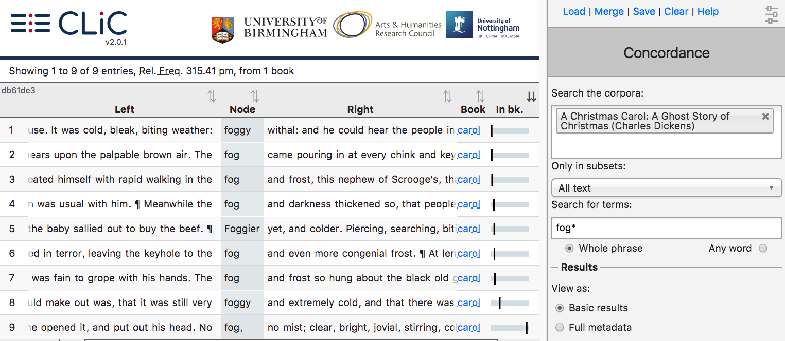
1.
2.
3.
4.

A concordance displays all occurrences of a word, phrase, or pattern in a text
or set of texts.

Notes

Exercise 1.c: The use of “fog*” across Dickens’s novels & A Christmas Carol

- Stay in the “Concordance tab”
- Under “Search the corpora”, keep “A Christmas Carol” and add “DNov – Dickens’s Novels”
- Under “Search for terms”, keep “fog*”
- Under “Results” – “View as” choose the “Distribution plot”. You should then see a plot like this (but with all 15 entries).
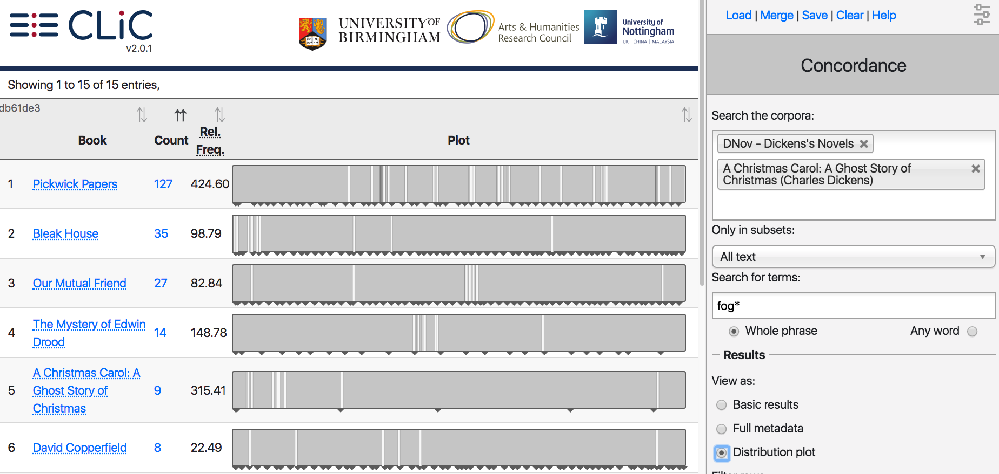
4.

- How is “fog*” distributed across the texts?
- In which texts does “fog*” occur a lot at the beginning?
- Click on a line on the distribution plot to see the context of a particular occurrence.
A distribution plot displays an overview of the occurrences of a word, phrase or pattern across a text or set of texts.

Notes

Exercise 1.d: Structure and beginning

Read the following extracts from the beginnings of Bleak House and Great Expectations. Can you find any similarities to the beginning of A Christmas Carol?

Fog everywhere. Fog up the river, where it flows among green aits and meadows; fog down the river, where it rolls deified among the tiers of shipping and the waterside pollutions of a great (and dirty) city. Fog on the Essex marshes, fog on the Kentish heights. Fog creeping into the cabooses of collier-brigs; fog lying out on the yards and hovering in the rigging of great ships; fog drooping on the gunwales of barges and small boats. Fog in the eyes and throats of ancient Greenwich pensioners, wheezing by the firesides of their wards; fog in the stem and bowl of the afternoon pipe of the wrathful skipper, down in his close cabin; fog cruelly pinching the toes and fingers of his shivering little 'prentice boy on deck. Chance people on the bridges peeping over the parapets into a nether sky of fog, with fog all round them, as if they were up in a balloon and hanging in the misty clouds.
(Bleak House, Chapter 1, paragraph 2)

Ours was the marsh country, down by the river, within, as the river wound, twenty miles of the sea. My first most vivid and broad impression of the identity of things, seems to me to have been gained on a memorable raw afternoon towards evening. At such a time I found out for certain, that this bleak place overgrown with nettles was the churchyard; and that Philip Pirrip, late of this parish, and also Georgiana wife of the above, were dead and buried; and that Alexander, Bartholomew, Abraham, Tobias, and Roger, infant children of the aforesaid, were also dead and buried; and that the dark flat wilderness beyond the churchyard, intersected with dykes and mounds and gates, with scattered cattle feeding on it, was the marshes; and that the low leaden line beyond, was the river; and that the distant savage lair from which the wind was rushing, was the sea; and that the small bundle of shivers growing afraid of it all and beginning to cry, was Pip.
(Great Expectations, Chapter 1, paragraph 3)
Notes

Exercise 2.a: Poverty

To study themes with CLiC, we have to think of strategies to find the relevant sections in a text. Some themes are signalled by the exact word (for exam
ple, a search for “family” is a good start to explore the theme of family), but this does not work for all themes.

- What search words would you use to explore the theme of poverty in A Christmas Carol?
- Click on the concordance tab. Select only “A Christmas Carol”.
- Try searching for “workhouse*”. How many occurrences do you find?
- What is the relationship between the occurrences and how does this link to the main themes of the novel?
Notes

Exercise 2.b: Searching in A Christmas Carol and all of Dickens’s novels

- In the concordance tab, under “Search the corpora”, keep “A Christmas Carol” and add “DNov – Dickens’s Novels”
- Again, search for “workhouse*”. How many occurrences do you find?
- Click on the “distribution plot” view – how is the term distributed across the texts?
- Go back to the “basic view” of the concordance lines.
- Click on the “Left” and “Right” column headers to sort the concordance lines.
- Use the KWICGrouper to search for additional patterns.
- What information does the concordance give about workhouses in the 19th century?
Notes

Exercise 3: Religion

Another themes in A Christmas Carol is religion. Can you think about words that would be useful to search when we are interested in finding out about religion?

- Click on the concordance tab.
- Choose “A Christmas Carol”.
- Try searching for “God”. Look through the concordance lines – how is “God” used?
- Now search for “bless” instead. Sort the lines to the left and right.
- Can you link the usage of “bless” across the novella to the theme of redemption?

Notes

Using CLiC

Take a screenshot: Use the Windows ‘snipping tool’ and select the area that you want to include. Save the screenshot with a meaningful name. When you include concordance lines in your document, make sure to write down if they were a sample or all of the lines. For example: “15 out of 28 examples of vampire in Dracula”.

Tagging results: Create your own tags with the ‘Manage tag columns’ menu. In that menu, just click on ‘add new’, then select the new tag and rename it (to something meaningful). When your results are tagged you can sort the concordance by the tags.
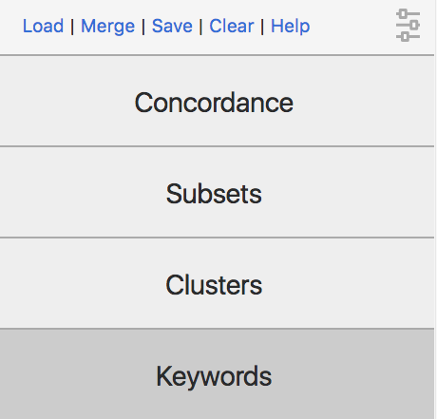
Saving results: Use the ‘Save’ button in the top right. You can then open the spreadsheet (for example of a concordance or a keyword list) in a spreadsheet viewer like Excel. If you have tagged a concordance, you can download the tagged results.

Copy the link: just copying and pasting a link to a concordance allows you to get back to the same results!

Loading results: When you come back to your research tomorrow, you can click on the ‘load’ button (in the same menu) to reload your query – together with your tags!

Merging results – combining your tags with your friend’s tags: If you and your friend both save a tagged concordance and want to compare if you tagged the same lines, you can use the ‘Merge’ button. This allows you to upload and combine two sets of tags.

Sorting by several columns – You already know how to sort a concordance by the first word on the right or on the left – and even by the word or phrase in the middle (the ‘node’). You can also sort the lines by the order in which they appear in the book by clicking on the ‘in bk.’ column. But what if you want to order them by the order in the book and by the right-hand side? Simply press the ‘shift’ button while you click on the two column headers! The one that you click first will be sorted first.

Advanced information is available from the CLiC User Guide. Just click on the ‘Help’ button in the top right corner of the CLiC page. This will take you to the CLiC Help menu where you can view and/or download the User Guide.

Free resources you might want to check out
- “The working classes and the poor”, resource from the British Library, www.bl.uk/victorian-britain/articles/the-working-classes-and-the-poor
- Our CLiC Activity Book: www.birmingham.ac.uk/clic-activity-book
- A short video on CLiC: https://www.youtube.com/watch?v=fnP2fkuocAA

You can use and adapt this handout for your own classroom activities as it is available freely under the following license:

This work is licensed under a Creative Commons Attribution-NonCommercial-ShareAlike 4.0 International License.
© 2019, Michaela Mahlberg & Viola Wiegand

To cite our work:

Mahlberg, M. & Wiegand, V. (2019) Finding links between the structure and themes of A Christmas Carol [Blog post]. CLiC Fiction Blog, University of Birmingham. Retrieved from https://blog.bham.ac.uk/clic-dickens/2019/05/17/finding-links-between-the-structure-and-themes-of-a-christmas-carol/

