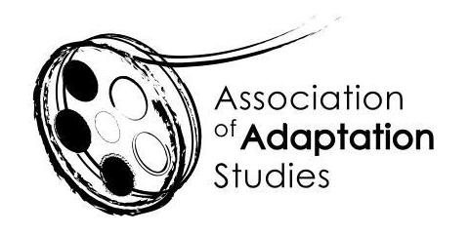

ADAPTATION STUDIES MENTORING WORKSHOP
University of Birmingham, UK | 6 June 2023

*** APPLICATION ***

Name
Email
Institution
Starting date of the PhD Project
Project Title
Project Abstract
(250 words)
Mobility (will you be able to attend the event in person? – please consider current regulations)

