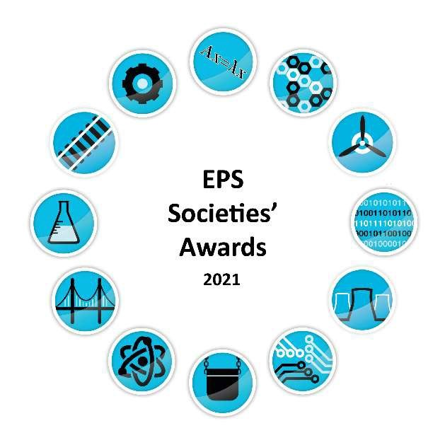
Nominee name | Award Category | Nominee society
Avery Cunningham | Diversity and Inclusion Award | NucSoc
BAME and Allies Event | Diversity and Inclusion Award | PPS: Poynting Physical Society
Claire Doswell | Diversity and Inclusion Award | ChemSoc
Fiona Clark | Diversity and Inclusion Award | ChemSoc
MathSoc | Diversity and Inclusion Award | MathSoc
NucSoc | Diversity and Inclusion Award | NucSoc
oSTEM: out in STEM | Diversity and Inclusion Award | oSTEM: out in STEM
PPS: Poynting Physical Society | Diversity and Inclusion Award | PPS: Poynting Physical Society
UB VR: Virtual Reality | Diversity and Inclusion Award | UB VR: Virtual Reality
WISE: Women in Science and Engineering | Diversity and Inclusion Award | WISE: Women in Science and Engineering
WIT: Women In Tech | Diversity and Inclusion Award | WIT: Women In Tech
Avery Cunningham | EPS Community Award | NucSoc
BEaMS and MathSoc | EPS Community Award | BEaMS and Mathsoc
ChemSoc | EPS Community Award | ChemSoc
Engineering Ball Organising Committee | EPS Community Award | MechSoc
Megan Jenkins | EPS Community Award | MathSoc
Nazibur Rahman | EPS Community Award | 93% Club
oSTEM: out in STEM | EPS Community Award | oSTEM: out in STEM
PPS: Poynting Physical Society | EPS Community Award | PPS: Poynting Physical Society
Ramsha Zahid | EPS Community Award | UB VR: Virtual Reality
UB VR: Virtual Reality | EPS Community Award | UB VR: Virtual Reality
WISE: Women in Science and Engineering | EPS Community Award | WISE: Women in Science and Engineering
WIT: Women In Tech | EPS Community Award | WIT: Women In Tech
AFNOM x CSS Lightning Talks | Head of College Idea of the Year | AFNOM
CSS Discord Server | Head of College Idea of the Year | CSS: Computer Science Society
EPS Running Festival | Head of College Idea of the Year | ChemSoc
Experiences of Black Professionals in the Nuclear | Head of College Idea of the Year | NucSoc
Forming of the 93% Club | Head of College Idea of the Year | 93% Club
Founding of the WIT Society | Head of College Idea of the Year | WIT: Women In Tech
International women's day series of events | Head of College Idea of the Year | BUMS: Birmingham University Materials Society
Mathsoc Charity Bake-Off | Head of College Idea of the Year | MathSoc
Poynting's Python Society | Head of College Idea of the Year | PPS: Poynting Physical Society
Avery Cunningham | Industrial Award | NucSoc
Energy Society | Industrial Award | Energy Society
Emma Kelwin & Amy Smith | Industrial Award | BUMS: Birmingham University Materials Society
Kyle Duffil | Industrial Award | BUCES: Birmingham University Chemical Engineering Society
MathSoc | Industrial Award | MathSoc
NucSoc | Industrial Award | NucSoc
PPS: Poynting Physical Society | Industrial Award | PPS: Poynting Physical Society
RailSoc | Industrial Award | RailSoc
SATNAV: Science and Technology News and Views | Industrial Award | SATNAV: Science and Technology News and Views
Tim Jena | Industrial Award | CivSoc
UBRacing | Industrial Award | UBRacing
UB VR: Virtual Reality | Industrial Award | UB VR: Virtual Reality
WIT: Women In Tech | Industrial Award | WIT: Women In Tech
Alex Agnew | Inspirational Committee Member | EWB Birmingham: Engineers Without Borders
Avery Cunningham | Inspirational Committee Member | NucSoc
Daniel Clark | Inspirational Committee Member | CSS: Computer Science Society
Emma Kelwin | Inspirational Committee Member | BUMS: Birmingham University Materials Society
Fatima Bibi | Inspirational Committee Member | WIT: Women In Tech
Jacob Wilson | Inspirational Committee Member | CSS: Computer Science Society
Jacqueline Henes | Inspirational Committee Member | CSS: Computer Science Society
Kate Huxtable | Inspirational Committee Member | MathSoc
Leela Muppala | Inspirational Committee Member | WIT: Women In Tech
Lera Popescu | Inspirational Committee Member | WIT: Women In Tech
Lex Millins | Inspirational Committee Member | PPS: Poynting Physical Society
Liam Ashcroft | Inspirational Committee Member | UBRacing
Paige Ramsden | Inspirational Committee Member | WISE: Women in Science and Engineering
Patrisia Pascan | Inspirational Committee Member | WIT: Women In Tech
Rhys Thomas Edward Morgan | Inspirational Committee Member | CSS: Computer Science Society
Robert Webster | Inspirational Committee Member | ChemSoc
Rohan Hornsby | Inspirational Committee Member | CivSoc
Valeria Popescu | Inspirational Committee Member | WIT: Women In Tech
Astrosoc | Outreach Award | AstroSoc
Lucie Hlubinkova | Outreach Award | ChemSoc
Lauren Josey | Outreach Award | ChemSoc
Elizabeth Driscoll | Outreach Award | ChemSoc
Robert Webster | Outreach Award | ChemSoc
WISE: Women in Science and Engineering | Outreach Award | WISE: Women in Science and Engineering
Valeria Popescu | Outreach Award | WIT: Women In Tech
Allan Dos Santos | Outreach Award | Energy Society
93% Club & oSTEM & BEaMs & WISE for Equal in STEM 2021 | Outstanding Event Award | 93% Club & oSTEM & BEaMs & WISE
Josh Ruck, Jack Smith, George Duggal, Yuean Ma for | Outstanding Event Award | AeroSoc
AFNOM for What the CTF?! | Outstanding Event Award | AFNOM
AFNOM & CSS for Lightning Talks | Outstanding Event Award | AFNOM & CSS
Andy Jones for BUMS Virtual careers fair - Speed | Outstanding Event Award | BUMS: Birmingham University Materials Society
Anwesha Sahu for Outreach Event | Outstanding Event Award | AstroSoc
AstroSoc for World Space Week | Outstanding Event Award | AstroSoc
Avery Cunningham for Experiences of Black | Outstanding Event Award | NucSoc
BUMS for BUMS Speed Networking | Outstanding Event Award | BUMS: Birmingham University Materials Society
CADSoc for Airgineers | Outstanding Event Award | CAD Society
ChemSoc for EPS Running Festival | Outstanding Event Award | ChemSoc
CSS for CSS Virtual Ball | Outstanding Event Award | CSS: Computer Science Society
Emma Kelwin for Mechsoc meets Hausbots | Outstanding Event Award | MechSoc
MathSoc for University Challenge | Outstanding Event Award | MathSoc
oSTEM for STEM, LGBTQ AND YOU 2021 | Outstanding Event Award | oSTEM: out in STEM
PPS for BAME and Allies in STEM | Outstanding Event Award | PPS: Poynting Physical Society
PPS & GUTS for Science On Tap: Theorectical Physics | Outstanding Event Award | PPS & GUTS
RailSoc for Inter-University Quiz | Outstanding Event Award | RailSoc
SATNAV for Futures in SciComm | Outstanding Event Award | SATNAV: Science and Technology News and Views
Virtual Reality for XR in Radiology | Outstanding Event Award | UB VR: Virtual Reality
WISE for WISE - International Women's Day 2021 | Outstanding Event Award | WISE: Women in Science and Engineering
Women in Tech for Talks with Successful Women in | Outstanding Event Award | WIT: Women In Tech
Rohan Hornsby | Role Model of the Year | CivSoc
Rhys Thomas Edward Morgan | Role Model of the Year | CSS: Computer Science Society
Liam Ashcroft | Role Model of the Year | UBRacing
Justin Chadwell | Role Model of the Year | CSS: Computer Science Society
Avery Cunningham | Role Model of the Year | NucSoc
Dimitrios Kotsis | Role Model of the Year | MathSoc
Jenny Brown | Role Model of the Year | BUCES: Birmingham University Chemical Engineering Society
Megan Jenkins | Role Model of the Year | MathSoc
Paige Ramsden | Role Model of the Year | WISE: Women in Science and Engineering
Valeria Popescu | Role Model of the Year | WIT: Women In Tech
Jacob Wilson | Role Model of the Year | CSS: Computer Science Society
Amy Johnson | Sports Personality of the Year | BUMS: Birmingham University Materials Society
Avery Cunningham | Sports Personality of the Year | oSTEM: out in STEM
Elizabeth Ward | Sports Personality of the Year | EPS Mixed Netball
James Wilkins | Sports Personality of the Year | Engineering Eagles
Max Castiglione | Sports Personality of the Year | BUCES: Birmingham University Chemical Engineering Society
Sam Davies | Sports Personality of the Year | MathSoc
Samraj Singh | Sports Personality of the Year | School of Engineering RFC
Tom Rowley | Sports Personality of the Year | BUMS: Birmingham University Materials Society
BUCES FC | Sports Team of the Year 2020/21 | BUCES: Birmingham University Chemical Engineering Society
BUMS Netball | Sports Team of the Year 2020/21 | BUMS: Birmingham University Materials Society
Engineering Eagles | Sports Team of the Year 2020/21 | Engineering Eagles
EPS Mixed Netball | Sports Team of the Year 2020/21 | EPS Mixed Netball
EPS Running Festival | Sports Team of the Year 2020/21 | ChemSoc
MathSoc Sports | Sports Team of the Year 2020/21 | MathSoc
PPS Football | Sports Team of the Year 2020/21 | PPS: Poynting Physical Society
PPS Netball | Sports Team of the Year 2020/21 | PPS: Poynting Physical Society
School of Engineering RFC | Sports Team of the Year 2020/21 | School of Engineering RFC
Andreea Radu | Staff Member of the Year | AFNOM & CSS
Daryl Johnson | Staff Member of the Year | CivSoc
Dr Sean Elvidge | Staff Member of the Year | AstroSoc
Dr Zoe Schnepp | Staff Member of the Year | ChemSoc
Grace Surman | Staff Member of the Year | MechSoc & oSTEM & Energy Society & WIT & RailSoc & PPS
Jenny Brown | Staff Member of the Year | BUCES: Birmingham University Chemical Engineering Society
Leah Nani-Alconcel | Staff Member of the Year | AeroSoc
Martin Herreros | Staff Member of the Year | UBRacing
Phill Williams | Staff Member of the Year | SATNAV: Science and Technology News and Views
Rachel Burgess | Staff Member of the Year | WISE: Women in Science and Engineering
Richard Sheridan | Staff Member of the Year | BUMS: Birmingham University Materials Society
Sharon Jones | Staff Member of the Year | NucSoc
Simon Goodwin | Staff Member of the Year | MathSoc
Avery Cunningham | The Great Achievement in EPS Award | NucSoc & oSTEM: out in STEM
Justin Chadwell | The Great Achievement in EPS Award | CSS: Computer Science Society
Megan Jenkins | The Great Achievement in EPS Award | MathSoc
Tom Goodman | The Great Achievement in EPS Award | CSS: Computer Science Society
Claire Fletcher | Volunteer of the Year | oSTEM: out in STEM
Fatima Bibi | Volunteer of the Year | WIT: Women In Tech
Jack Preece | Volunteer of the Year | MathSoc
Laura Joseph | Volunteer of the Year | BEaMS: Black, Ethnic and Minority Scientists
Leela Muppala | Volunteer of the Year | WIT: Women In Tech
Patrisia Pascan | Volunteer of the Year | WIT: Women In Tech
Valeria Popescu | Volunteer of the Year | WIT: Women In Tech

