Shift 2 Rail logo

S2R-OC-IPX-03-2018

Grant agreement n. 826238

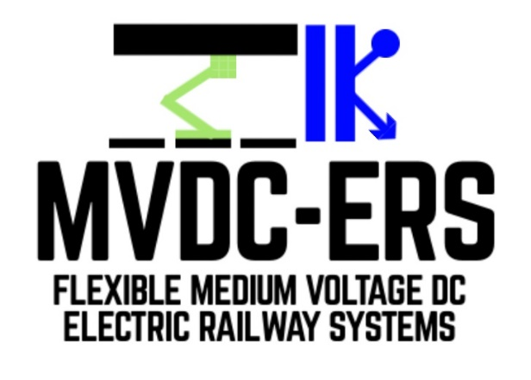

Deliverable D1.1: Literature review of converters suitable for MVDC railway electrification

# Document details

|  |  |
| --- | --- |
| Authors | Sina Sharifi, Pietro Tricoli |
| Due date | 30-04-2019 |
| Actual delivery date | 30-09-2019 |
| Lead contractor | University of Birmingham |
| Version | 1.0 |
| Prepared by | University of Birmingham |
| Input from | - |
| Reviewed by | Technical University of Cluj-Napoca |
| Dissemination level | Public |

# Project contractual details

|  |  |
| --- | --- |
| Project title | Flexible medium voltage DC electric railway systems |
| Project acronym | MVDC-ERS |
| Grant agreement no. | 828638 |
| Project start date | 01.12.2018 |
| Project end date | 30.11.2021 |
| Duration | 36 months |
| Supplementary notes | The document type is public |

# Disclaimer:

***\* Please note that this deliverable is undergoing S2R JU review and acceptance processes. At this stage this deliverable reflects only the author’s view and the S2R JU is not responsible for any use that may be made of the information it contains.***

1 Introduction 4

2 Abbreviations and acronyms 5

3 History of railway electrification 6

4 Conventional railway electrification systems 7

4.1 DC electrification systems 7

4.2 Single-phase low-frequency AC electrification system 8

4.3 Single-phase AC electrification system at mains frequency 9

4.4 Three-phase low-frequency electrification system 13

5 Comparison of proposed MVDC and conventional railway electrification systems 15

6 High-power MVDC converters 19

6.1 Voltage source converters 19

6.1.1 Two-level voltage source converters 20

6.1.2 Multilevel voltage source converters 21

6.2 Current‑source converters 28

6.3 Double-stage conversion 29

7 Protection and control issues in MVDC grids 31

7.1 Protection of MVDC converters 31

7.1.1 Internal faults 31

7.1.2 DC side faults 31

7.2 Control of MVDC grids 33

8 Potential benefits of using wide band-gap semiconductors in MVDC converters 36

9 Conclusion 39

10 References 40

# Introduction

The present report constitutes deliverable D1.1, a document produced in the framework of WP1 “Performance and characteristics of static converters for MVDC rail power supplies”, Task 1.1 “Literature survey”.

One of the main objectives of WP1 is to undertake a comparative evaluation of topologies of static converters for the supply of medium voltage DC rail electrification networks.

Hence, D1.1 “Literature review of converters suitable for MVDC railway electrification” compares the conventional railway electrification systems with proposed MVDC railway electrification to define the differences and requirements of the MVDC system. Then, D1.1 focuses on investigating high-power MVDC converters, as well as most important issues in MVDC networks such as protection and control. At last, D1.1 reviews potential benefits of using wide band-gap semiconductors in MVDC converters.

The deliverable has the following sections:

• Section 2 defines abbreviations and acronyms used in this report;

• Section 3 describes the history of railway electrification;

• Section 4 introduces conventional railway electrification systems;

• Section 5 compares proposed MVDC and conventional railway electrification systems;

• Section 6 presents high-power MVDC converters;

• Section 7 describes protection and control issues in MVDC grids;

• Section 8 clarifies potential benefits of using wide band-gap semiconductors in MVDC converters;

• Section 9 draws the conclusions;

• Section 10 presents the references.

# Abbreviations and acronyms

|  |  |
| --- | --- |
| AC | Alternating Current |
| ANPC | Active Neutral-Point Clamped |
| CHB | Cascaded H-Bridge |
| CNPC | Cascaded Neutral-Point Clamped |
| CSC | Current Source Converter |
| DC | Direct Current |
| DAB | Dual-Active Bridge |
| EMC | Electromagnetic Compatibility |
| EMI | Electromagnetic Interference |
| FACTS | Flexible Alternating Current Transmission System |
| FC | Flying Capacitor |
| GaN | Gallium Nitride |
| HMMC | Hybrid Modular Multilevel Converter |
| HVDC | High-Voltage DC |
| IGBT | Insulated Gate Bipolar Transistor |
| LC | Load-Commuted |
| LCC | Line Commutated Converter |
| MMC | Modular Multilevel Converter |
| MOSFET | Metal Oxide Semiconductor Field Effect Transistors |
| MVDC | Medium-Voltage DC |
| NNPC | Nested Neutral-Point Clamped |
| NPC | Neutral-Point Clamped |
| PWM | Pulse Width Modulation |
| RMS | Root Mean Square |
| SCR | Silicon Controlled Rectifier |
| Si | Silicon |
| SiC | Silicon Carbide |
| STATCOM | Static Synchronous Compensator |
| SVC | Static Volt-ampere reactive Compensator |
| THD | Total Harmonic Distortion |
| UPS | Uninterruptible Power Supply |
| VSC | Voltage Source Converter |
| WBG | Wide Band-Gap |

# History of railway electrification

Nowadays, electric traction is extensively used worldwide. The first type of electric traction was implemented by Direct Current (DC) power supplies. Tab. 1 briefly shows the most important events that happened in evolution of electric traction systems.

Table 1: Several important events in evolution of electric traction systems

|  |  |  |  |  |
| --- | --- | --- | --- | --- |
| **Notes** | **Date** | **Location** | **Manufacturer/Inventor** | **Reference** |
| Experiments on battery propulsion | 1837 | Massachusetts, USA | Thomas Davenport | [1] |
| Experiments on battery propulsion | 1838 | Scotland | Robert Davidson | [1] |
| Power supply along with traction line – The use of small DC locomotive | 1879 | Berlin, Germany | Werner von Siemens | [1], [2] |
| Electric tram line | 1881 | Berlin-Lichterfelde, Germany | Siemens & Halske company | [1], [2] |
| Electric railway | 1883 | Brighton, UK | Volk’s electric railway | [1] |
| Electric streetcar line | 1884 | Cleveland, Ohio, USA | East Cleveland street railway company | [1], [3] |
| Tramway network with simple overhead wire | 1886 | Montgomery, Alabama, USA | Van Depoele | [2] |
| Electric tramway network with sprung DC motors - speed control using rheostat and field control | 1888 | Richmond, Virginia, USA | Frank Julian Sprague | [1], [2], [4] |
| Underground electric traction in urban areas | 1890 | London and Liverpool, UK |  | [2] |
| Underground electric traction in urban areas | 1895 | Baltimore, Maryland, USA |  | [2] |

At earliest stages, two kinds of electric motors were common in electric traction systems: DC motors, which their speed could be controlled easily using a series of high-power resistors, and single-phase Alternating Current (AC) commutator motors, also known as universal motors [2]. Electric traction systems continued to develop in two different paths based on requirements of these motors and other technical issues.

One solution was expanding low-voltage DC systems suitable for DC traction motors, and the other was emerging low-frequency, high-voltage AC systems feeding AC commutation motors. In Central Europe and USA, the frequency was chosen as 16 2/3 and 25 Hz, respectively. In 1950s, the high-voltage AC electrification at industrial (mains) frequency was used. After that, 25 kV single-phase with the frequency of 50 or 60 Hz was chosen as standard for mainline electrification and some of old 1.5 kV DC (1900s) and 3 kV DC (1930s) networks were replaced by the AC network with mains frequency [1].

In the following section, these electrification systems and their issues will be investigated in more detail.

# Conventional railway electrification systems

This section reviews existing railway electrification systems, which are summarised in Fig. 1. The distribution of the various supply systems across the Europe is shown in Fig. 2.

existing railway electrification systems



Figure 1 - existing railway electrification systems

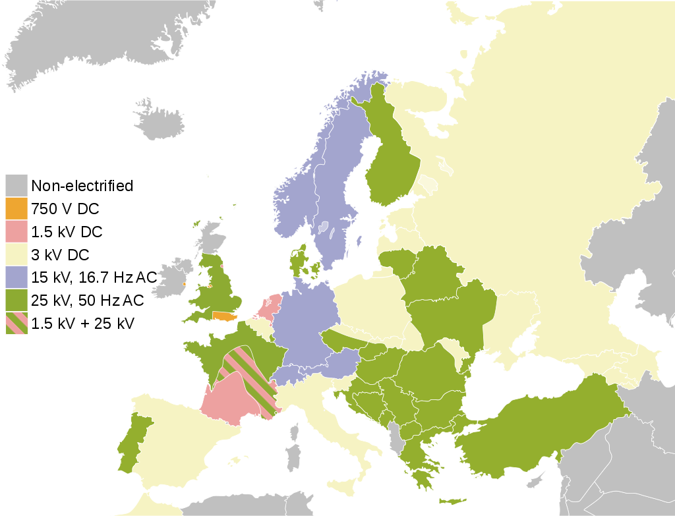

Figure 2 - Variety of electrification systems across the Europe [5]

## DC electrification systems

The first generation of electric traction motors was DC motors. The torque-speed characteristic of separately excited and series DC motors are highly compatible with the traction duty cycle, making them a suitable option for trains [1]. In the first steps, low-voltage DC electrification systems with voltages around 500 V was used for supplying trolley buses, trams and urban metros. However, supplying traction lines with heavy traffic and long distances was not possible with low-voltages, because of the high current needed and the significant power losses. This led to the introduction of higher voltages for DC systems, such as 750 – 1500 V [2]. Following this developments, between 1914 to 1916, 3000 V DC systems were implemented in Chicago, Milwaukee and St. Paul railroads in the USA [6].

Using the experience gained in the US, Italy used 4000 V in 1920 for the Torino-Ceres railway [2]. Voltages above 3000 V DC were also used in Poland, Belgium, Spain and other European countries [7].

In high-speed railways, which are normally operated between cities, traction substations are more spread apart and the total power consumption is higher than light railways. Therefore, there is the need to increase the supply voltage to transfer more power and keep voltage drop and power losses to an acceptable level. However, there is a technical limit in increasing the voltage of DC systems. Due to the lack of natural zero-crossing for the DC voltages, circuit breakers operating at high DC voltages are difficult to realise and expensive. In fact, the arc never extinguishes naturally, so the circuit breaker relies only on the strength of the springs and the design of the chamber to increase as much as possible the arc length during the opening procedure. Therefore, the voltage of DC railway electrification systems has been limited to around 3 kV. This technical limitation favoured the development and diffusion of high-voltage AC electrification systems that can take advantage of much simpler circuit breakers and protection systems [2].

## Single-phase low-frequency AC electrification system

For technical and economic reasons, the voltage level of electric traction systems was chosen in different ways in different countries. Single-phase low-frequency AC electrification systems were implemented in USA and several European countries including Germany, Switzerland, Austria, Sweden and Norway. In these systems, the supply voltage is around 10-15 kV and an on-board transformer reduces the voltage to level suitable for the traction drives. The 11 kV, 25 Hz New York – New Haven line in USA (1906) and 10 kV, 15 Hz Dessau-Bitterfeld electrified by Prussian railways (1911) are two example of using this system [2].

As mentioned earlier, series commutator motors can operate with AC power supply. However, when this motor is supplied with AC voltage at 50/60 Hz frequency, the commutation process produces a huge number of sparks, which have negative effects on operations and maintenance of the motor. The number of sparks in the commutation process is proportional to the supply frequency. Hence, in order to reduce this negative effect, the supply frequency in traction system was reduced to 16 2/3 (in countries with mains frequency of 50 Hz) and 20-25 Hz (in countries with mains frequency of 60 Hz).

The low-frequency system can be electrified in two different ways [2]:

* Constructing a separate power system for the railway (centralised system): before 1900, due to limited availability of suitable connection points to the public grid, it was preferred to build a separate power system for the railway that included generation, transmission and distribution.
* Connection to the three-phase main grid (distributed system): with the growth of railway loads and expansion of the public grid, it became cheaper to connect the railway electrification lines to the three-phase public grid using frequency converters, as shown in Fig. 3. At first, rotating converters based on electric machines with a different number of pole pairs were used to modify the frequency. After the development of power electronics in 1980s and 1990s, rotating converters were replaced by static cyclo-converters [8]. Cyclo‑converters are static frequency converters based on line‑commutated semiconductor devices, i.e. thyristors and operate a direct AC/AC power conversion. If the converters are connected to different part of the public grid, the electrification line must be sectioned using neutral sections to avoid recirculation of current through the railway. Cyclo‑converters do not generate voltage waveforms with high quality and hence, they introduce significant harmonic content on the public grid and the railway electrification line. Therefore, indirect conversion with force-commutated semiconductor devices, i.e. insulated gate bipolar transistors (IGBT) or integrated gate commutated thyristors (IGCT), also known as back-to-back configuration, has been proposed to address this issue. In this configuration, a rectifier stage converts the AC voltage to the DC form. The second stage converts the DC voltage to the AC form with desired frequency.

Distributed low-frequency railway 

Figure 3 – Distributed low-frequency railway [2]

In comparison to mains frequency systems, low-frequency traction power supplies have a lower reactance and, hence, lower voltage drops. Furthermore, the skin effect is lower and hence the current carried by the conductor can be increased. The advantages in terms of lower transmission losses, higher voltage stability and better electromagnetic compatibility has been investigated in [9]. However, the transformers are bigger and heavier and this is particularly a concern for the on-board traction equipment.

## Single-phase AC electrification system at mains frequency

After the Second World War, due to advancements of power electronics, static rectifiers could be installed on trains. Therefore, DC motors could be fed from AC power supply lines through on-board rectifiers and railway electrification systems could be connected to the main grid directly without any frequency converter. Further progress on motor drives with inverters lead to the deployment of three-phase induction motor drives [2].

The single-phase AC electrification system at 25 kV, 50/60 Hz is extensively used in regional and high-speed railways. A typical feeding arrangement of AC railways is shown in Fig. 4 [10]. In this configuration, the single-phase load of the AC railway is fed by traction transformers located in substations. In order to mitigate unbalanced loading, different phases of the public grid are loaded in adjacent substations. This leads to need of neutral sections, which prevent short circuit between two phases. There are also switchgears in neutral sections to ensure the seamless supply of the railway line when a substation is unable to operate normally, e.g. in the case of maintenance or outage.

Typical arrangement for AC railway electrification system at mains frequency 

Figure 4 - Typical arrangement for AC railway electrification system at mains frequency [10]

The simplest and the least expensive configuration for AC railway electrification system is based on a single-phase transformer connected to the three-phase grid on the primary side and to the AC catenary on the secondary side, as shown in Fig. 5a. However, this connection has some drawbacks: the ground currents may interfere with communication devices near the railway installations; the line impedance is substantial and, then, voltage drops are high; and there is a considerable potential difference between the rail and the earth, which may cause safety issues [10].

Different arrangements for AC railway  [10]: a) Direct transformer connection b) Direct transformer connection with return conductor

Figure 5 - Different arrangements for AC railway [10]: a) Direct transformer connection b) Direct transformer connection with return conductor

In order to decrease the return path impedance and reduce interference with communication systems, a return conductor can be added to the electrification system and bonded to the rails every 5 or 6 km, as shown in Fig. 5b.

Another solution is based on booster transformers, which are placed every 3-4 km and connected between the catenary sections and isolated rail sections, according to Fig. 6a. The booster transformers have unity turns ratio and due to the Ampere-Maxwell law, the return current has to flow almost entirely through the secondary winding. Fig. 6b shows an alternative configuration for implementing a system with booster transformers that uses a separate conductor alongside the rails for the return current.

Different arrangements for AC railway feeding system [10]: a) Booster transformer b) Booster transformer with return conductor

Figure 6 - Different arrangements for AC railway feeding system [10]: a) Booster transformer b) Booster transformer with return conductor

Another common configuration is shown in Fig. 7, where the catenary and an auxiliary feeder are connected to autotransformers. For a 25 kV supply system, the primary voltage of the autotransformer is 50 kV and the rails are connected to its centre tap. As the turn ratio of the autotransformer is 1:1, the voltage between the catenary and the rails is 25 kV. Because of higher input voltage (50 kV instead of 25 kV), the substations can be located further apart than the previous systems. In addition, because of Ampere-Maxwell law, the return current flows predominantly through the autotransformers. In fact, any current flowing through the rails would create a difference between the primary and secondary current of the autotransformers. This difference would be entirely a magnetising component for the autotransformer, which would increase the secondary current to counterbalance the increased flux linkage, thereby forcing the train current to flow to the return conductor rather than the rail current.

The traction electric load is a large single-phase load and causes unbalanced loading when it is connected to a three-phase main grid. As the unbalanced load produces negative sequence current, the three-phase main grid must have high short circuit power. That is the reason why the AC railways are typically connected to high-voltage lines [11]. Therefore, the railway load is only a small share of the total load of these lines, which leads to a reduced impact of the unbalance on voltage.

The use of autotransformers in AC electrification system  

Figure 7 - The use of autotransformers in AC electrification system [10]

To avoid the need to connect to high-voltage lines, transformers with special winding connections, also called balanced transformers, have been used in the railway industry to provide a balanced two-phase system from a balanced three-phase system. The most important types of balanced transformers are Scott, impedance matching, Le-Blanc and Woodbridge, shown in Fig. 8. In some cases, balanced transformers can also mitigate harmonic pollutions and improve the power quality. However, they do not completely solve the problem of unbalancing, because they only draw three-phase balanced current at the input when the load of their output phases are equal [11].

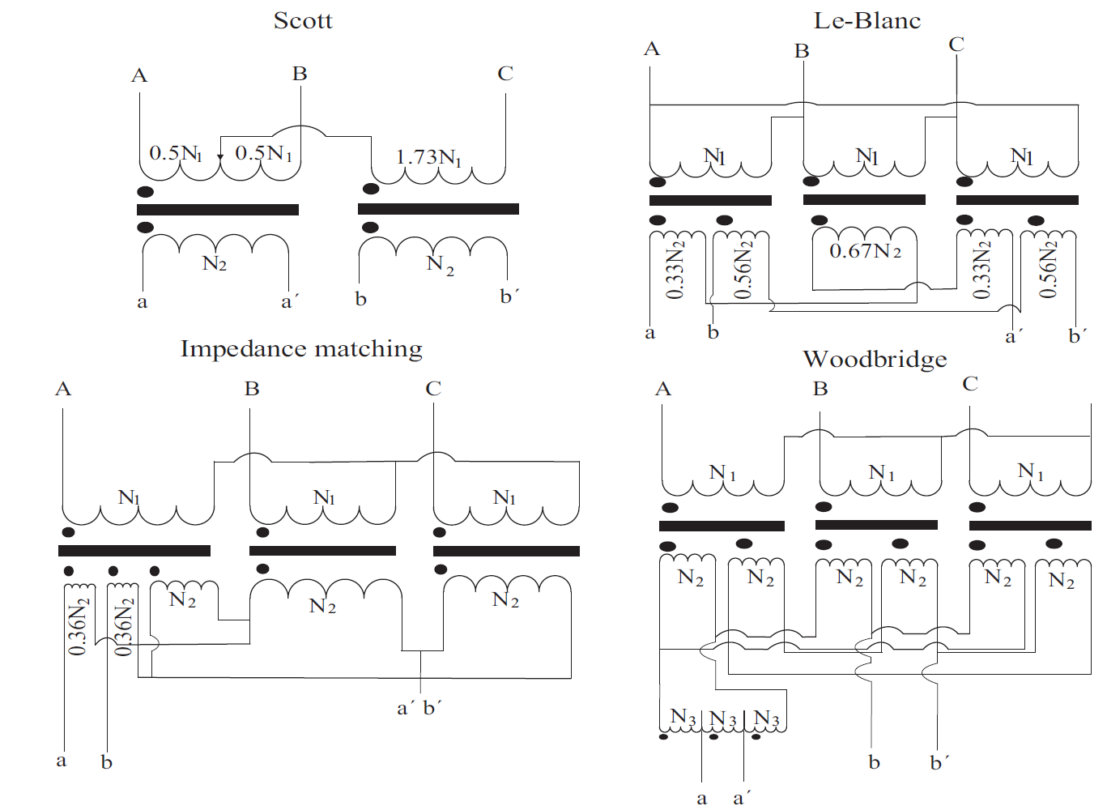

Figure 8 - Balanced transformers [11]

Static Volt-Ampere reactive Compensators (SVC) can also reduce the voltage drop and unbalanced loading effect using thyristors that connect either reactors or capacitors to the system for a controlled portion of the period. However, large passive filters must be installed to limit the harmonic contents produced by thyristor switching. Another solution for improving the power quality, is to use static synchronous compensators (STATCOM). As they are based on switch-mode converters, they can operate as active power filters to cancel the harmonic contents caused by the railway loads with passive filters smaller than those used in SVCs [8].

Recently, static frequency converters have been used to supply 50/60 Hz AC railways. In these schemes, the three-phase voltage is converted to the DC form, and then the DC voltage is transformed to the 50/60 Hz AC voltage. This system solves the problem of unbalanced loading and work with near unity power factor and nearly sinusoidal input current. The main advantage of systems based on static frequency converters are the capability of connecting to lower voltage grids, the control of the short circuit current, the power sharing between converters in different substations, and the removal of neutral sections [8]. However, converter‑based electrification systems have generally a lower efficiency and require a more complex control scheme.

A solution that combines STATCOM and converter‑based electrification systems is the co-phase traction power supply. This scheme uses a three-phase to two-phase converter formed by a static single-phase to single-phase converter along with an impedance matching transformer. The system is designed to balance the three-phase side irrespective of the level of loading on the railway [8].

## Three-phase low-frequency electrification system

In the early years of the 20th century, three-phase asynchronous motors were used for electric traction. These motors could be fed directly at high voltages, i.e. few kilovolts with high robustness, reliability and economic viability. At that time, due to lack of reliable high capacity adapter gear units, the motor was connected to the wheels through a crank. Hence, the motor speed had to be as low as the wheels. This can be achieved by reducing the frequency of the voltage supply. That is why the railway frequency was adopted for three-phase electrification. In 1985, a three-phase electrification system with the frequency of 16.7 Hz, feeding squirrel cage three-phase asynchronous motors, was tested in Switzerland [2].

This system was also used in other countries such as the USA, Poland and Italy. The system voltage was chosen even up to 3000 V, supplying motors through two overhead conductors and the rails as a path for the third phase. Speed control was done by changing number of motor poles and the supply frequency was chosen so that the train could run at speeds of 50-60 km/h and lower. As this electrification system worked with low-frequency, it had the same advantages of single-phase low-frequency AC systems. Furthermore, when the train travelled downhills, the motor speed increased slightly above the synchronous speed, thus enabling easily regenerative breaking.

On the other hand, there were serious disadvantages and limitations. Due to use of two overhead conductors and insulation issues, implementing three-phase system at junctions needed complicated connections. Furthermore, as stated earlier, the motor speed was strongly coupled with synchronous speed, causing difficulties in speed control. In addition, the two-wire contact line and its mechanical issues limited the train speed to 100 km/h, which was lower than that of steam locomotives (120-130 km/h). Moreover, rigid connection of motors and wheels caused ripples of motor torque and consequently, ripples of power drawn from the power supply, which resulted in interference with communication lines running next to the railway.

After few years, all the countries abandoned three-phase electrification system due to aforementioned drawbacks and mainly chose single-phase low-frequency AC electrification for their electric railways [2].

Currently, there are only a few three-phase railway systems in places where three-phase overhead system can be implemented with less complexity, for example some light railways like the Metromover in Florida, US, and the Bukit Panjang LRT line, Singapore. In many cases, these are due to be converted to a simpler DC power supply at the time of overhaul.

# Comparison of proposed MVDC and conventional railway electrification systems

As mentioned earlier, AC electrification is used to electrify lines between distant substations or lines with high consumptions, e.g. high-speed trains [7]. The AC electrification supply is not an optimal choice, because it often needs to be connected to a high-voltage transmission lines via complicated and expensive connections to cope with the imbalanced railway load. In addition, connection points to high-voltage transmission lines are not always available in the vicinity of railway lines.

On the other hand, the power rating of heavy railways and high-speed trains, which is typically 100-500 MVA with individual substations rated at 50-100 MVA, is compatible with medium-voltage distribution systems. Despite of high-voltage transmission lines, the distribution systems are available in most places. However, AC electrification systems cannot be connected to power distribution grids because of the imbalance caused by the negative sequence component of the current. Conversely, the rectifiers of DC electrification systems are three-phase and, as such, they draw balanced currents, allowing the connection to the power distribution grid.

However, well-developed DC circuit breakers in railway industry cannot operate at high voltages, causing the DC railway electrification voltage to be limited around 3 kV and consequently the maximum power of railway to be limited. In addition, higher voltages in DC supply system is not suitable for traction motors, as their nominal voltage is around few kV. Further, conventional DC electrification is not a suitable choice for better integration of railway and the power distribution system, because diode rectifiers are unidirectional converters that cannot control the power flow between the railway and the power distribution network.

The proposed Medium-Voltage DC (MVDC) electric railway system is based on fully controlled bidirectional power electronic converters in traction substations and DC-based power electronic traction transformers in trains to tackle technical challenges of using high voltage and high power ratings in conventional DC electrification while benefits from its advantages over conventional single-phase AC electrification systems [2]:

* In comparison to AC electrification at mains frequency, which have unbalanced loading problem, DC systems have low impacts on the power distribution network. In addition, the input power factor of the AC-DC converter and the harmonics injected to the network can be controlled to satisfy minimum standards required by the network.
* In the steady state, DC system does not have any inductances. Therefore, there is no voltage drop due to inductance, allowing more distances between traction substations [7]. Besides, there is no reactive power consumption which decrease the system’s capacity [12].
* DC system does not interfere with railway signalling systems and communication lines located near the supply system. Further, there is no induced voltages in the adjacent railway lines. Nevertheless, the Electromagnetic Interference (EMI), Electromagnetic Compatibility (EMC) and noise emission issues in MVDC electrification system must be investigated more, as it uses power electronics converters that may produce high-order harmonics.
* In the case of bilateral supply, DC substations can be easily paralleled and the substations can share the load, which can reduce the installed capacity of substations. Besides, there is no neutral sections in DC systems, avoiding power transfer interruption and in consequence, the speed loss of the trains. This also prevents the locomotive circuit breaker from mechanical and electrical stresses [13].
* Because of zero frequency in DC systems, there is no skin effect. Hence, conductors with smaller cross-sections can be used, which leads to cost savings.
* In comparison to converter‑based AC railways that provide the single-phase AC with desired frequency through two-stage AC/DC/AC conversion, the DC electrification needs only one stage AC/DC conversion, which can improve the efficiency and complexity of the electrification system.

The use of bidirectional power electronic converters also allows better integration of power distribution network and railway power supply as well as improving efficiency and giving extra capacity to the power distribution grid. The system is fully compatible with future scenarios in power system, where the installed capacity of renewable energy will increase and controlling power flows will be essential for seamless operation of the power system. The voltage level of proposed MVDC system can be chosen around 20 – 25 kV, which is compatible with insulation levels and mechanical structures used in existing infrastructures. The system must be able to mitigate stray currents, which is one of the problems in DC systems as it may cause electrolytic corrosion of metallic components.

Using static converters and in the presence of renewable power sources, MVDC railway power supply can interact with distribution grid in an innovative way. For instance, the railway electric lines and power distribution feeders can form a meshed grid. Therefore, operation of the both networks can be optimized using a proper control architecture. Fig. 9 shows a section of a railway line fed by two substations from utility grid and in-site renewable power sources.

Based on traffic conditions in the railway, the system can be operated in different scenarios. In heavy traffic conditions, the system can feed the trains with the help of renewable power sources. In light traffic conditions, the system can reduce the load of power distribution network using renewable power sources. Further, the system can absorb the maximum possible energy from regenerative braking process. The most important operating mode of the system is using railway electrification lines to provide a parallel path for the power distribution network and support distant nodes. In this operating mode, which can be used specially when no trains are available in the railway lines and the lines are idle, the capacity of the power distribution system will increase.

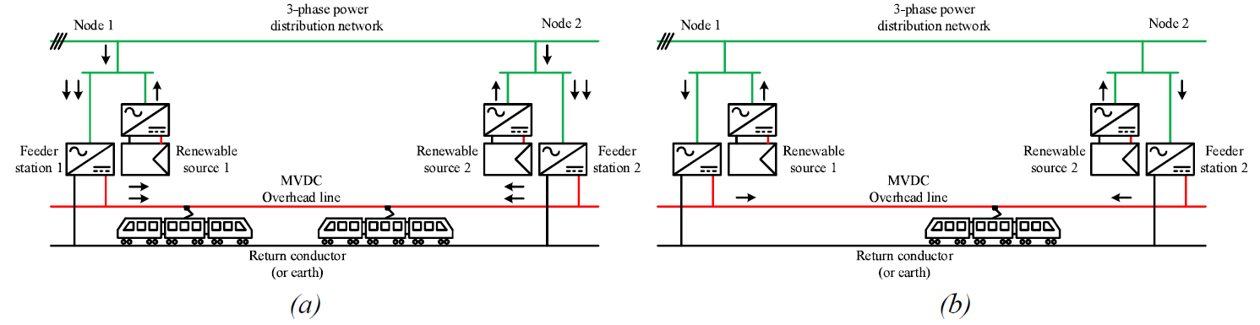

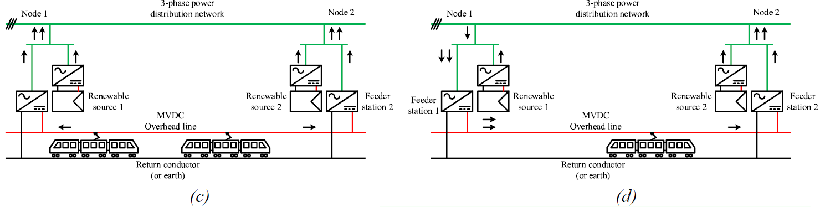

Figure 9 - Various operational modes in MVDC electrification system: (a) Heavy traffic condition, (b) Light traffic condition, (c) Regenerative braking, (d) Supporting power distribution grid

Reference [12] has first proposed a DC electrification system at high voltage levels. The proposed system is based on conventional HVDC transmission systems and uses a monopolar multi-terminal radial network, using line commutated 12-pulse thyristor converters. To keep reasonable insulation levels for the catenary, the system voltage has been chosen as same order as AC electrification, i.e. 30 kV. This system has the potential of implementing dual mode operations, i.e. suppling the system either with 30 kV DC or 25 kV AC. The proposed system has the capability of fault current limitation and avoid overcurrents using controlled thyristor rectifiers and fast protection equipment. During fault conditions, thyristors are triggered with a delay angle of around 90° or not triggered at all. This paper has also proposed a design for locomotives with three-phase asynchronous motors, consisting of a simple line-commutated high-voltage inverter, a high-frequency transformer operating at a frequency of few hundred Hertz, a four-quadrant rectifier and a three-phase voltage source inverter. However, the paper gives no details on the design of controllers, and especially how the fault current is limited. In addition, the high-voltage inverter on-board the locomotive has been implemented with thyristors, which require complicated commutation circuits.

In [7], a new MVDC multi-terminal system has been proposed as an alternative to existing AC and DC electrification systems. The proposed system, stemmed from [12], uses VSC as building blocks and allows a better integration of the railway with distributed generation and energy storage. As shown in Fig. 10, various subsystems with different voltage levels can be connected to a 15 – 25 kV DC railway line as a distributed energy hub or a super microgrid. The authors have also suggested two architectures for real-time control and power balancing, as well as two novel structures for rolling stocks which are compatible with both 3 kV and 24 kV DC supply. Further, by means of numerical simulations, the advantages of the proposed system over a conventional 2×25 kV AC railway supply system have been investigated in terms of simplicity of infrastructure and higher capacity. However, the paper, does not contain sufficient details on the design and control of the converters for the traction substation. In addition, modular multilevel converters with half-bridge submodules have been proposed, which are unable to block the DC fault current.

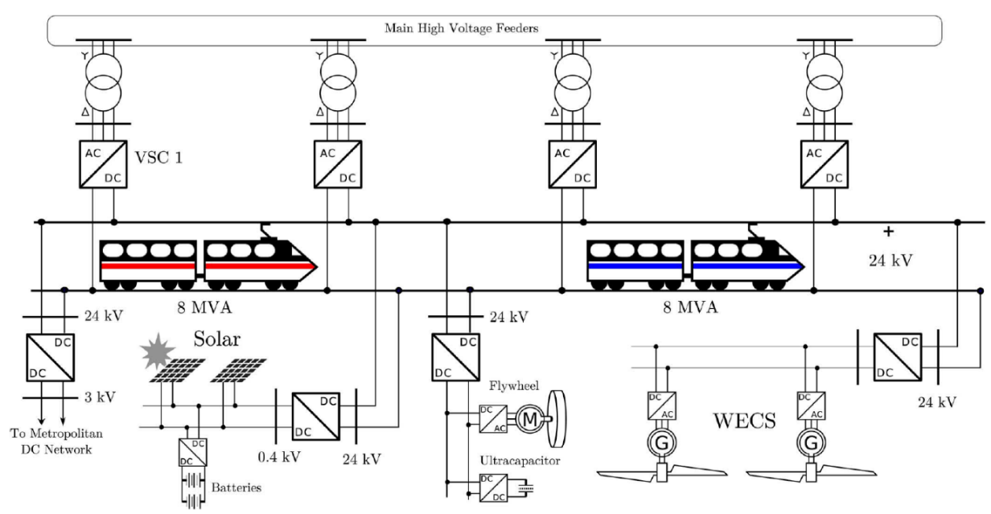

Figure 10 - Proposed MVDC multi-terminal system [7]

Potential benefits of MVDC railway electrification system and its challenges have also investigated in [13]. This paper evaluates with a mathematical model taking into account the rail-to-ground voltage, pantograph voltage and temperature of the overhead line how the DC voltage level (1.5 kV to 10.5 kV with the steps of 1.5 kV) affect the overhead line cross-sectional area and the spacing of traction substations for both suburban and high-speed transport services. The results show that for voltages above 7.5 kV DC, both cable cross-sectional area and substation spacing are comparable with commonly used AC systems. Furthermore, a case study based on Paris-Strasbourg line with real data of traffic conditions has been presented, showing that a 9 kV DC system has the same performance of a 2×25 kV AC system, while being simpler and not needing neutral sections and autotransformers. However, the authors have mentioned that more economic analysis must be performed to elaborate more accurately the advantages of a MVDC system.

In [14], the authors have proposed a configuration where a small number of high-power rectifiers are connected to the public grid to generate a multi-terminal high-voltage DC bus alongside the railway. This high-voltage feeder, as shown in Fig. 11, operates with a voltage level of 120 kV DC and can feed both DC and AC railways. In case of AC railways, a number of inverter substations, located at distances smaller than the rectifiers, provide a suitable AC voltage for the overhead line.

Reference [15] has further evaluated the above proposal using a unified AC-DC optimal power flow model. In comparison to a high-voltage AC system, which is already used for railways at 16 2/3 Hz, a high-voltage DC feeder would reduce the voltage drop of the catenary and reduce transmission losses. Furthermore, an optimisation method to minimise power losses has been formulated in [16] to investigate the optimal control of the converters.

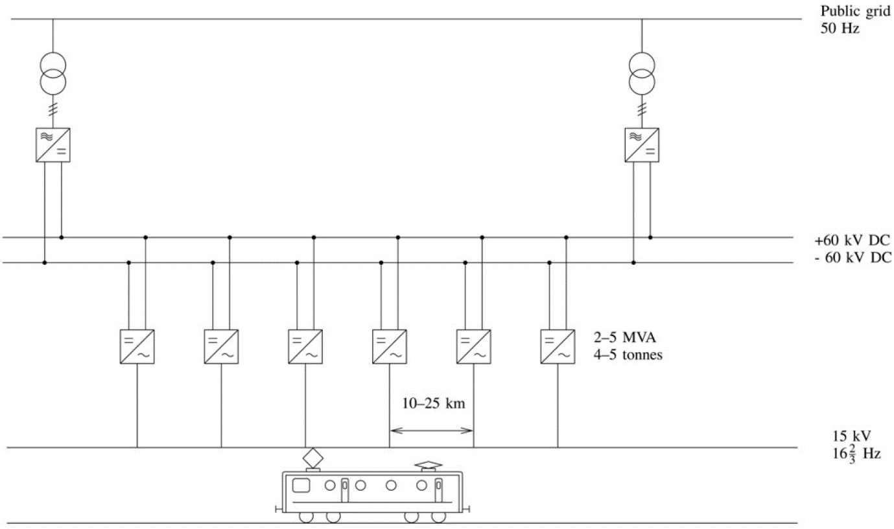

*Figure 11 – The multi-terminal high-voltage DC bus concept proposed in* [14]

# High-power MVDC converters

In the proposed MVDC system, the power converter is one of the most important components of traction substations, which is a high-power bidirectional AC-DC converter, with the power rating of 20-60 MVA. Concerning the railway load characteristics, the converter is able to tolerate temporary overloads for short durations. In the rectifier mode of operation, it supplies medium-voltage DC railway headlines with the voltage of 20-25 kV DC from the three-phase distribution network (medium-voltage AC) with the voltage of 11 or 33 kV AC. In the case of regenerative braking, the converter must inject the regenerated energy to the three-phase grid and act as an inverter. In addition, the ability of limiting DC fault current is highly desirable, because it can omit expensive and giant high-voltage DC circuit breakers from the protection system. Another important factor is the total energy efficiency of the converter, as it processes a large amount of energy.

In this section, various types of high-power converters are reviewed to find the potential solutions that meet the above requirements. These types of converters have been proposed and implemented in different industrial areas including MVDC distribution network, HVDC transmission, collection network for offshore wind farms and electric ships distribution network.

One possible classification for high-power converters is shown in Fig. 12 [17]. As matrix converters and cyclo‑converters are AC-AC converters, they are not suitable for MVDC electrification system. Power converters with DC link are divided to two major groups, named Voltage Source Converters (VSC) and Current Source Converters (CSC), which are discussed below.

Figure 12 - Categorization of high-power converters [17]

Figure 12 - Categorization of high-power converters [17]

## Voltage source converters

In these converters, the controller forms the output voltage and the load determines the current shape and direction. High-power VSCs can be categorized to two subgroups, as shown in Fig. 13 [17].

Categorisation of high-power voltage source converters 

Figure 13 - Categorisation of high-power voltage source converters [17]

### Two-level voltage source converters

Fig. 14 shows a three-phase two-level voltage source converter. This topology is called two level because at the AC side and in each phase, the voltage has only two levels: $\frac{+V_{DC}}{2}$ and $\frac{-V_{DC}}{2}$ [18]. This topology is mainly used in battery energy storages systems, Uninterruptible Power Supplies (UPS), lifts and cranes [19].

Two-level VSC

Figure 14 - Two-level VSC

In high-voltage application, ASEA Brown Boveri (ABB) group has implemented two-level VSC in a small scale HVDC transmission network, with the voltage of 20 kV DC and the power rating of 3 MW [20], [21]. At the AC side, this converter has been connected to 10 kV AC without the use of transformer. A large number of Insulated Gate Bipolar Transistor (IGBT) switches have been connected in series to enable the converter to be used at high voltages. In order to turn on/off the series IGBTs simultaneously, a special gate unit has been designed. In addition, voltage dividers have been used to evenly distribute the voltage across the series IGBTs and decrease the switching losses.

The two-level VSC in rectifier mode of operation is also known as Pulse Width Modulation (PWM) rectifier or active rectifier. The term PWM inverter is also used in the literature for inverter mode of operation. In both modes, the circuit topology is the same, but the control objectives are different. In the rectifier mode, the DC voltage is regulated while in the inverter mode, the magnitude and frequency of the AC voltage are controlled [22].

Implementation of a PWM rectifier-inverter in traction substation in conventional DC railways has been investigated in [22]. In this paper, a 3MW, 825 V DC PWM rectifier with eight paralleled IGBTs in each arm has been designed and compared with two anti-paralleled 12 pulse thyristor-controlled converters (explained in subsection 6.2) in the same condition.

Although the simulation results show that the PWM converter offers perfect performance in energy regeneration, low harmonic pollution, high-quality output voltage, good voltage regulation and zero reactive power consumption, the author has concluded that the thyristor-controlled rectifier is more suitable to be uses in traction substations. The results show that the PWM converter has higher total cost, higher acoustic noise and four times more losses. In addition, it cannot limit the DC short circuit current because anti-parallel diodes provide a path for fault current towards the AC side. Therefore, the rectifier must tolerate the short circuit current for 100-250 ms until the DC breaker isolates the fault. To amend this issue, a high-value short circuit impedance transformer must be used to decrease the amplitude of short circuit current and reduce the size of the converter elements.

The authors have concluded that considering power semiconductor costs, the use of PWM converters in traction substations is only beneficial for special cases, i.e. connection to weak grids, which are more sensitive to harmonic pollution and reactive power consumption. However, this conclusion is based on the semiconductors cost at the time that the paper has been published.

### Multilevel voltage source converters

#### Integrated Multilevel Converters

Developing multilevel VSCs has provided new solutions to high-power applications. In comparison to two-level VSCs, multilevel voltage source VSCs produce staircase voltage waveform at the AC side, which leads to less harmonic distortion. Furthermore, they offer higher efficiency, lower voltage stress on semiconductor switches, near-sinusoidal currents at the AC side (in rectifier operation) and smaller filters at both AC and DC sides. In some special cases, they can continue the operation during faults [17]. They are extensively used in motor drives, SVCs, Flexible Alternating Current Transmission Systems (FACTS), battery energy storage systems and HVDC transmission systems [19].

Multilevel topologies include Neutral-Point Clamped (NPC) converter, also known as diode-clamped converter, Active Neutral-Point Clamped (ANPC), Flying Capacitor (FC) and Nested Neutral-Point Clamped (NNPC) converters, which are shown in Fig. 15 and explained in [17].

As an example of using multilevel converters in MVDC, ABB has implemented NPC converter to interconnect two asynchronous power systems. In this project, a three-level NPC converter has been installed in each power system. Then, these two converters have been connected to each other through a common medium-voltage DC link. The converters are responsible for reactive power support as well as active power transfer [23].

The aforementioned multilevel converters are also called monolithic multilevel converters, because they do not have modular configurations. Therefore, in high-voltage applications, a large number of series semiconductor switches must be installed in these converters, which leads to complex and expensive design [19]. The voltage balancing across the elements in NPC and FC converters is another challenge regarding their use in high voltages [24].

|  |  |
| --- | --- |
| Multilevel VSC converters: a) Three-level NPC | Multilevel VSC converters:, b) Three-level ANPC |
| (a) | (b) |
| Multilevel VSC converters: c) Four level FC, | Multilevel VSC converters: d) Four-level NNPC |
| (c) | (d) |

*Figure 15 - Multilevel VSC converters: a) Three-level NPC, b) Three-level ANPC, c) Four level FC, d) Four-level NNPC*

#### Multi-cell converters

The multi-cell converters have been developed to amend these problems. The Cascaded H-Bridge (CHB) and Cascaded Neutral-Point Clamped (CNPC) converters are two popular multi-cell converters, which can operate in high voltages and continue their operation with lower capacity during faults. As shown in Fig. 16, these the CHB and CNPC converters consist of several cascaded two-level (also known as H-bridge) and NPC submodules, respectively. The submodules in turn consist of low power semiconductor switches, diodes and isolated DC sources. The nominal voltage of the converter can increase using higher number of submodules [17].

When the CHB and CNPC converters are used as rectifiers, it is not possible to form a common DC bus, because the isolated DC capacitors cannot be connected together. In inverter mode, the isolated DC sources are provided by phase-shifting transformer with multiple windings on the secondary side and rectifier bridges that are connected to each winding [17]. Therefore, the CHB and CNPC converters cannot be implemented as bidirectional AC-DC converters. However, cascaded topologies can be implemented in a multi-stage configuration to form a bidirectional converter, as will discussed in 6.3.

|  |
| --- |
| - (a) Cascaded H-Bride converter  (a) |
| Cascaded Neutral-Point Clamped converter  (b) |

Figure 16 - (a) Cascaded H-Bride converter, (b) Cascaded Neutral-Point Clamped converter

Concerning limited voltage and power rating of above converters, the Modular Multilevel Converters (MMC) have been developed to be used in wide range of voltages and powers, from MVDC to HVDC applications. Similar to CHB and CNPC converters, MMCs consist of several submodules in each phase. However, the DC sources in submodules are not isolated and are directly charged and discharged through the common DC bus. This feature together with modularity makes these converters a promising solution for high-voltage and high-power applications including motor drives, STATCOMs, multi-terminal HVDC systems and collection networks in offshore wind farms [17].

Fig. 17 and Fig. 18 show the MMC topology and various submodule arrangements, which are compared in Tab. 2 [17]. At the AC side, each phase connects to one leg of the converter. Each leg consists of two arms with N submodules. In each arm, an inductor is installed to limit the inrush currents in start-up, and circulating currents in steady state operation. As an attractive feature, the submodules can produce a bipolar voltage are able to block DC short circuit current and limit it to small values. In fact, for a given magnitude *V*ac,max of the AC fundamental harmonic, the average DC voltage output of each submodule can be controlled down to 0. In contrast, the unipolar submodules cannot block the fault current because it can flow through anti parallel diodes even though the semiconductor switches are closed. In fact, for these submodules the minimum average DC voltage output is equal to *V*ac,max.

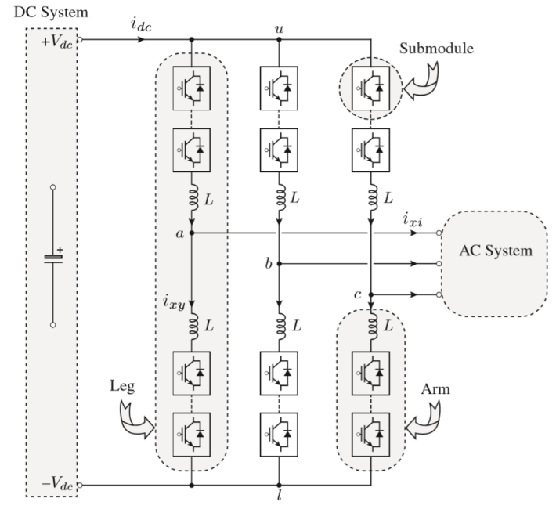

Figure 17 - Modular multilevel converter and its components [17]

|  |  |
| --- | --- |
| Various submodule arrangements: (a) half-bridge  (a)  Various submodule arrangements: (c) flying capacitor  (c)  Various submodule arrangements: (d) cascaded half-bridge  (e) | Various submodule arrangements: (b) full-bridge,  (b)  Various submodule arrangements (d) cascaded half-bridge  (d) |

Figure 18 - Various submodule arrangements: (a) half-bridge, (b) full-bridge, (c) flying capacitor, (d) cascaded half-bridge, (e) double clamp [17]

Table 2: Comparison of submodule arrangements, as indicated in [17]

|  |  |  |  |  |  |
| --- | --- | --- | --- | --- | --- |
| **Characteristic** | **Half-bridge** | **Full-bridge** | **Flying capacitor** | **Cascaded half-bridge** | **Double clamp** |
| Number of output voltage levels | 2 | 3 | 3 | 3 | 4 |
| Maximum blocking voltage of submodule | Vc | Vc | 2×Vc | 2×Vc | 2×Vc |
| Maximum Number of DC capacitors normalized to Vc | 1 | 1 | 3 | 2 | 2 |
| Number of devices normalized to Vc | 2 | 4 | 4 | 4 | 7 |
| Maximum Number of devices in conduction path | 1 | 2 | 2 | 2 | 3 |
| Power losses | Low | Moderate | Moderate | Moderate | High |
| design complexity | Low | Low | High | Low | High |
| control complexity | Low | Low | High | Low | Low |
| Bipolar operation | No | Yes | No | No | Yes |
| DC fault blocking | No | Yes | No | No | Yes |

The control unit of an MMC has several objectives, which makes it more complicated, especially when a large number of submodules are installed. In addition to output voltage and current control, the capacitor voltages must be controlled to maintain at the nominal value. Further, the control system must cancel the circulating currents, as they increase losses and degrade efficiency. A survey about various control strategies in MMCs can be found in [25]. Tab. 3 summarises several examples of using MMCs and their implemented controls.

In addition to aforementioned submodules, there are other submodule arrangements with higher number of switches and higher complexity, which have been extensively compared in [30]. Based on the requirements, the designers can choose the most suitable submodule structure for each application. In general, higher voltage blocking capability, bipolar output voltage and symmetrical voltage levels are desirable. However, these characteristics often are gained at the cost of higher number of components and in consequence, more cost and conduction losses and less reliability. In addition, the control design, mechanical structure of submodules and the protection schemes against internal faults will be more complicated. Therefore, there is a compromise between desirable output characteristics and the cost, losses and complexity of the submodules. In particular, these factors must be considered carefully in designing high-power converters with large number of submodules [30].

The MMC can be combined with other VSCs to form a Hybrid Modular Multilevel Converter (HMMC). For instance, the authors of [31] have proposed an HMMC, which is a combination of MMC with full-bridge submodules and two-level VSC as shown in Fig. 19. In this converter, called alternate arm converter, several series connected IGBTs have been implemented in each arm of MMC to control the direction of the voltage produced by each arm. Using these director switches, the upper arm produces the positive half-cycle of sinusoidal AC voltage and the lower arm creates the negative half-cycle. Thus, the voltage rating of each arm is approximately half of the voltage rating in a conventional MMC. The alternate arm converter is able to block DC fault current as well as operating as STATCOM in DC fault conditions to support the AC grid.

Table 3: Examples of using MMCs in different applications

|  |  |  |  |  |  |  |  |  |  |
| --- | --- | --- | --- | --- | --- | --- | --- | --- | --- |
| **Application** | **Submodule** | **Voltage Level (kV)  AC* DC** | | **Power Rating** | **# Modules (per phase)** | **#**  **Switches (per phase)** | **Controls implemented in converters** | **Notes** | **Ref** |
| MVDC distribution network | Half-bridge | 6.6 | 12 | 1 MVA | 16 | 32 | Arm-balancing, AC current | Coupled or centre-tapped inductors have been used as arm inductors | [26] |
| Medium-voltage rectifier for motor drives | Half-bridge | 6.9 | 10.5 | 3.15 MW | 22 | 44 | AC and DC current, average capacitor voltage, circulating current, vertical and  horizontal voltage balance** | - | [25] |
| HVDC transmission | Half-bridge | Not specified | 640 | Not Specified | 76 | 1216 | AC current, active power, reactive power, cell-voltage | explained in subsection 7.1.1 - 2nd harmonic filtering | [27] |
| MVDC distribution network | Not specified | 6.6 | 10 | 7 MVA | 20 | Not specified | DC voltage, circulating current, AC line current, horizontal  and vertical energy balancing | MMC has been used as rectifier to supply several inverters | [28] |
| Ships with variable speed gas turbine (variable frequency at the AC side) | Half-bridge | 4.16 | 10 | 25 MW | 20 | 40 | DC voltage, inner current | - | [29] |

* Voltage level for AC side corresponds to line-to-line Root Mean Square (RMS) voltage

** The aim of vertical balancing is to equally distribute the stored energy between two arms of the same leg. Horizontal balancing aims to equalize stored energy in the legs [31].

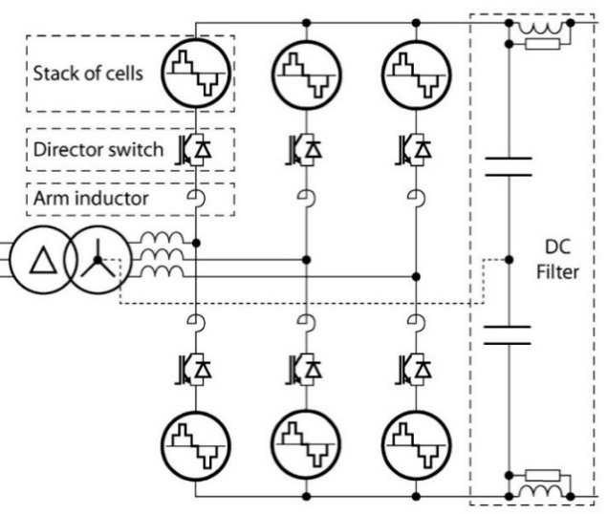

Figure 19 - Alternate arm converter [31]

In order to retain the stored energy of submodules in nominal value, their energy exchange in each half-cycle must be zero. In other words, the energy exchanges from AC and DC side must be equal. To achieve this, the peak voltage of AC side must be about 27% higher than the voltage of DC terminals, i.e., the DC voltage produced by each arm. This operation condition, called “sweet spot”, can be realized by choosing proper turn ratio for the AC side transformer. In sweet spot, director switches are switched at zero voltage (soft switching), which leads to reduction in their switching losses. Besides, at sweet spot condition, the total number of IGBTs is less than a conventional MMC with full-bridge submodules.

However, the fixed relation between AC and DC side voltage at sweet spot limits the independent control of active and reactive power. Various methods have been proposed to address this issue at the cost of considerable increase in the voltage rating of the converter [30]. In the case that the converter is not operated at sweet spot, there must be overlap periods which both upper and lower arms are active to balance the energy stored in the submodules. The use of overlap periods increases the number of IGBTs both in submodules and series director switches, and, thus the conduction losses [31].

The HMMCs can be formed in various ways. In [30], they are investigated in two categories: HMMCs with monolithic director switches and HMMCs with H-Bridge director switches. The general benefits and drawbacks of HMMC are summarized in Tab. 4.

Table 4: General benefits and drawbacks of HMMCs, as indicated in [30]

|  |  |
| --- | --- |
| **Benefits** | **Drawbacks** |
| Compact structure | Series connected switches |
| Reduced number of submodules | Higher conduction losses |
| Soft switching and low switching losses | Limitation on active and reactive power control |
| reduced number of active and passive elements | Possiblity of ripples in DC voltage and need to DC filter |
| Very small or no AC filters |  |

## Current‑source converters

Currently, diode bridge rectifiers and thyristor bridge rectifiers are used in conventional DC railway electrification systems to convert three-phase AC to DC voltage [2]. These two types of converters are the members of Current Source Converters (CSC). In contrast to the VSCs, these converters act as a current source, i.e. the direction of the current is always constant while the polarity of the voltage can change. This family can be divided to two categorizes: Load-Commuted (LC) or Line Commutated Converters (LCC) and PWM current source converters. In LCCs, widely use in railway electrification and HVDC systems, the semiconductor switches are commutated with the mains grid frequency (50 or 60 Hz). Conversely, the switching frequency is much higher in the PWM current source converters.

As well-known examples of LCC, the diode and thyristor bridge rectifiers produce DC voltage with 6 pulses. In order to reduce the DC voltage ripples, improve Total Harmonic Distortion (THD) at the AC side and reach to higher output voltages and currents, several bridges can be connected in parallel or series and form a 12, 24, 36 and 48 pulse converters. These configurations, called multi-pulse converters, often need to a transformer to produce a phase shift between AC inputs of the bridges. Fig. 20 shows a 12‑pulse diode rectifier with delta/star delta transformer, which provides 30 degrees phase shift for two bridges. Various three-phase multi-pulse configurations can be found in [32].

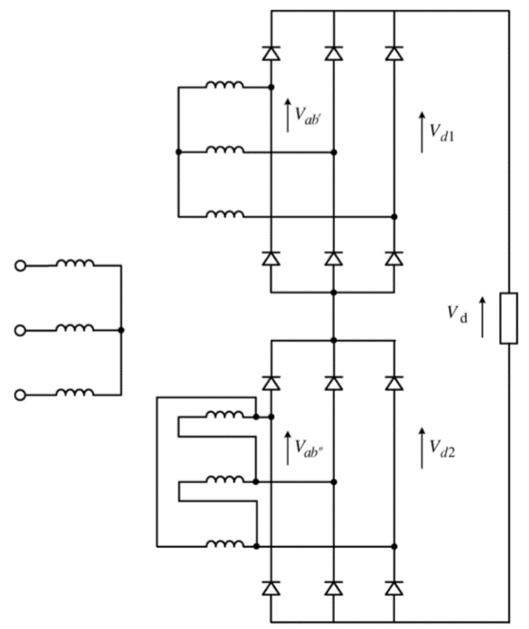

Figure 20 - 12 pulse diode rectifier with delta/star delta transformer [2]

The use of thyristor bridge rectifiers (controlled rectifiers) instead of diode rectifiers can have both positive and negative aspects [2]. In comparison to diode rectifiers, the ability of adjusting DC output voltage under various load conditions yields to lower losses. In other words, for a constant value of power, less amount of current is consumed, results in lower Ohmic losses. The voltage regulation also enables the system to be operated at more intense traffic, or for a constant traffic density, the distance between the substations can increase.

On the other hand, in order to provide wide variation in output voltage, the firing angle of the thyristors must be variable in wide range. This can degrade the power factor, THD at the AC side and the quality of the DC voltage, because the firing angle relates to the phase shift between the fundamental component of the current and the input voltage. In addition, thyristor rectifiers need to an input transformer with higher voltage and power ratings. In order to trigger the thyristors, more complicated control system and gate drivers must be used which reduces the reliability of the system. Further, thyristors deliver lower short-circuit currents, which leads to implementation of forced-air cooling. This also has negative effect on the systems’ reliability.

The regenerated energy from regenerative braking can be absorbed using reversible substations. As the output current direction in CSCs is constant, the only way to change the power transfer direction is to change the voltage polarity of the DC bus, which is not a practical solution in railway electrification. To amend this problem, a separate thyristor inverter is connected to the rectifier in opposite direction, forms anti-parallel configuration [33]. Another solution is to connect an active (PWM) converter to the rectifier. In braking mode, this converter acts as an inverter, while in normal mode, the converter is an active power filter for the rectifier [34].

Concerning DC side faults, the CSCs can tolerate DC short circuits. This inherent ability stems from the existence of inductors, which limit the increasing rate of fault currents. In particular, in thyristor-based LCCs, firing angle can be controlled to limit the dc fault current [35]. Further, in some types of CSC topologies, a series connected diode is integrated with each semiconductor switch, enabling it to block the voltage in both directions. Hence, it can block the voltage that supplies the short circuit current. On the other hand, the CSCs must be protected against open circuit faults using emergency current paths [36].

## Double-stage conversion

The use of multi-stage conversion can also be a possible solution for AC-DC conversion in the traction substation. In these configurations, the AC input voltage is converted to DC voltage. In the next stage and using a DC-DC converter, the DC voltage with desired level is produced. These two stages can be implemented by various topologies, for instance, the AC-DC stage can be a diode rectifier or CHB rectifier, while boost DC-DC chopper or Dual-Active Bridge (DAB) converter can act as the second stage.

DAB converter is a DC-DC converter implemented by a rectifier, a high-frequency transformer and an inverter. In Fig. 21, the first two-level VSC converts the input DC voltage to a high-frequency AC, which is scaled by the high-frequency transformer, and rectified by the second two-level VSC. High-frequency transformers are much smaller and lighter than line-frequency transformers that is an essential requirement in electric systems of locomotives, electric ships and other mobile applications.

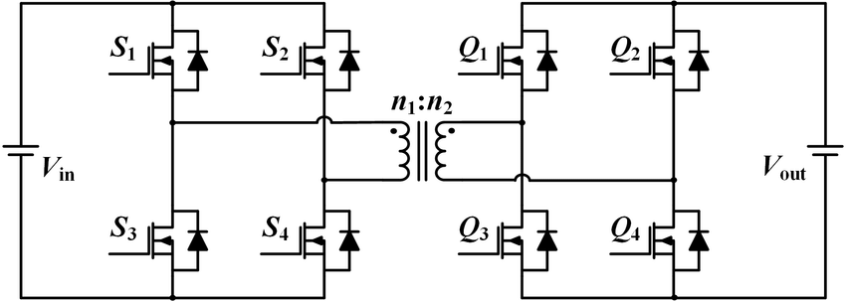

Figure 21 - Dual-active bridge converter

In [37], several paralleled sets consist of series connection of CHB and DAB converters is proposed for use in more-electric-aircrafts. As shown in Fig. 22, this configuration is modular and can be expanded to use in higher voltage levels and power ratings. Similar configurations are also proposed for solid-state transformers in distribution networks [38].

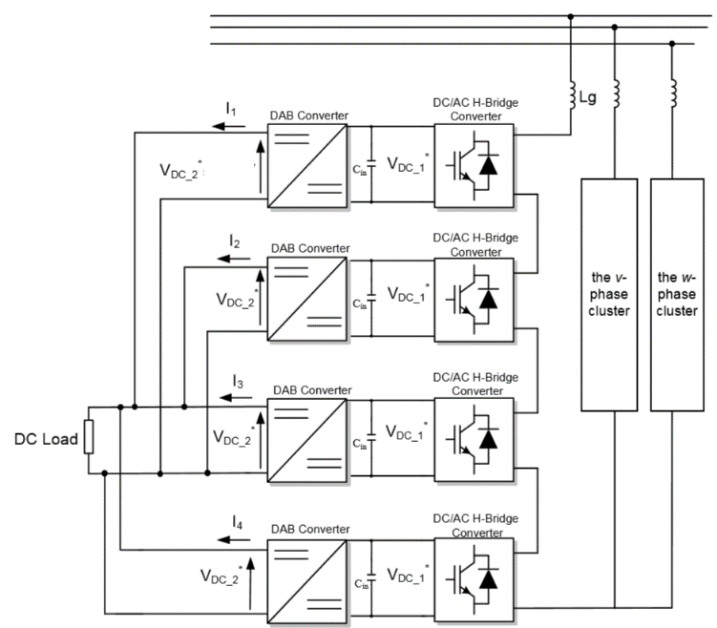

Figure 22 - Double-stage conversion proposed in [37]

The authors of [39] have compared four possible AC-DC converters for implementing in power distribution system in a ship with the voltage of 1.1 kV DC and the power of 3 MW. These four topologies are 12-pulse thyristor rectifier, a double-stage configuration consisted of diode rectifier and Integrated Gate-Commutated Thyristor (IGCT) DC-DC boost converter, a double stage topology formed by CHB connected in series with DAB converter, and a double-stage configuration with diode rectifier and DAB converter. Among them, the third arrangement is modular and can be extended for use in higher voltage and powers.

In [29] three types of rectifiers, i.e. diode rectifier connected in series with a boost chopper, three-level NPC and MMC with half-bridge submodules have been investigated to form 10 kV MVDC bus for power distribution of a ship. It is assumed that a variable speed gas turbine connected with a synchronous generator provides three-phase AC voltage with the voltage of 4.16 kV as an input to rectifiers. Considering required standards for power distribution system of ship, the rectifiers have been compared in terms of number of elements, number and physical footprints of capacitors and inductors, complexity of controller, DC voltage quality (amount of overshoot, settling time and ripple), THD at the AC side, efficiency and displacement power factor. The results of comparisons, which are done in several load conditions and AC side frequencies, show that the MMC has the best performance at the cost of high number of capacitors and more complex control schemes.

In comparison to using a single high-power AC-DC converter, the double-stage conversion may have less efficiency, as it has more conversion stages. On the other hand, using double-stage configurations with high-frequency transformers can decrease the overall size of the substation.

# Protection and control issues in MVDC grids

Operating with power electronic converters, MVDC grids are different from conventional AC grids. There are new issues in protection and control of the MVDC systems that must be concerned in designing stage. This section deals with challenges in protecting MVDC converters as the core of MVDC system, as well as coordination strategies for MVDC grids control.

## Protection of MVDC converters

Generally, the MVDC converters encounter three types of faults, i.e., faults at the AC side, internal faults and faults at the DC side. In MVDC traction substations, it is desired to have fault tolerant converters, working at high level of reliability. The AC side faults can be cleared using high-speed AC circuit breakers. However, clearing internal and DC side faults are quite challenging and will be discussed in the following. As the VSC converters are more common in MVDC networks, this section is concentrated on VSC converters.

### Internal faults

Modular converters, in particular MMCs, can offer seamless operation during the fault in submodules, which is the most common internal fault. As an example for reliable operation of MMCs, ABB has implemented MMC consisting half-bridge submodules with series IGBTs for HVDC transmission system [27]. In this converter, named “cascaded two-level” to show its difference with ordinary MMCs, each submodule contains two valves (semiconductor switch and anti-parallel diode). Each valve constructed from eight-series connected press-pack IGBTs in order to maintain continues operation of the converter during semiconductor switch failure. In such case, press-pack IGBTs become short circuit and the other healthy IGBTs in the valve guarantee the normal operation. They can withstand against slight overvoltage caused by IGBT failure until next scheduled maintenance, which typically happens every one or two years. In addition, using distributed cell-voltage control, the reference voltage for faulty submodules can be set to a lower voltage.

In the case of using MMCs in MVDC applications, the number of submodules are much lower than that of used in HVDC systems and the effect of faulty submodules is more intense. Therefore, using special redundant design can be beneficial. In [24], a MMC inverter with the ability of hierarchical redundancy has been proposed to implement at 1.5 - 15 kV DC system of an electric ship. In this converter, there are two sets of redundant submodules, called hot-reserved (activated) and cold-reserved (deactivated). In the control system, a hierarchical strategy has been implemented to change the faulty submodule with healthy reserves during different situations.

### DC side faults

Conventional VSCs used in HVDC, i.e., two-level and three-level converters are not able to limit the DC short circuit current. It stems from fact that the anti-parallel diodes provide a path for the fault current. Besides, the DC bus capacitors produce high amplitude surge current during DC faults. In particular, in a multi-terminal DC system like the MVDC railway, the surge and resonant currents can damage all the converters connected to the common DC bus, even those that are not involved in the DC fault. On the other hand, using MMCs that create a DC bus without any capacitors and can have fault blocking capability is a promising solution for multi-terminal DC systems [40]. This section explains more about the DC faults in the converters.

In MVDC distribution systems, the DC fault current can be supplied by AC source, DC source or energy storage components of the converters, i.e., inductors and capacitors. There are three possible solutions for protecting converters against DC short circuits [41]:

* Use of AC circuit breakers, which prevent AC side to supply fault current, but cannot interrupt currents from DC source and energy storage elements. Besides, AC circuit breakers need several tens of milliseconds to cut-off the AC current. During this time, DC fault currents may reach high values and damage the converter.
* Use of DC circuit breakers, which isolate the fault from all supply sources and can be implemented in the form of mechanical, solid-state or hybrid circuit breakers, as discussed in [42]. Although ultra-fast solid-state DC circuit breakers are well developed for lower voltages, installing cost-effective DC circuit breakers in higher voltages and MVDC distribution networks is a challenging task for the designers.
* Use of converters to limit the fault current, which based on the topology, disconnect the fault from AC source or all sources. One possible solution is to create an artificial three-phase short circuit within the converter and bypass the converter. This can be realised by turning on the upper arms IGBTs in the two-level VSCs and turning on one IGBT in all upper arm submodules in the MMCs. However, the fault current is still supplied from the DC source and energy storage components. In this method, the fault current can be extinguished by low-load or no-load DC circuit breakers when the capacitors and inductors have been discharged and during this time, the short circuit current may already damage the converter. The other solution is to use converters with inherent capability of fault blocking, demonstrated in the following subsection.

#### Fault blocking capability of converters

In conventional VSC converters and in the case of DC pole-to-pole faults, the IGBT switches are turned-off within a few microseconds, but the fault current still flows through anti-parallel diodes. Even though this also happens for an MMC with half-bridge submodules, some modifications can be made in MMC submodules to provide fault blocking capability.

In order to protect the anti-parallel diodes of half-bridge submodules from surge currents, a bypass thyristor can be added to half-bridge submodule, as shown in Fig. 23 (a). However, the AC circuit breaker must cut-off the AC supply to interrupt the fault, which is not fast enough. In addition, fast system restart is not possible, as it may need to several hundreds of milliseconds or more. Therefore, this configuration can be useful for the systems that implemented by the cables, where pole-to-pole faults are treated as permanent faults. In other applications like overhead line transmissions, pole-to-pole faults can be considered as non-permanent faults and it is desirable to restart the system as soon as possible. In order to improve the former topology, double thyristor switches can be integrated with half-bridge submodules, as shown in Fig. 23 (b). This configuration is able to interrupt DC fault current without AC circuit breaker [43].

Double clamp MMCs, shown in Fig. 18 (e) also have the ability of blocking DC fault current [44]. In some applications, the MMCs act as STATCOM and must continue their operation even during pole-to-pole DC faults, i.e., they must have fault ride through capability. While the double thyristor scheme and Double clamp MMCs are not suitable options for these applications, full-bridge MMCs [44], [45] can be chosen as a promising solution. Besides, a MMC with 50% half-bridge and 50% full-bridge submodules in each arm can also provide fault ride through capability [43] and is shown Fig. 24.

|  |  |
| --- | --- |
| protection of the anti-parallel diodes in half-bridge submodules (a) using a bypass thyristor | protection of the anti-parallel diodes in half-bridge submodule using double thyristors |
| (a) | (b) |

Figure 23 - protection of the anti-parallel diodes in half-bridge submodules (a) using a bypass thyristor (b) using double thyristors

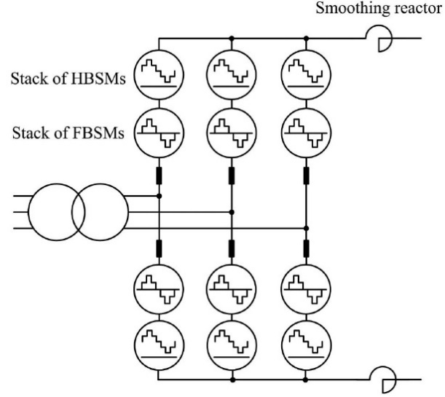

Figure 24 - MMC with 50% half-bridge and 50% full-bridge submodules for DC fault blocking

It should be noted that in comparison to MMCs with half-bridge submodules, all of the aforementioned converters need more elements and in consequence, have more investment cost, conduction losses and complexity. As an effort to decrease the number of element in hybrid MMCs, the authors of [41] have proposed a novel MMC which consists of half bridge submodules and has only one full bridge submodule in each lower arm. When a DC fault happens, all of the upper arm submodules provide an artificial three-phase short circuit in the converter and the full bridge submodules block the current from the line and arm inductors. Finally, the fault current decrease to zero and no-load DC disconnectors isolate the fault’s location. In this topology, the upper arm switches can have high fault current handling capability to tolerate against high fault currents supplied by the AC source.

## Control of MVDC grids

The proposed MVDC electrification system consists of traction substations, supplying the distributed MVDC bus from several points, along with the trains as moving loads or generators (in the case of regenerative braking). This implies that the MVDC supply system is a multi-terminal MVDC grid that can be simply developed in the form of double end feeding with the trains as T-junctions, or in the form of fully meshed configuration. These two configurations are shown in Fig. 25, where the AC-DC converters can be connected to different AC grids.

|  |  |
| --- | --- |
| Possible configurations for MVDC railway electrification system: (a) double end feeding | Possible configurations for MVDC railway electrification system: (b) mesh feeding |
| (a) | (b) |

Figure 25 – Possible configurations for MVDC railway electrification system: (a) double‑end feeding (b) mesh feeding

In a multi-terminal MVDC system, the control of power flows and DC voltage is an essential task. In particular, because of dynamic characteristics of the trains load, variable resistance of the catenary and distributed configuration of the MVDC bus, the control design for MVDC electrification system is a challenging task [46].

In a DC network, the DC voltage is one of the best indexes for stable grid operation. Similar to the frequency in AC grids, DC voltage has a direct relation with power flow and power balance. Unlike the frequency, the DC voltage value can be different in the various grid terminals, which complicates the DC voltage and power flow control. To address this issue, coordinated DC voltage control strategies have been proposed in the literature [47].

In VSC-based multi-terminal DC grids, the VSC converter of a terminal can be operated in different modes of operation. In constant DC voltage mode (Vdc), the converter retains the DC voltage at a desired value and controls the active power balance. In constant power mode (PQ), the transferred power becomes fixed to a given reference value, regardless of the voltage value at the terminals. Using the amplitude and phase angle of the voltage at the AC side, the active and reactive power are adjusted to reference values. The droop mode of operation is the combination of constant DC voltage and constant power mode. In this mode, the controller changes the DC voltage linearly and regulates the voltage and power flow simultaneously. The constant AC voltage-frequency mode (Vf) is used when the VSC is connected to a load. In this mode, the frequency, amplitude and phase of the AC voltage are set to desired values [47].

In each coordinated DC voltage control strategy, a specific operation mode is assigned to the terminal converters. Cooperating with each other, the converters accomplish the desire control objectives. These strategies can be divided to two main groups, centralised and distributed DC voltage control, as summarized in Fig. 26 and comprehensively discussed in [47].

coordinated DC voltage control strategies 

Figure 26 - coordinated DC voltage control strategies [47]

Concerning MVDC railway supply system, the control system will be designed in the next steps of the project based on a DC voltage control strategy as primary control loop. In addition to voltage sensors of the primary loop, current sensors will be used to implement an outer control loop, detecting DC short circuit faults from extraordinary current values. Based on the standards and information available for the railways and other similar applications like MVDC distribution networks, requirements of the system will be determined and the control system will be tuned to meet these requirements.

# Potential benefits of using wide band-gap semiconductors in MVDC converters

In MVDC traction substations, power converters must be highly efficient and reliable. In addition to these characteristics, the DC-DC converters mounted on the train must be compact and have high power density, while operating in harsh conditions.

As Silicon (Si) semiconductors have reached their theoretical limits, new generation of semiconductors named Wide Band-Gap (WBG) semiconductors have been emerged to replace with Si semiconductors. WBG semiconductors such as Silicon Carbide (SiC), Gallium Nitride (GaN) and diamond are used to develop IGBT, Metal Oxide Semiconductor Field Effect Transistors (MOSFET) and power diodes, which significantly improve the performance of the both substation and rolling stock power converters [48].

The maximum voltage that a commercial Si IGBT can block is limited to 6.5 kV. This implies that there are two options for medium-voltage VSCs, two-level or three-level topologies with large number of series connected switches, and the multilevel topologies. The first group needs to special gate driver and voltage divider circuits, while the second solution needs more components and more complex control schemes. This issue has been addressed by development of high voltage WBG switches like 15 kV SiC IGBTs. In addition, the WBG semiconductors enable the converters to operate at higher switching frequency (more than 3 kHz) while maintain high energy efficiency. This decreases the size and weight of passive filters and heat-removal system and in consequence, increases the power density of the converters [49].

In [49], a configuration for a solid-state transformer in transformer-less intelligent power substation has been proposed. In this multi-stage converter, shown in Fig. 27, the first stage is a bidirectional three-level NPC rectifier, which is connected to 13.8 kV AC grid and 22 kV DC bus. The performance of 15 kV SiC IGBT and 10 kV SiC MOSFET for use in a three-level NPC rectifier with lower voltages (7.2 kV AC and 11 kV DC) has been compared. Using measured loss data, the energy losses has been calculated, showing that both of them provide high efficiency (above 99 percent) in different operating conditions, i.e., unity power factor and STATCOM mode of operation, and switching frequencies of 3 and 10 kHz. At last, the 15 kV SiC IGBT has been selected for the first stage.

The second stage is a DAB converter, which is a bidirectional DC-DC converter (22 kV - 800 V DC) consists of a three-level NPC with 15 kV/20 A SiC IGBTs, a three-winding high frequency transformer and two-level converters connected to the secondary and tertiary windings of the transformer, with 1200 V/100 A SiC MOSFET switches.

The third stage is a low voltage inverter consists of three units of two-level VSCs with 1200 V/100 A SiC MOSFET switches. Three units are paralleled and connected between 800 V DC and 480 V AC grid., which are higher than 98 percent in each stage, and 96.75 percent for solid-state transformer.

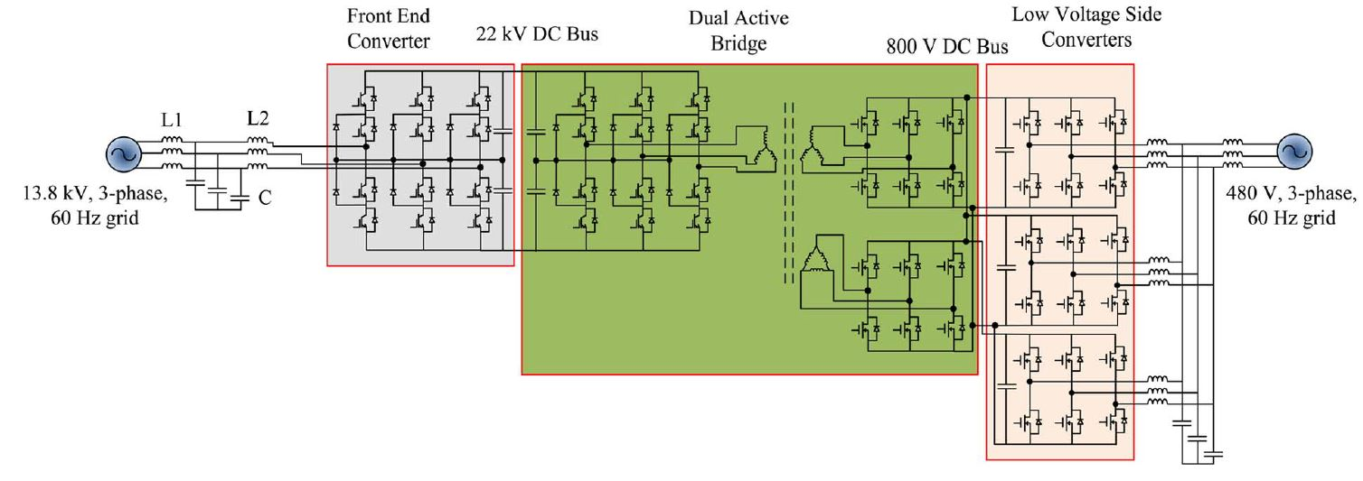

Figure 27 - Solid-state transformer proposed in [49]

The characteristics of a 10 kV/ 20 A SiC MOSFET module has been measured and analysed in [50]. In this module, there are two SiC MOSFETs, each has an anti-parallel SiC Schottky barrier diode. In addition, one Si Schottky diode has been connected in series with each valve, and one Schottky barrier diode has been paralleled with them, as shown in Fig. 28.

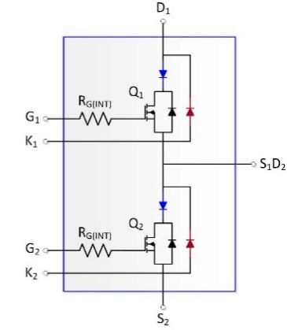

Figure 28 - The 10 kV/ 20 A SiC MOSFET module investigated in [50]

This module is able to switch inductive load currents very fast (under 100 ns), while it has small overshoot and parasitic ringing. At 2 kV DC and 20 A load current, switching losses has been measured as 2.5 mJ per switching cycle. This amount is approximately two orders of magnitude smaller than the amount for commercial Si IGBT modules, which are implemented at a few kV (but with lower voltage blocking capability in comparison to the SiC MOSFET module) and in the same operating conditions. In this paper, other static characteristics of the SiC module including capacitance-voltage measurements and forward conduction have been analysed.

In [51], the above study has been extended to full-scale modules, which can continuously handle 120 A current. This paper has also provided additional information on transient operation of the modules as well as a simulation model for them.

A MMC with full-bridge submodules has been proposed in [52] to be used in MVDC electrical power system of ships. In this MMC, a DC fault current control scheme has been implemented to block pole-to-pole DC faults. As a benefit of using 1.7 kV SiC MOSFETs in submodules, the switching frequency and the control frequency can be increased. Hence, the control loop can have faster response and interrupt the DC fault with lower peak value.

There are also some challenges regarding the use of high voltage WBGs in the converters. In comparison to Si semiconductors, WBG semiconductors have higher cost, lower production volume and are less studied in the literature.

Concerning the use of WBGs in locomotives, the extra cost of using WBG semiconductors is very small in comparison to the cost of a train. This makes it possible to use WBG in the train’s power system [53]. Regarding traction substation converters, further analysis needs to be performed in the next stages of the project.

# Conclusion

This deliverable has reviewed the conventional railway electrification systems and compared them with the proposed MVDC electric railway system.

Further, it has investigated high-power converters suitable for use in MVDC railway substations in two major groups, i.e., voltage source converters and current source converters. Considering their pros and cons, several options will be selected to simulate and approach to the best choice for the substation converter.

In addition, the deliverable has defined the protection and control of MVDC grids as the most important challenges in the system design. In the next steps of the project, the MVDC system configuration will be designed in more detail and these issues will be addressed.

At last, this document has described the advantages of wide band-gap semiconductors switches over silicon switches, such as blocking higher voltages and operating at higher switching frequencies with high efficiency. These features enable us to use simpler converter topologies and this will be considered in the topology selection.

# References

[1] R. J. Hill, “Electric railway traction. Part 1. Electric traction and DC traction motor drives,” *Power Eng. J.*, vol. 8, no. 1, pp. 47–56, 1994.

[2] M. Brenna, F. Foiadelli, and D. Zaninelli, *Electrical railway transportation systems*. Wiley, 2018.

[3] K. Segrave, *The electric car in America, 1890-1922: A social history*. McFarland, 2019.

[4] J. L. Sprague, “Frank J. Sprague invents: The constant-speed DC electric motor [History],” *IEEE Power Energy Mag.*, vol. 14, no. 2, pp. 80–96, 2016.

[5] “Railway electrification system.” [Online]. Available: https://en.wikipedia.org/wiki/Railway_electrification_system.

[6] W. D. Middleton, *When the steam railroads electrified*, 2nd ed. Bloomington, Indiana: Indiana University Press, 2002.

[7] A. Gómez-Expósito, J. M. Mauricio, and J. M. Maza-Ortega, “VSC-based MVDC railway electrification system,” *IEEE Trans. Power Deliv.*, vol. 29, no. 1, pp. 422–431, 2014.

[8] I. Krastev, P. Tricoli, S. Hillmansen, and M. Chen, “Future of electric railways: Advanced electrification systems with static converters for ac railways,” *IEEE Electrif. Mag.*, vol. 4, no. 3, pp. 6–14, 2016.

[9] U. Behmann and T. Schütte, “Advantages of low frequencies in converter-supplied railway traction power systems,” *RTR Rail Technol. Rev.*, vol. 53, pp. 34–37, 2013.

[10] R. J. Hill, “Electric railway traction. Part 3. Traction power supplies,” *Power Eng. J.*, vol. 8, no. 6, pp. 275–286, 1994.

[11] D. Serrano-Jiménez, L. Abrahamsson, S. Castaño-Solís, and J. Sanz-Feito, “Electrical railway power supply systems: Current situation and future trends,” *Int. J. Electr. Power Energy Syst.*, vol. 92, pp. 181–192, 2017.

[12] P. Leander and S. Ostlund, “A concept for an HVDC traction system,” in *International Conference on Main Line Railway Electrification 1989*, 1989, pp. 169–173.

[13] A. Verdicchio, P. Ladoux, H. Caron, and C. Courtois, “New medium-voltage DC railway electrification system,” *IEEE Trans. Transp. Electrif.*, vol. 4, no. 2, pp. 591–604, 2018.

[14] L. Abrahamsson, T. Kjellqvist, and S. Ostlund, “High-voltage DC-feeder solution for electric railways,” *IET Power Electron.*, vol. 5, no. 9, pp. 1776–1784, 2012.

[15] J. Laury, M. Bollen, L. Abrahamsson, and S. Östlund, “Some benefits of an HVDC feeder solution for railways,” in *NORDAC 2014*, 2014.

[16] J. Laury, L. Abrahamsson, and S. Östlund, “OPF for an HVDC feeder solution for railway power supply systems,” in *13th International Conference on Design and Operation in Railway Engineering (COMPRAIL 2012)*, 2012.

[17] S. Du, A. Dekka, B. Wu, and N. Zargari, *Modular multilevel converters: analysis, control, and applications*. John Wiley & Sons, 2017.

[18] O. Anaya‐Lara, D. Campos‐Gaona, E. Moreno‐Goytia, and G. Adam, “Appendix A: Voltage source converter topologies,” in *Offshore Wind Energy Generation*, 2014, pp. 223–269.

[19] B. Singh, B. N. Singh, A. Chandra, K. Al-Haddad, A. Pandey, and D. P. Kothari, “A review of three-phase improved power quality AC-DC converters,” *IEEE Trans. Ind. Electron.*, vol. 51, no. 3, pp. 641–660, 2004.

[20] G. Asplund, K. Eriksson, and K. Svensson, “DC transmission based on voltage source converters,” in *CIGRE SC14 Colloquium, South Africa*, 1997, pp. 1–7.

[21] G. Asplund, “Application of HVDC Light to power system enhancement,” in *2000 IEEE Power Engineering Society Winter Meeting. Conference Proceedings (Cat. No. 00CH37077)*, 2000, vol. 4, pp. 2498–2503.

[22] V. Gelman, “Insulated-gate bipolar transistor rectifiers: Why they are not used in traction power substations,” *IEEE Veh. Technol. Mag.*, vol. 9, no. 3, pp. 86–93, 2014.

[23] T. Larsson, A. Petersson, A. Edris, D. Kidd, and F. Aboytes, “Eagle Pass back-to-back tie: a dual purpose application of voltage source converter technology,” in *2001 Power Engineering Society Summer Meeting. Conference Proceedings (Cat. No.01CH37262)*, 2001, vol. 3, pp. 1686–1691 vol.3.

[24] Y. Chen, Z. Li, S. Zhao, X. Wei, and Y. Kang, “Design and implementation of a modular multilevel converter with hierarchical redundancy ability for electric ship MVDC system,” *IEEE J. Emerg. Sel. Top. Power Electron.*, vol. 5, no. 1, pp. 189–202, 2016.

[25] G. J. M. de Sousa, A. d. S. Dias, J. A. Alves, and M. L. Heldwein, “Modeling and control of a Modular Multilevel Converter for medium voltage drives rectifier applications,” in *2015 IEEE 24th International Symposium on Industrial Electronics (ISIE)*, 2015, pp. 1080–1087.

[26] M. Hagiwara, R. Maeda, and H. Akagi, “Control and analysis of the Modular Multilevel Cascade Converter based on Double-Star Chopper-Cells (MMCC-DSCC),” *IEEE Trans. Power Electron.*, vol. 26, no. 6, pp. 1649–1658, 2010.

[27] B. Jacobson, P. Karlsson, G. Asplund, L. Harnefors, and T. Jonsson, “VSC-HVDC transmission with cascaded two-level converters,” in *Cigré session*, 2010, pp. B4–B110.

[28] U. Javaid, A. Christe, F. D. Freijedo, and D. Dujic, “Interactions between bandwidth limited CPLs and MMC based MVDC supply,” in *2017 IEEE Energy Conversion Congress and Exposition (ECCE)*, 2017, pp. 2679–2685.

[29] D. Li, “Efficient generation of power in medium voltage direct current systems: variable speed operation and rectifier considerations,” Ph.D. dissertation, University of South Carolina, USA, 2013.

[30] A. Nami, J. Liang, F. Dijkhuizen, and G. D. Demetriades, “Modular multilevel converters for HVDC applications: Review on converter cells and functionalities,” *IEEE Trans. Power Electron.*, vol. 30, no. 1, pp. 18–36, 2014.

[31] M. M. C. Merlin *et al.*, “The Alternate arm converter: A new hybrid multilevel converter with DC-fault blocking capability,” *IEEE Trans. Power Deliv.*, vol. 29, no. 1, pp. 310–317, 2014.

[32] B. Singh, S. Gairola, B. N. Singh, A. Chandra, and K. Al-Haddad, “Multipulse AC–DC converters for improving power quality: A review,” *IEEE Trans. Power Electron.*, vol. 23, no. 1, pp. 260–281, 2008.

[33] T. Suzuki, “DC power-supply system with inverting substations for traction systems using regenerative brakes,” *IEE Proc. B - Electr. Power Appl.*, vol. 129, no. 1, pp. 18–26, 1982.

[34] P. H. Henning, H. D. Fuchs, A. D. le Roux, and H. d. T. Mouton, “A 1.5-MW seven-sell series-stacked converter as an active power filter and regeneration converter for a DC traction substation,” *IEEE Trans. Power Electron.*, vol. 23, no. 5, pp. 2230–2236, 2008.

[35] O. E. Oni, I. E. Davidson, and K. N. I. Mbangula, “A review of LCC-HVDC and VSC-HVDC technologies and applications,” in *2016 IEEE 16th International Conference on Environment and Electrical Engineering (EEEIC)*, 2016, pp. 1–7.

[36] J. Liang, A. Nami, F. Dijkhuizen, P. Tenca, and J. Sastry, “Current source modular multilevel converter for HVDC and FACTS,” in *2013 15th European Conference on Power Electronics and Applications (EPE)*, 2013, pp. 1–10.

[37] R. A. Mastromauro, S. Pugliese, and S. Stasi, “An advanced active rectifier based on the single-star bridge cells modular multilevel cascade converter for more-electric-aircrafts applications,” in *2015 International Conference on Electrical Systems for Aircraft, Railway, Ship Propulsion and Road Vehicles (ESARS)*, 2015, pp. 1–6.

[38] X. Liu, Y. Liu, J. Liu, and X. Zhang, “Coordinating voltage regulation for an AC–DC hybrid distribution network with multiple SSTs,” *J. Eng.*, vol. 2019, no. 16, pp. 1368–1372, 2019.

[39] D. Bosich, R. A. Mastromauro, and G. Sulligoi, “AC-DC interface converters for MW-scale MVDC distribution systems: A survey,” in *2017 IEEE Electric Ship Technologies Symposium (ESTS)*, 2017, pp. 44–49.

[40] R. Marquardt, “Modular multilevel converter topologies with DC-Short circuit current limitation,” in *8th International Conference on Power Electronics - ECCE Asia*, 2011, pp. 1425–1431.

[41] X. Huang, L. Qi, and J. Pan, “A new protection scheme for MMC-based MVdc distribution systems with complete converter dault current handling capability,” *IEEE Trans. Ind. Appl.*, vol. 55, no. 5, pp. 4515–4523, 2019.

[42] A. Giannakis and D. Peftitsis, “MVDC distribution grids and potential applications: future trends and protection challenges,” in *2018 20th European Conference on Power Electronics and Applications (EPE’18 ECCE Europe)*, 2018, p. P.1-P.9.

[43] S. Cui and S. Sul, “A Comprehensive DC Short-Circuit Fault Ride Through Strategy of Hybrid Modular Multilevel Converters (MMCs) for Overhead Line Transmission,” *IEEE Trans. Power Electron.*, vol. 31, no. 11, pp. 7780–7796, 2016.

[44] D. Schmitt, Y. Wang, T. Weyh, and R. Marquardt, “DC-side fault current management in extended multiterminal-HVDC-grids,” in *International Multi-Conference on Systems, Signals & Devices*, 2012, pp. 1–5.

[45] Y. Luo, P. Yi, X. Xiaofu, W. Jiang, and S. Yonghui, “DC fault ride-through method for full-bridge MMC-based MTDC systems,” *J. Eng.*, vol. 2019, no. 16, pp. 3175–3179, 2019.

[46] X. Yang, H. Hu, Y. Ge, S. Aatif, Z. He, and S. Gao, “An improved droop control strategy for VSC-based MVDC traction power supply system,” *IEEE Trans. Ind. Appl.*, vol. 54, no. 5, pp. 5173–5186, 2018.

[47] P. Simiyu, A. Xin, G. T. Bitew, M. Shahzad, W. Kunyu, and L. K. Tuan, “Review of the DC voltage coordinated control strategies for multi-terminal VSC-MVDC distribution network,” *J. Eng.*, vol. 2019, no. 16, pp. 1462–1468, 2018.

[48] B. Ozpineci and L. M. Tolbert, “Comparison of Wide-Bandgap semiconductors for power electronics applications,” Oak Ridge National Laboratory, Department of Energy (DOE), United States, Tech. Report. ORNL/TM-2003/257, 2003.

[49] S. Madhusoodhanan *et al.*, “Solid state transformer and MV grid tie applications enabled by 15 kV SiC IGBTs and 10 kV SiC MOSFETs based multilevel converters,” in *2014 International Power Electronics Conference (IPEC-Hiroshima 2014 - ECCE ASIA)*, 2014, pp. 1626–1633.

[50] A. N. Lemmon and R. C. Graves, “Comprehensive characterization of 10-kV silicon carbide half-bridge modules,” *IEEE J. Emerg. Sel. Top. Power Electron.*, vol. 4, no. 4, pp. 1462–1473, 2016.

[51] A. N. Lemmon, R. C. Graves, R. L. Kini, M. R. Hontz, and R. Khanna, “Characterization and modeling of 10-kV silicon carbide modules for naval applications,” *IEEE J. Emerg. Sel. Top. Power Electron.*, vol. 5, no. 1, pp. 309–322, 2017.

[52] J. Yu, R. Burgos, N. R. Mehrabadi, and D. Boroyevich, “DC fault current control of modular multilevel converter with SiC-based power electronics building blocks,” in *2017 IEEE Electric Ship Technologies Symposium (ESTS)*, 2017, pp. 30–35.

[53] K. Armstrong, S. Das, and L. Marlino, “Wide Bandgap semiconductor opportunities in power electronics,” Department of Energy (DOE), United States, Tech. Report. ORNL/TM-2017/702, 2017.