S2R-OC-IPX-03-2018

Grant agreement n. 826238

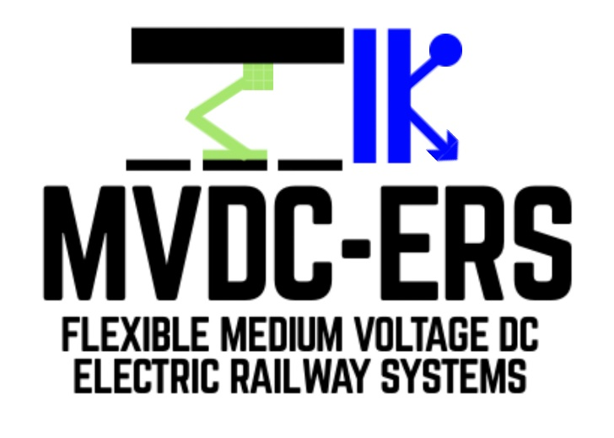

Deliverable D1.2
Assessment of performance for MVDC electrification systems

Document details

Authors | Sina Sharifi, Pietro Tricoli
Due date | 31-05-2021
Actual delivery date | 31-05-2021
Lead contractor | University of Birmingham
Version | 2.0
Prepared by | University of Birmingham
Input from | -
Reviewed by | Technical University of Cluj-Napoca
Dissemination level | Public

Project contractual details

Project title | Flexible medium voltage DC electric railway systems
Project acronym | MVDC-ERS
Grant agreement no. | 828638
Project start date | 01.12.2018
Project end date | 30.04.2022
Duration | 41 months
Supplementary notes | The document type is public

Disclaimer:

* Please note that this deliverable is undergoing S2R JU review and acceptance processes. At this stage this deliverable reflects only the author’s view and the S2R JU is not responsible for any use that may be made of the information it contains.
1 Introduction 3
2 List of Figures 4
3 List of Tables 6
4 Abbreviations and acronyms 7
5 Medium voltage DC (MVDC) traction power substation (TPS) model 8
5.1 MVDC railway parameters 8
5.2 Transformer, overhead line and load modelling 8
5.3 Modular multilevel converter model 11
5.3.1 Power circuit and guidelines about the ratings 10
5.3.2 Control and modulation 11
6 Performance analysis of an individual MVDC TPS 12
6.1 Power quality 13
6.2 Electromagnetic compatibility (EMC) 20
6.3 Input and output characteristics of the converters 21
6.4 Regenerative braking mode 21
6.5 Loss analysis 23
6.6 Transient scenarios 24
6.7 Impact on power distribution networks operating at different voltage levels 26
6.8 Impact of wide band-gap (WBG) semiconductor devices on efficiency and voltage level for the TPS converters 27
6.8.1 Possible options for MVDC TPS topology using under developing SiC IGBTs 27
6.9 DC side short circuit 30
6.10 Overloading capability 34
6.11 Possibility of low voltage DC connectivity for MMC-FB 35
6.12 Capability of superimposing test signals at higher frequencies to assess the rolling stock compatibility 35
7 MVDC railway network model 37
7.1 Double-end feeding scheme 37
7.1.1 Modelling renewable sources (PV farms) 37
7.1.2 Effect of temperature on PV farms production and the system performance 42
7.1.3 Power sharing 42
7.2 Mesh feeding scheme 45
7.2.1 Modelling of moving trains 48
8 Monitoring and verification of technical key performance indicator (KPI) “a”: Railway electrification simulation tool 49
8.1 KPI a1: Number of kilometres of lines simulated 49
8.2 KPI a2: Transmission and converter power losses identified 49
8.3 KPI a3: Reduction of the design power of substations 49
9 Conclusion 50
10 References 51

Introduction
The present report constitutes deliverable D1.2, a document produced for WP1 “Performance and characteristics of static converters for MVDC rail power supplies”, Task 1.2 “Software model” and Task 1.3 “Assessment of performance and characteristics”.
One of the main objectives of WP1 is to develop a detailed model of the converter feeder station, using bespoke developed software and analysing the model performance.
Hence, D1.2 “Assessment of performance for MVDC electrification systems” presents the MVDC railway properties and the converter topology selected for the traction substations. D1.2 also analyses the developed model in various scenarios, including normal and abnormal operation conditions, showing the proper functionality of the substation. The deliverable then investigates the performance of a double-end fed MVDC railway in the presence of renewable sources (PV farms). In addition, D1.2 describes a simulation case, where the trains’ load is equally shared between two traction substations. At last, the deliverable presents the simulation results for meshed MVDC network and reviews the current status of technical key performance indicator (KPI) “a”.

The deliverable has the following sections:
• Section 2, 3 and 4 describe list of figures, list of tables and abbreviations and acronyms used in this report;
• Section 5 introduces the developed model for MVDC traction power substaion;
• Section 6 presents the performance analysis of an individual MVDC substation in different case studies;
• Section 7 describes the MVDC railway network model;
• Section 8 reviews technical key performance indicator (KPI) a;
• Section 9 draws the conclusions;
• Section 10 presents the references.

List of Figures
Figure 1 - Model of MVDC railway electrification system 9
Figure 2 - Schematic of MMC-FB topology 10
Figure 3 - MMC-FB and the control unit: Overall structure 12
Figure 4 - Developed model of an individual MVDC TPS 13
Figure 5 - Load current profile 13
Figure 6 - Output DC voltage at TPS terminal 14
Figure 7 - Output DC voltage at TPS terminal (Magnified) 14
Figure 8 - Capacitor voltages in each arm of MMC-FB 15
Figure 9 - Arm voltages of leg “a” in MMC-FB 15
Figure 10 - Arm currents of leg “a” in MMC-FB 16
Figure 11 - Voltage and current of phase "a" of distribution network 17
Figure 12 - Voltage and current of phase "a" of distribution network (magnified) 17
Figure 13 - Power factor at distribution network: Full load of 680 A DC 18
Figure 14 - Power factor at distribution network: 10 % of full load (68 A DC) 18
Figure 15 - TDD of distribution network phase current 19
Figure 16 - Harmonic analysis of DC voltage 20
Figure 17 - Harmonic analysis of DC current 21
Figure 18 - Regenerative braking: DC current profile 22
Figure 19 - Regenerative braking: DC side voltage 22
Figure 20 - Regenerative braking: TDD of phase current at distribution network 22
Figure 21 - Regenerative braking: Phase voltage and current at distribution network 23
Figure 22 - Estimated efficiency curve for MMC-FB 24
Figure 23 - AC voltage dip: Voltage and current of phase "a" of 33 kV network 25
Figure 24 - AC voltage dip: Capacitor voltages in arm "a" of MMC-FB 25
Figure 25 - AC voltage dip: DC side voltage 26
Figure 26 - AC voltage dip: DC side current 26
Figure 27 - Two-level voltage source converter 29
Figure 28 - Three-level NPC converter 29
Figure 29 - Four-level NPC converter 29
Figure 30 - Cascaded two-level voltage source converter 30
Figure 31 - Simulation case for DC side short circuit 31
Figure 32 - Non-permanent DC short circuit: Voltage and current at DC side 32
Figure 33 - Non-permanent DC short circuit: DC current (zoomed) 32
Figure 34 - Non-permanent DC short circuit: Arm voltages at phase "a" of MMC-FB 33
Figure 35 - Non-permanent DC short circuit: Voltage and current at phase "a" of distribution network 33
Figure 36 - Permanent DC short circuit: Voltage and current at phase "a" of distribution network 34
Figure 37 - Permanent DC short circuit: Voltage of capacitors in arm "a" 34
Figure 38 - Super imposing test signals: adding 5th harmonic to DC side voltage 36
Figure 39 - Super imposing test signals: adding 5th and 15th harmonics to DC side voltage 36
Figure 40 - PV arrays and boost converter 37
Figure 41 - Simulation of the MVDC railway in the presence of PV farms: the network configuration 38
Figure 42 - Output voltage of TPS1, TPS2, PV farms and the load 39
Figure 43 - Capacitor voltages in leg "a" of TPS1 converter: Top arm and bottom arm 40
Figure 44 - Voltage and current of phase “a” at the AC side of TPS1 40
Figure 45 - Calculated TDD for TPS1 41
Figure 46 - Output power of TPS1, TPS2, PV farms and the load 41
Figure 47 - Output power of TPS1, TPS2, PV farms and the load (T_PV = 45 ⁰C) 42
Figure 48 - The simulation case for power sharing between TPSs 43
Figure 49 - Calculation of TPS2 voltage reference 43
Figure 50 - Power sharing: TPSs and load voltages 44
Figure 51 - Power sharing: TPSs power and sum of the consumed power in the network 44
Figure 52 - Meshed MVDC railway network 45
Figure 53 - Voltage of TPSs and loads in the MVDC meshed network 47
Figure 54 - Output power of TPSs in MVDC network 47
Figure 55 - Consumed power by loads in MVDC network 48
Figure 56 - Sum of the transferred power in MVDC network 48
Figure 57 - Modelling of moving trains by variable resistors and inductors 49

List of Tables
Table 1 - Parameters of MVDC railway electrification system 8
Table 2 - Parameters of TPS transformer 9
Table 3 - MMC-FB specifications 11
Table 4 - Current distortion limits for systems rated 120 V through 69 kV as indicated in [7] 19
Table 5 - Average power consumed by each part of the railway at full load of 17 MW 23
Table 6 - Parameters for PV farm simulation case 38
Table 7 - Average power losses of overhead lines and running rails from t = 0.4 to t = 0.8 s 45
Table 8 - Simulation parameters - meshed MVDC network 45

Abbreviations and acronyms
Abbreviations and acronym | Definition
DCCB | DC circuit breaker
EMC | Electromagnetic compatibility
GaN | Gallium nitride
IGBT | Insulated gate bipolar transistor
KPI | Key performance indicator
MMC-FB | Modular multilevel converter with full-bridge submodules
MOSFET | Metal oxide semiconductor field effect transistors
MPPF | Metalized polypropylene film
MVAC | Medium voltage AC
MVDC | Medium voltage DC
NPC | Neutral-point clamped
PI | Proportional-Integral
Si | Silicon
SiC | Silicon carbide
TDD | Total demand distortion
TPS | Traction power substation
WBG | Wide band-gap

Medium voltage DC (MVDC) traction power substation (TPS) model

MVDC railway parameters
In order to use the existing 25 kV AC infrastructure, nominal voltage for medium voltage DC (MVDC) supply system is chosen as 25 kV DC. Since the MVDC railway system is a new arrangement, there are no standards available for its operation. Therefore, existing standards for 25 kV AC railway [1] are used as a starting point to define operational conditions of MVDC railway, as shown in Table 1.
Table 1 - Parameters of MVDC railway electrification system
Parameter | Symbol | Value (kV)
Lowest non-permanent voltage | $$U_{min2}$$ | 17.5
Lowest permanent voltage | $$U_{min1}$$ | 19
Nominal voltage | $$V_{DC,nom}$$ | 25
Highest permanent voltage | $$U_{max1}$$ | 27.5
Highest non-permanent voltage | $$U_{max2}$$ | 29
Maximum voltage during long-term overvoltages | $$U_{max3}$$ | 38.75
The maximum duration for $U_{min2}<V<U_{min1}$ and $U_{max1}<V<U_{max2}$ is 2 and 5 minutes, respectively. Moreover, the duration of long-term overvoltages lies between 20 millisecond and 1 second. The substation busbar voltage at no-load condition should be less than or equal to the highest permanent voltage ($U_{max1}$) [1], and in this study, it is chosen as 25 kV.
The MVDC supply system will likely supply high-speed lines. Hence, the power rating of each AC-DC converter in MVDC TPSs is chosen at $P_{converter}=$20 MW. The nominal DC current for each converter is:
$$I_{DC,nom}= \frac{P_{converter}}{V_{DC,nom}}=800 A$$ | (1)
It is also assumed that the maximum load for each TPS is 17 MW. In other words, a margin of 3 MW is considered for safe operation of TPS during small overloads, as converters must be designed for the peak load due to their limited thermal inertia.

Transformer, overhead line and load modelling
As shown in Figure 1, MVDC railway electrification system is connected to power distribution network, which is modelled by a three-phase voltage source and AC cables impedance per unit distance ($r_{dist}$ and $l_{dist}$).
Depending on the distribution network voltage level, a transformer with apparent power of $S_{t}$ provides suitable voltage level for each AC-DC converter. For the base case, the voltage level of distribution network is chosen at 33 kV and the network operating frequency is 50 Hz. Therefore, each 20 MVA AC-DC converter has a dedicated step-down transformer with turn ratio of 3:1, providing 11 kV at the converter side. Table 2 shows the parameters used in the simulations. The values for $r_{dist}$ and $l_{dist}$ for 33 kV cables are chosen as 0.0601 Ω/km and 0.37 mH/km, respectively [2]. It is also assumed that the distance between distribution network and a MVDC TPS is 0.5 km.
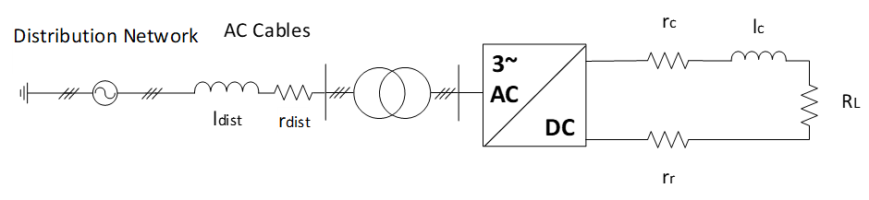
Figure 1 - Model of MVDC railway electrification system
Table 2 - Parameters of TPS transformer
Parameter | Value | Unit
$$S_{t}$$ | 30 | MVA
$$V_{pr}$$ | 33 | kV
$$V_{sec}$$ | 11 | kV
$$R_{pu}$$ | 1.1 | %
$$X_{pu}$$ | 10 | %
The MVDC railways use overhead line electrification system. The parameters $r_{C}$ and $l_{c}$ in Figure 1 represent the resistance and inductance of the overhead line equipment per unit distance. The running rails, as the path for return current, are modelled by $r_{r}$, which is resistance of the rails per unit distance. In all the simulation cases stated in this report, the time span is less than one second and during this time, the change in trains’ position is negligible. Therefore, the overhead lines and running rails are modelled by constant values.
The MVDC railways are double-track railway system, where there are two parallel paths for the inbound and outbound trains. The cross-sectional area for the contact wire conductors in each feeding path is considered to be 150 mm². Therefore, in each feeding path, the equivalent resistance and inductance for the overhead line equipment are assumed to be 0.16 Ω/km and 1.55 mH/km, respectively. The resistance for the running rails is 15 mΩ/km [3].
In a double-track system, the overhead lines (and also the running rails) are bonded together in every certain interval and can be modelled as parallel impedances for simplicity. Therefore, in all the simulation cases, double-track MVDC railways have been simulated by halving the overhead line (and running rail) impedances. In other words, the value for $r_{C}$ is chosen as 0.08 Ω/km, and the values for $l_{c}$ and $r_{r}$ are 0.775 mH/km and 7.5 mΩ/km, respectively.

Modular multilevel converter model
High-power converter topologies which are suitable for medium voltage AC (MVAC) to MVDC conversion have been studied and classified in the literature review (presented in deliverable D1.1). Following these efforts and in order to compare some of the main features, anti-paralleled thyristor rectifier with inverter, two-level voltage source converter, and modular multilevel converter with full-bridge submodules (MMC-FB) have been sized for the MVDC TPSs, and their power losses have been analytically calculated [4].
Based on the above analysis and considering MVDC TPS requirements such as the ability of limiting DC short circuit current and ability to work in a multi-terminal DC network, MMC-FB topology has been selected as the most promising solution for the MVDC TPSs. First, a numerical model for MMC with half-bridge submodules was developed in Matlab/Simulink and tested for the MVDC railways. As the MMC with half-bridge submodules cannot limit DC short circuit currents, the model was extended to MMC-FB topology. Therefore, the MVDC railways can be tested with two different converter topologies. In this report, all the analysis is undertaken with MMC-FB topology.

Power circuit and guidelines about the ratings
The MMC-FB has six arms and each arm consists of N submodules and one arm inductor, shown in Figure 2. Table 3 presents the parameters of the MMC-FB proposed for the MVDC TPS.
Considering that $U_{max3}$ has been defined for MVAC railways with nominal voltage of 25 kV RMS, the maximum voltage during long-term overvoltages in MVDC system can be assumed to be less. In other words, the peak value for nominal AC voltage is 35.36 kV, while the nominal voltage for MVDC system is 25 kV DC. Therefore, it is reasonable to consider the highest operating voltage of $U_{max2}$ + 10% = 31.9 kV for the converter.
As there are 8 submodules per arm, each switch in the submodule must block 4 kV. Hence, a commercially available 6.5 kV insulated gate bipolar transistor (IGBT) can be used for the submodule, considering enough margins for safe operation [5]. In the case that the highest operating voltage is selected more than 31.9 kV, the converter can still be realised with 6.5 kV IGBTs and a higher number of submodules. This shows one of the advantages of MMCs, i.e., modularity and ease of scaling to higher voltage ratings.
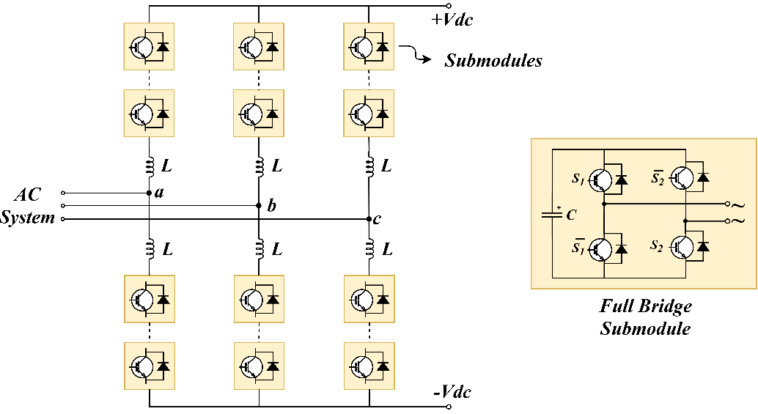
Figure 2 - Schematic of MMC-FB topology
Table 3 - MMC-FB specifications
Parameter | Definition | Value
$$P_{converter}$$ | Apparent power of the converter | 20 MVA
$$V_{DC,nom}$$ | Nominal voltage at DC side | 25 kV
$$N$$ | Number of submodules in each arm | 8
$$V_{C,n}$$ | Capacitor nominal voltage in each submodule | 3.13 kV
$$C_{sm}$$ | Capacitance of each submodule | 10 mF
$$L_{arm}$$ | Inductance of each arm | 8 mH
$$f_{s}$$ | Switching frequency of each submodule | 3 kHz
Considering nominal operating condition, negligible losses, unity power factor, and unit modulation index (m = 1), the maximum value for the arm current is calculated as follows:
$$V_{AC,phase,peak}= \frac{1}{2}m V_{DC}$$  $$\frac{3}{2} V_{AC,phase,peak}I_{AC,peak}= V_{DC} I_{DC}$$  $V_{AC,phase,peak}=12.5 kV, { I}_{AC,peak}=1.07 kA$  $$I_{arm}\left(t\right)= \frac{I_{DC,nom}}{3}± \frac{I_{AC,peak}}{2}\cos\left(ωt\right)$$  $$I_{arm,peak}= \frac{I_{DC}}{3}+ \frac{I_{AC,peak}}{2}=800 A$$ | (2)
Hence, a 6.5 kV, 1000 A IGBT-Diode module like ABB 5SNA 1000G650300 HiPak IGBT module [9] is sufficient to carry the submodule current and withstand the submodule voltage.

Control and modulation
The objective of converter control unit includes maintaining the capacitor voltages close to their reference value, regulating the DC side voltage to the nominal voltage, and operating the converter with unity power factor. This is done by measuring capacitor voltages, and currents and voltages at primary and secondary of the transformer.
Figure 3 demonstrates overall structure of the control unit, implemented in Matlab/Simulink. The measured quantities are transformed to d-q synchronous frame using Park and Clarke transformations [6]. While the outer control loops are responsible for controlling reactive power flow and capacitor voltages, the inner current control loops control $I_{d}$ and $I_{q}$. The calculated values for $I_{d}$ and $I_{q}$ are then transformed back to abc frame to provide proper AC reference waveforms.
Theses reference waveforms together with a reference signal for the DC side voltage are then sent to the modulator. Using a modified version of level-shifted carrier modulation, the number of submodules which should be inserted in each arm is determined. In addition, the capacitor voltages are sorted in the modulator block. Based on the arm current direction, the submodules with higher priority are selected and proper gate signals are sent to the corresponding switches.
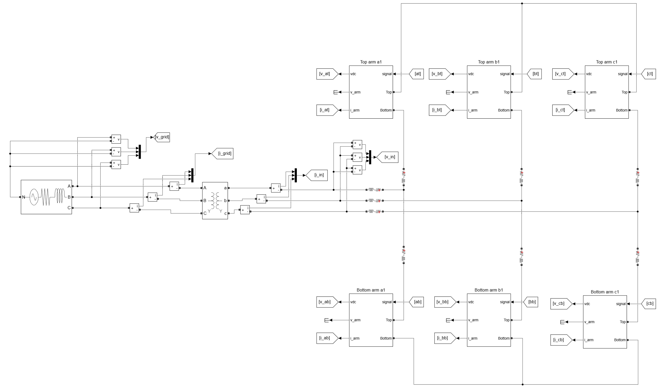
Figure 3 - MMC-FB and the control unit: Overall structure

Performance analysis of an individual MVDC TPS
This section deals with performance assessment of an individual TPS in both normal and abnormal conditions. The model used for the assessments is shown in Figure 4, where a MMC-FB is connected to 33 kV network by a transformer. At the DC side, a circuit breaker is used to connect the load after t = 0.2 s. This is to ensure that the DC link voltage has been stabilised at nominal value before connecting the load.
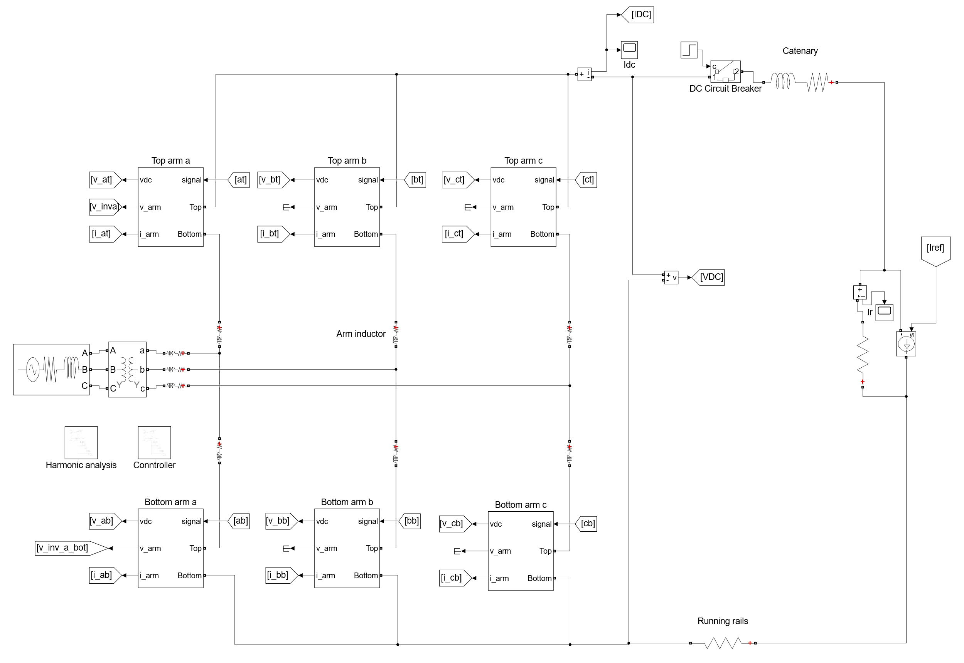
Figure 4 - Developed model of an individual MVDC TPS

Power quality
The trains’ load is modelled by a controlled DC current source. The DC current is changed according to Figure 5, to model a full load of 17 MW at 25 kV DC from t = 0.3 s to t = 0.8 s. The load distance from the TPS is 10 meters, which means the tests are done at converter’s terminal.
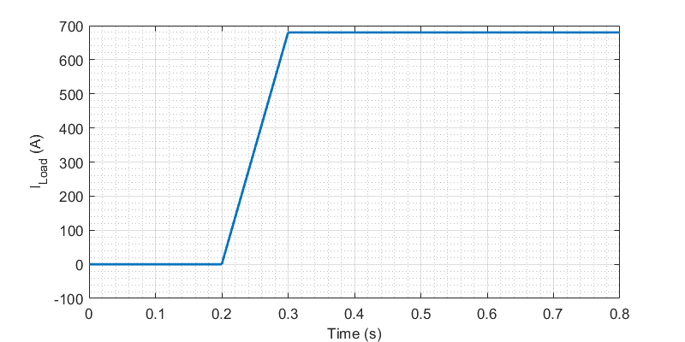
Figure 5 - Load current profile
As shown in Figure 6 and Figure 7 , the converter can regulate the DC voltage at 25 kV, having low voltage ripples. Thanks to the implemented modulation scheme, the peak-to-peak ripple of DC voltage is 1.23% at steady state (from t = 0.4 s onwards). Therefore, the converter can operate without DC side filter, saving the space and costs of DC side filter.
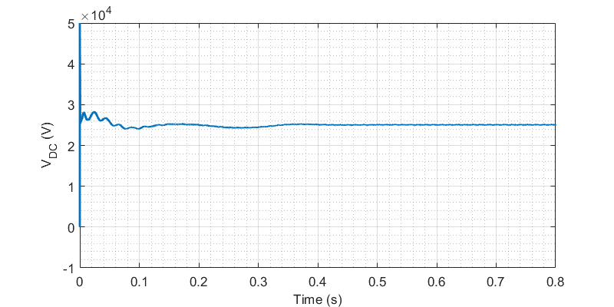
Figure 6 - Output DC voltage at TPS terminal
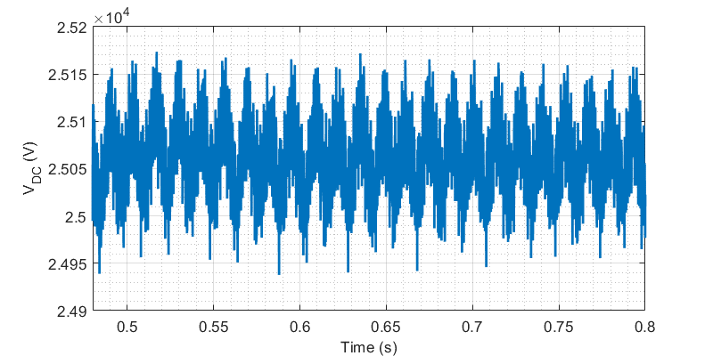
Figure 7 - Output DC voltage at TPS terminal (Magnified)
Figure 8 demonstrates capacitor voltages in each arm of MMC-FB, which are balanced and close to their reference, i.e., $\frac{V_{DC,nom}}{N}= \frac{25 kV}{8}$ = 3.125 kV. In addition, arm voltages and currents of leg “a” are represented in Figure 9 and Figure 10, confirming the normal operation of the converter.

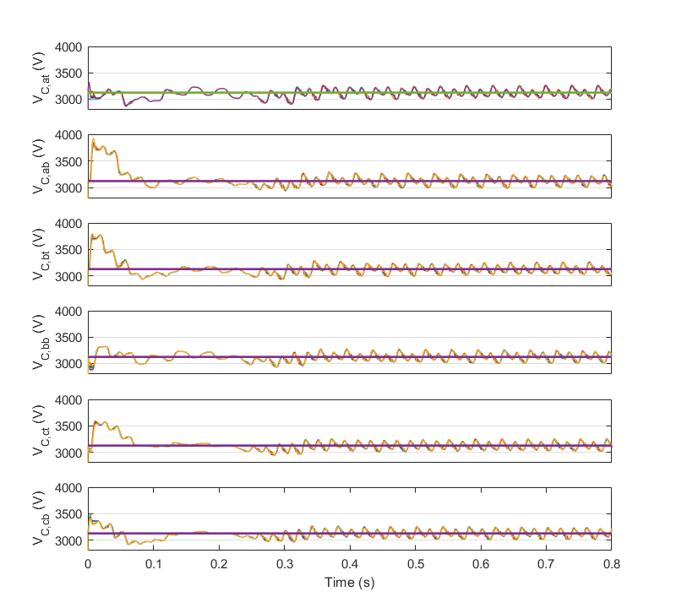
Figure 8 - Capacitor voltages in each arm of MMC-FB
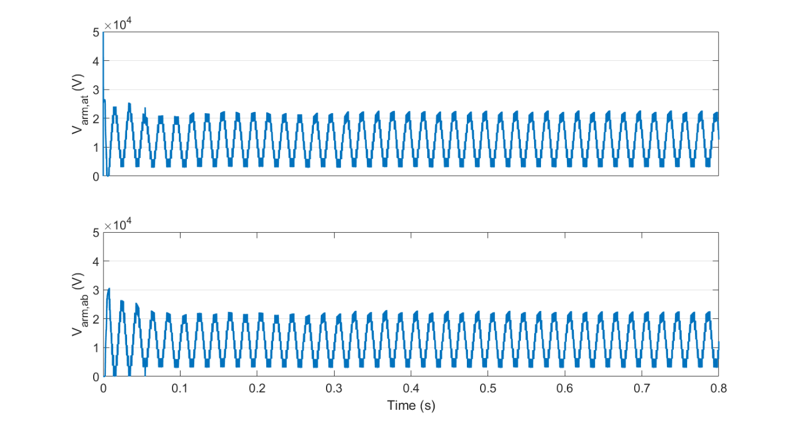
Figure 9 - Arm voltages of leg “a” in MMC-FB
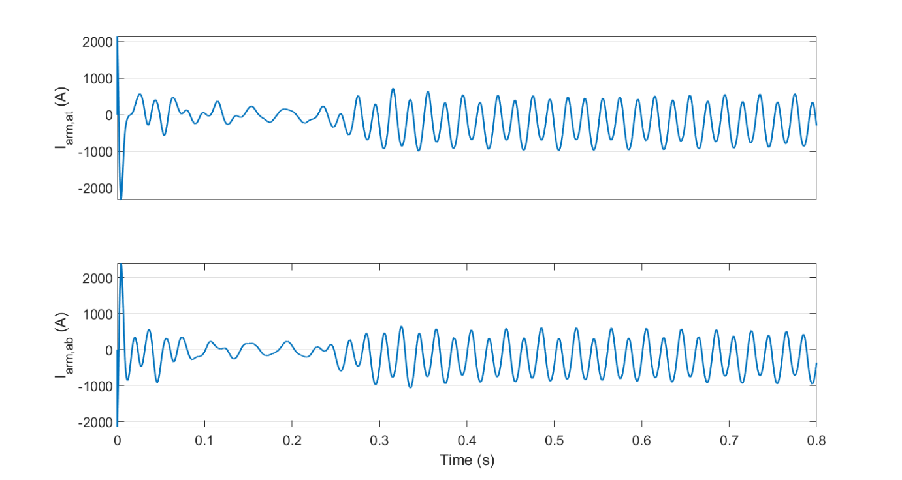
Figure 10 - Arm currents of leg “a” in MMC-FB
Figure 11 and Figure 12 depict voltage and current of phase “a” at 33 kV distribution network. It can be seen that the converter draws a high-quality sinusoidal current from the network. In addition, the current is in phase with the voltage, showing that the converter controller is working properly and the converter is feeding the load with nearly unity power factor. In other words, the transferred reactive power is negligible in comparison to the transferred active power. Assuming harmonic free voltages, the power factor at the distribution network is evaluated as follows:
$$PF =\frac{P}{\left|S\right|}= \frac{I_{RMS,1}}{I_{RMS}} × \cos{φ_{1}}$$ | (3)
where $P$ is the average of transferred active power, $S$ is total of apparent power, $I_{RMS,1}$ is the RMS value for fundamental component (first harmonic) of the phase current, $I_{RMS}$ is the RMS value for the phase current, and $φ_{1}$ is the phase difference between the phase voltage and the fundamental component of the phase current. As demonstrated in Figure 13 and Figure 14 and after the transients, the power factor at full load current (680 A DC) and 10% of full load current (68 A DC) is nearly unity, which means that the converter can maintain high power factor in both high and low load currents.
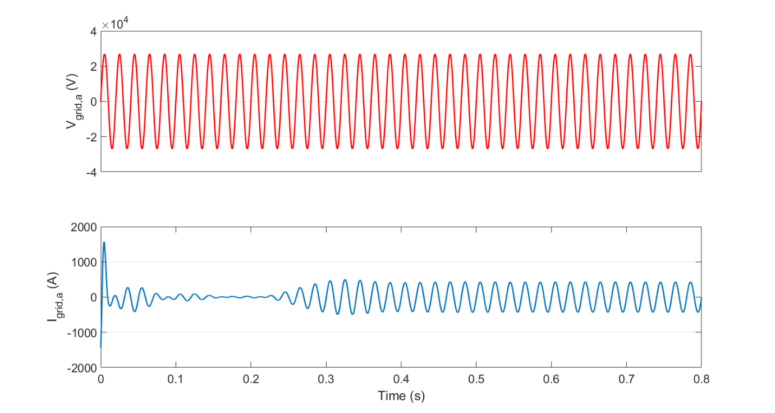
Figure 11 - Voltage and current of phase "a" of distribution network
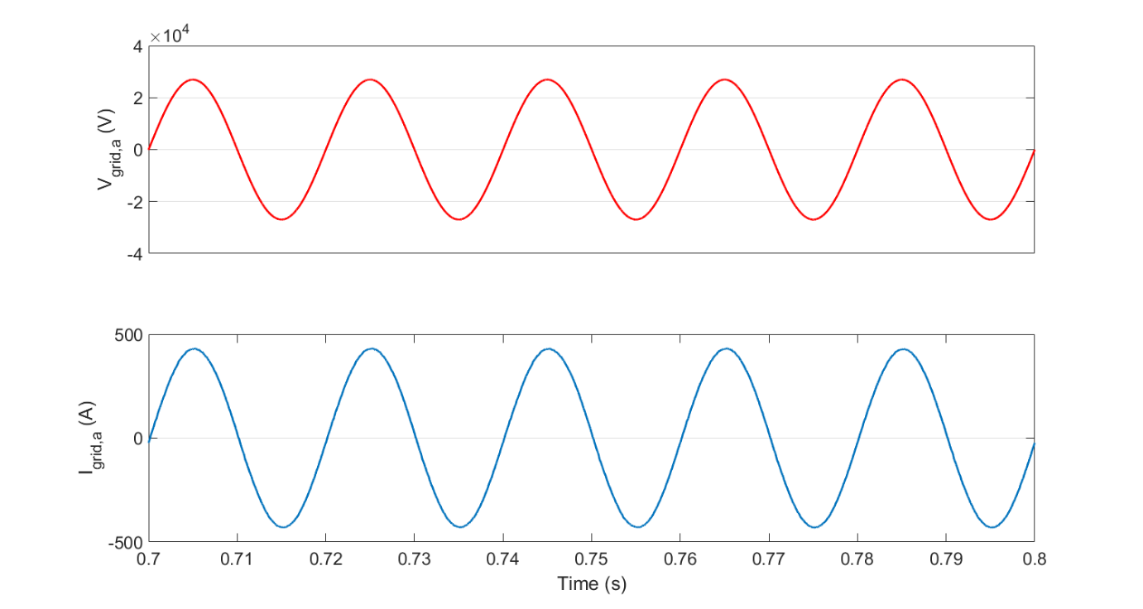
Figure 12 - Voltage and current of phase "a" of distribution network (magnified)
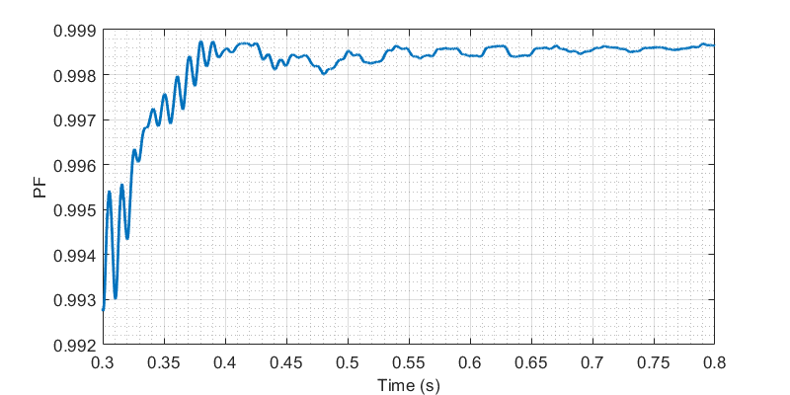
Figure 13 - Power factor at distribution network: Full load of 680 A DC
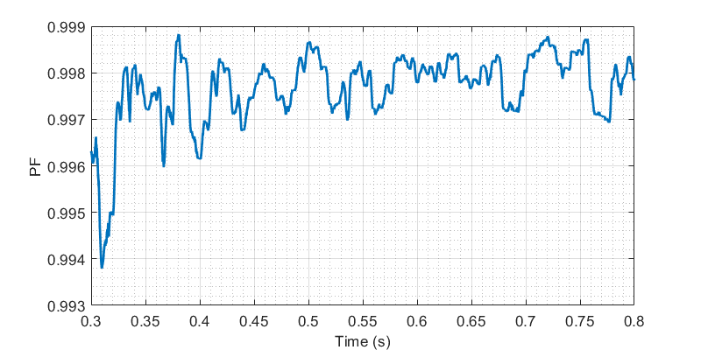
Figure 14 - Power factor at distribution network: 10 % of full load (68 A DC)
According to IEEE519-2014, harmonic contents of the AC networks should be monitored to ensure that the networks have sufficient levels of power quality. For 120 V to 69 kV networks, it is recommended to evaluate total demand distortion (TDD) for the currents. TDD is defined as “the ratio of the root mean square of the harmonic content, considering harmonic components up to the 50th order and specifically excluding interharmonics, expressed as a percent of the maximum demand current. Harmonic components of order greater than 50 may be included when necessary” [7]. In other words, TDD of the phase current ($I$) can be calculated as follows:
$$TDD (I) \%= \frac{\sqrt{\sum_{2}^{50}{{I_{RMS,n}}^{2}}}}{I_{L,RMS}} ×100$$ | (4)
where $I_{RMS,n}$ is the RMS value for n^{th} harmonic component, and $I_{L,RMS}$ is the RMS value for maximum demand current. Based on the maximum short circuit current ($I_{sc}$) and the maximum demand current ($I_{L}$), TDD and individual harmonics must be less than specified values in IEEE519-2014.
In this study, $I_{L}$ for a 20 MW, 33 kV feeder is assumed to be the nominal current of the feeder, which is 0.35 kA RMS. Moreover, the maximum fault levels on the 33 kV network is considered as 1000 MVA [8], therefore:
$$I_{sc}= \frac{1000 MVA}{\sqrt{3} ×33 kV}=17.5 kA$$ | (5)
Hence, the value for $\frac{I_{sc}}{I_{L}}$ equals to 50, and TDD and individual harmonics should be less than the specified values shown in Table 4. In this table, all the values are in percent of $I_{L}$.
Table 4 - Current distortion limits for systems rated 120 V through 69 kV as indicated in [7]
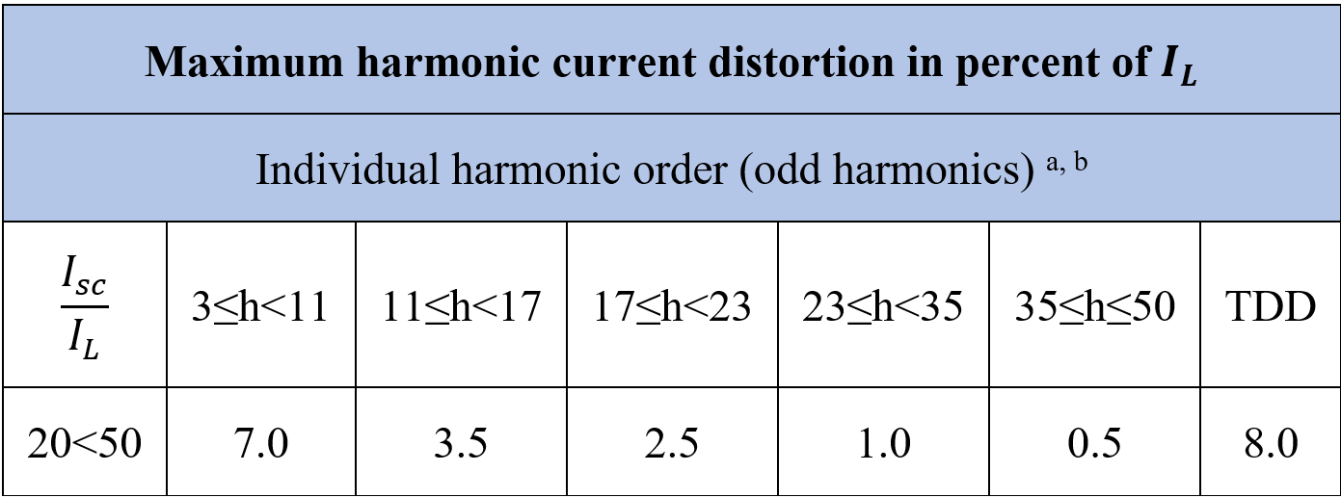
ª Even harmonics are limited to 25% of the odd harmonic limits above.
^{b} Current distortions that result in a dc offset, e.g., half-wave converters, are not allowed.
The evaluated TDD for the network current (phase “a”) is presented in Figure 15. It is obvious that after the transients, TDD decreases to less than 1%. Furthermore, all the harmonics (2nd to 50th) have been checked and their values are less than the values specified in Table 4, except for 44th harmonic, which is slightly (0.05) higher than the specified value. This high order harmonic can be easily filtered using AC side filters. Hence, the TPS converter complies with the standard for current harmonic emission.
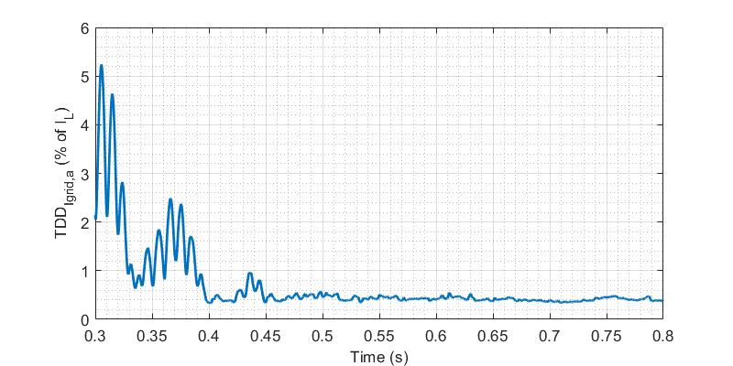
Figure 15 - TDD of distribution network phase current

Electromagnetic compatibility (EMC)
As discussed in section ‎6.1, at the AC side, the harmonic current emission by the converter complies with the standards. At the DC side, the voltage and current harmonics should not interfere with track circuit systems. As an example, the frequency of Clearguard TCM 100 Track Vacancy Detection System can be selected from 4.75 kHz to 16.5 kHz [9].
Figure 16 and Figure 17 demonstrate the harmonic analysis of the DC side voltage and current after t = 0.4 (with the same load condition as section ‎6.1). In these bar graphs, the amplitude of harmonic contents is calculated relative to the DC component. Obviously, the amplitude of high frequency harmonics in DC current is negligible. In the DC voltage spectrum, however, there are high frequency components (such as 0.03% or 7.5 V in 5.1 kHz). The supply voltage for Clearguard TCM 100 Track Vacancy Detection System is 24 V DC, which means that the interference is possible. Therefore, the operating frequency for the track circuit system should be selected to the frequencies which have negligible amplitude in the DC voltage spectrum (for example, 14.5 kHz).
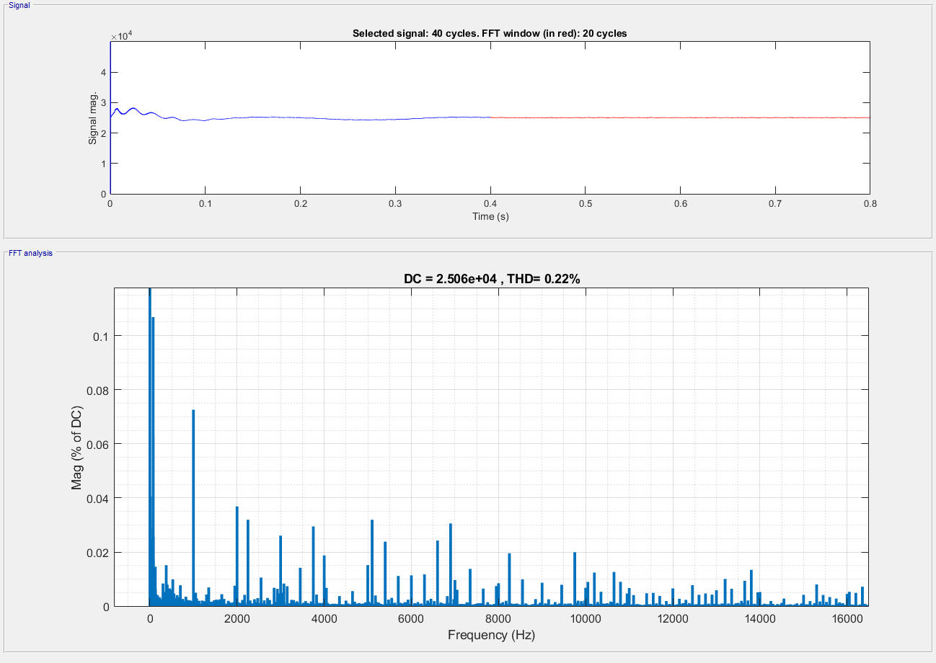
Figure 16 - Harmonic analysis of DC voltage
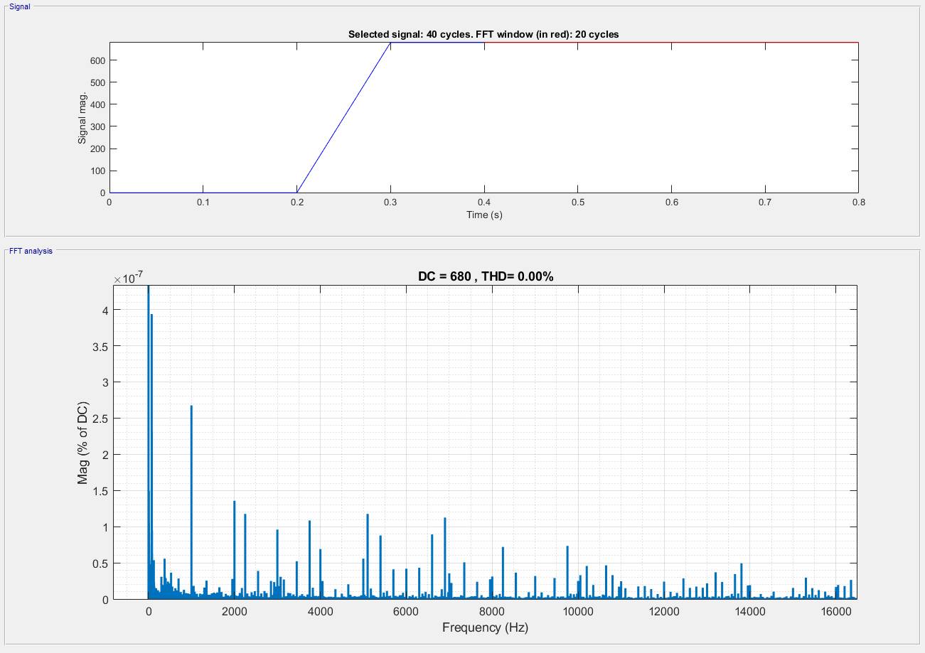
Figure 17 - Harmonic analysis of DC current

Input and output characteristics of the converters
In conventional MVAC railways, the railway TPSs act as resistive-inductive loads for the AC distribution network. While in nominal load conditions the MVAC TPSs have high power factor, in low load currents, the power factor drops and TPSs consume more reactive power, which is not desirable.
In the MVDC railways and thanks to the implemented control, the TPSs’ converters can control the reactive power flow. In normal operation, the converters operate with nearly unity power factor. Hence, the MVDC TPSs act as resistive loads for the AC distribution network. In the case that the distribution network needs reactive power support, the MVDC TPSs can act as a resistive-capacitive load and inject reactive power to the network. If needed, the MVDC TPSs can also act as resistive-inductive loads and consume reactive power from the network. At the DC side, the MVDC TPSs can regulate the voltage to the nominal value regardless of the trains’ load, so the TPSs have zero output impedance up to the rated value of the current.

Regenerative braking mode
To assess the TPS performance during regenerative braking, the trains’ load is modelled by a typical negative DC current profile, presented in Figure 18. The final value for DC current is -340 A, which is equivalent to 8.5 MW power regeneration at 25 kV, assuming that the regenerative braking rate is always less than 50%.
The DC side voltage and TDD of the distribution network phase current are demonstrated in Figure 19 and Figure 20, confirming proper TPS operation in regenerative braking mode. According to voltage and current of phase “a” at AC distribution network, shown in Figure 21, the current is 180 degrees out of phase from the voltage. In other words, the active power regenerated by the brakes is injected to the network with unity power factor.
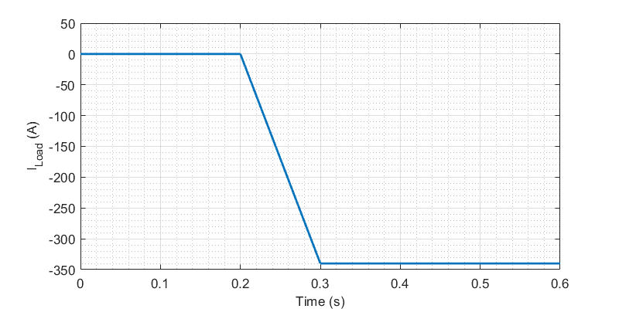
Figure 18 - Regenerative braking: DC current profile
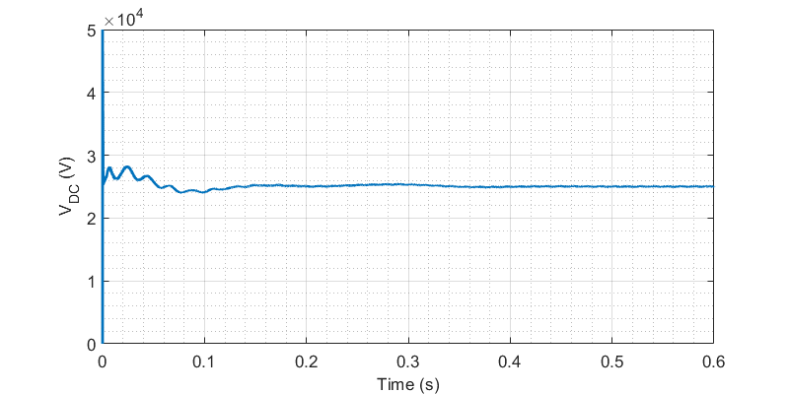
Figure 19 - Regenerative braking: DC side voltage
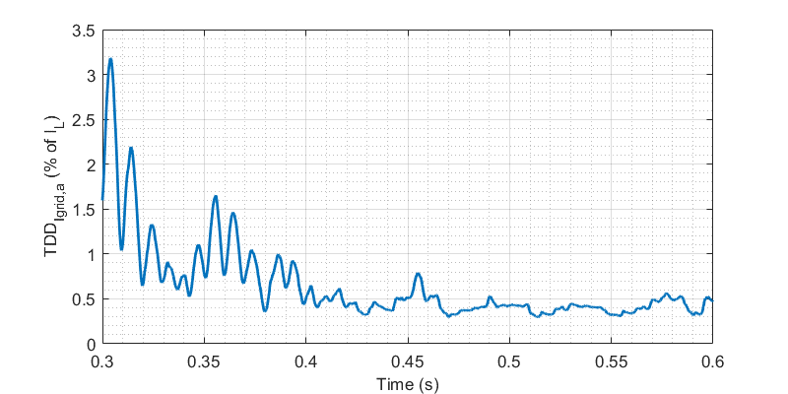
Figure 20 - Regenerative braking: TDD of phase current at distribution network
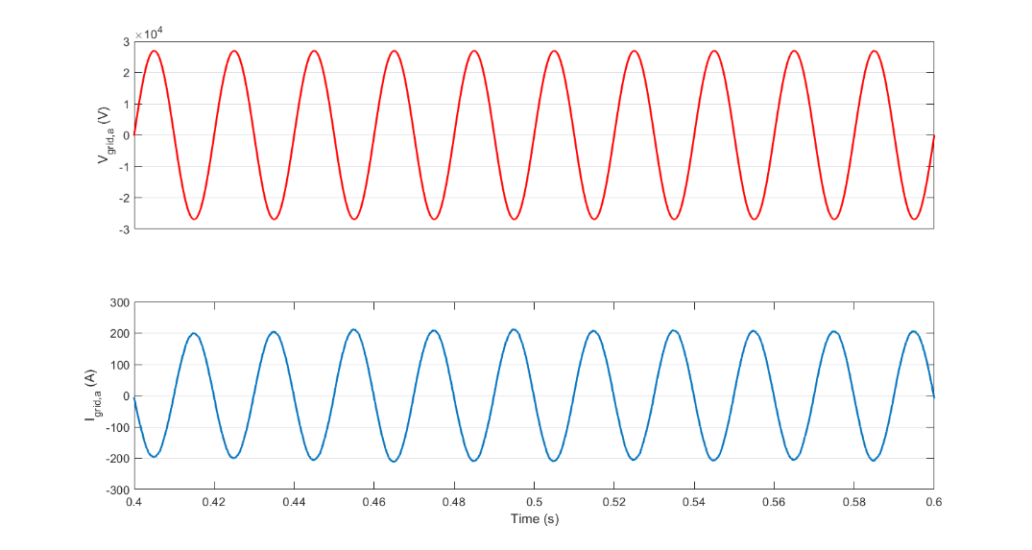
Figure 21 - Regenerative braking: Phase voltage and current at distribution network

Loss analysis
To estimate the MMC-FB energy efficiency, the converter is tested at different load conditions. The current profile is the same as Figure 5, but the final value is changed. Based on the average power consumption of the load, the converter, and 1 km of overhead lines and running rails from t = 0.3 to t = 0.8, the converter efficiency is calculated as follows:
$$η= \frac{{\overline{P}}_{out}}{{\overline{P}}_{out}+ {\overline{P}}_{loss,MMC}} ×100= \frac{{\overline{P}}_{Load}+ {\overline{P}}_{cw}+ {\overline{P}}_{rails}}{{\overline{P}}_{Load}+ {\overline{P}}_{cw}+ {\overline{P}}_{rails}+ {\overline{P}}_{loss,MMC}} ×100$$ | (6)
It is assumed that the converter is realised with ABB 5SNA 1000G650300 HiPak IGBT modules (6.5 kV, 1 kA) and the required parameters for the simulations are adopted from its datasheet [10].
Table 5 shows the average power consumed by each part of the MVDC railway at full load of 17 MW, which yields to 98.1 % of efficiency for the converter. The converter efficiency is also estimated in various load conditions and the results are presented in Figure 22. The negative values for the power represent the converter efficiency in regenerative braking mode. The converter efficiency in low load conditions is low. This is because the output power is low and the converter losses are considerable in comparison to the output power.
Table 5 - Average power consumed by each part of the railway at full load of 17 MW
 | Load consumption | Losses in overhead lines | Rail losses | Converter losses
Average power (kW) | 17010.46 | 36.99 | 3.47 | 328.34
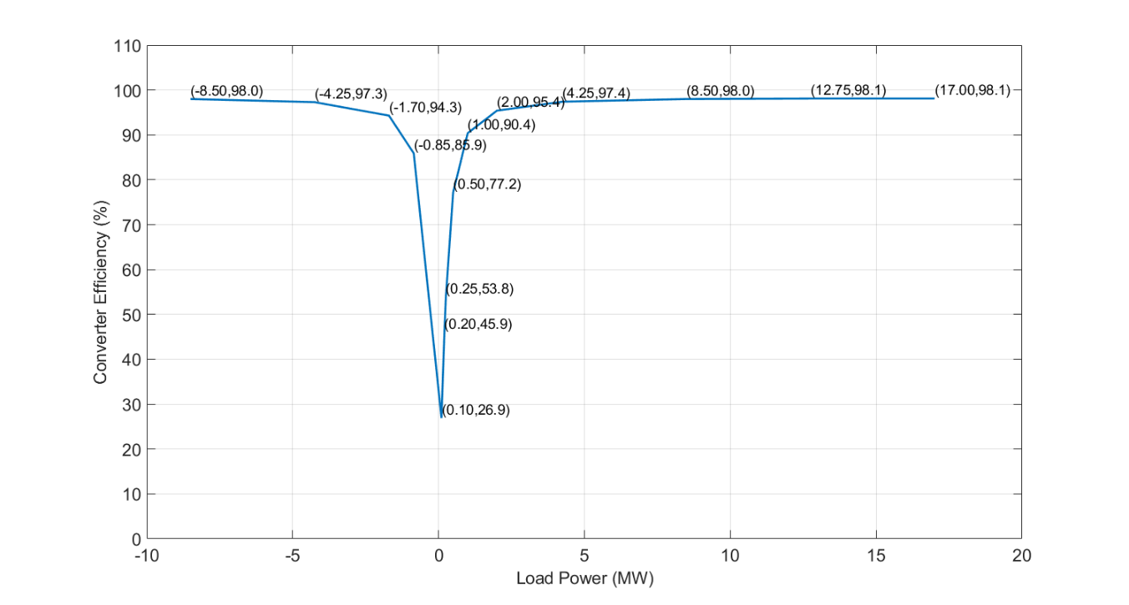
Figure 22 - Estimated efficiency curve for MMC-FB

Transient scenarios
In section ‎6.1, the rate of change in defined DC current profile (load current) between t = 0.2 s and t = 0.3 s is 170 MW/second and the converter can successfully track the current change and feed the load. Therefore, the converter can operate well under rapid and progressive traction load changes.
As another transient scenario, it is considered that the converter is supplying a full load current (according to Figure 5). At t = 0.3 s, a sudden AC voltage dip happens at the 33 kV distribution network, i.e., the voltage decreases to 90% of its nominal value. Then, the network voltage returns to the nominal value at t = 0.35.
The network’s phase voltage and current, capacitor voltages in one arm of MMC-FB, and voltage and current at the DC side are demonstrated in Figure 23 to Figure 26, showing that the converter can tolerate the sudden AC dip and feed the load without interruption.
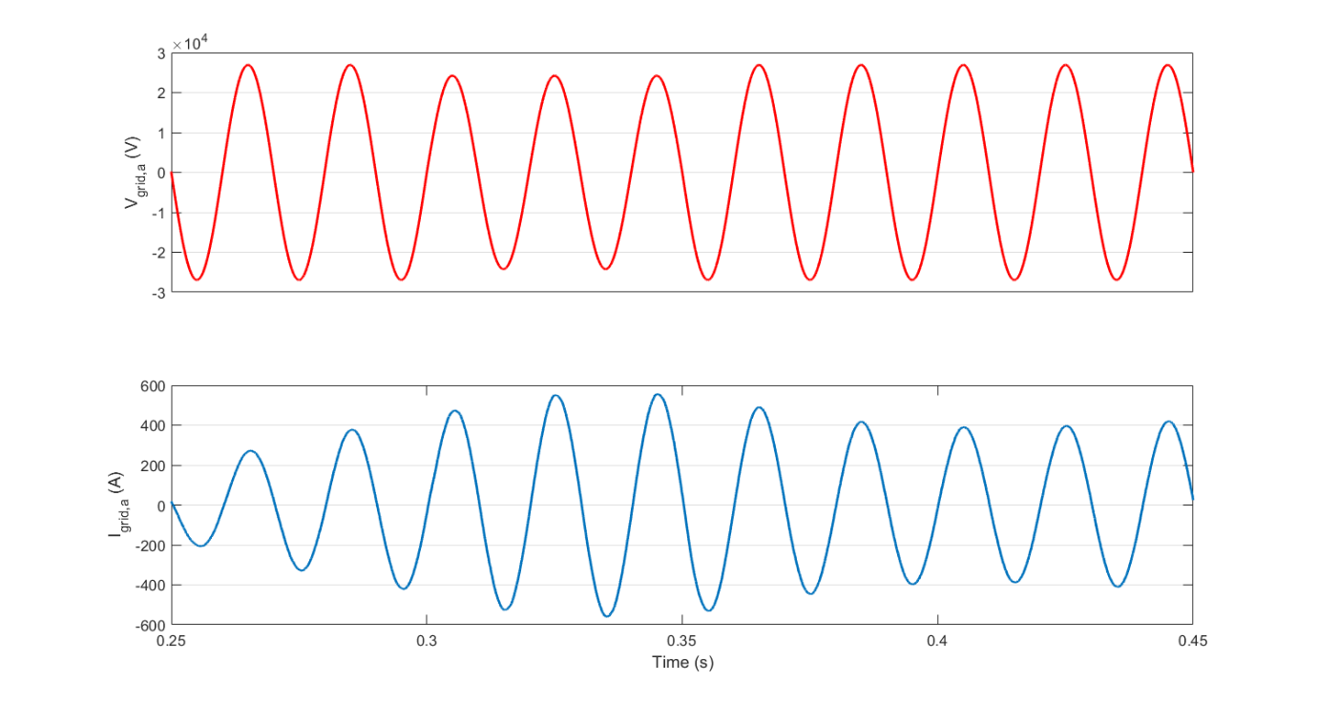
Figure 23 - AC voltage dip: Voltage and current of phase "a" of 33 kV network
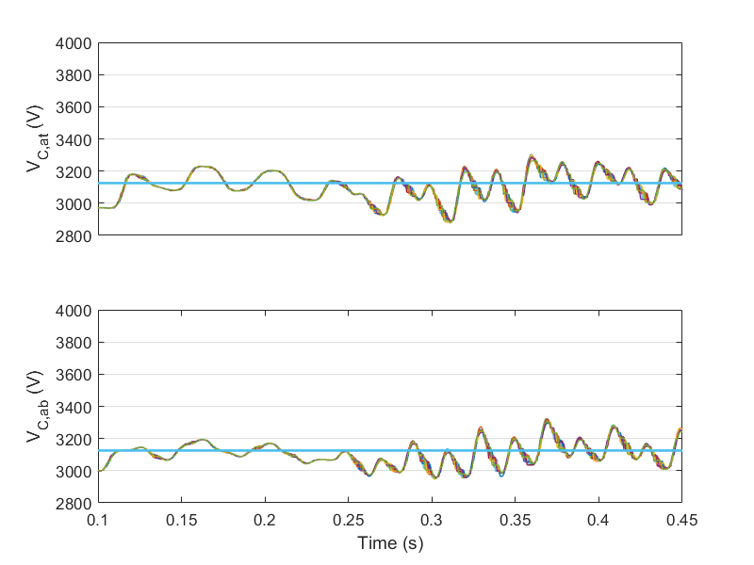
Figure 24 - AC voltage dip: Capacitor voltages in arm "a" of MMC-FB
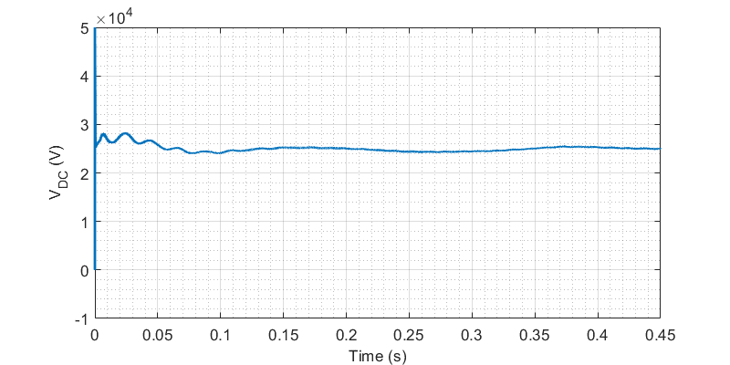
Figure 25 - AC voltage dip: DC side voltage
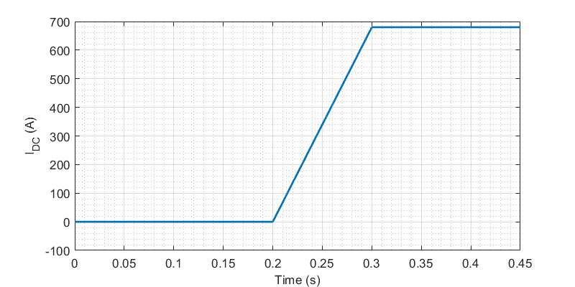
Figure 26 - AC voltage dip: DC side current

Impact on power distribution networks operating at different voltage levels
The selected power rating for MVDC TPSs (20 MW) is compatible with 33 kV distribution network capacities (for example, see [8]). Technically, it is possible to connect the MVDC railways to higher/lower AC voltage levels using step up/down transformers for the MMC-FBs. In addition, MMC-FBs are able to produce high quality AC currents which is required in networks with lower voltage levels.
In general, it is desirable to integrate the railway to AC networks with lower voltage level, as they are more accessible and they can be expanded with lower costs. Moreover, the cost of connecting MVDC TPSs to low voltage networks is less.
It is feasible to have dedicated 11kV/20 MVA feeders for the MVDC railways [8]. However, these feeders are supplied from 33 kV network by 33 kV/11 kV transformers in power distribution substations. If the feeders are only used for the railway loads, it is more sensible to have 33 kV/11 kV transformers in the MVDC TPSs and connect the TPSs to 33 kV network instead.
In addition, there might be some power limitations in weaker 11 kV networks, which means the TPSs’ apparent power should be decreased. This implies that more MVDC TPSs need to be installed with less distance in-between. In this case, although the cost of connection decreases, the number of TPSs, transformers and protection equipment increase. Therefore, the optimal voltage level varies from case to case and depends on the network capacity and conditions.

Impact of wide band-gap (WBG) semiconductor devices on efficiency and voltage level for the TPS converters
As silicon (Si) semiconductors have reached their theoretical limits, new generation of semiconductors named WBG semiconductors have been emerged to replace with Si semiconductors. WBG semiconductors such as silicon carbide (SiC), gallium nitride (GaN) and diamond are used to develop IGBTs, metal oxide semiconductor field effect transistors (MOSFETs) and power diodes, which significantly improve the performance of the both TPS and rolling stock power converters [11].
WBG semiconductors enable the power converters to operate in higher switching frequencies with higher energy efficiencies in comparison to their Si counterparts. Increasing switching frequency leads to decrease in size and volume of passive elements in the power converter. Specifically, the MMC-FB can be realised by smaller arm inductors. This increases the power density of the converter and saves some space in the TPSs, which can be helpful when the cost of land for the TPSs is high. In addition, decreasing the capacitance required in the submodules makes it possible to replace the electrolytic capacitors with metalized polypropylene film (MPPF) capacitors, and increase the converter reliability.
In terms of efficiency and at the same switching frequency (converter volume), the use of WBG semiconductors in MMC-FB yields to higher efficiency, thanks to their lower on-state resistance and switching losses.
However, WBG semiconductors with high voltage ratings are still under development and are not commercially available. At the moment, SiC switches have the highest voltage rating among WBGs. Although some studies about 27 kV SiC IGBT can be found in the literature [12], the highest voltage for a commercially available full SiC device is 3.3 kV (FMF750DC-66A, 3.3 kV, 750 A, Mitsubishi Electric). Therefore, at the current situation, the use of WBGs in MMC-FB yields to higher number of switches and probably, higher losses.

Possible options for MVDC TPS topology using under developing SiC IGBTs
The high voltage SiC MOSFETs and SiC IGBTs, which are suitable for high-frequency switching, are still under development [13]. To the best knowledge of authors, the highest reported blocking voltage among SiC MOSFETs and SiC IGBTs in research papers is 27.5 kV, achieved by a 27 kV/20A SiC IGBT [12]. To investigate the impact of WBG semiconductors on choosing the MVDC TPS converter topology, this subsection investigates the possible options for the converter topology if the 27 kV, 20 A SiC IGBT becomes available to use.
Concerning the current rating, the 27 kV SiC IGBT can only carry 20 A. This means that for the MVDC railway nominal current (800 A DC) and for any chosen topology, a high number of IGBTs (at least forty) should be installed in parallel. This implies that implementing such a low current device is not a wise and reasonable decision. In the rest of this subsection and to compare the topologies in voltage point of view, it is assumed that one individual switch can carry all the needed current.
Concerning the voltage rating, it is necessary to consider a safety margin for operating the IGBTs. Because of hard-switching in power converter topologies and the stray inductances in the switching path, it is mandatory to choose an IGBT with higher blocking voltage capability than the actual applied voltage [5]. In other words, the ratio of device blocking voltage to operating voltage should be selected in the range of 1.8 to 1.9 [14] or even higher. Hence, the maximum voltage that can be applied to a 27 kV SiC IGBT is 14.2 kV.
As discussed in section ‎5.3.1, the highest operating voltage for the MVDC TPS converter is 31.9 kV. Based on this information, there are several options for the converter topology, including:
1- Two-level voltage source converter, shown in Figure 27, with three series switches in each arm of the converter (18 IGBTs + 18 diodes)
2- Three-level neutral-point clamped (NPC), shown in Figure 28, with two series switches in each switching block (24 IGBTs, 36 diodes)
3- Four-level NPC, shown in Figure 29, without any series connection of switches (18 IGBTs, 30 diodes)
4- Cascaded two-level voltage source converter with two stages (N_{two-level} = 2) as shown in Figure 30 (12 IGBTs + 12 diodes, two transformers or a three-winding transformer)
5- Cascaded three-level NPC with two stages, similar to Figure 30 (24 IGBTs + 36 diodes, two transformers or a three-winding transformer)
6- Modular multilevel converter with full-bridge submodules, shown in Figure 2, with three submodules per arm (72 IGBTs, 72 diodes)
In general, and for all the topologies, the switching losses are proportional to the applied voltage. In comparison to using low voltage switches, the use of high voltage switches increases the switching losses. On the other hand, SiC devices generally have lower on-state resistance and switching losses in comparison to Si devices.
The two-level and three-level converters (options 1 and 2) suffer from low waveform quality at the AC side. To amend this issue, the switching frequency of the converter needs to be higher, and this leads to higher switching losses. In addition, connecting the semiconductors in series requires voltage divider circuits, snubbers and accurate gate circuits, causing increase in cost and design efforts of the converter. Moreover, the use of snubbers decreases the reliability and efficiency.
The cascaded converters avoid the series connection of switches. In this configuration, the AC input for each stage should be isolated from the input for the other stages. Furthermore, the stages can be controlled independently. Using a proper modulation scheme, the converter can reach to higher resulting switching frequency without increasing the actual switching frequency [14], [15]. These advantages, however, come at the cost of having more transformers (or having a multi-winding transformer) and more complicated control system.
The four-level converter has a lower AC side harmonic level. However, the power circuit and the control method are quite complicated. The MMC has the best waveform quality of all, but its control is even more complicated than the four-level converter.
In short, evolution of high voltage switches will obviously open new options for topology selection. As discussed, there are trade-offs in selecting different topologies. The cost, number of components, reliability, efficiency and control complexity are the key factors to select the most appropriate option.

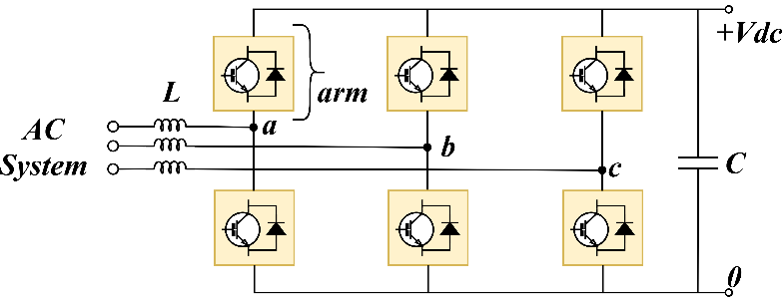
Figure 27 - Two-level voltage source converter
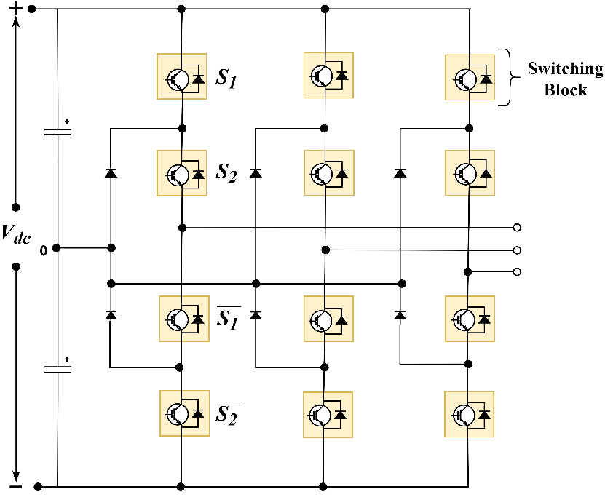
Figure 28 - Three-level NPC converter
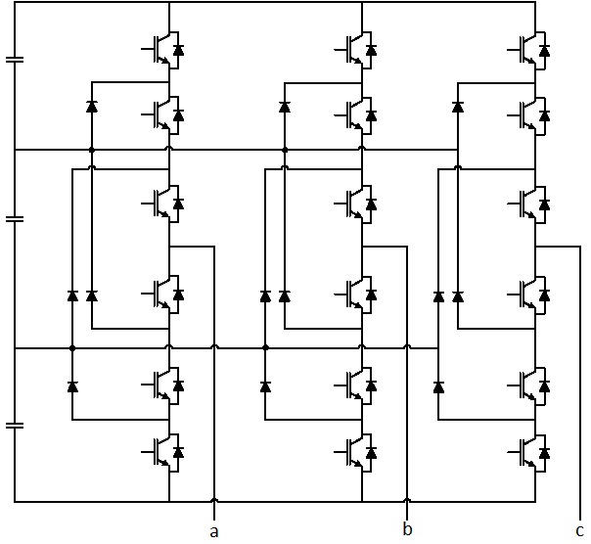
Figure 29 - Four-level NPC converter
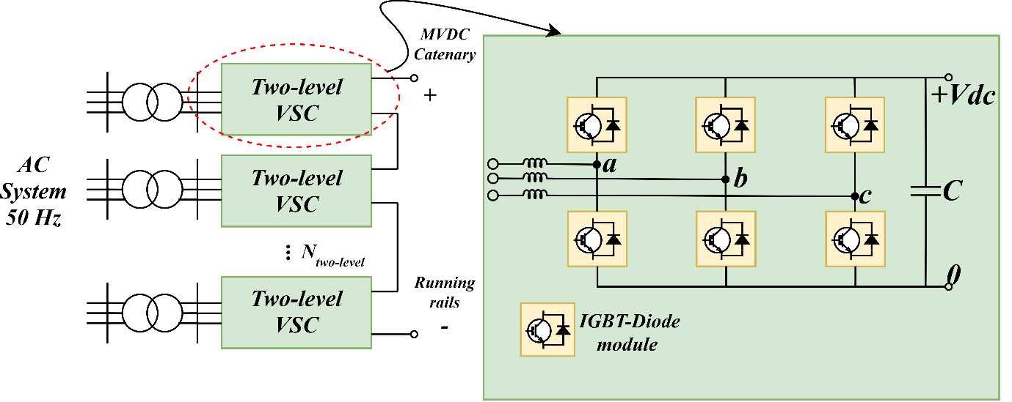
Figure 30 - Cascaded two-level voltage source converter

DC side short circuit
At the AC side, the MVDC TPS is protected by AC circuit breakers. At the DC side, the amplitude of DC fault currents in the 25 kV DC network can reach to several tens of kA. DC circuit breakers (DCCBs) in medium voltage and high current ratings are hard to realise, complicated and expensive. This is one of the main technical challenges that has prevented the MVDC railways to be industrialised so far.
One solution for this issue is to limit DC short circuit currents to $I_{DC,max}$ by the TPS converters. In this case, it is still needed to have DCCBs to disconnect the converter’s capacitors and inductors from the fault, but the current rating for these DCCBs is much lower. For example, $I_{DC,max}$ can be 120% of the nominal load, which is 960 A.
To realise this, a PI controller is added to the control unit. The controller senses DC side current and produces proper command for DC side voltage reference. If the current becomes higher than $I_{DC,max}$, the controller detects it as a fault current and decreases the DC voltage reference. To have low DC voltages, MMC-FB needs to produce negative arm voltages and this is done by inserting a number of submodules with negative output voltage. If the fault is a non-permanent fault, i.e., the current becomes less than $I_{DC,max}$ before DCCBs operation, the controller restores DC side voltage to nominal value and the converter continues supplying the loads. In a meshed MVDC network, all the TPSs implement the mentioned protection strategy, so the MVDC network is fully protected against DC short circuit currents.
Figure 31 demonstrates the simulation case where DC side fault is modelled by $R_{sc}$ = 0.5 Ω fault resistor. As an extreme case, an individual TPS initially supplies a load resistor of 31.25 Ω (equivalent to 20 MW at 25 kV), located 100 m away from the TPS. The load is connected at t = 0.1 s, and a DC fault happens at t = 0.25 s by connecting the fault resistor. In the simulation, AC and DC circuit breakers are deactivated, so the controller performance can be observed more clearly. To model a non-permanent fault, the fault resistor is disconnected at t = 0.45 s.
Figure 31 - Simulation case for DC side short circuit
Figure 32 and Figure 33 show the DC side current and voltage. The controller can limit the fault current within 320 µs and after that, the mean value for the current is less than $I_{DC,max}$. When the fault resistor is disconnected, the converter can restore the voltage to 25 kV successfully. Figure 34 and Figure 35 illustrate the arm voltage of phase “a” of MMC-FB, and the voltage and current of phase “a” of the distribution network, showing that the converter is normally feeding the limited fault current. Figure 36 shows the voltage and current of phase “a” of the distribution network when the fault is a permanent fault. The converter’s controller needs around 240 ms (12 cycles) to compensate the reactive power. During the fault, the capacitor voltages in arm “a” of the MMC-FB is shown in Figure 37. Even 0.45 s after the fault, capacitor voltages are still balanced and stable within ± 10% of their voltage reference.
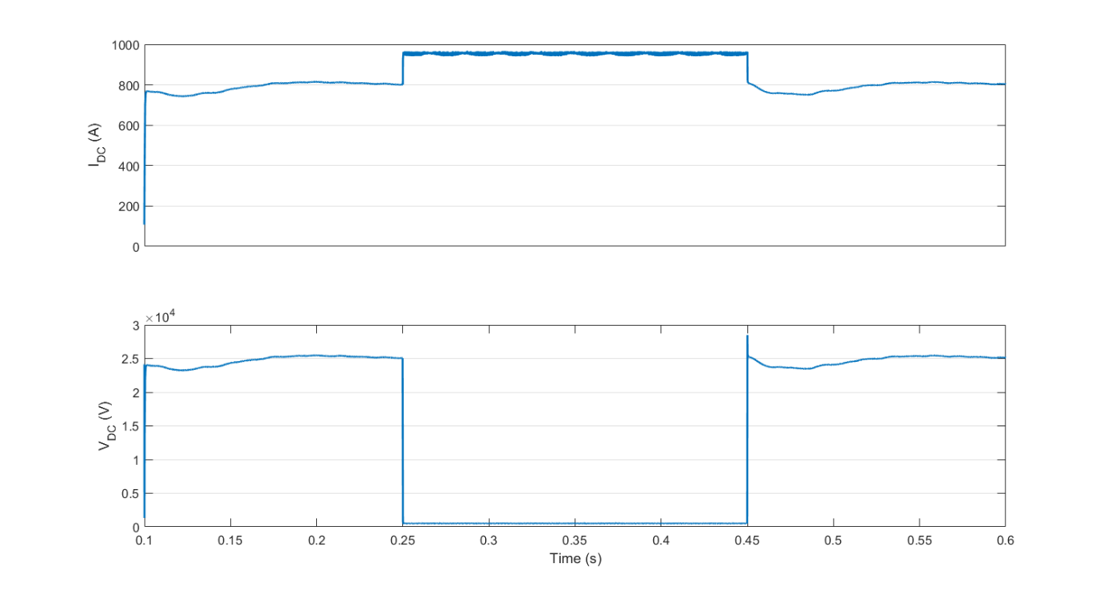
Figure 32 - Non-permanent DC short circuit: Voltage and current at DC side
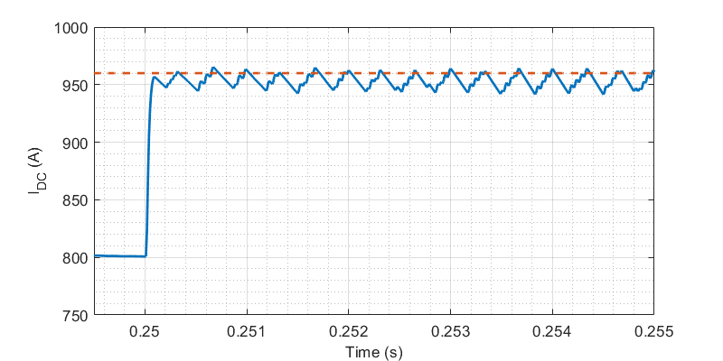
Figure 33 - Non-permanent DC short circuit: DC current (zoomed)
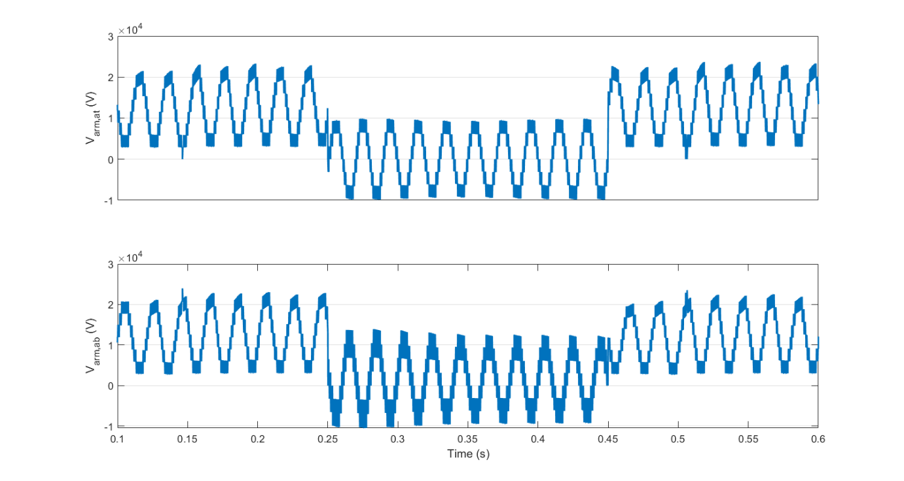
Figure 34 - Non-permanent DC short circuit: Arm voltages at phase "a" of MMC-FB
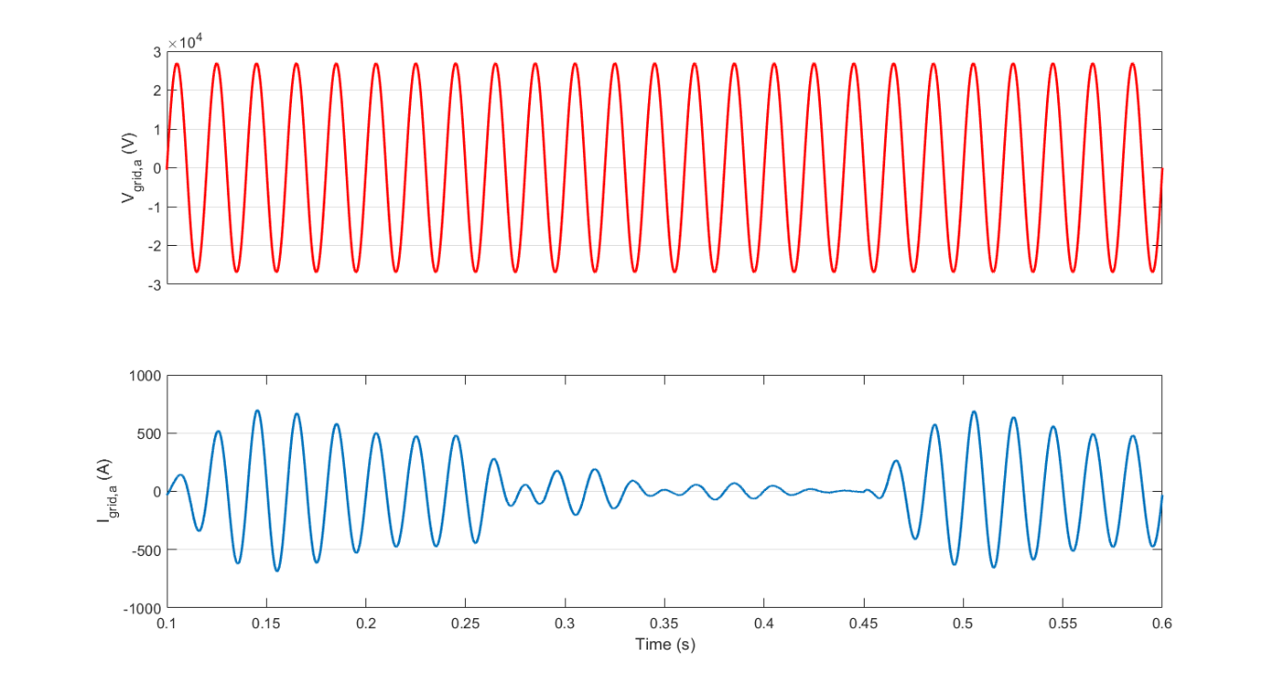
Figure 35 - Non-permanent DC short circuit: Voltage and current at phase "a" of distribution network
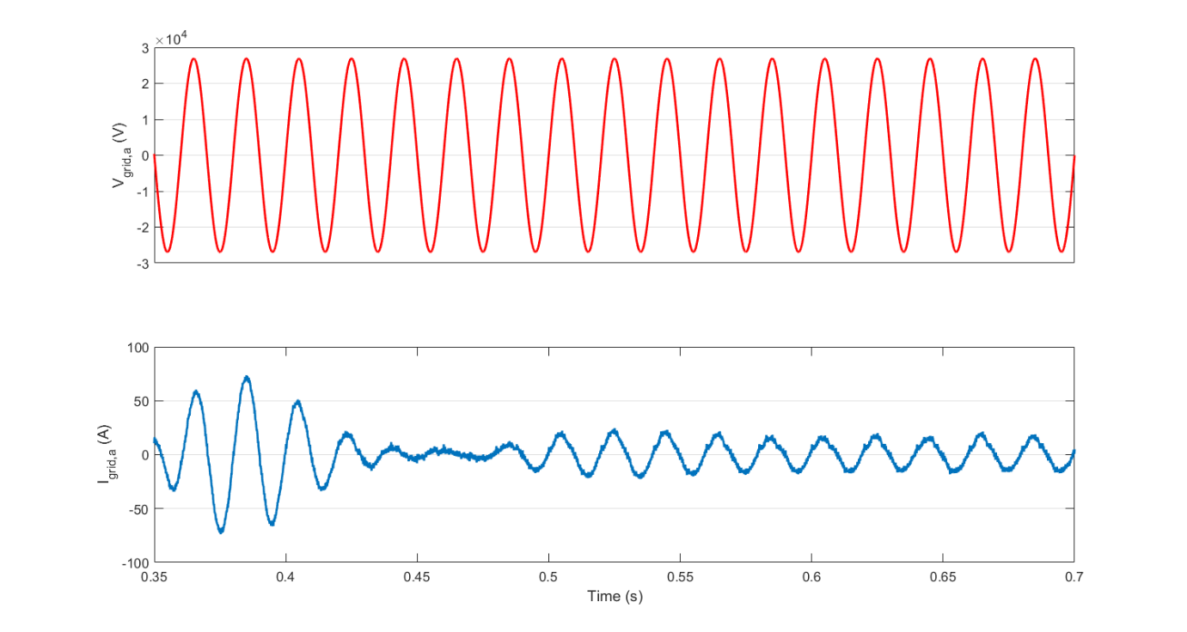
Figure 36 - Permanent DC short circuit: Voltage and current at phase "a" of distribution network
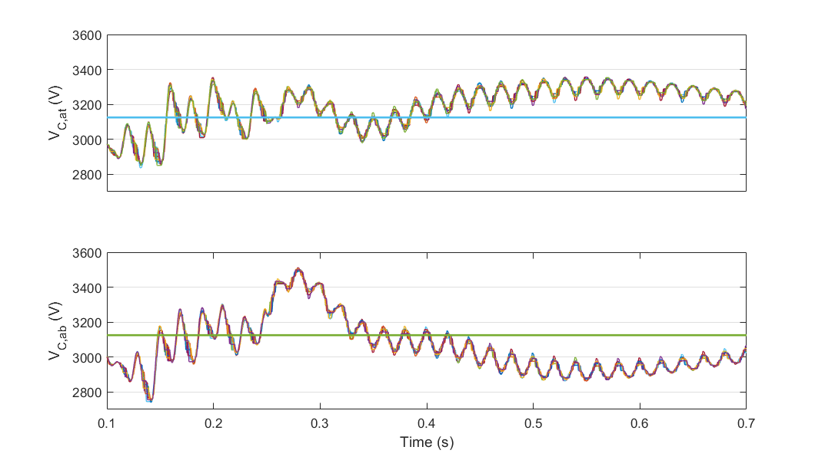
Figure 37 - Permanent DC short circuit: Voltage of capacitors in arm "a"
The DC fault current controller with the same parameters ($K_{p}$ = 175 and $K_{I}$ = 1) has been also tested in other extreme cases. For instance, distant fault (50 km far from the TPS), close fault when the converter is feeding 10 A (considered as no-load condition), distant fault when the converter is feeding 10 A. In all the above cases, the controller can successfully limit the fault current.

Overloading capability
While transformers can tolerate overloading to some extent, semiconductors like IGBT-Diode modules can only carry overcurrents for extremely short time intervals. For instance, the ABB 5SNA 1000G650300 HiPak IGBT module (6.5 kV, 1 kA) can carry a peak current of 2 kA, only for 1 millisecond [9]. Therefore, power electronic converters are designed based on the maximum values for the currents to avoid semiconductor overloading.
In the conventional DC railway electrification systems, the substations should be able to deliver 450 % of nominal load current for 10 seconds [16]. If the MVDC TPS is designed with this criterion, the MMC-FB converter needs to be redesigned based on $I_{DC,overload}=$ 3.6 kA:
$$I_{arm}\left(t\right)= \frac{I_{DC}}{3}± \frac{I_{AC,peak}}{2}\cos\left(ωt\right)$$  $$I_{AC,peak,overload}=6.55 kA$$  $${{(I}_{arm,peak})}_{max}= \frac{I_{DC,overload}}{3}+ \frac{I_{AC,peak,overload}}{2}=3.6 kA$$  $$N_{p}= ceil [ \frac{{{(I}_{arm,peak})}_{max}}{I_{C,nom}} ]=4$$ | (7)
which means that four 1000G650300 HiPak IGBT modules should be connected in parallel to carry the overload current. In other words, each full-bridge submodule needs 4*4 = 16 IGBT modules. Obviously, this increases investment cost for the MVDC TPSs.

Possibility of low voltage DC connectivity for MMC-FB
It is technically possible to connect low voltage DC sources like batteries or renewable sources to MMC-FB. This can be done by connecting the sources to the submodules’ capacitors via isolated DC-DC converters. However, having high number of submodules in the MMC-FB, this solution might not be cost effective. In addition, because of intermittent output power from renewable sources, the MMC-FB controller should be modified to keep the submodules’ voltage at nominal value by drawing power from the connected sources, and when the connected sources are unable to produce enough power, from the AC network.
An alternative solution is to integrate batteries and renewable sources to the common DC bus in the MVDC network. The integration of PV farms into the MVDC system is discussed in ‎7.1.1.

Capability of superimposing test signals at higher frequencies to assess the rolling stock compatibility
The MMC-FB is able to add arbitrary AC harmonics to the DC side voltage. Using this ability, the rolling stock compatibility tests can be done in the railway lines instead of special laboratories.
To show this ability, 5th harmonic (250 Hz) is added to the DC reference voltage. As shown in Figure 38, the DC side voltage mainly contains the DC component and the 5th harmonic. The DC voltage also contains 10th harmonic (500 Hz), produced by the modulation and switching process in the converter. If the amplitude of added harmonics is large enough, the 500 Hz component would not be a problem in testing process and it is dominated by the other components.
The amplitude and frequency of the added harmonics can be changed to proper values for the tests. As another example, 15th harmonic (750 Hz) is added to the to the previous example. The converter can successfully produce DC voltage and 5th and 15th harmonics, as depicted in Figure 39.
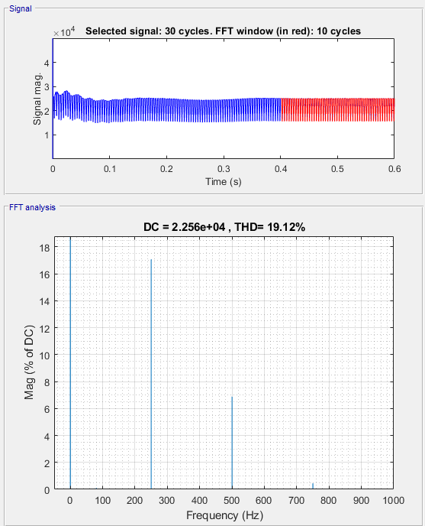
Figure 38 - Super imposing test signals: adding 5th harmonic to DC side voltage
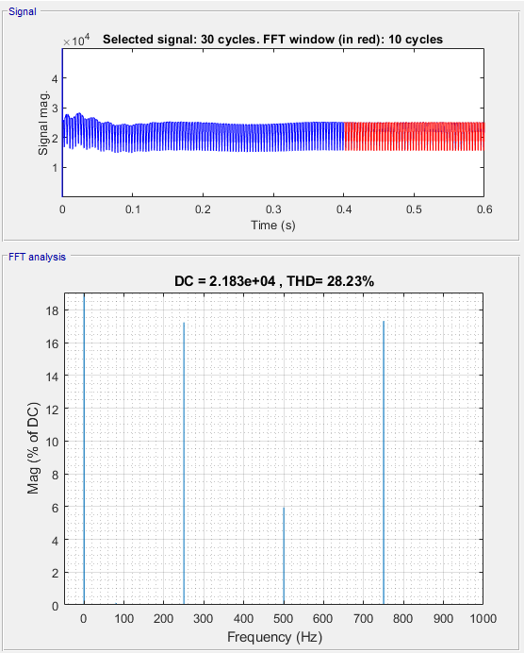
Figure 39 - Super imposing test signals: adding 5th and 15th harmonics to DC side voltage

MVDC railway network model

Double-end feeding scheme
In this section, the MVDC railway network is modelled by connecting TPSs together. In the first step, two TPSs are located at the start and end point of the railway line to form a double-end feeding scheme. The DC voltage reference for each TPS is set to 25 kV.

Modelling renewable sources (PV farms)
The network performance in the presence of renewable sources is investigated in this section. PV farms with the power of 0.53 MW are selected as renewable source unit. The PV farms’ open circuit voltage is 3.62 kV DC and they can be located in intended places in the railway network. The farms can also be connected in parallel to increase the renewable installed capacity. In the real world, an isolated DC-DC converter connects the PV farms to the MVDC network. In this report, a boost converter is used to integrate the PV farms for simplicity without affecting the results of the simulations. Figure 40 represents the boost converter. A PI controller adjusts the converter’s duty cycle and controls the PV farms’ current, ensuring that the PV farm is operating at maximum power point.
Figure 40 - PV arrays and boost converter
Figure 41 shows an illustrative simulation case where PV farms are connected to a double-end fed MVDC railway. The three-phase distribution network is modelled by two separate three-phase voltage sources. Although they can have phase shift to represent two different distribution networks, in this simulation case they are assumed to be in phase.
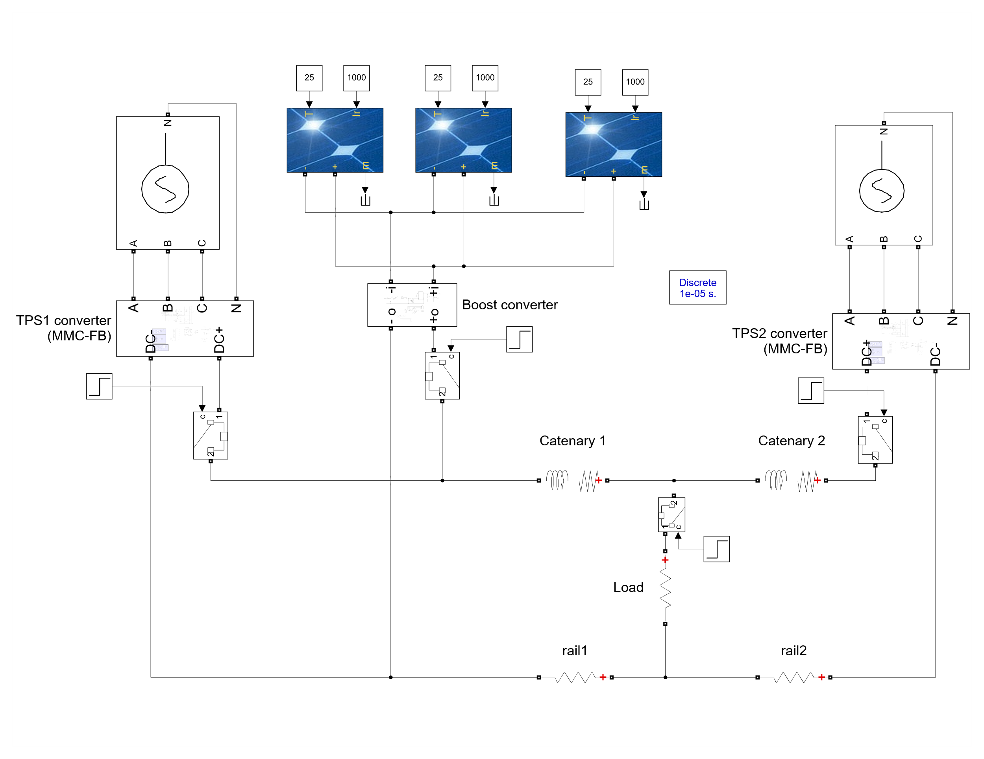
Figure 41 - Simulation of the MVDC railway in the presence of PV farms: the network configuration
Table 6 represents the other assumptions made in this simulation case. The trains’ load model is located between TPS1 and TPS2 and as the time span of the simulation is 1 second, the trains’ position is assumed to be fixed. Considering installed capacity of 20 MW for each TPS, the maximum value for the load power is chosen as 17 MW, which is modelled by a resistor. Using circuit breakers, TPS 1, TPS2, the PV farms and the load are connected by DCCBs to the railway network at t = 0.20 s, t = 0.21 s, t = 0.22 s and t = 0.26 s, respectively.
Table 6 - Parameters for PV farm simulation case
Parameter | Definition | Value
$$D$$ | Distance between two TPSs | 40 km
$$d1$$ | Distance between TPS1 and the load | 30 km
$$d2$$ | Distance between the load and TPS2 | 10 km
$$P_{PV}$$ | Installed capacity of the PV farm | 1.6 MW
$$P_{TPS}$$ | Installed capacity of each MVDC TPSs | 20 MW
$R_{L}$ | Load resistance | 36.76 Ω
$$T_{PV}$$ | Temperature of PV arrays | 25 ⁰C
$${Irr}_{PV}$$ | Solar irradiance | 1000 W/m²

Figure 42 depicts the voltages and currents at the TPSs and PV farms terminals. After the transients, the DC bus voltage lies within acceptable range stated in Table 1. The capacitor voltages in one leg of MMC-FB, phase voltage and current of phase “a” at the AC side, and the calculated TDD for TPS1 are represented in Figure 43 to Figure 45, showing the normal operation of the TPSs converters.
The output power of each TPS is inversely proportional to the distance between the load and the TPS. In this simulation case, the load is closer to TPS2, and TPS2 provides the highest share of the load at steady state, as demonstrated in Figure 46.
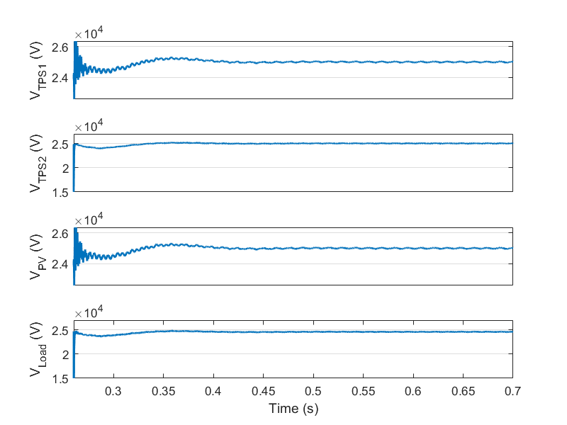
Figure 42 - Output voltage of TPS1, TPS2, PV farms and the load
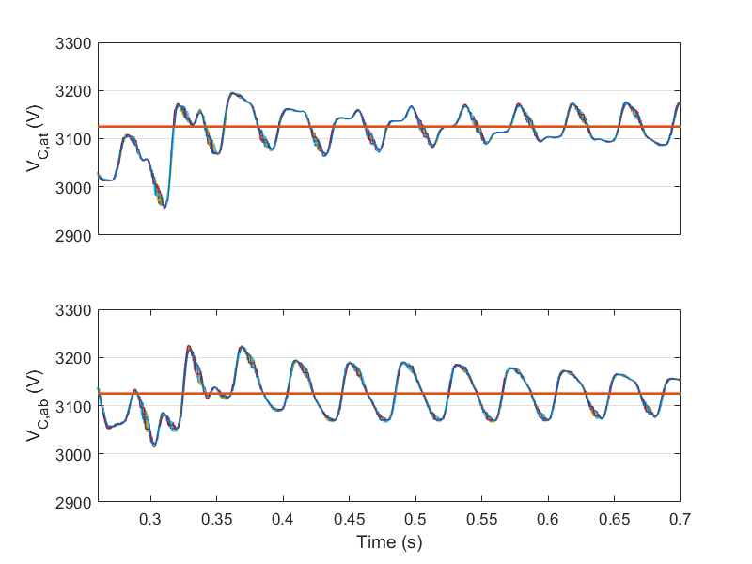
Figure 43 - Capacitor voltages in leg "a" of TPS1 converter: Top arm and bottom arm
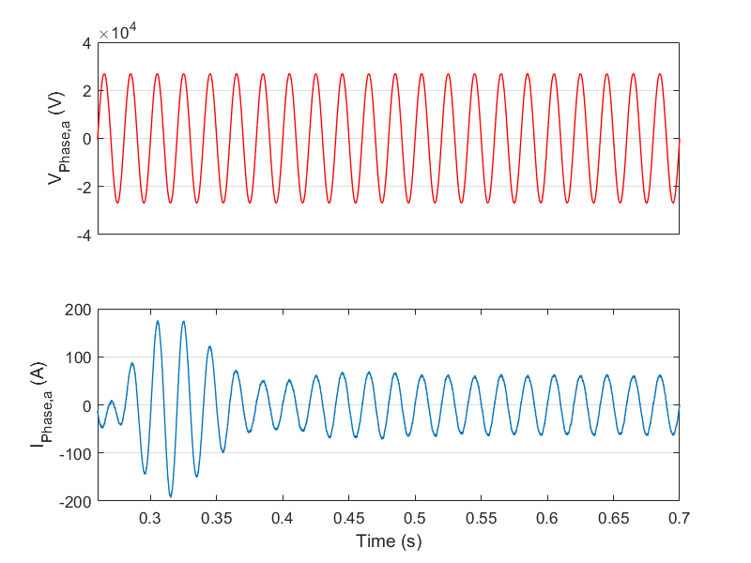
Figure 44 - Voltage and current of phase “a” at the AC side of TPS1
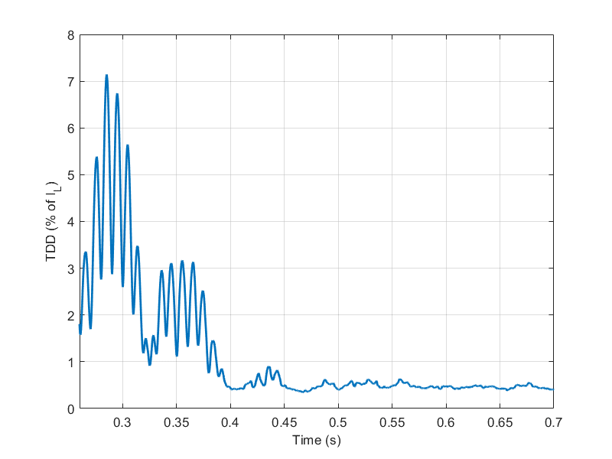
Figure 45 - Calculated TDD for TPS1
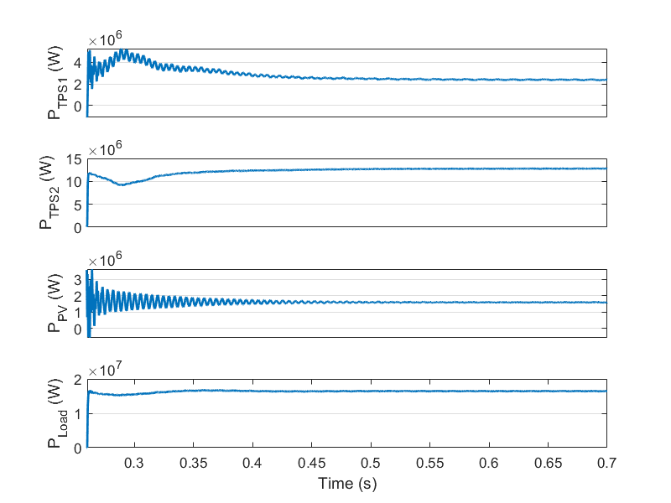
Figure 46 - Output power of TPS1, TPS2, PV farms and the load
As illustrated in this simulation case, the MVDC railways can easily use the power generated by renewable sources and decrease their carbon footprint. In the case that renewable sources are widely available, it might be possible to operate the railway solely relying on renewable sources. As the railways’ load is inherently discontinuous, and the peak of power consumption and the peak of renewable power production happen at different times of the day, the railway should still be connected to AC distribution network, ensuring that the instantaneous power is balanced. On the other hand, the renewable sources produce power during the day and inject the excess power back to the distribution network. In this way, the whole energy consumption can ultimately be supplied by the renewable units.

Effect of temperature on PV farms production and the system performance
In a sunny day, the temperature of the PV arrays in the PV farm increases. This leads to decrease in output power of the PV farm. In order to investigate the effect of PV arrays temperature on the MVDC railways performance, the simulation case ‎7.1.1 is repeated with $T_{PV}$ = 45 ⁰C. All the other parameters remain unchanged.
Figure 47 depicts the output power of TPSs, the PV farms and the load power in the new simulation case. In comparison to the simulation case with $T_{PV}$ = 25 ⁰C, the average output power of PV farms between t = 0.3 s and t = 0.7 s has been decreased from 1.595 MW to 1.476 MW. The system performance and output power of TPSs are nearly the same as the previous case. Therefore, it can be concluded that the temperature does not have a considerable effect on the system performance.

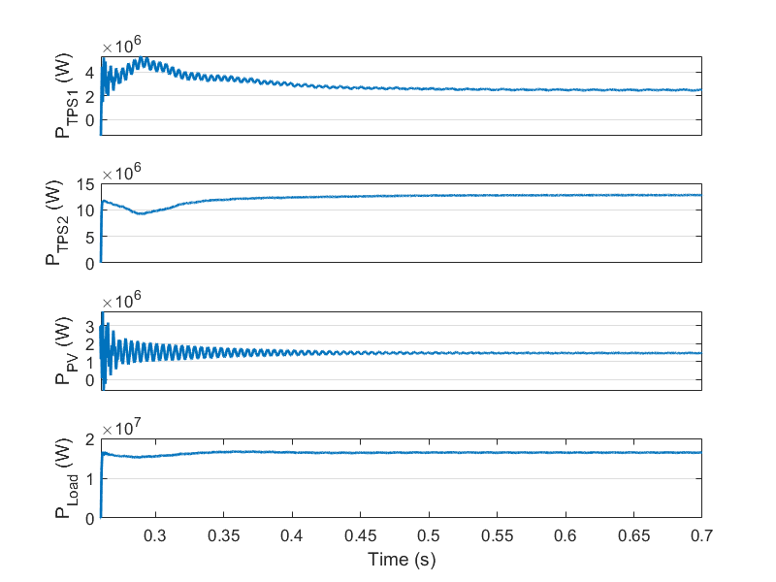
Figure 47 - Output power of TPS1, TPS2, PV farms and the load (T_PV = 45 ⁰C)

Power sharing
In the case of using a central control approach, it is possible to share the train loads between TPSs and consequently, decrease the installed capacity of each TPS. As a demonstrative case, a centralised control strategy is used to equally share the load to the TPSs in a double-end fed MVDC railway, shown in Figure 48. In the implemented control strategy, TPS output voltage and currents are measured and the data are sent to the central control unit. The central control unit calculates the output DC voltage references for each TPS and sends them to the corresponding TPS converter controller. In this simulation case, TPS1 voltage reference is fixed to 25 kV while it is variable for TPS2. As shown in Figure 49, a PI controller is enabled at t = 0.26 s to adjust the TPS2 reference so that TPS2 output power becomes equal to TPS1 output power.
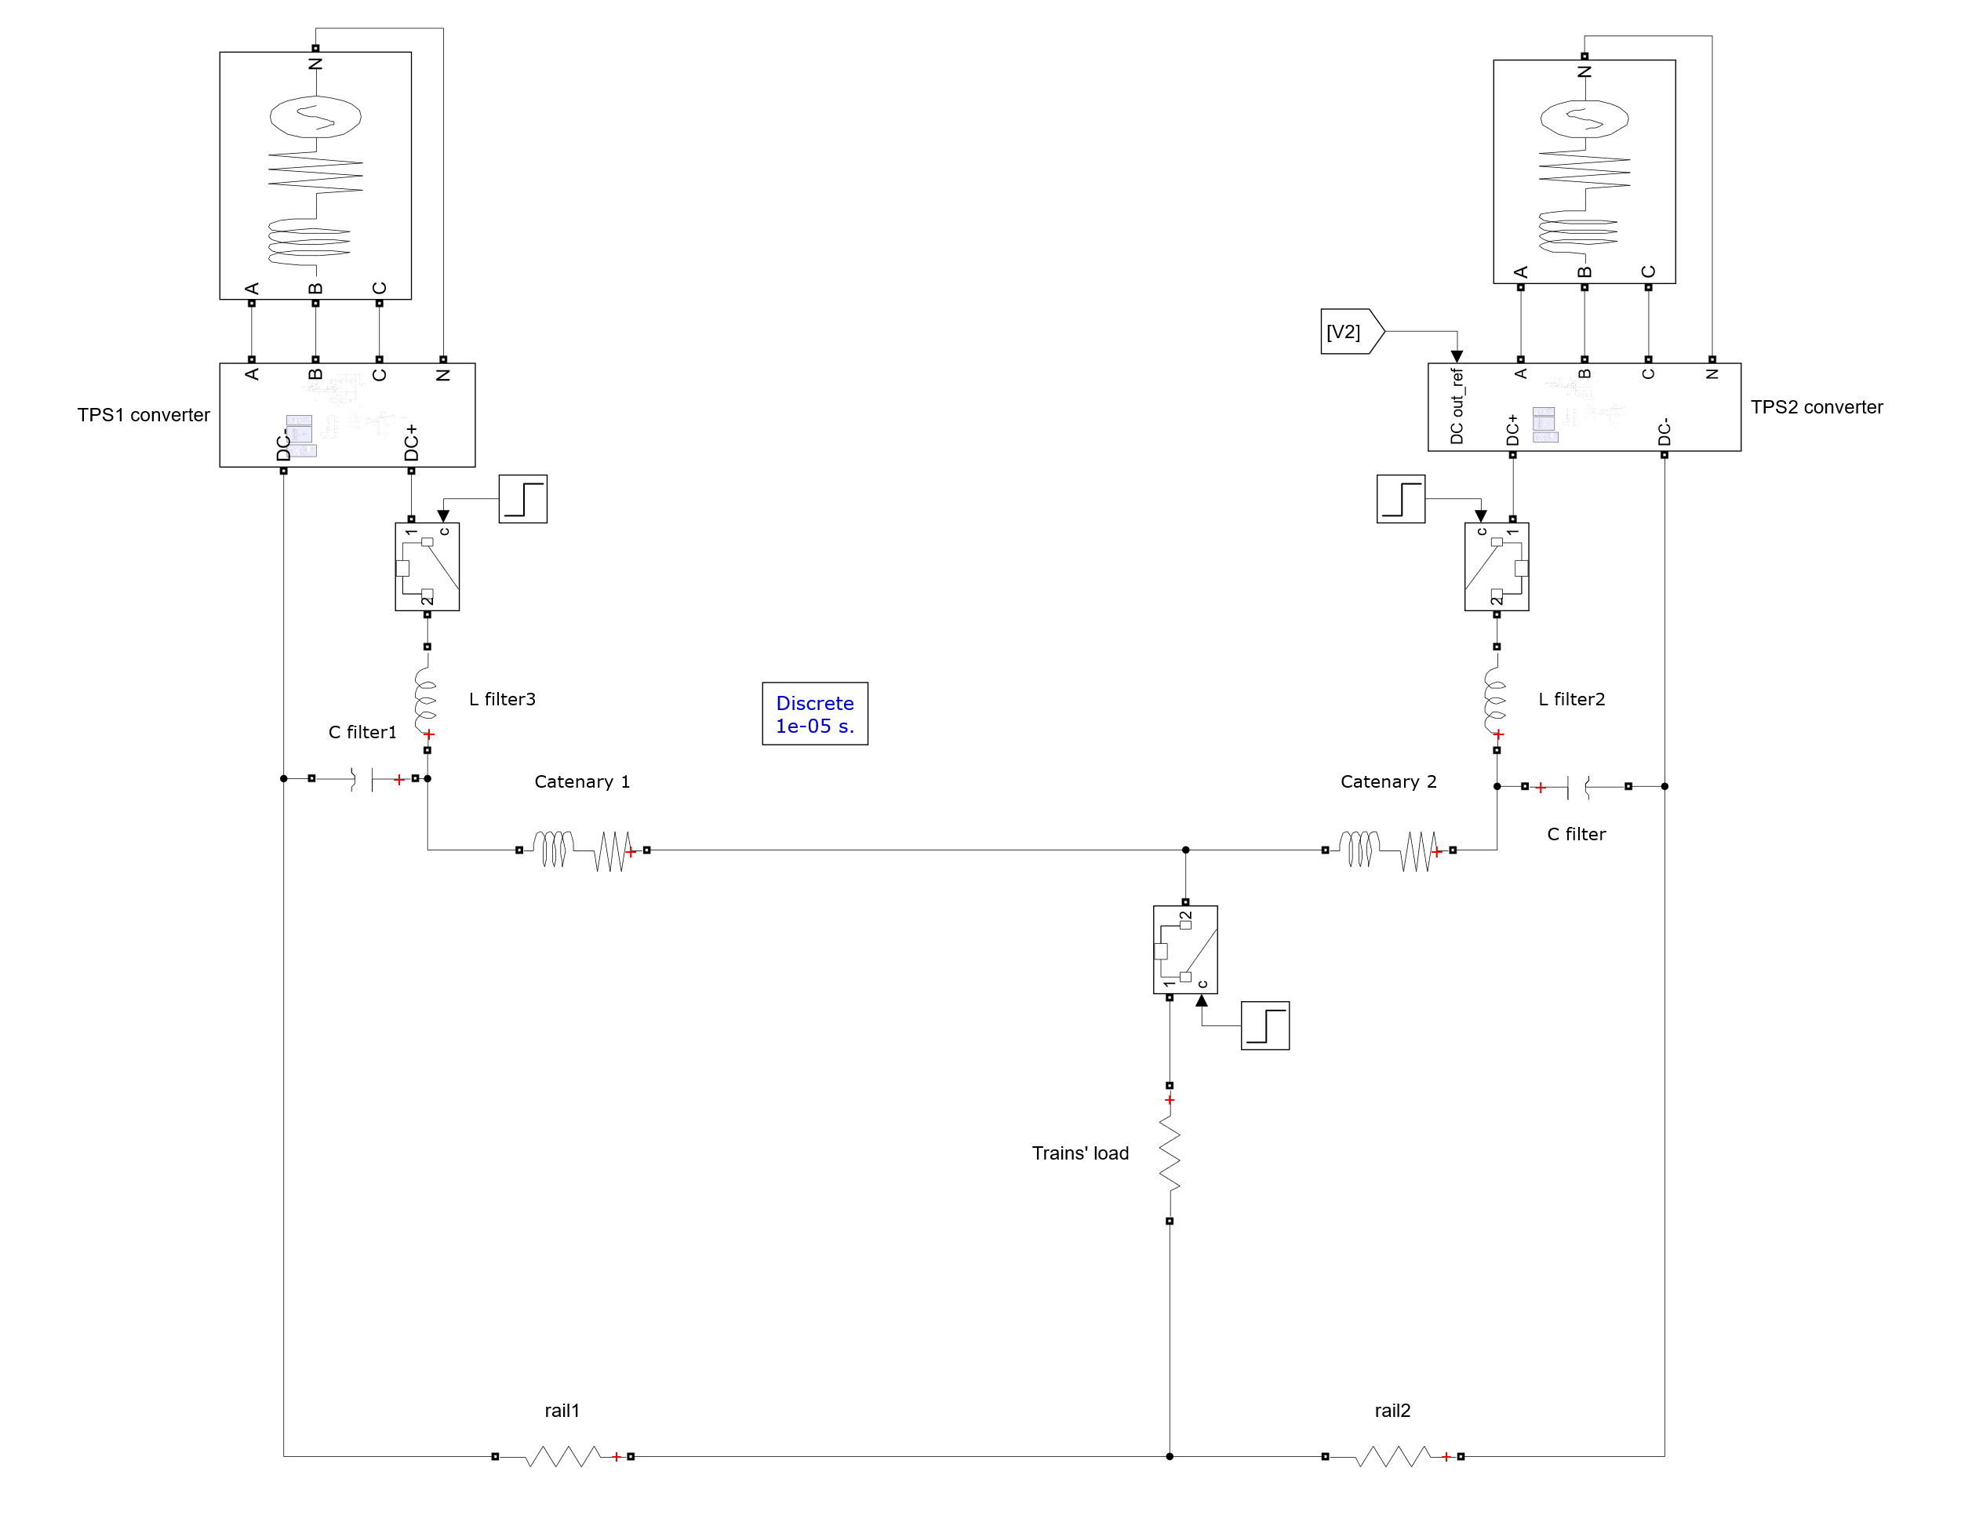
Figure 48 - The simulation case for power sharing between TPSs
Figure 49 - Calculation of TPS2 voltage reference
The TPS2 voltage reference is limited between 19 kV and 27.5 kV. This guaranties that the load voltage always lies within $U_{min1}$ and $U_{max1}$ (according to Table 1). To improve the controller performance, a LC filter (20 µF, 1.3 mH) is used at the DC side of TPSs. The distance between the two TPSs is 40 km, and a load resistor of 36.76 Ω, is switched at t = 0.35 s. The distances between the load and TPS1 and TPS2 are 35 km and 5 km, respectively.
As shown in Figure 50 the load and TPSs voltages are regulated in the normal range for MVDC railways (Table 1). Figure 51 depicts DC side power of the TPSs, and sum of the consumed power by the load, overhead lines and running rails. The consumed power is equally shared between two TPSs and in steady state and on the average, each TPS provides 8.1 MW of power. Therefore, the installed capacity for each TPS can be decreased to 10 MW.
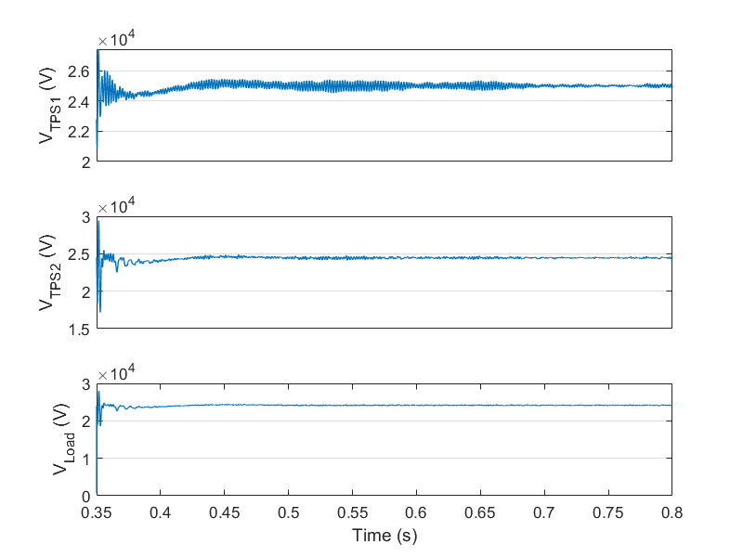
Figure 50 - Power sharing: TPSs and load voltages
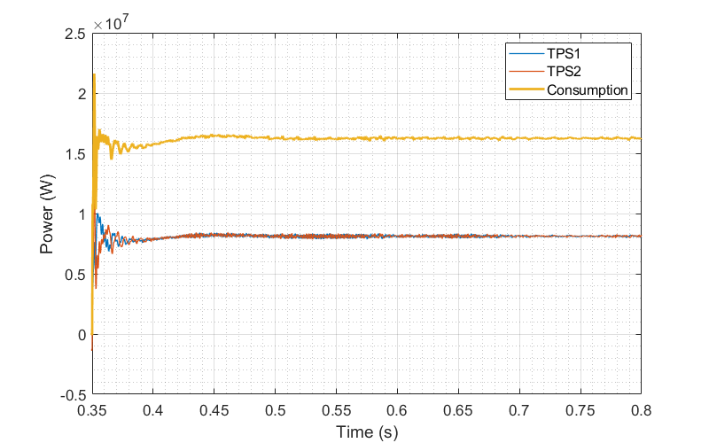
Figure 51 - Power sharing: TPSs power and sum of the consumed power in the network
On the other hand, the power provided by TPS1 needs to be transmitted for a length of 35 km of overhead lines and running rails. Table 7 summarises the average power losses (from t = 0.4 to t = 0.8 s) of overhead lines and running rails with and without centralised control scheme in operation, showing that the total average losses is increased when the power is shared between the TPSs. Therefore, there is a compromise between decreasing TPS installed capacity and the power losses in overhead lines and running rails.
Table 7 - Average power losses of overhead lines and running rails from t = 0.4 to t = 0.8 s
Average power | With Centralised control | Without Centralised control
${\overline{P}}_{OHL1}+{\overline{P}}_{rail1}$(kW) | 342 | 119
${\overline{P}}_{OHL2}+{\overline{P}}_{rail2}$(kW) | 119 | 245
Total (kW) | 461 | 364

Mesh feeding scheme
In this section, four TPSs are connected together to form an illustrative example of a meshed MVDC network, shown in Figure 52. To test the ability of connecting the TPSs to different distribution networks, the 33 kV distribution networks at TPS1 and TPS2 are in phase, while the 33 kV distribution networks connected to TPS3 and TPS4 have 30- and 60-degrees phase shift with respect to the other distribution network. In this simulation case, there is no central control unit (power sharing is not implemented) and each TPS has its own voltage reference of 25 kV. The simulation case is run for 0.4 seconds, where two load resistors (each one equivalent to full load of 17 MW) are connected to the network at t = 0.3 s, representing two trains accelerating in different directions in a double-track system. Table 8 shows other simulation parameters.
Figure 52 - Meshed MVDC railway network
Table 8 - Simulation parameters - meshed MVDC network
Parameter | Definition | Value
$$d1$$ | Distance between TPS1 and load1 | 20 km
$$d2$$ | Distance between load1 and TPS2 | 10 km
$$d3$$ | Distance between TPS2 and TPS3 | 30 km
$$d4$$ | Distance between TPS3 and load2 | 5 km
$$d5$$ | Distance between load2 and TPS4 | 25 km
$$P_{TPS}$$ | Installed capacity of each MVDC TPS | 20 MW
$R_{L1}$ | Load 1 resistance | 36.76 Ω
$$R_{L2}$$ | Load 2 resistance | 36.76 Ω
$$t_{L}$$ | Switching time for the loads | 0.3 s

Figure 53 depicts the TPSs and loads voltages from t = 0.28 s. The results show that the TPSs are able to regulate the MVDC network voltage to the nominal range. Figure 54 and Figure 55 illustrate the power profile for each part of the system. After a transient, TPS3, TPS2, TPS1, and TPS4 provide the most share of the loads, respectively. Moreover, sum of DC side power of the TPSs and consumed power by the loads are demonstrated in Figure 56. The difference between the curves shows the power losses in the TPS converters, overhead lines and running rails.
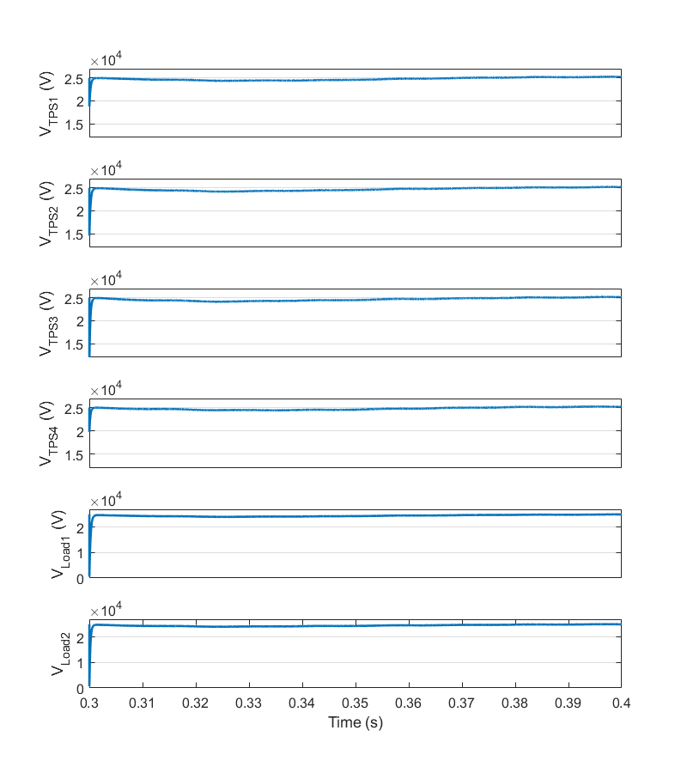
Figure 53 - Voltage of TPSs and loads in the MVDC meshed network
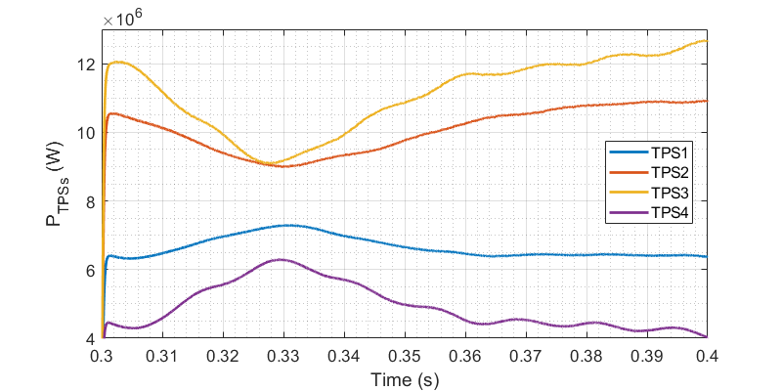
Figure 54 - Output power of TPSs in MVDC network
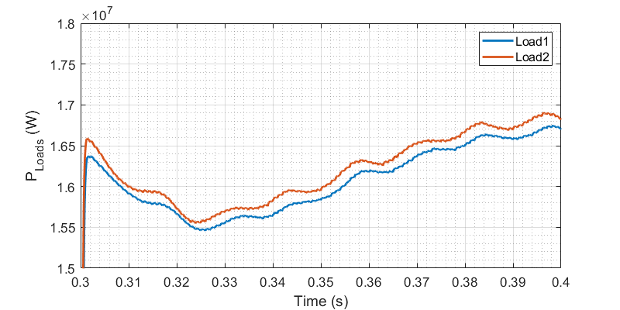
Figure 55 - Consumed power by loads in MVDC network
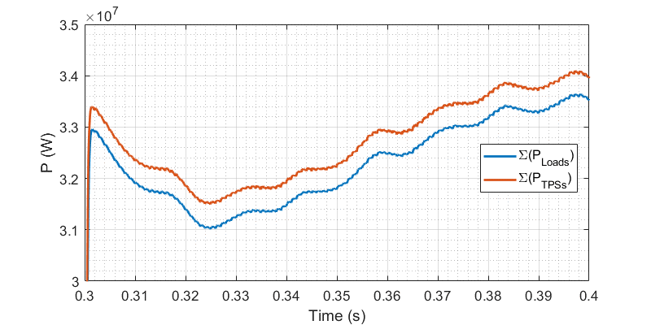
Figure 56 - Sum of the transferred power in MVDC network

Modelling of moving trains
The simulator model can be extended to model the moving loads, as shown in Figure 57. In this model, the overhead lines and rails are modelled with variable impedances and based on the trains’ position, the value for the impedances are updated. As the variable elements in Simulink are modelled with current sources, the parallel resistors ($RP$) are necessary to handle sudden current changes.
Nevertheless, in all the simulations cases stated in this report, the simulation is done in less than a second, and the trains are fairly stationary in this short time interval. Therefore, in all the above simulations, the model with fix impedance has been used.
Figure 57 - Modelling of moving trains by variable resistors and inductors

Monitoring and verification of technical key performance indicator (KPI) “a”: Railway electrification simulation tool

KPI a1: Number of kilometres of lines simulated
As discussed in the previous sections, the developed model is able to simulate different scenarios with different line lengths and load conditions. The maximum time for the mentioned simulation cases is around 3 minutes. The simulations are done by a standard personal computer with the following properties:
Processor: Intel® Core™ i5-9500T CPU @ 2.20 GHz
Installed memory (RAM): 8 GB
Therefore, the KPI a1 objective has been achieved as it is possible to simulate total of 400 km within different simulation cases.

KPI a2: Transmission and converter power losses identified
The loss analysis has been discussed in section ‎6.5. In addition, the software model can successfully evaluate the transmission losses, as mentioned in section ‎7.1.3.
According to the estimated efficiency curve for MMC-FB, shown in Figure 22, the efficiency at full load of 17 MW is 98.1%. Available efficiency curves for static converters which are based on MMC topology and designed for 16.67 Hz rail networks show that their efficiency is around 98.5% in quite similar conditions.
Therefore, the estimation of power losses from the model is within +/-20% of the values of similar converters developed for AC railways and the KPI a2 objective has been accomplished.

KPI a3: Reduction of the design power of substations
As stated in ‎7.1.3, equal power sharing between two TPSs in a double-end fed railway can decrease the installed capacity for each TPS by 50%, i.e., from 20 MW to 10 MW. The KPI a3 will be monitored again in M36.

Conclusion
This deliverable introduces characteristics of the medium voltage DC railway electrification system, the converter topology selected for MVDC traction power substations, and developed numeric model for the MVDC traction power substations and MVDC networks. Within various simulation cases, the document investigates the substation’s performance, indicating that it meets the desired quality measures in both normal and abnormal conditions. In particular, the substation converter can limit DC short circuit currents successfully, which means that the MVDC network can be protected by cheaper and simpler MVDC circuit breakers.
In addition, the document describes the converter’s efficiency estimation, and investigates the impacts of MVDC traction substations on distribution networks, possibility of low voltage connectivity for the power converters, and capability of the converters to superimpose test signals at higher frequencies.
The deliverable also presents simulation cases for double-end and meshed feeding schemes, showing proper functionality of the developed network model, performance of the MVDC network in the presence of renewable sources, and the idea of power sharing among substations. At the end, the document reviews the current status of technical key performance indicator (KPI) (a), “Railway electrification simulation tool”.

References
[1] Railway applications - Supply voltages of traction systems. BS EN 50163:2004 + A1:2007, 2007.
[2] ELAND®CABLES, “NR/PS/ELP/00008 19/33kV Graphite Covered MDPE Cable datasheet,” .
[3] C. Stackler, N. Evans, L. Bourserie, F. Wallart, F. Morel, and P. Ladoux, “25 kV–50 Hz railway power supply system emulation for power-hardware-in-the-loop testings,” IET Electr. Syst. Transp., vol. 9, no. 2, pp. 86–92, Jun. 2019, doi: https://doi.org/10.1049/iet-est.2018.5011.
[4] S. Sharifi, P. Tricoli, and T. Kamel, “Investigating the best topology for Traction Power Substations (TPSs) in a Medium Voltage DC (MVDC) railway electrification system,” Accepted for 23rd European Conference on Power Electronics and Applications (EPE’21), Sep-2021.
[5] ABB, “Voltage ratings of high power semiconductors,” 5SYA 2051 application note, 2013.
[6] A. Sangwongwanich, A. Abdelhakim, Y. Yang, and K. Zhou, “Chapter 6 - Control of Single-Phase and Three-Phase DC/AC Converters,” F. B. T.-C. of P. E. C. and S. Blaabjerg, Ed. Academic Press, 2018, pp. 153–173.
[7] IEEE Recommended practice and requirements for harmonic control in electric power systems. IEEE Std 519-2014, 2014.
[8] P. Twomey, “Electricity Specification 217, Issue 3, 33kV Connection up to 90MVA,” Electricity North West Limited, 2020.
[9] “Clearguard TCM 100 Track Vacancy Detection System - Continuous clear and occupied indication of track vacancy detection sections,” Siemens.
[10] “5SNA 1000G650300 HiPak IGBT module,” 5SNA 1000G650300 datasheet.
[11] B. Ozpineci and L. M. Tolbert, “Comparison of Wide-Bandgap semiconductors for power electronics applications,” Oak Ridge National Laboratory, Department of Energy (DOE), United States, Tech. Report. ORNL/TM-2003/257, 2003.
[12] E. Van Brunt et al., “27 kV, 20 A 4H-SiC n-IGBTs,” in Materials Science Forum, 2015, vol. 821, pp. 847–850.
[13] K. Jacobs, S. Heinig, D. Johannesson, S. Norrga, and H.-P. Nee, “Comparative Evaluation of Voltage Source Converters with Silicon Carbide Semiconductor Devices for High-Voltage Direct Current Transmission,” IEEE Trans. Power Electron., 2021.
[14] J. Ranneberg, “Transformerless topologies for future stationary AC-railway power supply,” in 2007 European Conference on Power Electronics and Applications, 2007, pp. 1–11.
[15] V. Gelman, “Insulated-gate bipolar transistor rectifiers: Why they are not used in traction power substations,” IEEE Veh. Technol. Mag., vol. 9, no. 3, pp. 86–93, 2014, doi: 10.1109/MVT.2014.2333762.
[16] R. D. White, “DC electrification supply system design,” in 2007 3rd IET Professional Development Course on Railway Electrification Infrastructure and Systems, 2007, pp. 35–62.

