S2R-OC-IPX-03-2018

Grant agreement n. 826238

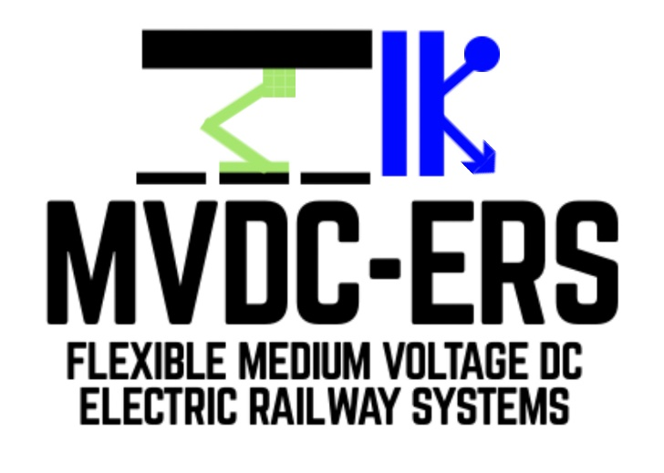

Deliverable D 2.1

Converters topologies for MVDC transformers

Document details

Authors | Izsák Ferdinánd Ferencz, Dorin Petreuș
Due date | 30-06-2020
Actual delivery date | 22-06-2020
Lead contractor | Technical University of Cluj-Napoca
Version | 1.0
Prepared by | Technical University of Cluj-Napoca
Input from | -
Reviewed by | University of Birmingham
Dissemination level | Public

Project contractual details

Project title | Flexible medium voltage DC electric railway systems
Project acronym | MVDC-ERS
Grant agreement no. | 828638
Project start date | 01.12.2018
Project end date | 30.04.2022
Duration | 41 months
Supplementary notes | The document type is public
Disclaimer:

* Please note that this deliverable is undergoing S2R JU review and acceptance processes. At this stage this deliverable reflects only the author’s view and the S2R JU is not responsible for any use that may be made of the information it contains.
Table of Contents

1 Introduction 3
2 Abbreviations and acronyms 4
3 History of electrical railway traction 5
3.1 General considerations on railway electrification and traction 5
3.2 DC traction systems 6
3.2.1 Interoperable traction 7
3.3 MVDC-ERS concept comparison with existing ERSs 7
3.4 PETT – original concept and evolution 10
4 Brief overview of state of the art PETTs and definition of suitable topologies for MVDC-ERS 17
4.1 The last 25 years of PETT concepts (1993-today) 17
4.2 Possible MVDC converter configurations 23
4.3 Dual Active Bridge Converters 24
4.3.1 DAB full bridge converter 24
4.3.2 DAB half bridge converter 25
4.3.3 Example of a DAB configuration for MVDC traction 25
4.4 Voltage balancing stages (VBS) 27
5 Specifications and requirements for traction 29
5.1 Inductive power factor of train 29
5.2 Capacitive power factor of train 29
5.3 Power levels of trains 30
5.4 Current limitation 30
6 Regenerative braking and on-board storage 31
7 Control and protection of traction converters 31
8 Potential benefits of using wide band-gap semiconductors in MVDC converters 33
9 Conclusion 36
10 References 37

Introduction
The present report constitutes deliverable D2.1, a document produced in the framework of WP2 “MVDC transformers for railway traction”, Task 2.1 “Definition of optimal converter topologies for MVDC transformers”.
One of the main objectives of WP2 is to undertake a comparative evaluation of topologies for the medium voltage DC transformers and to define the optimal topology for railway traction applications including evaluation of the performance of the converter.
Hence, D2.1 compares the conventional railway traction systems with new traction systems proposed and developed in the last decade that are also suitable for the MVDC railway electrification concept presented in this project. Differences and requirements of the MVDC traction system will be considered while investigating converter topologies for MVDC transformers and the impact of new wide band-gap (WBG) semiconductor technologies on their design. Then, D2.1 focuses on presenting the most suitable DC-DC converters for this application, defining an example of optimal configuration and requirements of control.

The deliverable has the following sections:
• Section 2 defines abbreviations and acronyms used in this report
• Section 3 describes the history of railway power electronic traction transformers (PETTs)
• Section 4 introduces the state of the art and classification of railway traction systems
• Section 5 presents the specifications of high-power converters suitable for MVDC-ERS traction
• Section 6 introduces the regenerative braking and on-board storage of the traction systems
• Section 7 describes protection and control issues of on-board traction systems
• Section 8 clarifies potential benefits of using wide band-gap semiconductors for PETTs
• Section 9 draws the conclusions
• Section 10 includes the references

Abbreviations and acronyms
ABB | ASEA Brown Boveri
AC | Alternating Current
ADC | Analog-Digital Converter
CAN | Controller Area Network
CFB/CHB | Cascaded F-Bridge/ H-Bridge
CO₂ | Carbon-dioxide
CSC | Current Source Converter
DAB | Dual-Active Bridge
DAFB/DAHB | Dual-Active Full/Half Bridge
DC | Direct Current
DMU | Diesel Multiple Units
DSP | Digital Signal Processor
EMC | Electromagnetic Compatibility
EMI | Electromagnetic Interference
EMU | Electric Multiple Units
ERS | Electric Railway System
FPGA | Field Programmable Gate Array
GaN | Gallium Nitride
HV/MV/LV | High Voltage / Medium Voltage / Low voltage
HVDC | High-Voltage DC
IC | Integrated Circuit
IFE/IBE | Isolated Front-End / Isolated Back-End
IGBT | Insulated Gate Bipolar Transistor
IO | Input - Output (interface)
ISOP | Input Series Output Parallel
LCC | Line Commutated Converter
LFT | Line/Low Frequency Transformer
MFT | Medium Frequency Transformer
MMC | Modular Multilevel Converter
MOSFET | Metal Oxide Semiconductor Field Effect Transistors
MVDC | Medium-Voltage DC
NPC | Neutral-Point Clamped
PCB | Printed Circuit Board
PETT | Power Electronic Traction Transformer
PWM | Pulse Width Modulation
RMS | Root Mean Square
Si | Silicon
SiC | Silicon Carbide
SST | Solid State Transformer
STATCOM | Static Compensator
THD | Total Harmonic Distortion
VSC/VSI | Voltage Source Converter/Voltage Source Inverter
WBG | Wide Band-Gap
ZCS/ZVS | Zero Current Switching / Zero Voltage Switching

History of electrical railway traction

General considerations on railway electrification and traction
The reason behind railway electrification was the reduction of operating costs, CO₂ emissions and an improvement in energy efficiency. The newly developed electric locomotives achieved more power than diesel engines, a better reliability and quieter operations. High power electric locomotives can also pull heavier freight at higher speed over slopes, thus increasing capacity in mixed traffic conditions, when time between trains is important. Having no local emissions, electric propulsion has a great advantage over diesel in urban areas and tunnels. Electric traction offers possibility for regenerative braking (turning kinetic energy into electricity) also, which can further increase efficiency by supplying other trains or the utility grid – especially useful in mountainous areas, where heavily loaded trains must descend for long distances [1].
The costs of line maintenance is increased by electrification, but many operators such as Network Rail in the UK claim that, as electric multiple units (EMU) are lighter than diesel ones (DMU), the wear-and-tear costs are lower [2]. Although electrical equipment near the tracks such as substations and catenary wires imply some additional maintenance costs, if there is enough traffic the reduced track and engine maintenance costs compensate these additional ones resulting in a significant advantage. The reason why electric railways have a higher efficiency is that central stations or power plants generate electricity with higher efficiency than mobile engines or generators. In nominal regime the energy efficiency of a diesel locomotive and a power plant would be almost the same [3], [4], but diesel motors decrease in efficiency at lower powers (non-nominal regime) [5] in comparison with a power plant that can shut down some generators or deliver elsewhere any power excess. Electric locomotives can also recuperate energy by regenerative braking and do not consume energy while being idle, except that needed for cooling systems. Additionally many fossil fuel power plants generate heat at high temperature [6] that can be used for heating or cooling districts. Hence such power plants are cleaner than mobile sources such as locomotive engines. Furthermore, power can also be generated by clean renewable energy sources like hydroelectric, geothermal, solar and wind [7].
As in the last decade the renewable energy market has increased rapidly, new opportunities are opening also for the power supply of electric railways. In the past decade railway electrification constantly increased and electrified tracks almost reached one third of the total tracks globally in 2012 [8]. According to a report of the International Energy Agency, between 1990 and 2015 due to the increase of railway electrification both the energy consumption per transport unit decreased and the CO₂ emissions per transport unit decreased by 35.8% and 31.6%, respectively. Moreover, half of these reductions were achieved in the decade of 2005 to 2015: rail energy consumption per passenger-km decreased by 27.8% and energy consumption per freight tonne-km decreased by 18.1%. Between 2005 and 2015, rail CO₂ emissions per passenger-km decreased by 21.7% and CO₂ emissions per freight tonne-km decreased by 19.0%. In this time (2005-2015) the share of oil products (diesel) decreased from 62.2% to 56% in the global railway fuel mix, while the share of electricity increased, whereof electricity generated by renewables has shown an increase of 65% [9]. The data presented in these reports points to the future tendency of integration of renewables in the railway system and to the necessity of innovation. The railway electrification system must become more compatible with renewable energy sources to keep up with the increase of the proportion of power generated by renewable sources. The most promising concept is a smart interoperable electric railway grid including green energy plants. The MVDC-ERS project studies and will lay foundation for such a smart grid.
At the moment, modern railway electrification systems use AC power to produce higher voltages using transformers connected to the public grid. For the same amount of power, the higher the voltage the lower the current. With lower currents, line losses are reduced and higher power can be delivered to the trains. The AC voltage is stepped down inside the locomotive with an on-board transformer and converted to a DC voltage to supply the traction motors and auxiliary loads as required. Some motors may directly use DC, but most of them are 3 or more phase AC motors which need further conversion from DC to three-phase AC using power electronics. The initial idea and advantage of AC motors was that power-wasting resistors were no longer necessary for speed control as in DC locomotives. When high-power semiconductors were developed, the classic AC and DC motors were replaced by three-phase induction motors fed by inverters that can vary frequency and voltage to control their speed. These new systems, called variable frequency drives, could operate on DC and AC of any frequency as well, therefore modern electric locomotives were designed to operate flexible under different frequencies and supply voltages simplifying cross-border operation [10].

DC traction systems
The earliest systems choose DC because of the limitations connected to regulate the speed of AC motors without power converters. The first applications of DC electric energy for traction date back to the 1860s, after in Davenport and Scotland experiments were made on battery drive in the years 1837 and 1838. After the successful demonstration of an electric tramway in 1860, it did not take long to develop the first electric DC locomotive in Berlin for demonstration in 1879 by Siemens. Then in 1880 more electric traction and railway systems appeared like streetcar lines, railway and were put into operation in the following decade. Starting from 1890, tramway and metro networks started to be adopted in some large cities due to the advantage of not releasing smoke like diesel engines. As these systems were adopted more widely, the voltage values had to be increased to meet the greater power requirements as well as longer distances. By 1916 it was reached 3,000 V, which is considered the current technological limit, with some systems above 3,000 V in the 1920s. The technological limitation consists in the difficulty to design reliable circuit breakers above 3,000V.
The relatively low voltage of DC systems requires very high currents from the power supply to obtain enough power for the locomotives. These high currents lead to large transmission losses. In areas like Eastern Europe, Italy, Belgium and Spain, where catenaries operate at 3 kV DC, basically two 1,500 V DC motors in series were used. However, even at 3kV power losses are very large for heavy trains and high-speed trains. Higher voltages could not be used with DC systems due to the difficulty of voltage transformation in way as efficient as AC transformers [11]. Nowadays better semiconductor devices are available, DC lines are still used and under development [12], [13]. Both systems (AC and DC) converts and transports high-voltage AC from the grid to lower voltage DC in the locomotive, the difference between the two electrification systems is the location where the conversion from AC to DC is done: at the feeding substation (in case of DC) or on the locomotive (AC). The choice of which one to be used, often depends on the already existing electrification system in the respective country or area and the costs of a new infrastructure. The conversion and transmission of electric energy cannot be done without magnetic field losses in transformers and inductors and ohmic losses in power electronics and wires. [14] In the case of a DC system the conversion takes place in a railway substation where can be used massive and efficient hardware systems that cannot be used on-board on a train where space is limited, and losses can be significantly higher. [15] Cooling systems and other conversion hardware and the energy used for their operation should be considered as well.

Interoperable traction

The versatility of power electronics converters introduced the possibility of using multisystem rolling stock, which ensure interoperability between different railway power supply systems. Different countries have different economic and environmental situations; thus, the electric railway systems may differ. Therefore, interoperable traction vehicles must adapt to different frequencies and voltages of the supply network while at the same time maintain performance as high as possible for each system. Modern railway applications have a dedicated on-board DC link to supply traction converters and auxiliary services. This DC link voltage is constant, independent of the power supply technology allowing an unchanged on-board configuration. To implement this, separate input stages are responsible for conversion and transformation. However, there are space and weight limitations on-board, especially in high-speed trains preventing the installation of dedicated input stages for the different power supply systems, thus reconfigurable circuits are necessary for transition between systems in a way that takes advantage of the same components with variable functions.
As the electromechanical components in multisystem vehicles consume considerable space and weight, they should be used only when they are necessary. Considering the relation of the available volume and weight distribution on wheels of bogies they must be carefully installed. Hence it is preferred, if possible, installation under the bogies in a centred position [12].
In the first years or decades of application of a new MVDC-ERS interoperable vehicles will be necessary as the transition to a new electrification system will not happen instantly. This will imply multi-voltage and multi-frequency transformer operation, the usage of four-quadrant converters and different multilevel solid-state converter or power electronic traction transformers. There are already 25kV AC - 3kV DC reconfigurable traction devices, hybrid locomotives, but a new MVDC railway electrification system will have to be investigated on this matter too, to offer smooth transition without losses in efficiency. Fortunately, new research on power electronic traction transformers with Silicon Carbide (SiC) semiconductor devices offers promising solutions [16].

MVDC-ERS concept comparison with existing ERSs
Current AC rolling stocks use a traditional line frequency transformer (LFT) at the input stage tuned to meet electromagnetic compatibility standards. Since these transformers works at low frequency, they are heavy and bulky. To reduce the weight of LFTs, new medium frequency transformers (MFT) were developed and different prototypes are still under research and testing. Power Electronic Traction Transformers (PETTS), also known as Solid-State Transformers (SSTs) are new types of converters with MFTs using power electronic semiconductor devices. They achieve power efficiency and power quality comparable with LFTs, as well as providing galvanic isolation and voltage transformation [17].
With reference to the MVDC electrification system, the main problem for the on-board traction system is the necessity to find suitable alternatives to transformers to step-down the high voltage to levels compatible with traction inverters and motors. Whilst some work has been undertaken on PETTs in the past (most notably in the ABB project [18]–[25]), these have largely been based around AC transformers with Power Electronics, whereas the focus for this research is on DC-based power transformers. To this aim, different topologies will be explored and compared in the next two sections.
In the following, the most widely used AC railway electrification systems – 25 kV, 50/60Hz ([26], [27]) – will be analysed in comparison with traditional DC railway electrification systems – 1,500/3,000V, in terms of electrical railway power supply system technology, number of connections to utility grid, substation, substation interaction, possibility of feeding current back to the grid, overhead lines, current transportation and collection systems, rolling stock, power fed back to the overhead line through regenerative braking, corrosion and leaks. The advantages and drawbacks are listed for each system in Table 1. As it can be observed, most of the drawbacks of DC systems are caused by the low voltage supply, thus higher number of substations, heavier overhead lines and higher traction losses. Due to the higher current, corrosion should also be considered. For these reasons, current DC systems are not economical regarding overhead lines – implying higher investments and operational costs (tear and wear) – and regarding substations – higher number meaning more expensive connections to the grid and higher maintenance costs.

Table 1 – Comparative analysis of AC and DC-ERSs. Based on [28], [16], [29], [30]–[32] and [33].

 | 25 kV 50/60Hz AC | 1,500V/3,000V DC | MVDC-ERS
Utility/main grid (power supply) | − possible unbalance on the utility grid  − strong electric connections needed  + medium to low number of connections (depending on substation technology if it is transformer or converter based) | + no unbalances on the grid  + possible connection to weaker parts of the utility grid  + low impact on the power distribution network  − high number of connections to the grid | + low impact and no unbalances on the grid  + low number of connections to the grid  + possible connection to weaker parts of the utility grid  + possibility to develop smart grids
Substation | + low number of substations, meaning lower investments and maintenance costs  + simple circuit breakers and switching devices  + simple fault detection  − in case of using converters, two conversion stages AC/DC/AC to solve unbalanced loading, larger substation (need of land) | − high number of substations, meaning higher investments and maintenance costs  − need of rectifiers (affects investments, maintenance and reliability)  − complex circuit breakers  − complex fault detection  + small substation | + fewer substations (no inductive voltage drop, allows more distance between substations) meaning lower investments and maintenance costs  + bilateral supply, substations can be paralleled to share the load  + Possibility of controlling DC short circuit currents by substation converters and using low-load or no-load DC circuit breakers  + only one conversion stage, thus improved efficiency and smaller substation
Interactions  in substations | − complex power supply diagram due to phase separation  − less flexibility in case of substation incident | + simple power supply diagram since there is no phase separation, beneficial in dense areas of traffic  + substations in parallel flexible in case of incident | + simple power supply diagram since there is no phase separation, beneficial in dense areas of traffic  + substations in parallel flexible in case of incident
Current fed back to the utility grid | + basic transformers needed to feed back currents to overhead line, or the two stage AC-DC-AC converters could also be used | − due to low voltage, the effectiveness of regenerative braking is rather low, but may be enhanced by technological upgrades of vehicles and/or substations. These upgrades implies relatively high investment costs, since voltage inverters are needed with harmonics generated (however power factor and harmonics injected can be controlled) | +/− inverters needed with harmonics generated, but power factor of AC-DC converter and harmonics injected to the grid can be controlled to meet standards
Overhead line  and current transportation | − high insulation distances, thus difficult implementation in urban areas and tunnels  − complex impedance jωL, therefore presence of inductive voltage drops  + low losses due to high voltage in traction circuit  + light overhead line due to lower current: lower costs  + low tear & wear of contact wire  + one contact wire  − neutral zones | + lower isolation distances, thus easier implementation in urban areas and tunnels  + absence of jωL complex part of impedance, thus no inductive voltage drops  − high losses due to high currents/low voltage in traction circuit  − heavy overhead line due to high current: higher costs  − heavy wear of the contact wire implying maintenance  − two contact wires  + no neutral zones  + no skin effect | − high insulation distances, thus difficult implementation in urban areas and tunnels  + absence of jωL part, thus no inductive voltage drops and reactive power consumption  + low losses (high voltage)  + no skin effect, thus smaller cross-sections; light overhead line due to lower current: lower investments  + low tear & wear of contact wire, low maintenance costs  + no neutral sections, avoiding power transfer interruptions and speed loss as well as mechanical and electrical stresses in locomotive circuit breakers
Current collection from the overhead line | + better current fetch in case of ice on the overhead line  + light catenary line enabling high speeds  + low wear of pantograph contact strips (low current) | − heavy wear of pantograph contact strips (high current)  − limited speed because of heavy catenary lines  − risk of contact wire fusion at standstill (high current) | + light catenary lines (since currents are lower) enabling higher performance and speeds (easier tensioning and maintenance of tension)  + low wear of pantograph contact strips (low current)
Rolling stock | − large and heavy transformers on-board, thus heavy rolling stock  − need of rectifiers on-board  + simple circuit breakers  − converter complexity and reliability | + no transformer on-board, thus lighter rolling stock  + no rectifier on-board, thus light and more reliable rolling stock  − converter complexity and reliability, complex circuit breakers | + smaller PETTs on-board, thus lighter rolling stock  + no rectifier on-board, thus lighter and more reliable rolling stock  − converter complexity and reliability, complex circuit breakers, current has to be controlled and limited in faults in on-board PETTs  − need of rolling stock development
Current fed back to the overhead line (regenerative braking) | − necessity to adjust the phase of the current with overhead line current | + no adjustments of the phase of the feedback current is needed | + no adjustments of the phase of the feedback current is needed
Current return | + low levels of current returning to substations due to high voltage | − high levels of current returning to the substations due to low voltage | + lower levels of current returning to substations due to high voltage, but the new system must be able to mitigate stray currents
Corrosion  and leaks | + low risk of corrosion due to low current leaks | − high risk of corrosion due to high current leaks | + limited corrosion due to lower return currents
Interferences | − ground currents may interfere /w communication devices near the railway installations and when power electronics are used  − large filters and compensators needed to improve power quality | + no interference with signaling systems, except when power electronics are used | +/- possible interference with signaling systems, no induced voltages in adjacent lines  − high power converters may produce high order harmonics  − EMI, EMC noise emissions have to be investigated
Conclusions | Allows more powerful traffic if well dimensioned | No phase-separation, of interest in dense areas of traffic. | Will combine advantages of current AC and DC systems, (most drawbacks are due to low voltage) however new operation procedures and regulations are needed.

As Table 1 summarises a new MVDC-ERS is a promising solution, as it combines the advantages of AC and DC ERSs and at the same time opens new opportunities for the design of future smart grids. This implies that some aspects presented in Table 1 need more research and investigations. Some examples are the faults detection in real time, new circuit breakers for HVDC in substations as well as in PETTs on-board in rolling stocks, insulating materials, overhead line design, flexible power-supply diagrams, necessary modifications of rolling stocks design for compatibility, the impact of high DC voltage on current collection. Several studies like [33] have shown environmental, and system stability benefits of High Voltage DC (HDVC) transmission lines. In the case of DC train systems potential cost savings, complexity of infrastructure and more friendly integration into the grid are highlighted as further advantages in [16], [29], [34],[32].

PETT – original concept and evolution
Looking at the history of PETTs, it can be observed that their origins date back as early as the 1960s. Figure 1 illustrates the concept of a PETT, as the LFT is replaced by an MFT as part of the chosen topology. With a higher operating frequency, MFTs achieve a reduced volume and weight at the same winding current density, and maximum magnetic field strength, as the induced voltage is proportional to frequency. The main difference between the MVDC-ERS concept and existing PETTs for AC-ERSs is in the first stage, having a MVDC supply instead of the MVAC one.
PETTs are mostly used in applications where power density and high efficiency are targeted, therefore it is highly researched for traction applications in electric railways and ships. To illustrate this, let’s take the example of 15kV/16.7Hz ERS: according to [35], the LFT is approximately 15% of the weight of the locomotive. Also ABB reported a system weight and volume reduction of 50% and 20% respectively applying only a 400Hz PETT instead of the LFT system [36]. With the appearance of low-floor vehicles or roof mounted traction equipment as well as higher power demand in the case of high-speed trains, the features offered by PETT technology are highly attractive. Additional features of PETTs include control of input and output voltages and currents, the flow of power and load protection in case of disturbances or line unbalances.

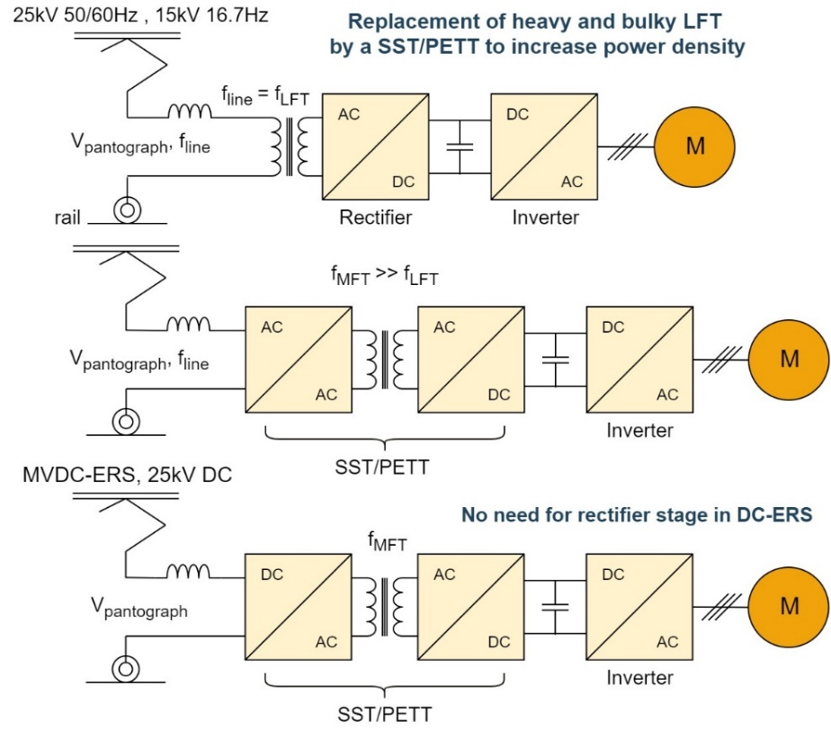
Figure 1 – SST replacing traditional line frequency transformers.
The article [37] demonstrates that all state of the art PETT topologies are derived from key concepts patented during the years 1968-1970. The article defines three basic key concepts being the common characteristic with modern PETTs: 1. medium frequency isolation stage, 2. medium input voltage and 3. controllability. All these three characteristics are desired for traction equipment. Figure 2 shows an MFT, with its resonant and non-resonant variants patented in 1968 by McMurray. One popular modern topology, the Dual Active Bridge converter is based on this concept, as well as other PETT topologies (see Fig. 5).
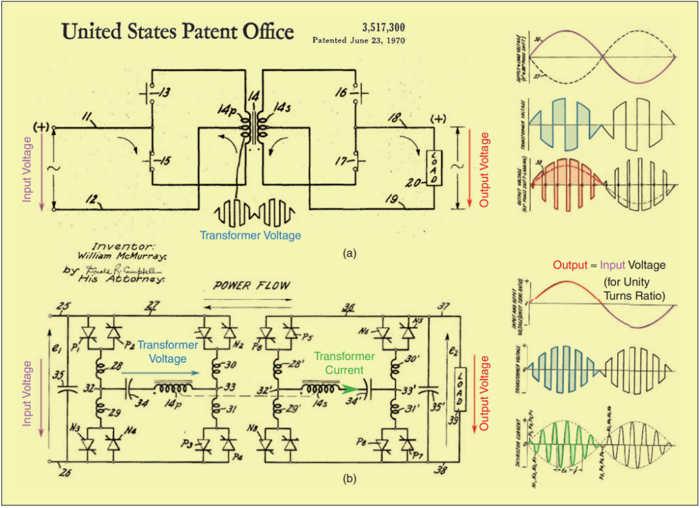
Fig. 2 – AC-AC converter with medium-frequency link patented by McMurray in 1968, including key waveforms, illustrating output stage regulation by phase-shift between primary and secondary bridges (from this DAB converters can be derived). b) resonant AC-AC configuration variant. [37]
As in 1968 high power fully controllable semiconductors were not available, McMurray used thyristors, which needed zero-crossing of current to turn off, therefore the transformer current was shaped into sinusoidal pulses. However, McMurray’s solution features power and load independent input-output voltage ratio and soft switching, that was necessary to reduce switching losses and it is still considered a strong advantage for many modern PETT topologies. Nonetheless, it was not possible to connect this topology directly to medium voltage power supplies for the limited blocking voltage of thyristors.

This was achieved with a multilevel topology as presented in 1969 also by McMurray in one of his patents, as shown in Fig. 3. He described a “fast transient response stepped wave switching power converter” really similar to Cascaded H-bridge (CHB) topologies. The converter cells have an isolation stage and are connected input series, output parallel (ISOP). PETT cells today uses bidirectional bus instead of the unidirectional diode rectifier on Fig. 3, however McMurray mentioned the usage of MFT for cell supply. ISOP structures also have self-balancing features of floating capacitor voltages [37].
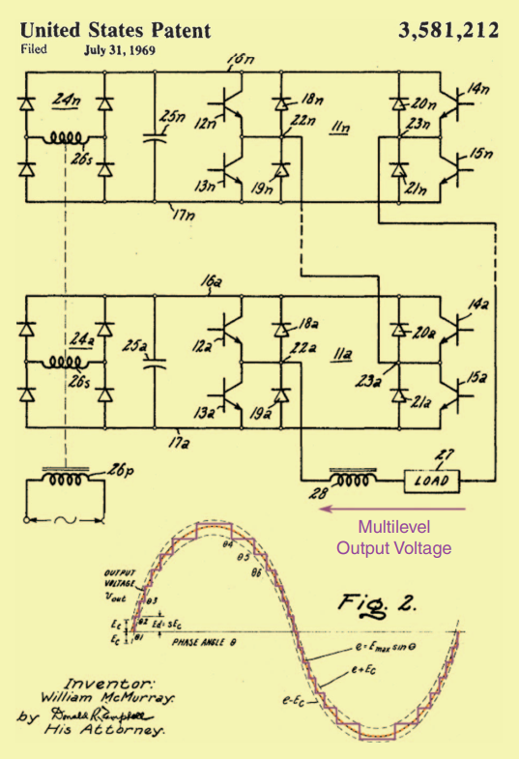

Fig. 3 – Fast response stepped-wave switching power converter by McMurray, 1971. [37]
The third key concept is the controlling stage. Weiss proposed in 1985 a configuration for traction applications as shown in Fig. 4, with MFT isolation like in McMurray’s approach. Weiss however interfaced the low voltage side DC bus with an additional control stage, a boost converter.

The boost converter realised by Weiss is controlled to draw a current proportional to the rectified output voltage that is in turn proportional to the primary side voltage. In this way, the power factor on the railway grid side is unity for all the load condition. As the control stage is placed on the low voltage side of the isolation stage, the converter can be referred as isolated front-end converter (IFE). This idea combined with the concept of cascaded modules has led to many PETTs developed for traction as well as other applications.

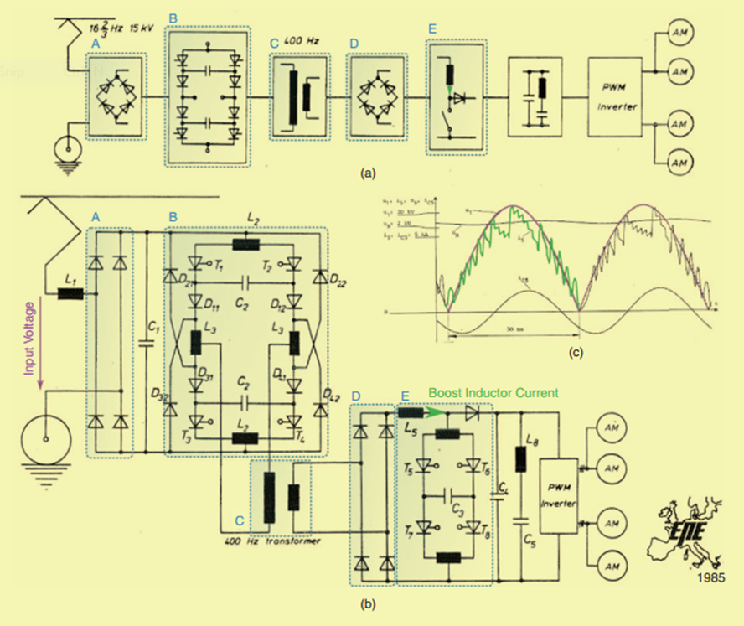
Fig. 4 – Topology with main frequency transformer eliminated, proposed by Weiss in 1985. [37]
Figure 5 from [37] sums up the main modern PETT topologies derived from the presented key concepts.
In 1979 a concept was patented, where instead of the direct matrix converter applied in McMurray’s original patent, an additional rectifier stage has been added [38]. The obtained processed AC voltage then applied to a higher frequency transformer in the isolation stage results in the presented modern PETT topology family of indirect matrix type converters in Fig. 5a). This has been patented recently, in 2008, by General Electric, who developed a 1 MW single-phase prototype with ISOP multi-module configuration using SiC devices of 10 kV and 20 kHz switching frequency. The declared efficiency was around 97%, with a weight reduction of 75% and size reduction of 50% in comparison with traditional LFT solutions [39].
The combination of McMurray’s converter in Fig. 3 and the DC-DC isolation stage supplying the cascaded modules in Fig. 2b has resulted in a topology with DC output and good controllability, as shown in Fig. 5b [40]. This configuration is maybe the most popular among modern SSTs, patented back in 1996 in Germany.

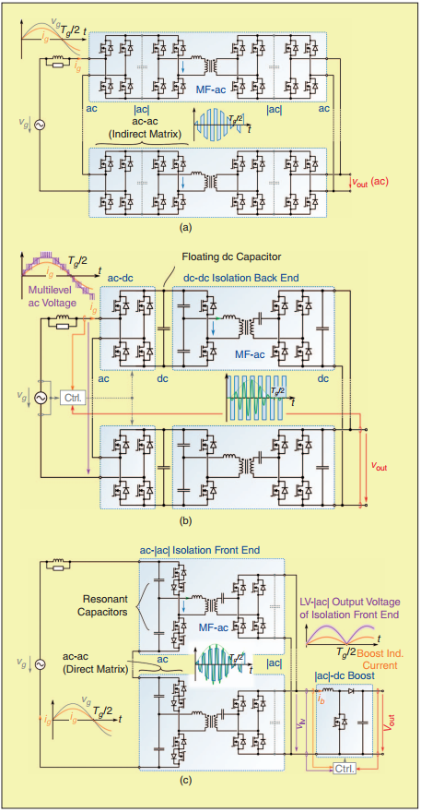
Fig. 5 – Modern SST topologies derived as a combination of the early concepts. a) modern matrix SST with ISOP configuration, similar as McMurray’s concept in Fig. 2. b) a modern isolation back-end converter with CHBs and multilevel output voltage (like concept in Fig. 3) c) modern isolation front-end topology using cascaded converter cells and resonant isolation (similar to a combination of concepts in Fig. 4 and Fig. 2b). [37]
The controlled stage located in the MV side [37] refers to as isolated back-end converter (IBE). The most significant application of this topology was the first fully functional PETT tested on a real locomotive in Switzerland, implemented by ABB in 2011. It was mounted on a shunt locomotive, interfaced with the 15 kV, 16.7 Hz AC railway electrification system. However, it did not use SiC devices, but 6.5kV silicon IGBTs with an operating fundamental frequency of 1.8 kHz. ABB obtained a peak efficiency of 96%, with a power density of 0.75kVA/kg that was double in comparison to LFT, 0.35kVA/kg [18]–[25].
The concept of Weiss from 1985 has been later improved by employing the resonant high-frequency link isolation stage of McMurray (Fig. 2b) realising an isolated front-end converter topology as in Fig. 5c). In contrast to the previously mentioned isolated back-end converter, here the capacitors of the isolation stage are small resonant or commutation capacitors, since there is no energy storage required in the isolation stage. The flow of power is controlled by the boost converter in the LV side and translated to the MV side providing unity power factor. In this way the measurements can be done in the LV side, with savings on the sensing equipment.
Other modern topologies based on the original concepts are the isolated modular multilevel converters and single cell configurations. The idea behind the modular multilevel converter is the simplification of modules by eliminating the necessity of DC supply for each, while keeping the cascaded structure as in Fig. 3 [41]. In 2004 it was already proposed for a traction application [42], however only for the MV side with a single MFT. The authors extended their work and defined this structure as a new multilevel converter family for traction in [43], as shown in Fig. 6.
The single cell structure is available due to the technological advance of WBG semiconductors, which have higher blocking voltages. Such structures include Neutral-Point Clamped (NPC) converters or two-level converters. This approach eliminates the necessity of cascaded modules while keeping the MFT isolation stage, which can be realised as in McMurray’s concept with a half-cycle discontinuous conduction mode resonant converter. Such a single cell structure was proposed in 2018 by Verdicchio in [29] and was also pursued by the project Future Renewable Electric Energy Delivery and Management (FREEDM) [44]. Both used NPC configurations with SiC devices. Another good option for MF isolation are DAB converters (patented in 1989 by DeDoncker [45]), which are highly controllable, but more complex as well. However, in a single cell structure the complexity will not be considered a drawback as in the case of modular structures, since there is only one module. Also, employing HV SiC devices, the system complexity will be very low and efforts can be focusses on improving the reliability.
As a conclusion, the original key concepts led to the definition of five main topologies for PETTs. In most traction converters developed recently, the modular structure is favoured due to its scalability to higher voltage levels and reliability (possibility of adding redundant cells), which are important requirements in traction applications. Therefore, even with the appearance of HV WBG semiconductors, cascaded modular and multicell topologies will remain integral part of PETTs. However, as mentioned earlier, some challenges must be still addressed before this technology reaches maturity. These include mainly protection issues against overvoltages, short circuit induced currents, good isolation and thermal management. IBE family is suitable and used for traction and IFE for auxiliary power supply, where high power density is needed, since IFE is less complex but also less flexible as IBE. Multilevel converters should be further researched for validation of its benefits in terms of isolation design compared to separated multi-winding transformer-based configurations. Finally, regarding single cell structure, it shows reliability issues (redundant design is challenging) at the expense of less complexity.
As an addition to the conclusions of this chapter, Table 2 summarises the differences between MFT and LFT technologies.
Table 2 – MFT and LFT technology comparison.
 | LFT | MFT
Power density | low | high
Efficiency | limited and lower | high
Transformer design complexity | low | high, moreover different applications need different and specific design
Operating/switching frequency | line frequency (low) | hundreds of Hz to tens of kHz
Power quality | fair | good, due to more control options
Technical maturity | reached its maturity | not yet mature, some topologies and configurations are reaching their potential faster than others
Fault current limitation | low | good
Fault isolation capability | poor | good, also redundant configuration is available
Control complexity | low | high and in some applications can be difficult, but rewarding
Switch and drives count | low | high number of devices, due to modular/multi-level structure, however WBG high-voltage devices can lower it
Flexibility | low | high, offers additional functionalities like fault limitation and isolation, voltage flicker compensation
Controllability | low, no control over transmitted power | high, good control over  power flow
Availability | high | fair, difficult to design and manufacture
Reliability | high | lower; under research and development, different configurations, like redundancy can bring improvements
Costs | low cost compared to state of the art technologies, much better kW/cost value | due to multilevel/multi-stage and/or multi-modular structure they have a higher cost (still low kW/cost value)
Losses | higher losses | lower losses

Brief overview of state of the art PETTs and definition of suitable topologies for MVDC-ERS
Based on the early concepts presented in the previous chapter, several PETT topologies have been studied, developed, prototyped and tested for railway systems by various university research groups and train manufacturers. The new wide band-gap semiconductor materials like silicon carbide encourages PETT development, especially when the 6.5kV and 10kV and later 15kV SiC components will be ready for commercialisation. SiC semiconductors allow switching frequencies as high as tens of kilohertz, leading to higher fundamental frequency of MFTs; when SiC devices will be available for higher voltages, it will also be possible to use fewer converter modules and/or stages. The operating frequency of new PETT structures is practically the switching frequency of power semiconductor modules, therefore is independent on line frequency.
The most timely application of PETTs would be for 15kV AC ERS connected traction vehicles, since the 16.7Hz supply frequency obliges locomotives to have on-board transformers heavier those for 25kV, 50 Hz or 60 Hz AC systems. In this case the new PETT technology achieves an increase of efficiency by 7% and a global weight reduction of 50% [12]. A new ERS, such as a flexible MVDC-ERS, would require also high-performance novel PETT structures to handle new challenges such as fault handling, protection circuits and smart-grid compatibility. In the MVDC-ERS concept the setup looks different in comparison to the main topological families defined in 3.4, as the line voltage is a DC voltage; thus, the rectifier stage is not needed in MVDC-ERS traction topologies. However, to improve the new MVDC line-based traction devices voltage balancing stages could be used instead of the rectifier stages. The concept of voltage balancing will be presented in a later chapter.

The last 25 years of PETT concepts (1993-today)
This section presents a review of PETTs for MV ERSs at 15kV and 25kV AC. Based on 3.4, in the following PETT topology families will be presented, that could be used in MVDC-ERS (same topologies as defined in 3.4, but without the rectifier stage in the primary) [46]. Let the first configuration type be the single cell structure in Fig. 6 on the next page, since the first PETT developed in ‘85 by Weiss and already presented in the previous chapter had such a structure. As seen in Fig. 4 it consisted of a matrix converter with a 400Hz MFT placed between an input and output rectifier and a boost converter at the output with the role of current shaping and voltage regulation. At that time thyristors were used, which were replaced by IGBTs in later topologies.
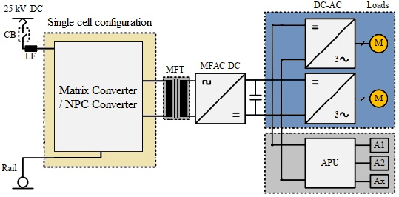
Fig. 6 – Single cell matrix/NPC based converter. (APU means Auxiliary Power Unit and M is Motor)
Later in ’93 another thyristor-based system was developed in Sweden also with matrix converter in the front-end and a four-quadrant converter at the output. The developers also suggested a cascaded configuration in the front-end with semi separated multi-winding isolation to avoid high line-current harmonics [47]. This concept was further studied and in 2001 the thyristors were replaced by high-voltage IGBTs. In this way the switching frequency was increased, since naturally commuted thyristors switched at line frequency. In the system developed in 2001 by S Norrga, a three-phase configuration was proposed to reduce high line-current harmonics. The switching frequency was 1 kHz with ZVS and the results on a 30 kW laboratory prototype showed a 40-50% weight reduction in comparison with an equivalent LFT. In the primary side, RC snubbers were added to reduce overvoltages caused by leakage inductance [48].
Previous research has shown that the single cell structure is not the best option for PETTS, as even with 6.5kV IGBTs (those with the current highest available blocking voltage), a series connection of semiconductor devices would be unavoidable. Therefore, the application of series connected front-end converters became more popular. In the future, when higher voltage SiC devices will be available, the single cell structure may be considered again. A single cell NPC converter based on 10 kV SiC MOSFETs was proposed as a concept for future MVDC-ERS in [29] in 2018. Single cell systems have low complexity and reliability but also low availability, since it is easier to have a more redundant design with multiple modules.
The next topology to be analysed is the multi-cell structure, which is modular and multi-level, as shown in Fig. 7. Several PETT systems with this configuration were developed in 2002-2008.
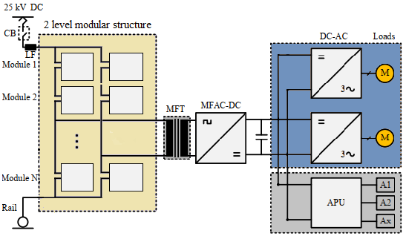
Fig. 7 – Modular multi-level structure (multicell).
After researches demonstrated the necessity of series connection of converters in the front end, in 2002, right after the concept presented in 2001, a multicell structure was proposed in [49] by the same author. He proposed a two-level modular structure using so called “cycloconverter sub-valve” cells with capacitive snubbers, which were included to avoid uneven voltage distribution among the “valves”. In the secondary circuit, a VSC was applied and with alternate switching of the VSC with the cycloconverter ZVS or ZCS was achieved. Norrga reported shortly after in a different paper also the design of the high-power MFT.
During 2003-2005 Siemens worked on a 2 MVA modular multi-cell converter for the 15 kV catenary. They developed an 8 module 17-level converter using 1.2 kV IGBTs and a 10 kHz MFT. Siemens made a full-scale prototype of the whole system too, with a predicted peak efficiency of 98%, based on simulations [47].
At the moment, the most commonly used topologies of PETT for MVDC applications are input-series output-parallel (ISOP) DC–DC converters, shown in Fig. 9 [47]. However, ISOPs have a large number of dc-dc modules, meaning many medium-frequency transformers and semiconductors, which can be a limitation Therefore, other multilevel structures have been proposed that use only one transformer, as shown in Fig. 8. The main disadvantage is the lack of good bypass features in case of module break downs. Different solutions were proposed for this problem in literature, but the low power density is still a limiting factor. ISOP PETT structures can also have power balance problems, which implies more complex control systems. SiC semiconductors will make possible the development of two-level converter topologies with fewer modules, simplifying the control system. The following two topology families will be ISOP structures.
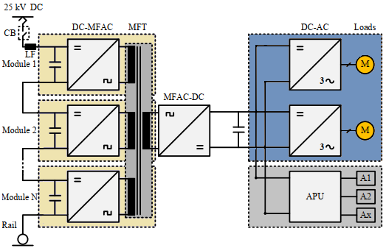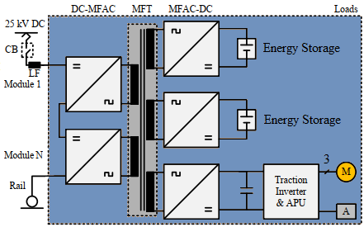
- b)
Fig. 8 – a) Cascaded ISOP setup with semi separated multi-winding isolation (SSMW).
b) Multi port multi-winding PETT configuration.
In 2003 Alstom developed an 8 module CHB PETT with ISOP structure using a semi separated multi-winding (SSMW) MFT of 5 kHz as isolation. The achieved power was 1.5 MVA and 6.5 kV and 3.3 kV IGBTs were used. Another two SSMW configurations were presented by University of West Bohemia, Czech Republic in 2008 for 25 kV AC ERS. For the first, they used a 400 Hz MFT and two cascaded H-bridges in the primary for a 12 kW 400 V laboratory prototype. The second was a 4 kVA matrix converter based PETT system also with only two modules, for which they proposed the separated multi-winding isolation as an option. In both their work the robustness of control and feasibility was validated at steady-state and for different load changes. Another relevant SSMW configuration PETT concept was developed in China by Tsinghua University in 2014. They presented two options too: a SSMW with independent output DC links in the secondary for an EMU setup and a SMW for locomotive with paralleled DC link capacitors. The concept was validated on a 6 kV laboratory experimental setup with an MFT having 6 primary and secondary windings. The main novelty of their work was the multi-port configuration in the output stage, shown in Fig. 8b. The simulations were based on the 25kV AC ERS with 23 cascaded modules and 1 kHz MFT. The work also highlighted the control algorithms used: soft switching achieved with phase-shift control, voltage balancing control and power decoupling calculation [47].
The most studied PETTs topology is the cascaded ISOP with separated multi-winding MFT, and hence it is analysed here in more depth.
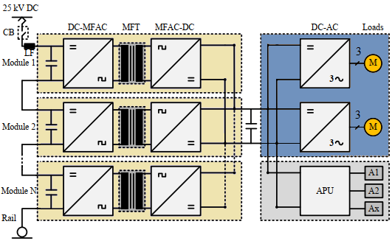
Fig. 9 – Cascaded ISOP setup with separated multi-winding (SMW) isolation.

One of the first structures was Rufer’s direct coupled multi-level based four-quadrant converter in ’96 and used the novel high-voltage IGBTs instead of thyristors. This was crucial in the evolution of PETTs, since IGBTs in comparison to thyristors are fully controllable. The DC-DC converters were bidirectional resonant converters with galvanic isolation using MFTs. Also is noteworthy to remark the ISOP structure of the whole system, since most of the later developed PETTs have used the same topology. From this configuration, four variants have been developed [46], see Figures 10-13.
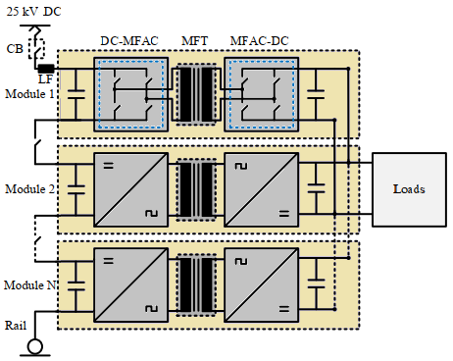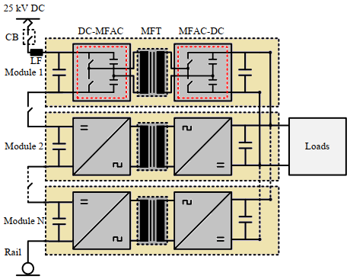
Fig. 10 – Active Full-Bridge converter topology with ISOP setup.
Fig. 11 – Cascaded Active Half-Bridge ISOP converter.

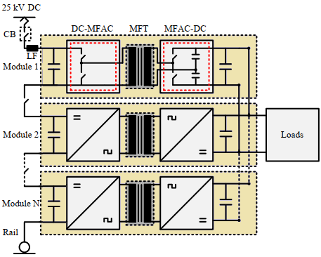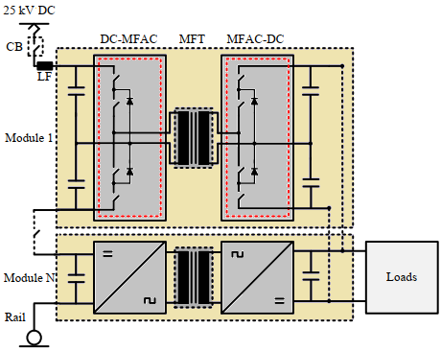
Fig. 12 – Asymmetrical Active Bridge converter topology, ISOP.
Fig. 13 – Diode-clamped ISOP converter topology with Half-Bridge.

In ’98 Siemens developed a similar structure as Rufer’s ’96 concept (MFT, high-voltage IGBTs, CHB and ISOP configuration) having the configuration as in Fig. 10. Among these early concepts (the ones from ‘85 to 2002 presented on the previous pages) the most promising would be the one developed in ’96, having modular feature and being fault tolerant. Most of later developed topologies that will be shown in the following are based on this one, using ISOP configuration and soft switching. However, it should be noted that joint multi-winding technology is a compromise for fault tolerance.
Looking at the evolution of PETTs it can be also noticed, that the number of publications per year is increasing. The new traction systems are developed by both the universities or other institutes and the leading railway traction system suppliers. The traction system suppliers have more experience and a better understanding of requirements, having also better opportunity to implement full-scale PET systems, thus offering a more practical concept approach. However, universities and institutes can develop sometimes really good ideas and theoretically well-defined concepts, which can be later used and implemented by the leading suppliers.
In 2002 ABB developed a 4.2 MVA, 12 module CHB PETT concept with 10 kHz MFT using full bridges for the DC-DC conversion stage as in Fig. 10. The chosen topology was an LLC resonant DC-DC converter, however they prototyped only the MFT. The conclusions of this paper indicated that each application will require specially designed transformer to match its configuration and requirements, therefore transformer design will be a major hurdle in contrast to the other parts of the converter. ABB paid special attention on its insulation problem [50].
In 2007 Bombardier presented a PETT system of 3 MVA with 8 CHB modules and 8 kHz MFTs capable of 500 kW maximum power transfer (per module), with a reported transformer weight of 18 kg. A 750 kW laboratory testing system was also developed. Similar to ABB, Bombardier used an outer voltage control loop and inner line-current control loop with PI and proportional-resonant (PR) respectively, to control the power flow Also, an active damping mode was suggested to reduce harmonic disturbances. The controller thus improved line current quality obtaining a THD of 1.92% [35].
In 2007 ABB also developed a PETT for EMU application, but this time used matrix converters with 16 cascaded modules. They achieved 1.2 MVA using 3.3 kV/400 A IGBT semiconductors with a 1.8 kV DC-link voltage, and a 400 Hz multi-winding MFT [47]. While back in 2002 ABB prototyped only the MFT, now they managed to prototype the whole system, that lead them to develop the first ever PETT implemented into an actual locomotive, that was tested in 2011 on the Swiss Federal Railways achieving a 95% efficiency and almost unity power factor. However, in 2011 they used the half-bridge configuration for the DC-DC converter, like the one in Fig. 11. For better fault handling, they implemented a redundant design including one extra module. For the control of the power flow within the modules, a slower outer DC-link voltage control loop with PI controller was used and a faster inner line-current control loop with PR control [18]–[25]. This project was presented in more detail in section 3.4.
Rufer worked on PETTs later too, he proposed another CHB based PETT in 2003 while working with EPFL. Its novelty was the reconfigurable connection between 15kV AC and 3kV DC lines. He even discussed an alternative front-end converter topology, having an asymmetrical configuration, like in Fig. 12. The concept was verified on a small scale test rig [47]. Later, he worked with IK4 IKERLAN (a private not-for-profit Technological Research Centre in northern Spain) focusing especially on MFT design. They developed in 2011-2012 a test rig and presented a 400 kW nanocrystalline-based MFT used in an LLC converter with 5 kHz switching frequency. The converter had a weight of 58.8 kg versus a 1 kHz switching frequency silicon-steel-based 500 kW MFT DAB converter with 462.7 kg weight [47]. This study has shown how power density of MFTs can be improved using new materials for the transformer’s core.
In 2014 the Federal University of Ceará, Brazil, combined the DAB topology with three-state cells and developed a PETT system, however without experimental validation. Also they used a centre-tapped transformer setup, which is disadvantageous due to increased weight, volume and complexity [47].
FREEDM published in 2014 another PETT with ISOP structure, where the isolation was realised by flyback inductors operated at high frequency. The topology used was full bridge with diodes connected in series with the transistors, a configuration as in Fig. 13. The study validated experimentally some voltage balancing methods on a small-scale rig supplied by a single-phase 120 V 60 Hz AC voltage. The difference to other works is that FREEDM used CSC instead of VSC, which can be a disadvantage in terms of input voltage quality.
In 2015 the Laboratory of Magnetic Suspension Technology and Maglev vehicle together with Southwest Jiatong University, China, analysed a three-level, multi-module diode-clamped PETT for railway applications. The DC-DC converter was a bidirectional half-bridge as in Fig. 13 and the rectifier had an H-Bridge configuration, both diode-clamped. The experimental validation was done only for 100 V input, 70 V output at the DC buses.
In [51] it is highlighted that CHB configurations are more mature and can reach higher voltages than other multilevel topologies, including diode-clamped configurations. Furthermore, diode-clamped converters have higher switching losses and unbalanced voltage, which could be solved with a voltage balancing stage. However cost would increase and many high-power high-voltage diodes would be necessary.
As a conclusion of this brief analyses of MV PETTs, it can be observed that most of them are designed for 15 kV AC ERS and only a few concepts are presented for 25kV ERS. Most of the projects are from Europe and the most preferred topological family is the one in Fig. 9, using CHB. Since 25kV is a higher voltage by 66% than 15kV, it implies more cascaded modules and higher costs. Therefore, as mentioned earlier, PETTs are mainly viable for 15kV ERS. However, for a MVDC-ERS, the cost for a PETT is lower since there is no rectifier stage[47]. The cascaded H-bridge and the matrix converters are the two preferred candidates for front-end converters, with CHB systems more mature and popular. In terms of the transformer, the multi-separated MFTs configuration is better than joint multi-winding MFT configuration, because it is easier to manufacture and has better fault handling performance. In terms of the system configuration, cascaded front-end converters with fully controllable power electronic devices must be used, in order to withstand the input voltage from the catenary. Usually input-series-output-parallel configuration is the most popular, as it uses a modular design that is good for redundancy. However, they have the disadvantages of high cost and low-power density necessity, thus topologies with reduced number of cascaded front-end converters would ultimately be preferred when new semiconductors with higher blocking voltage will become available
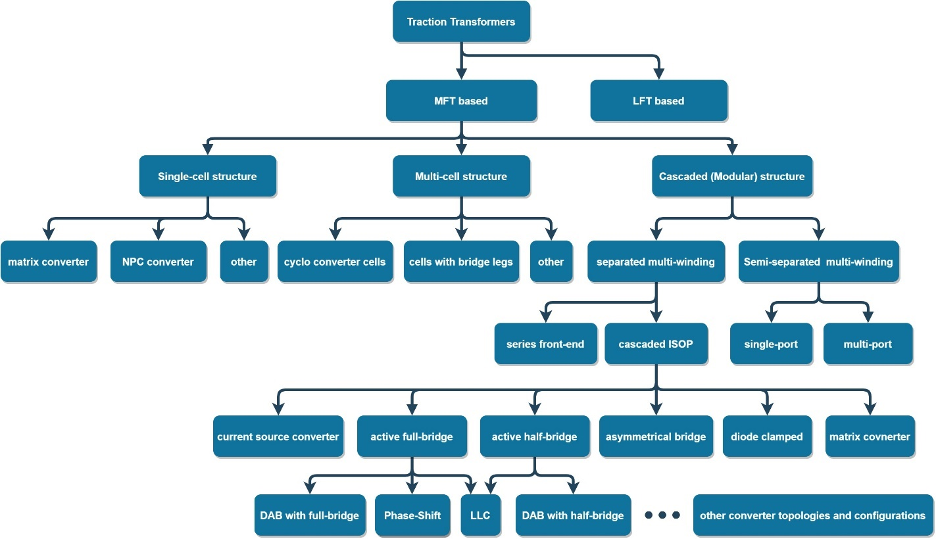
Fig. 14 – Summary of PETT classification.

Possible MVDC converter configurations

On the basis of the previous analysis, the three most promising topologies for MVDC-ERS traction converters are:
- a topology of cascaded buck converters with LLC resonant converters or a voltage balancing stage, as shown in Fig. 15a. In this way, the high input voltage is regulated, and the converters can use high-frequency transformers achieving galvanic isolation and soft switching [32].
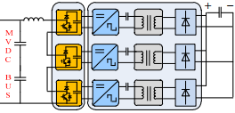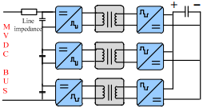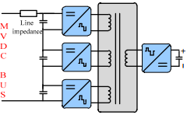
Fig. 15 – a) Cascaded Buck-LLC b) Cascaded ISOP DAB c) Multi-Active-Bridges [52]
- Dual Active Bridge converters used in ISOP configuration, as shown in Fig. 15b. The DAB topology has the advantage of good control over power flow, having the capability of regulating both input and output voltages [52].
- Multiple active bridges on the primary side with a single low voltage side cell, relying on high voltage SiC MOSFET devices, as shown in Fig. 15c. For lower conduction loss synchronous rectification can be implemented [52].
For all cases, the core of a PETT is the isolated DC-DC converter, which can have different topologies too. The following figure show the power flow in DAB cells that are suitable candidate for DC-DC modules. The voltage on the capacitors are directly related to the power transferred, thus when the capacitor voltages are balanced in the primary side, the power also will be balanced. The secondary side capacitor voltages will be in the same way determined by the transferred power [52].
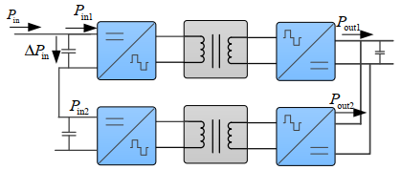
Fig. 16 – Power flow in DAB cells.

Article [53] from 2018 presents the benefits of MVDC grid over MVAC grid for on-board integrated power systems. The authors proposed a DC/DC SST using ISOP series resonant DAB topology in modular structure, including steady-state modelling and a control algorithm to achieve DC bus equalization (for a stable voltage on the LV side) and fast response. Simulation results were presented for a 1.2MW system.

Dual Active Bridge Converters
The DAB converter is a DC-DC converter implemented by a rectifier, a high-frequency transformer and an inverter. In Fig. 17, the first VSC converts the input DC voltage to a high-frequency AC, which is scaled by the high-frequency transformer, and rectified by the second two-level VSC.

DAB full bridge converter

DAB converter is a topology with the advantages of decreased number of devices, soft-switching commutations, low cost, and high efficiency. This topology is suitable for applications where the power density, cost, weight, and reliability are critical factors.
Some advantages of DAB converters:
- It can be bidirectional
- Compatible with MFTs
- Configured with small duty cycle values (more linear output current)
- Can be controlled by phase-shift, duty cycle and both (single-phase-shift, dual-phase-shift, extended-phase-shift, triple-phase-shift)
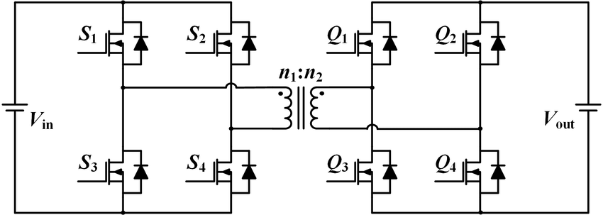
Fig. 17 - Dual-active bridge converter

DAB half bridge converter

The benefits of the DAB half bridge converter are bidirectional power flow capability, high efficiency, low switching loss, and simple circuit structure. Other advantages:
- Switching regions can be improved using phase-shift and duty cycle control together, which is advantageous against large BUS voltage variations
- Low number of switches
- Smooth low-voltage side current
- Natural soft switching
- Perfect candidate for small size, high efficiency
- Can be modular
Drawback: Unbalanced voltage between two capacitors in DC link side.

Example of a DAB configuration for MVDC traction

To show the typical waveforms of this topology, a simulation was implemented in PSIM software, based on its mathematical model designed in Mathcad. The simulated converter has 8 modules of 150 kW and 1,500 V output. The control algorithm was a voltage control loop with PI regulator. The topology of the converter and its control are shown in Fig. 18.
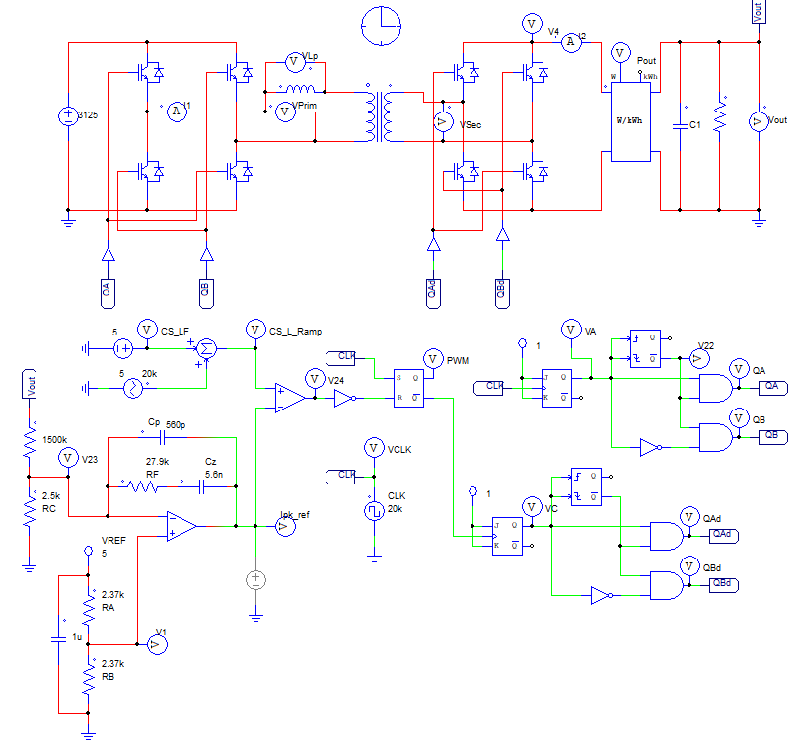
Fig. 18 – DAB module for MVDC PETT.
The waveforms for a single module can be seen on Fig. 19. On the primary side, the voltage is kept below 5 kV thus 6.5kV IGBTs can be used (two IGBT modules are operating at the same time, transistor pairs being switched, therefore the voltage between 5 and 6 kV is supported by two IGBTs in series). The secondary side current is almost double than that in the primary, rising close to 400 A. Another simulation was made for an 8-module configuration with 25kV input voltage, using an ISOP structure, see Fig. 20.
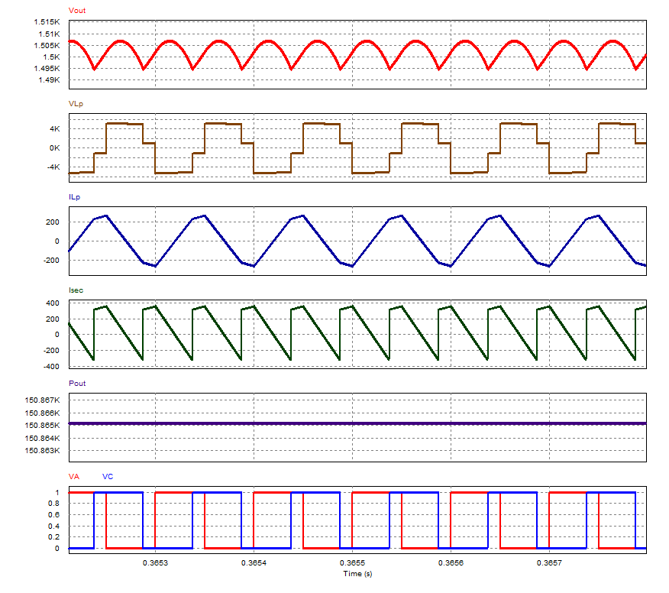
Fig. 19 – Simulation results for a 150 kW power DAB module. With red - the output voltage, brown - the voltage on the primary inductance, blue - the current on primary inductance, green - the current in the secondary and purple – the output power.
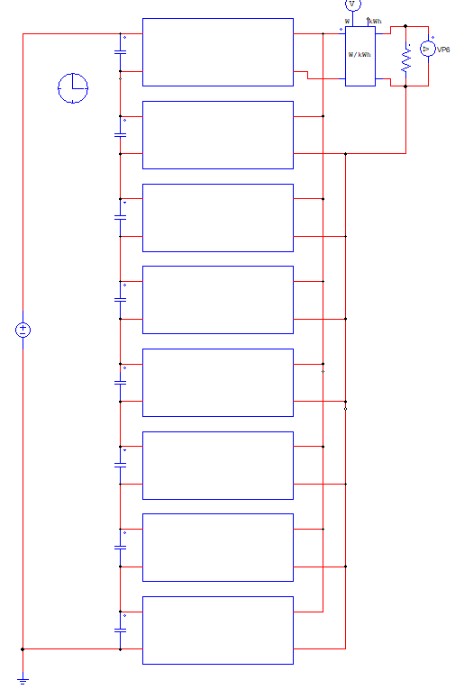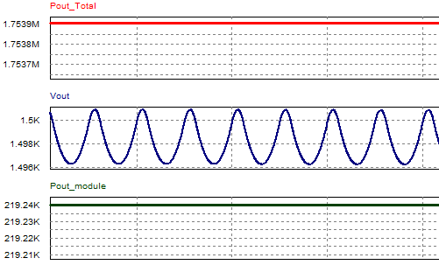
Fig. 20 - ISOP of 8 modules with 3,125 V DC input voltage each (total of 25,000 V DC) and 1,500 V DC output voltage. Simulation result for a 219 kW per module, 1.75 MW total output power configuration.

Voltage balancing stages (VBS)
As discussed in the previous chapter, at the moment, the most commonly used topologies of DCPET for MVDC applications are input-series output-parallel (ISOP) dc–dc converters, which has been deeply studied already. However ISOPs have an increased number of dc-dc modules, meaning many medium-frequency transformers and semiconductors. This brings up limitations and no possibility for further improvements. Therefore other multilevel structures are proposed, which uses only one transformer, but the structure has technical bottlenecks, like lack of good bypass features in case of module break downs. Different solutions were proposed for this problem in literature, but the power density is still limited. ISOP PETT structures can also have power balance problems, which implies more complex control systems. Paper [54] proposes a novel DCPET topology that can be a possible candidate to improve the aforementioned limitations. The proposed configuration has the features of ISOP structures except showing increased power density by reducing the number of switches and transformers required and eliminating the necessity of other by-pass devices. The VBS is also explained in detail, how it can achieve voltage balance in case of imbalances. For ZCS the resonant period has to be equal to the switching period and the time of conduction of the switches to be 0.5T_{s}. The paper presents the equations for power losses as well as design considerations for the VBS. The topology can vary according to requirements of a given application. If the number of VBSs is n, then the number of isolated bidirectional DC converter stages (IBDC) k, can be between 1 and n. These characteristics may eliminate the restrictions of the PETT, such as switching frequency, weight, volume, and costs, which makes the proposed PETT configuration superior and potential for the on-board traction applications.
As seen on Fig. 21, this topology has two parts: the isolated conversion stage (blue) and a voltage-balance stage VBS (orange). The VBS is 2+1 voltage-balancing converter (VBC) with 2 series half-bridges and capacitors with output voltages 0, V_{in}/2 and V_{in.} The conversion stage is isolated input-series output-parallel converter consisting of 2 bidirectional dual active bridge DC-DC converters, having the 2 input capacitors in series between P_{p} and P_{n} – the medium voltage bus and output capacitors in parallel between Q_{p} and Q_{n} – the low-voltage bus.
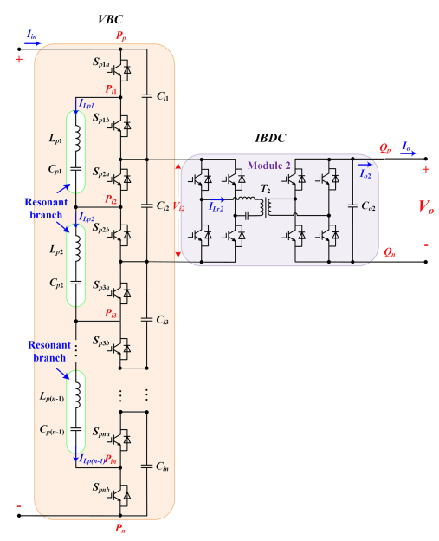
Fig. 21 - The derived topology of VBS PETT, when k=1. [54]
The VBS consists of 2 switching pairs S_{p1a}, S_{p1b} and S_{p2a}, S_{p2b} between the resonant branch L_{p1}, C_{p1}. This structure can achieve self-balancing voltage in different working conditions. The isolated conversion stage can be different topology, any other bidirectional isolated converter than the chosen DAB in this application. The number of stages can be adjusted according the requirements of applications, also the number of VBSs. The improvement of this novel topology is that when some isolated bidirectional DC converter stages (IBDCs) are eliminated - thus their number is smaller than the input capacitors - the VBC will still ensure voltage balance and the rest of IBDCs will still operate at the rated voltage [54].
As a conclusion, these topologies have 4 major advantages: the high-voltage IGBTs can be replaced by low voltage IGBTs, which can help increase switching frequency and reduce costs; the number of the high-frequency transformers will not increase, which can further reduce costs, improve power density, and simplify isolation design; ZCS or ZVS can be guaranteed for all the switches in the dc/dc stage, which can ensure high efficiency of the PETT and the control strategy of the dc/dc module is simple because of the voltage self-balancing capability of the proposed VSBR converter. Furthermore, the paper contains a performance comparison between three different configurations of 3000V input, 600V output, 150kW power, demonstrating improved efficiency, greater power density, reduced number of switches and reduced IGBT losses. [54].

Specifications and requirements for traction

Inductive power factor of train
Table 3 – MVDC-ERS parameters from work package 1 (WP1) of this project.
Parameter | Symbol | Value (kV)
Lowest non-permanent voltage | $$U_{min2}$$ | 17.5
Lowest permanent voltage | $$U_{min1}$$ | 19
Nominal voltage | $$V_{DC,nom}$$ | 25
Highest permanent voltage | $$U_{max1}$$ | 27.5
Highest non-permanent voltage | $$U_{max2}$$ | 29

On the range of U_{min1} to U_{max1} (19-27.5kV) the total power factor λ (active power/apparent power) must be:

$$\begin{aligned}\left\{\begin{aligned}λ≥0.95, if P_{pant}>2MW \\ λ>0.85, if P_{pant}<2MW \end{aligned}\right.\#\left(1\right)\end{aligned}$$

where P_{pant} is the instantaneous power at the pantograph. In the cases when this power is below 2 MW, the overall (traction and auxiliaries) average power factor must be greater than 0.85 over a complete timetabled journey [55].
Inside yards and depots, when traction power is switched off but all auxiliaries are still running and the power drawn is greater than 200 kW, the power factor should be ≥ 0.8.

$$\begin{aligned}λ=\sqrt{\frac{1}{1+{\left(\frac{W_{Q}}{W_{P}}\right)}^{2}}}\#\left(2\right)\end{aligned}$$

Equation 2 presents the calculation of the overall average λ for a train journey, including stops as a function of active (W_{P} in MWh) and reactive energy (W_{Q} in MAh) [55].
During regenerative braking, the power factor can decrease freely to keep the voltage within limits.

Capacitive power factor of train
The capacitive power factor of a train is not limited, since a train should not behave as a capacitor. However, during regenerative mode if there is capacitive power, it shall be limited to 150 kvar on the range U_{min1} to U_{max1} [55].

Power levels of trains
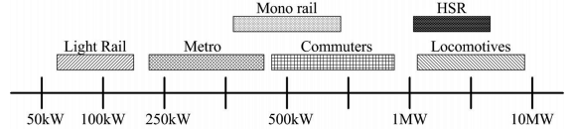
Fig. 22 – Railway power levels. [56]
As seen in Fig. 22, locomotives and electric multiple units usually operate at powers of hundreds of kWs up to even over 10 MW depending on their load, speed and type.

Current limitation
Each train should have an automatic regulation device that, in case of weaker network or abnormal operation, adapts the maximum current drawn from the contact line as a function of the contact line voltage. Therefore, a current limiter has to be present in the control of the traction converter. According to standard EN 50388 from 2012, the maximum allowable current on classic lines is 800 A and 500 to 1,500 A on HS TSI (High-Speed Technical Specifications for Interoperability) lines (depending on their category), in the case of the 25kV AC power supply system [55].
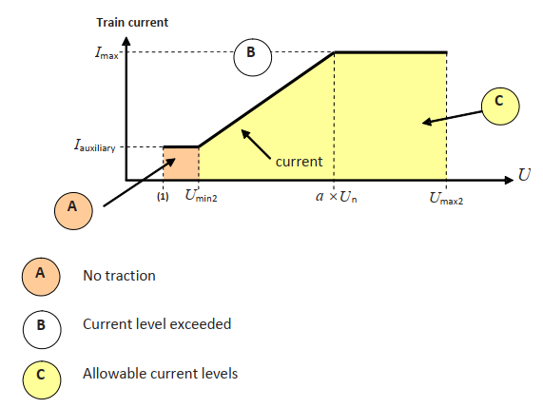
Fig. 23 – Maximum current consumed by the train at nominal voltage. [55]
The value of a in Fig 23, the knee point factor, for 25kV AC power supply systems is 0.9.

Regenerative braking and on-board storage
Regenerative braking (RB) has a significant role in energy saving of traction systems. Depending on the type of train, between 5% and 17% of energy can be recuperated. For example, the N700 series of Shinkansen has shown a 4.5% energy saving, the American Acela Express 8%, the Pendolino trains in UK 17%, and the New Delhi’s metro line 30%. RB is also beneficial for independently powered trains: the hybrid diesel locomotives for Indian Railways shown a fuel consumption reduced by 15%, and emissions reduced by 50% [57].
Regenerative braking is a mature technology and widely available in traction systems, however it is easier to use in AC electrification systems than DC ones. In fact, DC systems typically require a higher cost of investments for the inverting substations [57].
RB is more effective for rail vehicles with frequent stops, such as tram and metro lines. Almost all modern trains are equipped with a RB system, however the benefits are proportional to the frequency of stops.
Some of the difficulties of implementation of RB in DC systems is the low voltage and the lack of possibility to feed current back to the public grid, especially in urban areas. In the MVDC-ERS concept these problems are mitigated, since the voltage is as high as of the AC systems and the traction substations are all bidirectional.
The energy recuperated by the train can be injected to the electrical infrastructure, or stored on-board on an energy storage system. It was found that energy storage systems can achieve peak power reduction and enable catenary-free operations if needed. According to [58] the energy saving results obtained and presented in various publications is around 30%, depending on the type and storage technology used for energy storage system, which are mainly supercapacitors, batteries and flywheels. The advantages of supercapacitors and flywheels are: fast response, a long lifespan and a high power density. Among the batteries, the most popular are lithium-ion and lithium-titanate having the former a high energy density and the latter a high number of cycles.
From this analysis, it is evident that regenerative braking has to be maintained with PETTs. This is generally not an issue, as all the power converter topologies used for PETTs are bidirectional and can easily control the power flow to the electrical infrastructure.

Control and protection of traction converters
There are several options for the DC-DC converters control implementation. The first choice is between analogue control and digital control. The advantages associated with analogue control are low price, low complexity, small printed circuit board (PCB) area required and high performance. However, analogue control relies on ICs developed by semiconductor manufacturers which greatly limits the control method flexibility and converter’s topology choice (no control IC can be found for the DAB converter for example). These disadvantages exclude the use of analogue control for the tasks that need to be completed in this project. Digital control allows a much greater flexibility and complexity of the control algorithms. A few examples of commonly used hardware platforms for digital control are: rapid prototyping systems (dSPACE for example [59]), digital signal processors (DSPs) and field programmable gate arrays (FPGAs).
A rapid prototyping system like dSPACE has a large number of analogue to digital, digital to analogue and general-purpose IO interfaces to cover the requirements of almost any converter’s topology control system. Rapid prototyping systems are usually provided with a high-level graphical programming tool (like Simulink) that greatly reduces programming times. The major drawback of this approach is that system integration is limited. It may be difficult to add a Wi-Fi, CAN or other protocol-based connection to the control system developed. Also, the control system needs to be migrated to a custom hardware platform for production.
The second choice for digital control implementation is the use of a DSP. DSPs are popular because they are easy to use, cheap and sufficiently performant for most control system’s requirements. A wide variety of programming languages generally familiar to engineers such as C, C++ or high-level graphical description languages (Simulink) accelerate and facilitate DSP programming.
The third hardware platform option for digital control implementation are FPGAs [60]. The choice between FPGAs and DSPs has been widely debated in the past decade. Several comparisons between FPGAs and DSPs in applications such as synchronous motor control [61], Static Compensator (STATCOM) control [62], artificial intelligence [63], [64] or signal processing applications [65] prove that FPGA devices drastically reduce execution times, increase controller bandwidth and increase throughput. Besides these advantages, FPGAs provide a greater number of digital IOs and parallel DSP blocks, allowing multiple high complexity control algorithms to be implemented on one device, reducing the number of ICs in the system. The increased performance of FPGAs is reflected however in much higher prices and in a more complex auxiliary circuitry (more power supplies with very tight tolerances to power the device, more PCB layers) that further increases the price of the system. Furthermore, unlike DSPs (C2000 family from Texas Instruments is a good example [66]), FPGAs are not specifically designed for control systems lacking high performance internal Analog-Digital Converters (ADCs) or Pulse Width Modulation (PWM) generators. While ADCs can be added externally, the performance of dedicated PWM generator structures can’t be obtained on FPGAs, at least not with a significant amount of effort. Therefore, for implementing DC-DC converter’s control system, regardless whether is a DAB or other topology the first option is a DSP unless it is proved that such a device can’t achieve some specific performance parameters required.
In the MVDC traction system, the control of DC voltage is an essential task, since it has a direct relation with power flow and power balance. In addition to voltage sensors of the primary loop, current sensors have to be used to implement an inner control loop and regulate the DC current.
Regarding protection, two major contributors to Electromagnetic Interference (EMI) are high variations of the current that create overvoltage due to the stray inductances of current loops; and high variations of the voltage that create leakage current in the magnetic elements due to stray capacitive couplings. Overvoltages are produced in the DC-DC voltages also by the ringing effect. Therefore, protection circuitry is necessary for short circuit currents and overvoltages. In order to combat overvoltages, snubber circuits and active gate control could be used, considering not to increase number of components at the expense of significantly higher costs. The best solution is to choose components (including IGBTs and DC link capacitors) with low stray inductance (in the case of capacitors low ESL). Laminated DC-busbars can also reduce EMI, since they are designed with low stray inductance and resistance. More details about designing SSTs for reduced EMI can be found in [67]. The study in [67] summarises some important design considerations such as: minimizing distances between the conductors by using thin isolation; choosing insulation materials with high dielectric constant, breakdown strength and thermal conductivity; careful choice of DC link capacitors; careful choice of shape, location and routing of the conducting points to provide multi-layered current flow in opposite directions with equal strength; low impedance design of conductors (thin and flat with fewer holes and larger area of surface).
Another protection challenge is the design of gate drives, since desaturation protection against short circuit and overcurrent needs MV diodes of higher costs, not to mention inconsistency of protection current caused by variations in temperature, voltage and other conditions. To address this issue, currently Rogowski coil-based protection circuits are under investigation [68].

Potential benefits of using wide band-gap semiconductors in MVDC converters
The design goal of MVDC traction converters are high efficiency and reliability. In addition to these characteristics, the DC-DC converters mounted on traction vehicles must have power density as high as possible (compactness), while capable sometimes of operation under harsh conditions.
As Silicon (Si) semiconductors have already reached their full potential, new generation of semiconductors and switching devices using new WBG materials have been emerged to replace Si devices. Such WBG semiconductors are: SiC, Gallium Nitride (GaN) and diamond. They are used to develop IGBTs, MOSFETs, thyristors, JFETs, GTOs, BJTs and power diodes, which significantly improve the performance of power converters. GaN and SiC are currently the most mature among WBG semiconductors, therefore in this study only these two will be considered. Although GaN can achieve higher frequency and voltage, due to the lack of good bulk substrates and lower thermal conductivity, currently SiC is more promising. Some achievements in SiC technology include: bulk material growth, advances in SiC wafers, larger dielectric critical field, meaning a ten times higher blocking voltage for the same thickness [69].
Commercial Si IGBTs are limited to a blocking voltage of 6.5 kV and temperature of 200 ℃ (which implies complex and expensive cooling sometimes) in comparison to SiC devices, which have much higher thermal conductivity and can operate even above 300-400 ℃ with a melting point of 3000℃ [69]. WBG semiconductors enable the converters to operate at higher switching frequency (up to 100 kHz) while maintaining high energy efficiency. This decreases the size and weight of passive filters and heat-removal system and in consequence, increases the power density of the converters.
SiC Schottky diodes have been commercialised since 2001 already and they are used in IGBT power modules too as freewheeling diodes. These IGBTs are the so called Si-SiC hybrid semiconductors and Japanese railways reported a reduced mass and volume of 60% in traction converters [37]. Also Mitsubishi Electric launched in 2015 traction inverters based only on SiC devices for the Japan-Tokyo 1.5 kV DC metro and a 30% energy consumption decrease was reported along a power loss reduction of 55% [70]. Two years later, in [71] the first traction system for high-speed trains was reported based on SiC devices combined with train-draft cooling system and a new series of 6-pole induction motors. Thanks to SiC technology, the main transformer and the conversion system could be installed in the same car due to compactness and to the 10% smaller new motors, an overall system weight reduction of 20% was achieved compared to the previous series of the train. In [72] a PETT was presented built with the earlier mentioned junction barrier SiC diodes and 15 kV/120 A SiC MOSFETs. At 1 MVA power, the achieved efficiency was 98% and the weight reduction 70%. A SiC MOSFET traction inverter was also operated in the Stockholm Metro System for 3 months and showed increased power density, achieving a reduction of 51% volume and 22% weight [73].
According to [69] SiC devices are developed for a large variety of applications and voltage ranges starting from JFETs, junction barrier diodes, IGBTs, MOSFETS and BJTs to SiC-GTOs. However, some of these devices are not as mature as others due to reliability problems. Theoretical studies show that SiC MOSFETs are a good candidate up to a 10-15 kV breakdown voltage, while IGBTs are the devices with the highest potential for applications above 15 kV, due to their very good on-state performances. In [74] a 27 kV SiC IGBT was reported as laboratory experiment and [68] mentions an engineering sample of a SiC GTO of 22 kV. Hitachi already commercialised 3.3 kV hybrid SiC IGBTs (as used in [70] and [71]) and their all SiC IGBT is on the way too, under development for production [75]. Paper [68] presents a survey on recent advances of MV SiC power devices. Beside the already mentioned advantages of SiC devices, it mentions some reports about lower on-state resistance, switching energy and cooling requirements However, higher voltage ratings and switching frequencies imply challenges in the packaging. To avoid overshoots and current imbalances mentioned in the previous chapter, the packaging must have low parasitic capacitance and inductance. In [76] a 57% loop inductance reduction was achieved only by adding decoupling capacitors inside the MOSFET module and [77] also reports such inductance reduction by doing different tests without and with decoupling capacitors A stacked substrate structure that improves not only the parasitic capacitance reduction but thermal performance as well was also presented in [76]. The smaller dimensions of SiC devices brings also insulation issues, therefore [76] proposed a stacked insulation structure, reducing the strength of peak electric field by up to 40% compared to single substrates.
The authors of [68] also tested three SiC devices, two of them MOSFETs and based on the reports of the last few years defines the 3.3 kV rated SiC devices as the most mature ones currently, showing good static/dynamic performances, body diode surge current capability, avalanche capability and short-circuit ruggedness. In [78] a 10 kV SiC MOSFET with 6.5 kV Si antiparallel diode are compared using a series-resonant DC/DC converter test bench. The results show a significant reduction of losses with the SiC module and in the conclusions, it is mentioned that 10 kV SiC modules without anti-parallel diodes are under development and tests are already undergoing. The SiC MOSFET with the highest voltage studied so far reaches 15 kV, which has been compared with the 15 kV SiC IGBT in [79] and [80]. The conclusion of the two studies was that SiC MOSFETs are better for low current applications and IGBTs for high current applications (Hitachi has two modules under development, one of 1,200 A and one of 1,800 A – both at 3.3 kV [75]). Also, the on-state resistance of MOSFETs becomes high above 15 kV. The articles categorise the SiC devices for future applications as follows: MOSFET up to 15kV, IGBT between 15-35 kV and GTOs above 35 kV.
Another study, [77], presents a test-bench and a SiC MOSFET model in PSIM to efficiently compare different bus-bar designs and evaluate SiC switching behaviour. Furthermore, an additional test bench was developed to undertake thermal and electrical measurements and Si-IGBTs in comparison to SiC MOSFET modules for a VSI application. The simulation results about the impact of bus-bar design on the turn-off of SiC-MOSFETs show that SiC MOSFETs have lower turn-on energy than Si-IGBTs with same ratings. Then the paper presented different methods for measurement of losses. The results showed that SiC MOSFETs have 60% less power losses than Si-IGBT for 15 kHz switching frequency. Si-IGBT modules have the same losses of SiC MOSFETS only at 1 kHz switching frequency. For 20 kHz switching frequency the total loss reduction is 57% compared to Si-IGBT. However, at low frequency – 1 kHz - Si-IGBT modules have lower losses. It can be concluded that the experimental results confirm the losses reduction, operation at increased frequencies and junction temperatures. The analysis also provided useful guidelines for SiC inverter design in traction applications. Finally, the paper highlighted also the necessity of high current modules for traction applications. At the moment, commercially available 1.7 kV SiC devices already allow the design of traction inverters for metros and trams, as seen in [70] and [71].
The work in paper [81] evaluates a 1,200 V/800 A all-SiC dual module designed for electric military vehicle under a 1000 hour operation test operated at 10 kHz frequency with different load profiles. During the test, it was observed that none of the measured characteristics suffered any significant unfavourable change more than 10% compared to their initial value. The length of the test represented 11,783 miles of usage, which corresponds to over a half of expected inverter lifecycle in such a vehicle. This validates also the reliability of SiC devices.
In another paper, [82], as part of a Swiss project titled ”SwiSS Transformer - P3: 99% Efficient Solid State SiC Transformer Cell Demonstrator” in the context of PETTs a 10kV SiC based PFC was studied. The authors designed a PFC of 25 kW achieving 99.1% efficiency at full load and a power density of 3.28kW/dm³. In [83] a 10 kV SiC based 25 kW single phase bidirectional AC/DC PETT was presented and the paper also introduced the concept of integrated Triangular Current Mode (iTCM) operation and demonstrated its superiority over PWM. With the iTCM concept they achieved a semiconductor losses reduction of 40% and an increased switching frequency as well as full range soft switching.
Paper [84] studied two SiC modules, a 1.7 kV/1,100 A and a 3.3 kV/750 A in the context of the recently proposed MVDC-ERS of 9 kV in [29]. The paper proposed a driver for ZVS of the SiC MOSFETs and a test bench to define module losses. The experimental measurements on the test-bench included turn-off energy losses for both SiC modules (based on which the simulation model was designed). In the last section of the paper a 9kV/1.5kV ISOP PETT configuration was also presented, consisting of 6x360 kW modules. The obtained efficiency, based on simulations, was between 98.8% and 99.3%, depending on converter operation mode (Continuous Conduction Mode – CCM or Discontinuous Conduction Mode – DCM) and module output power. The study validated the efficiency of soft switching over hard switching in the case of the proposed configuration and the ZVS capabilities of the presented gate driver.
As a summary, SiC semiconductors offers higher efficiency, better thermal characteristics and higher switching speeds with lower losses, all of these useful for MVDC-ERS traction. They can be already used for the tractions systems of light rail vehicles, and the future development of the technology will make them increasingly attractive also for other types of trains.

Conclusion
While PET-based systems are more expensive than traditional LFT-based systems due to the large number of high-voltage power devices and advanced cores used in MFTs, they have a number of attracting advantages. Firstly, the improved efficiency and power quality, secondly a redundant design, which improves availability, and thirdly the increased power density. However, the large number of components, reduces their reliability in some cases and requires complicated design and control strategies. For MVDC traction, LFT-based systems are not even an option, as the need of two converters and the possibility of choosing the intermediate AC frequency will certainly lead to MFTs for the higher achievable power density.

Regarding the pros and cons of PET-based systems discussed, it is important to notice that the benefits are evident, while most drawbacks are technologies and materials dependent. A further development of power devices and materials, as well as investigation of topologies and control methods will probably mitigate most of the drawbacks.

MVDC-ERS presents a concept of a new DC railway electrification system, based on the new technology that makes possible its implementation. Such a novel system will open new opportunities and functionalities of an interoperable smart DC grid. At the same time the new system will combine the advantages of various new technology and the advantages of current ERSs. The on-board PETTs will have to be redefined also for the new system and its needs.

References
[1] P. M. Kalla-Bishop, Future Railways and Guided Transport. IPC Transport Press Ltd, 1972.
[2] Network Rail, “UK Network Rail electrification strategy report,” 2010.
[3] Е. П. М. Дробинский В.А., “Как устроен и работает тенловоз” (How the diesel locomotive works), 3rd ed. Moscow: Транспорт, 1980.
[4] И. В.Н., “Конструкция и динамика тепловозов” (Construction and dynamics of the diesel locomotive). Москва: Транспорт, 1968.
[5] С. А. Э. Хомич А.Э. Тупицын О.И., “Экономия топлива и теплотехническая модернизация тепловозов” (Fuel economy and the thermodynamic modernization of diesel locomotives). Москва: Транспорт, 1975.
[6] U. Wang, “Gigaom GE to Crank Up Gas Power Plants Like Jet Engines.”
[7] W. W. Hay, The economics of electrification. New York: Wiley, 1982.
[8] International Energy Agency, “Railway Handbook 2015,” p. 18.
[9] International Energy Agency, “Railway Handbook 2017.”
[10] Wikipedia, “Railway Electrification System.” [Online]. Available: https://en.wikipedia.org/wiki/Railway_electrification_system.
[11] Wikipedia, “Electric locomotive article.” [Online]. Available: https://en.wikipedia.org/wiki/Electric_locomotive.
[12] M. Brenna, F. Foiadelli, and D. Zaninelli, Electrical railway transportation systems. Wiley, 2018.
[13] B. Electric, “Electric railway traction Part 1 Electric traction and DC traction motor drives,” Power Eng., vol. 8, no. February, pp. 47–56, 1994.
[14] П. Д. А. Винокуров В.А., “‘Электрические машины железно-доровного транспорта’ (Electrical machinery of railroad transportation),” Москва: Транспорт, 1986, pp. 95–99.
[15] С. Н. Н. Сидоров Н.И., “Как устроен и работает эелктровоз” (How the electric locomotive works). Москва: Транспорт, 1988.
[16] A. Gomez-Exposito, J. M. Mauricio, and J. M. Maza-Ortega, “VSC-Based MVDC railway electrification system,” IEEE Trans. Power Deliv., vol. 29, no. 1, pp. 422–431, 2014, doi: 10.1109/TPWRD.2013.2268692.
[17] A. Steimel, “Power-Electronics Issues of Modern Electric Railway Systems,” 10 th Int. Conf. Dev. Appl. Syst. DAS 2010, vol. Advances i, no. May 2010, doi: 10.4316/aece.2010.02001.
[18] C. Zhao et al., “Design , Implementation and Performance of a Modular Power Electronic Transformer ( PET ) for Railway Application Keywords Configuration of the PET demonstrator,” Proc. 2011 14th Eur. Conf. Power Electron. Appl., pp. 1–10.
[19] D. Dujic et al., “Laboratory Scale Prototype of a Power Electronic Transformer for Traction Applications Former ABB colleague Keywords Power Electronic Transformer Topology,” Proc. 2011 14th Eur. Conf. Power Electron. Appl., vol. i, pp. 1–10.
[20] T. Besselmann, A. Mester, D. Dujic, and S. Member, “Power Electronic Traction Transformer : Efficiency Improvements Under Light-Load Conditions,” IEEE Trans. Power Electron., vol. 29, no. 8, pp. 3971–3981, 2014, doi: 10.1109/TPEL.2013.2293402.
[21] D. Dujic, F. Kieferndorf, F. Canales, and U. Drofenik, “Power Electronic Traction Transformer Technology,” Proc. 7th Int. Power Electron. Motion Control Conf., vol. 1, pp. 636–642, 2012, doi: 10.1109/IPEMC.2012.6258820.
[22] D. Dujic et al., “Power Electronic Traction Transformer-Low Voltage Prototype,” IEEE Trans. Power Electron., vol. 28, no. 12, pp. 5522–5534, 2013, doi: 10.1109/TPEL.2013.2248756.
[23] C. Zhao et al., “Power electronic traction transformer-medium voltage prototype,” IEEE Trans. Ind. Electron., vol. 61, no. 7, pp. 3257–3268, 2014, doi: 10.1109/TIE.2013.2278960.
[24] C. Zhao et al., “Power electronic transformer (PET) converter: Design of a 1.2MW demonstrator for traction applications,” SPEEDAM 2012 - 21st Int. Symp. Power Electron. Electr. Drives, Autom. Motion, pp. 855–860, 2012, doi: 10.1109/SPEEDAM.2012.6264496.
[25] M. Claesens, D. Dujic, F. Canales, J. K. Steinke, P. Stefanutti, and C. Veterli, “Traction transformation: A power-electronic traction transformer (PETT),” ABB Rev., no. 1, pp. 11–17, 2012.
[26] EN 50163: Railway applications. Supply voltages of traction systems. 2007.
[27] IEC 60850: Railway applications – Supply voltages of traction systems, 3rd ed. 2007.
[28] O. P. Leander, “A concept for an HVDC traction system,” International conference on main line railway electrification, Hessington, England, pp. 169–173, 1989.
[29] A. Verdicchio, P. Ladoux, H. Caron, and C. Courtois, “New Medium-Voltage DC Railway Electrification System,” IEEE Trans. Transp. Electrif., vol. 4, no. 2, pp. 591–604, 2018, doi: 10.1109/TTE.2018.2826780.
[30] D. Laousse, C. Brogard, H. Caron, C. Courtois, and S. Denis, “Direct current - A future under which conditions?,” no. August 2017, pp. 114. 260-275, 2016.
[31] M. Unibertsitatea, L. Abrahamsson, and J. Sanz, “Electrical railway power supply systems : current situation and future trends,” Int. J. Electr. Power Energy Syst., no. November, 2017, doi: 10.1016/j.ijepes.2017.05.008.
[32] H. Shigeeda, H. Morimoto, K. Ito, T. Fujii, and N. Morishima, “Feeding-loss Reduction by Higher-voltage DC Railway Feeding System with DC-to-DC Converter,” 2018 Int. Power Electron. Conf. (IPEC-Niigata 2018 -ECCE Asia), pp. 2540–2546, 2018, doi: 10.23919/IPEC.2018.8507567.
[33] K. Meah and S. Ula, “Comparative evaluation of HVDC and HVAC,” Proc. IEEE Power Eng. Soc. Gen. Meet., pp. 1–5, 2007.
[34] A. Verdicchio, P. Ladoux, H. Caron, and S. Sanchez, “Future DC Railway Electrification System - Go for 9 kV,” 2018 IEEE Int. Conf. Electr. Syst. Aircraft, Railw. Sh. Propuls. Road Veh. Int. Transp. Electrif. Conf., pp. 1–5, 2019, doi: 10.1109/esars-itec.2018.8607304.
[35] M. Steiner and H. Reinold, “Medium frequency topology in railway applications,” 2007 Eur. Conf. Power Electron. Appl. EPE, 2007, doi: 10.1109/EPE.2007.4417570.
[36] N. Hugo, P. Stefanutti, M. Pellerin, and R. Sablières, “Power Electronics Traction Transformer,” Proc. Eur. Conf. Power Electron. Appl., pp. 1–10, 2007.
[37] J. E. Huber and J. W. Kolar, “Solid-State Transformers,” IEEE Ind. Electron. Mag., vol. 10, no. September, pp. 19–28, 2016, doi: 10.1109/MIE.2016.2588878.
[38] R. F. Brewster and A. H. Barrett, “Three phase ac to dc voltage converter with power line harmonic current reduction,” 1979.
[39] M. K. Das et al., “10 kV, 120 a SiC half H-bridge power MOSFET modules suitable for high frequency, medium voltage applications,” IEEE Energy Convers. Congr. Expo. Energy Convers. Innov. a Clean Energy Futur. ECCE 2011, Proc., pp. 2689–2692, 2011, doi: 10.1109/ECCE.2011.6064129.
[40] M. Steiner and H. Reinold, “Antriebssystem für ein Schienenfahrzeug und Ansteuerverfahren hierzu,” German Patent DE 196 30 284 A 1, 1996.
[41] A. Lesnicar and R. Marquardt, “A new modular voltage source inverter topology,” in 10th European Power Electronics Conference (EPE), 2003.
[42] M. Glinka and R. Marquardt, “A New Single Phase AC/AC-Multilevel Converter for Traction Vehicles Operating On Ac Line Voltage,” EPE J., vol. 3, no. 14, pp. 7–12, 2004, doi: 10.1080/09398368.2004.11463567.
[43] M. Glinka and R. Marquardt, “A new AC/AC multilevel converter family,” IEEE Trans. Ind. Electron., vol. 52, no. 3, pp. 662–669, 2005.
[44] A. Q. Huang, M. L. Crow, G. T. Heydt, J. P. Zheng, and S. J. Dale, “The future renewable electric energy delivery and management (FREEDM) system: The energy internet,” Proc. IEEE, vol. 99, no. 1, pp. 133–148, 2011, doi: 10.1109/JPROC.2010.2081330.
[45] R. W. DeDoncker, M. H. Kheraluwala, and D. M. Divan, “Power conversion apparatus for dc/dc conversion using dual active bridges,” 1991.
[46] J. Winter, T. Schirmer, A. Iraklis, A. Lusiewicz, and H. Dittus, “Overview of Three-Stage Power Converter Topologies for Medium Frequency-based Railway Vehicle Traction Systems,” IEEE Trans. Veh. Technol., vol. PP, no. c, pp. 1–1, 2019, doi: 10.1109/tvt.2019.2895500.
[47] J. Feng, W. Q. Chu, Z. Zhang, and Z. Q. Zhu, “Power Electronic Transformer-Based Railway Traction Systems: Challenges and Opportunities,” IEEE J. Emerg. Sel. Top. Power Electron., vol. 5, no. 3, pp. 1237–1253, 2017, doi: 10.1109/JESTPE.2017.2685464.
[48] P. C. Kjær, S. Norrga, and S. Östlund, “A Primary-Switched Line-Side Converter Using Zero-Voltage Switching,” vol. 37, no. 6, pp. 1824–1831, 2001.
[49] S. Norrga, “A soft-switched bi-directional isolated AC/DC converter for AC-fed railway propulsion applications,” IEE Conf. Publ., no. 487, pp. 433–438, 2002, doi: 10.1049/cp:20020156.
[50] L. Heinemann, “An actively cooled high power, high frequency transformer with high insulation capability,” Conf. Proc. - IEEE Appl. Power Electron. Conf. Expo. - APEC, vol. 1, no. c, pp. 352–357, 2002, doi: 10.1109/apec.2002.989270.
[51] S. Kouro et al., “Recent advances and industrial applications of multilevel converters,” IEEE Trans. Ind. Electron., vol. 57, no. 8, pp. 2553–2580, 2010, doi: 10.1109/TIE.2010.2049719.
[52] S. Wang, Z. Zheng, Y. Li, and L. Peng, “A modular DC solid state transformer for future onboard DC grid,” 2016 Int. Conf. Electr. Syst. Aircraft, Railw. Sh. Propuls. Road Veh. Int. Transp. Electrif. Conf. ESARS-ITEC 2016, no. 3161001, pp. 1–6, 2017, doi: 10.1109/ESARS-ITEC.2016.7841351.
[53] L. Peng, S. Wang, L. Xu, Z. Zheng, and Y. LI, “Onboard DC Solid State Transformer Based on Series Resonant Dual Active Bridge Converter,” 2018 IEEE Int. Conf. Electr. Syst. Aircraft, Railw. Sh. Propuls. Road Veh. Int. Transp. Electrif. Conf., pp. 1–6, 2019, doi: 10.1109/esars-itec.2018.8607334.
[54] J. Zhang, J. Liu, J. Yang, N. Zhao, Y. Wang, and T. Q. Zheng, “A Modified DC Power Electronic Transformer Based on Series Connection of Full-Bridge Converters,” IEEE Trans. Power Electron., vol. 34, no. 3, pp. 2119–2133, 2018, doi: 10.1109/TPEL.2018.2842728.
[55] European Committee for Electrotechnical Standardization, “Railway Applications - Power supply and rolling stock - Technical criteria for the coordination between power supply (substation) and rolling stock to achieve interoperability,” 2013.
[56] D. Ronanki, S. A. Singh, and S. S. Williamson, “Comprehensive Topological Overview of Rolling Stock Architectures and Recent Trends in Electric Railway Traction Systems,” IEEE Trans. Transp. Electrif., vol. 3, no. 3, pp. 724–738, 2017, doi: 10.1109/TTE.2017.2703583.
[57] Climate Technology Centre & Network, “Regenerative braking for trains.” [Online]. Available: https://www.ctc-n.org/technologies/regenerative-braking-trains.
[58] M. Khodaparastan, A. A. Mohamed, and W. Brandauer, “Recuperation of regenerative braking energy in electric rail transit systems,” IEEE Trans. Intell. Transp. Syst., vol. 20, no. 8, pp. 2831–2847, 2019, doi: 10.1109/TITS.2018.2886809.
[59] R. V. Meshram, M. Bhagwat, S. Khade, S. R. Wagh, A. M. Stankovic, and N. M. Singh, “Port-Controlled Phasor Hamiltonian Modeling and IDA-PBC Control of Solid-State Transformer,” IEEE Trans. Control Syst. Technol., vol. 27, no. 1, pp. 161–174, 2019, doi: 10.1109/TCST.2017.2761866.
[60] E. Monmasson, L. Idkhajine, M. N. Cirstea, I. Bahri, A. Tisan, and M. W. Naouar, “FPGAs in industrial control applications,” IEEE Trans. Ind. Informatics, vol. 7, no. 2, pp. 224–243, 2011, doi: 10.1109/TII.2011.2123908.
[61] L. Idkhajine, E. Monmasson, and A. Maalouf, “Extended Kalman filter for AC drive sensorless speed controller - FPGA-based solution or DSP-based solution,” IEEE Int. Symp. Ind. Electron., pp. 2759–2764, 2010, doi: 10.1109/ISIE.2010.5636605.
[62] C. A. Sepulveda, J. A. Munoz, J. R. Espinoza, M. E. Figueroa, and C. R. Baier, “FPGA v/s DSP performance comparison for a VSC-based STATCOM control application,” IEEE Trans. Ind. Informatics, vol. 9, no. 3, pp. 1351–1360, 2013, doi: 10.1109/TII.2012.2222419.
[63] E. Nurvitadhi, J. Sim, D. Sheffield, A. Mishra, S. Krishnan, and D. Marr, “Accelerating recurrent neural networks in analytics servers: Comparison of FPGA, CPU, GPU, and ASIC,” FPL 2016 - 26th Int. Conf. Field-Programmable Log. Appl., no. c, pp. 1–4, 2016, doi: 10.1109/FPL.2016.7577314.
[64] M. Kaminski and T. Orlowska-Kowalska, “Comparison of DSP and FPGA realization of neural speed estimator for 2-mass system,” Proc. - ISIE 2011 2011 IEEE Int. Symp. Ind. Electron., pp. 1543–1548, 2011, doi: 10.1109/ISIE.2011.5984390.
[65] Y. Bai et al., “FPGA vs DSP: A throughput and power efficiency comparison for Hierarchical Enumerative Coding,” IEEE/IFIP Int. Conf. VLSI Syst. VLSI-SoC, pp. 318–321, 2013, doi: 10.1109/VLSI-SoC.2013.6673300.
[66] S. W. Lee, “Demystifying Type II and Type III Compensators Using Op- Amp and OTA for DC / DC Converters,” no. July, pp. 1–16, 2014.
[67] D. Ronanki and S. S. Williamson, “Topological Overview on Solid-state Transformer Traction Technology in High-speed Trains,” 2018 IEEE Transp. Electrif. Conf. Expo, ITEC 2018, pp. 858–862, 2018, doi: 10.1109/ITEC.2018.8450135.
[68] B. Hu et al., “A Survey on Recent Advances of Medium Voltage Silicon Carbide Power Devices,” 2018 IEEE Energy Convers. Congr. Expo. ECCE 2018, pp. 2420–2427, 2018, doi: 10.1109/ECCE.2018.8558451.
[69] J. Millan, P. Godignon, X. Perpina, A. Perez-Tomas, and J. Rebollo, “A survey of wide bandgap power semiconductor devices,” IEEE Trans. Power Electron., vol. 29, no. 5, pp. 2155–2163, 2014, doi: 10.1109/TPEL.2013.2268900.
[70] K. Hamada et al., “3.3 kV/1500 A Power Modules for the World’s First All-SiC Traction Inverter,” pp. 14–18, 2017, doi: 10.7567/ssdm.2014.e-4-4l.
[71] K. Sato, H. Kato, and T. Fukushima, “Development of SiC Applied Traction System for Shinkansen High-speed Train,” 2018 Int. Power Electron. Conf. IPEC-Niigata - ECCE Asia 2018, pp. 3478–3483, 2018, doi: 10.23919/IPEC.2018.8507486.
[72] A. Q. Huang, L. Wang, Q. Tian, Q. Zhu, D. Chen, and W. Yu, “Medium voltage solid state transformers based on 15 kV SiC MOSFET and JBS diode,” IECON Proc. (Industrial Electron. Conf., pp. 6996–7003, 2016, doi: 10.1109/IECON.2016.7793121.
[73] M. Lindahl, E. Velander, M. H. Johansson, A. Blomberg, and H. P. Nee, “Silicon carbide MOSFET traction inverter operated in the Stockholm metro system demonstrating customer values,” 2018 IEEE Veh. Power Propuls. Conf. VPPC 2018 - Proc., 2019, doi: 10.1109/VPPC.2018.8604975.
[74] E. Brunt et al., “27 kV, 20 Ampere-rated 4H-SiC n-IGBTs,” Mater. Sci. Forum, vol. 821–823, Jun. 2015, doi: 10.4028/www.scientific.net/MSF.821-823.847.
[75] “3.3 kV Hybrid SiC IGBT commercialised and 3.3kV all SiC IGBT under developement.” [Online]. Available: http://www.hitachi-power-semiconductor-device.co.jp/en/products/igbt/3300v/index.html.
[76] C. DIMarino et al., “Design of a novel, high-density, high-speed 10 kV SiC MOSFET module,” 2017 IEEE Energy Convers. Congr. Expo. ECCE 2017, vol. 2017-Janua, pp. 4003–4010, 2017, doi: 10.1109/ECCE.2017.8096699.
[77] J. Fabre, P. Ladoux, and M. Piton, “Characterization and Implementation of Dual-SiC MOSFET Modules for Future Use in Traction Converters,” IEEE Trans. Power Electron., vol. 30, no. 8, pp. 4079–4090, 2015, doi: 10.1109/TPEL.2014.2352863.
[78] J. Casarin, P. Ladoux, and P. Lasserre, “10kV SiC MOSFETs versus 6.5kV Si-IGBTs for medium frequency transformer application in railway traction,” Electr. Syst. Aircraft, Railw. Sh. Propulsion, ESARS, vol. 2015-May, pp. 5–10, 2015, doi: 10.1109/ESARS.2015.7101518.
[79] K. Vechalapu, S. Bhattacharya, E. Van Brunt, S. H. Ryu, D. Grider, and J. W. Palmour, “Comparative Evaluation of 15-kV SiC MOSFET and 15-kV SiC IGBT for Medium-Voltage Converter under the Same dv/dt Conditions,” IEEE J. Emerg. Sel. Top. Power Electron., vol. 5, no. 1, pp. 469–489, 2017, doi: 10.1109/JESTPE.2016.2620991.
[80] V. Pala et al., “10 kV and 15 kV silicon carbide power MOSFETs for next-generation energy conversion and transmission systems,” 2014 IEEE Energy Convers. Congr. Expo. ECCE 2014, pp. 449–454, 2014, doi: 10.1109/ECCE.2014.6953428.
[81] T. E. Salem and R. A. Wood, “All-SiC Dual Module,” vol. 29, no. 5, pp. 2192–2198, 2014.
[82] D. Rothmund, S. Member, T. Guillod, S. Member, D. Bortis, and J. W. Kolar, “99.1% Efficient 10 kV SiC-Based Medium-Voltage ZVS Bidirectional Single-Phase PFC AC / DC Stage,” IEEE J. Emerg. Sel. Top. Power Electron., vol. 7, no. 2, pp. 779–797, 2019, doi: 10.1109/JESTPE.2018.2886140.
[83] D. Rothmund, D. Bortis, J. Huber, D. Biadene, and J. W. Kolar, “10kV SiC-based bidirectional soft-switching single-phase AC/DC converter concept for medium-voltage Solid-State Transformers,” 2017 IEEE 8th Int. Symp. Power Electron. Distrib. Gener. Syst. PEDG 2017, no. c, pp. 1–8, 2017, doi: 10.1109/PEDG.2017.7972488.
[84] J. Fabre, J. M. Blaquière, A. Verdicchio, P. Ladoux, and S. Sanchez, “Characterization in ZVS Mode of SiC MOSFET Modules for MVDC Applications,” ICCEP 2019 - 7th Int. Conf. Clean Electr. Power Renew. Energy Resour. Impact, pp. 470–477, 2019, doi: 10.1109/ICCEP.2019.8890157.

