Shift2Rail projects FUNDRES/IN2STEMPO/MVDC-ERS joint Newsletter
October 2021
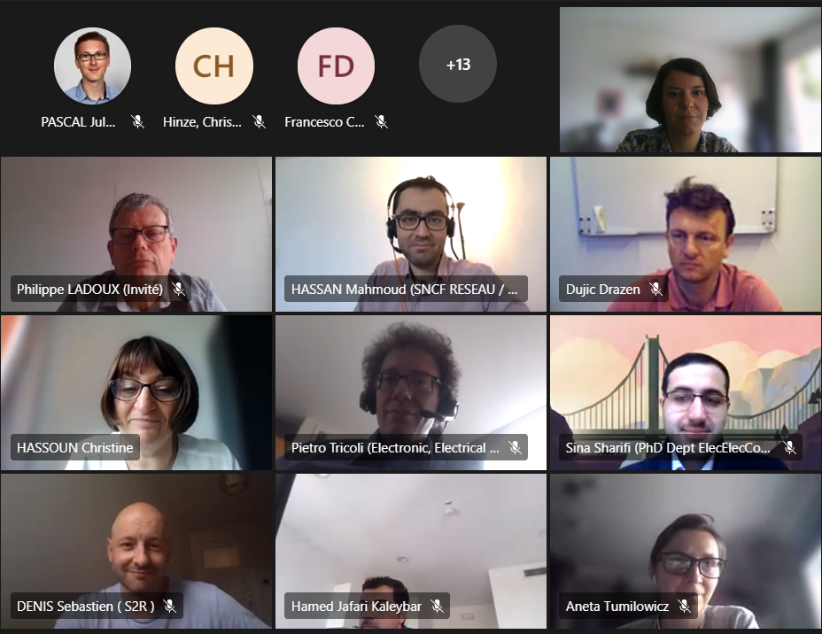
On 29 June 2021, members of the Shift2Rail-funded projects FUNDRES / IN2STEMPO / MVDC-ERS met online for a webinar on smart railway traction power supply.
In2stempo and FUNDRES are two complementary IP3 Shift2Rail funded projects while MVDC-ERS is an IPx Shift2Rail funded project. These three projects are focussed on railway electrification systems.
Information on IP3 and IPx challenges, Innovations and Ambitions can be found on the Shift2Rail website.
The morning session was dedicated to the presentation of the project objectives and results achieved so far.
A round table led by Sebastien DENIS, IP3 Programme Manager at the Shift2Rail JU was organised in the afternoon to underline synergies, compare the main results and discuss the future of these research.
Summary of the discussions during the round table:
Concerning the future substations, In2stempo and FUNDRES are considering the same topology (Modular Multilevel Converter (MMC) but not the same voltage level and not the same power conversion (AC/AC for In2stempo and AC/DC in the FUNDRES project). MVDC-ERS and FUNDRES have synergies concerning the power supply from the public grid and the integration of renewable resources. MDVC-ERS is not only looking on the INFRA side but is also considering a power electronics solution for rolling stock. SNCF-Réseau have both interest in 25kV AC and 9kV DC. On this last point, it is important to place some milestones to maybe converge to an optimized DC power system in 20 years because it is not possible to switch directly from 1.5kV DC to 9kV DC.
The power supply is an important point but it is mandatory to think about rolling stock and evaluate the feasibility of a new traction chain. Discussions between traction unit suppliers and rail network operators must be initiated. It is necessary to think about new motor drive technologies if the operating voltage is increased. The switch to medium voltage traction motors is not being explored a lot. A complete overview of the railway traction system is required and we need to think about business too.
Progress in a gradual manner is the best way to push a new solution. Doing a demonstration is always a question of cost and full-scale validation poses serious safety concerns. This must be carefully planned. The objective of the rail system is to transport passengers and we cannot risk lives if something goes wrong. We need sites where we can improve technologies. Testing in real life is important. This is the reason why we need a strong support which is the role of the European Union. We also need a support from Transmission System Operators (TSOs) and railway infrastructure operators and they can find common interests there.
There are other new technologies experimented on rolling stock: the main issue with battery is the charging time, hydrogen discuss safety. They are more complementary solutions, not really competing. Finally, more electrification projects are expected. Considering renewable sources, it is important to integrate them in the power supply of railway lines. Demonstrating is one of the highest priorities.
Recording of the round table available HERE.

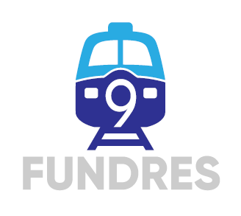
Future Unified DC Railway Electrification System
FUNDRES presents a deep thinking and related work to define the future of railway, based on new unified Future Unified Dc Railway Electrification System based on 9 kvDC, able to integrate the existing lines during transition period.
Download summary (PDF)
FUNDRES Final event will be held physically at the Ecole Polytechnique Fédérale de Lausanne (EPFL) in Lausanne on Wednesday 17 November 2021 from 9:00 to 17:00 CET.
Register here
For more information, please consult the project website or contact Dr. Philippe LADOUX, Project Coordinator for LAPLACE.

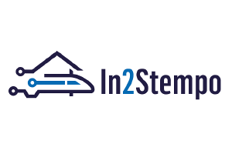
Innovative Solutions in Future Stations, Energy Metering and Power Supply
In2Stempo’s Work Package 3 (WP3) is studying Flexible AC Transmission Systems (FACTS) to exploit the full potential of the 25kV 50 Hz rail power supply system.
Download summary (PDF)
For more information on IN2STEMPO, please consult the project website or contact Mr. Mahmoud HASSAN, Energy engineer at SNCF Réseau and WP3 Leader of IN2STEMPO.

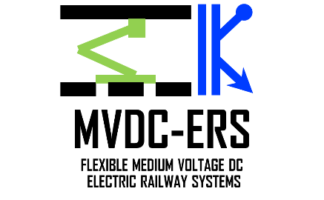
Flexible Medium Voltage DC Electric Railway Systems
The overall aim of Flexible Medium-Voltage DC Electric Railway Systems (MVDC-ERS) is to investigate the next generation railway electrification systems, DC Power Electronic Traction Transformers (DC PETTs) and technologies for integrating renewable sources, to challenge the traditional rail approach and develop innovative and breakthrough technological concepts.
Download summary (PDF)
For more information on MVDC-ERS, please consult the project website or contact Dr. Pietro TRICOLI, Project Coordinator for the University of Birmingham.

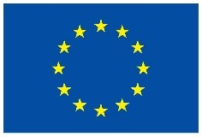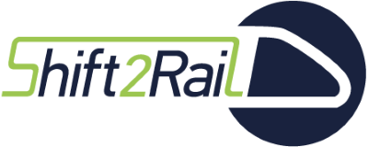

These projects have received funding from the Shift2Rail Joint Undertaking under the European Union’s Horizon 2020 R&I programme under grant agreement Nº: 881772 (FUNDRES) – 777515 (IN2STEMPO) – 826238 (MVDC-ERS)

