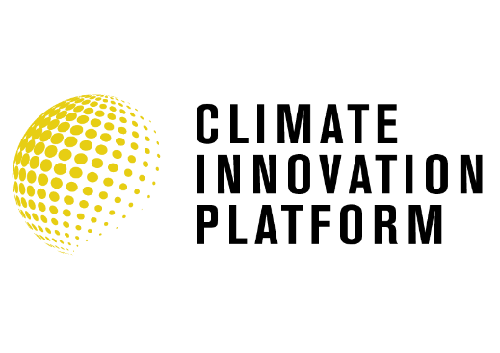
Climate Innovation Platform - Cohort 5
Application Questions

Contact Name:
Company Name:
Job Title:
Address:
Email:
Contact Number:
Companies House Registration Number:
Year of Incorporation:
Company Profile:
Can you simply describe the Innovation and the business opportunity?
What environmental, societal, and/or economic impact will your innovation/business have and how does your innovation reduce carbon emissions?
Please quantify/detail the projected reduction in carbon emissions expected from your innovation?
Does your innovation change the market with a transforming technology or a new business model?
What is/are the differentiating features (product capabilities), functions (uses of the product and features) and/or benefits (advantages delivered to the intended customer or users)?
What IP can be or has been protected?
Who are the primary customer groups (target groups)?
What are the team’s core competencies, what gaps exist and how will these be developed?
How do you plan to scale the business?
What funds are available now and will these last long enough to complete the commercialisation journey?
What funds are required in the next 12 – 18 months and what funding opportunities are you currently engaging with?
What are the benefits of the CIP programme to you? / How will working with the University of Birmingham/Energy Systems Catapult/Tyseley Energy Park support your business development?
Please share if you are interested in desk/office space and/or workspace based in Birmingham?

