PhD PROJECT PROPOSAL

PhD Project Title
Net-zero topological engineering: development of compact energy storage devices for carbon conscious living

PhD Supervisory Team
Principal Supervisors: Dr Adriano Sciacovelli, a.sciacovelli@bham.ac.uk, Birmingham Centre for Energy Storage, School of Chemical Engineering

Industrial Supervisor: Phil Ward, Eskimo Ltd

Co-Supervisor/s: Dr Alexandra Tzella, a.tzella@bham.ac.uk, Continuum Mechanics and Nonlinear Systems Research Groups, School of Mathematics

Project Abstract

Imagine a world where you are your family lives in a home that exclusively use solar, wind, geothermal and other forms of clean renewable energy sources (RES). Storage of energy is crucial in such world as it ensures that fluctuating RES always meet energy demand. This project aims to develop novel ‘thermal batteries’ for storage of heat/cold in zero-carbon buildings by broadening, applying and validating the technique of topological optimization. What truly constitute a optimal ‘thermal battery’ is currently unknown as it needs to concurrently account for thermal phenomena, RES intermittency, manufacturability constraints, and ultimately the preferences of house occupants.

Detailed Project Description

Background
It is a common misconception that most of the energy used is in the form of electricity. In reality, Heating and Cooling (H&C) actually accounts the great majority of energy consumption. Boosting the use of clean renewable energy sources (RES) to supply H&C, particular for buildings, is essential, but it is a trend currently not on track toward a net-zero society by 2050 [LINK]. The greatest barrier is the lack of systems that can effectively store thermal energy (heat/cold) to allow greater use of RES.

There is a current push toward compact ’thermal batteries’, i.e. systems for storing heat/cold, which take advantage of novel energy storage materials: phase change materials and thermochemical materials [LINK]) to store larger amount of energy stored in a reduced volume to ultimately increase utilization of RES. A central limitation, however, is the lack of fully tailored battery designs that allow faster energy charging/discharging in combination with novel energy storage materials. Achieving fully customized thermal batteries that concurrently satisfy the needs of high performance, manufacturability and end-user preference requires a radical re-think of the whole design process.
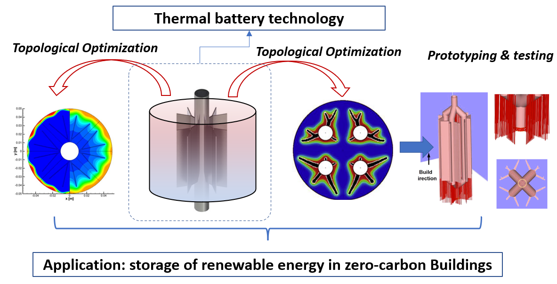

Aim, Specific Objectives and Intended Outcomes
The overarching aim of this project is to develop with the aid of topological optimization framework the first fully customed thermal battery device, manufacture it, and ultimately demonstrate its superior performance. The specific objectives are:

- To advance a topology optimization algorithm to guide the discovery of non-intuitive optimized thermal battery geometries
- To numerically analyse how the optimal designs of thermal batteries are influenced by storage material properties and energy charging/discharging strategies
- To study manufacturability of the optimized thermal battery geometries
- To realize and experimentally test a thermal battery lab prototype in cooperation with the industrial partner (ESKIMO) to form the basis for future commercialization

The project will produce the following outcomes:
- A specialized topology optimization framework to account for
  - influence of energy storage materials properties and
  - the time-dependent nature of energy charging/discharging process
  - A range of optimal thermal battery designs, with associated guidelines for manufacture them
  - A first thermal battery lab prototype (~2.5 kWh at ~60°C) manufactured and tested in collaboration with industrial partners

Methodology
The project will unfold in three main phases:

Phase 1: Upgrade of topological optimization framework. The work will expand the capability of algorithms already developed by the supervision team [LINK]. Two-steps will be taken: i) a tailored ‘Isotropic Material with Penalisation method with Homogenization (SIMP-H)’ to account for the specific properties of thermal storage materials ii) integration of the SIMP-H with an existing Finite Element Model (FEM) to optimize topology and behaviour of thermal batteries (e.g. temperature distribution, flow field etc)

Phase 2: Discovery of optimal thermal battery topologies. The requirements (e.g. amount energy stored needed, compactness, temperatures) defined collaboration with industrial partner (ESKIMO) will feed in the TO framework (Phase 1) and a range of TO designs produced for different performance targets (efficiency, costs, charge/discharge rates). Systematic post-processing TO designs will be performed to interpret how performance targets links with topological features and vice-versa.

Phase 3: Experimental testing of optimized thermal battery prototype. Selected TO design from Phase 2 will be fabricated in manufacturing facilities available at supervision team labs and ESKIMO. Charging/discharging of energy will be emulated with the test rig available at the BCES (main supervisor lab). The fabrication and testing will i) validate TO results as well ii) provide evidence on how to optimise thermal batteries offered by ESKIMO as future commercial products.

Training and skills to be developed over the PhD
The project is inherently interdisciplinary in its nature; the training programme will ensure the PhD researcher will develop the core skill set needed to successfully achieve the Objectives and Outcomes of the project. The key areas of training will be:

- Numerical modelling (e.g. CFD, Finite element/finite volume methods)
- Mathematical optimization and homogenization theory
- Advanced transport phenomena (e.g. thermo-fluid processes with phase change)
- Fundamentals of energy storage material science
- Design for Manufacturing
- Entrepreneurship and Innovation

Suitability for CDT in Topological Design
The projects belong to the CDT Research Theme of ‘Topological Optimization’ and it contributes to the impact of the CDT in the macro area of ‘Net-zero engineering’. The project advances topological optimization methods and numerical modelling so that the thermal battery systems can be developed to achieve greater performance and manufacturability. Optimization will be pursued by extending the state-of-the-art ‘material distribution optimization approach’ (so-called SIMP approach) and applying it to energy storage problems. In full alignment with the CDT the project is fully interdisciplinary: it will leverage expertise across Chemical Engineering, Mathematics, Material & Metallurgy as well as the industrial know-how of ESKIMO Ltd.

Research groups and supervising team
The whole project will be supervised by: AS, Birmingham Centre for Energy Storage (BCES), School of Chemical Engineering (Energy Storage, Topology optimization for Energy) and ESKIMO Ltd’s team (Industrial Co-supervisor). UoB School of Mathematics (AT) and School Materials & Metallurgy (MA) will provide specialized co-supervision on mathematical optimization and on manufacturability. The student will have access to computational and experimental facilities (BCES and the BlueBear HPC). Through secondments at the ESKIMO Ltd and support by School Materials & Metallurgy student will have access to facilities for manufacturing of optimized thermal battery prototypes.

Link to Wider Research Strategies
The project is linked to major UoB strategies toward Net-Zero; the student will directly benefit from resources and opportunities provided by: the Energy Research Accelerator (ERA; ~£60M investment across 6 midlands universities), the Birmingham Centre for Energy Storage (~16M investments across UoB Campus), EPSRC Supergen Energy Storage Network+ (led by UoB Chemical Engineering). The project also directly links with the internationally leading research The Advanced Materials Processing Lab.

Background student
Enthusiasm and wiliness to work at the interface between different disciplines in a multicultural environment is a key requirement. Background in Energy Engineering, Chemical Engineering, Computational or Physical sciences are all adequate, as well as affiliated backgrounds. Prior exposure to Computational Fluid dynamics (e.g. COMSOL/OpenFoam etc) and/or programming (e.g. Matlab, Python or others languages) is preferable.

