PhD PROJECT PROPOSAL

PhD Project Title
Fermi surface topological transitions

PhD Supervisory Team
Principal Supervisors: Dr Clifford Hicks, c.hicks.1@bham.ac.uk, Condensed Matter Group, School of Physics and Astronomy

Associated Academic: Prof. Stephen Hayden, s.hayden@bristol.ac.uk, School of Physics and Astronomy, Bristol University

Project Abstract
Metals are defined by their Fermi surfaces, which are the surfaces in momentum space that separate occupied from unoccupied states. Changes in topology of Fermi surfaces can have strong effects on the electronic properties of the metal. In this project, a Fermi surface topological transition that can be induced in Sr₂RuO₄ by uniaxial stress will be studied. Sr₂RuO₄ is a correlated metal, and in the vicinity of this transition its superconducting critical temperature more than doubles, and magnetic order appears. This project will involve design and construction of a uniaxial stress cell suitable for neutron scattering measurements, and so is a good project for students who want to study fundamental physics while also improving their engineering skills.

Detailed Project Description
Sr₂RuO₄ is one of the most-studied materials in condensed matter physics, for several reasons. One is that crystals can be grown to an extremely high level of perfection. Another is that it is a correlated metal – meaning that there are strong interactions between the mobile electrons. A third reason is that it is a superconductor, and this superconductivity is completely mysterious. Even though its critical temperature T_{c} is only 1.5 K, the superconductivity cannot be explained by known mechanisms.

The superconductivity, and the electronic properties of Sr₂RuO₄ generally, are strongly affected by uniaxial stress. Panel A in the figure below shows a sample of Sr₂RuO₄ mounted for measurement under uniaxial stress. Panel B shows the Fermi surfaces of unstressed Sr₂RuO₄. Panel C shows these Fermi surfaces when uniaxial stress is applied parallel to the conducting planes: the largest Fermi surface touches the Brillouin zone boundary at the points indicated.
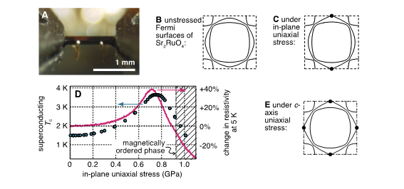
When the Fermi surface touches the Brillouin zone boundary in this way, T_{c} more than doubles. Panel D shows T_{c} against uniaxial stress, and it is seen to pass through a pronounced peak. Panel D also shows the resistivity of Sr₂RuO₄ against uniaxial stress. A small bump in the resistivity shows where magnetic order onsets. The existence of this magnetic order has been proved with muon spin rotation.

In this project you will study this Fermi surface topological transition and the magnetic order further. Through measurements of the strain in the sample as a function of applied stress, you will determine the condensation energy of the magnetic order, and how it compares with that of the superconductivity. Through these stress-strain measurements you will see how the superconductivity and magnetism interact. Finally, through neutron scattering measurements, you will determine the structure of the magnetic order. Doing so will involve designing and building a new uniaxial stress cell, which will provide an opportunity to learn how to use CAD software, and to learn how to make engineering projects work in practice.

The final panel in the figure, panel E, shows how the Fermi surfaces deform when Sr₂RuO₄ is compressed along its c axis. If time permits, you may also study how this transition appears in stress-strain data, and its effect on superconductivity.

