PhD PROJECT PROPOSAL

PhD Project Title
Unravelling topological features of liquid-liquid phase transitions in network liquids

PhD Supervisory Team
Principal Supervisors: Dr Dwaipayan Chakrabarti, d.chakrabarti@bham.ac.uk, Chemistry and Topology, School of Chemistry

Co-Supervisors: Prof. Mark Dennis, m.r.dennis@bham.ac.uk, Theoretical Physics, School of Physics and Astronomy

Associated Academic: Prof. Francesco Sciortino, Sapienza Universitá di Roma
Prof. Ivan I. Smalyhk, University of Colorado, Boulder

Project Abstract
The proposed project seeks to undertake a research program, combining theoretical and computational approaches, to unravel topological features of liquid-liquid phase transitions (LLPTs) in network liquids, in both molecular and colloidal scales, and nucleation phenomena where relevant. The use of topological concepts will provide a deeper understanding of the LLPT phenomenon and of its physical origin, independent of the size of the constituent units, spanning atomic, molecular and colloidal scales. Understanding the hydrogen-bond network of water – the most important liquid for our existence – will be central to this research and critical to transforming our understanding of the world around us.

Detailed Project Description
Research background, intended outcomes and methodology
The study of liquid-liquid phase transitions (LLPT) in one-component systems has drawn much attention over the past three decades.¹ From the original proposition for water,² formulated to explain water’s striking array of anomalous thermodynamic
properties,³ the concept has found applications in numerous atomic and molecular systems.^{4–7} Computational studies have revealed that a LLPT involves a transition between two liquid networks, having distinct densities, and have employed a plethora of order parameters to characterise their distinct structural features.¹ However, a clear microscopic picture that fundamentally distinguishes the two liquid networks has remained elusive. A very recent theoretical study by Chakrabarti and co-workers has uncovered a topological distinction between the two liquid networks in a model system of designer colloidal particles (see Fig. 1a), hereafter referred to as “colloidal water”, comprising tetrahedral units, as well as in molecular water.⁹ This study reveals that the LLPT, in both colloidal water and molecular water, occurs between an unentangled low-density liquid (LDL) and an entangled high-density liquid (HDL), the latter containing an ensemble of topologically non-trivial motifs, such as knots and links.⁹ This radically new perspective of LLPT at the microscopic level sets the foundation for further theoretical investigation in tetrahedral liquids in particular, and network liquids in general (see Fig. 1b), from a topological perspective, which the proposed project will undertake. The colloidal water model has been developed, in particular, to provide an experimentally amenable system to investigate LLPT, which has proved extremely challenging because of the competition with crystallisation in the deeply supercooled region of water, with the LLCP occurring in water’s so-called “no man’s land”.^{1,10}
The aim of the proposed project is to unravel topological features of LLPTs in network liquids in general. The first objective of the project is to assess the generality of the topological distinction between LDL and HDL that we have identified in the case of water, as well as in its colloidal analogue (see Fig. 2), for other tetrahedral liquids, such as silicon^{6,21} and silica⁵, which will be investigated using molecular dynamics (MD) simulations . The second objective is to investigate how the existence of an LLPT and its character is influenced by the connectivity of the network at its nodes. To this end, we will investigate colloidal models of network liquids of different connectivity (Fig. 1b),¹⁰ using Monte Carlo (MC) simulations. Here, a pertinent question is whether the liquid network evolves from being unentangled to entangled as the pressure increases at low temperatures, as for water, and if so, whether the evolution can, under certain conditions, become discontinuous. The third objective is to investigate the mechanisms of nucleation of one liquid into the other, employing the topological order parameters that we introduced.⁹ Even for water, there is currently a very little understanding of nucleation of HDL within LDL, and vice versa. We will investigate whether there is a universal topological mechanism for LLPT related nucleation phenomena across different length scales, similar to the untying of knotted vortices in classical fluids¹¹ and superfluids,¹² revealed by the helicity.
[1] J. C. Palmer, P. H. Poole, F. Sciortino and P. G. Debenedetti, Chem. Rev. 118, 9129 (2018).
[2] P. H. Poole, F. Sciortino, U. Essmann and H. E. Stanley, Nature 360, 324 (1992).
[3] P. G. Debenedetti, J. Phys. Condens. Matter, 15, R1669 (2003).
[4] J. N. Glosli and F. H. Ree, Phys. Rev. Lett. 82, 4659 (1999).
[5] I. Saika-Voivod, F. Sciortino and P. H. Poole, Phys. Rev. E 63, 011202 (2000).
[6] S. Sastry and C. A. Angell, Nat. Mater. 2, 739 (2003).
[7] L. Henry, M. Mezouar, G. Garbarino, D. Sifré, G. Weck and F. Datchi, Nature 584, 382 (2020).
[8] P. Zalden et al., Science 364, 1062 (2019).
[9] A. Neophytou, D. Chakrabarti and F. Sciortino, Nat. Phys. 18, 1248 (2022).
[10] D. Morphew, J. Shaw, C. Avins and D. Chakrabarti, ACS Nano 12, 2355 (2018).
[11] D. Kleckner and W. T. M. Irvine, Nat. Phys. 9, 253 (2013).
[12] D. Kleckner, L. H. Kauffman and W. T. M. Irvine, Nat. Phys. 12, 650 (2016).

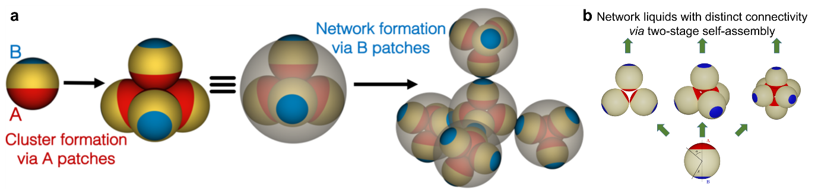
Figure 1: Network liquids formed via two-stage colloidal self-assembly. (a) Colloidal model of water; (b) network liquids of different connectivity

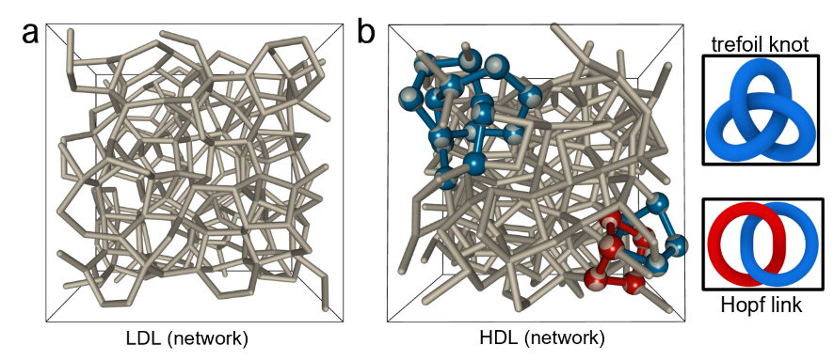
Figure 2: Links and knots in colloidal water. Representative snapshots of the (a) low-density liquid (LDL) and (b) high-density liquid (HDL) networks of colloidal water.
Training and Skills
The PhD student will be trained in state-of-the-art computational techniques, largely underpinned by theoretical concepts of statistical mechanics and topological physics, in connection with phase transitions. The student will develop programming skills in suitable languages to contribute to existing software packages, and also learn to apply open-source software suites.
Suitability of the project for the CDT in Topological Design
The project falls within the research theme of Topological Materials. It will promote high-quality interdisciplinary science, foster cross-fertilisation of ideas across different disciplines and provide a platform for international engagement.
Links with research in the research groups of the supervising team
The project builds on a series of work in the Chakrabarti group, establishing self-assembly routes to colloidal open crystals and most recently to tetrahedral liquids, thereby revealing the topological nature of the liquid-liquid phase transitions therein. The project will also benefit from the world-leading expertise of Prof. Dennis in topological physics.
Links with research strategies, possibly including UoB, EPSRC, partner organisations
The project shares the University’s research vision in encouraging collaborative and interdisciplinary research and is aligned with the EPSRC’s priority in Physical and Mathematical Sciences Powerhouse. The project will draw on the international collaboration with Prof. Francesco Sciortino of Sapienza Università di Roma and will offer an opportunity for us to engage with International Institute for Sustainability with Knotted Chiral Meta Matter (SKCM²) in Japan and led by Prof. Ivan I. Smalyukh of the University of Colorado Boulder.
Candidacy
The project should be suitable for students with an undergraduate degree in chemistry / physics / materials science / related areas with training in theoretical and computational techniques.

