PhD PROJECT PROPOSAL

PhD Project Title

Topological Design of Anti-fouling and Anti-Microbial Materials

PhD Supervisory Team
Principal Supervisors: Dr Nan Gao, n.gao@bham.ac.uk, Biomedical Engineering Group, School of Engineering

Co-supervisors: Dr Manuel Banzhaf, Institute for Microbiology and Infection, School of Biosciences
Prof. Duncan Shepherd, d.e.shepherd@bham.ac.uk, School of Engineering
Dr Carl Anthony, c.j.anthony@bham.ac.uk, Micro-engineering and Nano-technology Research Group, School of Engineering

Project Abstract

This project will sit at the interface between several disciplines, including Micro-Nano-Engineering, Topological Design, Biosciences, and Advanced Manufacturing to develop antifouling and antimicrobial materials. It is designed in response to the significant challenges that fouling and bacterial adhesion have been causing to several industrial applications, including water treatment membranes and healthcare products. In this project, state-of-the-art fabrication techniques (3D printing and micro-machining) will be used to fabricate distinct micro-nano-structures. Further, we will make use of topological design to guide the design of the micro-nano-structures so that they can prevent fouling and bacterial adhesion without the need of subsequent chemical treatment.

Detailed Project Description
Research background, intended outcomes and methodology
The primary question guiding this project is how to overcome the lack of in-depth understanding of the antifouling and antimicrobial mechanism without utilising toxic substances or cytotoxic compounds. Addressing this question will require an interdisciplinary approach that brings together research expertise from micro-nano-engineering, topological design, biosciences, and advanced manufacturing. This PhD project is designed in response to the significant challenges caused by fouling and bacterial adhesion to various industries. For example, fouling causes one of the largest costs associated with membrane processes in water treatment, the failure of which leads to the lack of access to clean water, either for drinking or everyday use.^{[1]} Further, fouling of biomedical devices will put patients needlessly at risk of infection and contributing to the burden imposed by healthcare-associated infections in National Health Service. Specifically, indwelling urinary catheters are responsible for most hospital-acquired urinary tract infections (UTIs),^{[2]} which account for approximately 35-40% of all hospital-acquired infections.^{[3, 4]} This is followed by surgical site infections that account for 20% of all hospital-acquired infections.^{[3]} The pathogenesis of these infections is related to the susceptibility of device/instrument surfaces to bacterial adhesion and microbial colonization,^{[5-7]} especially in the presence of fouling liquids such as urine, blood and even water/moisture.
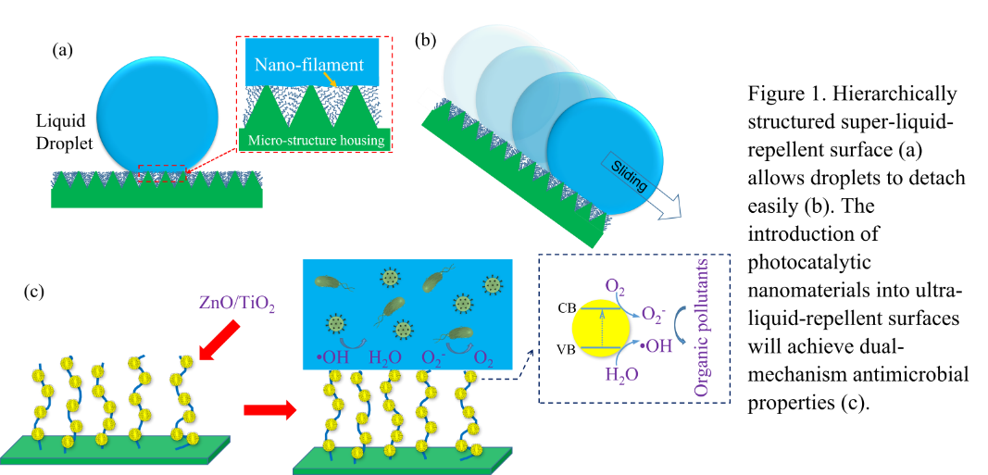

A possible solution to fouling and bacterial adhesion is the utilisation of super-liquid-repellent materials that incorporate self-cleaning properties. However, commonly used liquid repellent materials will lose their liquid repellent properties in the presence of low-surface-tension fluids such as physiological fluids and hydrocarbon-based fluids. Further, the durability of the commonly used liquid repellent materials, which are largely polymer-based, is vulnerable to harsh conditions resulting from environmental stresses and abrasion. Therefore, this project will develop a new generation of self-cleaning surfaces made of inorganic-organic composite materials that exhibit superamphiphobic properties (Figure 1) by using a combination of techniques, including 3D printing, laser ablation and inkjet printing deposition. On the one hand, the inorganic component can enhance the mechanical robustness of the surface. On the other hand, the superamphiphobic property will allow the surface to repel both water and low-surface-tension fluids. It should be noted that the inorganic components of the surface will be made of photocatalytic materials, such as ZnO and TiO₂, that can degrade organic contaminants. This means that hydrocarbon-based particulate matter deposited on the surface can be decomposed directly by the surface. Residual particles will be carried away, due to minimal surface adhesion, by liquid flows and/or droplets, hence enabling the surface to feature self-cleaning properties. This will lead to antimicrobial and antifouling surfaces that prevent the adhesion of pathogenic microorganisms or the formation of microbial biofilms.

Training and skills to be developed over the PhD
Over the course of the PhD project, the student is expected to develop knowledge and
skills that will equip him or her to undertake independent research at the frontier of
surface fabrication, biomedical engineering and healthcare technologies. The student is
also expected to take up employment in policy or practice communities that exploit such
knowledge. To enable the student to achieve this goal, the PhD programme will offer a
range of opportunities in subject-specific training and research methods training.
The subject-specific training relates to the bodies of knowledge needed to master fabrication techniques such as 3-D printing, laser machining and surface coating. The
research methods training will provide a theoretical and practical grounding in analytical
skills including data analysis, software and data collection. This challenging project will
bring the PhD candidate excellent research experience across topological design, cutting-edge material characterisation, and data analysis.

Explanation of why the project is suitable for the CDT in Topological Design
This multi-disciplinary project will bring together biomedical engineering, advanced
manufacturing and healthcare technologies to enable the topological design of ultra-liquid- repellent surfaces. It will contribute to the application of topologically structured ultra-liquid-repellent surfaces onto biomedical devices. In addition, it will be related to ‘real world’ problems so that the analysis performed by the PhD student will resonate with the substantive questions he or she is exposed to in biomedical engineering and healthcare technologies and even wider areas.

Links with research in the research groups of the supervising team
The project supervisors have established a strong interdisciplinary network with
researchers (Prof Duncan Shepherd, Prof Stefan Dimov, Dr Carl Anthony, Dr Sophie Cox
and Dr Manuel Banzhaf) across the College of Engineering and Physical Sciences and the
College of Life and Environmental Sciences. The research through this PhD
project will be heavily linked to the Biomedical Engineering Research Group and the
Healthcare Research Group. It will also be linked to industrial applications in biomedical
devices and healthcare technologies.

Links with research strategies
The research of functional materials for antifouling and antimicrobial applications through this project will manifest itself in the UK’s strategy in prompting multidisciplinary and interdisciplinary studies. It is pertinent to the EPSRC’s priorities in Frontiers in Engineering, Manufacturing and Technology and Transforming Health and Healthcare. The anticipated research outcomes relevant to these processes are highly aligned with two research and innovation priorities, Productive Nation and Healthy Nation, identified in the EPSRC Delivery Plan (2019) to generate economic impact and social prosperity. In addition, the cross-disciplinary nature of this project is also well aligned with Objective 3 of World-Class Ideas (multidisciplinary approaches and new concepts) and Objective 5 of World-Class Impacts (using multidisciplinary approaches to inform policy and protect human health) identified in UKRI Strategy 2022–2027.

An ideal/acceptable undergraduate background and interests
PhD candidates should be strongly motivated to undertake multidisciplinary research in a
highly collaborative environment. The candidates should have or be about to obtain a good degree (at least 2.1) in chemical engineering, materials science and engineering, mechanical engineering, physics or a related subject, with excellent communication skills. Experience in micro-fabrication and biomedical engineering would be an advantage, but not necessary.

References:
1. Herzberg, M. and Elimelech, M., Journal of Membrane Science, 2007.
2. Miller, B.L., et al., Infection Control & Hospital Epidemiology, 2013.
3. Klevens, R.M., et al., Public Health Reports, 2007.
4. Saint, S., et al., American Journal of Infection Control, 2015.
5. Zhang, S., et al., ACS Biomaterials Science & Engineering, 2019.
6. Trautner, B.W. and R.O. Darouiche, American Journal of Infection Control, 2004.
7. Feneley, R.C.L., I.B. Hopley, and P.N.T. Wells, Journal of Medical Engineering &
Technology, 2015.

