PhD PROJECT PROPOSAL

PhD Project Title
Simulation-Driven Topology Design of Pneumatic Shape-Changing Objects

PhD Supervisory Team
Principal Supervisor: Dr Hyunyoung Kim, h.kim.4@bham.ac.uk, School of Computer Science, Human-Centred Computing Group
Co-Supervisor/s: Dr Lauren Thomas-Seale, l.e.j.thomas-seale@bham.ac.uk, School of Engineering, Biomedical Engineering Group and Manufacturing Research Group.

Associated Academics: Dr Anne Roudaut, Anne.Roudaut@bristol.ac.uk, Department of Computer Science, University of Bristol, Bristol Interaction Group.

Project Abstract
Imagine a world where a mother builds robot arms that can hand objects to her disabled husband, and a father builds a toy that has the shape of the children’s favourite character and wiggles its tail when touched. Towards this vision, we aim to provide software that lay users can design soft robots and interactive objects. The software will be able to predict the behaviour of pneumatically powered objects based on their designs. It further should find the best designs based on the target shape-change provided by lay users.

Detailed Project Description
Currently, research in soft robotics [1] and HCI [2,3] provided software tools to design shape-changing objects based on elastic materials. However, the research focuses on simple robotic applications such as grippers or does not provide a shape-change simulation of the objects in the design process. This limits the exploration of novel designs of pneumatic soft robots and interactive objects. The software developed in this project should be able to design and predict the behaviour of pneumatically powered soft robots and shape-changing objects. Our final goal is to allow lay users to input the shape-change of a target object and the software finds the best design for them.
Aims:
- To computationally simulate the behaviour of pneumatic widgets before fabricating them (WP1)
- To enable movement and shape-change driven design (WP2)

WP1: The first goal of this project is to understand how the topology of elastic polymer widgets affect the objects’ shape-change when they are pneumatically inflated. Our recent paper shows that different initial shapes and design parameters result in varied types and scales of shape changes [3] (Figure 2). We want to investigate the shape-changes systemically and embed the data in our software so that users can see the simulated shape-change on the software before fabricating pneumatic objects. To evaluate the software’s accuracy and improve it, the work package will involve fabricating shape-changing widgets and comparing their behaviour with simulation results.
WP2: Our second goal is to build software that can suggest widget designs to users based on the shape-change they want. It will be based on the software above. One of the main contributions of this work package will be developing an easy-to-use interface for users to input desired shape-changes and see simulation results to minimize their design iteration. This work package will also involve user studies to evaluate if the software is usable and can support users’ creativity.

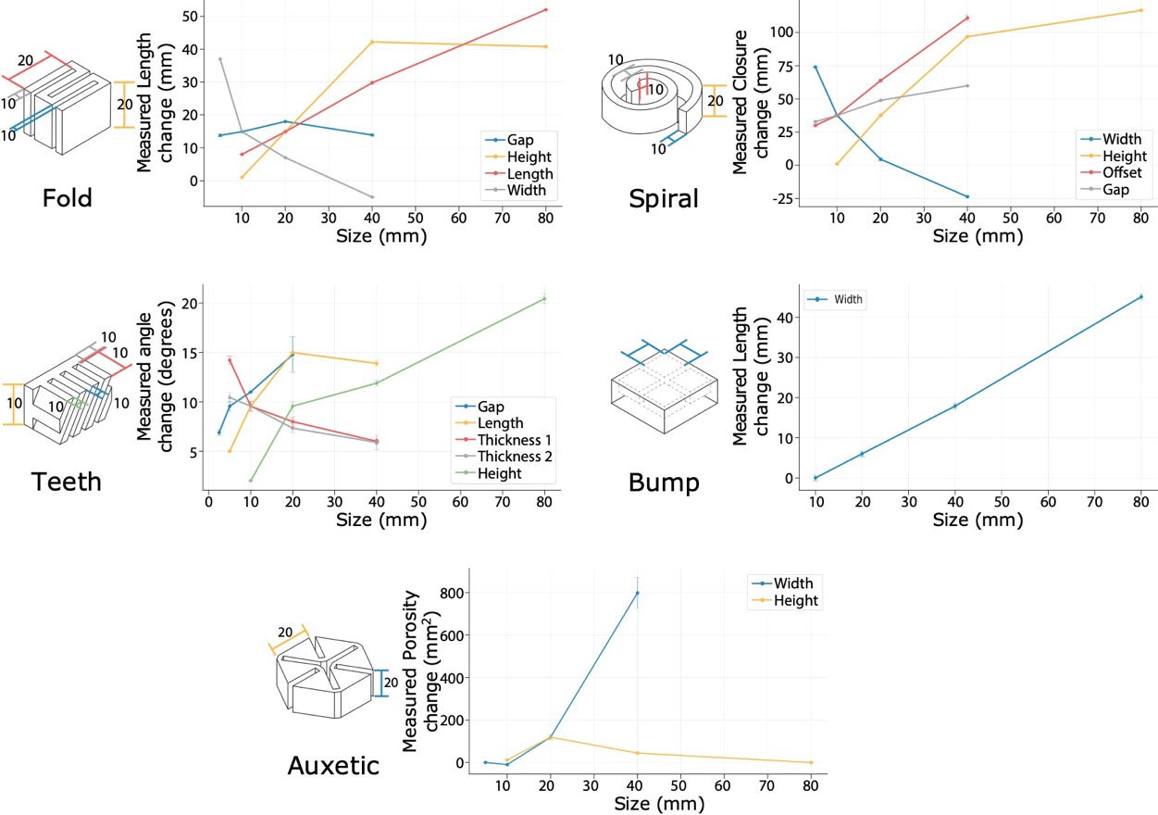
Figure 2. Results of the characterization of pneumatic shape-changing widgets [3]. These plots show the magnitude of the modified features versus the change of shape the widgets expressed. The numbers on the widgets show the baseline size of the features. For example, the Fold widget had baseline parameters of gap 10 mm, length 20 mm, height 20 mm, and width 10 mm. We then changed each parameter one by one, e.g., changed length from 10 mm to 80 mm (red line in the plot).
(1) https://softroboticstoolkit.com/sofa
(2) Sarah Sahabi, SoRoCAD 2.0: Extending a CAD Tool for Soft Robotics, Bachelor’s Thesis
(3) Hyunyoung Kim, Aluna Everitt, Carlos Tejada, Mengyu Zhong, and Daniel Ashbrook. "MorpheesPlug: A Toolkit for Prototyping Shape-Changing Interfaces." In Proceedings of the 2021 CHI Conference on Human Factors in Computing Systems, pp. 1-13. 2021.

