PhD PROJECT PROPOSAL

PhD Project Title

Imaging the topology of proton therapy beams using topological proton-acoustic sensors

PhD Supervisory Team
Principal Supervisors: Dr James Guggenheim, j.a.guggenheim@bham.ac.uk, Institute of Cardiovascular Sciences

Co-Supervisor: Dr Tony Price, t.price@bham.ac.uk, Particle Physics, School of Physics and Astronomy

Associated Academics: Prof. Ben Cox, University College London

Project Abstract
The aim of this PhD is to develop a proton-acoustic imaging method for mapping the topology of proton beams used in proton therapy (PT). Mapping PT beam topology is necessary for quality assurance and treatment planning. However, traditional methods are slow, taking several hours prior to treatment. In this project, we will investigate whether PT beams can be mapped more quickly using a new technique called proton-acoustic imaging, in which proton-generated ultrasound waves are detected to form images. This could save the NHS time and money by increasing PT patient throughput, and pave the way to better PT treatments.

Detailed Project Description
BACKGROUND AND AIMS:

The aim of this PhD is to develop a proton-acoustic imaging system for mapping the topology of proton beams in proton therapy (PT).

PT is an increasingly important way of treating cancers. It involves launching a beam of high energy protons into a patient. This beam travels through the tissue and is absorbed. A significant proportion of the absorption occurs at a single depth, at a location referred to as the “Bragg peak” (BP). If the beam is sufficiently well-targeted, the BP’s location can be precisely tuned to the site of the cancer. This allows destroying the cancer, while sparing the surrounding healthy tissue. In principle, PT therefore provides a well-controlled dose distribution, affording minimal unwanted healthy tissue damage. In practice however, it is difficult to precisely position the BP accurately due to challenges associated with predicting or measuring the beam propagation. To address this challenge, this project will investigate the feasibility of mapping the topology of proton beams and delivered dose distributions during treatment using ultrasonic imaging; a technique called “proton-acoustic” or “ionoacoustic” imaging [1-3]. By allowing a real time assessment of the beam, this technique could inform adaptive treatments, leading to better-controlled doses and improved treatment outcomes.

The physical basis for proton-acoustic imaging, is that when thermal energy is imparted to tissue due to a pulsed proton absorption, this leads to a rapid temperature rise. This in turn leads to a pressure rise, causing the generation of high frequency acoustic (ultrasonic) waves. These waves can be detected and used to form an image of the initial pressure distribution, thereby revealing the originating dose distribution. This is the same principle behind another emerging medical imaging technique called photoacoustic imaging, in which lasers, rather than proton beams, excite ultrasound in living tissue [4] (figure 2b; adapted from https://www.youtube.com/watch?v=Xun23etGNIA).

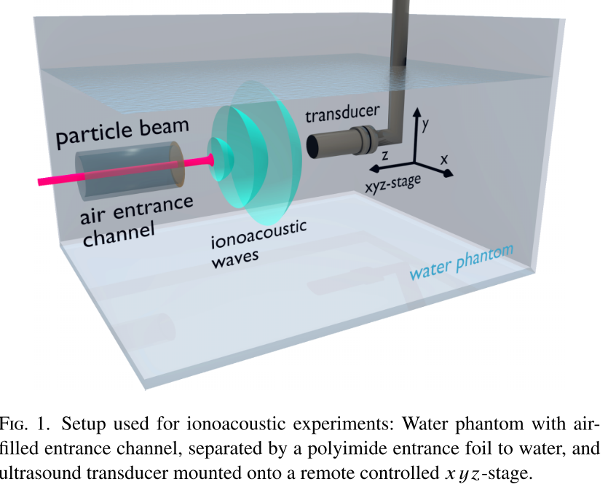
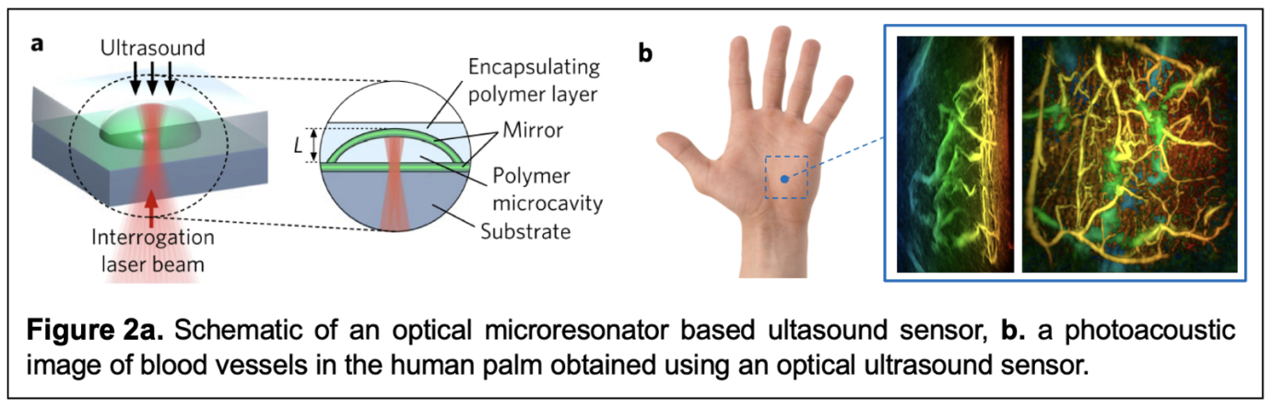
The vision for this PhD is to use proton-acoustics to monitor PT beam topology during treatments, paving the way to better outcomes. A range of research has shown proton-acoustic measurements can be made, in principle [1-3] (figure 1). This PhD will take this work significantly further, addressing key challenges in the field including developing an imaging system based on ultrasensitive topological optical microresonator based ultrasound sensors [5] (figure 2a) to address the currently unmet need for higher detection sensitivity and image fidelity.

Specific goals will include: predicting proton-acoustic signals via simulation; establishing detector requirements (sensitivity, directivity, bandwidth); developing a prototype system; demonstrating proton-acoustic imaging; developing methods for extracting quantitative information such as the beam energy.

TRAINING AND SKILLS TO BE DEVELOPED: The student will have an opportunity to gain a range of generic and technical research skills in a medical physics and engineering context, guided by multiple supervisors and colleagues, in areas including:
- Proton therapy physics (e.g. proton beam propagation, radiobiology)
- Ultrasonic engineering (e.g. ultrasonics, electronics, sensor design and characterisation)
- Optical engineering (e.g. topological sensor design and characterisation)
- Image reconstruction and signal analysis (e.g. ultrasound propagation, inverse problems)
- Imaging system development (synchronisation, hardware control, component integration)
- Photoacoustic and proton-acoustic experimentation (generation, detection, acquisition)
- Research skills (project/time management, critical path analysis, goal setting, reporting)
- Learning/dissemination (communication, literature review, publication, presentation)

WHY TOPOLOGY? This PhD fits in the CDT because it is about measuring, analysing - and eventually influencing and studying the effects of - the topology of PT beams. Furthermore, we will investigate detecting the beams using topological ultrasound sensors. The student will therefore benefit from a training and research surroundings centred on Topology and Topological design, with multiple synergies plus unique offerings to the rest of the cohort.

ENVIRONMENT: The PhD will be hosted by the Birmingham Photoacoustic Imaging Group (BPG, Colleges of MDS and EPS), with support of Nuclear Physics (College of EPS). The newly-founded BPG comprises 2 PI’s, 2 PDRA’s and 3 PhD students, and occupies renovated medical engineering labs in the Medical School. The group’s interests include various aspects of the development and application of photoacoustic and related thermoacoustic (e.g. microwave, ion beam) technologies. Specialities include sensor development and characterisation. In this project, we will collaborate with University College London’s Photoacoustic Imaging Group (Dept Medical Physics), one of the world’s largest and most productive photoacoustics groups, comprising 20-30 researchers who have contributed to just about every part of the technique’s development.

This project ties in closely with multiple funding applications currently under development by the supervisory team. Growing links include several external collaborators including industrial and academic groups developing advanced PT sources well-matched to the proton-acoustic approach. The project is therefore timely, and the student and project will benefit from an ecosystem involving an extended team of industry, clinical, and academic collaborators. Examples of existing relevant relationships are supervisor’s links with the LhARA group (Imperial College London + collaborators, https://www.imperial.ac.uk/high-energy-physics/research/experiments/lhara/), and an R&D collaboration set up between University Hospitals Birmingham and Advanced Oncotherapy (AVO) https://www.avoplc.com/en-gb/Company/Our-History. From the student’s perspective, this should provide an exciting environment to support their research, highlight its relevance, and facilitate its real-world impact.

CANDIDATE: The suitable candidate will have an interest in doing a PhD involving highly novel and impactful medical / ultrasonic / PT physics and engineering. They will have a suitable undergraduate and/or Masters degree in Physics, Engineering or another suitable related topic. They will have an ability/willingness to: manage time; self-direct; self-motivate; communicate; and carry out excellent science.

REFERENCES:
- Assmann et al. Ionoacoustic characterization of the proton Bragg peak with submillimeter accuracy. Med. Phys. 42, 567–574 (2015).
- Jones et al. Acoustic time-of-flight for proton range verification in water. Med. Phys. 43, 5213–5224 (2016).
- Hayakawa et al. Acoustic pulse generated in a patient during treatment by pulsed proton radiation beam. Radiat. Oncol. Investig. 3, 42–45 (1995).
- ﻿Beard. Biomedical Photoacoustic Imaging. Interface Focus 1, 602–631 (2011).
- Guggenheim et al. Ultrasensitive plano-concave optical microresonators for ultrasound sensing. Nat. Photonics 11, 714–719 (2017). https://www.nature.com/articles/s41566-017-0027-x

