PhD PROJECT PROPOSAL

PhD Project Title
Novel Designs of Bone-like Scaffolds using Topology Optimisation and Additive Manufacturing

PhD Supervisory Team
Principal Supervisor: Dr Khamis Essa, Director of the Advanced Manufacturing Lab,School of Engineering
Co-Supervisor/s: Dr Adel Abdelwahab, Biomedical Research Group, University of Birmingham, Dubai Campus
Dr Usama Attia, Usama.Attia@the-mtc.org, The Manufacturing Technology Centre (MTC)

Detailed Project Description
Project abstract (200-500 words approx, with up to 5 references)
Around the world, fractures are a common reason for admission to hospitals. In England only, there were 2,489,052 fracture admissions between 2004 and 2014 [1]. As a result of these high rates of bone fractures, the field of bone tissue regeneration has extensively attracted researchers worldwide. The complex and hierarchical structure of bone tissue serves its diverse functions including mechanical, biological and chemical. This hierarchical structure of bone tissue is composed of optimised irregular arrangements of macrostructures (such as cortical and cancellous bone), microstructures (such as osteons and trabeculae), sub-microstructures (like lamellae), nanostructures (such as fibrillar collagen), and sub-nanostructures (such as minerals and collagen molecules), see Fig.1 [2]. The mechanical function needs of bone tissue is supported by its component phases and the organisation of its hierarchical structure [3].
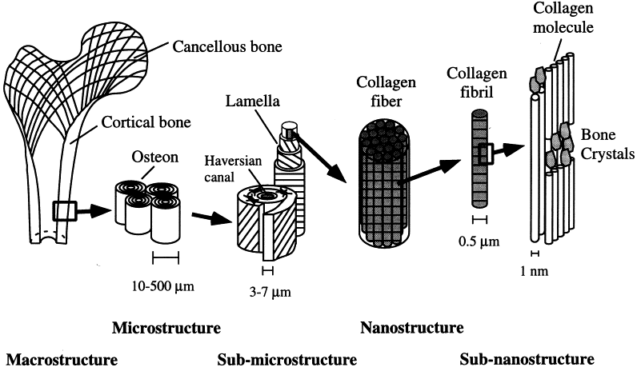

Fig. 1: Hierarchical structural organization of bone [2].

Extensive bone defects caused by trauma, tumour, and/or infection must be replaced by a functional alternative [3]. Autografts (bone tissue harvested from various sites of the patient body) has been widely accepted as the standard method for small defect reconstruction [4]. However, there are some limitations associated with autogenous bone grafting procedures, such as donor site morbidity, limited bone supply, anatomical, structural, and surgical limitations [5]. Other biological sources such as allograft (bone tissue harvested from one individual to another) and xenogenic (bone tissue harvested from another species) bone also been evaluated and used with varying clinical success for bone repair and regeneration. Hence, the use of synthetic materials is another way to repair and regenerate lost bone tissue [5]. However, it is still challenging to obtain synthetic bone substitutes that mimic the physical and biological properties of the healthy bone tissue more closely.
In bone tissue engineering, highly porous scaffold materials provide a pathway for cell attachment, bone in-growth, and vascularisation. To improve integration of porous scaffold material and the living bone tissue, material features like porosity, pore size, pore geometry and pore connectivity have to be controlled in a suitable range.
In this project, we propose using topology optimisation techniques to design cellular structures for bone-like scaffolds with different hierarchical levels made from hydroxyapatite submicron particles extracted from readily available molluscs shells and manufactured using Digital Light Processing (DLP) additive manufacturing technology. The shells are available in abundance with a global aquaculture production of approximately 15 million tonnes in 1 year and costing £88.95/tonne to landfill. These resulting bone-like scaffolds will offer mechanical properties that match the intended site for implantation and provides sufficient interconnectivity of the porous network that favour tissue integration and vascularisation. The resulting bone substitutes will demonstrate biocompatibility, osteogenic properties, and mechanical properties closer to those of natural bone tissues to avoid stress shielding which results in unwanted bone resorption and implant loosening.
References:
[1] Toby Jennison and Mark Brinsden, Fracture admission trends in England over a ten-year period, Ann R Coll Surg Engl, Volume 101, 2019, Pages 208–214.
[2] Jae-Young Rho, Liisa Kuhn-Spearing, Peter Zioupos, Mechanical properties and the hierarchical structure of bone, Med Eng & Phy, Volume 20, Issue 2, 1998,
Pages 92-102.
[3] Toktam Ghassemi, Azadeh Shahroodi, Mohammad Ebrahimzadeh, Alireza Mousavian, Jebraeel Movaffagh, Ali Moradi, Current Concepts in Scaffolding for Bone Tissue Engineering, Arch Bone Jt Surg. Volume 6, Issue 2, Pages 90-99.
[4] Sang-Woon Lee, Csaba Balázsi, Katalin Balázsi, Dong-hyun Seo, Han Sung Kim, Chang-Hyen Kim and Seong-Gon Kim, Comparative Study of hydroxyapatite prepared from seashells and eggshells as a bone graft material, Tissue Eng Regen Med, Volume 11, 2014, Pages 113–120.
[5] Craig Misch, Use of the mandibular ramus as a donor site for onlay bone grafting, J Oral Implantol, Volume 26, 2000, Pages 42-49.

