PhD PROJECT PROPOSAL

PhD Project Title
Topological Analysis of the Socioeconomic and Environmental Impact of Engineering Design Decisions

PhD Supervisory Team
Principal Supervisors: Dr Lauren Thomas-Seale, l.e.j.thomas-seale@bham.ac.uk, Biomedical Engineering Research Group, School of Engineering

Industrial Supervisor: Autodesk

Co-Supervisor: Dr Tony Samuel, t.samuel@bham.ac.uk, Topology and Dynamics Group, School of Mathematics
Dr Sabrina Kombrink, Topology and Dynamics Group, School of Mathematics

Project Abstract
The importance of environmental and socioeconomic factors – known as the triple bottom line – are of critical importance to the future survival and development of human civilisation. Yet the majority of engineering development of products and processes take little to no account of the broader socioeconomic and environmental implications when making production choices. The hypothesis of this research is that transdisciplinary design, to transfer knowledge between relevant but distinctly different academic disciplines, can be facilitated through mathematical concepts (geometric and topological) which have the capacity to analyse high dimensional datasets and represent the relationships of and between complex systems.

Detailed Project Description
Background:
The importance of environmental and socioeconomic factors – known as the triple bottom line – are of critical importance to the future survival and development of human civilisation. Yet this knowledge is still far removed from the general remit of engineering. Whilst engineering is the bedrock of modern society, the interface between engineering and the requirements of our swiftly changing civilisation is indirect and suboptimal.

These limitations in design knowledge have recently been brought into stark relief: the cost of a ventilator valve in 2018 was less than £100. In 2020, the production of ventilator valves could not fulfil the global requirements because of increased demand and travel disruption caused by SARS-COV-2. The design of the ventilator failed to incorporate the non-fiscal value of globalisation versus localisation [1]. The majority of engineering development of products and processes take little to no account of the broader socioeconomic and environmental implications, as highlighted in [2].

The UK is committed to sustainable energy generation and material use through the Clean Growth Strategy and the Circular Economy Package. Yet in these proposals, how design engineering – the fundamental discipline underpinning the creation of all products – will achieve these targets is insubstantial. The design process relies heavily on a product design specification – a co-creation of customer and engineer – to capture product requirements. However, subjectivity is inherent; the specification is limited by the perspective of engineer and customer. Thus, the implementation of engineering design has hitherto fallen short.

Transdisciplinary design is an emerging concept, referring to movement of information between academic disciplines and engineering design. Integrating multidisciplinary knowledge into the design of a product can be beneficial in several ways. Figure 1 describes what would be required of a process to facilitate the transfer of comprehensive information across the broad interfaces that exist between academia and facets of industrial engineering, and thus enable transdisciplinary engineering design.

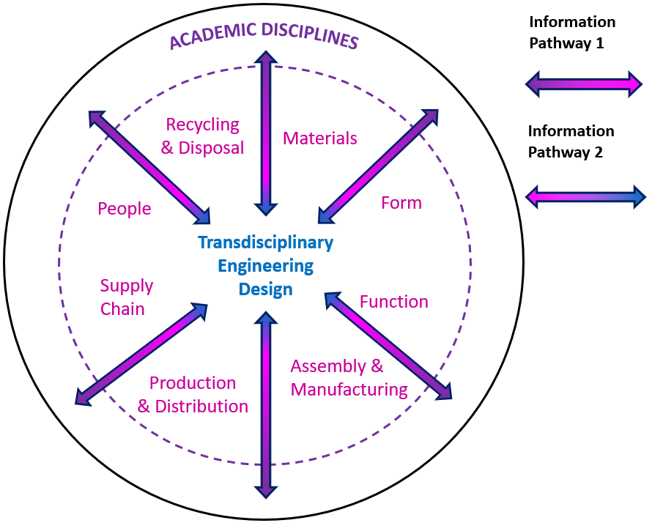

Figure 1: The (idealised) active transfer of information between academic disciplines to enable transdisciplinary design engineering.

The hypothesis of this research is that transdisciplinary design can be facilitated through mathematical concepts which have the capacity to analyse high dimensional data sets and represent the relationships of and between complex systems.

Intended outcomes:
Using geometric and topological techniques, a thorough socioeconomic and environmental analysis of relevant data sets relating to production design (type of manufacturing, location of manufacturing, location of market, supply, and delivery logistics) will be performed. Through this analysis it is expected that trends and patterns, which will help to quantify the impacts of production design decisions, will be identified.

Methodology:
Topology and geometry have recently provided a suite of powerful and robust tools for analysing high-dimensional data sets. Loosely, topological data analysis equips a data set with a notion of distance (metric), asks questions about the resulting geometric space to build new insights into the original data set, and helps predict patterns and trends.

The first fundamental step will be to unearth an appropriate metric on a given data set relevant to production design which allows to determine the distance between points. Once a suitable metric is identified, we can use different methods to analyse the space, for instance, to use the data set together with its metric to form a graph, and as such,
- analyse the homology groups of the space, to understand how porous it is, namely how correlated the data is;
- use concepts from fractal geometry, such as the box-counting dimension or its multi-fractal analogues, to identify hot and cold spots;
or to use the data set together with its metric to build a subset of n-dimensional Euclidean space (i.e. a manifold) and to
- analyse the local and global curvature, search for peaks and troughs (mountains and valleys) and identify lower-dimensional sub-spaces/manifolds to understand how the data is clustering.
Identifying an appropriate metric and analysing the associated topological and geometric properties go hand in hand: if the metric is too simple, it may not see the rich structures exhibited by the data set; and if it is too complex, our analysis might become too complex to be able to identify important attributes. Therefore, a fine balance between discovery and analysis is required. A good starting point will be the studies [3,4,5].

Links with research strategies:
This project will contribute towards the sustainability pillar of the University of Birmingham’s 2030 Strategic Framework as well as EPSRC’s priority areas: Frontiers in Engineering, Manufacturing and Technology, Digital Futures, and Engineering Net Zero.

Proposal alignment to the CDT:
The project themes underpin both the development of a topological data analysis technique for qualitative data sets, and its application to real-world engineering challenges. Via the proposed work, we will showcase the immense impact that the translation of topological approaches from mathematics into engineering and industry can offer.

Links with the research groups of the supervisory team:
The principal supervisor is an expert in design engineering, and the co-supervisors bring their expertise in geometry and topology to the project.

Training and skills to be developed over PhD:
- To be familiar with core concepts in algebraic topology, fractal geometry, and geometric analysis, and be able to apply these methods to analyse high-dimensional data sets.
- To be able to identify information relevant to production design and to identify trends and patterns which quantify socioeconomic and environmental impacts.
- To bring 1) and 2) together.
The principal supervisor will lead the supervision of the PhD, providing training in production design. The co-supervisors will advise the PhD in the areas of algebraic topology, fractal geometry, and geometric analysis.

Ideal undergraduate background:
- A strong mathematics profile with training in analysis, geometry, or topology
- Familiarity with at least one programming language
- A strong interest in engineering and production design, or data science

References
[1] Bryson & Vanchan (2020) Tijdschr. Econ. Soc. Geogr. 111(3):530-542
[2] McNamara (2017) Soc. Sci. Med. 176:1-13
[3] Carlsson (2009) Bull. Amer. Math. Soc. 46:255–308
[4] Lopes and Betrouni (2009) Medical Image Analysis 13:634–649
[5] Wua, Jinb, Mia and Tangc. (2020) Results in Engineering, 6

