MVDC-ERS Newsletter No.4 (April 2021)
- Software model of medium voltage DC (MVDC) railways
Modular Multilevel Converter with Full-Bridge submodules (MMC-FB), shown in Fig. 1, has been chosen for AC-DC converter topology in the MVDC traction power substations (TPSs). A special modulation scheme has been implemented to minimise the ripples at the DC side. Fig. 2 shows the DC side voltage when the full-load of 800 A is connected to the converter at t = 0.1 s. At the AC side, current harmonics complies with IEEE-519 standard.
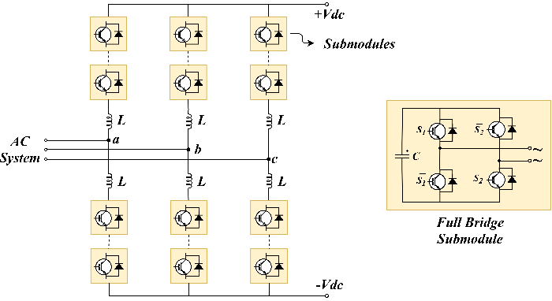
Figure 1 - Modular Multilevel Converter with Full-Bridge submodules
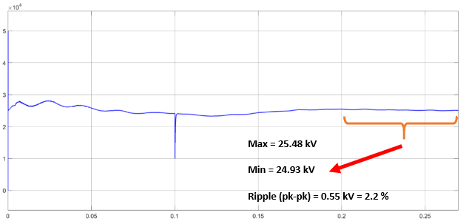
Figure 2 - DC side voltage of MMC-FB
Thanks to the bipolar submodules and the implemented control, the converter is able to limit the DC side short circuit current to 120% of nominal load current by decreasing the DC side voltage, as shown in Fig. 3. In this way, MVDC railways can use low current DC circuit breakers, which are simpler and cheaper than high current DC circuit breakers.

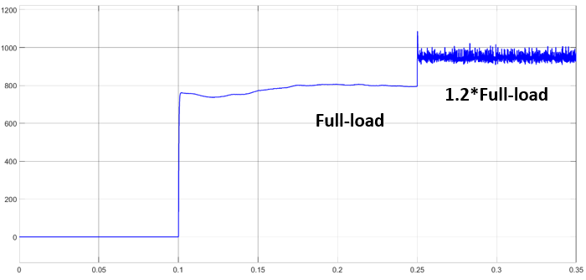
(a)
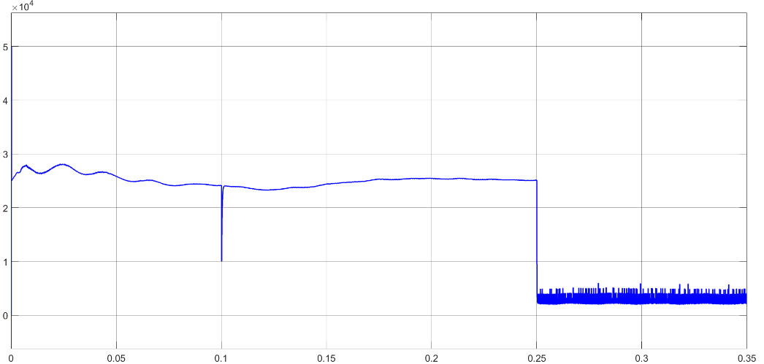
(b)
Figure 3 - An example of fault current limiting in MMC-FB: a) DC side current b) DC side voltage
Fig. 4 shows the software model for a MVDC TPS in Matlab/Simulink environment. This model is used for evaluating performance of the MVDC TPS in various operating conditions.
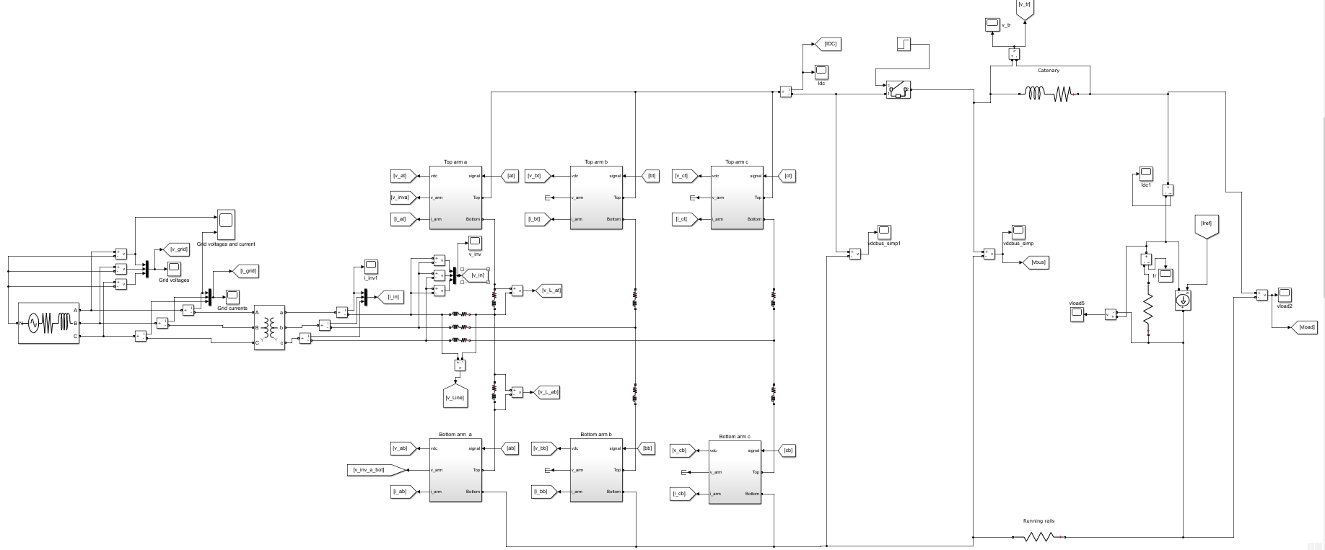
Figure 4 - Software model for a MVDC TPS
The model has also been extended to double-end feeding and multi-terminal (meshed) network to simulate the whole MVDC railway system. Furthermore, to assess the network performance in presence of renewable resources, photovoltaic (PV) arrays have been added to the network. More details about the MVDC simulator and TPS performance analysis will be published in deliverable D1.2 (Due in May 2021).
- Software model of MVDC traction transformer
The software model of the power electronic traction transformer (PETT) is an 8 module multi-modular input series output parallel (ISOP) system with dual active bridge (DAB) modules, capable of 1.2 – 4 MW of total power depending on the requirements and the design. The designed example for this project is a 1.2 MW system with 1500 V output, however an automated design sheet is developed as well, to easily scale and design the converter module components for other requirements. The input of the system is the nominal catenary voltage, 25000 V DC.
The control system of the PETT consists of a PI loop for each module with the input voltage as reference, except for the first module, which has the output voltage as reference – all forming decoupled control loops. The software model is still under development to be able to test different scenarios. To demonstrate the PETT’s operation, a traction inverter along with a 3-phased induction motor is attached to its output. The whole system is shown on Fig. 5, with the control loops on the left and the inverter with the traction motor on the right.
The results of the complete PETT system will be published in deliverable D2.2 at the end of the project, together with its performance evaluation and small scale prototype. Some waveforms are shown as well, in Figs. 6-8. Fig. 6 depicts the secondary/output waveforms, Fig. 7 shows the THD of the output and Fig. 8 represents the total system output power.
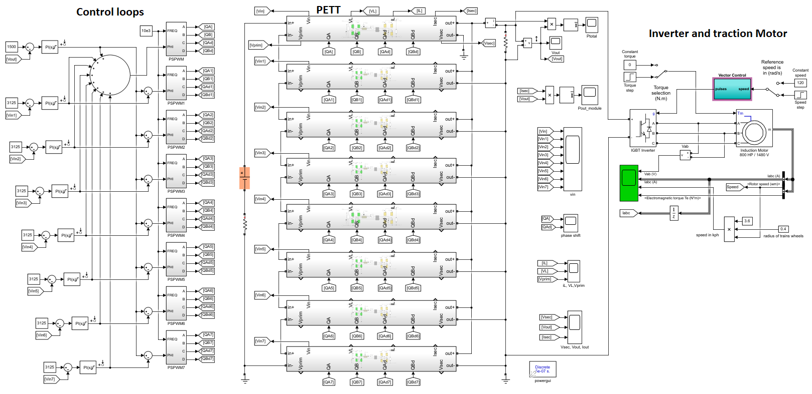
Figure 5 - Software model for the MVDC PETT
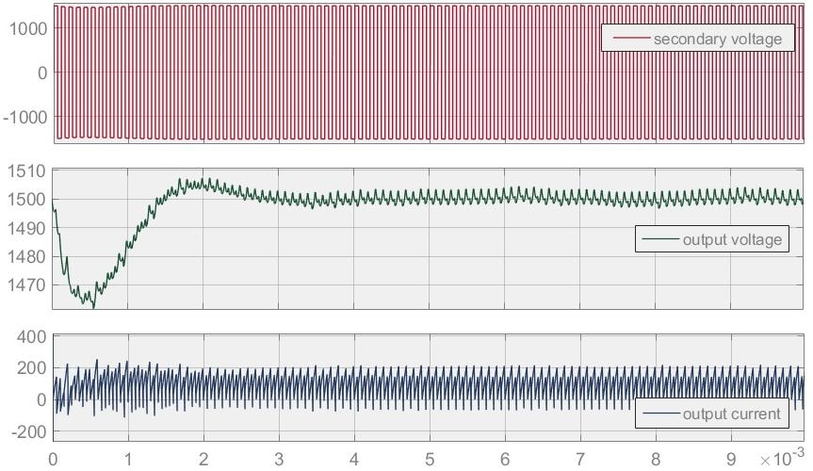
Figure 6 –The obtained response of the output voltage – x axis in milliseconds
Figure 7 – THD of the output
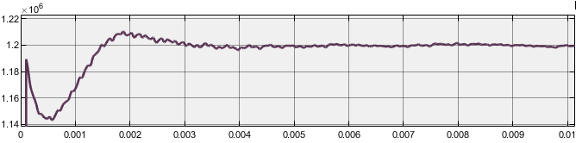
Figure 8 – Total system power
- The MMC lab demonstrator
To verify the main characteristics of the proposed electrification system, a small-scale demonstrator of MMC-FB is under development. Fig. 9 shows the converter frame, racks and the full-bridge submodules. The power and measurement circuits are almost ready to use and the next step is to develop controller codes and test the converter.
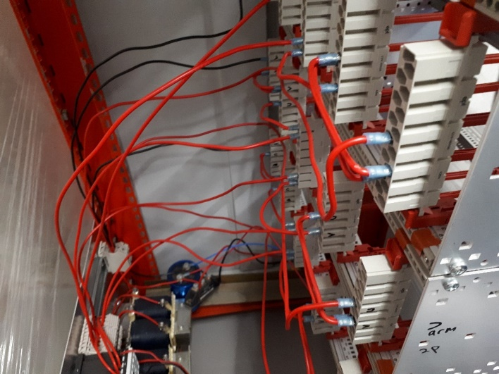
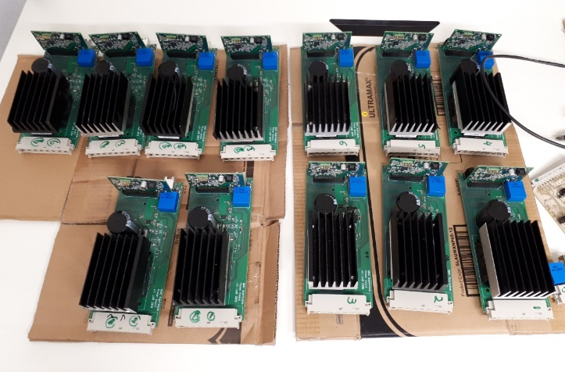
Figure 9 – MMC-FB lab demonstrator
- Update on publications
We will present the conference paper “Investigating the best topology for Traction Power Substations (TPSs) in a Medium Voltage DC (MVDC) railway electrification system” in 23rd European Conference on Power Electronics and Applications (EPE 21), which will be held online from 6th to 10th September 2021. In this paper, three different topologies have been sized for the MVDC railways. Using analytical approach, the power losses of each topology has also been estimated.
Another paper will have a poster presentation during 5th–7th May 2021 at the 44th International Spring Seminar on Electronics Technology (ISSE 21). In the paper our PETT software model will be presented. The paper will also be extended into a journal paper soon.
We will also present a poster about the MVDC-ERS research in Centre for Power Electronics (CPE) Annual Conference, which will be held virtually from 13-15 July 2021. Regarding our review paper, it is now submitted to IEEE Transaction on Transportation Electrification.

