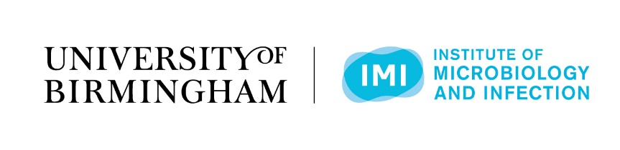

Welcome to the 7th Mol Micro and 8th M4 Meeting

15th & 16th September 2022

Aston Webb Great Hall and Bramall Music Building

University of Birmingham

Conference Programme
Day 1
8.00-9.00: Registration

9.00-9.10: Welcome (David Grainger)

Scientific Session 1: Interactions between microbes and their environment (chaired by David Grainger)

9.10-9.40: Julia van Kessel: Indiana State University (USA)
9.40-9.55: Selected abstract
9.55-10.10: Selected abstract
10.10-10.25: Selected abstract
10.25-10.40: Selected abstract

Coffee Break and Trade exhibition: Aston Webb Great Hall

11.20-11.35: Winner of the Junior Award for Microbiology 2022

Scientific Session 2: Gene expression and RNA biology

11.35-12.05: Tom Santangelo: Colorado State University (USA)
12.05-12.20: Selected abstract
12.20-12.50: Thorsten Mascher: Technical University of Dresden (Germany)

Lunch and Trade exhibition: Aston Webb Great Hall
Scientific Session 3: Understanding bacterial cell structure (chaired by Andy Lovering)

14.00-14.30: Klas Flardh: Lund University (Sweden)
14.30-14.45: Selected abstract
14.45-15.00: Selected abstract
15.00-15.15: Selected abstract

Coffee Break and Trade exhibition: Aston Webb Great Hall

Scientific Session 4: Molecular biology of human pathogens 1 (chaired by Liz Ballou)

15.45-16.15: Angelika Gründling (Imperial College London)
16.15-16.30: Selected abstract
16.30-16.45: Selected abstract
16.45-17.00: Selected abstract

17.00-17.30: Flash presentations

17.30-19.30: Poster session and Trade exhibition

BBQ and Social: Biosciences Quad

Day 2

Scientific Session 5: Replication and cell division
9.10-9.40: Kristina Jonas: Stockholm University (Sweden)
9.40-9.55: Selected abstract
9.55-10.10: Selected abstract
10.10-10.25: Selected abstract
10.25-10.40: Selected abstract

Coffee Break and Trade exhibition: Aston Webb Great Hall
Scientific Session 6: Beyond model organisms: new frontiers in microbiology
11.20-11.50: Dirk Schüler: University of Bayreuth (Germany)
12.05-12.20: Selected abstract
12.20-12.35: Selected abstract
12.35-12.50: Selected abstract

Lunch and Trade exhibition: Aston Webb Great Hall

Scientific Session 7: Signalling mechanisms
14.00-14.30: Selected abstract
14.30-14.45: Selected abstract
14.45-15.00: Selected abstract
15.00-15.15: Selected abstract

Coffee Break and Trade exhibition: Aston Webb Great Hall

Scientific Session 8: Molecular biology of human pathogens 2 (chaired by Manuel Banzhaf)
15.45-16.15: Eva Frickel (University of Birmingham, UK)
16.15-16.30: Selected abstract
16.30-16.45: Selected abstract
16.45-17.00: Selected abstract

Closing remarks

