Neighbourhood Futures

The role of community festivals in connecting communities for wellbeing and sustainability

November 2023
This report is the result of a collaboration between the Centre for Urban Wellbeing, Birmingham Settlement and many individuals working together. From the University of Birmingham, we are grateful to Hannah Absalom, Koen Bartels, Susanne Börner, Niyah Campbell, Charles Goode, Gerald Jordan, John Munro, and Francis Pope for organising workshops, talks and walks. From the University of Bristol, we thank Paul Clarke, Laurene Cheilan, Keri Facer, Marisela Gutierrez Lopez Helen Manchester, Carolina Valladares Celis. Thanks go to all the event speakers and workshop leaders: Ben Hughes, University College London, Tony Armstrong, Locality, Councillors John Cotton and Sharon Thompson, Rebecca Dillon-Robinson, Ramboll Regenerative Cities, St Germain’s Church, Civic Square, Singamajig, the Birmingham & Black Country Wildlife Trust, MIND, Giovanni ‘Spoz’ Esposito, Belinda Bins, The Head Gardener, Stitch Up Sewing Group, Birmingham Settlement Community Choir and the wider Settlement Team for leading and supporting numerous workshops and activities.

We thank Clare Harewood from Birmingham Voluntary Services Council for organising the Urban Futures Story competition, and Anna Haydock-Wilson of Little Fish Films for producing a film of the event. Thank you to Jessica Hoffman, Paul Clarke, Duncan Speakman, Heidi Gautrey and Sam Steer from Uninvited Guests for their work with the Future Places Toolkit. We are grateful to the student and staff research volunteers: Laura Kudrna, Tomos O’Sullivan, Elizabeth Parker, Kritika Singh, Beckye Williams. Special thanks to our summer student research placement, Beth Sykes for her dedication to the research and support in organising the festival with Rebecca Hadley.

We gratefully acknowledge funding from the University of Birmingham Public and Cultural Engagement team and Research England Quality-related Research Policy Support Fund PSF-4: Urban Wellbeing in Policy. We also thank the Economic and Social Research Council funding for the Centre for Sociodigital Futures (award ES/W002639/1) for supporting the Future Places Toolkit, Futures Studio and Learning Domain collaboration.

The event would not have been possible without the wonderful staff and volunteers at Birmingham Settlement, and we thank them for their ongoing community organising, free money advice, family activities and health and wellbeing support.

About The Centre for Urban Wellbeing
The Centre for Urban Wellbeing at The University of Birmingham was established in 2020 to support interdisciplinary and community-engaged research informed by the best global evidence and insights to address urban wellbeing inequalities.

About Birmingham Settlement

Founded in 1899, Birmingham Settlement is one of the oldest charities in the city. Based across north-west Birmingham, with bases in Aston, Ladywood and Kingstanding, the Settlement works together with its communities to deliver effective services in response to the presenting and emerging needs of those communities.

Suggested citation:
Pykett, J., Sykes, B., Jordan, G., O’Sullivan, T., Parker, E., Williams, B., Singh, K. (2023) Neighbourhood Futures. The role of community festivals in connecting communities for wellbeing and sustainability. Centre for Urban Wellbeing, University of Birmingham.

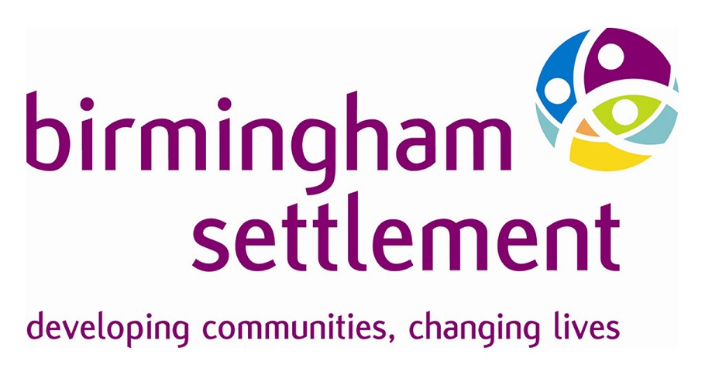
Neighbourhood Futures

About this report
In the summer of 2023 the Centre for Urban Wellbeing at University of Birmingham collaborated with Birmingham Settlement to organise their first ever Neighbourhood Futures Festival. This was a week long programme of events, talks, activities held at their new Birmingham Settlement Nature and Wellbeing Centre in Birmingham. Our aim was to help to make community connections and support local participation in activities to improve community wellbeing and sustainability.

Summary of recommendations

- Neighbourhood festivals can be a good way to reach communities that community and voluntary sector organisations wish to serve. Inviting specific groups to collaborate and pre-booked events can help to expand the sector’s offer on wellbeing and sustainability.

- Creative performance methods such as participatory theatre, poetry and storytelling can be valuable ways to create longer term wellbeing and sustainability outcomes for the festival.

- Birmingham Settlement has a unique community development model which supports a self-determining and self-sustaining community. It is valuable to measure, evaluate and share this model as a core organisational goal and across the sector.

- Community and voluntary sector organisations should include more measures of community wellbeing and social value in funding proposals and programme evaluations.

- There is a timely opportunity to work further with umbrella organisations such as Locality, Birmingham Voluntary Services Council’s Environment and Energy Network, and regional universities to extend and develop a network of local community organisations on energy resilience, retrofit, and community-led climate action plans.

- Community festivals can be usefully evaluated on how well they:
- connect rather than fragment the third sector
- unlock the power of communities
- address structural inequalities
- deliver on addressing the most pressing needs of their communities
- generate local community wealth

What we know about community wellbeing

The way in which communities relate to each other in the places where they live can influence people’s sense of personal wellbeing as well as the wider wellbeing of the community. A review of evidence on place-based interventions was conducted in 2023 by New Local for the What Works Centre for Wellbeing (New Local 2023) to try to understand the effectiveness of interventions that are designed to address local or regional population needs that arise as a result of complex social and environmental inequalities in places.

Their evidence review considered several community wellbeing outcomes including social relations, connectivity, community control, pride, and sense of place. It found that collective agency and control were shaped by:
- neighbourhood connections
- decision-making influence
- developing community capabilities
- community tensions, conflict and power imbalances
- availability of funding and sustaining collective action

Key factors included:
- involvement of communities as equal partners in place-based interventions;
- facilitating opportunities for them to shape programme visions, priorities, action and sometimes delivery;
- increasing knowledge, skills, confidence and power;
- ensuring there is a plan for dealing with disagreements, acknowledging the historical contexts of community relationships and providing realistic forms of decision making;
- overcoming structural barriers such as lack of sustained funding

These elements are needed to ensure that interventions provide communities with the knowledge and skills to enhance their agency beyond funded programmes. It was found that effectiveness of community work can depend on the existing strength and maturity of relationships within communities.

Taking action on wellbeing and sustainability to enhance community agency

In this work, we consider how engaging in collective action on wellbeing and sustainability itself could lead to more community agency and control, instead of focussing on the relationships between each of thee important aspects of community wellbeing?

As health inequalities researcher and geographer Beverley Searle has argued, “a focus on wellbeing is essential for the transformation needed in the face of global injustices and environmental crises” (2021: 294). She notes how eco-psychological research has highlighted the role of self-efficacy, confidence and self-esteem in motivating pro-environmental behaviours.

This more ‘relational’ world-view, where wellbeing is seen as with living within planetary boundaries and is defined by our relations with others, could provide the basis for community action which takes a more transformational approach to tackling the climate, biodiversity and global inequality crises.

The role of community festivals in shaping wellbeing

Community festivals and events are one way of creating, building and sustaining collective agency. They are common across towns, villages and cities in the UK and beyond, and are seen as entertaining and educational cultural moments in the life, history and future-making of a place.
Community festivals are often focussed on arts, heritage, sports, food, environment, civic pride, historical celebrations, identity- or interest- based social groups, or based on seasonal or religious calendars. They can range from small village fetes to large music or sporting mega-events attracting crowds from outside the local area. Organisers can include voluntary sector organisations, community groups, businesses, tourism bodies, campaigning organisations and local authorities.

An existing sense of civic identity and belonging is sometimes presumed to be present in the planning of community festivals and events. These can be focused on celebrating a ‘way of life’ in a particular place or involving community members in the planning processes (Jepson and Clarke 2015). Researchers have looked at the potential impacts include revenue-generation for such groups, economic impacts in the wider area, place-making, pride, social bonding and improved quality of life for families, through memorable event experiences and improved wellbeing for volunteers, through providing a sense of connection and reciprocity (Jepson et al 2019; Brownett and Evans 2020; Coren et al 2022).
Yet ‘community’ is rarely homogenous. Community festivals can be useful in shaping a sense of shared community, but can also lead to conflict over the use of space and feelings of exclusion. Larger festivals sometimes involve tensions between festival-goers, policing and surveillance, experienced differently in relation to gender and ethnicity (Hoover et al 2021; Yolal et al 2016).
While community festivals are often intended to promote social cohesion, economic development and place, some researchers see them as masking inequalities and creating spectacles, which obscure forms of urban marginalisation and injustices by promoting “cities as consumer playgrounds” (Waitt 2008).
Their objective success in terms of impact and subjective perceptions of such events cannot be separated, and in this report we pay attention to both the immediate experiences of the Neighbourhood Futures Festival as well as identifying areas of potential conflict and its role in longer term systemic issues of urban wellbeing inequalities.

Background and vision for the festival
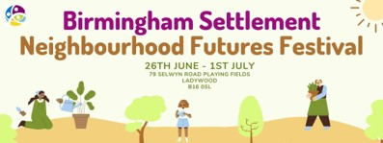

The inaugural 2023 Neighbourhood Futures Festival launched the new Birmingham Settlement Nature and Wellbeing Centre by Edgbaston Reservoir at its site on Selwyn Road. This is located in the wards of Ladywood and North Edgbaston, a 30-minute walk west from the City Centre. The site has been owned by Birmingham Settlement since the land was left in trust by Joseph Gillott in 1923. It has laid fallow for the last 20 years. They started developing it as a flagship site for the city in 2016 to demonstrate the value of neighbourhood ecological developments and to provide opportunities for learning, personal development, arts, sport, culture, wellbeing, and connections to nature.

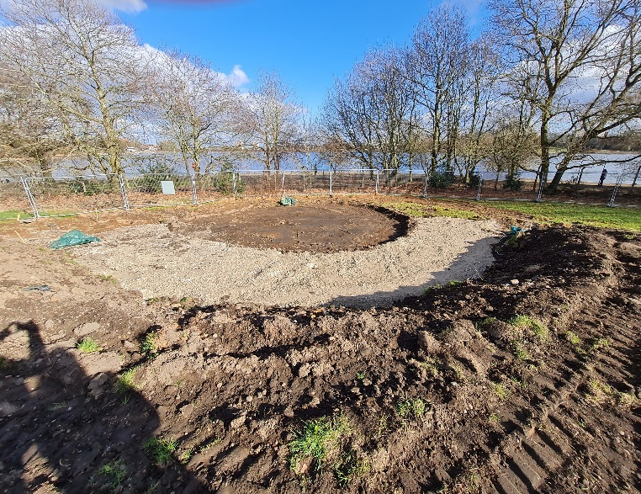
The site neighbours Edgbaston Reservoir, and is characterised by mature trees, hedgerows, grasses and meadow. Working with ecological landscape architects Axis Design and ecological landscape planners and Blue Wigwam, Birmingham Settlement have sensitively planned the developments using sustainable design, engineering and building materials, keeping materials on site, installing a ground heat source and using methods to lock in biodiversity, seedbanks and to sustain and create new habitats. There is also a commitment to prioritising walking and cycling to the Centre.
The site under construction

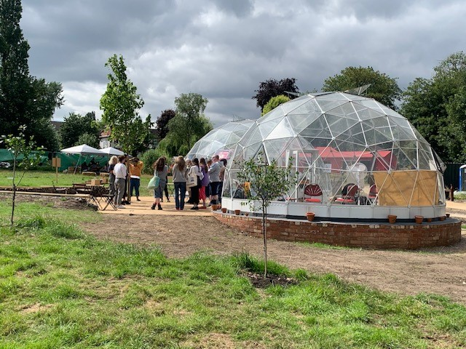
The Centre is an open space with geodesic learning domes, an outdoor amphitheatre, a community orchard, allotments and The Red Shed, which hosts a learning and meeting space, café and toilets. These spaces have been designed to meet people’s needs, to inspire and ignite interest, discussion and neighbourhood action on the environment, sustainability and wellbeing.

Birmingham Settlement saw the festival as a way to support and generate a new way for community organisations to work across the city to connect community wellbeing, green spaces and sustainable action. Making new connections would act as a springboard for community organisations to be empowered to act in their neighbourhoods. This would involve people in community based activity, increase participation and pull people back together in the neighbourhood to relate to each other after what had been a challenging few years during the Covid-19 pandemic.
We co-designed the festival activities in order to:
- Support and generate a new way for community organisations to work across the city to connect community wellbeing, green spaces and sustainable action.
- Make new connections and act as a springboard for community organisations to be empowered to act in their neighbourhoods.
- Involve local people in community based activity, increase participation and pull people back together in the neighbourhood following the Covid-19 pandemic.
- Give an opportunity for people who may not have yet seen themselves as part of the solution to the climate crisis to shape the city’s net zero agenda

The festival aimed to:
- Increase awareness of the new Nature and Wellbeing Centre among local residents and neighbours
- Engage with new partners and funders to be a blueprint for ‘future neighbourhoods’
- Raise aspirations for future neighbourhoods across Birmingham and beyond
- Encourage new volunteers to join Birmingham Settlement
- Mark progress in the development story of the site, to track and learn

We want to model sustainability living and to build a city-wide network for community organisations to take collaborative action on the ecological crisis and create regenerative neighbourhood living.
Rebecca Hadley – Training and Learning Manager

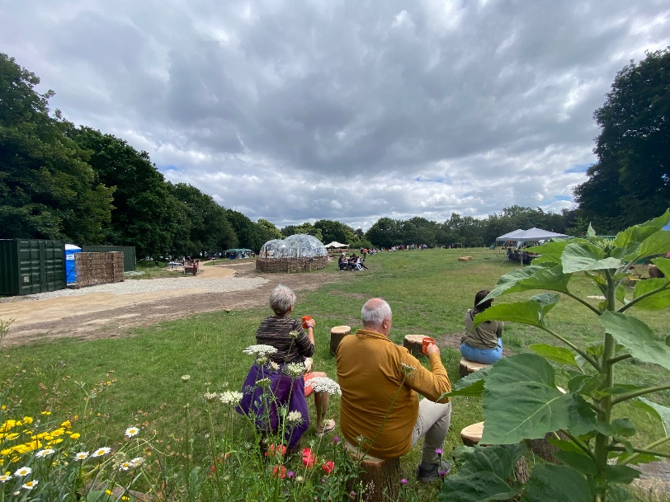
Continuing the historical relationship between Birmingham Settlement and the University of Birmingham

Birmingham Settlement was founded in 1899, one year before the University of Birmingham (Glasby 1999). At this time, the founders and staff at Birmingham Settlement were involved with giving lectures at the University, hosting renowned social reformers such as Beatrice Webb, and founding the first ever social studies lectures. This influenced many generations of social workers.

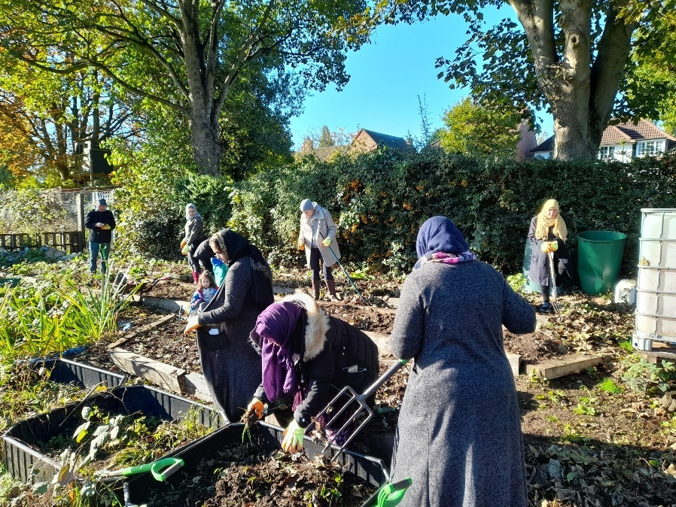
During the 1980s the Future Studies Centre was set up, to explore alternative futures. This Centre developed new thinking on the concept of the “Village in the City” leading to friends and neighbours schemes, and regeneration of the Newtown area of Birmingham.
The Birmingham Settlement Nature and Wellbeing centre builds on their Centre for Urban Ecology which in 1984 was an early forerunner promoting urban green infrastructure, energy conservation, community growing and biodiversity education.

There have been several further collaborations with the University Since the 1990s, including the ENACT project which took a community-led research approach to turn ‘Enquiry into Action’, shaping actions on race and health inequalities, affordable credit, substance addiction and urban regeneration. Our work together continues this long civic commitment of the university to draw in and serve its surrounding communities.

Festival activities

The festival’s main themes were neighbourhood, environment and wellbeing, and a week-long programme of activities was developed in collaboration. Each day focussed on a theme such as urban wellbeing, mental health, sustainability and climate action, community participation, family and community day.

Researchers, educators and students and research partners from the University of Birmingham’s Centre for Urban Wellbeing delivered talks, workshops and activities on a range of topics including:
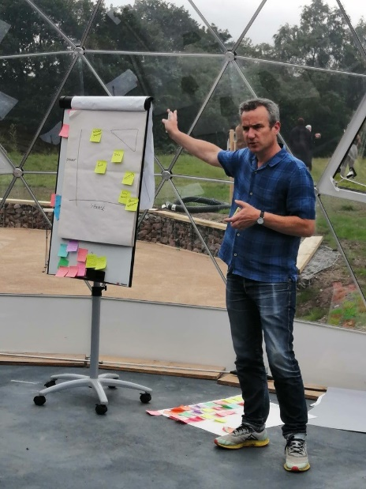
- community action
- low traffic neighbourhoods
- sustainable building and retrofitting
- neighbourhood planning and regenerative cities
- youth mental health and mental health recovery
- visualising air pollution
- storytelling for change

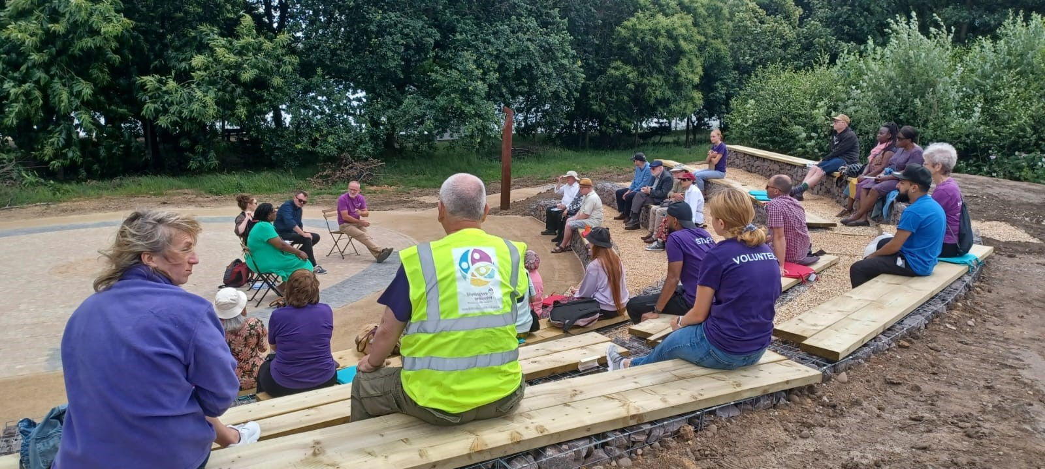

Artists provided energetic, thoughtful and interactive performances:

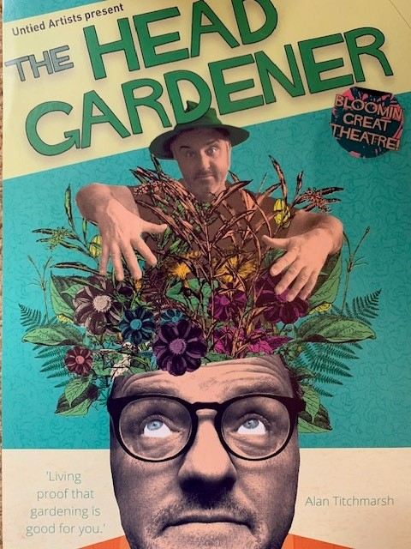
The Monster Clean Up by Belinda Bins engaged children with issues of waste and environmental harm.

The Head Gardener – Digging Deep into Why We Could All Do with a Bit More Horticulture in Our Lives by United Artists provided a moving and personal theatre performance about the role of gardening in mental health recovery

An active storytelling session from Giovanni ‘Spoz’ Esposito, the former poet laureate for Birmingham from The Word Association.

Spoz worked with University of Birmingham Researcher, Dr Hannah Absalom to develop a poetry anthology featuring the work of festival goers. Diverse communities told their stories about the site, locality and connections with Birmingham Settlement. You can access the poems here.

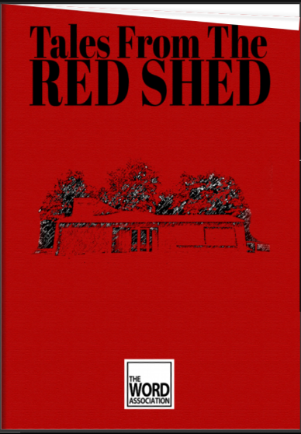
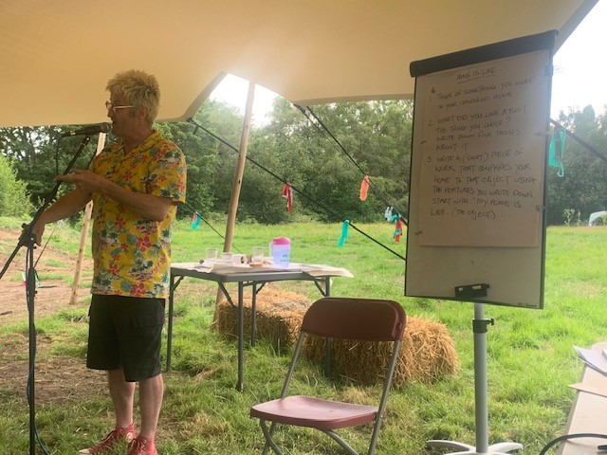

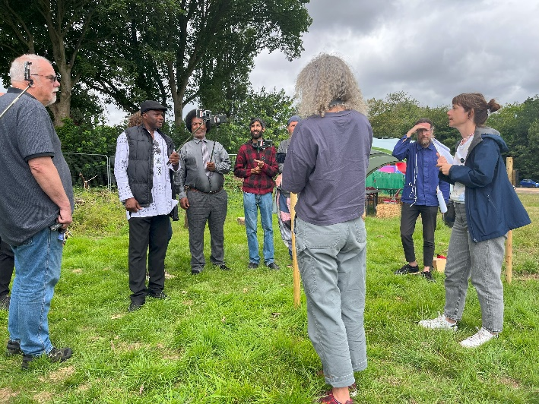
The ESRC Centre for Sociodigital Futures created a bespoke immersive experience for residents to try out an Augmented Reality tool, the Future Places Toolkit for publicly re-imagining the site and their local environment.

You can see a film about this activity here.

In total there were around 50 free sessions offered by a range of other organisations, including nature crafts and scavenger hunts for families, walking tours, a sailing trip and wellbeing activities such as mindfulness, Tai Chi, singalongs, upcycling workshops, food sharing and walkalong sessions on neighbourhood economics.

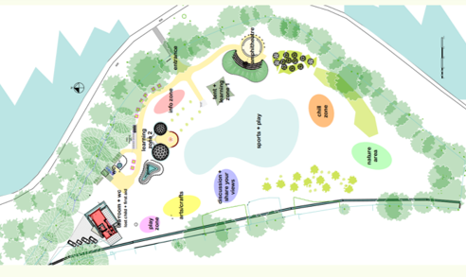
The festival site was divided into activity zones. This included a tea room with food and refreshments at the Red Shed, which also acted as a gathering space and co-ordinating centre for organisers. There was a zone for family and craft activity, with several tents and shelters; a nature zone, an amphitheatre for a performance space, talks and speeches, two learning zones including a shelter, geodesic domes and outdoor terrace, a sports and play area, a chill zone, and an area for local organisations and information on volunteering.

Over 1000 people attended the festival over six days, including members of the public and passersby, existing clients and volunteers at Birmingham Settlement, members of groups who were attending and exhibiting.

Some were local residents and frequent visitors to the Reservoir, who had been watching the developments of the site over the past years and were curious about how it would be used.

Others were regular clients with Birmingham Settlements’ wellbeing clubs and activities at their other sites in Kingstanding or Aston. Some were members of asylum seeker befriending groups, others were families out for a walk or bike ride in the local area, people visiting friends or family in the city for the day, or visitors from other ‘friends of’ reservoirs and parks groups in Birmingham.

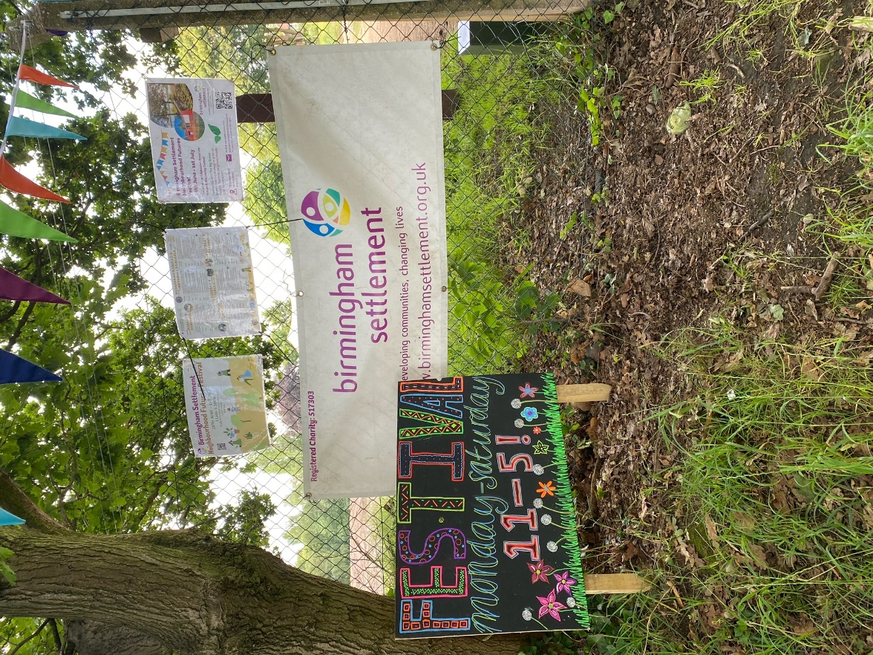

About the research

The research focus for our partnership with Birmingham Settlement was gather experiences, opinions and perspectives of residents, community groups, voluntary sector organisations and civic leaders to evaluate the potential for this neighbourhood festival to achieve its aims.

We wanted to provide a baseline survey of a range of wellbeing outcomes, including personal wellbeing, connections to nature, social connections and sense of community, and to put this in the context of the local demographic profile of the locality and the local assets of the community.

The overall research approach was place-based action research which involves taking action to address a real-world problem working with local stakeholders, rather than conducting research ‘on’ people (Schafft and Greenwood 2003: 22). Birmingham Settlement staff were involved in setting the issues to be researched, and as part of a longer involvement will have opportunities to learn new research skills such as administering surveys, running focus groups and engaging in creative storytelling research methods. They will play a lead role in designing and implementing actions.

Research Aims

The research priorities of the Centre for Urban Wellbeing have been shaped by consultation with over 30 community and voluntary sector organisations, wellbeing researchers and local authorities, and is organised around five key areas:

- Healthy living environments including mental wellbeing, stimulating, safe environments and social interaction
- Income inequalities including access to finance, early years care, education and employment
- Evidence to inform incorporating wellbeing into urban planning strategies
- Access to and use of nature and green spaces, and tackle land ownership inequalities
- Challenging the underlying economy and its assumptions including growth of consumption and production at all costs

As part of the wider Urban Wellbeing in Policy project, our research has been looking at developing and evaluating ways of involving community groups and residents in research which could shape policies for tackling urban wellbeing inequalities in the region.

Research Questions

Through partnering with Birmingham Settlement, we developed the following research questions:

- What are the best methods for engaging with local community members and organisations for planning an annual Festival event?
- How can the Neighbourhood Futures Festival build sense of community, inclusion and belonging, social connection, trust and collective action?
- How could Birmingham Settlement Nature and Wellbeing Centre shape nature connectedness and wellbeing for future community organising on sustainability?

Methods

There is a small but important literature from tourism studies, arts and wellbeing, marketing/management and geography on evaluating community events. A mixed-method evaluation framework for local authority run community events attempts to capture the economic, cultural, social and personal impacts of festivals, ranging from tracking numbers of attendees, to surveys and focus groups on wellbeing, civic pride, preservation and cultural improvement, to measures of business growth, investment and place image (Wood 2008).
Our action research approach involved our community partner in establishing the priority impacts to be researched, and we set out to gather data which:
- addressed our shared aims,
- used a range of engaging and inclusive research methods relevant to diverse community members,
- provided information and analysis in a format transferable for uses beyond academic research, and
- added critical insight through reflective interpretations based on researcher knowledge of the literature on community wellbeing and urban governance.

Our methods included:

Data collection method | Purpose
- Asset map | Information and visual portrait of local assets and connections for funding applications, presentations to stakeholders and forward planning for service provision, volunteering and future events.
- Demographic profile of the neighbourhood | Understand the profile and diversity of the local population at ward level, to compare with festival participants and monitor equality, diversity and inclusion.
- Survey | Provide a baseline description of a sample of festival participants’ personal wellbeing, connections to nature, social connections and sense of community.
- Evaluation forms | Quick and basic feedback on participant’s perceptions of the festival and ideas for how the space could be used in the future.
- Participant observation | A rich description of the event each day to build a picture of participant perceptions, behaviour, interactions and the atmosphere and engagement with activities.
- Creative participatory methods | Activities such as a story writing competition, poetry writing, creating rich pictures, group discussion methods and an augmented reality experience were used to engage, include and inspire – not all outcomes are reported here as these involved a much larger number of researchers.
- Feed-forward workshop | Using the evaluation to stimulate strategic visioning for the organisation, and support to plan next steps, through backcasting methods.

Ethical Considerations

Volunteer student and staff researchers were briefed on their roles, methods, informed consent by both staff at University of Birmingham and Birmingham Settlement, and provided with safeguarding, health and safety and data protection protocols. The research was reviewed and approved by the University of Birmingham Science, Technology, Engineering and Mathematics Ethical Review Committee, ref: ERN_23-0321.

Limitations

The research methods were selected to be practical, useful for the co-organisers to both plan, rapidly evaluate and forward plan from the festival, and to gather immediate feedback on participants’ experiences, interactions and perceptions. The main limitations were the low sample size, which means that the findings are not representative of all festival participants. We mainly surveyed participants who were attending the activities, talks and workshops, so the responses will be more representative of those who engaged more meaningfully with the festival, rather than those who were coming in briefly to have a look or participate perhaps in the sports, crafts and children’s activities. We also did not research people under the age of 16 so this group is not represented in the findings.

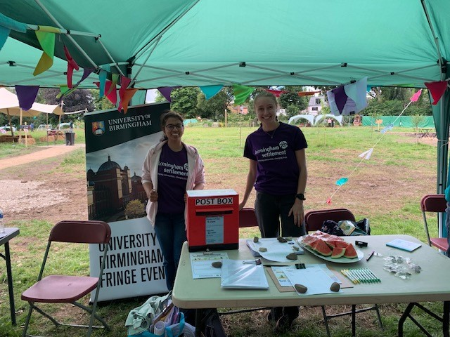
Participant Observation methods are always subjective, informed by the perspectives, identity and personal experiences of the researcher(s). It is therefore important to be transparent about who the researchers are. They were staff and students from University of Birmingham: two males and five females; two citizens from outside the UK; six white ethnic background, one from India; one who lives 1.5 miles walk from the site. This report has been written by researchers also involved in the organisation of the festival in a voluntary capacity for Birmingham Settlement.
Findings

The festival had 1048 visitors throughout the week, including over 300 on the family and community day on Saturday. 18 visitors to site registered for volunteering with Brimingham Settlement.

We gathered 37 evaluation forms from festival visitors over the week, and 54 respondents to our survey. The longer survey included questions about experiences of the festival, personal wellbeing, connections to nature, social connections and sense of community. We also collected demographic information so that we can understand and describe the characteristics of people who attended and who completed the study (figure 1).

Characteristics | Frequency (%)
Gender
Non-binary/third gender | 1 (2%)
Female | 27 (54%)
Male | 22 (44%)
Disability (yes) | 6 (12.2%)
Ethnic Background
White | 26 (53.1%)
White-Scottish | 3 (6.1%)
Other White Background | 3 (6.1%)
Black or Black British Caribbean | 5 (10.2%)
Black of Black British African | 1 (2.0%)
Asian or Asian British - Indian | 7 (14.3%)
Asian or Asian British Pakistani | 1 (2.0%)
Mixed – White and Black African | 1 (2.0%)
Other | 2 (4.0%)
Job Category
Managers | 6 (13.3%)
Professionals | 13 (28.9%)
Clerical Support workers | 1 (2.2%)
Craft and related trade workers | 1 (2.2%)
Retired | 12 (26.7%)
Other | 6 (13.3%)
Not currently in paid work | 4 (8.9%)
Unemployed | 2 (4.4%)
Annual household income (Net)
Less than 10k | 1 (2.9%)
10-20k | 6 (17.1%)
21-30k | 6 (17.1%)
31-40k | 7 (20.0%)
41-50k | 4 (11.4%)
51-60k | 2 (5.7%)
61-70k | 2 (5.7%)
71-80k | 2 (5.7%)
More than 80k | 5 (14.3%)
Education level
University Higher Degree (MSc/MA/PhD) | 16 (40%)
Undergraduate First Degree (BA/BSc) | 12 (30%)
A Levels or equivalent | 5 (12.5%)
GCSE or equivalent | 5 (12.5%)
Other school qualifications (e.g., BTEC, OCR, NVQ, HND) | 2 (5.0%)
Figure 1. Demographic details of survey respondents

We had 6 volunteer participant observers who had been provided with a training session and an observation sheet which was aimed at encouraging informal researcher interactions and conversations with attendees, eliciting rich descriptions of the event, and gathering information about people's experiences, discussions and activities.

The aim of collecting this data was to help Birmingham Settlement to develop future activities at the site, and the University of Birmingham to do further research on community wellbeing.

The participant observation and evaluation data was organised into themes by two researchers (BS and JP), based on a combination of themes identified in the reviewed literature on community agency and connection (deductive themes), and themes identified in the data (inductive themes).

Asset Map: What spaces and places already exist in the neighbourhood?

We produced an asset map and directory of local community and social organisations including:
- sports and leisure associations and facilities
- community centres
- community groups
- residents’ associations
- places of worship
- homelessness shelters
- additional needs services
- parks, playgrounds and open spaces
- medical and health services
- educational institutions

This map was used to locate key assets, space and places within 1 mile of Birmingham Settlement’s Nature and Wellbeing Centre, to identify potential community partners for the festival and for the charity’s ongoing activities.

Demographic portrait: Who lives here and what are their backgrounds?

Youth unemployment and a skills/qualification gap can be identified as key social challenges for the area. There is a high degree of ethnic and religious diversity in the area which can mean a culturally rich and vibrant community which for some may feel fragmented. There are more people living alone in their households, suggesting a potential for social isolation.

- Ladywood (8,313/ km²) and North Edgbaston (6,095/ km²) have higher population densities than Birmingham (4,275/ km²) and are all more densely populated than England as a whole (433.6/ km²).

- Ladywood has a high percentage of younger people, with 55.1% of the population between 20-39 years, 36.0% of North Edgbaston residents were within this age range (26.3% national average).

- Ladywood (9.0%) and North Edgbaston (7.3%) have higher than average unemployment than in England (3.5%).

- Both Ladywood and North Edgbaston are much more ethnically diverse than England, with a spread across all ethnic groups, and a higher percentage of people with religious faith than England.

- General health was distributed similarly in Ladywood and North Edgbaston than England, with no sizable differences in spread.

- In Ladywood (51.4%) and North Edgbaston (37%) more residents have achieved Level 4 qualifications and above than England averages (33.9%), however, a greater percentage have no qualifications in North Edgbaston residents (23%) when compared with and Ladywood (13.6%) and England (18.1%).

- Both Ladywood (49.8%) and Edgbaston (37.1%) have more single-person households than the average for England (30%).

 | Ladywood Ward | North Edgbaston Ward | Birmingham | England
Population | 25,700 | 22,600 | 1,144,900 | 56,490,000
Population density | 8,313/ km² | 6,095/ km² | 4,275/ km² | 433.6/ km²
Sex (F:M) | 48.6: 51.4 | 48.4: 51.6 | 51.1: 48.9 | 51: 49
Age 0-19  20-39  40-59  60-79  80 and over | 19.1%  55.1%  18.1%  6.5%  1.2% | 25.0%  36.0%  25.2%  11.1%  2.7% | 28.9%  30.1%  24.9%  12.5%  3.7% | 23.2%  26.3%  26.3%  19.3%  4.9%
Ethnicity  Asian, Asian British or Asian Welsh  Black, Black British, Black Welsh, Caribbean or African  Mixed or Multiple ethnic groups  White  Other ethnic group | 20.5%  22.5%  6.7%  41.9%  8.4% | 40.6%  18.1%  4.6%  29.1%  7.6% | 31%  11%  4.8%  48.6%  8.4% | 9.6%  4.2%  3.0%  81.0%  2.2%
Economic activity status  Economically active: In employment  Economically active: Unemployed  Economically inactive | 57.0%  9.0%  34.0% | 51.1%  7.3%  41.6% | 49.7%  5.9%  44.4% | 57.4%  3.5%  39.1%
Disability (disabled under the Equality Act) | 12.5% | 16.0% | 17.3% | 17.3%
Religion No religion  Christian  Buddhist  Hindu  Jewish  Muslim  Sikh  Other religion  Not answered | 32.5%  33.8%  1.1%  3.5%  0.1%  19.3%  1.7%  0.8%  7.2% | 16.8%  28.6%  0.5%  3.2%  0.1%  35.1%  8.5%  0.8%  6.4% | 24.1%  34.0%  0.4%  1.9%  0.1%  29.9%  2.9%  0.6%  6.1% | 36.7%  46.3%  0.5%  1.8%  0.5%  6.7%  0.9%  0.6%  6.4%
General health Very good health  Good health  Fair health  Bad health  Very bad health | 54.2%  32.3%  9.4%  3.1%  1.1% | 48.2%  33.4%  12.9%  4.4%  1.2% | 47.6%  33.3%  13.2%  4.5%  1.5% | 48.5%  33.7%  12.7%  4.0%  1.2%
Highest level of qualification No qualifications  Level 1, 2 or 3 qualifications  Apprenticeship  Level 4 qualifications and above  Other qualifications | 13.6%  29.7%  2.3%  51.4%  2.9% | 23.4%  33.5%  3.0%  37.0%  3.1% | 23.9%  39.7%  3.6%  29.9%  2.9% | 18.1%  39.9%  5.3%  33.9%  2.8%
Household size 1 person in household  2 people in household  3 people in household  4 or more people in household | 49.8%  31.3%  9.1%  9.8% | 37.7%  22.5%  12.4%  27.4% | 31.5%  26.7%  15.1%  26.7% | 30.1%  34.0%  16.0%  19.9%
Figure 2. Demographic Profile of Ladywood and North Edgbaston Wards, Birmingham and England [Source: Office for National Statistics – Census 2021]

What did people think of the site?

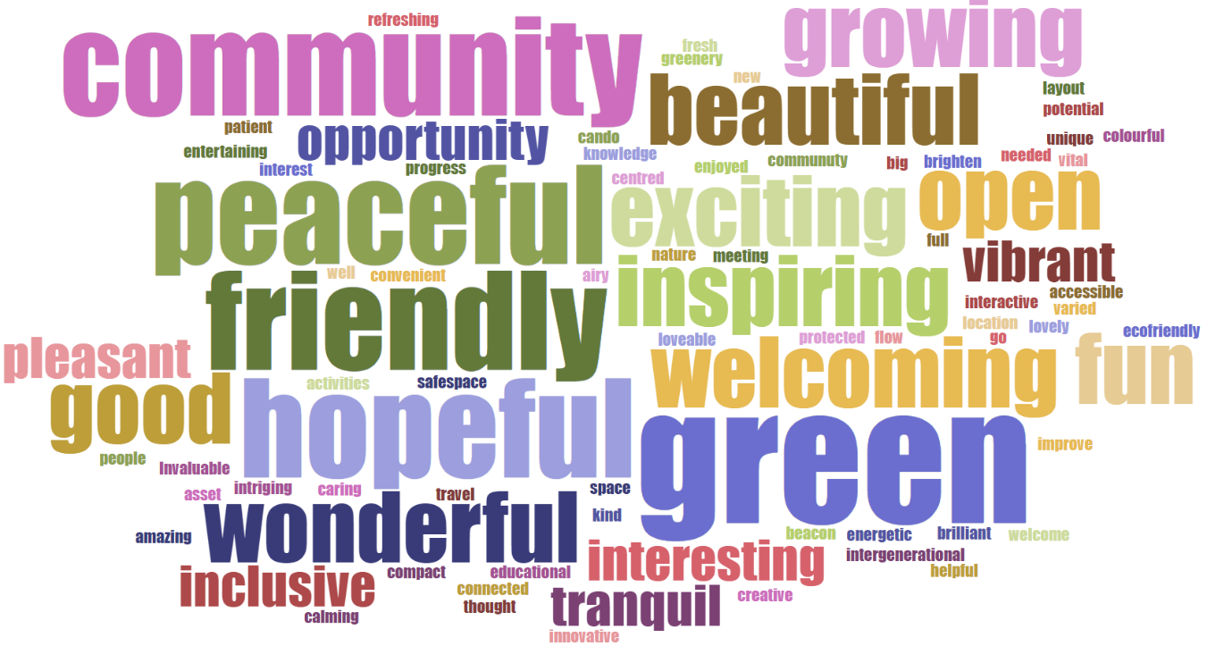
Figure 3. Word cloud for responses to 'What 3 words would you use to describe the site'
Participants came up with 111 words to describe the site. The most common word used was green/greenery which appeared 6 times. The words tell us something about people’s overall impressions of and reactions to the site. We have categorised the words by association into 5 main categories: nature (n=16), aesthetics (n=9), community (n=27), emotions and value (n=31), and future (n=14).

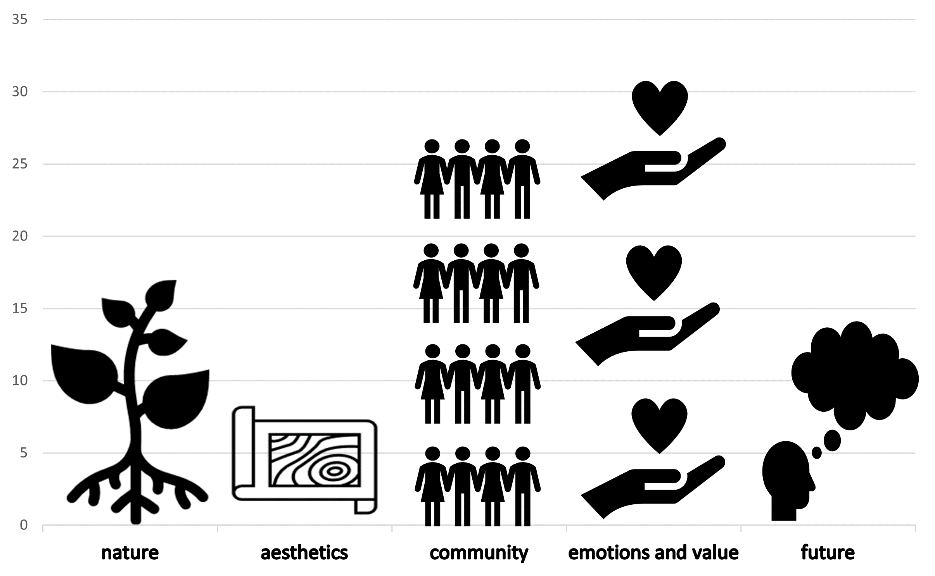
Figure 4. Frequency of words used to describe the site

Most of the words were emotions or value judgements made by participants, including words like “good”, “amazing”, “lovely”, “wonderful”, “educational”, “inspiring”, “intriguing”, “vital”, “brilliant” and “fun”.

The second most common theme was community, with people describing “can-do”, “meeting people”, “friendly”, “helpful”, “welcoming”, “inclusive”, “caring”, “connected”, “safe space”, “patient”, “kind”, “accessible”, “intergenerational” and “needed”.

Words associated with nature included “green”, “growing”, “airy”, “open”, “eco-friendly” and “full of nature”, while related words about aesthetics and how the site looked and felt included “beautiful”, “vibrant”, “unique”, “compact” and “colourful”.

Fourteen words were grouped into the category of future thinking, as they described things like “opportunity”, “optimism”, “potential”, “innovative”, “hopeful”, “beacon”, “progress” and “creative”.

When asked about the main thing participants would remember about the festival, 23 participants noted how the festival fostered a sense of community (e.g., staff were very welcoming and friendly); 16 participants highlighted their strong appreciation for the day’s activities (e.g., the enjoyable range of activities for all groups); nine participants described their appreciation for the natural beauty and scenery of the site (e.g., how “pretty” the field looks); and three participants noted other memorable aspects (e.g., the history of the site, an appreciation of the amount of work that went into producing the festival, and the free hot chocolate).

What did people think could be improved?

Visitors had some suggestions for how the festival and the site could be improved, as evidenced in the evaluation forms and through conversations with researchers and Birmingham Settlement staff and volunteers.

These can be grouped together as suggestions of:
- More local publicity
- More shelter (from the sun, wind and rain)
- Free tea and coffee
- More and longer sessions, with clearer information on booking
- Better access from Selwyn Road and more signage
- More activities for young people
- More funding, perhaps charging for entry to raise funds
- More opportunity to hear from and connect with local leaders
- Holding the event in the school holidays
- Provision of more chairs, picnic blankets
- More stalls, including food stalls, baking sales, flowers, jumble, tombola’s and raffles

When asked about what could be improved about the festival, the most common response was that it could have been better advertised (n = 15). Other responses included that the festival needed higher attendance (n = 8); more activities (n = 5); and improved accessibility around the timing of activities around people’s schedule’s (n = 5). Five participants felt that the festival required no changes.

Social Connection

Social connection was one of the most important themes identified in the evaluation forms, with 15 participants referring to community, communal spaces and connecting with others. People attending the festival reported that they recognized that “community connections are valuable”. They also found the site to be a “beautiful, protected, safe space”. Others mentioned the importance of “working together” to achieve “shared values”. One noted that “I got to speak to other residents of the area who had great ideas about the neighbourhood”, whilst another stated that they “learned about other peoples perspective on life and work”.

Participant observers noted how many participants arrived for scheduled events or activities, but then stayed for a couple of hours, engaging in some activities but also seem to be a ‘hub’ forming around the tea room. Some returned several days during the week.

There were some participants who already had a strong sense of connection to Birmingham Settlement, perhaps through having been a volunteer, a client, or having an interest in local history or the specific history of the Reservoir. A couple of participants attending together stated that Birmingham Settlement felt like family. The organisation and peer group members were their regular points of social contact, and they felt lost if someone was not there.

Observers noted that it was overall a good environment to get to know neighbours, and the educational talks encouraged dialogue, even if groups and individuals tended to splinter off after these. Others were first time visitors to the site, who were enthusiastic about its possibilities for connecting with others through wellbeing activities, enjoyment of green space and community action on sustainability. People often tended to relate to each other by talking about the place that they lived, the history of the area, and how they thought the space should be used in the future.

One researcher observed that visitors attending in groups were not tending to interact outside of the scheduled events, suggesting the need for organised activities to encourage social connection. By contrast, one highlight of the week was the weekend community day which was very well attended, and for which there were more children’s activities including a bouncy castle and tug-of-war competition. The tug of war developed spontaneously, and engaged people of all ages. This attracted a great deal of attention from people across the site and was enjoyed with lots of laughter.

Other participants found it harder to make new social connections at the festival. One older participant who lived alone stated that: “no one has talked to me other than that one person and you”. Direct invitations and organising more activities for an older age group could be one way of addressing this, though equally some activities were notable for the way they encouraged intergenerational discussion, such as the poetry and storytelling workshop, the educational talks, and the Future Places Toolkit.

Attendees who participated in the survey had a positive perception of the festival. Most agreed or strongly agreed that the festival met their accessibility needs (n = 43, 79.6%) and felt able to participate in the activities (n = 48, 90.6%). They felt that the festival provided an inclusive environment (n = 41, 80.4%), and many felt that had a positive opinion about Birmingham Settlement after the event (n = 46, 86.8%).

Participants’ levels of social connection at the festival was rated using the UBC State Social Connection Scale (Lok & Dun, 2022). When asked about their sense of social connection at the festival, participants felt mostly neutral with respect to feeling distant to people (n = 20); feeling like they could relate to most people (n = 19); like an outsider (n = 20); close to people (n = 33); like they had a sense of belonging (n = 24); a strong bond with people (n = 23); and that they were able to connect with other people (n = 22). Participants largely agreed that they felt disconnected from the world around them while at the festival (n = 25); that they saw people as friendly and approachable (n = 24); and accepted by others (n = 20).

There were no statistical or meaningful differences in the average social connection scores between people who identified as males (M = 31.57) and females (M = 42.07); white (M = 40.20) and minoritized (M = 40.58). No differences were observed between people who earned less (M = 39.58) and more (M = 40.56) than a £30k per year (gross). No differences were observed among participants with (M = 40.71) and without (M = 40.41) a university degree. No relationship between age and social connection was found.

Community Agency

Making social connections is only one part of building strong communities. Enhancing community agency, control and capacity are essential for enabling communities to participate in democracies and to act together. This was evident in some of the form survey responses and research observations at the festival. One participant took the following new idea or connection from the day: “Lots of exciting ideas about community climate action - ways we can work together and support each other to mobilise”. Another, who attended four days of the festival wrote about “how communities can do much more to help each other”. These ideas about community were common in discussions and evaluation responses.

For others, the talks and sessions had given them a more personal sense of agency – in the evaluation forms several participants wrote about new aspirations to take up writing and storytelling (n=3), gardening (n=3) and clothes mending (n=9): “I should maybe take up writing?”, “I may want to take a horticultural course.”

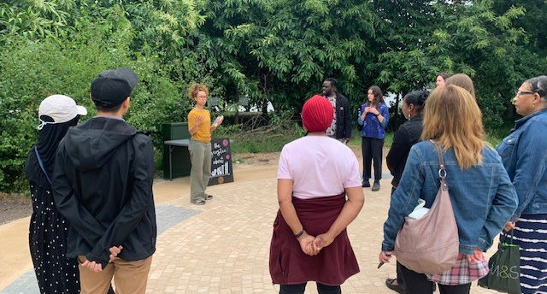
A walking discussion session on creating new civic infrastructure for future neighbourhoods was led by local Ladywood based Community Interest Company, Civic Square. This introduced participants to the ideas of development economist Kate Raworth, using her book Doughnut Economics. The idea here was to offer a new way of talking about the economy and the social foundations needed for human and planetary wellbeing. Participants were invited to “step inside the doughnut” in order to personally reflect on the limitations of mainstream economic thinking, how we can model economies on natural systems of regeneration instead of growth, what kind of conversations we can have with friends and families to address our hopes and fears about the future of the economy, and actions we can take to create new local based economies including retrofitting urban developments, composting and sharing skills.

In a discussion of the history and future role of Birmingham Settlement led by a researcher from University College London, participants described the specific roles that such social and community infrastructure organisations can play in enhancing community agency and collective capacity.

When asked to summarise Birmingham Settlement in one word, participants spoke about:

Connection
Pioneering
Support
Versatile
Diversity
Relationships
Accessible
Positivity
Real
Bringing people together
Open
Consistency
Longevity
Friendly
Inclusive

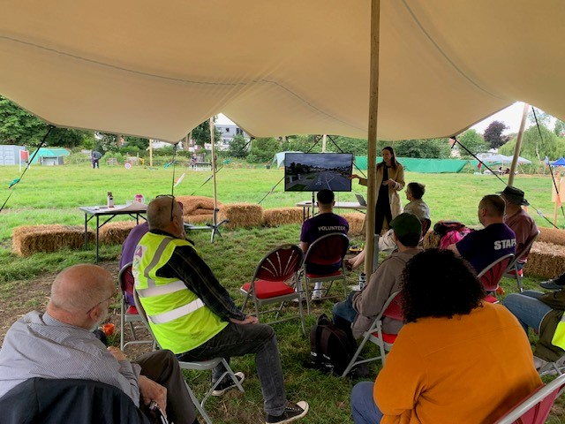
During a workshop on sustainable neighbourhoods, more areas of tension and conflict emerged. Some participants felt that interactions with nature from a young age would be conducive to creating a tighter knit community, and that the site has the potential to create that. Some participants felt that neighbourhood and city-wide planning consultations were not effective in meaningfully gauging resident viewpoints and felt ignored by formal processes. On the other hand, some participants noted that these consultations were frequently dominated by those with the loudest voice and that opposition to local developments was not always shared by the whole community.

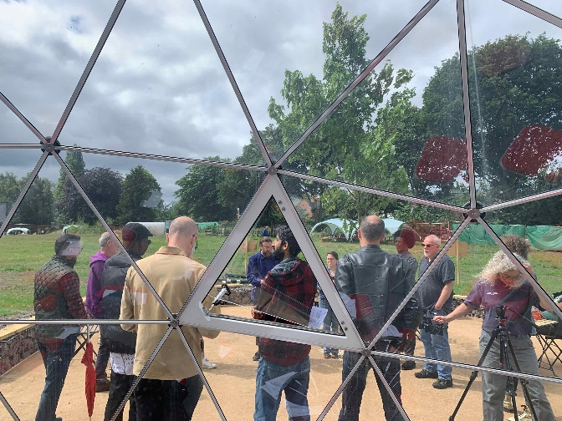
The Future Places Toolkit Augmented Reality experience and future thinking workshop gave intergenerational groups participants the capacity to collectively imagine how the new buildings and site could be used as a community centre, how play would look like for children in the future, what trees could be planted, what sounds, smells, experiences we might encounter.

This got people thinking about what changes at the community-level, local governance, and national political change might be needed to ensure the hopeful futures envisaged. A collective sense of ownership over this space is required to be built for this vision to be successful. At the end many participants said they felt more hopeful about the future after the workshop. The interactive nature of this workshop made it very engaging for the participants as their creative imagination could become a reality through the experience.

During the session on the history of Birmingham Settlement and the wider settlement movement, it was noted that the charity has an important role to play in gathering stories and connecting to the world of policy, working with other place-based organisations, developing community strength, providing opportunities for self-determination.

Nature Connection and Wellbeing

Participants at the festival used the following words to describe the site: “Green”, “friendly”, “community”, “peaceful”, “hopeful”, “wonderful”, “open”, “inspiring”, “growing”, “good”, “fun”, “exciting”, “beautiful”, “vibrant”, “tranquil”, “pleasant”, “opportunity”, “interesting” and inclusive”. One respondent highlighted the importance of the natural world on their mental health. In response to the question “what new idea or connection did you take from the day?” one participant said “we don’t have to lose

hope, keep blooming like flowers”, and another wrote: “we are more connected and living in the future we dreamed about”. They felt some connection to nature and made an analogy between plants and optimism about the future.

Some respondents acknowledged “the importance of green space within city centres for locals” and felt positive about “the ideas/ love between mental health and gardens”. One passerby who only briefly entered the site spoke to a researcher about a family member who had experienced recently homelessness and mental ill-health, who he thought would benefit from coming to this space. A participant felt the site should be used for in situ/outdoor counselling service and a centre for building a sense of personal resourcefulness.

Attendees who completed the survey strongly endorsed feeling connected to their natural world across several domains.

 | Number and % of participants in agreement with item
I often feel a sense of oneness with the natural world around me. | 37 (75.5%)
I think of the natural world as a community to which I belong. | 40 (83.3%)
I recognize and appreciate the intelligence of other living organisms. | 40 (81.7%)
I often feel disconnected from nature. | 15 (30.6%)
When I think of my life, I imagine myself to be part of a larger cyclical process of living. | 30 (63.9%)
I often feel a kinship with animals and plants. | 38 (79.2%)
I feel as though I belong to the Earth as equally as it belongs to me. | 29 (60.5%)
I have a deep understanding of how my actions affect the natural world. | 32 (66.7%)
I often feel part of the web of life. | 30 (62.5%)
I feel that all inhabitants of Earth, human, and nonhuman, share a common ‘life force’. | 32 (66.7%)
Like a tree can be part of a forest, I feel embedded within the broader natural world. | 28 (58.4%)
When I think of my place on Earth, I consider myself to be a top member of a hierarchy that exists in nature. | 20 (41.6%)
I often feel like I am only a small part of the natural world around me, and that I am no more important than the grass on the ground or the birds in the trees. | 22 (45.9%)
My personal welfare is independent of the welfare of the natural world. | 20 (41.7%)
Figure 5. Frequency of survey participants who agreed with the statements on nature connection

Participants’ connection to nature was measured using the Connectedness to Nature Scale (Mayer & McPherson Frantz, 2004). No meaningful statistical differences were observed with respect to how people felt connected to nature between people who identified as male (M = 52.33) or females (M = 51.25); or as white (M = 51.73) or minoritized (M = 51.06). No differences were observed between people earning above (M = 49.63) or below (M = 54.54) £30k per yea; or between people with (M = 50.51) and without (M = 52.81) a university education. However, there was a relationship between a person’s age and their connection to nature, such that older participants felt more connected to nature (r = .51).

Participants’ wellbeing was measured using the Warwick-Edinburgh Mental Wellbeing Scale (Tennant and colleagues, 2007). Respondents’ overall wellbeing scores had an average of 51.00 and a standard deviation of 10.01, which is on par with the UK national average (Mean = 51, Standard Deviation = 7) (Tennant et. Al., 2007). No meaningful statistical differences were observed in wellbeing scores among people who identified as women (M = 51) and men (M = 53). No differences in mental wellbeing were observed between people from minoritized ethnic backgrounds (M = 51.31) and white people ((M = 51.53); people earning above (M= 53.64) and below (M = 47.67) £30k per year; and people with (M = 50.56) and without (M = 54.82) a university education. There was also no relationship between participants’ age and mental wellbeing (r = .22).

Some people stated that they had come to the festival to connect with the community/ neighbours, some people to hear from experts, others because of a concern over environmental health and the impacts of the degrading environment on their personal health.

One participant described how their involvement with wellbeing sessions had introduced them to thinking more deeply about own health, and had given them a sense of belonging. Following the theatre performance by The Head Gardener, someone mentioned that the new ideas that they took from the festival was that “A poor mental health diagnosis is not the end of the road,” suggesting the power of storytelling and theatre to challenge preconceptions.

The sports zone was primarily used by younger people, however, sports seemed to be a good way to engage both parents and their children in multigenerational activities. The busyness of the archery section and mini football pitch were examples of this. The Tai Chi class was particularly successful, and participants recognized the wellbeing benefits from partaking in this activity outdoors; “feel much calmer for having spent an hour outside”, “feel the breeze from the reservoir”, “feel grounded”.

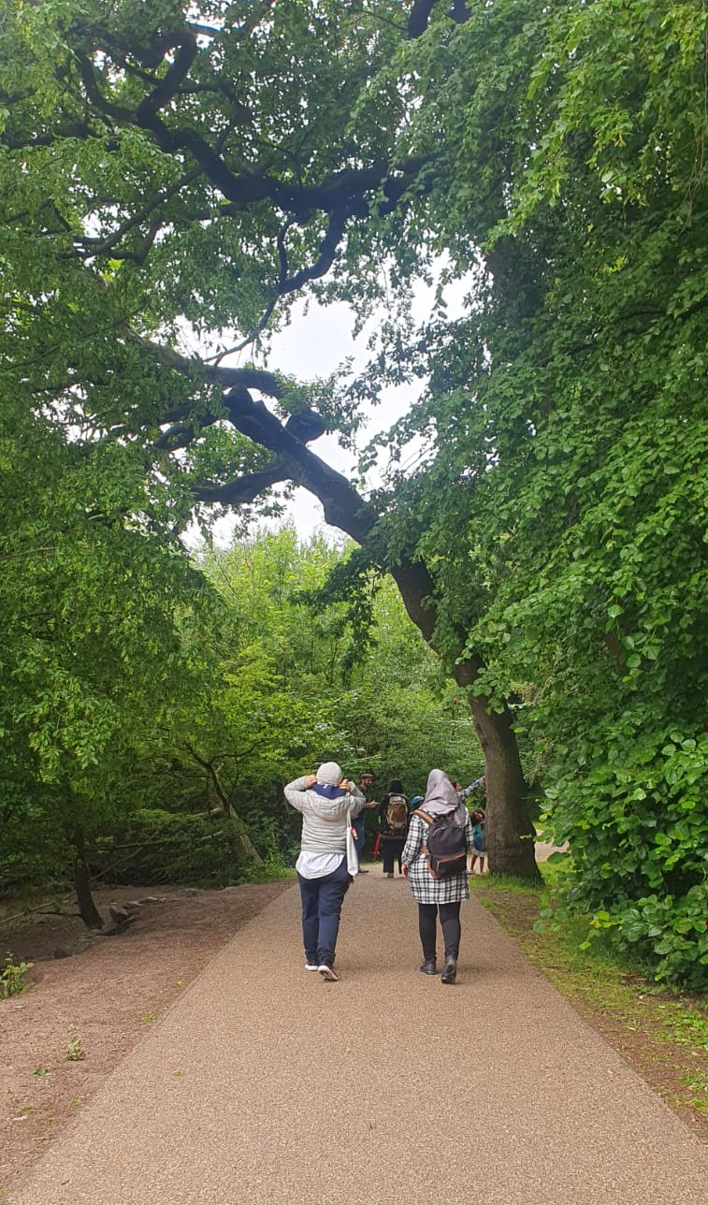
In one nature workshop, one researcher heard participants talking and imagining what fruits would grow here in the future and what other things they'd like to see in this space. They felt that community growing and collective cooking could help to address loneliness among people living around this area and potentially help to involve young people who are substance users. The geodesic domes were noted by one person as a place which encouraged people to look at the sky.

During a mindful walk led by one university researcher, participants described how this made them appreciate nature more, gave them a ‘break from the busyness of cities’ in general and gave them a new way of looking at the everyday. They were encouraged to collect objects and sticks, share pictures and stories, and to pause, reflect and be curious. Participants walked together, comparing their experiences with different qualities of nature in Iran, Africa, Germany and the UK. One participant said their top priority for future activities at the site would be “bringing nature and the value of it to people from all backgrounds”.

Community belonging was measured using the Brief Sense of Community Scale (Buckley and colleagues, 2022). Most attendees who completed the survey endorsed a strong sense of belonging to their community and neighbourhood. Specifically, they felt that they could get what they want from their neighbourhood (n = 31, 64.6%); that their neighbourhood could help fulfil participants’ needs (n = 29, 60.4%); and that they felt like a

member of, (n = 30, 62.5%), and belonged to their neighbourhood (n = 30, 62.5%). Many also reported feeling connected to (n = 28, 58.3%), and have a good bond with others in (n = 33, 47.9%), in their neighbourhood. However, participants were more neutral about whether or not people in their neighbourhood are good at influencing each other (n = 25; 42.4%), and having a “say” about what goes on in their neighbourhood (n = 21, 35%).

Place Ownership and Belonging

As one researcher noted, “I got the impression that a lot of people were taking it all in, some for the first time, and were surprised by the setup of the site and what was available.” In this sense, there was a sense of surprise that such a nice space was open to the public and that people were actively being asked to give ideas about how best to use it in the future.

Place-ownership of the Birmingham Settlement sites was apparent, and conversations about the need for a collective sense of ownership within neighbourhoods for future visions to be successful was discussed in the Future Places Toolkit session. Feeling welcome on the site was another factor that helped increase space-place belonging. Neighbours being specifically invited to attend the festival through door-to-door fly-posting and direct emails helped people to feel welcome and as though they belonged on the site.

A minority of participants were concerned that they would no longer be able to freely use the site, which had previously been derelict but open to e.g. dog walkers. One group of older women had a very strong sense of ownership over the spaces operated by Birmingham Settlement and were very attached to their local site in Aston in particular, favouring ease of access to the location over the nature of wellbeing activities on offer.

One researcher noted how there were not strict boundaries between staff, clients or service users, and volunteers. Rather, many volunteers and some staff mentioned that they had first encountered Birmingham Settlement as clients or volunteers and later became staff.

The idea of a sharp distinction between the ‘community to be served’ and ‘service providers’ is therefore somewhat dissolved, which suggests a

strong sense of belonging, and adherence to the historical ethos of Birmingham Settlement.

An aspiration for Birmingham Settlement’s repurposing and development of the festival site is that people shouldn’t know they’re moving from council or public land to this space. It should all feel public, and it should foster a sense of openness and community belonging. Stewardship of this public-use land comes with constraints, however, including the need to manage access, protect community assets, health and safety and legal responsibilities.

Future Places

There were a range of opportunities for participants to consider and discuss the history, present and future of this local site, the role of Birmingham Settlement, and their place as creators of neighbourhood futures.

In the session on the history of Birmingham Settlement, worries about the future were discussed. There were some concerns about the limits of what could be achieved through the site in light of the deep austerity experienced in the UK over the past decade. It was felt that the priority should be the cost of living challenges, housing needs, legal and citizen advice that will help people to survive, let alone flourish.

On the other hand one visitor felt that the site and family-based activities could offer a good way to tackle the costs and usual consumerism of taking a family day out, and the current cost of living crisis was referred to often. The ‘pay what you can’ model of the café was appreciated in this respect. This suggests that the present work of the money advice group withing Birmingham Settlement is highly valuable and should be connected to the future of the Wellbeing and Sustainability Centre.

One researcher described how through talking to people coming out of the activities and talks, they developed an awareness and appreciation of how attendees made sense of Birmingham through stories. This related to their sense of how the city has changed and how Birmingham’s citizens continued to adapt and change as a result of those changes.

Some of these stories related people’s sense of how Birmingham previously had a negative reputation externally but had with time become
a better place to live. Others spoke about the citizens of Birmingham as good people despite what others in the UK might think of them – one person spoke about this having to do with the working-class background of the city. At the same time, there were also stories of struggle and issues with affordability of living in Birmingham.

Some workshop participants described a specific set of ideals when describing their aspirations for the site. They said it could be a “place of diversity and unity”, “flexible and open”, “a place for sharing of food, resources and ideas”, and “a non-hierarchical space”.

Many festival attendees engaged with the Future Places Toolkit research method, learning how augmented reality can help people to envisage future developments in different environments. This form of research helped people to understand alternative perspectives and ignited conversations between different neighbours which may not have otherwise arisen. Participants valued this research and engagement method. When asked what new idea or connection they took from their day at the festival, people said:
- “augmented reality and planning for a more hopeful future”
- “more connected and living in the future we dreamed about”
- “people had great ideas about our neighbourhood”.

There were lots of ideas from participants about how the site could be used in the future, including those in favour of regular craft, cooking, fitness and yoga classes, gardening and nature-based activities, sessions for children or teenagers, storytelling, educational talks and life skills training. Cost, and transport for dispersed communities to and from the site was seen as important for access and inclusivity.

Visitors made the following suggestions for their top priority for future activities at the site:

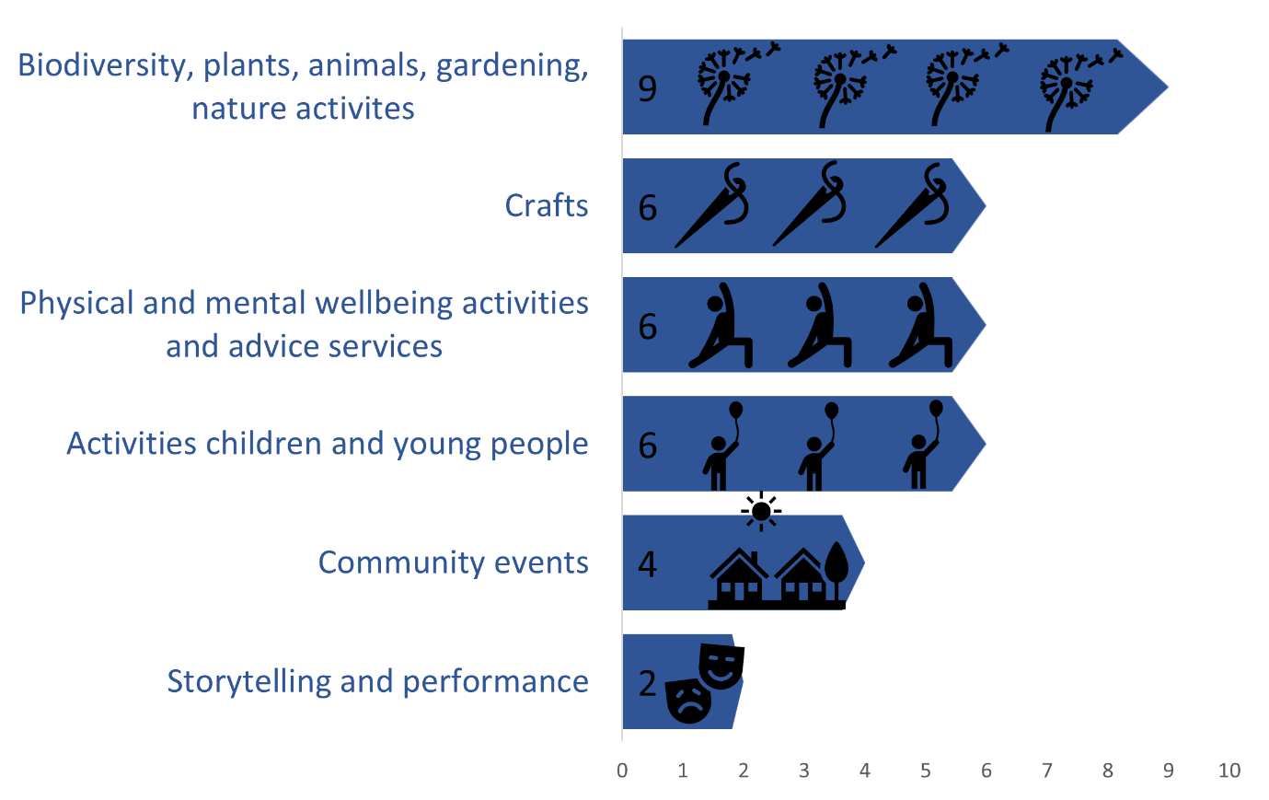
Figure 6. Frequency of survey participants' suggestions for the future of the site

On Sociodigital Futures in a Birmingham park
One of our research aims was exploratory - to experiment with and find out how well creative participatory methods work as a way of understanding the impact of the festival on those experiencing it. Workshops used a variety of methods for this including producing ‘rich pictures’ or visual diagrams of community involvement, making commitments to participatory citizen science on air pollution, and an immersive augmented reality experience,

Tales from the Red Shed is an anthology of festival participant’s poems created through two storytelling and poetry workshops.

Urban Futures stories is a story competition in which local writers submitted stories which imagined a city of the future which is more equal, sustainable and just for all its residents. The winning stories were read aloud at the festival and a discussion held around the role of local writing groups in mental wellbeing, social connectedness and imagining futures.

Future Places Toolkit is an immersive participatory theatre and augmented reality experience which we ran at the festival.

Here we present two reflective poems produced by researchers, as a way to highlight the diverse ways in which research can be useful in drawing out meaningful and personal interpretations of community events.

Creative Participatory Methods

When we ask:
what happened
these last 30 years?

The response is, sometimes,
a form of shellshock,
whiplash.

They came, so fast,
the mobile phones, the internet,
the speeding up
of the whole
wide
world.

The cameras now face two ways,
said the Dad, thinking
of his daughters.

The young women talked,
of social media, of phone lines as lifelines
during lockdown,
normality kept going
when the world
went mad.

The Canadians, recently arrived,
told of family, reshaped around
zoom screens
and intercontinental distance,
remembering a childhood of landlines
and letters,
cycling to see friends.

What happened
these last 30 years?
We asked.

There were memories, wry, confused
of pagers,
faxes.

Tales, of contact sped up,
of space eroded,
of time eaten alive,
spooled out
like so many threads
unwoven.

Fraying at the edges
like the loss of a welfare state,
of youth services,
of housing.

The frayed stories
Of personal troubles
not made into social issues.

What helped?
Who helped?
We asked,
as your world was reshaped.
The answer came back -
Not much.

---

When we ask:
What might happen
these next 30 years?

The response is, for some,
silence.
Who asks us this question?
Who listens?

30 years of lost land, lost rights
sit heavy on tongues,
save for those
whose church
and community offers
a powerful conviction
of the possibility
of a better world.

For the others, slowly,
as the kids in the park
play tug o’war
and run, shrieking
across the field,
and families shelter
in shaded corners for lunch,
and volunteers paint plant pots,
make sandwiches,
share tea,
slowly then,
they begin to tell us:
more of this, please.

More space for us to grow together,
make together. To create shelter
for our kids, to reweave the threads,
to listen,
and welcome each other.

And yes, maybe in 30 years
We might welcome a hologram
Harry Styles
to dance over there
on that new stage.

And yes, maybe we might
whisk ourselves smoothly,
powered by light,
across the lake.

And yes, maybe these tents
will become places
we can speak
with the stars.

But when we rise,
in the air balloons of our imagination
our kids at our side,
dreaming above this land,
they tell us,
it is the land, and its people,
we want to see,
woven,
together.

Keri Facer
02.07.23

Future Home Place

Many months of emails, diary management, coordination, marketing, funding, administration.

All the practical and unseen groundwork needed to make something happen.

The emotional labour of persuasion, expectations and anticipation.

The pleasure of finding new relationships and collaborations.

The gratitude for others’ efforts, time, ideas and knowledge.

And for learning new ways to feel interaction, sound, sight, voice, colour and place.

Doing things with care and consideration.

Responding and taking responsibility.

Planning an experience, a welcome and an invitation.

Finally, it happens, slowing down time to make a meaningful connection.

A week in a field in search of a collective imagination.

Seeing our place in the world, mobile, changing, walking - rooted to the ground but stretching out in time and space.

A tool to bring the future home and to share it in this place.

Jessica Pykett
06.07.23

Discussion and Recommendations

The Neighbourhood Futures Festival was the first time Birmingham Settlement had run a week long community event of this nature, and was the launch of a new chapter in its long history, building on past programmes which had focussed on nature, habitats and ecosystems, collective use of land, wellbeing activities and engaging with action research to shape local futures.
In this final section we return to our research questions to consider the wider implications of the findings and themes described above.

Community Event Planning

We found that creative research methods were an effective way of sparking interest from people with both a long-standing relationship with Birmingham Settlement, new neighbours in the locality, and speculative passersby curious to see how the site is being developed. We demonstrated the capacity for partnership working between universities and community sector organisations in order to generate interest, engage over 1000 community members, and gather new baseline data on levels of social connection, personal wellbeing and connections to nature.
It is always challenging to gather participant feedback at live events, so it is important to develop research methods which are built into the activities and add value for participants rather than over-burdening them.
Working with a range of community organisations and performance artists including poets, theatre companies, artist facilitators, and using digital technologies in new creative and collaborative ways outdoors at the site enabled researchers to help Birmingham Settlement, its volunteers and clients to tell their own stories, the stories of the place, to share skills, perspectives on people’s concerns about the area and get involved in place-making activities.
Ensuring that all organisations have a shared understanding of event aims and long-term aspirations of Birmingham Settlement and its clients is crucial for designing engagement methods collaboratively.
RECOMMENDATION 1: Neighbourhood festivals can be a good way to reach communities that community and voluntary sector organisations wish to serve. Inviting specific groups to collaborate and pre-booked events can help to expand the sector’s offer on wellbeing and sustainability.

RECOMMENDATION 2: Creative performance methods such as participatory theatre, poetry and storytelling can be valuable ways to create longer term wellbeing and sustainability outcomes for the festival.

Building a Sense of Community

The overwhelmingly positive response from participants and visitors who took part in our evaluation survey suggest that they valued the festival in terms of its potential for creating a sense of community, inclusion and belonging. Social connections were mentioned frequently, as well as opportunities for collective action. Trust (in community, institutions, society) was less commonly discussed, suggesting one area where the
role of community events could be better understood.

One area which could be developed is to brief all organisations involved about the best ways to enhance how information is conveyed, how to build strong connections and relationships with participants and how to evaluate community wellbeing. Some resources and services which could help with this include:
- What Works Centre for Wellbeing Guide for charities on measuring wellbeing: https://lnkd.in/eKrqZ8ht
- Pro bono Economics free social value accounting services: http://edgetc.org

RECOMMENDATION 3: Birmingham Settlement has a unique community development model which supports a self-determining and self-sustaining community. It is valuable to measure, evaluate and share this model as a core organisational goal and across the sector.

RECOMMENDATION 4: Community and voluntary sector organisations should include more measures of community wellbeing and social value in funding proposals and programme evaluations.

Shaping Nature Connectedness and Wellbeing for Community Organising on Sustainability?

Participants had a lot of generative ideas about how the site could be used in the future to provide opportunities for people from different backgrounds to come together to care for the land, engage in community growing, share food, learn about sustainability and organise to act together on the climate crisis. These included practical ways to connect with each other, activities which would have dual benefits in terms of personal wellbeing, and actions which would strengthen local communities. The site was valued as a shared space which could bring together civic leaders, scientists and researchers, community groups and organisers, and service providers. Participants felt that they had benefitted from outdoor methods of community engagement, and opportunities to think about the future of the site, locality and their place within it.
RECOMMENDATION 5: There is a timely opportunity to work further with umbrella organisations such as Locality, Birmingham Voluntary Services Council’s Environment and Energy Network, and regional universities to extend and develop a network of local community organisations on energy resilience, retrofit, and community-led climate action plans.

Longer term developments: time to build a new social infrastructure?

While community festivals can no doubt have a wide range of societal, cultural and economic impacts, and act as important focal points for collaborative action, community capacity building, social connectedness

and agency, one-off or even regular events need to be part of a wider social infrastructure if they are to have lasting effects and contribute to addressing persistent urban wellbeing inequalities. It is therefore a useful time for reflection and forward planning for Birmingham Settlement to develop its strategic vision as a place-based community organisation. This section outlines some considerations from wider national debates on the future role of the community and voluntary sector to support this task.

The term ‘social infrastructure’ is growing in relevance within the UK, following over a decade of austerity. This term can refer to:

- the community and voluntary sector, who play a pivotal role in service provision and filling the gaps left by public funding cuts yet are often unequally distributed across cities (DeVerteuil et al 2020);
- the spaces and places including libraries, green and blue spaces, community development, community hubs, known to benefit individual and collective wellbeing and improve social relations (Bagnall et al 2023)
- forms of collective consumption including the goods and services on which everyone regularly relies and which are essential for human needs and socio-economic security and sustainability. This is sometimes referred to as the ‘everyday economy’ or ‘foundational economy’ and includes local wealth created by both employment in and consumption of health, social care, education, housing, food, and retail sectors (Bentham et al 2013).

In a recent international review on social infrastructure commissioned by the British Academy, social infrastructure is defined as:

“physical spaces in which regular interactions are facilitated between and within the diverse sections of a community, and where meaningful relationships, new forms and trust and feelings of reciprocity are inculcated among local people” (Kelsey and Kelsey 2021 cited in Hollins et al 2023: 2)

This definition points to the importance of regular, inclusive and meaningful relationships built on trust and mutuality – relationships which take time to develop and which are often developed in places and neighbourhoods. The review also notes that connecting with the natural world is a key element of social infrastructure – indeed it highlights a research gap in understanding the “inter-cultural connective uses of natural spaces” in addition to its known value in relation to wellbeing and public health (Hollins et al 2023:37).

This can involve skills development, new identify formation and building of social relationships and networks through action on creating, sustaining and improving access to natural spaces. The other key elements of social infrastructure are categorised as openness of purpose, connectivity, community voice, resistance and inclusion/exclusion.

As part of the historical and international settlement movement, Birmingham Settlement has long been embedded in local areas, building long term relationships. This is captured in its core purpose: to ‘create opportunity and choice – connecting and empowering people through action, activities, and shared learning to build and sustain wellbeing for all”.

Birmingham Settlement provide money advice, health and wellbeing groups, regular social activities for older adults, children and families, people with disabilities, hot food, warm spaces a community choir. This makes them a core part of the social infrastructure of Birmingham. Their work is place-based at their current locations in Aston, Kingstanding and Edgbaston.

The settlement movement is thus part of an evolving and diverse social infrastructure, working alongside but also competing with other kinds of third sector organisations, charities, social enterprises, online platforms, umbrella organisations, advocacy and campaigning bodies, statutory and non-statutory service providers for scarce funding.

While this sector has sometimes been labelled as a ‘shadow state’ – filling the gaps in welfare and care left by decades of central government austerity (Wolch 1990), it is also a fiercely independent sector, characterised by ‘symbiotic power’ (DeVerteuil et al 2020) which is both internally competitive and co-operative.

Nurturing the imagination infrastructure

Another new term which has emerged in relation to the future of place-based community development is the concept of the “imagination infrastructure”. The National Lottery Community Fund ran an Emerging Futures Fund, and anti-poverty charity, the Joseph Roundtree Foundation has funded social innovators to support collective, anticipatory and radical forms of imagination and has launched a programme of work on develop community capacity to imagine and shape alternative futures.

Examples of this in Birmingham include the work of MAIA group who have led arts and cultural work to “dream up landscapes and reimagine ourselves and reimagine our communities”, and Civic Square, whose core team include designers, storytellers and formerly a ‘department of dreams’ to build and retrofit ecological, regenerative and socially just neighbourhoods, informed by Kate Raworth’s ‘post-growth’ ideas about doughnut economics – living within planetary boundaries.

This approach is informed by the contention that societies are currently suffering from an imagination deficit – that future visions are dominated by business innovators, fictional accounts or apocalyptic tendencies, and that we do longer have the imaginative faculties to think about positive ways to radically reshape our public services, democracies or everyday places (Mulgan, 2020).

Yet while this imagination infrastructure is important and valuable, it is equally crucial to critically reflect on what forms of civic and urban experimentalism are shaped by this approach. Some have criticised the ‘urban lab’ model for depoliticising “the radical praxis to which it aspires”.

For much the same reasons, urban governance researchers can often be suspicious of the claims and impacts of urban festivals (Thompson and Lorne 2023:22).

The design-thinking, participatory and ‘commoning’ rationales of peer-to-peer ‘urban lab’ experiments for creative and place-based problem-solving have been challenged by some who regard its forms as lacking democratic accountability and representation. Paying special attention to who is involved in community events, the diversity of communities engaged and felt levels of trust and connection are crucial.

Civic experimentalism has been criticised for promising unproven models and theories of change, and an overly controlling approach to philanthropic funding. Given how scarce community and voluntary sector funding has become in the UK, care must therefore be taken to ensure that funds are used effectively for services for those in the most deprived groups.

RECOMMENDATION 6: Community festivals can be usefully evaluated on how well they:
- connect rather than fragment the third sector
- unlock the power of communities
- address structural inequalities
- deliver on addressing the most pressing needs of their communities
- generate local community wealth

Learning from global examples can be helpful, and sometimes act as a reminder that empowering communities doesn’t necessarily mean shying away from political controversies and issues of conflict. There are some inspiring examples of collective imagination and community agency shaping urban developments from across the world.

One example of effective community involvement in neighbourhood planning, is Barcelona’s ‘superblocks’. This emerged not as a result of

community ‘cohesion’ but out of protest and conflict. The superblocks are climate adaptation strategies based on transforming urban living experiences through encouraging walking and cycling, multipurpose places, public space usage and citizen participation in planning (Zografos et al 2020).

This examples demonstrates that dealing productively with community conflict can transform cities, address the sustainability and wellbeing needs of people and planet. This can require bravery, commitment and far-reaching goals which balance immediate needs with future thinking.

Next steps – urban wellbeing in policy

The Neighbourhood Futures Festival was part of a wider project supported by the University of Birmingham in partnership with the West Midlands Combined Authority (WMCA), Birmingham Voluntary Service Council, Lodestone Communications, The Remote Assistant and Rebel Kindly.

Through this work we ran policy masterclasses from April-July 2023 with the WMCA health and prevention team, trialling new ways to bring community voices and diverse forms of evidence into the research-policy sphere.

The demonstrated capability of the Birmingham Settlement Nature and Wellbeing Centre to serve as a site for convening local organisations, civic institutions, researchers and community members offers an example use case for the space, based on finding ways to bring communities together, bringing them into conversation with elected officials, using stories to influence how policies are implemented, and supporting grassroots initiatives on urban wellbeing and sustainability.

There are further opportunities to partner with CUWb on the development, training and capacity building for our Community Wellbeing Citizens Panel during 2024-25.

You can get in touch with us at urbanwellbeing@bham.ac.uk

References

Bagnall, A. M., Southby, K., Jones, R., Pennington, A., South, J. & Corcoran, R., 2023. Systemic review of community infrastructure (place and space) to boost social relations and community wellbeing: Five year refresh. London: What Works Centre for Wellbeing, available at https://whatworkswellbeing.org/wp-content/uploads/2023/01/Places-and-Spaces-Review-Refresh-31-Jan-2023-final-with-logos.pdf

Bentham, J., Bowman, A., de la Cuesta, M., Engelen, E., Erturk, I., Folkman, P., Froud, J., Johal, S., Law, J., Leaver, A., Moran, M. & Williams, K., 2013. Manifesto for the Foundational Economy. Centre for Research on Socio-Cultural Change, available at: https://hummedia.manchester.ac.uk/institutes/cresc/workingpapers/wp131.pdf

Brownett, T. & Evans, O., 2020. Finding common ground: The conception of community arts festivals as spaces for placemaking. Health & Place, Volume 61, 102254, https://doi.org/10.1016/j.healthplace.2019.102254

Buckley, T. D., Kim, K. & Burnette, D., 2021. Psychometric testing of the Brief Sense of Community Scale with Older Adults in Puerto Rico. Journal of Community Psychology, 50(5), pp. 2116-2129, https://doi.org/10.1002/jcop.22758

Coren, E., Phillips, J., Moore, J., Brownett, T., & Whitfield. L., 2022. An Examination of the Impacts of Volunteering and Community Contribution at a Community Festival Through the Lens of the Five Ways to Wellbeing. International Journal of Community Well-being, Volume 5, pp. 137-156, https://doi.org/10.1007/s42413-021-00154-2

DeVerteuil, G., Power, A., & Trudeau, D. (2020). The relational geographies of the voluntary sector: Disentangling the ballast of strangers. Progress in Human Geography, 44(5), 919-937. https://doi.org/10.1177/0309132519869461

Glasby, J., 1999. Poverty and Opportunity: 100 Years of the Birmingham Settlement. 1st ed. Studley: Brewin Books.

Hollins, H., Skropke, C., Smith, H., Harries, R. & Garling, O., 2023. Social infrastructure: international comparative review. Institute for Community Studies. Available at https://www.bennettinstitute.cam.ac.uk/publications/social-infrastructure-international-comparative-review/

Hoover, K. C., Crampton, J. W., Smith, H. & Berbesque, J. C., 2021. Surveillance, trust and policing at music festivals. Canadian Geographies, 66(2), pp. 202-219, https://doi.org/10.1111/cag.12695

Jepson, A. & Clarke, A., 2015. Exploring Community Festivals and Events. London: Routledge.

Jepson, A., Stadler, R. & Spencer, N., 2019. Making positive family memories together and improving quality-of-life through thick sociality and bonding at local community festivals and events. Tourism Management, Volume 75, pp. 34-50, https://doi.org/10.1016/j.tourman.2019.05.001.
Kelsey, T. & Kenny, M., 2021. Townscapes: The Value of Social Infrastructure (No. 7; Policy Series). Bennett Institute for Public Policy. Available at: https://www.bennettinstitute.cam.ac.uk/publications/social-infrastructure/
Lok, I. & Dunn, E., 2022. The UBC State Social Connection Scale: Factor Structure, Reliability, and Validity. Social Psychological and Personality Science, 14(7), pp. 835-844. https://doi.org/10.1177/19485506221132090

Mayer, F. S. & Frantz, M., 2004. The connectedness to a nature scale: A meausre of individuals' feeling in community with nature. Journal of Environmental Psychology, 24(4), pp. 503-515, https://doi.org/10.1016/j.jenvp.2004.10.001

New Local 2023. Rapid review of community agency and control,
as final outcomes, or enablers of place-based interventions to improve community wellbeing. London: What Works Centre for Wellbeing, People’s Health Trust and Community Fund, available at https://whatworkswellbeing.org/wp-content/uploads/2023/06/Rapid-Review-Community-Agency-and-Control.pdf

Mulgan, G. 2020. The Imaginary Crisis (and how we might quicken social and public imagination. UCL Science and Technology, Engineering & Public Policy Working Paper Series. Available at: https://www.ucl.ac.uk/steapp/sites/steapp/files/2020_04_geoff_mulgan_swp.pdf

Schafft, K. A. & Greenwood, D. J., 2009. Promises and Dilemmas of Participation: Action Research, Search Conference Methodology, and Community Development. Journal of the Community Development Society, 34(1), pp. 18-35, https://doi.org/10.1080/15575330309490101

Searle, B., 2021. “Subjective wellbeing and transformation” in B.Searle, J.Pykett and M.J. Alfaro-Simmonds. (Eds.) A modern Guide to Wellbeing Research. Edward Elgar, Cheltenham, p284-300.
Tennant, R., Hiller, L., Fishwick, R., Platt, S., Joseph, S., Weich, S., Parkinson, J., Secker, J. & Stewart-Brown, S., 2007. The Warwick-Edinburgh Mental Well-being Scale (WEMWBS): development and UK validation. Health and Quality of Life Outcomes, 5(63), https://doi.org/10.1186/1477-7525-5-63

Thompson, M. and Lorne, C., 2023. Designing a New Civic Economy? On the Emergence and Contradictions of Participatory Experimental Urbanism. Antipode 55(6), pp1919-1942. https://doi.org/10.1111/anti.12962

Waitt, G., 2008. Urban Festivals: Geographies of Hype, Helplessness and Hope. Geography Compass, Volume 2, pp. 513-537, https://doi.org/10.1111/j.1749-8198.2007.00089.x

Wolch, J., 1990. The Shadow Sate: Government and Voluntary Sector in Transition. The Foundation Centre, New York.
Wood, E. H., 2008. An Impact Evaluation Framework: Local Government Community Festivals. Event Management, 12(3-4), pp. 171-185, https://doi.org/10.3727/152599509789659768
Yolal, M. et al., 2016. Impacts of festivals and events on residents' well-being. Annals of Tourism Reasearch, 61, pp.1-18, https://doi.org/10.1016/j.annals.2016.07.008
Zografos, C., Klause, K. A., Connolly, J. J. T. & Anguelovski, I., 2020. The everyday politics of urban transformational adaptation: Struggles for authority and the Barcelona superblock project. Cities, 99, https://doi.org/10.1016/j.cities.2020.102613

