Launch: Institute for Mental Health and Centre for Human Brain Health
Edgbaston Park Hotel | 53 Edgbaston Park Road | Birmingham B15 2RS | United Kingdom

Tuesday, 24 September 2019 - Wednesday, 25 September 2019
Convene app – delegate user guide

- Download and install the Convene app from either the iOS app store or for Android phones from Google play. The below images show the app icon.
App store:

Google play:

2. Open the Convene app & select which option you want to sign in with (sign in with email recommended).
3. Check your email and follow the link to validate the Convene app.
4. Back in the Convene app, enter your name and proceed to the next page.
5. You will be taken to the ‘Event Chooser’ homepage. Click the ‘Enter Code’ link at the top of the page.

6. Enter ‘LAUNCHIMHCHBH’ and click Submit.
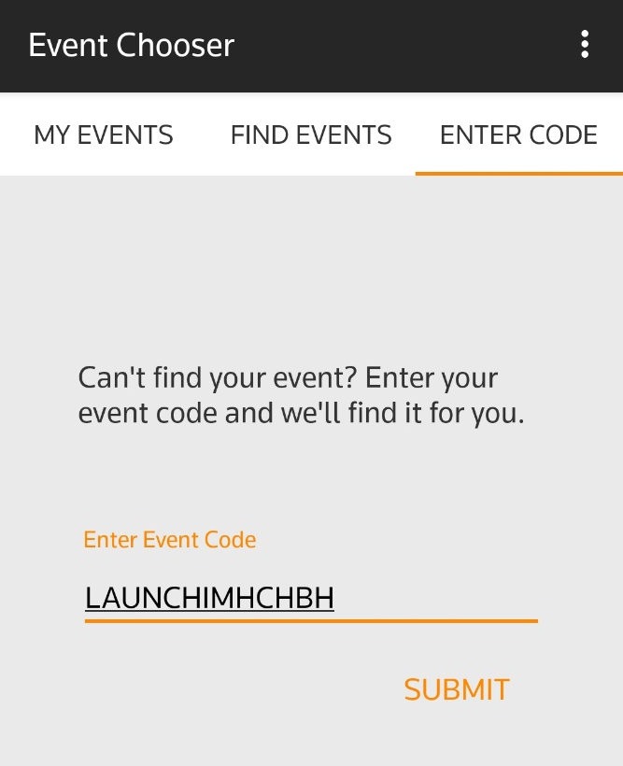
7. You will reach our event homepage. Click ‘Open’.
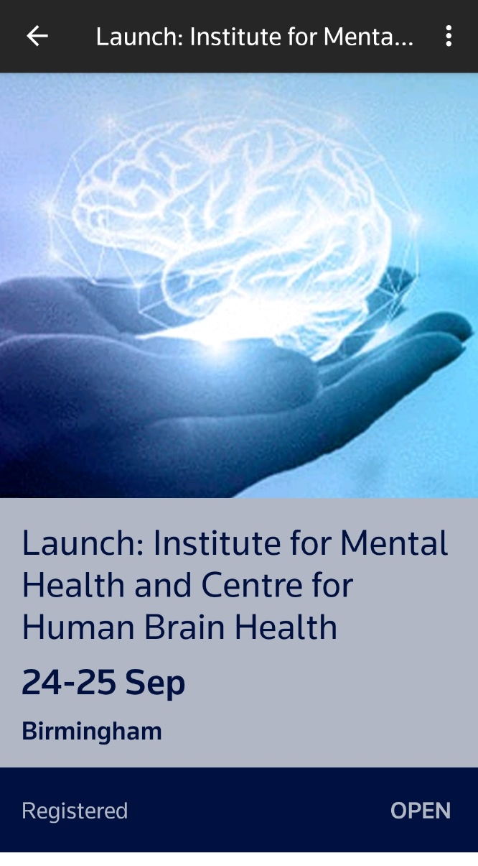

8. Use the app to view the schedule for both days, including speaker biographies, talk titles, event information and links to social media.
