Participant Information Sheet

Impact of transcutaneous spinal cord stimulation on autonomic cardiovascular control and upper-body exercise performance in individuals with a spinal cord injury (STIMEX-SCI): An exploratory study

Chief Investigator: Tom Nightingale, PhD - Assistant Professor in Exercise
Physiology, University of Birmingham
Email: T.E.Nightingale@bham.ac.uk
Telephone: 0121 414 8011

Study Contact: Dan Hodgkiss, MSci – PhD Student, School of Sport, Exercise and Rehabilitation Sciences, University of Birmingham.
Email: stimex-sci@contacts.bham.ac.uk
Telephone: 0121 678 1000

Study Psychologist: Jet Veldhuijzen van Zanten – Professor, School of Sport, Exercise and Rehabilitation Sciences, University of Birmingham.
Email: veldhujj@bham.ac.uk
Telephone: 0121 414 3379

Sponsor: University of Birmingham

Funder: The International Spinal Research Trust (ISRT)

BRIEF PROJECT OVERVIEW
What’s the purpose of the study?
This study is investigating the effects of a non-invasive form of spinal cord stimulation (called transcutaneous, meaning across the skin surface) on cardiovascular control, upper-body exercise performance, fitness and a few other health outcomes in individuals with a spinal cord injury (SCI). During exercise, individuals with higher levels of SCI (i.e., above the sixth thoracic segment) typically have lower peak heart rates and blood pressure that ultimately limit exercise performance and overall physical capacity. Overtime, this can significantly increase the risk of cardiovascular disease (e.g., stroke or heart attack) to a greater extent than the general population. Epidural spinal cord stimulation (involving an implanted electrical stimulator) has recently resolved low blood pressure and improved exercise performance in an individual with tetraplegia, yet this requires an invasive surgical procedure costing upwards of £100,000. Preliminary work from our research group has revealed improvements in cardiovascular control and exercise performance with non-invasive transcutaneous spinal cord stimulation (TSCS) in a small group of individuals, but this needs to be explored further.

How long is the study?

What’s in the booklet?
The project is formed of two parts: AIM 1 and AIM 2. The first aim lasts 3 weeks with a total time commitment of approx. 11.5 hours. This is split across 5 assessment visits.
The second aim lasts 9 weeks plus a 6-week follow-up period with a total time commitment of 34 hours. This is split across 16 exercise intervention sessions, 6 assessment visits along with home-based assessments.
You can choose to do AIM 1 only if you wish.
In this booklet you will find out what the study involves, along with criteria for whether you can be included or not. There is information on the potential risks that could occur during the study. You will also read about the benefits of taking part and the reimbursements we will be able to offer you, Finally, there is information on your rights as a participant and contact details of both the research team and other individuals if you have any concerns.

Why take part? You are one of 60,000 people living with an SCI in the UK, and one of 3 million worldwide. By taking part you would be contributing to a novel and exciting research project that is aiming to improve the quality of life for people living with an SCI. If you want to make a difference and you are keen to find out more, a full explanation of the study can be found below and can be discussed over a telephone call with a researcher from the University of Birmingham when you are ready.
DETAILED PROJECT OVERVIEW

AN INVITATION TO TAKE PART
Thank you for taking the time to read this leaflet. We would like to invite you to take part in this study. Before you decide if you want to participate or not, it is important for you to understand why the research is being done and what it will involve. Please take the time to read the following information carefully and discuss it with friends or relatives, if you wish. Please ask us if there is anything that is not clear or if you would like more information (contact details are on the first page).
GLOSSARY OF SCIENTIFIC TERMINOLOGY
Before we go into the detail of the study, you may want to refer to these terms if you do not understand what something means:

- Transcutaneous spinal cord stimulation (TSCS): This involves small, round sticky pads called electrodes that are placed on the skin-surface over the area where your spinal cord is located. These electrodes are connected to a device that delivers electrical stimulation which is non-invasive and painless.
- CV-TSCS: This is transcutaneous spinal cord stimulation that has been optimised to improve your blood pressure (cardiovascular stimulation). The settings used during this stimulation are identified during your ‘mapping session’.
- SHAM-TSCS: This is transcutaneous spinal cord stimulation that does not improve your blood pressure and is intended to be a control to the CV-TSCS.
- Time or trial to fatigue: These are the exercise trials that you will perform during Visits 3-5. You will exercise at a high-intensity until you feel as though you cannot continue exercising anymore.
- Cardiopulmonary exercise test: A fitness test on an arm-crank ergometer that increases in intensity every few minutes until you are exhausted.
- Cardiorespiratory fitness: This is an overall measure of your fitness capacity.
- Autonomic nervous system: This is the system responsible for regulating responses such as your heart rate, blood pressure and brain blood flow. It also contributes to the control of your breathing, bowel, bladder and sexual functions.
WHAT IS THE AIM OF THIS STUDY?
The first aim of this study is to determine whether non-invasive transcutaneous spinal cord stimulation (TSCS) can improve performance in an exercise trial to fatigue, as well as improve responses (heart rate, blood pressure, brain blood flow) to a series of cardiovascular challenges. The second aim is to explore whether undertaking exercise sessions with TSCS for 8 weeks can lead to improvements in overall fitness and cardiovascular disease risk factors, cognition, motor function and quality of life in individuals with spinal cord injury.
WHY HAVE I BEEN CHOSEN?
You have been chosen because you:
- Are aged 16 years or older
- Have been living with a motor-complete SCI at the cervical or thoracic level (between C5 – T6) for more than one year
- Can move your shoulders and arms voluntarily to operate the arm-crank exercise equipment and do not currently have any painful musculoskeletal dysfunction, unhealed fractures, pressure sores, or active infections that may interfere with testing activities

You should not participate in this study if you:
- Are ventilator dependent
- Are pregnant
- Have been diagnosed with a cardiovascular, cerebrovascular, respiratory, metabolic, musculoskeletal, bladder, or renal disease unrelated to your SCI
- Have any implanted metal in the trunk or spinal cord that would prevent the use of transcutaneous spinal cord stimulation
- Have suffered from brain trauma, a psychiatric disorder or epilepsy (including a family history of epilepsy)
- Are currently taking neuromodulatory drugs
- Are implanted with an epidural stimulator
- Do not speak English

Note: Women who become pregnant during the course of the study will be advised to notify research staff, and upon notification, will be withdrawn from the study. Researchers will be obliged to follow-up to confirm a successful delivery/healthy baby or to log any adverse events.
WHAT WILL HAPPEN TO ME IF I AGREE TO TAKE PART?
You have expressed an interest in taking part in this study and have been provided with this participant information sheet by a member of the research team at the University of Birmingham. If after reading this information sheet you would like to take part in this research study, you can contact either the primary study contact or chief investigator (contact details on the first page) to discuss the study with you. After you have had more than 24 hours to consider taking part, you will be contacted by a member of the research team and an appointment arranged to give you an opportunity to ask questions and discuss the study in more detail. The research team will perform checks to see if you are able to take part in the study; if you are eligible then you will be asked to sign a consent form, but if you do not meet the criteria to participate then you will not be able to participate further in the study and any information collected about you so far will be destroyed. You are encouraged to ask questions prior to and throughout the study if there is anything you do not understand or feel uncomfortable with. Following provision of informed consent and providing the information provided does not exclude you from the study, your participation in the study starts and your first data collection assessment will be scheduled. This will take place no less than 48 hours after the screening/informed consent has been completed. Providing we have your consent, we may also write to your GP to inform them of your intent to participate or inform them of any concerns during the study.
DO I HAVE TO TAKE PART?
No. Taking part in this study is entirely voluntary. If you would like to participate, you will be given this information sheet to keep and be asked to sign a consent form, but you are still free to withdraw at any time and without giving a reason.
You should feel under no pressure to participate and if at any time you are asked questions that you are not comfortable with answering (e.g., those asked on questionnaires) you are free to not disclose this information. Though please do bear in mind that all information collected will be kept strictly confidential. However, if you do decide to withdraw, any data collected from you up until that point will be retained, unless you state otherwise.

OVERVIEW OF THE STUDY
This study is split into two parts (AIM 1 & AIM 2). Both parts involve visits to the School of Sport, Exercise and Rehabilitation Sciences at the University of Birmingham. Aim 1 is investigating the acute, short-term improvements in exercise performance with TSCS. Aim 2 is a longitudinal study that will explore whether exercising two times per week for 8-weeks with TSCS will lead to improvements in fitness and other health outcomes. If you do not have the commitment for the whole study, then you are able to participate in Aim 1 only if you wish.

Please refer to the study overview in the figure on the next page.
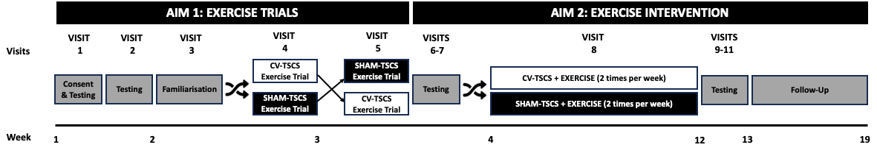

Figure 1. Please read the information in the below paragraphs and refer to this figure to understand the timeline of the study, assessment visits and exercise sessions to be performed throughout. Abbreviations: CV-TSCS, cardiovascular-optimised transcutaneous spinal cord stimulation; SHAM-TSCS, sham transcutaneous spinal cord stimulation.

For Aim 1, you will first be screened for eligibility via a telephone call where a member of the research team will cross-check the inclusion/exclusion criteria with you before you can take part in the study. At this stage the researcher will explain the study to you in detail and you will be able to ask any questions you have. When your eligibility has been confirmed, you will be invited to the University of Birmingham to provide informed consent and then undergo some preliminary outcome assessments, including a fitness assessment. You will undergo a ‘stimulation mapping session’ whereby we manipulate the TSCS intensity and location of electrodes to identify what settings are optimal to safely increase your blood pressure and regulate cardiovascular control; otherwise known as cardiovascular-optimised TSCS (CV-TSCS). During these visits, we will also monitor your heart rate and blood pressure responses to a series of tests both with and without CV-TSCS, described below (Visits 1-2). We will then calculate an exercise intensity for you to work at during a familiarisation exercise trial (Visit 3), before you perform the same bout of exercise with either CV-TSCS or a sham stimulation (SHAM-TSCS) in a randomised order (Visits 4-5, see crossover arrow in Figure 1). During these sessions you will be required to exercise at a high intensity until you fatigue (i.e., keep exercising until you feel like you cannot continue).

For Aim 2, you will be invited to undergo some blood sampling, cardiovascular health, cognitive function and motor control assessments (Visits 6-7). At this point, you will be randomly assigned to receive an 8-week exercise intervention with either SHAM-TSCS or CV-TSCS. The investigators have no control over which group you are assigned to; this is down to chance and is similar to flipping a coin. These exercise sessions will be supervised by a researcher at the University of Birmingham. Halfway through the intervention you will perform another assessment of your fitness and a sit-up test to test your cardiovascular function (Visit 8). After 8-weeks, you will undergo the same assessments as performed in Visits 1-2 and 6-7 (Visits 9-11). Finally, six weeks following the end of the intervention you will answer some questionnaires at home or at the University. Throughout the study you will also need to log any illnesses/symptoms you experience.

TIME REQUIREMENT
In total, you will be enrolled in the study for a duration of approximately 19 weeks (~4.5 months). Please refer to Figure 1 to see the specific time requirements for each visit below:

Week 1:
- Telephone call (~30 minutes): Eligibility screening
- Visit 1 (~3.5 hours): Informed consent and demographics. Mapping session and tests of your heart rate and blood pressure responses with and without stimulation (see Pages 13-14 for more info)
- Visit 2 (~3.5 hours): Tests of your heart rate and blood pressure responses with and without stimulation whilst brain blood flow is monitored, and a cardiopulmonary exercise test to determine your fitness (see pages 13-14 for more info)

Weeks 2-3:
- Visits 3-5 (~1.5 hours each): Familiarisation and exercise trials to fatigue with CV-TSCS and SHAM-TSCS
- Visit 6 (~1.5 hours): Blood sampling, cardiovascular health assessments and tests of cognitive function such as memory and recall
- Visit 7 (~2 hours): Motor function assessments (e.g., balance and muscle activity). Note: you have the choice of opting-in or out of one of these assessments.

Prior to Week 4, you will also be asked to complete a set of online questionnaires (~30 minutes) and wear a device on your chest for 3-days to monitor your physical activity levels and heart rate variability. You will also be asked to wear a blood pressure monitor on your upper-arm for 24 hours to monitor free-living blood pressure changes at home.

Weeks 4-11:
- Exercise intervention (~60 minutes each session): Exercise sessions will initially last ~48 minutes, with ~10-15 minutes additional to account for a short warm-up and cool-down and measuring blood pressure before and after exercise.
- Visit 8 (~1.5 hours): Fitness test and a sit-up test with heart rate and blood pressure monitoring. This session will be completed halfway through the exercise intervention (approx. Week 8).

Week 12:
- Visit 9 (~3 hours): Fitness test plus the same assessments as Visit 6
- Visit 10 (~4.5 hours): Repeat of the heart rate and blood pressure responses tests and motor function assessments conducted in Visits 1 and 7
- Visit 11 (~2 hours): Repeat of the heart rate and blood pressure responses tests conducted during Visit 2

During this week, you will also be asked to complete a set of online questionnaires (~30 minutes) and wear a device on your chest for 3-days to monitor your physical activity levels and heart rate variability. You will also be asked to wear a blood pressure monitor on your upper-arm for 24 hours to monitor free-living blood pressure changes at home.

Week 19:
You will be asked to repeat the questionnaire battery you completed in Weeks 3 and 12.

More details on all of these procedures and the time involved for each are provided below. Monitors should be relatively unobtrusive, however, if you are finding these to be annoying then please contact a member of the research team. Lastly, if you find the time requirements for these assessments to be too much at a time, these assessments can be split across separate days for your convenience.

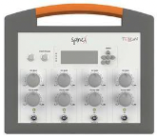
WHAT IS TRANSCUTANEOUS SPINAL CORD STIMULATION (TSCS)?
TSCS is a non-invasive form of electrical stimulation that is applied over the skin surface at specific levels of your spinal cord. The electrical stimulation is delivered using sticky electrodes that are plugged into a constant current stimulator device (see image on the right). Using this device, we aim to activate your spinal circuitries by increasing the intensity of the stimulation until we observe a safe but beneficial elevation in your blood pressure.
WHAT DO I HAVE TO DO FOR EACH OF THE MEASUREMENTS?
You will be asked to refrain from vigorous-intensity exercise and the consumption of alcohol, caffeine and smoking for 24 hours prior to each assessment. Most of the assessments will be performed following at least a 4 hour fast. However, blood samples will be collected in the morning during Visit 6 and Visit 9 following an overnight fast (no food for at least 10 hours). Researchers will confirm these requirements with you prior to your assessment.
You do not need to answer any questions or complete any procedures that you are not comfortable with.
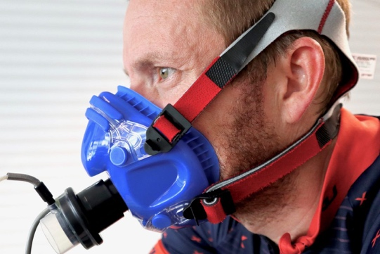
Cardiorespiratory fitness [time = ~45 minutes]. Assessed during Visits 2, 8 and 9. You will be asked to complete an arm crank test that will get progressively harder until you reach exhaustion. During the test, we will be recording the gases you breathe in and out using a facemask secured over your mouth and nose. Heart rate will be measured throughout using a chest strap. Blood pressure will also be monitored before and after exercise, with a cuff placed around your upper arm. A warm-up and cool-down will be performed before/after the test.
Demographic assessments [time = ~30 minutes]. Assessed during Visit 1. Participant characteristics such as height, weight and waist circumference will be captured, along with medical and treatment history (this could include current medication use, surgeries or procedures and information about your injury). We will ask you to inform us of your medication use once you have completed the exercise intervention after (after Aim 2) and after a six-week follow-up period.
Heart rate variability [time = ~15 minutes]. Assessed during Visits 1 and 10 (and the 3-day monitoring, see below). This is assessing the balance of the sympathetic (fight or flight) and parasympathetic (rest and digest) branches of your autonomic nervous system that controls the speed that your heart beats. You will be asked to breathe at a standardised rate (i.e., to the sound of a metronome), while resting in bed with an electrocardiogram (ECG) attached to your chest.
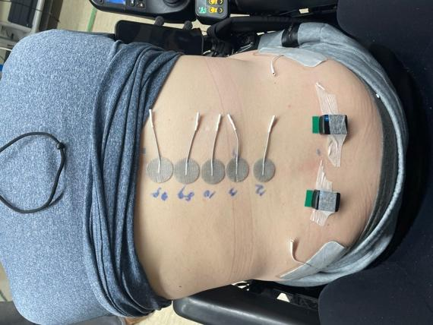
Mapping session [time = ~60 minutes]. Completed during Visit 1. During this session we will position some electrodes over your spinal column and manipulate the frequency and intensity of the stimulation whilst continuously monitoring your heart rate and blood pressure response until we have identified the parameters/settings that optimise this change in blood pressure. See picture on the right for an example mapping session setup. A sonographer will also record a few images of your heart using ultrasound to investigate how your heart function responds to TSCS, such as whether it increases contractility (strength of each beat) and/or the stroke volume (amount of blood pumped out of the heart with each beat). See bottom of Page 10 for more info.
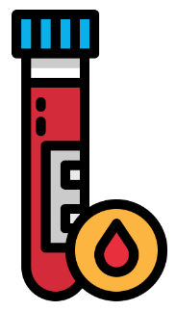
Blood samples [time = ~2-5 minutes]. Before, after and 90 minutes following the exercise trials on Visits 4 and 5, a trained phlebotomist will take a 20 ml blood sample (~ 4 teaspoons) from a vein located at the front of your elbow after a 4-hour fast. Finger prick blood samples will also be taken before and after each exercise trial. These will be used to look at metabolic (e.g., glucose, lactate etc.), adrenaline responses and immune cell markers.
During Visits 6 and 9, a 25 ml blood sample (~ 5 teaspoons) will be taken following an overnight fast. For these visits we ask that you have not eaten or drank, except water, for at least 10 hours before this test. These blood samples will be used to look at similar outcomes as described above as well as other cardiometabolic (e.g., glucose, insulin, lipids etc.) and inflammatory (e.g., C-reactive proteins and cytokines etc.) outcomes.
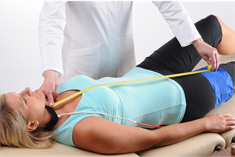
Brain blood flow [time = ~40-60 minutes]. Assessed during Visits 2, 4, 5 and 11. Ultrasound probes will be covered in gel, placed either side of your forehead and fitted using a head strap (see picture on the right). This will be applied during the autonomic nervous system (heart rate and blood pressure response) tests during Visits 2 and 11 as well as the exercise trials in Visits 4 and 5.
Arterial stiffness [time = ~15 minutes]. Assessed during Visits 6 and 9. This assessment is also known as carotid-to-femoral pulse wave velocity and is a measure of the speed of your pulse between two different points of your body. Two inflatable cuffs will be placed around your neck and groin. We will also measure the distance between your neck and groin using a measuring tape. See example in the picture.
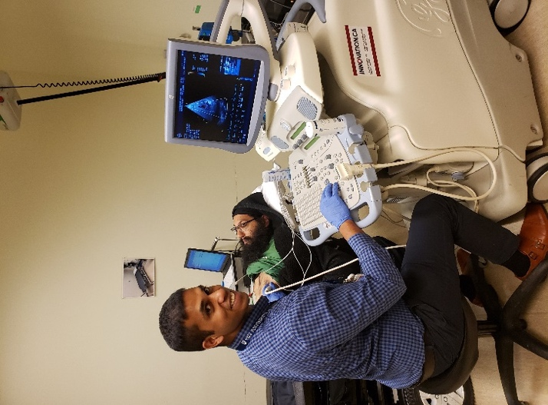

Heart structure and function [time = ~15 minutes]. Assessed during Visits 1, 6 and 9. An ultrasound probe covered in gel will be applied to your chest so we can collect pictures of your heart. From these pictures, we can measure the size and function of your heart, including how much blood it is capable of pumping out. Heart rate will be measured continuously during this assessment using an ECG, which involves placing 3 electrodes (stickers) on your chest.
Images of your heart and blood vessels will contain no identifiable data. These images will be stored for offline analysis and destroyed 5 years after study completion.
Cognitive function [time = ~15 minutes]. Assessed during Visits 6 and 9. You will be asked to complete shortened cognitive tests that measures attention, short-term and working memory. These tests will be delivered orally by a researcher.
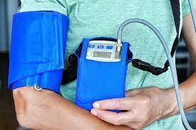
Blood pressure instability [time = 24 hours]. Assessed before, after, and six weeks following the exercise intervention. You will be provided with a portable blood pressure monitor, with a cuff attached to your upper-arm (as shown to the right) that will inflate every 15 minutes during the daytime and every hour during the night-time. During this time, we ask that you do not alter your behaviour and engage in normal activities of daily living. Alongside this, we ask you to keep a diary of daily activities (e.g., transfers, wheeling, eating etc.) and note down whether you are experiencing any symptoms that could be linked to variable blood pressure (e.g., headaches, dizziness, fatigue, blurred vision etc.). These devices must not get wet, they are not to be worn in the shower/bath/pool. However, they can be worn at all other times during the day and night, including when you sleep. After 24-hours you can remove these and put them aside to be collected.
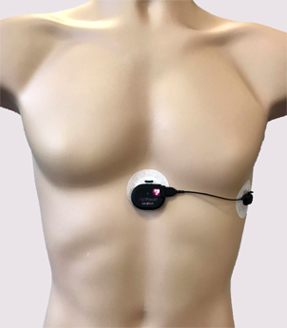
Physical activity level [time = 3 days]. Assessed before, after and six weeks following the exercise intervention. You will be asked to wear an activity monitor on your chest (see picture on the right) for 3 days, attached either using electrodes or a belt. This device measures movement and heart rate (including heart rate variability) to provide an accurate representation of the amount of physical activity you are performing and the energy that you are expending. We ask you to keep a diary of any exercise you perform or when you take the device off to go in the shower.
Muscle tissue oxygenation [time ~40-60 minutes]. Assessed during Visits 3-5. Two adhesive, non-invasive probes which will be attached to your leg to monitor how much oxygen is delivered to your leg muscles during the exercise trials.
Health-related quality of life questionnaires [time = ~30 minutes]. Assessed before, after and six weeks following the exercise intervention. We are interested to find out about different aspects that are known to influence the overall quality of life of people with SCIs. You will be asked to opt-in or opt-out of completing a series of questionnaires. The questions will ask about your ability to do everyday tasks, and your bowel, bladder, and sexual function. These questionnaires are commonly used in people with SCIs. However, you may find some of these questions difficult or uncomfortable to answer, and, as with all assessments, you do not have to complete all the questions if you prefer not to. You will be able to choose whether to answer these at home or with a researcher at the University of Birmingham. Your participation in the study will not be influenced if you do not feel comfortable answering these questions.
Experiences of the exercise intervention [time = ~ 10 minutes]. Assessed following the exercise intervention. You will also be asked to complete a short questionnaire to provide information on the usability and satisfaction with the arm-crank exercise intervention you have completed. These quotes may be used in publicly available documents but will be anonymised so that you can never be identified.
Illnesses throughout the study [time = ~ 5 minutes]. At the end of each week throughout the entire study, you will be asked to complete an illness log detailing any symptoms of illnesses or pain you have experienced throughout that week.
Food diary [time = ~ 10 minutes]. In the 24-hours before the exercise trials in Aim 1, we will ask you to record the food and drink you consume. This is so that we can provide you with the same meals prior to the other exercise trials.
Seated balance [time = ~60 minutes]. Assessed during Visits 7 and 10. You will sit on an elevated platform or bed with your feet off the floor. You will attempt to maintain your balance whilst we perform a number of tasks with you (e.g., slight nudge forwards/backwards, leaning, twisting around etc,). We will monitor the electrical activity of some of your trunk muscles using surface electrodes (stickers with wires attached) attached to your skin. These will only measure the electrical signals that your muscles make by themselves and will not be painful.
The following is another additional motor control assessment that you are able to opt-in to completing when you provide informed consent:

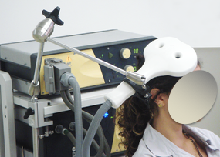
Transcranial magnetic stimulation [time = ~90 minutes]. Assessed during Visits 7 and 10. During this assessment we will be monitoring your breathing muscles responses to techniques called cervical and transcranial magnetic stimulation. These electrical signals will be recorded using the same technique described above. It is a non-invasive stimulation technique that enables assessment of the pathways between the nerves, brain and muscles of interest. Essentially, we will reposition a magnetic coil over you’re the back of your neck and head until we find the optimal location and apply several rounds of stimulation to trigger responses in your breathing muscles. This feels a little like being tapped on the head and is not painful.

DESCRIPTIONS OF THE TESTS PERFORMED DURING VISITS 1-2 & 10-11
These are the tests designed to challenge your autonomic nervous system (the system controlling your heart rate and blood pressure). For these visits, you can arrive at the lab having only fasted for 1 hour.

Tests without brain blood flow measurements:
- Cold pressor test – you will place your hands and then feet in a bowl of cold water (≤4°C) for no longer than 2 minutes at a time
- Respiratory function – you will inhale completely and then blow into a mouthpiece in a ‘blast effort’ for as long as you can, a minimum of three times
- Heart rate deep breathing response – you will be asked to breathe in and out for roughly ~5 seconds at a time whilst following an audio cue so that we can monitor your heart’s response to breathing deeply

Tests with brain blood flow measurements:
- Bedside sit-up test – following 5 minutes of supine rest you will be moved into an upright “sit-up” position with your legs dangling off the side of the bed. You will remain in this position for 15 minutes
- Neurovascular coupling – you will be asked to open and close your eyes for 30 seconds. During the ‘eyes open’ phases, you will be asked to focus on a strobe light to encourage the activation of the main artery in your brain that provides blood flow the area responsible for visual perception
- Valsalva manoeuvre – in a similar fashion to the respiratory function test, you will be asked to blow through a breathing tube at a high pressure for 15 seconds. This will be performed three times

Each test will be conducted both with and without CV-TSCS. Cardiovascular measurements (heart rate and blood pressure) will be performed during all tests. See image below for an example set up:

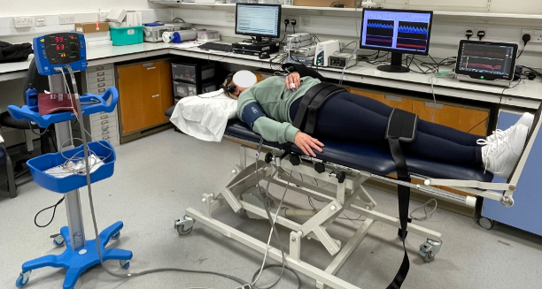

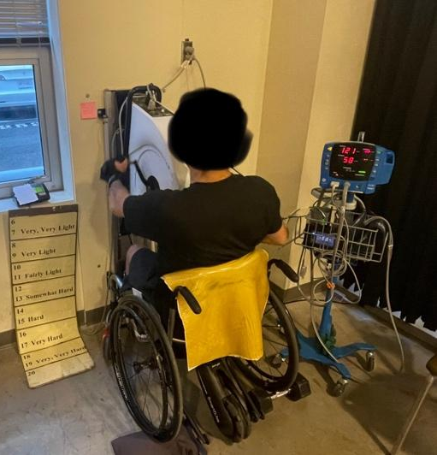
DESCRIPTION OF THE EXERCISE TRIALS (VISITS 3-5)
Following the fitness test you will have performed during Visit 2, we will calculate workloads to be performed during the exercise trials that correspond to specific percentages of your maximum effort. Following a 5-minute warm-up and measure of your blood pressure, you will exercise for a minimum of 21 minutes at several exercise intensities, as follows:

- 0 – 7 minutes: Light intensity (e.g., 40-46% max)
- 7 – 14 minutes: Moderate intensity (e.g., 55-61% max)
- 14 – 21 minutes: Vigorous intensity (e.g., 73-79% max)

If you are still exercising at the 21-minute timepoint, you will continue exercising at a vigorous-intensity until 28-minutes, upon which the intensity will then be increased every 3.5-min until you fatigue (i.e., until you feel that you cannot continue). Upon finishing, you will have a few minutes rest before performing a cool-down.

During these visits you will wear a face mask to monitor breathing gases, a chest strap to record heart rate, and a head strap with ultrasound probes to monitor your brain blood flow. Blood pressure will also be taken immediately and 15 minutes following exercise. During Visits 4 and 5 only, finger prick and venous blood samples will be taken before and after exercise. You will perform the exercise trials during Visits 4 and 5 with CV-TSCS and SHAM-TSCS in a randomised order and will NOT be told which stimulation you are receiving.

DESCRIPTIONS OF THE INTERVENTIONS YOU COULD RECEIVE
For both groups, you will perform the same exercise sessions however one group will receive CV-TSCS and one will receive SHAM-TSCS. You will NOT be told which group you have been randomly assigned to.

CV-TSCS plus exercise intervention (experimental group)
Aerobic arm-crank exercise performed at a vigorous-intensity for 48 minutes with CV-TSCS (identified from your mapping session on Visit 1). The intervention has been designed so that during each exercise session you will perform intermittent 3-minute bouts of vigorous-intensity exercise, with 2-minute active rest periods in-between. These will be performed two times per week for 8 weeks. All sessions will be performed at the University of Birmingham, supervised by a researcher. Breaks during each session will be provided as necessary. A warm-up and cool-down before/after each session will also be performed. The vigorous-intensity 3-minute bouts will be prescribed at approximately 73-79% of your maximum effort depending on your injury classification. Your heart rate will be measured throughout, and blood pressure recorded regularly. Intensity will be altered based on your ratings of perceived exertion (i.e., how hard you feel that you are exercising), which will be captured after each training session using a standardised scale. We aim to adjust the intensity to ensure that your training progresses over the 8 weeks. Grip aids and tensor bandages will be used to assist with gripping the handle of the arm-crank for individuals with cervical injuries if required. The actual targets for duration, intensity and frequency may be adjusted by a clinical exercise physiologist based on your tolerance to the training parameters.

SHAM-TSCS plus exercise intervention (control group)
The same procedures described above will be performed by individuals randomised to the control group, but the stimulation applied by the researcher will be a sham rather than the optimised CV-TSCS.
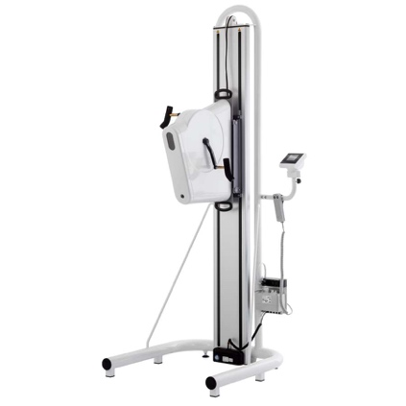
The picture to the left shows the arm-crank exercise setup used in this research study. The same equipment will be used to assess cardiorespiratory fitness (i.e., the maximal effort test described on page 9). The arm-crank can be moved up and down until you are comfortable.
The same setup will be used in both CV-TSCS and SHAM-TSCS with the addition of stimulation.

WHAT ARE THE POSSIBLE RISKS OF PARTICIPATING?
All assessments will take place in a controlled research or home-based environment. Every effort will be made to ensure your safety, privacy, and comfort. All procedures will be conducted by experienced and trained members of the research team. These procedures offer minimal risks to you, however, the following risks/discomforts that could be associated with these procedures are outlined below:

- There are risks associated with using spinal cord stimulation, yet adverse events are unexpected as this study will only be using parameters and electrodes similar to individuals using a transcutaneous electrical nerve stimulation (TENS) machine. There may be a slight risk of skin irritation but we will monitor your skin temperature with a temperature probe near the electrodes. We will also ask you to confirm any allergies before using any electrodes, gels and/or plasters.
- The adhesive electrodes (stickers) used for the activity monitor, ECG, muscle tissue oxygenation and electrical muscle activity may cause mild discomfort when removed. We will take care to ensure your comfort with placement and removal of these. If you experience any skin irritation, we will advise for alternate sites to place the stickers or provide you with a fabric chest strap to attach the activity monitor to instead, given this is worn for a prolonged period of time.
- The blood samples may cause a bruise and there is a potential risk of infection. These risks will be minimised by following good clinical practice. You may experience some light-headedness or headaches as a result of the overnight fast for the blood samples. This is equivalent to missing breakfast and is the minimal standardisation procedure for collecting fasting blood samples. You will be able to eat immediately once the blood sample procedure has been completed.
- The ultrasound procedures are non-invasive and offer minimal risk. You may experience some discomfort due to the cold gel or because the assessments require you to lie on a procedure bed for an extended period of time. There is a very small risk that you might fall out of bed (e.g., due to strong, involuntary spasms), though steps will be taken to ensure this does not occur (e.g., using guard rails where appropriate).
- You may experience some discomfort with the cuff inflation around your upper-arm when measuring blood pressure. There are no known risks associated with this short-lived restriction of blood flow to your arm. It is possible you may feel brief numbness and/or tingling in your hand, and a “pins and needles” sensation upon cuff deflation. These sensations should only last a few minutes.
- Performing any form of vigorous-intensity exercise carries a minor risk. Risks include sensations of fatigue, physical exhaustion and fainting. The sensation of fatigue is short-lived and will subside in a few minutes upon stopping exercise. The risk of a cardiovascular event (such as a heart attack) is extremely low, approximately a 0.01% chance. You will warm up before each exercise bout and will be closely monitored throughout for known indications for stopping exercise [including sustained maximum heart rate, pain in the chest (angina), confusion etc.]. The primary study contact/researcher (Dan Hodgkiss) is first aid trained (including cardiopulmonary resuscitation training) and will be present during all exercise testing sessions. The School of Sport, Exercise and Rehabilitation Sciences is equipped with an automated defibrillator in close proximity to the space where testing will take place. There is also a risk you may experience mild muscle soreness after the arm cycling exercise. You are free to stop and rest at any point during the exercise sessions and are also free to stop the exercise intervention should you feel discomfort and wish to stop/withdraw from the study.
- If you have a higher-level spinal cord injury (above the sixth thoracic segment) then there is an increased risk of experiencing both high and low blood pressure. High-blood pressure is due to a condition called autonomic dysreflexia, which is triggered by a stimulus below the level of injury (e.g., full bladder). You will be asked to empty your bladder prior to any assessments. You may also feel faint or nauseous after exercise or upon moving from lying flat to a seated position. Blood pressure will be measured before and after exercise and the supervising member of staff will be trained to identify signs and symptoms of blood pressure instability, along with appropriate mitigation strategies if necessary.
- The transcranial brain and cervical magnetic stimulation may cause you mild discomfort but this is unlikely. The assessment will start at a lower intensity and only increase gradually if you feel as though you are happy for us to do so. You can stop the procedure at any point if you feel discomfort.
- You may experience some negative emotions when we ask for personal information or when completing questionnaires that relate to your current mood or ability to perform activities of daily living. You may find certain questions within the survey uncomfortable to answer, but you do not have to answer them if you choose not to (you can say prefer not to say rather than answering the question). Your responses will not be judged and will remain confidential. If you are worried about any aspect of your physical or mental health, then we advise you to discuss this with a member of your clinical care team or relevant healthcare practitioner. In addition, should you feel any distress during the study you can speak with the primary study contact (Dan Hodgkiss) who is trained in mental health first aid and can be a first-point of call should you wish to discuss anything either during a study visit or at home (see contact details at the end of this document for if you require immediate support). Overleaf is contact information for UK organisations that provide emotional support for people experiencing distress.

Spinal Research – spinal cord injury support
- https://spinal-research.org/ or 02038 247400
Spinal Injuries Association – spinal cord injury support
- https://www.spinal.co.uk/ or 0800 980 0501
Back-Up Trust – spinal cord injury support
- https://www.backuptrust.org.uk/ or 020 8875 1805
The Samaritans (UK) – general mental health support
- https://www.samaritans.org/ or
MIND (UK) – mental health support
- https://www.mind.org.uk/ or

WHAT ARE THE POTENTIAL BENEFITS OF PARTICIPATING?
The costs of all your tests, examinations and interventions as part of this study will be provided at no cost to you. The study will help to improve our knowledge of the effectiveness of using TSCS in the SCI community, both during exercise and at times when autonomic dysfunction may impact other activities of daily living. It is currently unknown whether being randomly assigned to the exercise intervention with CV-TSCS will provide a personal therapeutic benefit for you. However, others may benefit from the overall conclusions to be drawn from the results of this study. At your request, you will be able to obtain personalised feedback on how your health has changed over the course of the study and how your body has responded to exercise. This information can only be made available to you once you have completed the study (e.g., after the six-week follow-up period). Please be aware that these results should not be viewed as diagnostic measures.

HOW WILL I BE CARED FOR DURING EACH VISIT?
All assessment and exercise session visits will be performed in the School of Sport, Exercise and Rehabilitation Sciences at the University of Birmingham. The building is easily located via map (provided upon enrolment) and has accessible parking spaces near the entrance. All assessments will be performed in spacious ground floor rooms and there are accessible toilets located on each corridor. There will be a member of the research team with you at all times; students and staff are friendly and approachable, so you are encouraged to ask questions if you are unsure of, or require, anything at all. On long visit days you are allowed to bring in food/snacks/drinks. There are kitchen facilities (microwave, kettle, toaster, hot drinks) on the ground floor and are available for you to use. We also have vending machines if you forget to bring snacks, as well as multiple food outlets on campus. You are allowed to have breaks at any time, there is a lounge or waiting room that you can rest in until you are ready to continue.

WILL THERE BE ANY PAYMENT OR REIMBURSEMENTS OFFERED FOR TAKING PART?
Compensation totalling a maximum of £640 will be provided upon completion of the project. This is broken down into: 11 visits x £40 plus £200 for the exercise intervention (£100 for each 4-week period completed). This compensation should cover any personal expenses (i.e., parking, transportation and replication of food/drinks costs) as a result of travelling to participate on this study. Receipts are not required and all reimbursements will be given at the end of the study.
CAN I OBTAIN FEEDBACK FROM THE STUDY?
Yes, if you wish to know the results of this study, a summary of the results can be provided once the study has concluded. On the Consent Form there is a space to indicate if you would like to receive a study summary.
WHAT WILL HAPPEN TO THE RESULTS OF THE RESEARCH STUDY?
The results of this project may be published anonymously in a scientific journal and presented at international conferences; however, names of participants will never be published. Anonymised data from the study and/or stored blood samples may be shared with third party collaborators to inform future research. There is a section on the consent form for you to agree to this.
WILL MY TAKING PART IN THIS STUDY BE KEPT CONFIDENTIAL?
Your participation in this study will be kept confidential. Data generated throughout the duration of a study will be managed in accordance with the University’s Code of Research Practice and the terms and conditions of the Data Protection Act 2018. In accordance with the University of Birmingham’s data storage policy, all data will be stored securely for 10 years after the study has finished. After this time, it will be permanently destroyed.
How will we use information about you? We will need to use information from you for this research project. This information will include your initials, name, date of birth, medical history and contact details. People will use this information to do the research or to check your records to make sure that the research is being done properly. People who do not need to know who you are will not be able to see your name or contact details. Your data will have a code number instead. We will keep all information about you safe and secure. Once we have finished the study, we will keep some of the data so we can check the results. We will write our reports in a way that no-one can work out that you took part in the study.
What are your choices about how your information is used? You can stop being part of the study at any time, without giving a reason, but we will keep information about you that we already have. We need to manage your records in specific ways for the research to be reliable. This means that we won’t be able to let you see or change the data we hold about you. If you agree to take part in this study, you will have the option to take part in future research using your data saved from this study. To do this, data may be shared anonymously with other researchers (in the UK or abroad) upon reasonable request to the chief investigator or housed on a public repository. This is good practice within the scientific community and is encouraged by journals and funders to promote transparent reporting of research findings.
Where can you find out more about how your information is used? You can find out more about how we use your information by:
- visiting https://www.hra.nhs.uk/information-about-patients/
- asking a member of the research team
- sending an email to the study contact Mr. Dan Hodgkiss (stimex-sci@contacts.bham.ac.uk OR DDH749@student.bham.ac.uk) or the Chief Investigator Dr. Tom Nightingale (T.E.Nightingale@bham.ac.uk)
- ringing us on +44 (0)121 414 8011
- contacting the University’s Data Protection Officer via email or phone (dataprotection@contacts.bham.ac.uk or +44 (0)121 414 3916).

WHAT WILL HAPPEN TO STORED BLOOD SAMPLES FROM THE STUDY?
With your consent, any spare stored and anonymised biological samples collected from you during this research study may be used in the future by researchers or collaborators at institutions in the UK or abroad. The aim of this will be to further explore how spinal cord injury and exercise impacts cardiovascular health in future ethically approved research studies. It must be stressed that should samples be shared with collaborators, these will be anonymised with no identifiable information relating back to you. If you do not consent for future research to use your stored, anonymised data/blood samples, these will be destroyed upon completion of the study.

WHAT WILL HAPPEN IF I WISH TO WITHDRAW FROM THE STUDY?
You can stop being part of the study at any time, without giving a reason, but we will keep information about you that we already have. You may withdraw from this study at any time without necessary explanation. However, if you choose to enter the study and withdraw at a later time, all data collected about you during your enrolment in the study will be retained for analysis. Your withdrawal from this study will not result in penalty or loss of benefits to you, to which you are otherwise entitled. You will be reimbursed for each visit completed up to the point of withdrawal.

WHAT WILL HAPPEN IF I LOSE CAPACITY TO PROVIDE CONSENT?
If you should happen to lose capacity to consent during the study, then your participation would stop. No new samples or personal data would be collected. Any data collected up to that point will have been anonymised and as such will be retained and used for the purposes for which consent has already been given.

WHAT IF NEW INFORMATION BECOMES AVAILABLE THAT MAY AFFECT MY DECISION TO PARTICIPATE?
You will be informed in writing of any new information related to this study pertaining to your safety or anything that might influence your willingness to participate or continue.

WHO DO I CONTACT IF I HAVE QUESTIONS ABOUT THE STUDY DURING MY PARTICIPATION?
If you have any questions or desire further information about this study before or during participation, or if you experience any adverse events, you can contact Mr. Dan Hodgkiss (PhD researcher leading the study) or the Chief Investigator (CI), Dr. Tom Nightingale (contact details for both are located on the first page). If you become pregnant during the study, this needs to be reported to the CI and the research team. If this is the case, you will be withdrawn from the study and are advised to consult with your GP.

If you would like to speak the study psychologist, please contact Prof. Jet Veldhuijzen van Zanten – email: veldhujj@bham.ac.uk, Tel: +44 (0)121 414 3379.

WHO DO I CONTACT IF I HAVE ANY QUESTIONS OR CONCERNS ABOUT MY RIGHTS AS A RESEARCH PARTICIPANT?
If you are at any time unhappy or have cause to complain about any aspect of your treatment during this study, and are uncomfortable approaching the research team, please contact Prof. Gareth Wallis, SportExR Head of Research – email: G.A.Wallis@bham.ac.uk, Tel: +44 (0)121 414 4129.

You can also contact the sponsor’s representative within the University of Birmingham’s Research Governance Team via researchgovernance@contacts.bham.ac.uk

WHO IS ORGANISING, FUNDING AND INSURING THIS STUDY?
This study is being led by a research team at the University of Birmingham as part of a PhD educational qualification. The study is being sponsored by the University of Birmingham. The University has Clinical Trials indemnity coverage for this trial, which provides cover for harm which comes about through the University’s, or its staff’s, negligence in relation to the design or management of the trial and may alternatively, and at the discretion of the University provide cover for non-negligent harm to participants.

The study is funded by The International Spinal Research Trust (ISRT) and it has been reviewed and approved by a Research Ethics Committee (Wales REC 7: 23/WA/0284).

AFTER STUDY COMPLETION
You will no longer be able to use TSCS during exercise sessions as your participation in the study will be complete. However, based on the information collected during this study, you may be eligible to participate in future research studies that may be investigating TSCS. There is an option to consent to be contacted about future research studies on the consent form. Irrespective of the intervention group you are assigned to, if you wish to start incorporating arm-crank exercise into your lifestyle following the completion of all assessments (after approximately 4.5 months), researchers can provide you with online resources from reputable sources or direct you to accessible exercise practitioners in your local area. However, upon completion of the study, you will not be monitored by the research team and you will be advised to consult with your GP or SCI care physician before starting any unsupervised exercise programme.

