The University of Birmingham
Edgbaston
Birmingham B15 2TT
United Kingdom

Chief Investigator: Dr Shin-Yi (Chloe) Chiou
Associate Professor in Motor control and Rehabilitation
School of Sport, Exercise & Rehabilitation Sciences
Telephone: 0121 414 5315
Email: s.chiou@bham.ac.uk

Community-based exercise training for continuing recovery after spinal cord injury
Research Participant Information Sheet
Version 2 02/06/2023

Invitation
You are being invited to take part in a research study. Before you decide it is important for you to understand why the research is being done and what it will involve. Please take time to read the following information carefully and discuss it with others if you wish. Please ask us if there is anything that is not clear or if you would like more information. Take time to decide whether or not you wish to take part. Thank you for reading this.

What is the purpose of the study?

An injury to the spinal cord can disrupt the communication between the brain and the body, causing a loss of function below the injury, such as sensation and limb movement. In the early stages following the injury, the body is doing all it possibly can to repair these communication channels. Early intensive rehabilitation often stops soon after a patient with spinal cord injury leaves a specialized rehabilitation hospital, while it is evident that recovery can continue to 2 years post-injury and more. In this study we want to know

Can a self-directed, home-based upper-body exercise training programme as a means of continuing rehabilitation for recovery after SCI?

Why have I been chosen?

You are someone who recently had a spinal cord injury and are undertaking rehabilitation for recovery from the injury.

Do I have to take part?
No. It is entirely up to you. If you would like to take part, you will be asked to sign a consent form. Even after you have signed this consent form and agreed to take part in the study, you are free to withdraw from the study at any time without your treatment being affected.
Once you have decided to take part in this research, a member of our research team will discuss the study with you and answer any questions you may have.

What will happen to me if I take part?
If you are happy to take part, you will be asked to sign a consent form, followed by initial assessment before you start the intervention. You will find a study diagram in the next page.

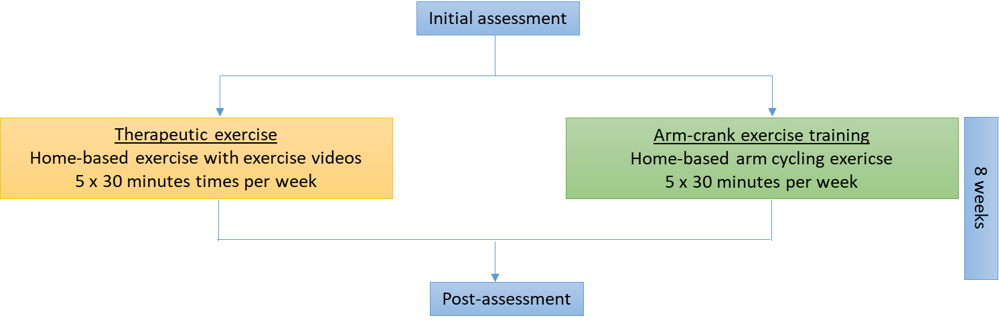
Study diagram.

Assessment (60 minutes)
We will assess your function before and after 8 weeks of the exercise intervention. The assessment can be carried out in your home, in a quiet outdoor space, or at University of Birmingham on your choice. If you travel from your home to another place for the assessment, your travel expenses will be reimbursed.

During each assessment, we will measure your physical function, including muscle strength and spasm, balance, and fitness. We will stick some self-adhesive sensors on your skin over the muscles of the arms and legs and of your back to collect signals from the muscles. The sensors are light-weighted and wireless. You would not feel them much when they are on your skin. Finally, we will go through some questionnaires with you, which ask you about your health, anxiety levels, and pain. Some of the questions may be sensitive (i.e., whether you are currently having suicidal thoughts).

If we have concerns on your wellbeing based on your answers, we may suggest available helplines to you, such as Samaritans 116 123, CALM 0800 58 58 58 and/or notify your GP. This is to ensure you are supported and protected.

Randomisation
You will be randomly allocated into one of the two interventions: 1) arm-crank exercise training, or 2) therapeutic exercise. To minimise the bias of subjective preference, you won’t be able to choose which intervention you will be receiving.
Arm-crank exercise training
You will undertake the exercise in a seated position, 5 days a week, 8 weeks in total. It is your choice to do 5 consecutive days of exercise or spread them across 7 days. Exercise duration will be 30 minutes per session and the intensity should be kept at the moderate intensity. You will be given a stationary arm bike, an activity tracker (e.g., Fitbit), and shown how to set up the bike and the watch and to do the exercise. If you have or have access to a smartphone, you will also be shown how to place the phone on your chest to monitor your posture during the exercise; this is to ensure you are doing the exercise correctly.

Therapeutic exercise programme
You will be doing exercise in a seated position with an online exercise video for core training, 5 days a week, 8 weeks in total. There will 8 exercise videos in total and each video lasts ~30 minutes.

Focus group (30-60 minutes)
At the end of the study, you may be contacted by a member of the research team who will invite you to attend a focus group where you will be sharing your experience of taking part in this study and discussing your views on the intervention you undertook. This will help us to understand what is needed in continuing rehabilitation for other like you to recover from their injury. It will be an informal discussion which will be audio recorded and transcribed by members of the research team; your initials will be included in the transcription but your identity will not be revealed. The conversation will focus on your own experience of undertaking the intervention, feasibility of the intervention and support. You can choose to attend a focus group remotely or in-person. If you choose to do it remotely, you can join the interview using a device with zoom software installed (free) or simply call in using your telephone. If you would like to speak to us and other participants in-person, we will arrange to meet in an agreed place. Only the invited participants will be allowed to join. When publishing data collected from the focus group interview, we may include direct quotations from you and your study ID number in the publication.

As you currently live at home and are under the primary care of the NHS, we will notify your GP regarding your study participation so that they are informed.

What are the risks involved in taking part?
The assessment techniques are safe and non-invasive. There are minimal risks from having these test performed. All tests will be performed within your limits of tolerance, and you will be given as must rest as you need between tests. You may experience mild muscle soreness following the exercise training. The discomfort can be managed by taking pain killers or hot/cold packs. Self-adhesive electrodes may cause mild discomfort when removed; this will be done with care.

Current government guidelines and local safety procedures in relation to the ongoing pandemic will be adhered to in order to minimize any risk of exposure to COVID-19.

What are the possible benefits of taking part?

It is not yet known if the exercise plan will help you recover better from your injury. While there may be no direct benefit from taking part this study, data collected from this study will help to inform future treatments for spinal cord injuries. At the end of the study, you can choose to continue with the exercise training or move on to do something else.

How will we use information about you?
In order to carry out the research project described above, we will need to collect information about you, and some of this information will be your personal data including;
- your name and initials
- date of birth
- contact detail.
The research team will use this information to do the research or to check your records to make sure that the research is being done properly. People who do not need to know who you are will not be able to see your name or contact details. Your data will have a code number instead.
We will keep all information about you safe and secure. Once we have finished the study, we will keep some of the data so we can check the results. We will write our reports in a way that no-one can work out that you took part in the study.

What are your choices about how your information is used?
You can stop being part of the study at any time, without giving a reason, but we will keep information about you, i.e., both identifiable and non-identifiable data already collected with consent, that we already have. No further data will be collected from you. If you decide to stop taking part in the study your treatment will not be affected.
If you lose capacity to consent during the study, you will be withdrawn from the study. Data collected up to that point with consent will be retained and used in the study.
We need to manage your records in specific ways for the research to be reliable. This means that we won’t be able to let you see or change the data we hold about you.
Where can you find out more about how your information is used?
You can find out more about how we use your information
- at www.hra.nhs.uk/information-about-patients/
- our leaflet available from www.hra.nhs.uk/patientdataandresearch
- by asking one of the research team
- by contacting our Data Protection Officer:
The Data Protection Officer, Legal Services, The University of Birmingham, Edgbaston, Birmingham B15 2TT
Email: dataprotection@contacts.bham.ac.uk Telephone: +44 (0)121 414 3916

What if something goes wrong?
In the extremely unlikely event that anything goes wrong while you are taking part, local hospital facilities are available (A&E department), as well as an emergency assistance telephone 44444. You should call 999 if there is a medical emergency when undertaking the study at home.

University of Birmingham holds insurance policies which apply to this study. If you experience serious and enduring harm or injury as a result of taking part in this study, you may be eligible to claim compensation without having to prove that University of Birmingham is at fault. This does not affect your legal rights to seek compensation.

If you are harmed due to someone’s negligence, then you may have grounds for a legal action. Regardless of this, if you wish to complain, or have any concerns about any aspect of the way you have been treated during the course of this study then you should immediately inform the Investigator (Dr Chloe Chiou, 0121 414 5315 or email: s.chiou@bham.ac.uk) in the first instance. Alternatively, you can contact the Patient Liaison Services (PALS) at <Insert local PALS contact details here – delete this text on completion> if you wish to complain to an independent point of contact.

The normal National Health Service complaints mechanisms are also available to you.

What will happen to the results of the research study?
The results of the study will be analysed by the research team and presented at neuroscience, neurological and other health care conferences and published in scientific journals. No individual subject will be identified in any report or presentation arising from the research.

Who is organising, insuring and funding the research?
The study will be run by a research team based at University of Birmingham and funded by the University of Birmingham. The University has in place indemnity coverage for this study, which provides cover for harm which comes about through the University’s, or its staff’s, negligence in relation to the design or management of the study and may alternatively, and at the discretion of the University provide cover for non-negligent harm to participants.
The NHS Trust has a duty of care to its patients, in the event of clinical negligence being proven, compensation will be available via the NHS indemnity.

Will I be paid for taking part in the study?

You will not be paid for your participation in the study, but we will pay for your travel expenses for undertaking the follow-up assessments. Please keep the receipts for your journey as these will be required for your reimbursement. You can claim up to £100 per return journey.

Who has reviewed the study?
This study has been approved by the West Midlands - Black Country Research Ethics Committee.

Contact for further information about this study.
If you would like to consider this study further before you make your decision, please take your time to do so. You may ask for further information by telephoning 0121 414 5315. The person to speak to is the chief investigator, Dr Chloe Chiou. Alternatively, you may also send an email to s.chiou@bham.ac.uk to request further information.

