IRAS: 326143; REC REF: 23/WM/0121
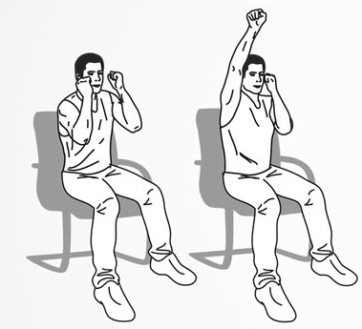
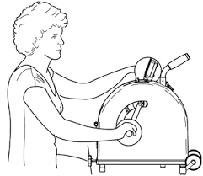

Scan the QR code to see our project webpage

Arm Cycling vs. Upper-body Exercise for Physical Function
We are looking for volunteers with a spinal cord injury living in the community to undertake an 8-week, home-based exercise programme. The programme requires 30 minutes of self-directed exercise for 3-5 times/week.
We will visit your home or a place that is convenient for you to help you get set up and to evaluate your muscle activity, balance, fitness and health before and after the exercise programme.
Do you have a direct injury to the spinal cord and want to improve physical function via exercise?
Contact us for information!

If you would like further information about the study, please contact Mr Humain Choudhury (University of Birmingham) at h.choudhury@bham.ac.uk or telephone/WhatsApp on 07587055782.
Thank you!

