Technician Commitment: Stage 3 Self-Assessment & Action Plan Guidance
Please note: This guidance and template is for institutions who have already submitted their Stage One and Two Self-Assessments & Action Plans, 1 and 3 years after becoming an official signatory of the Technician Commitment. This guidance and template refers to the third stage of self-assessment and action planning to be submitted 6 years after the submission of the original submission.
The Technician Commitment aims to ensure visibility, recognition, career development and sustainability for technicians working in higher education and research, across all disciplines.
The third stage of self-assessment and action planning process asks for reflection on past action plans, evidence of progress and engagement and a further 36 month action plan. The self-assessment includes a ‘RAG’ analysis of previous action plans - a ‘Red, Amber & Green’ status report.
The Technician Commitment Steering Board does not seek to dictate how organisations promote a positive culture for the technician community. This is a matter for autonomous institutions and the technician, research and academic community to agree. It is expected that as a minimum, signatories publicly state their Technician Commitment signatory status and institutional action plans on a dedicated and discoverable webpage, along with their named point of contact. The Steering Board asks signatories to evidence that the ‘technician voice’ is present in the development and formation of institutional action plans. The Technician Commitment is a collaborative endeavour and the Steering Board will support and facilitate the establishment and sharing of best practice demonstrated in the self-assessments and action plans. A vibrant community of Institutional Leads tasked with implementing the Technician Commitment has developed since the Commitment’s inception and the Steering Board aims to ensure a range of forums are available to enable peers to share expertise, good practice and experiences.
Cross referencing to other sector institutional reviews relevant to technicians is welcomed; for example, the Steering Board are keen to learn how signatories are advancing equality, diversity and inclusion for the technical community and institutions may wish to reference Athena SWAN and Race Equality Charter submissions. The Steering Board are also keen to learn of Teaching Excellence Framework (TEF) submissions and Research Excellence Framework (REF) environment statements where technicians have been explicitly mentioned. The Steering Board are particularly keen to see activity and plans to enact the recommendations of the TALENT Commission embedded in Stage 3 self-assessments and action plans.
The Technician Commitment Steering Board, through the executive team, will choose a limited number of submissions for active review between the institution and the Technician Commitment.
Please note that finalised Action Plans should be signed off at an institutional leadership level (e.g. Vice-Chancellor/President/Director level).
For any additional queries, please contact techscommit@gatsby.org.uk

Evaluating Impact through Self-Assessment & Future Action Planning

Organisation: University of Birmingham
Name of Institutional Lead: Professor Rachel O’Reilly, Pro Vice Chancellor for Research and Dr Kate Bishop, Director of Operations College of Medicine and Health
E-mail: k.bishop@bham.ac.uk
Contact Number: 0121 4143780

Please provide an overview of technical staff structures in your organisation, along with details of any changes to these over the past 6 years in response to the Technician Commitment.
The University of Birmingham (UoB) has two branches of staff: academic and professional services. Technicians fall under the latter category ultimately reporting to and led by the Registrar.
There are over 400 technicians and technical specialists across the five academic Colleges, Estates and IT services. The majority are based in the 3 STEMM Colleges; Engineering & Physical Sciences (EPS), Life and Environmental Sciences (LES) and Medicine and Health (CMH). The detailed management structures in each area and function vary depending on discipline, size, balance of research, teaching and service delivery.
There are two grade structures for professional services staff within UoB, which are subject to different terms and conditions. Throughout the period of self-assessment these were support staff (band 200- band 500) and Academic and Other Related (AOR, Grade 6-Grade 10). In November 2023, after consultation with staff and the appropriate Unions, changes were introduced to the support staff pay scales and terms and conditions, with all support staff on all grades receiving an uplift in their pay. In September 2023 the majority of support staff (86%) moved on to the new terms and conditions with a small percentage electing to remain on the previous arrangements. The new terminology refers to professional services staff and uses grade 2- grade 5. In July 2024 agreement was achieved with the support staff trade unions, following which all remaining staff moved to the new pay scales and terms and conditions.
Figure 1 below shows the pathway for progression for STEMM technicians through the organisation and maps the potential movement between academic and AOR pathways. (View alt text for description of image.)

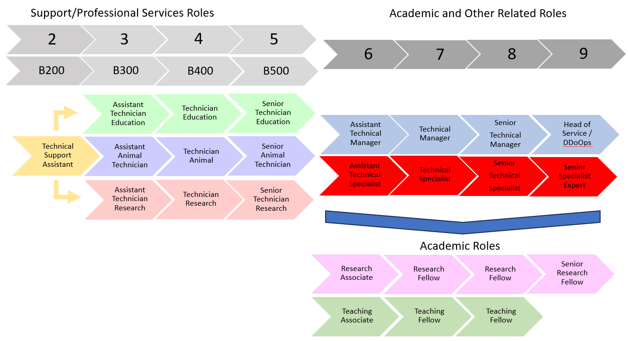Figure 1 – Pathway for technical roles, with generic titles and associated generic job descriptions.

Please provide an overview of the governance, leadership and reporting lines of the Technician Commitment at your institution, along with details on how it is resourced, and information on how your organisation has engaged with the wider community within and beyond your institution. How has this developed since you became a signatory?
In 2017, the University of Birmingham established its Technical Academy to support the delivery of the Technicians Commitment. In 2021, the management and oversight was refreshed when staff across the University changed leading to the Technical Academy relaunch in March 2023. Figure 2 shows the governance structure with an Operations Group reporting to a Steering Group which is co-chaired by a member of the University Executive Board (Pro Vice Chancellor for Research) and a member of the Registrar’s Leadership Group (Director of Operations, College of Medicine and Health). Within the University since 2021 the relationship with the University’s wider Birmingham Professional initiative has grown and the Technical Academy has a dedicated page on the Birmingham Professional intranet site signposting to the more in-depth content on the Technical Academy’s own pages. Mala Patel (Operations Manager for the Collaborative Teaching Laboratories), a member of the Technical Academy Operations Group sits on one of the Birmingham Professional subgroups focussing on career development ensuring that connection remains live.
Two members of the Technical Academy Steering Group also sit on the University Apprenticeship Steering Group allowing cross pollination and a focus on technical apprentices
The budget for the Operations Group to deliver on actions is provided by contributions from the three STEMM Colleges who have the largest numbers of technical staff between them and covers the cost of events, coach travel to HETS and marketing materials etc. Colleges and Departments have local budgets which can be accessed by technicians for professional development activity and related social and community building events.
Since 2021, engagement by University of Birmingham technicians with Midlands (MI) Innovation Talent has increased threefold, and MI Talent roadshows have been hosted at UoB in 2022 and 2023 which had over 50 attendees at each event. The second event, led by Emma Monaghan a Technical Manager in the College of Life and Environmental Sciences was a development on the first where technicians from the University who had benefitted from the support provided by MI Talent or had followed different career pathways presented their own journey and experiences.
In 2023, the University supported the delivery of face-to-face cell culture programme in partnership with MI Talent with three events in the summer led by the College of Medicine and Health teaching lab team that had 19 attendees across the 3 sessions. In 2023, Tendai Makuwatsine a Technical Manager in the College of Engineering and Physical Sciences was appointed as a committee member to the newly established UK Institute for Technical Skills and Strategy Council and will be joining the MI Technical Managers Strategy Committee as the second representation from the University alongside the chair of the Operations group.
We continue to engage with opportunities with National Technician Development Centre (NTDC) and will be launching their survey of technical skills in the late 2024.

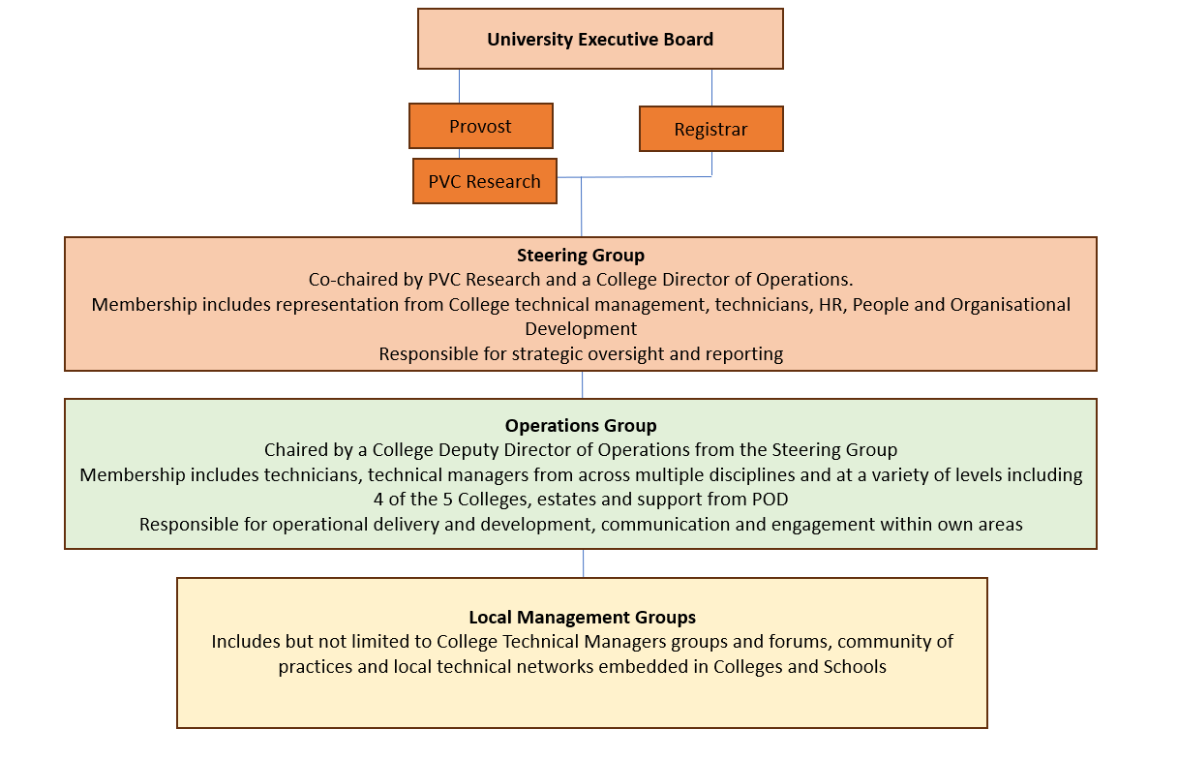Figure 2: Governance Structure for Technical Academy at the University of Birmingham. (View alt text for description of image)

Please provide a RAG analysis on your institutional 36-month action plan indicating which activities you have undertaken and completed (green), which are in progress (amber) and which are still to be carried out (red). Please provide an explanation for those categorised as red.
This may be detailed here or attached to this document as an appendix.
The last UoB Technician Commitment SED and action plan was submitted in September 2021 and feedback received in September 2022. The action plan within the SED commenced in October 2021. Progress has been steady with some aspects achieved within expected timelines, but others are slower than was originally intended. Please see attached appendix 1 for full detail against the 2021 action plan.
The first 6 months of the current action plan focussed on the development of the Technical Academy Operations Group to a confident and engaged position with members of the group implementing and delivering on key actions within the subsequent 30 months, including updated communication channels and the development of a schedule of events. The focus has been on building that momentum within the University and actions that projected activity beyond the University has been of a lower priority beyond promoting opportunities for Technicians that are available to them.
Whilst not detailed within the 2021 action it was agreed that a dedicated Technical Academy Working Group should be established to look at arrangements relating to research funded fixed term contract technical staff, the impacts of these arrangements and alternative options. Recommendations from the Working Group were to transition a core of fixed term contract technical staff to permanent contracts and associated processes to manage the financial and HR related aspects have been established. The Working Group has engaged with technical staff, academic staff, HR, Operations and Finances colleagues to establish core principles and draft operational processes, which will enable and support the wider changes considered by the University Executive Board in relation to externally funded fixed term contracts for all staff. The group has also considered the development of technician specific skills matrix and skills assessment tools, to support the recruitment and development of the technical workforce.
Several of the 2021-2024 actions will evolve or be further developed in the 2024-2027 action plan.

Please provide evidence that your previous action plans are having impact. (For example, you may wish to provide links to initiatives, websites, testimonials, articles/blogs).
Examples of career journeys from a selection of staff supported in career development and change via apprenticeships, education and secondment can be found in appendix two.
There has been an uptick in external training uptake since the changes in the Technical Academy were implemented in 2021 with increased engagement with MI talent with attendance on MI talent training session more than tripling during the 12 month period from March 2022 compared with the 12 months from March 2020. Technical staff at UoB have delivered technical training sessions in flow cytometry and tissue culture, provided placement opportunities for technicians in other MI partners and with funding support from MI Talent worked with peers at Warwick and Nottingham Universities to deliver a technician led event with the Royal Microscopical Society. Further details can be found in appendix 3.

Please provide details of how your institution is enacting the recommendations of the TALENT Commission (https://www.mitalent.ac.uk/theTALENTcommission).
The Technical Academy and its associated oversight structures are also used as the vehicle for delivering on the Talent commission recommendations. This retains consistency and actions are integrated into the same 36-month action plan.
The Operations group are accountable for developing events including local training, networking and communication. The steering group have oversight and are looking at the more systemic and cultural aspects, such as committee membership. This latter remains challenging at the most senior level of the University, which have little to no professional service representation. However, there is a slow increase in membership of specialist groups such as the Human Tissue oversight Committee, Finance User Reference Group as these are actively promoted in the technical community, bringing the technical voice into those areas.
Tendai Makuwatsine, a technical manager in the School of Physics and Astronomy sits on the ITSS strategy committee as well as the Technical Academy operations group.

Technical Apprenticeships at the University of Birmingham.
The University has increased its number of technical new entrant apprentices over recent years. In January 2024 there were 33 new entrant apprentices on programme. Apprentices are studying a range of standards including Engineering Technician (level 3), Laboratory Technician (level 3) and Technician Scientist (level 5).
New entrant apprentices are supported by a dedicated apprenticeship team and receive:
• Dedicated group induction
• Three development days focusing on: soft skills, career development support, networking.
• 8 weekly one to one with member of the apprenticeship team
• Support from the apprenticeship team with next steps
• Optional outward-bound trip to the Raymond Priestly Centre, the Lake District.

Recently, we have established a group of technical managers who will develop internal events targeted at technical apprentices. Apprentices have also benefited from attending the MI TALENT apprentice knowledge cafes.
We have had good success with our technical apprentices with successful completion rates below:
Year | Completion rates
2022 | 5/6 completed, 5 in permanent roles
2021 | 6/6 completed, all in permanent roles
2020 | 3/3 completed, all in permanent roles

Apprentices have had good success progressing into permanent employment with the University or further study. Since 2020, 16 apprentices secured permanent employment.

Please provide a 36-month action plan; detailing plans to ensure your organisation continues to address the themes of the Technician Commitment and details of how impact will be evidenced and initiatives resourced: (this may be detailed here or attached to this document as an appendix). Please evidence how the ‘technician voice’ was present in the development and formation of the 36-month action plan.
In October 2023, the Operations group ran an Away Day to collaborate on developing this SED including reviewing the 2021-24 action plan; RAG rating and assessing against the Talent Commission report and to use that to develop an outline 36 month plan for 2024-27. The members were then tasked with taking those suggestion back to technicians in their local areas for comment and consultation on key questions which were used to refine the plan. The “mini-goals” under each action are the ideas and suggestions for specific and manageable tasks created from these exercises.

The University also carried out it’s biannual staff survey in the summer of 2023 which poses questions for all staff around PDR, career development, wellbeing and line manager engagement and analysis of the response has been undertaken to help inform the action plan.
From the consultation undertaken and the survey responses it is clear there remains a demand for training and development that is not entirely being met, albeit the personal development review process scores very positively (>80% positive) as a forum for discussion its translation to being supported as professional development, to being listened to and understanding how career aspirations can be supported are markedly lower at approx. 50% for each of these areas. A large part of the next action plan will therefore focus on improving the skills managers and technicians have in translating that PDR conversation into action.
The NTDC survey is expected to help us crystalise conversations on the nature and specificity of training requirements and we will build on that.
Another focus will be looking at how the University moves on from the successful local recognition schemes and University wide Birmingham Professional awards for technicians into external recognition of our technicians. Promoting nominations for the Papin Prize and looking to build on the pockets of good practice in recognising technicians in papers, articles and impact cases.
The final strand will be moving forward the work on strategic planning, concluding the work on establishing a more secure foundation of employment within the University being led by a working party of the Steering group which has been looking at the work needed to do to reduce the number of recurrent fixed term contracts and the process changes that would be required to deliver a systemic change.
Please see appendix 4 for the full action plan

Please confirm that your Technician Commitment status and 3-year action plan is published on your organisation’s website and provide the relevant URL here:
We have a dedicated external facing webpage where the previous SED including the action plan is posted.
https://www.birmingham.ac.uk/staff/excellence/professional/technical-academy/index.aspx
The internal Sharepoint site, which is University members only, has a dedicated page on the action plan linking to the full SED and full plan. A snapshot of that site can be found below:
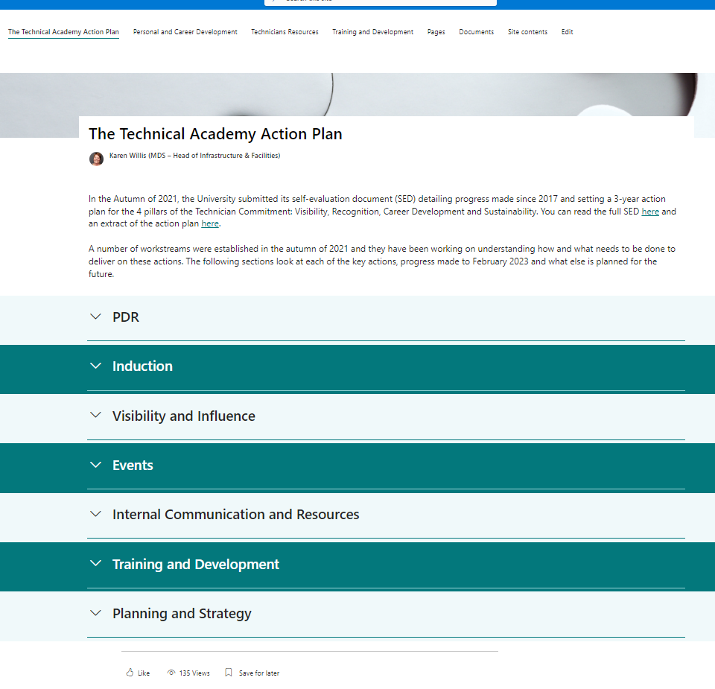

Signed………………Rachel O’Reilly…………………………
(Technician Commitment Nominated Institutional Lead)
Date: 20th August 2024
Signed……Kate Bishop
(Technician Commitment Signatory – Leader of Institution)
Date: 23rd August 2024
Appendix 1 RAG Rated 2021-2024 Action Plan with commentary.
Technician’s Commitment Priority Area(s) | Aim | Actions | Planned outcomes/outputs | Markers of success | Timescale | Owner | Notes and comments | Overall RAG Rating (s)
Technician’s Commitment Priority Area(s)  Career development  Visibility  Recognition | Aim  Enhance the career development, recognition and visibility of technical staff | Actions  Update PDR guidance and templates for technical staff and managers so that it references the Technical Academy and the opportunities for Technicians | Planned outcomes / outputs  - Increased awareness of the Technical Academy and opportunities for technical staff and line managers  - Increased engagement with the Technical Academy by technical staff  - Open and enabling conversations around paper authorship between PIs, line managers and technicians  - Increased engagement of technical staff with teaching, training and development, secondments and shadowing opportunities  - Increased numbers of technical staff undertaking professional registration | Markers of success  Increase in numbers of staff participating in Technical Academy events and training and development.  Increased numbers of technicians being named on papers.  Increased numbers of technical staff securing professional registration | Timescale  For implementation in 2022 PDR cycle | Owner  TA Steering Group | Notes and comments  The initial aims have been achieved with the University HR Intranet site on PDR updated with a section specific to Technicians including the addition of a prompt for conversations to be used by reviewees and reviewers.  The PDR process are currently under review and further content will be developed when agreed.  There are limited metrics available to measure change in acknowledgements and authorship of papers. Anecdotally there are pockets of good practice, but the general feedback has been that it is still not normal practice in many areas.  The University has a clear policy that membership of professional bodies is a personal cost across all staff types unless there is an equivalent benefit such as discount on conference attendance. A previous 2 year pilot in 2017/18 where funding was provided did not result in a significant benefit or uptake in registration. In light of the pressures from cost of living increases a decision was made by the working group and ratified by the Steering group that we would de-prioritise this aspect rather than place added pressure on our junior staff. We will continue to support those who wish to follow this path.  Notes and comments | Overall RAG Rating  Green but with elements requiring further development as new actions in the next Cycle
Technician’s Commitment Priority Area(s)  Career development  Visibility  Recognition | Aim  Enhance the career development, recognition and visibility of technical staff | Actions  Develop a revised and consistent functional on-boarding and induction process for technical staff  Actions | Planned outcomes / outputs  - New staff are signposted to and encouraged to engage with the Technical Academy and Technicians Commitment  - Shared awareness and engagement with the priorities and aims of our commitment to technical staff  Technical staff are aware of opportunities, development pathways, resources etc |  | Timescale  January 2022 | Owner  TA Steering Group | Notes and comments  A review of induction processes was conducted by the working group and processes are consistent. Alongside the standard induction checklists there is an optional technician checklist available on the University HR Sharepoint page (Ref#) There are potential improvements that could be built into our Core HR and Finance platforms including links to mandatory training specific to technicians and these will be explored in the next action plan cycle. | Overall RAG Rating  Green but with elements requiring further development as new actions in the next Cycle
Technician’s Commitment Priority Area(s)  Visibility  Sustainability  Recognition | Aim  Raise visibility of technical staff  Enhance understanding of contribution of technical staff to research and education  Enhance influence and professional capital of technical staff | Actions  Increase internal and external communications and showcase activities to grow reputation, value and influence of the Technical Academy and technical workforce | Planned outcomes / outputs  - More technical staff participating and showcasing their talents in University events e.g. Open Days and University Showcase events  - Increased inclusion of technician profiles on internal and external websites e.g. group websites, facilities websites etc  - A dedicated Technical Academy newsletter and dedicated Technical section in key internal comms (e.g. Buzz)  - Increased promotion of technical vacancies to students via Careers Network, local employability teams, the Guild etc | Markers of success  Increased visibility of the technical workforce across the Universities communication channels, including website, publications and events | Timescale  Ongoing throughout the 36 month period | Owner  TA Steering Group | Notes and comments  Technicians and the Technical Academy are recognised in key parts of the University’s intranet including HR and research strategy pages as well as a dedicated section in our Birmingham Professional intranet site which links to the full Technical Academy site,  There remains work to be done in encouraging our technicians to engage in opportunities to showcase themselves outside of their local areas and comfort zones. | Overall RAG Rating  Amber with elements requiring further development and consolidation in next Action Plan Cycle
Technician’s Commitment Priority Area(s)  Career Development  Sustainability | Aim  Raise understanding and availability of resources to help technical staff  Enhance sense of belonging and community amongst technical staff  Enhance sense of self-worth and connection to the core purpose of the University amongst technical staff | Actions  Deliver an ongoing programme of events through the Technical Academy Operations Group  Increased communications and information/guidance resources for technical staff and their line managers | Planned outcomes / outputs  - Continued access for technical staff to networking, training and social events  - A network of Technical Champions embedded in Colleges  - An online resources hub for technical staff to access guidance, advice, general updates, key information, notices about upcoming training and events, best practice, upcoming internal and external prize opportunities, secondments, professional registration etc  - Increased engagement of technical staff with internal recognition and reward schemes, and external recognition events (e.g. Papin Prize)  - Increased conference and events attendance and uptake of appropriate funding opportunities | Markers of success  Development and delivery of a refreshed schedule of TA events  Provision of dedicated communications and guidance to the technical community | Timescale  Initial planning to be completed within first 6 months, with delivery and ongoing development continuing throughout the 36 month period | Owner  TA Steering Group | Notes and comments  Initial planning of an events programme took longer than expected but in 2023 a number of events have been successfully run including a technician poster showcase, tours for technicians of key facilities within the University and training sessions on the university PPMS. This needs further development within the next action plan to widen the breadth and to introduce some more bespoke events with smaller target audiences.  In March 2023, a soft relaunch took place of our Technical Academy to coincide with the release of a new SharePoint site with dedicated content covering career and personal development, events and training. A new dedicated email distribution list of technicians was also introduced in late 2022 to aid targeted dissemination of key information.  There remains work to be done in ensuring the information technicians want and need is available as that is currently imbalanced towards one of our Colleges with the others working on defining and providing the content needed by their technicians | Overall RAG Rating  Amber with elements requiring further development and consolidation in next Action Plan Cycle
Technician’s Commitment Priority Area(s)  Career Development  Sustainability | Aim  Encourage greater mobility and skills diversity  Encourage ambition and broadening of horizons for technical staff and their line managers  Development of a growth mind-set | Actions  Development of new training and development schemes and programmes for technical staff, with appropriate promotion and dissemination of existing and new training and development opportunities to technical staff and managers | Planned outcomes / outputs  - New training pathways resulting in a recognised qualifications  - Defined career progression framework for technical staff  - Increased apprenticeship opportunities across UoB  - Increased engagement with MI Talent programme  - Establishment of network of mentors for targeted support to staff and applicants during recruitment and application stages  - Increased engagement and uptake of technical staff with current POD coaching and mentoring programme  - Establishment of a work-shadowing scheme | Markers of success  Provision of clear career development pathways for technical workforce  Increased apprentice opportunities  Increased engagement with Midlands TALENT  Increased access to technical mentors and coaching | Timescale  Ongoing throughout the 36 month period | Owner  TA Steering Group | Notes and comments  As with the events programme progress has been slower than hoped. It has been challenging to obtain detailed requirements from our technical community with feedback and comments lacking the specificity needed to develop a bespoke programme so to date activity has been broad and largely focussed on the softer side of development. To support staff on different working patterns across research and teaching several sessions were delivered twice; at different times and days of the week.  A small working group developed documents describing the career progression pathways within the University in 2022 and these were shared with the technical community and can be found on the Technical Academy SharePoint site.  However, the resources to use this effectively in Steering line management conversations and to allow an individual to interpret in relation to their specific circumstances have not yet been developed.  The University has a structured approach to coaching that is available to technicians but mentoring is more informal and relies on the line manager conversations and contacts with those willing to mentor. A member of the Operations group for the Technical Academy has been actively involved in developing a MiTalent scheme but mentoring opportunities are still not easy to find internally.  There has been some improvement in technician engaging in secondments in some areas. But opportunities for shadowing rely heavily on volunteers and no progress has been made. |  | Overall RAG Rating  Amber/Red. Some progress made but significant work still to be done
Technician’s Commitment Priority Area(s)  Sustainability | Aim  Integrated view of skills and development needs of technical staff | Actions  Integrated planning and strategy tools | Planned outcomes / outputs  - Succession planning integrated with School and College strategic plans  - Skills audit and training needs analysis  - Analysis of staff survey results | Markers of success  Identification of business critical posts and development of clear succession plans to ensure business continuity | Timescale  Ongoing throughout the 36 month period | Owner  TA Steering Group | Notes and comments  However there have been unexpected barriers in terms of resource that have slowed this  The University IT and data teams integral to updating and developing have had significant demands around other strategic priorities meaning that this component remains underdeveloped.  Progress has been made in initiating the NTDC skills survey which will run in late 2024.  The Bi-Annual University staff survey has been analysed in relation to Technicians and it is clear there is a need for support and training for managers of technical staff in translating the conversations in PDRs into substantive actions and outputs that create a change |  | Overall RAG Rating  Red/Amber  Some progress but significant steps still to be taken in the next cycle

Appendix 2: Staff Journey case studies
The following 3 case studies provide examples of the different journeys some of our technical staff have taken with the support of their line managers. Each includes a brief description of who they are and what they have achieved followed by their own views in their own words. These are shared as examples with our wider community on our Technical Academy SharePoint site.

- Gurjeevan Ghuman
Gurjeevan started his career at the University as a level 4 apprentice within our collaborative teaching labs. During that time, he has been supported in his development in several ways including undertaking a placement at Keele funded via MI Talent. On completion of his apprenticeship in late 2023 Gurjeevan was successful in obtaining a role as a research technician in the School of Metallurgy and Materials. He describes his development in his own words is below.

How I developed…

At the University of Birmingham, Christopher Bradley developed me vastly by allowing me to attend CPD courses. During my time at the CTL I worked as an apprentice LEVEL 3 Education Technician. The MI Talent funding scheme was introduced to me by a Technician Trevor Hardy. I believe Trevor encouraged me to apply for the funds at Keele University. During my time at Keele University, I worked in the Anatomy Laboratory. I was in duty to take care of the donated organs and bodies. Keele University allowed me to effectively communicate with members of the Keele community, such as Paul Clews. Paul was the technical manager of the department, and he was impressed by my confidence whilst working methodically with delicate bodies. The CTL helped me develop as a character. I met a wide range of different staff who also had different personalities. I believe this was an important step in my career as it is important to understand the differences in workplace organisations.
The CTL staff developed me hugely. I communicated with a wide range of technical staff including technical staff who were on a higher banding than me. The importance of this really benefitted my apprenticeship KSB’s as not every KSB was accessible with the grading I was on. To allow me to access the full potential, I worked with Senior Technicians who also helped me progress and create documentation which was relevant to the apprenticeship standard. I cannot thank the staff enough; the CTL has really been a huge benefit to me from self-development to technical development.

- Faileigh Harriott
Faileigh started work at the University as one of our first technical apprentices in the teaching laboratories within the Medical School. On completion of her apprenticeship, she was retained on a permanent basis and when an opportunity became available moved to the next grade within the same team. Because it wasn’t possible for her to move to a higher-level apprenticeship, she instead has undertaken a part time Open University programme. To support that she was given both study time and financial support towards the fees. In 2023 she made the move a next level post in on our research service laboratories. Her journey in her own words is below.

My Career Journey – Faileigh Harriott

Faileigh joined University of Birmingham as a Level 5 apprentice in the Teaching laboratories in 2018. As part of her role in the Medical School teaching laboratories, she supported all laboratory practical sessions for Biomedical Science and Pharmacy. Her apprenticeship required her to complete a HND in Biology. In 2021 she joined the Open University part time to complete her Bsc Biology degree, whilst continuing to work in the teaching laboratories as a Band 400 technician and taking on a responsibility to mentor new apprentices joining the team. Faileigh joined the Genomics Birmingham team in 2023 as a Band 500 Senior Research Technician, her aim is to develop her career in the area while completing further studies.

Faileigh Harriott Career Journey: My experience of starting as a Level 5 Scientist apprentice in 2018 was positive, I enjoyed the mix of practical and classroom work whilst building a portfolio of all the skills, knowledge and experience I was gaining. Taking the apprenticeship route has not only given me more work-based experience, but it has also helped build my professionalism and confidence as an individual. By studying part time on a HND, it allowed me to apply for the Open University in 2021 to convert my HND into a Bsc in Biology whilst still working full time in the laboratory. My role in the teaching laboratories was to support the Biomedical and Pharmacy practical sessions from preparation to in session support. I learnt a lot of fundamental skills in this department between 2018-2023 which gave me the opportunity to progress into higher banding (BAND 400), taking on more responsibilities independently.
In 2023, I became a Band 500 Senior Genomics Research Technician for the Genomics Birmingham Team at University of Birmingham. In this role so far I have expanded my knowledge and experience in new areas and new technologies, whilst continuing to study alongside.

- Alison Leese

Alison has been a technician at the University for many years, initially as a research technician and has worked in both the College of Medicine and Health and in the College of Life and Environmental Sciences. Her journey as a technician had brought her to a role in laboratory management which she had been doing for several years and during which she had developed an interest in GCP and GCLP compliance. An opportunity arose to step into a 12-month secondment to cover maternity leave in Clinical Research compliance teams through 2023 which was supported by her line manager. She thrived in that opportunity and has been retained in a permanent role in that team. Her own thoughts on her secondment are below.

My experience of Secondment Opportunities at the University of Birmingham

I am currently on a year’s secondment. To be honest, like most people I hadn’t given secondments much thought but I had gone as far as I could as a laboratory manager. This seemed like a good opportunity to learn some new skills and experience working in a different sphere of the University with the security of knowing I had a position to go back to at the end.
During the last eleven months I have learnt so much about an area I was relatively unfamiliar. For me it has all worked out well. I love the new job and a permanent position in the team came up and I am staying.
Even without a permanent move, by doing the secondment I would have gained more capability and confidence to apply for positions I wouldn’t normally have considered.
A secondment was a perfect stepping stone to progress my career and in every part of my working life as technician, laboratory manager and now, I have learnt new skills.
Don’t be afraid to go for a secondment in a completely different area, it can be daunting at first but secondments are there to learn and have new opportunities.

Alison Leese
Senior Compliance Facilitator
Clinical Research Compliance Team
COLMDS

Appendix 3:
MI Talent engagement, (numbers and feedback on tissue culture training provided by Edward Bowerman of MI Talent)
Attendees at MI Training Sessions

Year | Dates | Attendees
Year 1 | 1 March 2020 to 28 Feb 2021 | 26
Year 2 | 1 March 2021 to 28 Feb 2022 | 62
Year 3 | 1 March 2022 to 28 Feb 2023 | 73
Year 4 | 1 March 2023 to 29 Feb 2024* | 51
* as of December 2023

Programmes attendance

Programme | Dates | Attendees
Technical Careers Mentoring Programme | 2021-22 | 4
Preparation for Technical Management and Leadership #1 | Feb-March 22 | 1
Technical Careers Mentoring Programme | 2022-23 | 1
Preparation for Technical Management and Leadership #2 | Jan-March 23 | 7
Collaborative Leadership for Technicians | May - June 22 | 5
Leadership in Action | Jun - Jul 2023 | 11

Roadshows
16-May-22 Stand and workshops 50
15-Mar-23 Tech academy - stand and intro session 50

Funds
There have been six Birmingham technicians who have received money from the TALENT Conference and Training Fund.

Delivery of Cell Culture Growth sessions by UoB for MI Talent
Matthew Sutton, a teaching laboratory manager, delivered three face to face tissue culture training sessions in June, July and September 2023. 19 technicians from across the 8 MI universities enjoyed the sessions. Most participants already had some background and experience in cell culture but chose to attend the course because they wanted some reassurance about their practical techniques and cell culture theory. There was some very positive feedback. Matthew and his team were really helpful. The course was really useful and enjoyable. It was a very productive day. There was space to ask lots of questions specific to the various technicians’ roles at their home universities. There was the opportunity to take away a lot of useful resources. Matt and the team made everyone really welcome and the training itself was meaningful and very engaging.
Further Examples of Engagement
Delivery of Technical Training by UoB to the MI Flow cytometry Group
Shahram Golbabapour, a technical specialist in Mass Cytomety, has contributed to wider teaching and learning. In collaboration with MI TALENT, MI Flow Cytometry Group, and suppliers, Shahram has developed and delivered at least 3 sessions to support technical training.
  - Flow Cytometry Basic Course is delivered in collaboration with Nottingham University.
  - Mass Cytometry Course is delivered in partnership with Standard Biotools.
  - High Dimension Analysis Course is delivered in partnership with CytoBank.
On those sessions he has targeted technicians locally at the University of Birmingham and MI members.
- Flow Cytometry Facilities Meeting. Royal Microscopical Society. Adriana Flores-Langarica set up a partnership with Sarah Bennet, at Warwick University and David Onion, at Warwick University to submit a TALENT Collaboration Fund to request funds to host the Flow Cytometry Facilities Meeting at Birmingham in 2024. The meeting is unique since it is delivered by technicians for technicians. Currently, the 3 partners are actively working on the organization and planning of the event, including program. The visibility and recognition gained by this event is key and will showcase the expertise in the midlands. Finally, the networking opportunities to engage with specialist at a national level will be significant. https://www.rms.org.uk/rms-event-calendar/2024-events/flow-facilities-meeting-2024.html. The meeting hosted 80 attendees, across 34 academic organisations (Scotland, North of England, Midlands, London and East and South of England). The event was sponsored by 13 companies in addition to the MI Talent contribution.

- TALENT Placement. The Flow cytometry unit supported and hosted a TALENT placement for Steven Servin, a technician from Warwick University. The post allowed Steven to gain training on the ARIA sorter, which allowed him to start delivering service at Warwick. Steven visited the University of Birmingham for 1 week. Following that, Warwick is looking to reapply to the same program to send a technician to visit Genomics Birmingham in the next round.

Outreach by the MDS Technology Hub
Specialist Alessandro di Maio has been leading on a joint project with the UKRI-MRC Laboratory of Molecular Biology (LMB) at the University of Cambridge called Microscopes4schools (M4S) initiative. Microscopes4schools aims to bring microscopy to classrooms, enabling children to use. Teachers will also keep the microscopes in their classroom for two weeks to use to enhance other teaching across the curriculum. This is not limited to science subjects; they could use the microscopes creatively for other subjects, including art, with the aim to encourage interdisciplinary thinking. There is also an opportunity to ‘Meet the Scientist’, where students can remotely interact with specialists from the University of Birmingham, asking questions about their career and finding out what their job entails. The project targets local schools with a high proportion of pupils from less advantaged (e.g. free school meals) or from under-represented backgrounds, providing them the opportunity to use scientific equipment and experience research activities.

Appendix 4: Stage 3 Action Plan
Action | Technician’s Commitment Priority Area(s) | Mini-Goals | Markers of success
Action  Increase internal communications and showcase activities to grow reputation, value and influence of the Technical Academy and technical workforce | Technician’s Commitment Priority Area(s)  Visibility & Recognition | Mini-Goals  - Technician examples on information screens across campus.  - Technician ‘Heroes’ promotion campaign.  - Poster campaign promoting what we can do to support technicians.  - Link to Birmingham Professional Scheme – dedicated Birmingham Professional Technician showcase event.  - Advertise opportunities for technician case studies through the TA. One from each department each year.  - Create local TA champions who can promote the TA and try to reach technicians that may be doing great work but are not extroverts. At least one champion per department to be in place by the end of 2024.  - Tech events, for Technicians by Technicians – showcases of work, talks, tours of different research facilities. Two events delivered each year.  - Ensure all technical staff profiles are on TA SharePoint  - Technical managers to be briefed so they encourage technical staff to engage with TA. Increased engagement at TA events, through footfall, case studies etc.  - Technician Careers events – providing technicians with examples of different pathways. At least one event per year, modelled on the Birmingham Professional ‘me in 3’ events. | Markers of Success  Increased evidence of technician engagement via the staff survey. Higher attendance with positive feedback at technician led events and activities
Action  Increase external communications and showcase activities to grow reputation, value and influence of the Technical Academy and technical workforce | Technician’s Commitment Priority Area(s)  Visibility & Recognition | Mini-Goals  - TA to send a broader range of representatives to relevant conferences e.g. TALENT, ITSS, NTDC.  - TA to actively seek case studies that could be showcased at external events. To have at least one case study externally each year.  - Collaborate with local universities to share best practise.  - TA to deliver a bespoke session on technical careers to work experience students.  - Increase support and comms and work across the TA to coordinate entries to Papin Prize. | Markers of success  Increase in requests for support and case studies demonstrating engagement with external activity
Action  Increase representation in local and University activity and decision making by Technicians | Technician’s Commitment Priority Area(s)  Visibility & Recognition | Mini-Goals  - Increase representation on internal groups e.g. EDI groups, Birmingham Professional, Teaching.  - Technicians to have a voice in varied committees, allowing them to suggest actions throughout to benefit all parties. All relevant committees to have at least 1 technical representative | Markers of Success  Increased and more diverse membership of groups and committees across 3-year plan
Action  Engage with External Relations to promote content about technicians and widen understanding of the range and skill of roles across the University | Technician’s Commitment Priority Area(s)  Visibility & Recognition | Mini-Goals  - Articles in internal online magazines and weekly bulletins | Markers of Success  Increased number of articles across 3-year plan.
Action  Increase amount of technicians voted for in internal & external awards. | Technician’s Commitment Priority Area(s)  Visibility & Recognition | Mini-Goals  - Increase promotion of Papin prize etc. provide opportunities to review nominations internally for quality enhancement prior to submission  - Raise profile and increase nominations to the University Technician of the Year: Encourage and support local communications and provide opportunities to discuss nominations to improve quality and quantity. | Markers of Success  Nominations and winners increasing year on year over 3-year window

Action | Technician’s Commitment Priority Area(s) | Mini-Goals | Markers of success
Action  Optimise Technician engagement and representation in REF 2029 | Technician’s Commitment Priority Area(s)  Visibility & Recognition | Mini-Goals  - Ensure members of Technical Academy Operation Group are informed and engage with REF 2029 preparations in their relevant areas. | Markers of Success  Activity will traverse 3-year plan with outcomes later.
Action  Improve PDR as a route to recognition and development | Technician’s Commitment Priority Area(s)  Career Development & Recognition | Mini-Goals  - Engage academic feedback during PDR including of sharing the importance of doing so.  - Provide focussed sessions as part of TA events on implementing PDR recommendations  - Include active engagement outside of immediate work sphere as an objective eg participation in Birmingham Professional Events, Outreach etc  - New staff are signposted to and encouraged to engage with the Technical Academy and Technicians Commitment  - Promote use of Pure to record impact and papers for Technicians | Markers of Success  Improved feedback via annual and pulse surveys. Increased case studies and improvement in Technicians with impact and papers recorded via PURE.
Action  Improve understanding and implementation of career pathway by providing additional tools and resources both online and through PDR and one to ones | Technician’s Commitment Priority Area(s)  Career Development | Mini-Goals  - Utilise NTDC outputs to develop programmes of development in support of ambitions to create permanent technical roles with clear training and development pathways in disciplines  - Development of Work Shadowing Program.  - More secondment opportunities for Technical Staff.  - Explore appropriate national qualifications relevant to technical staff.  - Every technician has a personal CPD record.  - Improve training and support available to managers to support staff in developing their careers  - Use PDR and one to ones to provide opportunities to expand role expectations beyond technical expertise. Example, outreach, presentations, committees, open days, training others.  - Enhance PDR process to include a minimum of 1 specific career development conversation with line manager a year. | Markers of Success  Improved feedback in one to ones, PDR as well as staff survey engagement scores. Increase in range and diversity of case studies showing career pathway in action and with successful outcomes.
Action  Improve learning opportunities for technicians and provide enhanced digital tools to support personal and career development | Technician’s Commitment Priority Area(s)  Career Development and Sustainability | Mini-Goals  - Utilise NTDC survey outputs to develop programmes of development and skills training  - Consider and encourage minimum of CPD days, in alignment with Research concordat.  - Work with POD & CSOT to move all online training for technical staff to CORE Learn.  - Regular review of training pages on SharePoint.  - Engage with CORE Learn. (HR Online platform)  - Program of action learning for technicians.  - Achieve engagement with academic research and education on future technical skills requirements. | Markers of Success  Improved feedback in one to ones, PDR as well as staff survey engagement scores. Increased evidence of staff being successful in moving through career pathway.
Action  Improve stability of employment conditions | Technician’s Commitment Priority Area(s)  Sustainability | Mini-Goals  - Implement recommendations of review into reducing the reliance on fixed term contracts and align to wider changes across all staff groupings. To include mechanisms to match skills to externally funded and commissioned activity, linked to improved training and skills development alongside improved line manager training. | Markers of Success  Greater proportion of technical staff on permanent contracts.
Action  Support change in culture and upskill line managers to support staff development by providing better systems | Technician’s Commitment Priority Area(s)  Sustainability & Career Development | Mini-Goals  - Create personalised career pathway for technical staff: LM collate feedback in interim PDR and share training requirements with TA. TA to provide the training /shadowing opportunities internal and external via MI. Implement mentoring scheme to assist the career planning.  - Development of training database using NTDC survey results as launchpad.  - Investigate the feasibility creating a CPD scheme | Markers of Success  Improved feedback via staff and pulse surveys online manager and career development support.

