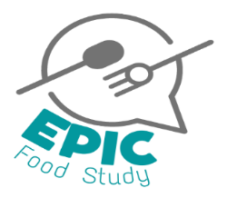
PARENT/CARER PARTICIPATION OPT-OUT FORM
Enhancing Policy In SChool Food (EPIC) study

Please only complete this form if you DO NOT want your child to take part in this study. If you are happy for your child to take part, we do not need you to return this form to us.

I am not willing for my child to take part in the study Please initial the box below.

Name of child: ……………………………………

School/Youth Group: …………………………………………….

Class: ……………………………………………..

Name of parent/guardian: ………………………………………………………….

Signature of parent/guardian: ………………………………………………………….

Date: ……………………………………………..
[For paper copies]
PLEASE RETURN THIS OPT-OUT FORM TO YOUR CHILD’S [SCHOOL OR YOUTH GROUP] OR EMAIL IT TO epicfoodstudy@contact.bham.ac.uk
Please return by this date:

