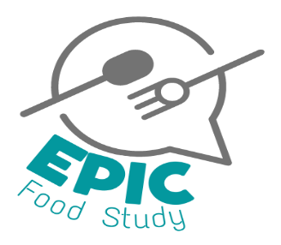

Enhancing Policy in school Food (EPIC) Study
You are invited to take part in a workshop about school food
Who are we?
We are a team of researchers at the University of Birmingham. We have recently carried out research about food and eating in secondary schools. We explored how school food influences what pupils choose to eat. We are now conducting a new study to use these findings to help people that work in the government adapt the current rules and guidance that are in place for school food.
What will happen?
You will be invited to a workshop with other young people at your [school/community group]. The group will include young people of different ages and genders. We will share our research findings and ask your opinion about them. We will ask you to share your own experiences of school food. We will record the discussion on an audio recorder so we can listen back to it.
What else will I be asked?
We will also ask you to fill in a short survey with questions about your age, gender, ethnicity, the area where you live and whether you have free school meals. This is to make sure we include a wide range of young people in our research.
What about my information?
We will keep information about you very safe and private for 10 years and then it will be destroyed. We will follow data protection law. We will use your information in reports and may use your quotes in other workshops but we will not use your name. Only researchers and other professionals that are approved by the University of Birmingham will know what you have said. If you would like to know more about your rights or how we use your information, please visit: [website]
Why should I take part?
You may help to improve food and support for healthy eating in secondary schools in the future. You will be given a £20 shopping voucher as a thank you for taking part.
[You will be given time in school to attend the workshop / the workshop will be arranged at a convenient time and place]
Do I have to take part?
No. The choice to take part is up to you and your parents. We encourage you to discuss this study with your parent/guardian. We will ask you if you are happy to take part at the start of the workshop. If your parents don’t want you to take part they will need to complete a form and return it to your school. [provide return date and location]
Any questions? Get in touch: epicfoodstudy@contacts.bham.ac.uk

