Data collection form explained

Automatically assigned, REDCap. You cannot change this.

Please check your hospital name and complete the missing information using the link: https://docs.google.com/spreadsheets/d/14coKEM0jpWim9Dl7x62VG3hi8GoD8kQD/edit?usp=sharing&ouid=118150622425289126302&rtpof=true&sd=true

4. Date of accident (dd/mm/yyyy) _______________________
The date of injury.

5.Date of admission (dd/mm/yyyy)_______________________
Admission date to this study hospital.

6.Still admitted at 30 days ❑ Yes ❑ No
Was the patient still admitted in the current hospital 30 days after they were initially admitted to the current facility?

7.Date of discharge/death (dd/mm/yyyy) __________________
If no to question 6, fill in the date that the patient was discharged (or died) at this facility.

8.Age (yrs) ______
Only individuals 18 years and older can be included in the study.

9.Sex
❑ Male ❑ Female ❑ Non-binary ❑ Unknown
Non-binary means they do not exclusively identify as either male or female. Unknown means this information was not recorded or is unknown.

10.Residence type (as locally defined)
❑ Rural ❑ Urban ❑ Unknown
Is the patient from a rural or an urban area? The definition of rural and urban will differ according to your setting. However a possible explanation of a rural area could be regions characterized by lower population density, open spaces, farmland, health facilities are further away from the community, etc. If you do not know or you are unsure then tick the unknown box.

11.Mechanism of injury (tick all that apply)
❑ Fall/slip/trip from standing ❑ Fall from height ❑ Assault ❑ Gunshot
❑ Road traffic collision ❑ Unknown
❑ Other (specify) ___________________

How did the patient fracture their femur? Did they:
- Fall/slip/trip from standing - Fall, slip, or trip while they were standing/on a flat surface or fall from <1 meter
- Fall from height - Fall from height > 1 meter such as a ladder, a building, a step, etc
- Assault – Intentional injury by another person with any kind of weapon
- Gunshot – Was the assault from GSW?
- Road traffic collision - Injury occurred through transport (pedestrian, driver, passenger, car, truck, motocycle)
- Unknown - Information on how the patient fractured their femur was not disclosed by the patient or is not available from their file
- Other – The patient fractured their femur in a manner not described by the other options for e.g. the roof caved in on them while they were asleep

12.Femur fracture site (tick all that apply)
❑ Left ❑ Right ❑ Unknown

If there was a bilateral fracture, tick left and right and complete the management information below.

13.Was an x-ray done to confirm the diagnosis?
❑ Yes ❑ No ❑ Unknown
Was the patient’s diagnosis confirmed using an x-ray (Yes) or was the diagnosis solely based on a clinical examination (No).
If there is no information on whether an x-ray was done, or if you are unsure, select unknown.

14.What type of fracture did the patient have?
❑ Open ❑ Closed ❑ Unknown
Open fracture i.e. a compound fracture, is a broken bone that has broken through the skin or is exposed by a deep wound? OR
Closed fracture, or a simple fracture, where the skin around the broken bone remains intact. OR
Unknown, If the type of fracture sustained is unknown or this information is not clear.

15.Where was the location of the femur/hip fracture? (Tick all that apply)
❑ Neck or head
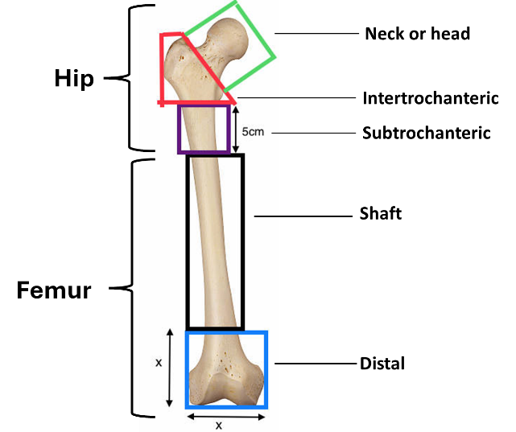
❑ Intertrochanteric
❑ Subtrochanteric
❑ Shaft
❑ Distal
❑ Femur (specific site unknown)
❑ Hip (specific site unknown)

Where was the location or site of the fracture? Use the figure on the right as a guide.
- Neck or head – colour green
- Intertrochanteric - colour red
- Subtrochanteric – colour purple
- Shaft – colour black
- Distal – colour blue
- Femur (specific site unknown)
- Hip (specific site unknown)

16. Did the patient have any other injuries?
❑ Yes ❑ No ❑ Unknown

Aside from the femur fracture, did the patient have any other injuries? For example, a head wound or arm fracture, etc.

16.1. Please specify location of additional injuries (tick all that apply)
❑ Head ❑ Neck ❑ Chest ❑ Abdomen ❑ Pelvis
❑ Upper limb fracture ❑ Non-femur lower limb fracture
❑ Spine
❑ Other:_________________________________

Specify the additional injuries, ASIDE from the femur fracture.

17. Treatment delays
17.1. Number of facilities visited before this admission
❑ 0 ❑ 1 ❑ 2 ❑ 3+ ❑Unknown

How many healthcare facilities did the patient visit after they were injured, and before they were admitted to this hospital? This includes clinics, day hospitals, etc.

17.2. Traditional healer(s) visit prior to this admission
❑ Yes ❑ No ❑ Unknown

Did the patient visit a traditional healer/sangoma/herbalist/traditional medical practitioner before they were admitted to this hospital? (please ask the patient if possible)

18.What was the definitive treatment for the femur fracture?
❑ Non-operative (traction) ❑ Operative

Did the patient receive an operation for their femur fracture or were they treated only non-operatively (traction or POP) at this hospital? Remember if the patient is going to another hospital for an operation, they cannot be enrolled in this study as this is only for patients who are having definitive treatment.

18.1. If non-operative, specify the approach (tick all that apply)
❑ Skin traction
❑ Skeletal traction
❑ Plaster of Paris
❑ Other (specify) _______________________________

If the femur fracture was definitively treated non-operatively, choose the treatment administered.

18.2. If operative, specify the approach (tick all that apply)
❑ Internal fixation ❑ Hemiarthroplasty
❑ External fixation ❑ Total Hip Replacement
❑ Other (specify) ________________________________

If the patient had an operation to manage their femur fracture, which operation did they have?

19. Date of operation _________ (dd/mm/yyyy)

If the patient had an operation at this hospital to manage their femur fracture, specify the date.

20. Was anticoagulation therapy for deep vein thrombosis prophylaxis administered? E.g. aspirin, heparin, low molecular weight heparin, or anything else not listed
❑ Yes ❑ No ❑ Unknown

Was the patient given any anticoagulation therapy for deep vein thrombosis? If this information is not clear or unknown, tick unknown.

21. Outcomes (Patient to be followed up for 30 days of admission or at discharge. Not both!)
21.1. Mobility status
❑ Bed bound/carried out of the hospital ❑ Wheelchair ❑ Walking with a stick/crutch
❑ Walking unaided ❑ Walking with a frame ❑ Unknown
❑ Other________________________________________

At the time of discharge or at 30 days of admission, what was the patients mobility status? If other, then specify.

21.2. What was the patient’s final outcome? (at 30 days or at discharge/death)
❑ Still admitted
❑ Discharged to another facility for rehabilitation
❑ Discharge home
❑ Transferred to a different health facility for additional management
❑ Dead - Date of death _____________________________(dd,mm,yyyy)
❑ Other (specify) ________________________________

- Still admitted means still at the this hospital 30 days after admission.
- Discharged to another facility for rehabilitation means was the patient discharged before 30 days and if yes did they go home or to another facility for follow up care in the form of rehab or physiotherapy?
- Discharge home means did the patient go to another facility for additional treatments?
- Transferred to a different health facility for additional management means did the patient die before 30 days of admission? If yes on which date did they die?
- Other (specify) means any other outcomes?

21.3. Did the patient encounter any complications from their injury or management (select all that apply)?
❑ Pressure sores
❑ Unplanned re-operation
❑ Deep vein thrombosis and/or pulmonary embolism
❑ Surgical site infection
❑ Unknown
❑ Other (please specify) _______________________________

Please ask the patient or examine them if possible

