
11.Mechanism of injury (tick all that apply)
❑ Fall/slip/trip from standing ❑ Road traffic collision
❑ Fall from height ❑ Gunshot
❑ Assault ❑ Unknown
❑ Other (specify) ___________________

12.Femur fracture site (tick all that apply)
❑ Left ❑ Right ❑ Unknown

13.Was an x-ray done to confirm the diagnosis?
❑ Yes ❑ No ❑ Unknown

14.What type of fracture did the patient have?
❑ Open ❑ Closed ❑ Unknown

15.Where was the location of the femur/hip fracture? (tick all that apply)
❑ Neck or head
❑ Intertrochanteric
❑ Subtrochanteric
❑ Shaft
❑ Distal
❑ Femur (specific site unknown)
❑ Hip (specific site unknown)

16. Did the patient have any other injuries?
❑ Yes ❑ No ❑ Unknown

1.Country name___________________________________________

2. Hospital name___________________________________________

3.Hospital type
❑ 1st level (Primary/District)
❑ 2nd level (Provincial, Regional, Secondary)
❑ 3rd level (Tertiary)
❑Other:____________________________

3.1. Please specify:
❑ Public ❑ Private ❑ Unknown

4. Date of accident (dd/mm/yyyy) _______________________

5.Date of admission (dd/mm/yyyy)_______________________

6. Still admitted at 30 days ❑ Yes ❑ No

7. Date of discharge/death (dd/mm/yyyy) __________________

8.Age (yrs) ______

9.Sex
❑ Male ❑ Female ❑ Non-binary ❑ Unknown

10.Residence type (as locally defined)
❑ Rural ❑ Urban ❑ Unknown

Patient REDCAP No:

Case Report Form

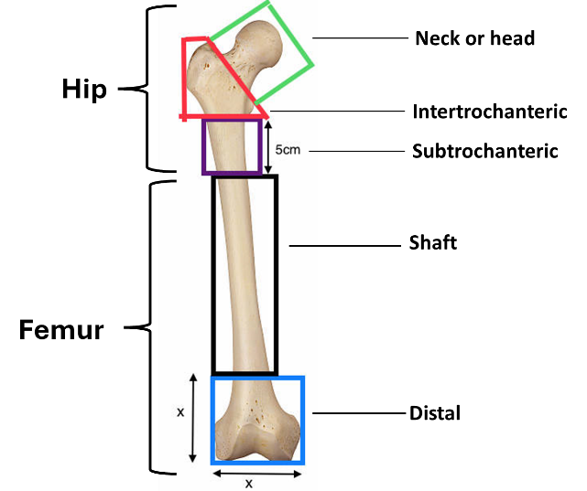
16.1. Please specify
❑ Head ❑ Neck ❑ Chest ❑ Abdomen ❑ Pelvis
❑ Upper limb fracture ❑ Additional lower limb fracture
❑ Spine
❑ Other:_________________________________

17. Treatment delays
17.1. Number of facilities visited before this admission
❑ 0 ❑ 1 ❑ 2 ❑ 3+ ❑Unknown

17.2. Traditional healer(s) visit prior to this admission
❑ Yes ❑ No ❑ Unknown

18.How was the patient managed at your facility?
❑ Non-operatively ❑ Operatively

18.1. If non-operative, specify the approach (tick all that apply)
❑ Skin traction
❑ Skeletal traction
❑ Plaster of Paris
❑ Other (specify) _______________________________

18.2. If operative, specify the approach (tick all that apply)
❑ Internal fixation ❑ Hemiarthroplasty
❑ External fixation ❑ Total Hip Replacement
❑ Other (specify) ________________________________

19. Date of operation _________ (dd/mm/yyyy)

20. Was anticoagulation therapy for deep vein thrombosis prophylaxis administered? E.g. asprin, heparin, low molecular weight heparin, etc.
❑ Yes ❑ No ❑ Unknown

21. Outcomes (Patient to be followed up for 30 days of admission or at discharge. Not both!)
21.1. Mobility status
❑ Bed bound/carried out of the hospital
❑ Wheelchair
❑ Walking with a stick/crutch
❑ Walking unaided
❑ Walking with a frame
❑ Unknown
❑ Other________________________________________

21.2. What was the patient’s final outcome at your facility?
❑ Still admitted after 30 days
❑ Discharged to another facility for rehabilitation
❑ Discharge home
❑ Transferred to a different health facility for additional management
❑ Dead - Date of death _____________________________(dd,mm,yyyy)
❑ Other (specify) ________________________________

21.3. Did the patient encounter any complications from their injury or management (select all that apply)?
❑ Pressure sores
❑ Unplanned re-operation
❑ Deep vein thrombosis and/or pulmonary embolism
❑ Surgical site infection
❑ Unknown
❑ Other (please specify) _______________________________

