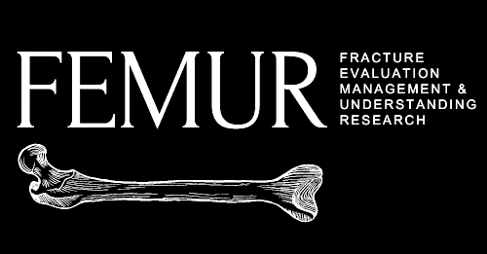

Fracture Evaluation Management & Understanding Research:

A prospective cohort study

Consent form

I am giving permission on behalf of myself.
□ Yes □ No

I was allowed to ask questions about the project.
□ Yes □ No

I agree to share my data for this project.
□ Yes □ No

I understand that my name or surname will not be part of the data collected and therefore no one will know that I took part in the study.
□ Yes □ No

I understand that I can choose if I want to take part in the study or not. I may stop taking part in the study at any point without anything bad happening to me.
□ Yes □ No

I understand that my data will only be used for research and my real name or any of my information will not be used at any time during the study.
□ Yes □ No

I understand that my research data will be stored for a period of 20 years.
□ Yes □ No

_____________________ _____________________
Participant’s code/pseudonym Date
(other name assigned)

_____________________ _____________________
Consent taker Date

If after we have finished the work,
1) You have questions, concerns, or complaints,
2) You would like to talk to the project team,
3) You think the project has harmed you, or
4) You wish to stop taking part in the study; please feel free to contact: XXX, the Principal Investigator in [insert country], [insert contact details] or femurstudy@gmail.com

