REDCap User Manual for

FEMUR Study

2024/2025



Table of Contents
Introduction 3
Data collection period: 3
Process of collecting data: 3
Using REDCap for data collection 1
How to access REDCap and set a password 1
How to login 2
How to find the project 3
How to add new patient record (and data) 4
How to save a patient record 5
How to edit an existing patient record 6
How to delete a patient record (and data) 7
How to logout 10
Contact us 11

Introduction

Data collection period:

Thank you for agreeing to contribute data to the FEMUR Study. Remember that the study period will include a minimum consecutive data collection period of 28 days. Data collection can commence at any time from February 1 – June 30, 2025 (Example 1). This includes weekends. Data collection can continue for longer than 28 days, however the project manager should be informed of this (femurstudy@gmail.com) (Example 2). Femur fracture patients can be managed operatively or non-operatively.

Example 1:

Hospital A starts data collection on the February 1st. All femur fracture patients definitively treated at Hospital A, either operatively or non-operatively, and that have consented to participating in the study (if applicable), are enrolled over the next 28 days. This includes weekends. The last patients are enrolled on the February 28th, which concludes the minimum data collection period.

Example 2:

Hospital B starts data collection on the February 1st. All femur fracture patients definitively treated at Hospital A, either operatively or non-operatively, and that have consented to participating in the study (if applicable), are enrolled into the study. Data collection continues consecutively for 43 days and concludes on March 15th.

Process of collecting data:

Data can be collected in 2 ways. However, in the end all data has to be entered into REDCap, the web-based platform that will be used for data collection:

- Directly onto the web-based platform, REDCap.
- First on the CRF paper-based form and then at a later stage captured onto the web-based platform, REDCap.

Using REDCap for data collection

How to access REDCap and set a password

- Access the link to the University of Birmingham’s REDCap page via email. If you cannot find the email in your inbox, check your junk mail folder. Alternatively, click on https://qc.redcap.bham.ac.uk/redcap_v14.3.14/index.php?pid=16 or paste into your internet browser.
- After opening REDCap in your internet browser, type in your username (enclosed in your email).
- You will need to set a password for yourself: to do this, click “Forgot your password?” on the internet page after typing your username in the username box.
- An email will be sent to you with prompts to set a password —follow these prompts.

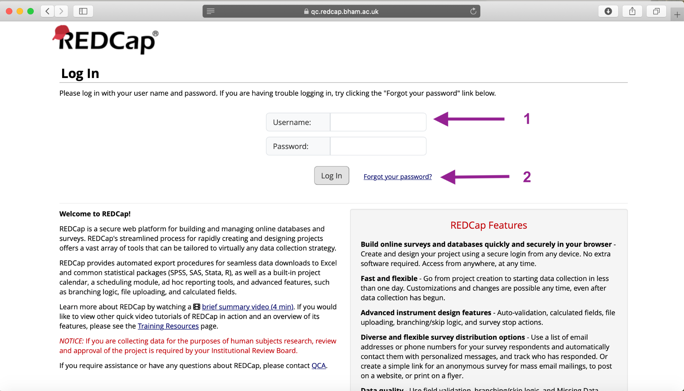

How to login
- (After setting your password)
- You will be required to insert your username and password into the homepage every time you want to login to REDCap.
- After typing your username and password, REDCap will require you to authenticate before you can access the project. This is a security measure.
- You will have 2 options by which to authenticate: via email or via an authentication application.
  - Should you choose to authenticate via email: choose the email option on REDCap - a 6-digit code will be sent to your email
  - Should you choose to authenticate using an authentication application (such as Microsoft Authenticator or Google Authenticator): choose the relevant option on REDCap - a 6-digit code will appear in your app
- Type the 6-digit code into REDCap on your internet browser within 2 minutes of receiving the pin.
- If the code is accepted, you will see the project home page.

How to find the project
- Unless you have multiple REDCap projects associated with your unique username and password, you will be taken directly to the project homepage after successfully logging in.
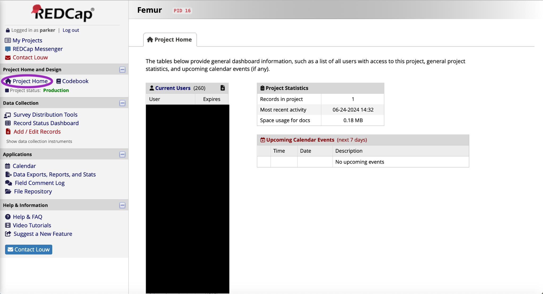

How to add new patient record (and data)
- On the interactive menu on the left of the screen, click the option “Record Status Dashboard” or “Add / Edit Records”. This will open a new format on the main screen.
- On the main screen, click the green prompt “+ Add new record”. This will open a new survey form in which to enroll a new patient and add their data.
- REDCap will automatically assign a Record ID
- To add their data, follow the prompts of the questionnaire. This will require you to type data, choose from drop-down options, or choose appropriate options multiple choice-style.
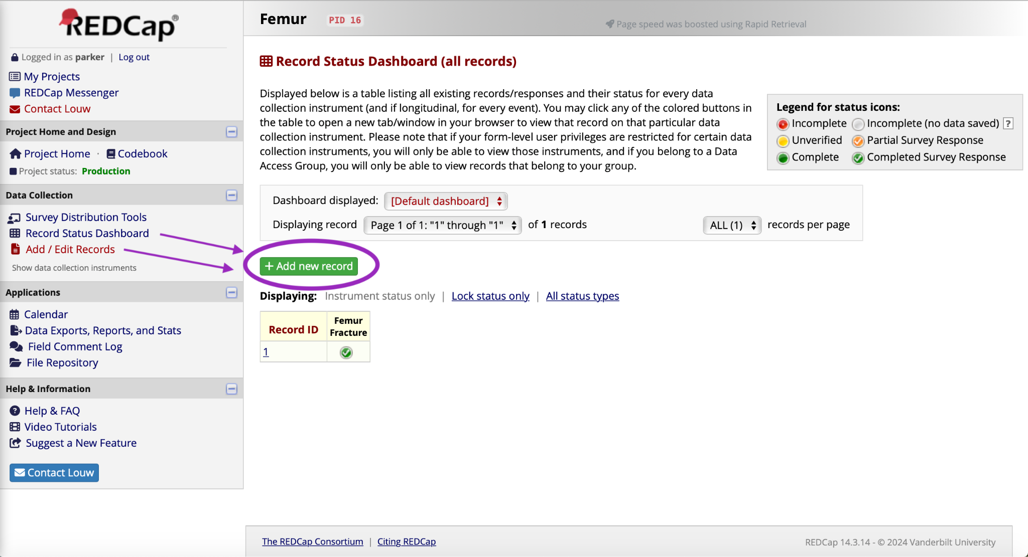

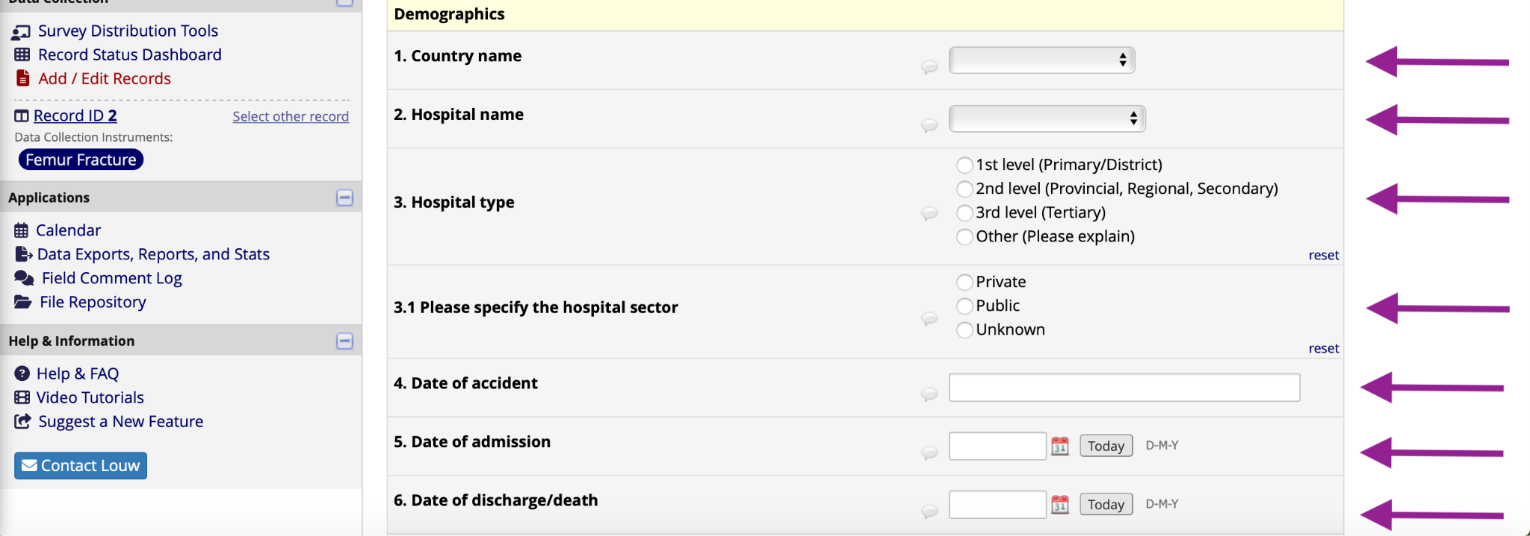

How to save a patient record
- Once you are ready to submit or save your data record, scroll to the bottom of the form.
- Update the form status as “Incomplete” or “Complete”. If you intend to come back to the form to edit or add additional data, label the form as “Incomplete”.
- Once you wish to exit or submit the form, scroll to the end of the form and click on the “Save and Exit Record” prompt in blue.
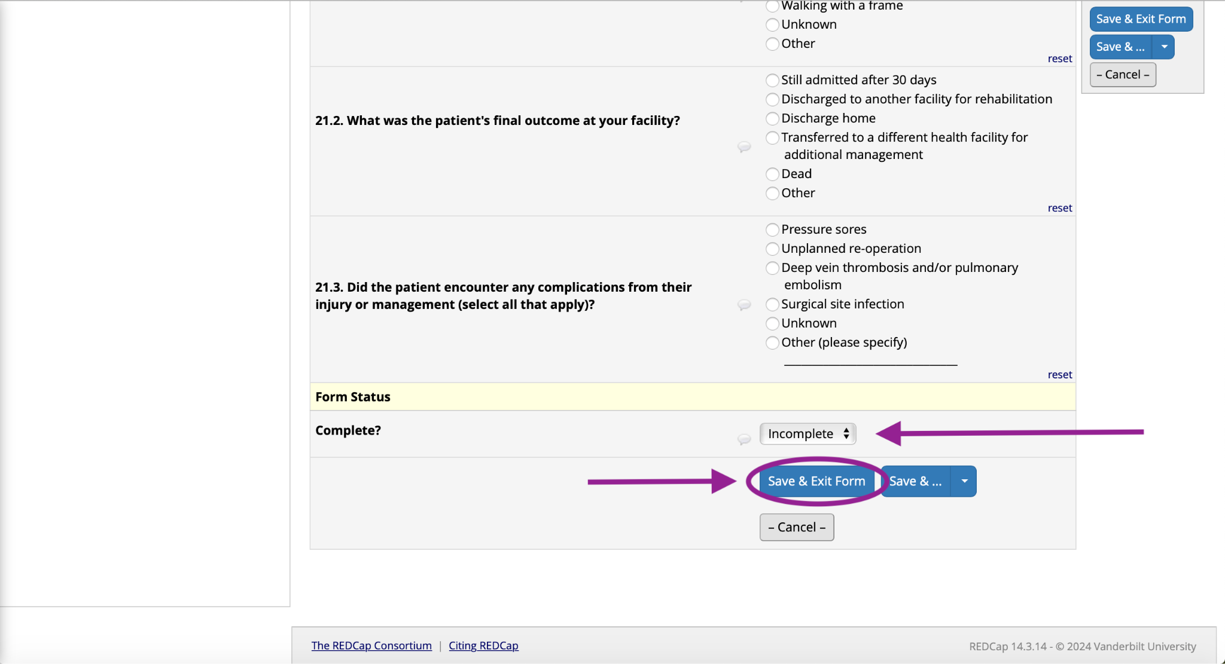

How to edit an existing patient record
- To do this, click on the relevant record. You can find specific records by clicking the “Add / Edit Records” prompt on the interactive menu on the left of the screen.
- This prompt will open a new menu on the main screen, where you will be able to search existing records by Record ID.
- Alternatively, you can find your records by clicking the “Record Status Dashboard”. This will open a list of all your existing records on the main screen. You will be able to open the record you are looking for here by clicking on the Record ID.
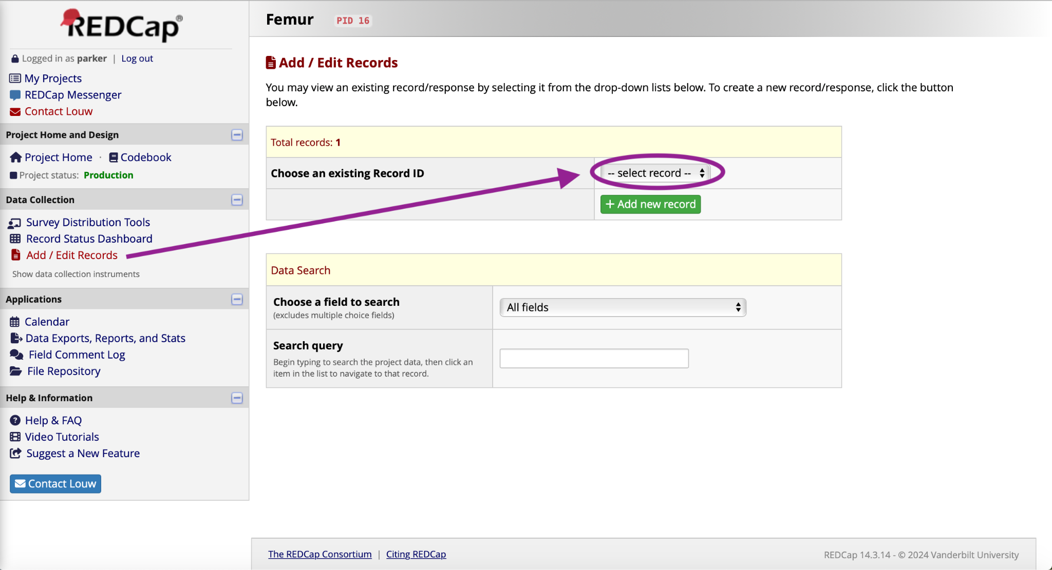

How to delete a patient record (and data)

- To do this, click on the relevant record. You can find specific records by clicking the “Add / Edit Records” prompt on the interactive menu on the left of the screen.
- This prompt will open a new menu on the main screen, where you will be able to search existing records by Record ID.
- Alternatively, you can find your records by clicking the “Record Status Dashboard”. This will open a list of all your existing records on the main screen. You will be able to open the record you are looking for here by clicking on the Record ID.

- After clicking on the record ID, e.g. record 4, the next window will appear.
- Click on “choose action for record” and select delete record.

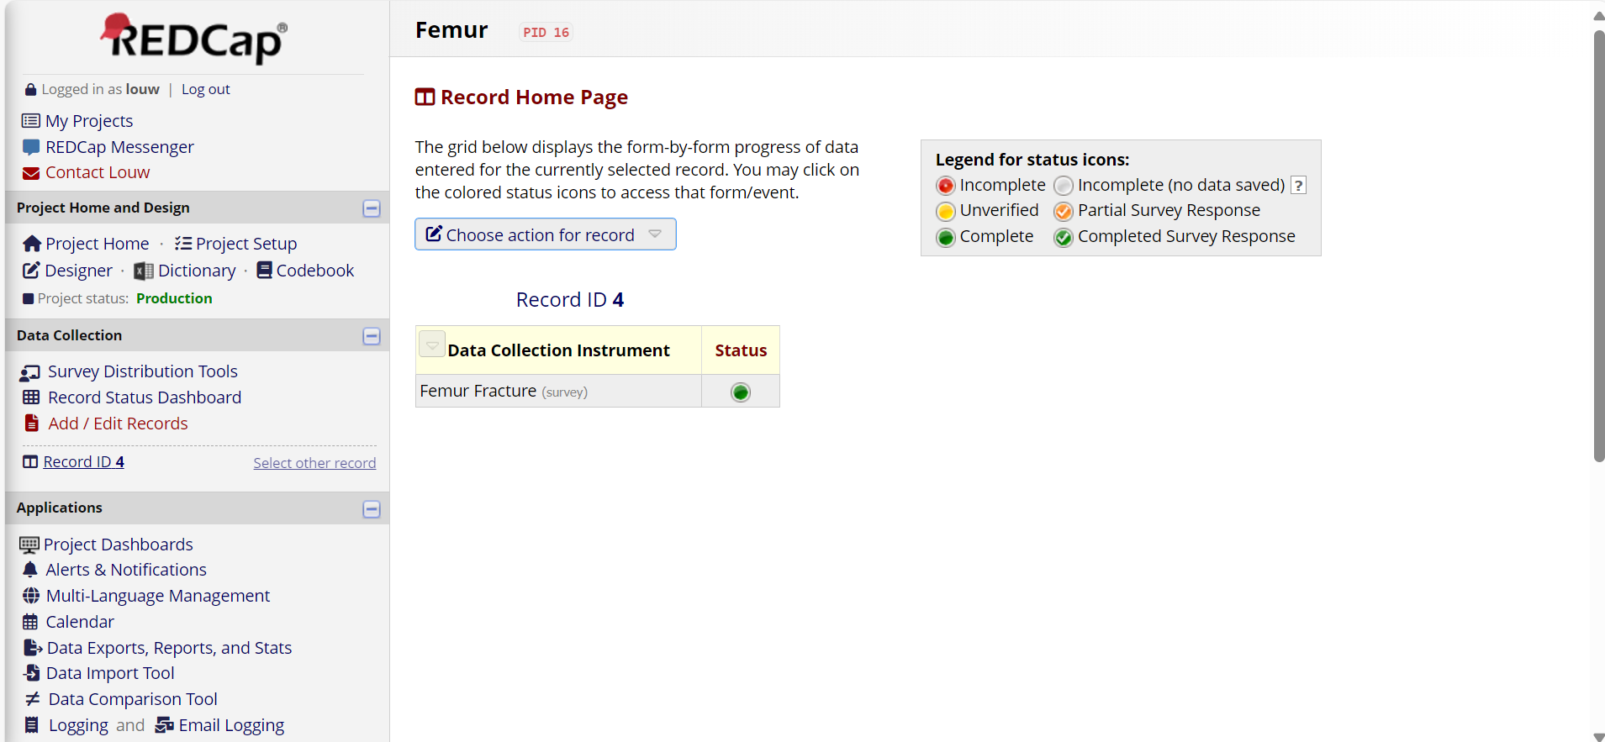

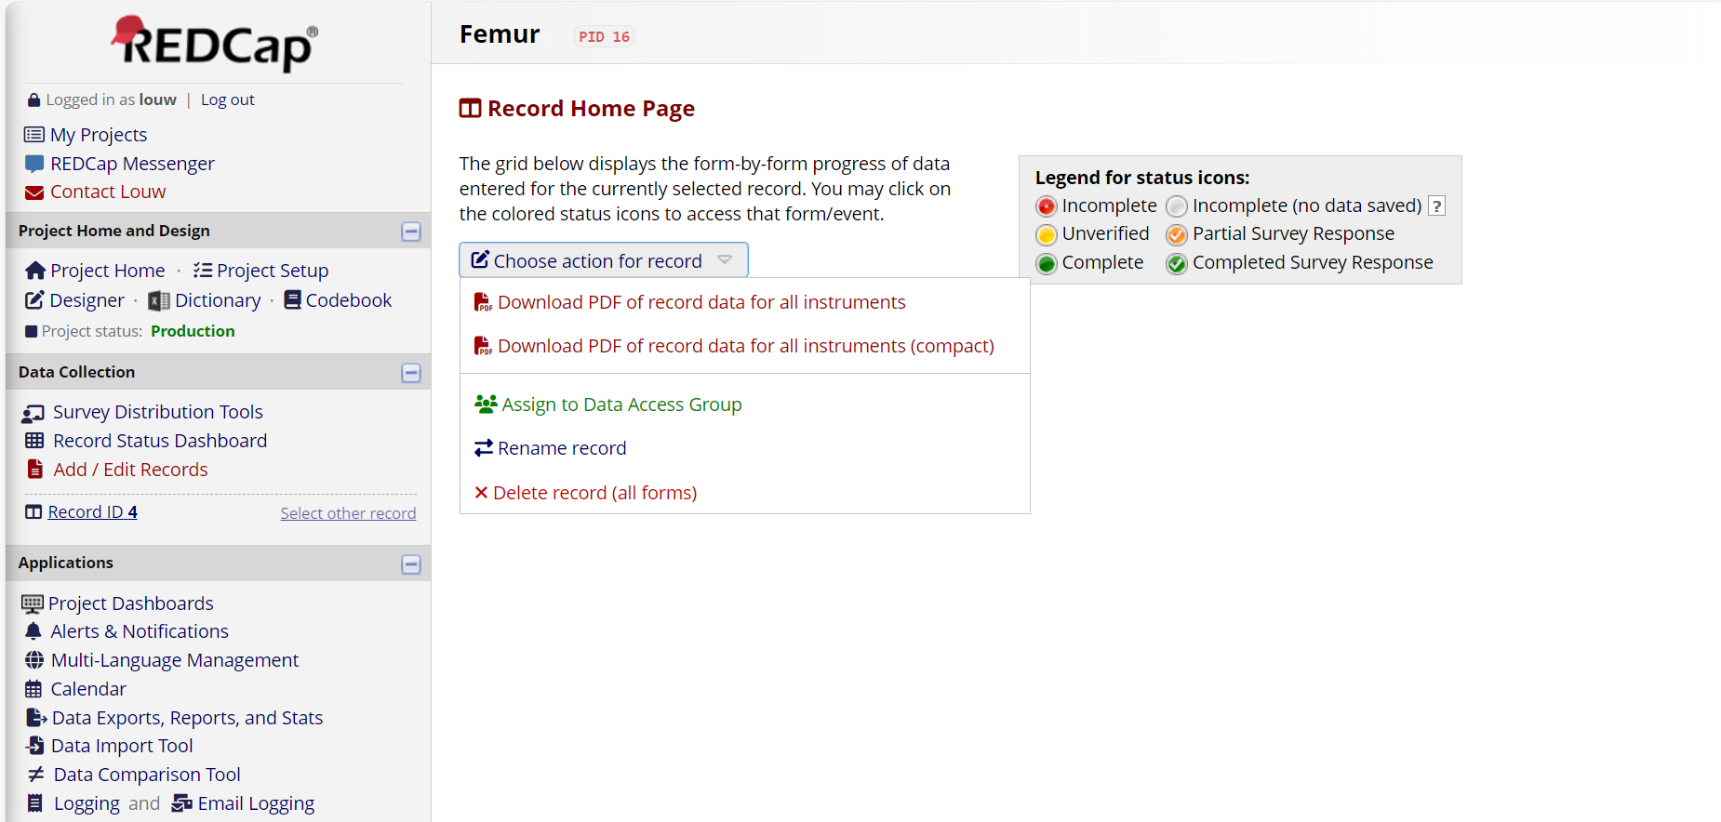

- You will be asked if you are sure that you want to permanently delete the record. Click on “delete record”.

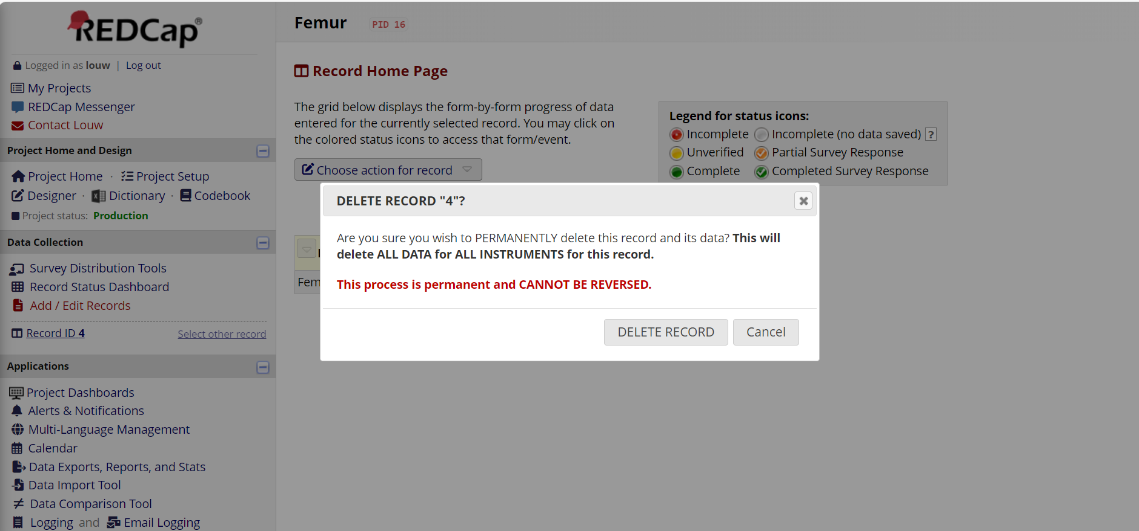

How to logout
- (Remember to save/submit your changes first!)
- Click on the “logout” link at the top of the interactive menu on the left of the screen
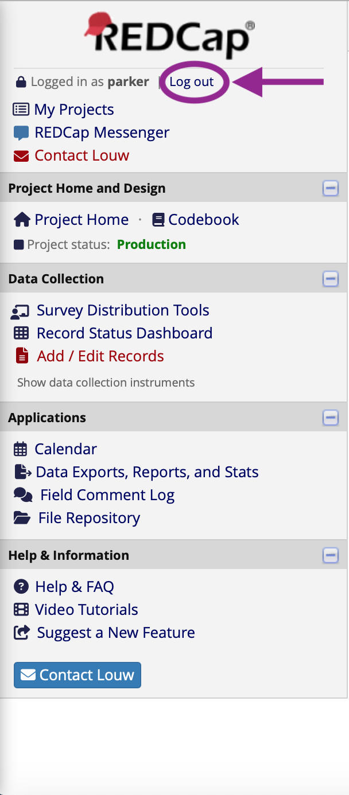

Contact us
If you have any additional questions or require clarity on any aspect related to the data collection process, please let us know on femurstudy@gmail.com.

