FEAST: Food and Eating Environments in
Alternative Education and Special Schools STudy
Summary
Who are we?


Why are we here? We want to find out about food and mealtimes at your school.


We will ask you some questions. We will record your voice.
you do.

What will happen?

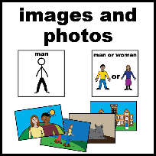
We may ask you to do a drawing.
We will take a picture of any drawings you do.

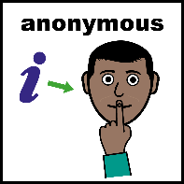
We may use your words or pictures in our reports. We won’t use your name.

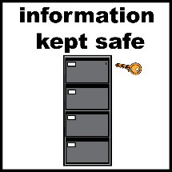
We will keep information about you very safe and private.

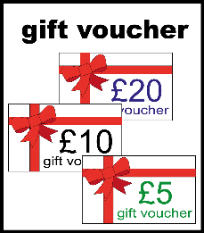
Why should I take part? Your views may help improve food in schools. You will be given a £10 shopping voucher.


What if I change my mind? You can ask us to stop at any time. You don’t have to give a reason.

Full Information:
Hello! We are a team of researchers at University of Birmingham. We would like to ask you about the foods and drinks served at your school and how you feel about eating at school.
What will happen?
- We will explain our research to you. We will give you a chance to ask questions. We will ask if you are happy to take part.
- If you are happy to take part, we will ask you some questions about school food. To help you to share your views, we may ask you to:
  - Talk to us
  - Use picture cards or play food
  - Draw a picture or write your views down
  - Take some photos about school food
  - Talk with a researcher when you are eating your lunch
  - Allow us to observe you during break/lunch
- You can choose from any of these options. You can choose to do this on your own, with an adult of your choice (e.g. a teacher, support worker or mum/dad/carer) or with a small group of other children. This will take place during school and for maximum of one hour We might meet you few times. We will record this on an audio recorder so we can listen back to it. We may take a photo of your drawings/words.
- If you don’t want to take part anymore, you can ask to stop. You don’t have to give a reason.
- We will ask your mum, dad or carer for information about you. This will include questions about your age, ethnic group, the area where you live, any special educational needs, whether you have free school meals, whether you are a boy or a girl and whether you speak English as your main language.
- We will also ask your school some questions about you. This may include questions about your needs and the types of foods and drinks you have at school.
What about my information?
- We will keep information about you very safe and private for 10 years and then it will be destroyed.
- We will follow data protection law. This means we will follow Data Protection Act 2018 to keep your information safe.
- We will use your information in reports. We may use your words or pictures. We will not use your name, your school’s name or the names of anyone else you mention. Only researchers and other professionals that are approved by University of Birmingham will know what you have said.
- Other researchers may ask to use the information we have collected from you. If we agree to share your information with them, we will make sure they keep your it secure. We will not share your name or personal details with them.
- If you would like to know more about your rights or how we use your information, please visit: https://www.birmingham.ac.uk/privacy
Why should I take part?
- You may help to improve food and support for healthy eating in schools in the future.
- You will be given a £10 shopping voucher as a thank you for taking part.
Do I have to take part?
- No. The choice to take part is up to you and your parents/carers.
- Before you decide, please talk to your parent/guardian about this research.
- We will ask you if you are happy to take part.
- We will ask your parents if they are happy for you to take part. If they say yes, they need to complete a form and return it to your school*.
- If you change your mind later, you can ask to be removed from the study. We can remove your data up to two weeks after you have taken part in an interview. If you take part in a group session, we will not be able to remove your data.
Any questions? Speak to your parent or teacher. Or email to research team: feast@contacts.bham.ac.uk

