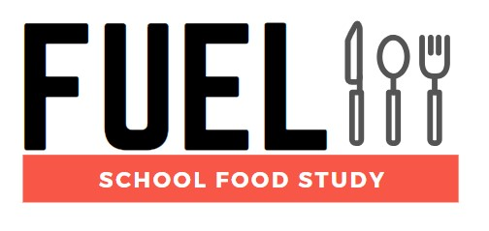

**Newsletter Issue 5 - July 2021**

**Back under way**

Welcome to the fifth newsletter from the FUEL Study.

We are pleased to share that, following the hiatus caused by the COVID-19 pandemic, the FUEL study has now restarted, with more schools agreeing to take part and data collection sessions taking place. We also have details on a new study looking into peoples’ experiences and views of COVID-19 alternative free school meal schemes.

**Recruitment update**

Before the study suspension in March 2020, 24 schools had agreed to take part and 835 pupils had consented to participate in the study. Since restarting after the Easter break, data collection has taken place in 4 schools, and the total number of schools that have joined the study is up to 28. To help mitigate the disruption to recruitment caused by the pandemic, we have opened the geographical recruitment area to include schools in the East Midlands. We have recently started getting in touch with schools from this area to help us reach our target of 44 schools signed up to the study.

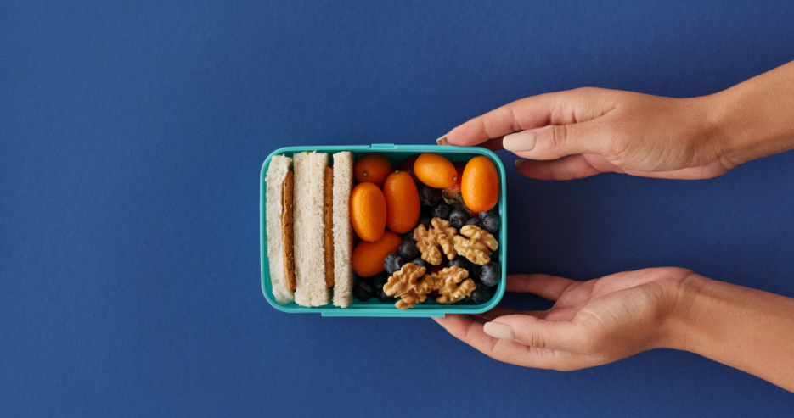

**A related study**

The GENIUS School Food Network and The School Food Review working group (made up of leading practitioners and campaigners working to improve school food) are giving you a chance to have your say about the current UK School Food System!

More details can be found by clicking [this link](https://twitter.com/Lauren15__/status/1406873357354668032?s=20).

Please find the link to the surveys by clicking [here](https://acsurvey.qualtrics.com/jfe/form/SV_2o9IJDGZ1rPQ78a).

If you are directly involved in the operational aspect of school food (School catering team, school caterers or local authority caterers) please select the School Food Catering Stakeholders Survey.

All other school food stakeholders (pupil, parent, teacher, principal, school governor, local authority, civil society organisation or academic/researcher) please select School Food Stakeholders Survey.



**Thoughts from our Advisory Panels**

Over the last few months, we have been consulting with two panels who are advising us on the FUEL study. One panel consists of young people, including people who attend secondary schools, and the other includes secondary school senior leader and other teachers, and governors. We asked them what they would particularly like to know about from the information that we are collecting in the FUEL study. The young people’s panel were very interested in links between what young people eat and drink and their overall wellbeing. They were also interested in how their diet affects their dental health. The panel of teachers and governors were interested in how many pupils in school are eating a nutritionally balanced lunch, and the factors that stop young people from eating healthily. The views of our advisory panels will help us with our approach to analysing and presenting our study findings.

If you have any views on this, or would like to add any suggestions for our team to consider, please let us know by 31st July 2021 by email at [fuelstudy@contacts.bham.ac.uk](mailto:fuelstudy@contacts.bham.ac.uk).

**Resuming data collection in September**

The FUEL study team will continue working hard over the summer, and hope to recruit more schools over the remaining weeks of term. Data collection will resume in September, with several schools expressing a preference for data collection to take place then. Some schools that have been contacted regarding taking part in the study have also asked to be contacted again in September, so the autumn term will hopefully be a very busy time for us, as we are sure it will be for you.

**Providing opportunities for students**

Over the last two years, the FUEL study has been providing students with the opportunity to learn about research. This includes work experience placements for secondary school pupils and an undergraduate student, and supplying research projects for Medical students and a Masters student. Topics include the eating environment in schools, adolescent sugar intakes across the day, comparing nutritional intakes of pupils based on how they travel to and from schools, assessing the environmental sustainability of typical adolescent diets, and the fast food environment surrounding schools. As well as providing valuable experiences and skills for these students, this also helps us to understand the diets of the young people taking part in the FUEL study better. We hope to be able to share their findings with you soon.

This has been a year like no other, and we would like to thank everybody that has been involved in the study at any point. We hope that you have a good summer and we look forward to working with you over the next year.

Chief Investigators: Dr Miranda Pallan - Prof Peymane Adab

Researchers: Dr Emma Lancashire - Dr Marie Murphy - Ms Rhona Duff

Administrator: David Alexander

Contact us

fuelstudy@contacts.bham.ac.uk

0121 614 8072

Twitter: @FuelStudy

Address: IAHR, Murray Learning Centre, University of Birmingham, B15 2TT

For information about the study visit our [website](https://www.birmingham.ac.uk/research/applied-health/research/chronic-disease-epidemiology-and-management/fuel-study.aspx) or watch our short [video](https://biteable.com/watch/fuel-study-for-schools-2419604).

Institute of Applied Health logocid:image001.jpg@01D1FFB5.65BB1D20cid:image001.jpg@01D1FFB5.65BB1D20