

**Newsletter Issue 6 - December 2021**

**Merry Christmas!**

Welcome to the sixth newsletter from the FUEL Study.

The FUEL study has had a great term since the start of the school year, with even more schools agreeing to take part and more data collection sessions taking place. This month we have information on recent findings on ways of increasing school meal consumption and also details of an exciting opportunity for school stakeholders to assist in the development of an intervention to support whole school approaches to food.



**Recruitment update**

With Christmas fast approaching, it is a good time to look back and reflect on the year. Before the COVID-19 pandemic, the study had 24 schools signed up, with data collected from 835 pupils across 12 schools. The study was due to restart in January 2021, but as you will no doubt remember, there was another lockdown causing a further delay in recruitment. We are really pleased that since April, data collection has taken place in a total of 26 schools, with a further 14 schools having agreed to take part or showing an interest. In total, 1757 pupils have now completed surveys so far.

We are pleased to confirm that an extension to the study timeline has been agreed to make up for the time lost over the pandemic. This will mean that we can complete data collection in these 14 schools early next term, and, with the team busy contacting more schools, we can add to the current total of 40 schools to hopefully reach the study target of 44.

**Increasing healthy school food consumption - ‘Nudge’ strategies**

A recent review of the literature in the USA looked at the most effective ways of increasing school meal consumption. The review found evidence that offering a wide choice of fruits and vegetables, especially pre-sliced fruit, increased their consumption. Longer lunch breaks and adapting recipes to improve palatability of dishes, such as vegetable and wholegrain dishes, also increased consumption of vegetables and wholegrains. Simple ‘nudges’ such as verbal prompts from staff may also be helpful in increasing fruit and vegetable intakes.

Over the summer, one of our medical students Sharon Darkwa looked at nudge strategies that are in place in schools taking part in the FUEL study. Sharon found that six out of ten schools offered a larger number of healthy snacks (e.g. fresh fruit, salad pots) than unhealthy snacks (e.g. crisps, cakes, biscuits). One in ten schools used verbal prompts to encourage selection of healthier foods and one had signs or posters that promoted healthy eating. Nine out of ten schools had an attractive dining area in which to eat.

We look forward to continuing our data analysis on the additional 18 schools that have taken part since Sharon undertook her analysis.



**Looking for catering managers and staff for interviews - £20 voucher for participants**

Dr Marie Murphy is carrying out a study on how secondary school eating environments support young people to make healthy choices. Marie is looking for secondary school catering staff to take part in a one-to-one interview over the phone or on Zoom/Teams. Participants will receive a £20 Love2Shop voucher as a thank you for taking part. Interested? You can get in touch with Marie at [m.murphy.3@bham.ac.uk](mailto:m.murphy.3@bham.ac.uk) to find out more.

**CONNECTS-Food Study**

The CONNECTS-Food study (CO-desigNed systems iNtervEntion impaCTing whole school approaches to Food) aims to design a practical intervention to help primary schools deliver existing policies which promote whole school approaches to food.

The study is being conducted by a team of researchers from the Department of Health Sciences at the University of York in collaboration with researchers in the Queens University Belfast, Newcastle University, University of Bradford and the University of Leeds.

If you are interested, or would like more info please contact the CONNECTS-Food team via the Twitter account [@GENIUSSFN](https://twitter.com/GeniusSFN) and they will put you in touch with the research team.

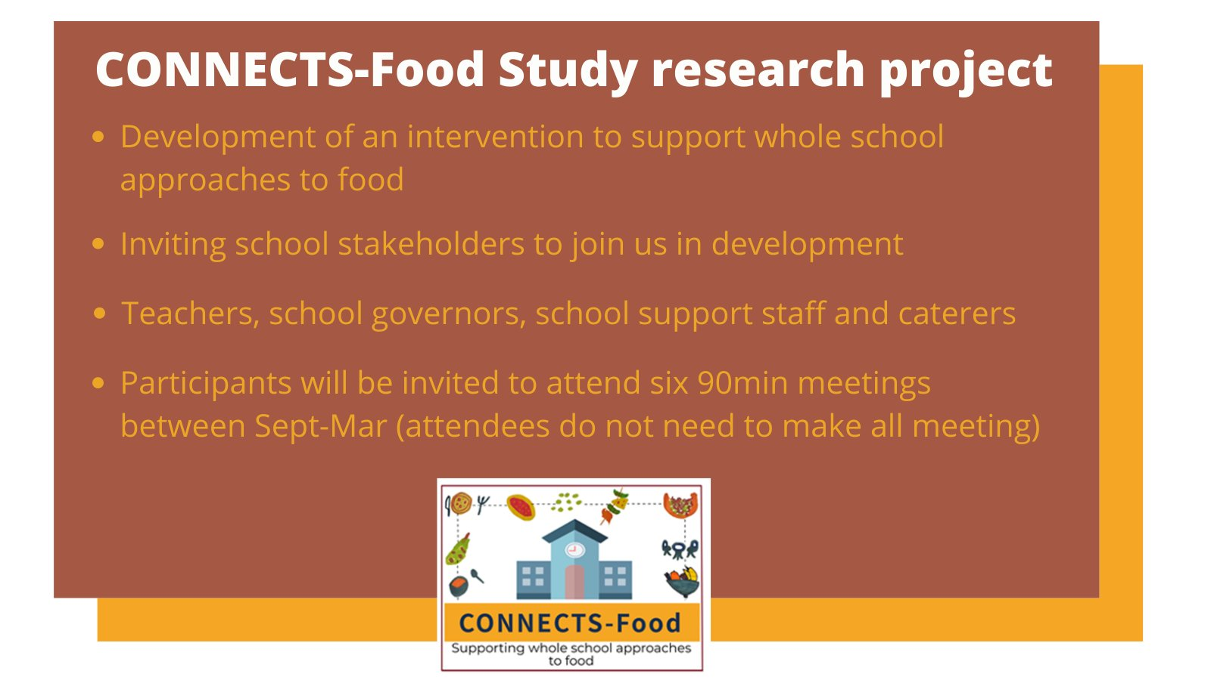

2021 has, just like 2020, had many challenges for everybody. As always, we would like to thank everybody that has been involved in the FUEL study and made it as successful as it has been so far. It has taken a huge effort by many different people, including teaching and catering staff and senior-leadership team members at schools. We would like to take this opportunity to wish you a very Merry Christmas and we hope you have a well-earned Happy New Year.

Chief Investigators: Dr Miranda Pallan - Prof Peymane Adab

Researchers: Dr Emma Lancashire - Dr Marie Murphy - Ms Rhona Duff - Ms Louise McLeman

Administrators: David Alexander - Katie Youngwood

Contact us

fuelstudy@contacts.bham.ac.uk

0121 614 8072

Twitter: @FuelStudy

Address: IAHR, Murray Learning Centre, University of Birmingham, B15 2TT

For information about the study visit our [website](https://www.birmingham.ac.uk/research/applied-health/research/chronic-disease-epidemiology-and-management/fuel-study.aspx) or watch our short [video](https://biteable.com/watch/fuel-study-for-schools-2419604).

cid:image001.jpg@01D1FFB5.65BB1D20