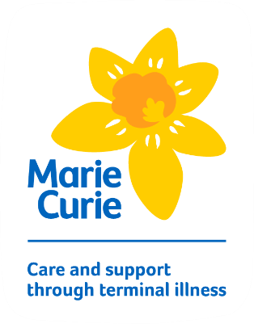

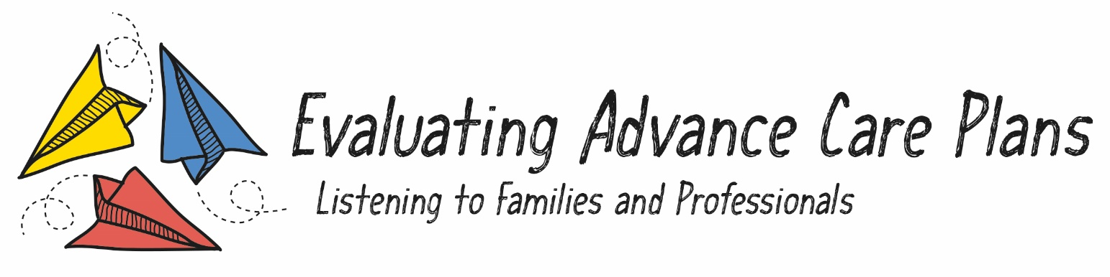

**Final Report for Families**

**Dr Karen L Shaw and Jenna Spry, on behalf of the research team.**

**April 2021**

Cartoon style illustration showing what matters to families. 


**Thank you!** For your interest in this study - which finished last year. This report tells you what we did, what we found out and what we have been doing with the findings to make a difference.

About the study

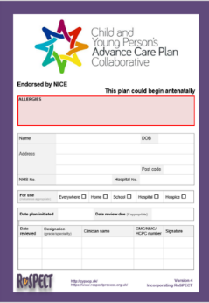We asked families and professionals to share their views on the Child and Young Person's Advance Care Plan (CYPACP). Some people also call it the purple pages.

Although it is used across the UK, there is very little evidence about what works well and what needs improving. Our study aimed to address this by examining how families, professionals and organisations work together to make plans. Most importantly, we wanted to know if the CYPACP works for families.



What we did

We used in-depth interviews, group discussions and online surveys with 19 parents and 127 different professionals in the West Midlands. This helped us gain an in-depth view of the CYPACP from everyone’s perspective. We looked at what worked well and why. We also looked for problems and invited people to make suggestions about possible solutions.

This information was analysed carefully to identify key issues. These were discussed with parents and professionals at end-of-study events and combined with findings from other studies. This helped us to make a detailed list of recommendations to improve care.

What we found

**Advance care planning is a valuable part of high-quality care.** People described many positive benefits of having a CYPACP and professionals felt it was a better way to plan care, compared to previous ways of working. However, we also found out about areas where progress can be made to improve things for families and staff.

**Families told us that they need more choice and support.** Parents described making a CYPACP as an important thing to do for their children. It could be challenging and emotionally draining, but no one regretted it. However, they did want more choice about how they are made (e.g. when, where, who is involved) and improved support.

**Cartoon style illustration of people talking about the child and young person's advance care planUsing the CYPACP is complex.** It involves lots of different people, organisations and processes. Many professionals and organisations have worked hard to do this well. However, there were too many times when people caring for children didn’t know about the CYPACP or failed to use it without being asked. Parents and professionals felt more needs to be done to raise awareness of the CYPACP and train professionals to use it with skill.

**The CYPACP has room for improvement**. Families and professionals had many ideas for improving the CYPACP document and how it is used. This included advice about how to discuss plans with families, how to make them more personal and how to ensure they are used properly when needed. They also suggested a range of resources that could help, e.g. information leaflets, access to advice and emotional support.

What difference is this making?

* **We have developed a detailed list of recommendations for the CYPACP Collaborative Working Group** whoare responsible for the CYPACP. This offers practical strategies to encourage appropriate use of the CYPACP. It will also be available to all NHS and private organisations who use the CYPACP.
* **We have sent the findings to UK regional clinical networks** who make decisions about local care for children who have serious conditions.
* **We ran a study day for professionals** who are involved in advance care planning. This included information about using the CYPACP, talks by parents and had workshops to help professionals improve their skills.
* **We invited all families who took part in the study to attend a family fun day** to tell them more about the findings and to seek their feedback about next steps.
* **We are working with the Children’s Palliative Care Education Standard Framework** (Action Group) to ensure that advance care planning is part of learning for all professionals who care for children who have serious conditions.
* **We have been working with the University of Birmingham** to ensure that advance care planning is included in their medical and nursing education.
* **We have worked with leading charities to develop policy statements** that call on national leaders for health care and education to recognise the importance of advance care planning for children and their families. We are also working with them to ensure that these messages are heard.
* **We are talking about advance care planning whenever we get the opportunity.** We are writing articles for medical journals and have presented the findings at local and international medical conferences. This includes information for general audiences and specific professional groups such as the ambulance service and intensive care staff.
* **The findings have also helped us to gain additional funding** to look at advance care planning. This has allowed us to do a national survey to see how plans are made in maternity and neonatal care services for babies who may need an advance care plan.

**This is all thanks to the generous support of the families**

**and professionals who took part.**

More details about the study findings

The full report and other documents are available on the study website at: [www.birmingham.ac.uk/acp-study](http://www.birmingham.ac.uk/acp-study) or from **Dr Karen Shaw** at **k.l.shaw@bham.ac.uk**

**Research team:** Dr Karen Shaw (Principal Investigator), Jenna Spry (Research Fellow), Dr Serena Cottrell, Dr Carole Cummins, Nicki Fitzmaurice, Prof Sheila Greenfield, Dr Gemma Health, Dr Sue Neilson, Dr Magdalena Skrybant, Dr Paul Thompson, Janette Vyse.

**Steering group:** Emma Aspinall, Lizzie Chambers, Sue Davies, Matt Greaves, Emma Murphy, Hardev Notta, Charity Nyumbazi, Debs Smith, Nita Tailor.

Thank you to Marie Curie for funding this study.