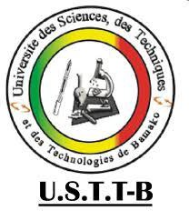
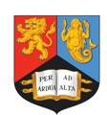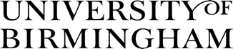

The Mali MaaCiwara* Project Newsletter
*(pronounced MaaChi·wara) Nov 2021 Issue 1

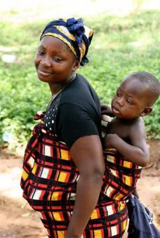

The main overall aim - To investigate the impact of a community-based intervention to improve food-safety and
hygiene, child feeding, and hygienic child play, as well as women’s empowerment and community action. Project Setting: Urban communities in Bamako and rural communities in Bamako, Ségou & Sikasso, Mali. Intervention: Based upon smaller successful studies in Nepal and the Gambia. Provisionally, the intervention will be 5 days of community campaigns about food safety/hygiene, nutrition and hygienic play dispersed across 35 days (days 1,2,17,15,35) plus volunteer home visits followed by a 9-month reminder campaign day.
Evaluation: 27 Mothers and children in each community (6-36 months old) will be assessed at baseline, 4- and
15-months post intervention.
Planned project period: February 2021- February 2024.
Outcomes Measured: Diarrhoea; chest infection; growth; child development; women and social outcomes. We are also interested in exploring the role in women’s empowerment and the contribution of better health through community action and cohesion resulting from our intervention.

In this first issue:
- Project summary
- Overall project progress
- FR preliminary findings
- Capacity building & PhD students
- Sub study: Communal handwashing trial
- Fun fact
- Partners and collaborators
- Latest news on funding
Next steps

Progress so far
- Processes of the study: Trial registration is underway, and protocol will soon to be sent for publication in an open access journal.
- Initial studies: Research to understand the study communities and also to help us adapt our intervention (Formative Research) was completed in 42 households in 5 rural and 3 urban communities; report is written for intervention adaptation (see details below).
- Formation of advisory groups: Trial Steering committee/Data management committee (TSC/DMC) has been formed. International Expert Advisory Group (IEAG), Mali National Expert Advisory Group (NEAG) and local Community Committees are being established.
- Study sites recruitment: 120 communities (clusters) for the study have been recruited and consented in both urban and rural areas. These communities will be randomly allocated to receive the intervention or not after baseline data collection in January 2022 . Recruitment of fieldworkers for baseline data collection is underway.

Sub-Studies: Communal handwashing Study (see details below).

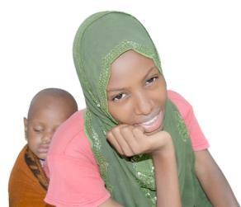

Preliminary Formative Research (FR) findings
- FR was conducted in low socioeconomic status communities in Bamako in the neighbourhoods of Banconi and Sabalibougou; in Sikasso and Segou. In rural areas, the participating villages were Dialakoroba, Zantiguila, and Tienfala in Koulikoro region.
- A total of 42 mothers with a child aged 6 to 36 months answered a questionnaire and were observed 6-8 hours. Mothers had average age of 27 years and 35 had no education, not completed primary education and could not read at all. Focus group discussions were also held separately with mothers, grandmothers, fathers, and grandfathers in each participating community.
- The findings were relatively similar in both rural and urban areas.
- Food poisoning and contamination was attributed to germs or dirty hands, poor storage, not properly cooking food, mixing food with other foods to eat and eating cold foods.
- When observed, most mothers did not wash their hands before carrying out critical tasks such as cooking, feeding the baby or eating themselves.
- The main barrier to food diversity and eating fruit and vegetables was access and costs. Some complementary foods were associated with taboos. The start of complementary foods varied from 3 months to 9 months.
- When observed, children sat or played on the soil/ground outside the house. One child was observed playing outside the house on a cover. When mothers were away or busy, other family members or neighbors looked after the child.
Children eating soil was mostly accepted. Frequently, animals were kept in the yard and animal droppings were observed close to children played. In some instances, the children playing on the ground/dirt were observed mouthing sand/soil or animal droppings.

Capacity building &
PhD students
- Mali project staff are offered associate membership of University of Birmingham and have access to a wide range of training, scientific meetings, library facilities and other resources. For example, some staff have already attended a masters’ module on randomised controlled trials.
- A needs assessment is underway to direct capacity building for individual staff in UK and Mali, especially career development of junior researchers and PhD students on the project.
- A total of four potential PhD students are about to register at UoB or USTTB, scheduled to use data or samples from the study.
We are currently seeking additional funding to support fees and conferences of students and staff; any support from our partners would be very appreciated.

Communal handwashing sub-study
- Data collection for this sub-study, funded by University of Birmingham Institute for Global Innovation (IGI), was conducted in July 2021. Randomised controlled trial Registration No. PACTR202103829129395. Analysis is currently underway.
- The practice of members of the same family washing hands in the same communal bowl of water before mealtimes (without changing the water and without soap) is common in many communities in Mali and West Africa. In Mali, families often associate it with consolidating family social bonds. This practice has persisted through the COVID-19 period despite intense national programs and media messaging to wash hands with soap.
- Our study investigated an intervention to reduce cross- contamination of hands and improve hand hygiene. This was a very low-cost intervention, aimed at being acceptable and feasible by families. This was the use of soap during the communal handwashing in the same bowl, with rinsing of hands in a separate bowl. This intervention required only 2 bowls of water, making it feasible for water-scarce settings.
- A total of 230 rural and urban households were randomly allocated to the intervention or control groups. An experimental situation was created where members in each household were asked to wash their hands in the same bowl of water, while samples of the water and hand swabs were taken at various times. In the intervention group, the individuals washed with soap and then rinsed in a separate bowl. Hand swabs and water samples were tested microbiologically for stool bacteria (E. Coli counts).
- A nested qualitative study explored the motivations for the continual use of communal handwashing, possible interventions and the views of participants using soap as part of communal handwashing.

Partners and collaborators

Partners: Loughborough University; London School of Hygiene and Tropical Medicine (LSHTM) International Centre for Diarrhoeal Disease Research (ICDDR), Bangladesh; WaterAid HQ London; Gambian Ministry of Health.
Collaborators: Ministry of Health, Mali; National Public Health Laboratories, Mali; and UNICEF Mali offices; World Health Organisation (WHO), HQ Geneva; West African Health Organisation (WAHO), Save the Children International, USAID and Mali Health.

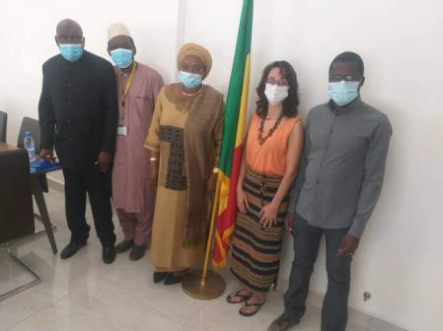
Photo Nov 2020:
Left to right: Mr Hassane Ombotembe, Prof Ousmane Tour (MaaCiwara Co-PI Mali), Ms Diallo Fanta Siby (Former Minister of Health), Dr Semira Manaseki-Holland (MaaCiwara Co-PI UK), Dr Cheick Sidibe (Trial Manager, Mali).
We are very much grateful to all our former and new partners/collaborators both locally in Mali and internationally. We are specifically grateful to WAHO, WHO, UNICEF, USAID and other partners/collaborators that supported with letters during the funding application stage of this project.

Meaning of MaaCiwara
‘Ciwara’ is traditionally a very important and positive ritual symbol among the Bambara people in West African representing an antelope. It means a prize given to a person for great achievements, particularly warriors or those with good agricultural work or someone trying to achieve something that will be valuable for the community.
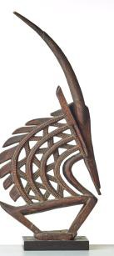

Symbol of ciwara.

Maa’- Refers to mothers
MaaCiwara (this is a Bambara spelling pronounced MaaChi·wara)
In the context of this project refers to all mothers who change their behaviours, working effortlessly to ensure
their children grow healthily and contribute to society in the future.

Latest news on funding
- Global Challenge Research Fund (GCRF) under UK Research and Innovation (UKRI) that funds our project through the Medical Research Council (MRC) announced substantial budget cuts to all ongoing overseas projects for 2021-22 due to COVD-19, which unfortunately affected our project.
- MaaCiwara project was at a good stage where activities could be slowed/paused. The project reprofiled to receive 4 months of funding to support our viability. This has been approved by UKRI to enable us to implement an adapted version of our program. However, as we have lost a significant budget, we have lost some key staff positions.
- We are very grateful to the University of Birmingham that has supported the study and we are exploring other funding and collaborations to ensure the project is executed with minimal change to the original protocol; please inform study managers of any funding opportunities you are aware of.
Additional small funds for new sub-studies have enriched and added some shared funding to MaaCiwara.

Next steps

- Trial registration and publication of MaaCiwara study trial
protocol.
- Training needs assessment for staff and PhD students for capacity building.
- Completing and testing database for field data collection.
- Recruitment and training of field workers for baseline data collection in January 2022
- Development of the intervention components, campaign program and tools to be used

Website: https://www.birmingham.ac.uk/research/applied-health/research/maaciwara-study/our-research.aspx
Twitter: @MaaCiwara

Email project managers: e.a.asamane@bham.ac.uk or c.sidibe@bham.ac.uk Tel: +447835781821 or +223 76 32 96 04

Funders: Medical Research Council (MRC) UK Research and Innovation (UKRI)-Global Challenge Research Fund (GCRF); University of Birmingham Institute for Global Innovation, (Co-funded in kind UOB, USTTB)

