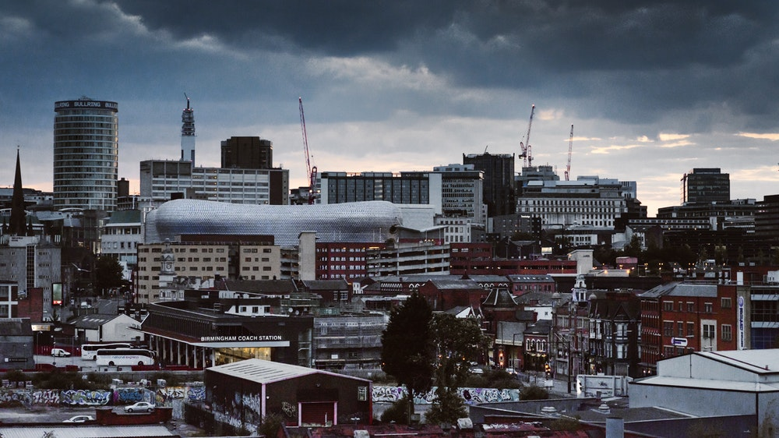

An Introduction to Birmingham

Birmingham is the second-most populous city in the United Kingdom, after London, and the most populous city in the English Midlands. It is also the most populous metropolitan district in the United Kingdom, with an estimated 1,137,123 inhabitants (according to Wikipedia), and is considered the social, cultural, financial, and commercial centre of the Midlands. It is the main local government of the West Midlands conurbation, which is the third most populated urban area in the United Kingdom, with a population of 2,897,303 in 2017. The wider Birmingham metropolitan area is the second largest in the United Kingdom with a population of over 4.3 million. It is frequently referred to as the United Kingdom's "second city (though not by people from Manchester or Glasgow).
A market town in the medieval period, Birmingham grew in the 18th-century Midlands Enlightenment and subsequent Industrial Revolution, which saw advances in science, technology, and economic development, producing a series of innovations that laid many of the foundations of modern industrial society. By 1791, it was being hailed as "the first manufacturing town in the world", but also the “Toy Shop of Europe” (there are still a few factories and toy shops). Birmingham's distinctive economic profile, with thousands of small workshops practising a wide variety of specialised and highly skilled trades, encouraged exceptional levels of creativity and innovation and provided an economic base for prosperity that was to last into the final quarter of the 20th century (in other words, it’s been pretty quiet for the last 50 years or so). The Watt steam engine was invented in Birmingham (so there).
The resulting high level of social mobility also fostered a culture of political radicalism which, under leaders from Thomas Attwood to Joseph Chamberlain, was to give it a political influence unparalleled in Britain outside London, and a pivotal role in the development of British democracy. Nevertheless, we still don’t have an elected Mayor, because 57.8% voted against one in 2012 (I guess that’s democracy). From the summer of 1940 to the spring of 1943, Birmingham was bombed heavily by the German Luftwaffe in what is known as the Birmingham Blitz (Coventry also likes to blame the Blitz). The damage done to the city's infrastructure, in addition to a deliberate policy of demolition and new building by planners (that’s the real reason), led to extensive urban regeneration in subsequent decades, not all of it tasteful. In other words, you have to look harder for the nice bits, but that makes it more rewarding (our tips in this intro will hopefully help you).
Birmingham's economy is now dominated by the service sector (ie. we don’t make much anymore, besides sandwiches). The city is a major international commercial centre, ranked as a beta-world city (no idea what that means, but it sounds impressive) by the Globalization and World Cities Research Network the joint highest ranking with Edinburgh and Manchester of all British cities outside of London; and an important transport, retail, events and conference hub. Its metropolitan (post-industrial) economy is the second largest in the United Kingdom with a GDP of $121.1bn (2014), and its six universities make it the largest centre of higher education in the country outside London (surely the good times can’t last). Birmingham's major cultural institutions – the City of Birmingham Symphony Orchestra, the Birmingham Royal Ballet, the Birmingham Repertory Theatre, the Library of Birmingham, Wetherspoons on Alcester Rd, the Barber Institute of Fine Arts – enjoy international reputations (ok, I lied about the Wetherspoons), and the city has vibrant and influential grassroots art, music, literary and culinary scenes. It is the birthplace of heavy metal music, which is currently being celebrated in an exhibition at Birmingham Museum and Art Gallery, and the clientele of the Hammer and Anvil pub in Queensway. The city will host the 2022 Commonwealth Games (that’s an SSHM conference year anyway, so we could not have hosted an EAHMH conference then). Birmingham is the fourth-most visited city in the UK by foreign visitors (we might be third this year thanks to this conference). And this was before Peaky Blinders launched in 2013.
People from Birmingham are called Brummies, a term derived from the city's nickname of "Brum", which originates from the city's old name, Brummagem, which in turn is thought to have derived from "Bromwich-ham" (which still doesn’t adequately explain things). The Brummie accent and dialectare is particularly distinctive. Why not try out some of these distinctly Birmingham expressions during your stay here:
A face as long as Livery Street – a really sad face
Bost – it’s broken
Council pop – tap water
Having a Benny – to throw a strop
Leg it – run away
Munch – to hug or cuddle
Tara-a-bit – see you later
The cut – canal
Tea – dinner around 6/7pm
Tot – an alcoholic drink

More information on Birmingham shopping, events, entertainment: https://visitbirmingham.com/

Landmarks:
Birmingham Cathedral, Colmore Row, Birmingham (Centre of Birmingham City)
http://www.birminghamcathedral.com/
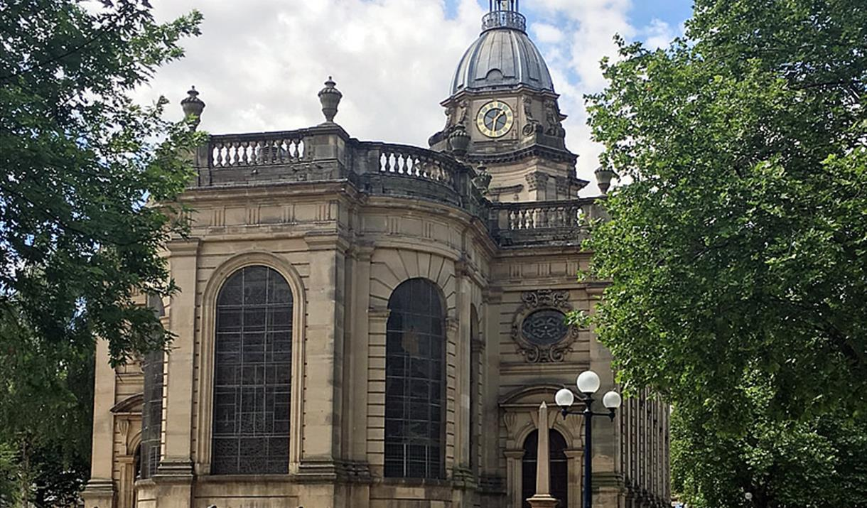

About
Birmingham Cathedral is a fine English Baroque parish church designed by Thomas Archer. Completed in 1725, it is one of the most beautiful historic buildings in the city centre. The Cathedral contains four famous Pre-Raphaelite stained-glass windows designed by Sir Edward Burne-Jones. The popular churchyard, now beautifully restored, has a perimeter of cast-iron railings, with a double row of plane trees.
Opening Times Shop open most days from
07:30 – 18:30 weekdays* 10:30 – 15:30
08:30 – 17:00 weekends

Birmingham Museum & Art Gallery, Chamberlain Square
https://www.birminghammuseums.org.uk/bmag/visit
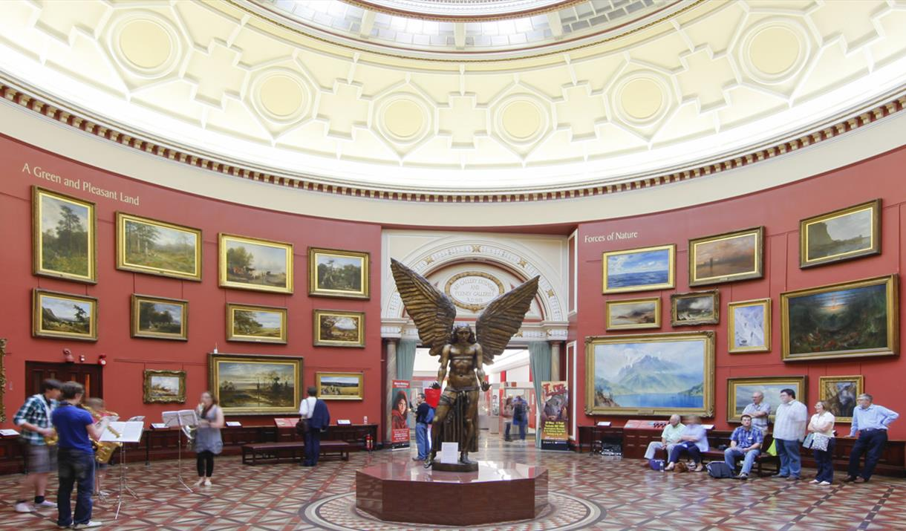
What’s On:
Collecting Birmingham: Who Is Birmingham?
https://www.birminghammuseums.org.uk/bmag/whats-on/collecting-birmingham-who-is-birmingham
18 April – 27 October 2019 – This event is free
Discover new collections that reflect the experiences of diverse Birmingham people – from working lives, to community activists and protest movements.

This is the final exhibition of the Collecting Birmingham project, an innovative acquisitions and engagement project that has collected objects and oral histories over the past three years, focusing on stories of people from Aston, Soho, Nechells and Ladywood.

This exhibition will not only showcase the objects that have been collected on the project but more importantly, it will highlight the people of Birmingham who have generously contributed their stories, and who have shared difficult and complex histories and issues.

People’s lived experiences, their achievements, their struggles and the histories that have been written-out of the popular historical narrative are an essential part of what the Collecting Birmingham project has learnt and collected.
Take a look at the people and stories in this exhibition, how do your experiences of Birmingham differ?

Within and Without:Body Image and the Self
https://www.birminghammuseums.org.uk/bmag/whats-on/body-image
22 July – 1 September 2019 – This event is free
The exhibition examines how social, historical and cultural factors affect body image and how this is expressed through objects and artworks. It explores how body image impacts on issues such as social status, gender, stage of life, health, aesthetics, religion, politics and sexuality.
The theme has been shaped into a single narrative selected by volunteers working with staff on the exhibition’s development.

The Body Image exhibition is the second to take place in our Story Lab gallery. This space invites our visitors to help shape the future of the museum.

What stories should the museum tell? How should objects be displayed? What is missing? Explore the theme of Body Image and contribute your ideas to the exhibition.

Home of Metal presents Black Sabbath - 50 Years

https://www.birminghammuseums.org.uk/bmag/whats-on/home-of-metal-presents-black-sabbath-50-years

26 June - 29 September 2019
Monday - Thursday 10am - 5pm - Friday 10.30am - 5pm – Fee £13.57

A major exhibition exploring the legacy of Black Sabbath and their global fan base. A blockbuster exhibition devoted to the music that was born in and around Birmingham. Music that turned up the volume, down-tuned the guitars, and introduced a whole new meaning to the word ‘heavy’.

The exhibition celebrates Black Sabbath from the perspective of their fans, to show the impact and cultural legacy of the band as pioneers of Heavy Metal, and to celebrate this unique, significant part of British music heritage.
Formed in Aston, Birmingham England in 1968 and cited as the pioneers and godfathers of Heavy Metal, Black Sabbath was founded by Tony Iommi, Geezer Butler, Ozzy Osbourne and Bill Ward. The exhibition aims to explore how the music of four working class lads captured the hearts and minds of fans globally. A testament to their loyalty, the exhibition will pay homage to the fan’s devotion and document the fifty-year relationship.

This immersive exhibition will feature historical photos, ephemera, and memorabilia sourced directly from the band members as well as portraits and stories from the Home of Metal fan archive that mark this unique moment in history.

Morag Myerscough, one of the UK’s most acclaimed designers will design Home of Metal: Black Sabbath – 50 Years for the Gas Hall in Birmingham Museum & Art Gallery, the largest exhibition space in a museum or gallery outside London.
Visit the Home of Metal website: https://homeofmetal.com

The Coffin Works, Fleet Street
http://www.coffinworks.org

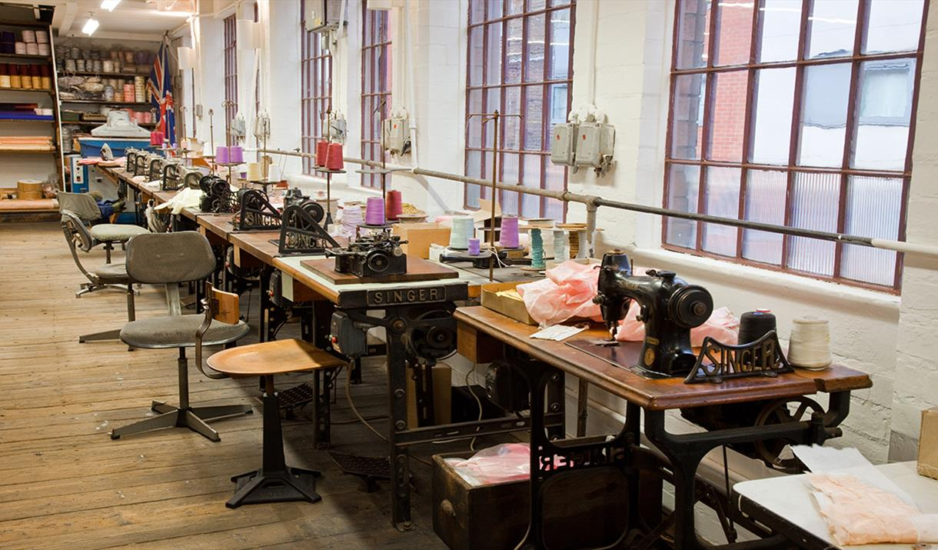

The shelves and workbenches at Newman Brothers are full of original stock and tools of the trade. With the original machinery working again, you can truly experience how this old Jewellery Quarter firm once operated on a day-to-day basis, producing some of the world's finest coffin furniture, including the fittings for the funerals of Churchill, Chamberlain and the Queen Mother. Travel back in time to experience how Newman Brothers operated during its heyday, entering a 1960s time capsule where the sounds of the day mingled with the industrial sounds of a working factory.

Back to Backs – Hurst Street, Birmingham
Birmingham Back to Backs
https://visitbirmingham.com/things-to-see-and-do/back-to-backs-p1321241

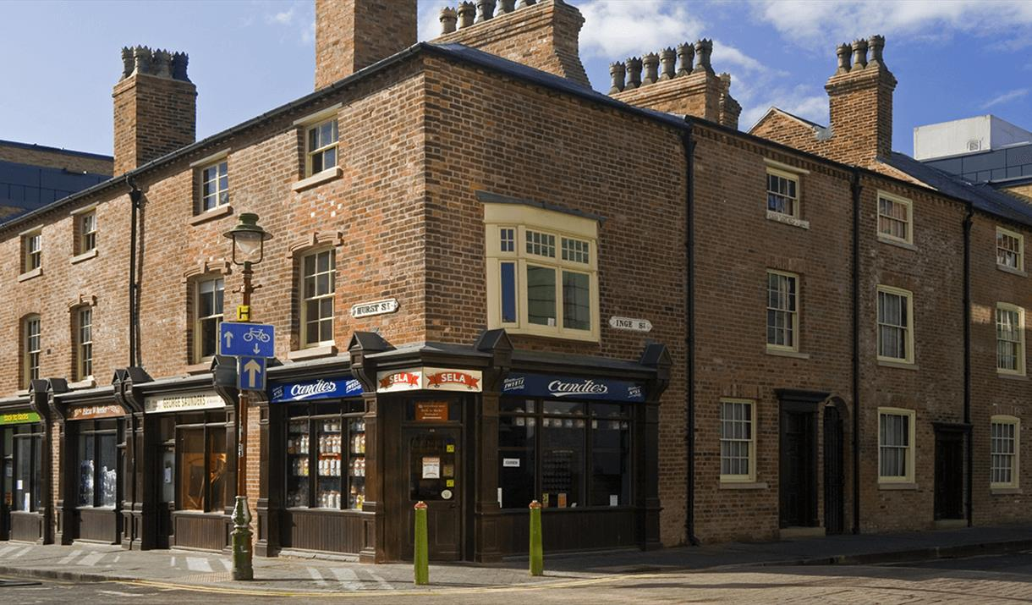

Court 15 - Birmingham’s last remaining court of Back to Back houses. Follow a trained tour guide, where you will hear stories from over 200 years of history as you learn about the people and families who called these houses and the city of Birmingham home.

**Please note you need to book a tour, guided tours only, national trust property, bring your membership if you have one.

If you wish to visit the Midlands’ last example of Back to Back housing, you will need to book a tour. For further information on how to book please visit the webpage:
https://www.nationaltrust.org.uk/birmingham-back-to-backs/features/how-to-book-your-visit-to-the-birmingham-back-to-backs

Telephone number: phone 0121 666 7671 between 11am and 3 pm
Email address: backtobacks@nationaltrust.org.uk

Winterbourne House and Garden, Edgbaston Park Road (close to the Conference Centre)
https://visitbirmingham.com/things-to-see-and-do/winterbourne-house-and-garden-p322981

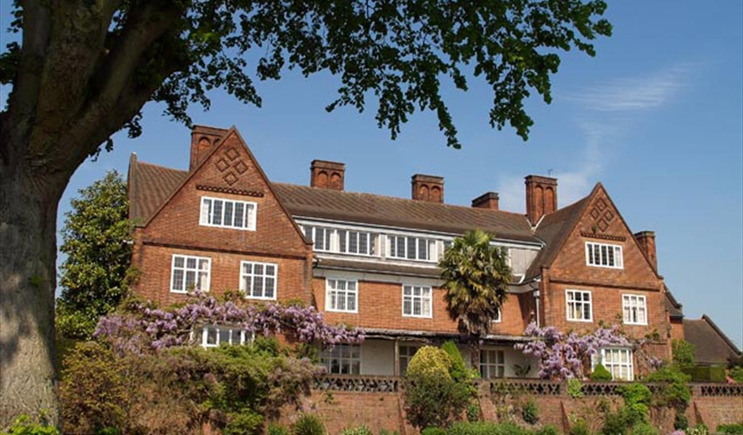

Tel: 0121 414 3003 – Entry fee £7.20 per ticket

Restored to its Edwardian Arts and Craft splendour, Winterbourne House is a unique heritage attraction – set within seven acres of beautiful botanic gardens.

Only minutes from Birmingham city centre, Winterbourne is one of the best surviving examples of an Edwardian Arts and Crafts suburban villa garden.
Offering colour and interest throughout the year, the seven acre Grade II listed garden is home to a beautiful walled garden, striking colour themed borders, original sandstone rock garden and stream side planting.
Inside, exhibition rooms on two floors tell the history of the house and its owners.
The garden also displays plants from around the globe with collections of plants from China, North and South America and the alpine areas of the world. There is a programme of public garden events running throughout the year including open days, special interest tours, local heritage days and music concerts. Visitors can enjoy lunch or refreshments in the terrace tea room.

Lapworth Museum of Geology, University of Birmingham
https://www.birmingham.ac.uk/facilities/lapworth-museum/index.aspx

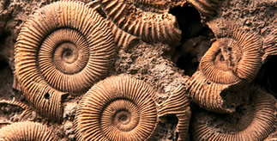

The Lapworth Museum of Geology is now open following an extensive redevelopment. Visitors can now enjoy a state-of-the-art museum experience showcasing one of the UK’s most outstanding rock, fossil and mineral collections, through a range of innovative and interactive exhibits – all completely free of charge.

On the University of Birmingham campus, a five minute walk from the University Station. Building number R4 in the red zone of the University campus map.

Opening times
Monday - Friday: 10am - 5pm
Saturday and Sunday: 12 noon - 5pm

The Barber Institute of Fine Arts
https://www.birmingham.ac.uk/university/campus-destination/barber.aspx

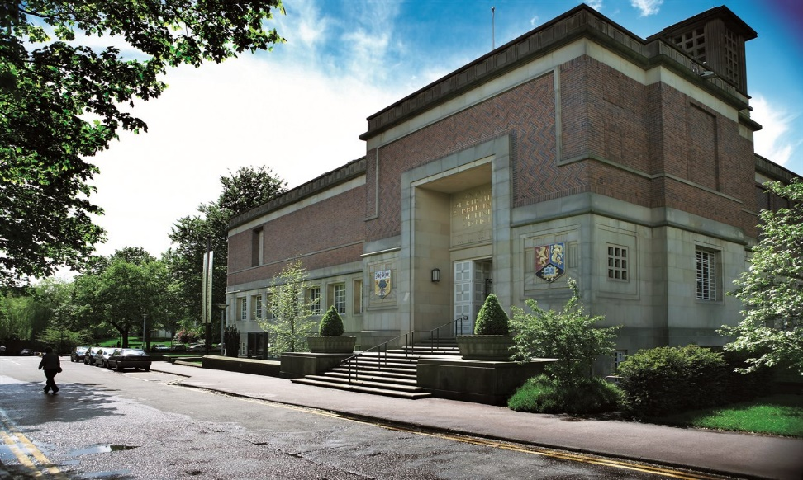

Free Admission – open Monday – Friday 10am – 5pm Saturday & Sunday 11am – 5pm

The Barber Institute of Fine Arts is housed in one of Birmingham’s finest Art Deco buildings. Whether you are enchanted by Monet, captivated by Rossetti or inspired by Van Gogh, the Barber houses one of the finest small collections of European art in the UK.

The Barber's collection includes prime examples by many of the greatest visionaries in the history of Western art including Botticelli, Bellini, Rubens, Van Dyck, Poussin, Claude, Gainsborough, Turner, Ingres, Manet, Monet, Renoir, Degas, Van Gogh, Gauguin and Magritte. Perhaps best known for its major French 19th Century paintings, including world-class Impressionist masterpieces, the gallery also boasts beautiful Renaissance panel paintings and key canvases by Baroque Italian and Dutch and Flemish masters. The collection is enhanced by a year-round programme of exciting temporary exhibitions.
The Barber Institute lives the vision of its founder, Lady Barber, who wished to establish a centre ‘for the study and encouragement of art and music’. The jewel in the cultural crown of the University of Birmingham, it uses its world-class collections to create inspirational opportunities for learning and enjoyment for all. It is also home to a concert hall, which hosts a series of top classical concerts by international soloists, ensembles and orchestras; including the free Friday lunchtime concerts.
Cadbury World, Bournville (one train stop away from Birmingham University)
https://www.cadburyworld.co.uk/en

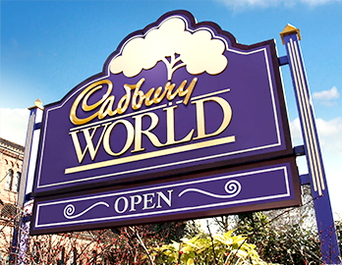

There's so much to see and do in Cadbury World's chocolatey zones. From learning how your favourite confectionery is made and uncovering the fascinating story of Cadbury chocolate, to playing in chocolate rain and adding your favourite treat to a delicious pot of warm liquid Cadbury Dairy Milk whilst you watch our chocolatiers reveal the secrets of traditional chocolate making. You'll discover the origins of the cocoa bean amidst trees and waterfalls in the Aztec Jungle, before jumping on board the magical Cadabra ride and visiting the 4D Chocolate Adventure zone, a 4D cinema experience featuring Cadbury's most popular characters.

Pre-book tickets to guarantee entry.

Birmingham Jewellery Quarter, St. Pauls Square
https://jewelleryquarter.net/visiting

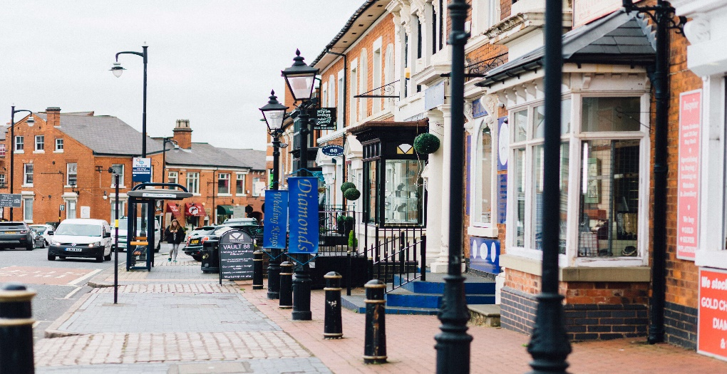

This area of unique character has been described by English Heritage as a ‘national treasure’ and as having a ‘particular combination of structures associated with jewellery and metalworking which does not seem to exist anywhere else in the world’.
The Quarter contains one of Europe’s largest concentration of manufacturing jewellers. Combining the very best of traditional craftsmanship with innovative designs and high-quality materials, they create beautifully crafted custom jewellery.

Also nestled in amongst these businesses is also the Quarter’s non-jewellery independents ranging from drinks merchants, florists, chocolatiers and home furnishings.

Museum of the Jewellery Quarter, 75-80 Vyse Street, Birmingham
https://www.birminghammuseums.org.uk/jewellery

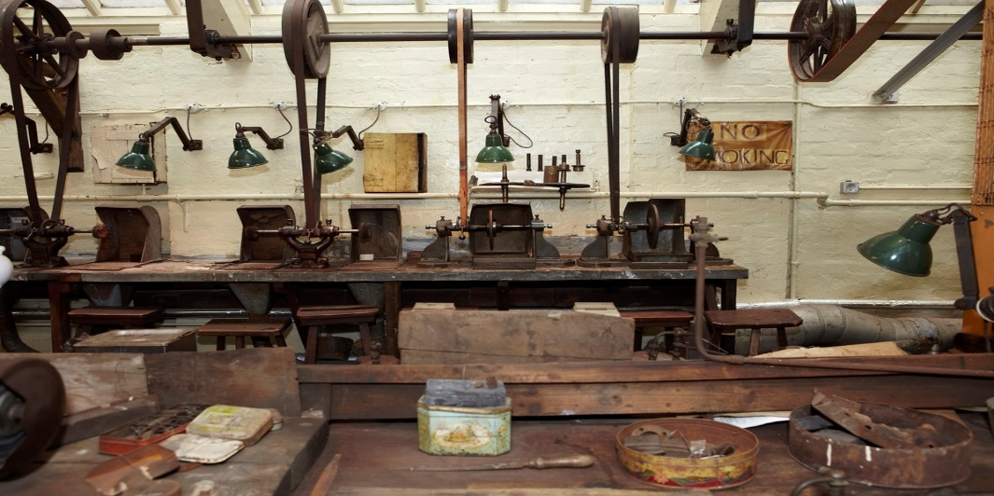

Opening Times: Tuesday – Friday 10.30am - 4pm, Saturday 10.30am until 5pm

The Museum of the Jewellery Quarter is built around a perfectly preserved jewellery workshop offering a unique glimpse of working life in Birmingham’s famous Jewellery Quarter.

When the proprietors of the Smith & Pepper jewellery manufacturing firm retired in 1981 they simply ceased trading and locked the door, unaware they would be leaving a time capsule for future generations.

Today the factory is a remarkable museum, which tells the story of the Jewellery Quarter and Birmingham’s renowned jewellery and metalworking heritage.
Explore this extraordinary time capsule on a lively guided tour. Watch live demonstrations at the jewellers’ bench of the traditional skills of this fine trade, and discover what it was like to work here.

The museum also contains two self-led galleries – 'Story of the Jewellery Quarter' which explores the history and development of the Jewellery Quarter and 'Earth’s Riches' which displays jewellery made from natural materials from across the world.

Pen Museum, Jewellery Quarter
Unit 3, The Argent Centre, 60 Frederick Street, Birmingham B1 3Hs

https://penmuseum.org.uk/

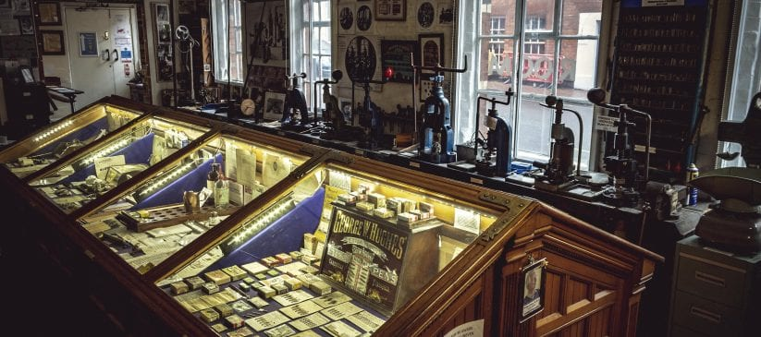

Phone: 0121 236 9834
Open: Tuesday – Saturday 11:00 am – 4:00 pm

IMMERSE YOURSELF IN THE EXCITING WORLD OF PENS AND CALLIGRAPHY AND EXPLORE OUR AMAZING COLLECTION.

5,000+ OBJECTS FROM BIRMINGHAM’S STEEL PEN TRADE.

The Pen Museum focuses on the important legacy of Birmingham’s 19thCentury pen trade and its significant contribution to improving literacy throughout the world. It’s located in a former pen factory, built in 1863, where visitors experience writing with feather quills and steel nibs and can also make their own nib using traditional methods. The Museum narrates the interesting lives, stories and important expertise of manufacturers, owners and workers that resulted in Birmingham once manufacturing 75% of the world’s pens. Our team are also happy to answer (where possible) general questions about pens.

Soho House – Home of Matthew Boulton from 1766 – 1809
Soho Avenue, (off Soho Road), Birmingham B18 5LB
https://www.birminghammuseums.org.uk/soho/about

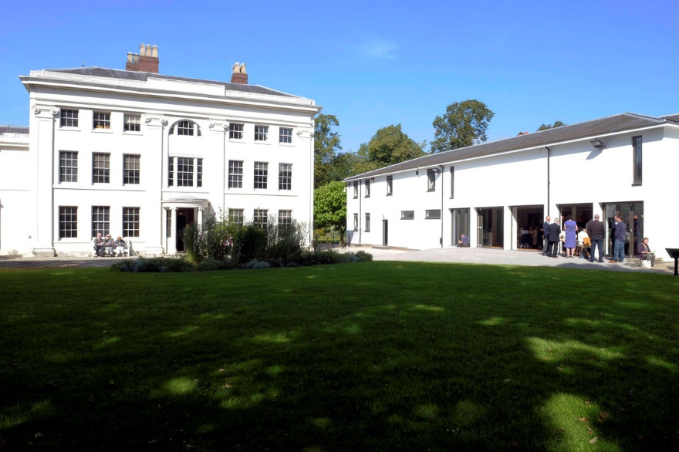

Opening times Wed – Thursday 11 am – 4pm Entry Fee: £7
Phone: 0121 348 8150

Soho House was the elegant home of the industrialist and entrepreneur Matthew Boulton from 1766 to 1809.

The house has been beautifully restored and reflects the fashions and tastes of the late Georgian period.

There’s also the chance to see some of the products of Boulton’s nearby factory – where buttons and buckles, clocks and vases, and silver and Sheffield plate tableware were made – and where he developed the steam engine in partnership with James Watt.

Soho House was also a favourite meeting place of the Lunar Society, a leading Enlightenment group. The Lunar Society would meet every month on the night of the full moon to dine, conduct experiments, and discuss philosophical matters of the day.

Members of the society included Erasmus Darwin, James Watt and Joseph Priestly who all gathered around the Lunar Room table and engaged in a lively exchange of ideas which inspired many new discoveries and inventions.
Birmingham Library, Broad Street
https://www.tripadvisor.co.uk/Attraction_Review-g186402-d2457263-Reviews-Library_of_Birmingham-Birmingham_West_Midlands_England.html

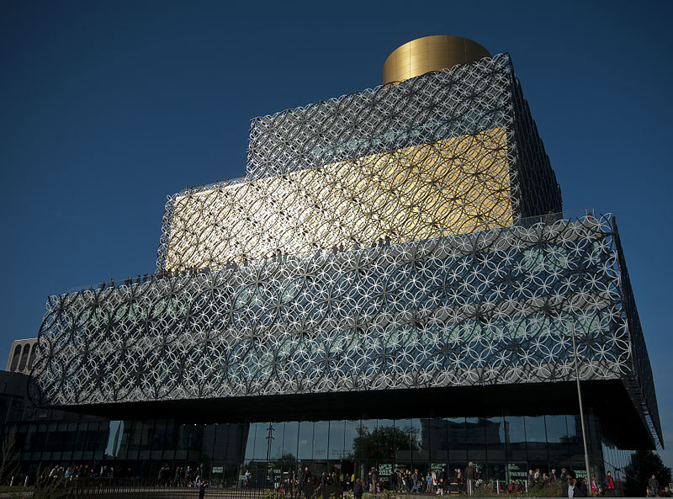

About

The Library of Birmingham is a public library in Birmingham, England. It is situated on the west side of the city centre at Centenary Square, beside the Birmingham Rep (to which it connects, and with which it shares some facilities) and Baskerville House. Upon opening on 3 September 2013, it replaced Birmingham Central Library. The library, which is estimated to have cost £188.8 million is viewed by the Birmingham City Council as a flagship project for the city's redevelopment. It has been described as the largest public library in the United Kingdom, the largest public cultural space in Europe, and the largest regional library in Europe. 2,414,860 million visitors came to the library in 2014 making it the 10th most popular visitor attraction in the UK. Go to the Library’s secret garden for a view over Birmingham

Birmingham Botanical Gardens – Westbourne Road, Edgbaston
https://www.birminghambotanicalgardens.org.uk/

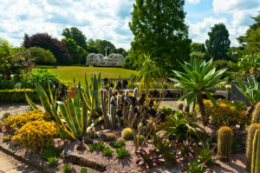
Opening times Monday – Sunday 10 am – 6pm Tickets £7.50

Being one of Birmingham’s best attractions, The Birmingham Botanical Gardens offers something for everyone, be it one of our four stunning glasshouses showing tropical rainforest to arid desert, playground, tearoom and garden gift shop all surrounded by some of the most beautiful gardens in the UK.

There are four glasshouses which range from our exotic Tropical House through to our Subtropical, Mediterranean and Arid Houses. There is a large lawn in front of the glasshouses with a range of beds and shrubberies around its perimeter. Overall, the character is that of a Victorian public park with a bandstand set in 15 acres (6.1 ha) of landscaped greenery. The gardens are approximately 0.7 miles from the University and a 15/20 minute walk from Chamberlain Halls of Residence.

Selfridges & John Lewis, The Bull Ring Shopping Area and Grand Central Station

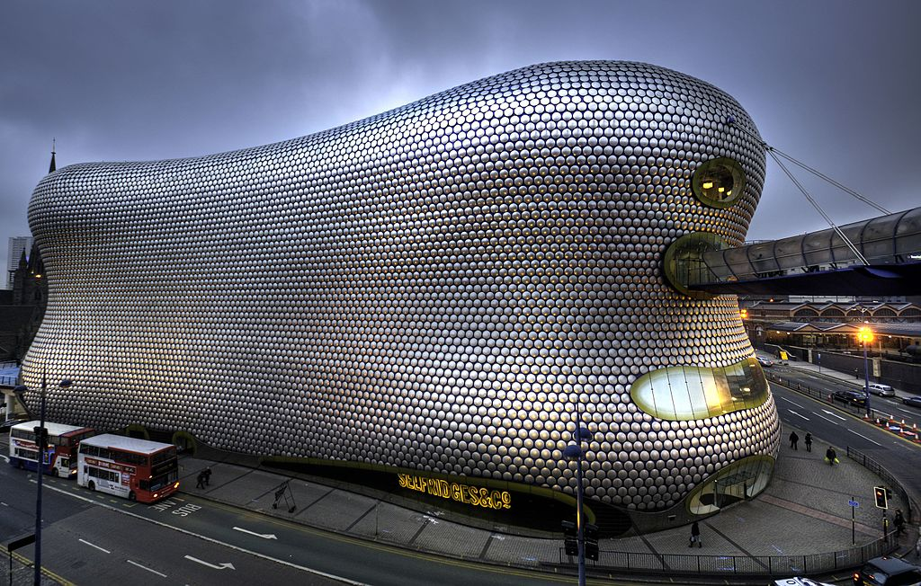

Selfridges – above Opening Times Mon- Wed 10.00 am – 8.00 pm

Thurs- Fri 10.00 am – 9.00pm

About

Bullring, Grand Central and LinkStreet have teamed up to become THE shopping destination in Birmingham.
Part of the Bullring Estate, Grand Central is Birmingham’s newest prime shopping centre, located above New Street Station and next to the Bullring.
Anchored by a 250,000 sq ft. John Lewis store, the centre offers brands including Hobbs, The White Company, Cath Kidston and Carluccio’s, Selfridges.
You'll find all Grand Central has to offer in the Shops and Restaurant directory as well as the centre map.

Brindley Place, Broad Street, Birmingham
https://www.brindleyplace.com/

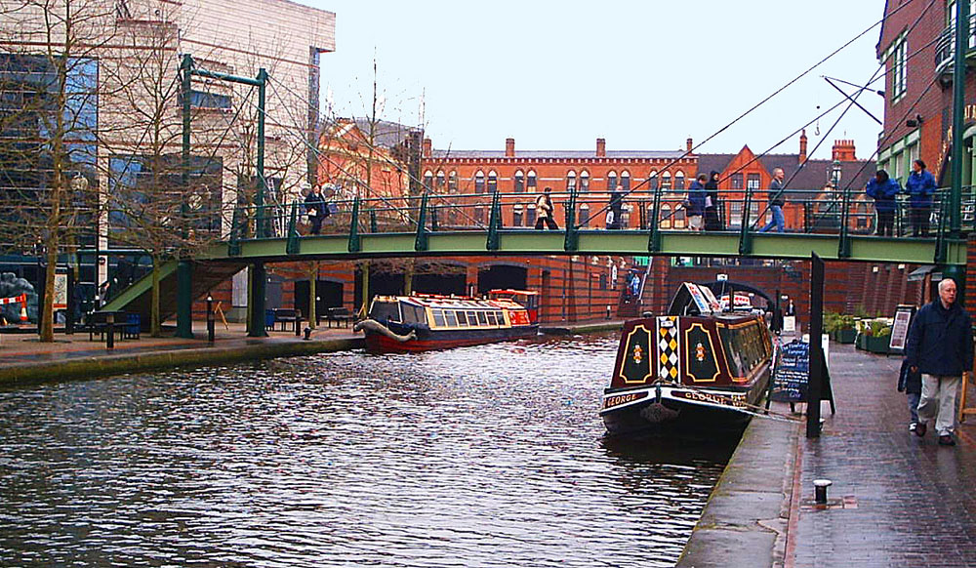

The BCN Main Line canal of the Birmingham Canal Navigations between the International Convention Centre (left) and Brindleyplace (right) in central Birmingham

Home of Sea Life Centre, Canals, Pubs, Clubs, Restaurants, Symphony Hall, Ikon Gallery

Tree-lined squares, International cuisine and an enviable canal side location make Brindley Place one of Birmingham’s most exciting destinations.

Brindley Place is perfectly positioned next to Arena Birmingham (formally the NIA) and the International Convention Centre (ICC) home to the Symphony Hall making it an ideal place for a pre-concert meal and drinks. It is also well connected being just a ten minute walk from New Street Station and just off Broad Street which is served by local buses.

Ikon Gallery, Brindley Place, off Broad Street
https://www.ikon-gallery.org/

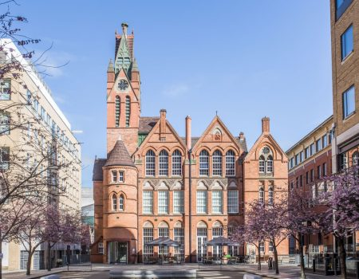

Ikon is an internationally acclaimed contemporary art venue located in Birmingham, UK.
The gallery features temporary exhibitions over two floors. Ikon shows work by artists from around the world and a variety of media is represented, including sound, film, mixed media, photography, painting, sculpture and installation.
Free entry, donations welcome
Standard Opening Times
Tuesday – Sunday, 11am-5pm
Closed Mondays except Bank Holidays
0121 248 0708
https://www.google.co.uk/maps/@52.4773719,-1.9114103,201m/data=!3m1!1e3
Restaurants/Pubs

The Balti Triangle – Highgate/Sparkhill, Birmingham
https://visitbirmingham.com/inspire-me/areas/balti-triangle

Birmingham is the original home of the Balti. From award-winning city centre restaurants to authentic family-run establishments in the Balti Triangle, no visit to Birmingham is complete without sampling the delicious flavours for yourself.
In a city full of places serving up cracking curry, Birmingham is lucky to have a specific area devoted to one particular style - the beloved balti. The Balti Triangle, just to the south of the city centre along Ladypool Road, Stoney Lane and Stratford Road, was named for the number of eateries serving up curries using the balti method. The Balti triangle is approximately 30 minutes away from the University by public transport, bus, rail or taxi.

Dilshad Restaurant 618-620 Bristol Road, Selly Oak
https://www.dilshad.uk.com/menu

This is in the student quarter, cheap and cheerful fare

The name Dilshad translates quite literally as “heart’s happiness” and this is the ethos behind the taste and flavours on offer in the menu.
Dilshad brings the love for authentic Indian food to the heart of Birmingham- committed in providing excellence in refined and creative cuisine, which has been recognised in the form of numerous awards, including “Best Indian Food” and also a 5 star rating from thebaltiguide.com. The menu incorporates both traditional classic flavours and innovative original new dishes.

The Attic - Bournville
http://atticbrewco.com/where-to-find-us/

Located at Unit 3R2, Mary Vale Industrial Estate, Stirchley B30 2DA (Located opposite Bournville Train Station)
Brewed on site, pop up food
Opening Hours: Friday 4 – 10 pm Saturday 1 – 10 pm

There are numerous pubs/restaurants in the local villages of Harborne & Edgbaston examples

The Physician, Harborne Road, Edgbaston
https://www.brunningandprice.co.uk/physician/

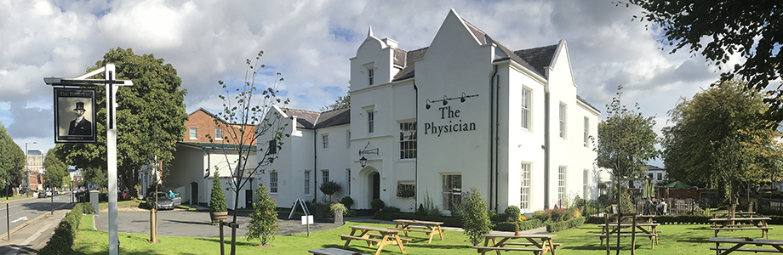

The Physician was once known as the BMI building and used to house the vast 'Sampson Gangee Library for the History of Medicine'. We believe it was commissioned in 1863 when the Calthorpe Estate expanded to accommodate a huge population growth from the turn of the 19th century. The building oozes historical grandeur; its high ceilings and large sash windows create beautiful rooms of all shapes and sizes which lend themselves perfectly to becoming a beautiful pub.
There is a huge reclaimed wooden bar at the heart of the building, housing 8 local cask ales, with plenty of room for a 50 strong wine list and array of spirits. The bar overlooks a large wooden floored room, perfect to house the hustle and bustle of drinkers in front of the open fire. It's off this area that you will find smaller rooms to squirrel away in if you choose to have more intimacy or you can opt for the light and airy garden room overlooking the flag stone walled terrace garden to the rear of the pub. There are also 2 rooms that can be used for private dining, both comfortably seating 18.

Winners of the Pub & Bar Award 2018
We are absolutely thrilled to have been awarded the 'Best Pub in the County' National Pub & Bar award.

The High Field, 22 Highfield Road, Edgbaston
https://www.highfieldedgbaston.co.uk/

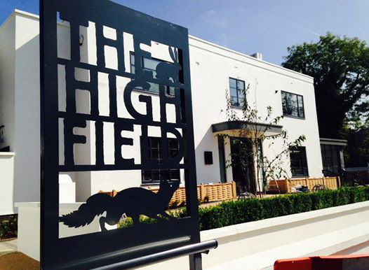

As well as serving quality fresh food in our restaurant and a range of drinks in the bar, The High Field has a spacious garden and sunny terrace. There is also public parking on-street and adjacent to our garden.

We serve food all day, along with quality draught beers, ale on hand pumps, plus a carefully chosen wine list with quality-variety value.

The Plough, High Street, Harborne
https://theploughharborne.co.uk/

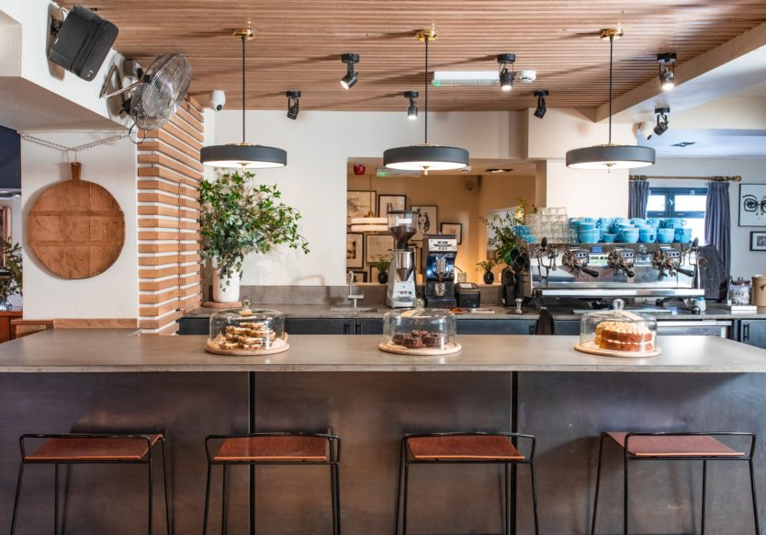
The Plough is an independent eatery that has been serving the people of Harborne since 2003. We offer freshly cooked comfort food, pub classics, stone baked pizza and a whole range of healthy options to suit every taste. We pride ourselves on our selection of beers, quality coffee, our range of craft spirits and a carefully selected wine list that mixes classics with natural wines from tiny producers around the globe.

The Bell, 11 Old Church Road, Harborne
https://www.classicinns.co.uk/thebellharborne

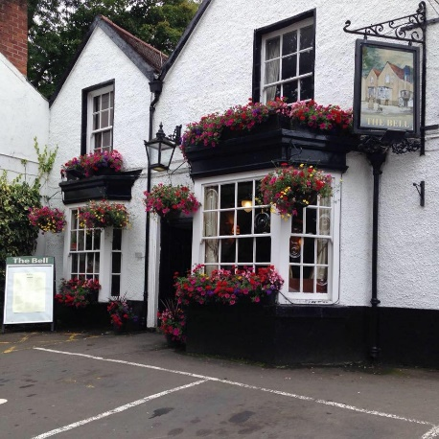
Next door to the old church of St. Phillips and mentioned in the doomsday book, “a cosy local pub with a bowling green”

The White Swan, Harborne Road
https://www.thewhiteswanpub.com
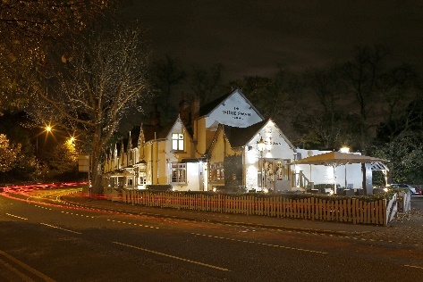

“The White Swan is a premium pub, bar and restaurant with its own courtyard.

Tap & Spile, Birmingham
http://www.tapandspilerestaurant.co.uk/

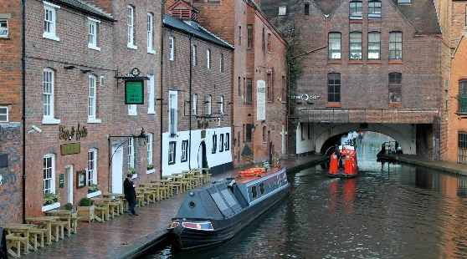

This may be just off Broad Street but it is an oasis for real ale lovers.

The Tap & Spile Pub & Restaurant can be found along the Birmingham Canal Old Line and overlooks the city’s famous Gas Street canal basin. Dating back to 1821, this impressive historical building is home to one of the city’s favourite traditional style pubs where a hearty British pub menu keeps everyone happy.

Our menu provides an extensive selection of dishes and we are certain to offer something for everyone’s tastes. We pride ourselves for our warm and friendly service and our homemade food which keep our guests coming back for more. Offering ample seating within and exterior benches for watching the canal slowly flow on sunny days, we are sure to match any mood or occasion.

Old Joint Stock – 4 Temple Row West, Birmingham
https://www.oldjointstock.co.uk/

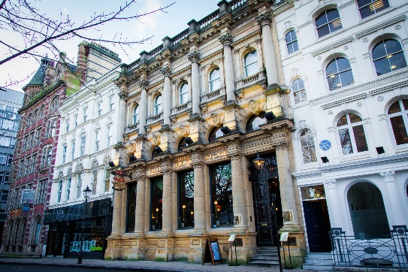

Over the top ostentatious former bank

Built in 1862 by Julius Alfred Chatwin, the establishment was originally designed as a library before becoming the Birmingham Joint Stock Bank. Lloyds Banks then took ownership of the premises in 1889 - the very same year as Birmingham recieved official City status.
More than a century later, and The Old Joint Stock is a stunning pub - making a wonderful feature of the original fixtures and fittings. One of the best pubs in Birmingham and beyond, it is the UK's highest seller of London Pride.
As well as our beautiful bar, we are also home to the Old Joint Stock Theatre, a professional 100 seat studio theatre. Our programme of shows is always busy and features everything from new writing to musical theatre to improv comedy and more! Visit our What's On page to see our upcoming shows, or pick up a programme next time you're visiting.

The Bartons Arms - 144 High Street, Aston
https://www.thebartonsarms.com/

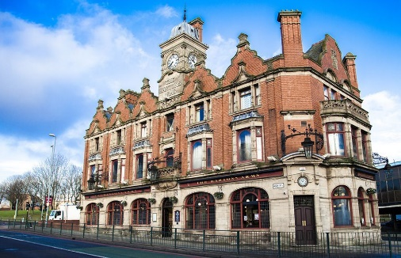

For those people who really wants to see a traditional pub in Birmingham

Welcome to The Bartons Arms. For more than 100 years this public house has stood on this site. The stunning design of the current Bartons Arms remains one of the finest examples of Victorian pub architecture and one of the most beautiful pub interiors in the country.
The existing building was built in 1901 at a cost of some £12,000 on the site of a former pub purchased for £10,000. Designed by a Mr. Brassington of James and Lister Lea, the area’s primary pub building firm at the time, to be the flagship of the Mitchell and Butlers brewery estate. While the exterior, sporting a foursquare clock tower is in an imposing brick and stone neo-Jacobean style, said to be inspired by the nearby Aston Hall, the interior is the epitome of Victorian decorative grandeur. You will find a riot of original features, rich mahogany woodworking’s, stained and engraved windows and mirrors, snob-screens, sweeping wrought-iron staircase and what the pub is best known for, its wall to wall Minton-Hollins tiles, from shiny-glazed decorative patterns to huge painted scenes. Thai Cuisine.

Additional information and far too many to mention in more detail, but please, firstly, have a look at the ‘Brum Secrets Zine’ by Ellie Munro:
https://mbsbham.wordpress.com/2019/06/06/a-guide-to-travel-accommodation-and-food-drink-in-birmingham/

The ‘zine has a lot more options, this list includes places that, are good for vegetarians or vegans, or are corrections/additions to the ‘zine. These are all independents – Birmingham has plenty of options if you’re looking for chain restaurants.

Birmingham City Centre
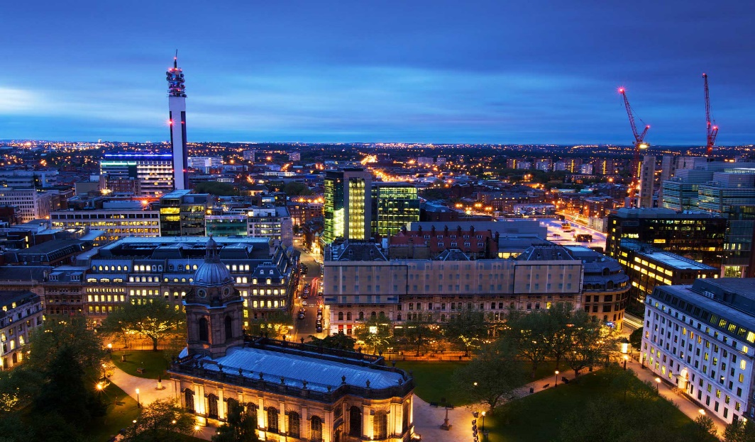

Original Patty Men’s sister bar, Kilder has an amazing range of craft beers and a cheese & meat based menu (these are the best cheese toasties in town, hands down; the OPM vegetarian burger is fabulous – ‘wing Wednesdays’ also have a veggie and sometimes vegan option).
https://www.kilderbar.co.uk/ & http://originalpattymen.com/

Clink beer is now (due to a trademark issue) known as Beer Digbeth @beerdigbeth, Gibb Street, & is close to Baked in Brick (fantastic pizzas) https://bakedinbrick.co.uk/
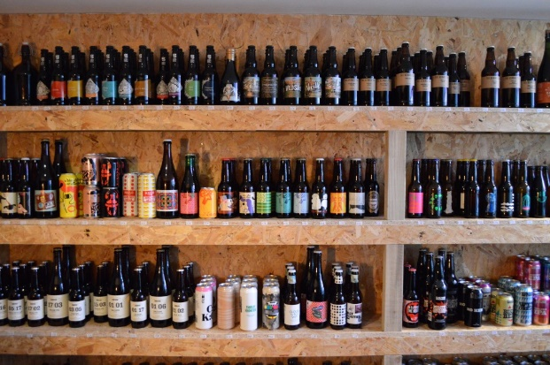

Digbeth diner on Lower Trinity Street – a collective of street food stalls – always has vegetarian/vegan options, and specialises in them on Thursday nights. https://www.digbethdiningclub.com/ - but to see the menu/line up check their social media @digbethdiner

Natural Bar and Kitchen on Suffolk Street- Fully vegan restaurant in slightly unlikely location, the ‘pay by weight’ buffet is particularly popular http://www.naturalbar.co.uk/

Also good for the vegetarians/vegans in the zine: Cherry Reds, Warehouse Café, Yorks Café (several branches in town), and Damascena (middle eastern food, also based in Harbourne and the original in Moseley).

Edgbaston

Blue Piano - Harborne Road
Don’t be put off by the slightly odd exterior & website, this does great Southeast Asian food, with a full vegan menu http://www.thebluepiano.co.uk/
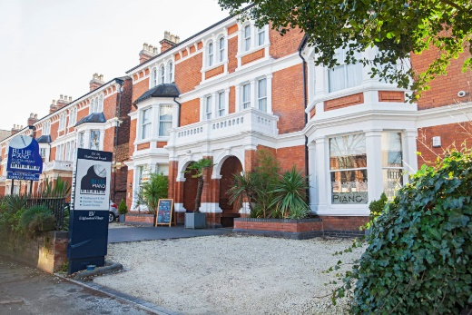

Loki
Second branch of the city centre wine bar – a great system where you can buy ‘samples’ of dozens of wines. Deli (cheese/meat) food. https://www.lokiwine.co.uk/edgbaston/

Laghi’s Deli – Islington Row
Local favourite, Italian deli & small restaurant (hand made pasta) http://laghis.com/

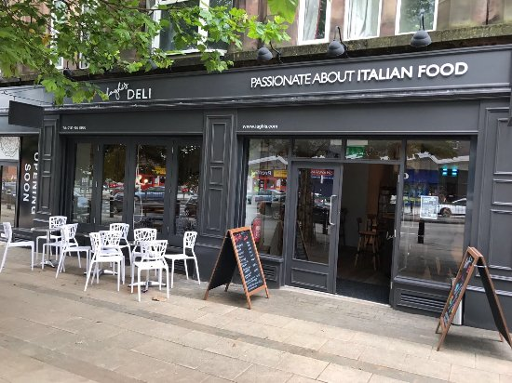

Harborne
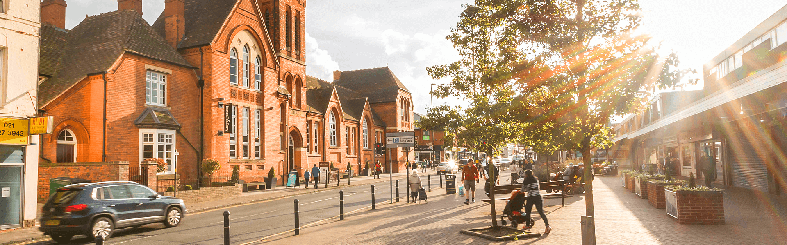

Paper Duck – craft beer focused. No in-house food but you can order from Wok Chi next door and eat in the bar! @thepaperduck & http://wokchi.co.uk/

Kings Heath
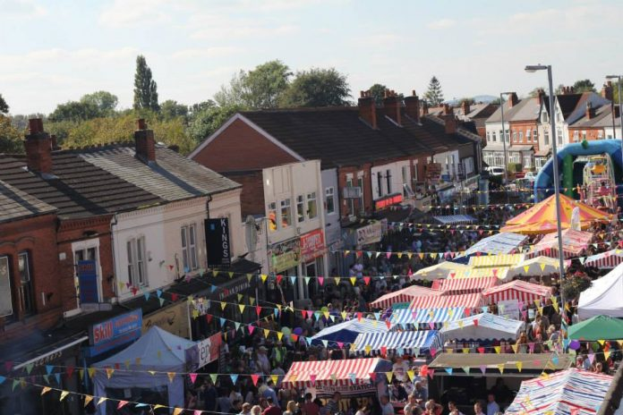

Has also boomed in the last 18 months: probably the best brunches in town are available here

Bloom Poplar Road, – incredible breakfast and brunch. No reservations so turn up early for the weekend. https://www.bloomkingsheath.com/

Early Bird – imaginative brunch dishes and absolutely stunning patisserie & bakery goods. Go with an appetite. https://theearlybirdbakery.co.uk/

The Juke – Craft beer. Food pop-ups usually Wed – Sunday, check in advance although generally Thursday night is the vegetarian/vegan specialist in-house @thejukebars https://www.facebook.com/thejukebars/

Poli – absolutely the most hipster, instagrammable new opening in Birmingham this year. Also, delicious. Pizza focused but the sides are incredible. Booking advised. @polikingsheath https://www.facebook.com/POLIKingsHeath/

Grace & James – natural and organic wine bar owned by the people who run Poli (who are not called Grace & James); cheese platters and vegan cheese available to snack on. https://www.facebook.com/graceandjameskh/

Hop & Scotch – bar focusing on craft beers and whisky (hence the name). currently no food, but a good range of crisps. @hopscotch_Brum https://www.facebook.com/HopScotchBrum/

Moseley
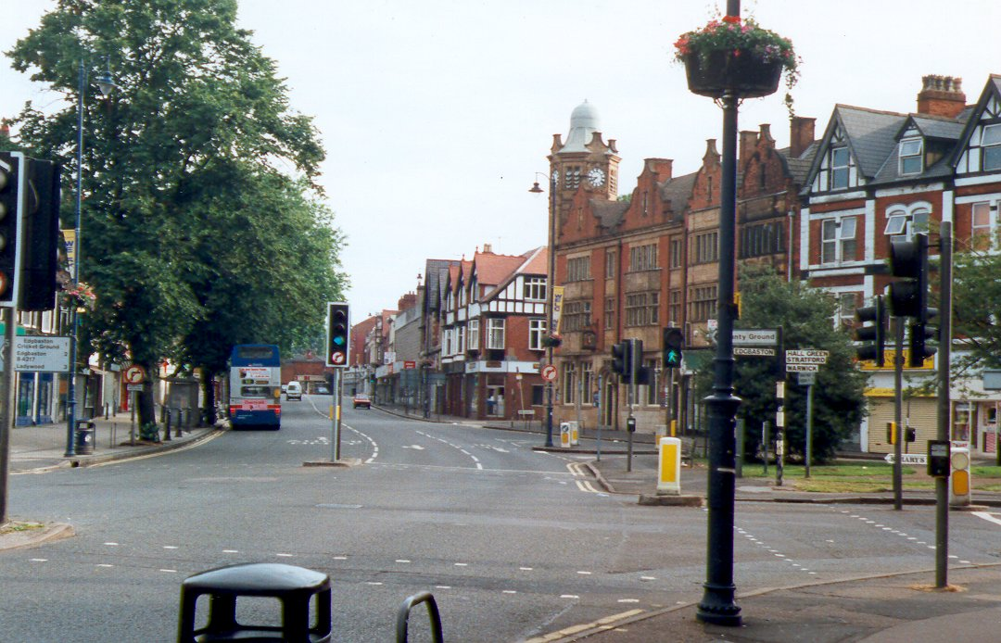
Moseley Folk & Arts Festival 30 Aug – 1 Sept 2019
https://www.moseleyfolk.co.uk/

Dark Horse – BBQ and pizza, surprisingly large number of vegetarian options. ‘hearty’. http://www.darkhorsemoseley.co.uk/

Damascena, Alcester Road- original branch of the middle-eastern restaurant/café http://damascena.co.uk/

Zindiya – indian street food (there’s been a lot of these opening in the city centre recently, but Zindidya remains the original & best) https://www.zindiya.co.uk/

Stirchley
Has really boomed in recent years; there is now a ‘Stirchley Mile’ if you have the stamina:

Attic Brew Co. have a range of food pop-up options in their warehouse like brewhouse, usually vegetarian options but check ahead https://www.facebook.com/atticbrewco/

Caneatcafe are mostly brunch and lunch but sometimes do evening events http://www.caneat.co.uk/

Ditto Loaf, a bakery doing bread, cakes and lunch – there will be queues out of the door just before opening time https://loafonline.co.uk/bakery/

Wildcat Tap, great craft beers https://stirchleywildcat.co.uk/

Cork & Cage, yet more craft beers with an emphasis on sours and wilds, but also with fabulous Turkish food (lots of veggie options) https://corkandcage.co.uk/

Eat Vietnam – just opened! https://www.facebook.com/eatvietnamuk/

Opening soon:
Glasshouse brewroom https://www.facebook.com/glasshousebeerco/

High End dining
If you’re after something really special or fancy, and can book in advance, these are the best options in Birmingham

Michelin starred:
Adams (city centre) https://www.adamsrestaurant.co.uk/
Carters (Moseley) https://cartersofmoseley.co.uk/
Purnells (city centre) https://purnellsrestaurant.com/
Simpsons (Edgebaston) https://www.simpsonsrestaurant.co.uk/

Not starred but close in quality:
Folium (city centre/Jewellery quarter) https://www.restaurantfolium.com/home/
Harbourne Kitchen (Harbourne) https://www.harbornekitchen.com/
Wilderness (city centre) https://www.wearethewilderness.co.uk/

Finally: one of the best guides to eating & drinking in Birmingham is the Independent Birmingham website: https://www.independent-birmingham.co.uk/

Cinemas
There are other cinemas in Birmingham but here are few suggestions:

Cineworld – Birmingham Broad Street
https://www.cineworld.co.uk/cinemas/birmingham-broad-street

Odeon - Birmingham New Street
https://www.odeon.co.uk/cinemas/birmingham_new_street

Everyman - Mailbox Birmingham
https://www.everymancinema.com/mailbox-birmingham

Theatres:
There are other theatres in Birmingham but here are few suggestions:

Birmingham Hippodrome – Hurst Street
https://www.birminghamhippodrome.com/

The Alexandra – Suffolk Street
https://www.atgtickets.com/venues/alexandra-theatre-birmingham/

Birmingham Repertory Theatre – Broad Street
https://www.birmingham-rep.co.uk/

