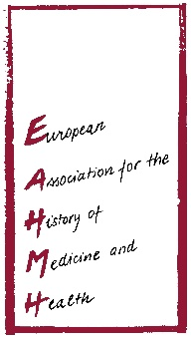
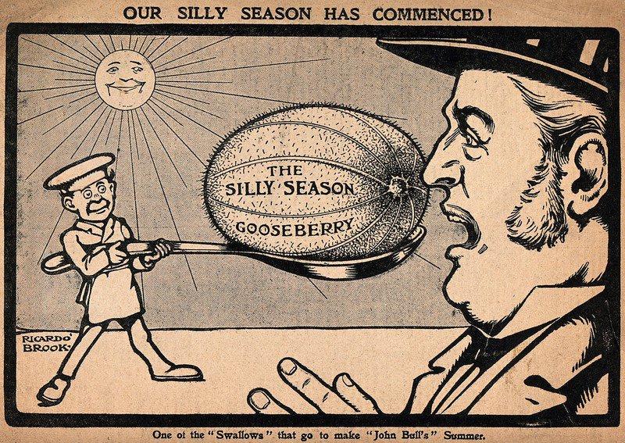
Sense and Nonsense
S3N$e & nonβNz^{e}

European Association for the History of Medicine and Health
2019 Biennial Conference

University of Birmingham, Edgbaston | 27th - 30th August
PROGRAMME GUIDE

Sense and Nonsense
European Association for the History of Medicine and Health
30th Anniversary Conference August 2019
Birmingham, England | 27th – 30th August 2019

University of Birmingham Medical School
University of Birmingham Edgbaston Park Hotel and Conference Centre

Welcome to the European Association of the History of Medicine and Health Biannual Conference August 2019 during this 30th Anniversary year of the Association.
An exhibition of memorabilia, photographs, and programmes will be on display in the University of Birmingham Medical and Dental School and Conference Centre.
The Conference venue is the University of Birmingham Medical and Dental School for the registration and welcome reception on Tuesday 27 August with the full Conference event taking place at the University of Birmingham, Edgbaston Park Hotel and Conference Centre.

Keynote Speakers
Ludmilla Jordanova – Visual Culture in the Department of History, Durham University
Tracey Loughran – Faculty of Humanities, University of Essex
Robert Jutte – Institute for the History of Medicine of the Robert Bosch Foundation, in Stuttgart
Vanessa Heggie – History of Medicine, University of Birmingham

Hosted by the University of Birmingham - Institute of Applied Health Research

Cover Image “the Silly Season” courtesy of Wellcome Collection

EAHMH Scientific Board

Officers

President
Jonathan Reinarz, Birmingham (UK)
Past-President
Octavian Buda, Bucharest (Romania)
Chairperson
Frank Huisman, Utrecht and Maastricht (The Netherlands)
Secretary
Post currently vacant
Treasurer
Jonathan Simon, Lyon (France)
Members
Laurinda Abreu, Lisbon (Portugal)
Heiner Fangerau, (Germany)
Anne Hardy, London (Great Britain)
Hilary Marland, Warwick (Great Britain)
Noortje Jacobs, Rotterdam (Netherlands)
Alfredo Menéndez-Navarro, Granada (Spain)
Hannah Newton (Reading)
Kaat Wils, Leuven (Belgium)
University of Birmingham “A Brief History”

The University grew out of the radical vision of our first Chancellor, Joseph Chamberlain. Founded in 1900, Birmingham represented a new model for higher education. This was England’s first civic university, where students from all religions and backgrounds were accepted on an equal basis.
Birmingham has continued to be a university unafraid to do things a little differently, and in response to the challenges of the day. It was a founder member of the National Union of Students and the first university in the country to:
- be built on a campus model
- establish a faculty of commerce
- incorporate a medical school
- offer degrees in dentistry
- create a women’s hall of residence
- have a purpose-built students’ union building

The University of Birmingham was established by Queen Victoria by Royal Charter in 1900 and was the UK’s first civic or 'redbrick' university. The first phase of building work on the campus was completed in 1909 under the auspices of the esteemed architect Sir Aston Webb. We celebrated the centenary of those buildings in July 2009.

Chamberlain was amongst the most visionary politicians of his time and his impact on the city of Birmingham, beyond the establishment of the University was immense, particularly in his improvements to living conditions and education. Thanks to Chamberlain's tireless work, the University was granted a Royal Charter by Queen Victoria on 24 March 1900 - and with the generous donation of land and funds, the University of Birmingham was born.

Mason College

The University grew out of Mason College, which can trace its roots back to the medical education seminars of Mr John Tomlinson in 1767–68. He was ‘First Surgeon’ to the Birmingham Workhouse Infirmary and his 28 weekly lectures on anatomy were the first ever held outside London or south of the Scottish border. Mason Science College itself was founded by Kidderminster-born Josiah Mason in 1875. From humble beginnings, Mason made his fortune by mass-producing key rings, pens, pen nibs and electroplating.
He became one of the country’s most esteemed industrialists and philanthropists and was knighted for his generosity in establishing a great orphanage in Erdington, a suburb of Birmingham. The College became Mason University College in 1898 with the Right Honourable Joseph Chamberlain MP becoming the President of its Court of Governors.

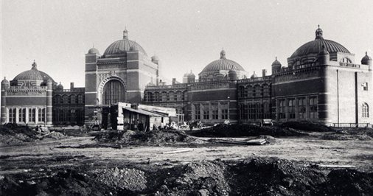
University of Birmingham – Aston Webb
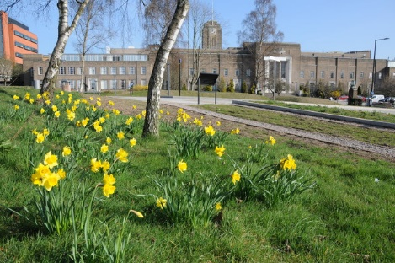
University of Birmingham – Medical and Dental School

Tuesday 27 August
Registration & Introductory Talk
Welcome Reception

Floor plans of Medical & Dental School
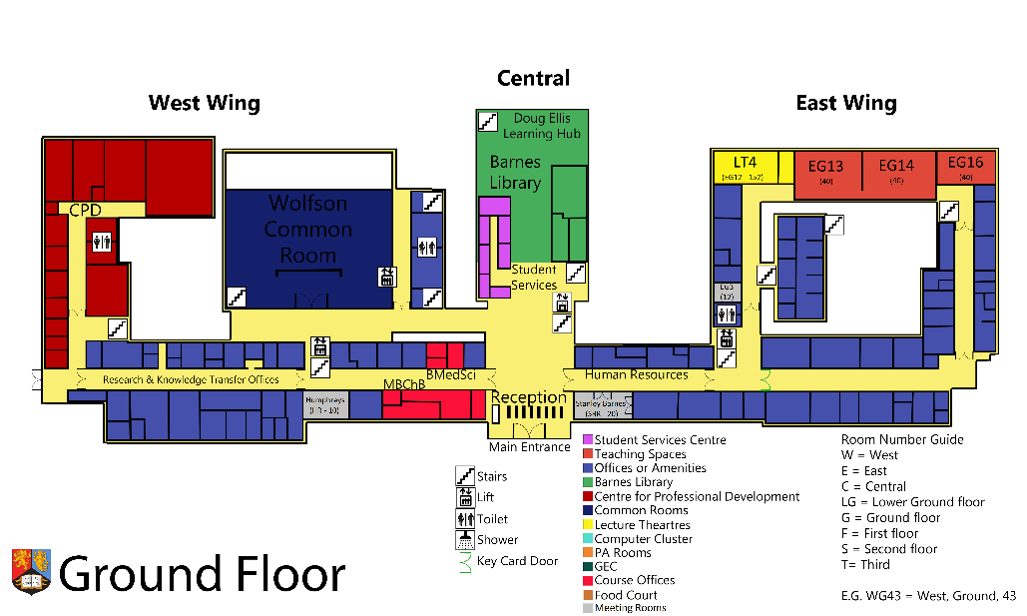
Wolfson Common Room, and Atrium, Registration and Welcome Reception
Medical School Entrance
10 steps up to door entrance

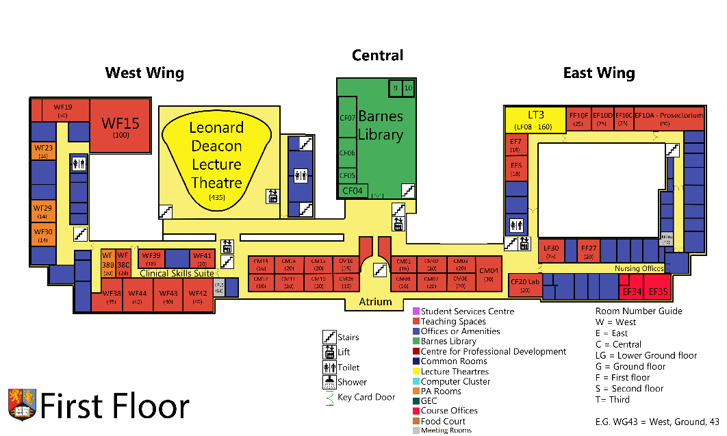
16:00 – 17:00
CM01 – EAHMH Board Meeting
17:00 – 18:00 Welcome and Introductory Talk
12:30 – 16:00 Workshop –
Senses and Health/care
Tuesday 27 August Medical School 14:00 - 19:00

Room WF15 12:30 – 16:00
Workshop – Senses and Health/care Environments (lunch provided)

Wolfson Common Room Atrium From 14:00
Registration

CM01 16:00 – 17:00
EAHMH Old Board Meeting

Leonard Deakin Lecture Theatre 17:00 – 18:00
Welcome Introductory Talk – Jonathan Reinarz

Reflections of 30 years of EAHMH
Frank Huisman - Maastricht University & UMC Utrecht

Wolfson Common Room 18:00 – 19:00
Welcome Reception

