Standard Operating Procedure:

Clinical trials unit selection, Set-up and oversight of laboratories

Supersedes: | N/A – new document
Last reviewed: | Apr-2026
Next review in: | 2029, Quarter 1 (Jan-Mar)

Access the Clinical Research e-Pathway for a roadmap to help navigate a complete project lifecycle.

Contents
Purpose 3
Scope 3
Implementation plan 3
Stakeholders 4
Background 5
Process map 6
Procedure 8
1. Assessing prospective laboratories 8
Identification of a prospective laboratory 8
Assessment of a new laboratory 8
Review of completed questionnaire 8
Escalation of disagreement 9
Documentation of assessment outcome 9
Authorisation 9
Filing and archiving 9
Exceptional circumstances - deferred laboratory use 9
Assessment of a previously assessed laboratory 10
Sample collection locations (basic sample handling) 10
Use of external templates and manuals 10
Filing requirements 10
2. Contracts and agreements 10
Operational governance and communication processes 11
3. Laboratory set-up 11
Consent verification and shipment documentation 12
Assay validation 13
4. Ongoing activities 13
5. Maintaining oversight 13
6. Archiving 14
List of expected outputs 14
Related documents 15
Associated QMS documents 15
Additional QMS documents 15
References & frameworks 15
Abbreviations 16
Document contributors 17
Document history 18
Document version log 18
Document revision log 18

Purpose
This standard operating procedure (SOP) describes the procedure for assessing whether a laboratory, either based at the University of Birmingham (UoB) or external to UoB, is set up in compliance with Good Clinical Practice (GCP) in the laboratory.
The SOP also outlines procedures for Clinical Trials Units (CTUs), and chief investigators (CIs) of independent clinical trials of investigational medicinal products (CTIMPs) where applicable, to set-up and maintain oversight of laboratories once engaged in a clinical trial, including storage and traceability of human tissue samples, sample analysis, data integrity, and computerized systems, using a risk-based approach where appropriate.

Scope
This SOP applies to: (1) CTIMPs sponsored by the University of Birmingham (UoB); (2) CTIMPs where a CTU is acting as a national coordinating sponsor within the UK; and (3) CTIMPs sponsored by another institution, except to the extent that the SOP is inconsistent with any contract between UoB and that institution (excluding procedure section 1, Assessing Prospective Laboratories).
For the avoidance of doubt, this SOP applies:
to all laboratories involved in:
- sample collection for future analysis outside of the trial,
- determining eligibility,
- measuring stratification factors,
- analysis of samples for primary, secondary, tertiary or exploratory endpoints,
- storage of human tissue samples,
- processing of human tissue samples.
regardless of whether the laboratory is an academic laboratory (at UoB or external to UoB), a commercial laboratory or an NHS laboratory.
even if the laboratory is added after the trial has already commenced.
This SOP does not apply to laboratories that are storing, processing or analysing human tissue samples for non-CTIMP trials and studies, including those where samples were originally collected under a CTIMP ethical approval, but are now being analysed under a separate, non-CTIMP protocol and ethical approval. Where this SOP does not apply, the CI of a clinical research project may, at their discretion, refer to it as a non-binding source of guidance.
Please Note: This SOP does not apply to the UoB Human Biomaterial Resource Centre (HBRC), which operates under a Human Tissue Authority (HTA) Licence.
This SOP may be followed as best practice for all other types of trials and clinical studies involving human samples.

Implementation plan
For trials that are currently in the process of selecting laboratories to perform sample storage, processing or analysis, whether these trials are in set-up or ongoing, this SOP will be implemented from the effective date stated in the header of this document.
For trials that have finalised laboratory selection, and the laboratories are being used before this SOP’s effective date, the ongoing activities (section 4) and maintain oversight (section 5) elements of this SOP apply from the effective date. Retrospective assessment may be considered to ensure alignment with laboratory GCP, where feasible.
For trials in the setup:
If laboratories are performing sample storage, processing or analysis for primary endpoints, or assessing eligibility or stratification factors, it will be verified at the sponsorship application stage that laboratory assessment has been completed. Completed laboratory assessment questionnaires will be a mandatory condition for sponsorship approval.

Stakeholders
Note that where the UoB takes on the sponsor’s responsibility, the UoB will delegate the majority of these duties to the chief investigator (CI), to a CTU and/or to the Clinical Research Compliance Team (CRCT), who may delegate these duties further within their team(s). All delegation of duties will be documented (e.g. using either the CI declaration and/or the Clinical Trials Task Delegation Log (UoB-SPO-QCD-001) or equivalent CTU QCD).
CI (for the purposes of this SOP, this term will include the UoB lead where the CI is not a member of staff at the UoB)
Clinical Research Compliance Team (CRCT)
Clinical Research Oversight Committee (C-ROC)
CTU (to be defined within the CTU who is to be accountable for the actions described here, e.g., Team Leader, Trial Manager, etc.). Where a CTIMP is being managed independently, outside of a CTU, where this SOP states ‘the CTU will’, read this to be ‘the CI (or delegate) will’.
Human Tissue Oversight Committee (HTOC)
Laboratory Management
Research Ethics, Governance and Integrity Team (REGI)

Background
The Medicines for Human Use (Clinical Trials) (Amendment) Regulations 2025 (UK Statutory Instruments (SI) 2025 No. 538), which are being implemented in 2026, include clarity around the Sponsor's role in the selection and oversight of laboratories. The CI may choose to use laboratories based at UoB, or laboratories external to the UoB (i.e. non-UoB laboratories), including academic, commercial and NHS laboratories, to perform sample storage, processing or analysis. Regardless of location, the sponsor retains ultimate responsibility for ensuring that laboratories comply with GCP.
Compliance must be assessed before storage, processing or sample analysis (as applicable) being initiated, and in accordance with this SOP and the standards described in the European Medical Agency - Reflection paper for laboratories that perform the analyses or evaluation of clinical trial samples (PDF - 135 KB) the International Council on Harmonisation (ICH): Guidelines for GCP E6(R3) and The Medicines for Human Use (Clinical Trials) Regulations 2004 (as amended) (UK SI 2004 No. 1031), as amended in 2025.
This SOP applies to trials where funding is secured, and the trial is in set-up. For guidance around laboratory considerations and involvement at the grant application stage, contact CRCT (crct@contacts.bham.ac.uk).

Process map
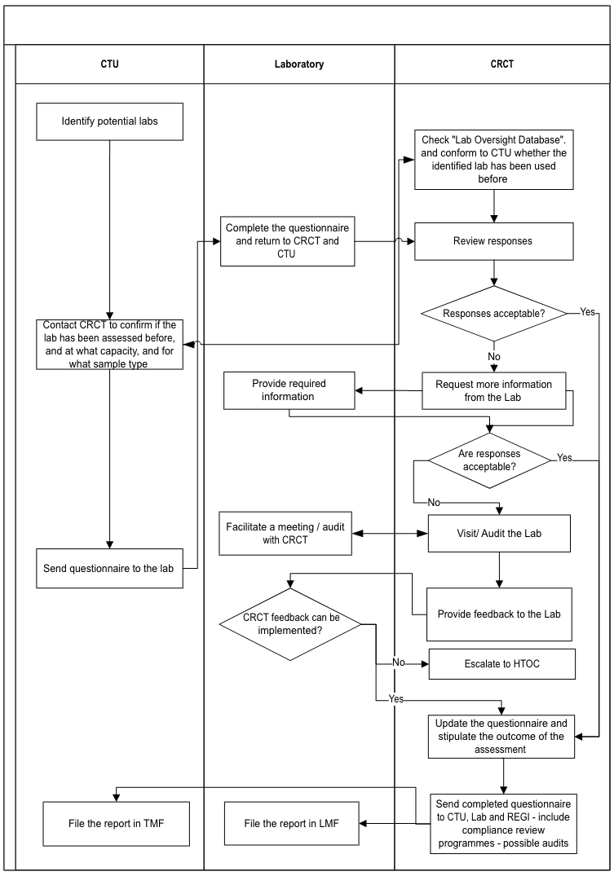
Laboratory assessment and selection procedure

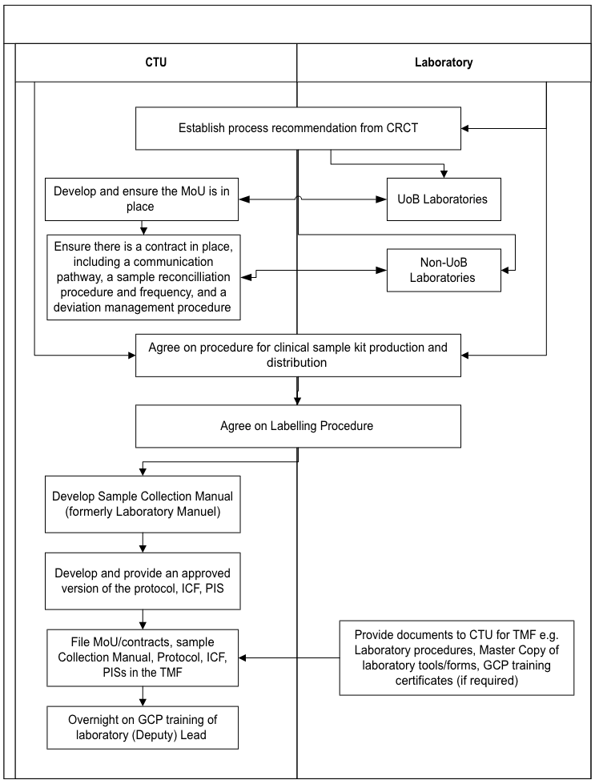
Procedure for operational governance and communication pathway

Procedure
- Assessing prospective laboratories
This section applies to laboratories involved in the storage, processing, or analysis of clinical trial samples.
  - Sections 1.8 to 1.18 of this SOP do not apply to locations that perform basic sample handling activities only. Basic sample handling activities include:
Centrifugation of blood or urine for preparation before transport
Aliquoting of samples in accordance with the Sample Collection Manual
Temporary storage of samples before shipment
Portioning or sectioning of tissue samples for onward transfer
Conduct of standard-of-care laboratory analyses where the trial team accesses only the reported clinical result
  - Locations performing basic sample handling must:
Be informed of applicable Good Clinical Practice (GCP) requirements relating to sample handling and documentation
Comply with protocol-specific sample handling instructions
Maintain appropriate documentation to ensure traceability
  - Where there is uncertainty regarding whether a laboratory falls within the scope of Sections 1.1–1.13, the CTU must seek guidance from the CRCT before proceeding.

Identification of a prospective laboratory
  - Where a clinical trial requires the collection of samples for storage, processing, or analysis by a laboratory, the CTU must identify one or more laboratories that may be suitable to perform the required activities.
  - A prospective laboratory may be an internal laboratory (e.g., a UoB laboratory); or an external laboratory (i.e., a non-UoB laboratory).
  - Where a non-UoB laboratory is identified, the CTU must ensure that relevant institutional procurement and contracting processes are followed in addition to the requirements of this SOP.
  - Identification of a prospective laboratory may occur during trial set-up or during trial conduct, where additional laboratory services become necessary.

Assessment of a new laboratory
To meet the Sponsor’s responsibilities around the selection and oversight of laboratories that is outlined in The Medicines for Human Use (Clinical Trials) (Amendment) Regulations 2025 (UK SI 2025 No. 538), a review of laboratories must be performed prior to the laboratory being used for sample storage, processing or analysis. This applies to trials in set-up and to ongoing trials adding new laboratories (e.g., for sub-studies).
  - The CTU must initiate an assessment before onboarding a laboratory. The CTU must complete the section titled ‘to be completed by the CI/CTU representative’ section of the self-assessment questionnaire (Laboratory Self-Assessment Questionnaire (UoBH-CRL-QCD-025)) and send the questionnaire to the laboratory lead with a defined completion deadline.
  - The CTU must copy the CRCT (crct@contacts.bham.ac.uk) into correspondence when issuing the questionnaire to ensure visibility and resource planning.

Review of completed questionnaire
  - Once the completed questionnaire has been returned by the laboratory to the CTU and CRCT, the CRCT will review the questionnaire, liaising with the CTU to resolve trial-specific queries where required. Based on the level of assurance provided in the questionnaire, the CRCT will determine one of the following outcomes:
Sufficient Assurance: Where responses demonstrate that the laboratory can conduct the trial work to the required standard, the CRCT will accept the assessment with no further action required.
Insufficient Assurance – Further Information Required: Where responses do not provide sufficient assurance, the CRCT may request additional information or clarification from the laboratory. Should the supplementary information demonstrate that the laboratory can meet the required standards, the CRCT will accept the laboratory assessment.
Persistent Insufficient Assurance – Further Evaluation Required: Where assurance remains insufficient following the request for further information, the CRCT will undertake additional evaluation. This may involve the CRCT (and the CTU where required) meeting with the internal laboratory team (for UoB laboratories) or a vendor audit (for external laboratories) conducted in accordance with the Compliance Review SOP (UoB-CPR-SOP-001). The purpose of further evaluation will be to assess how identified deficiencies will be addressed. If this evaluation confirms the laboratory’s capability to meet the required standards, the CRCT will accept the assessment.
Inadequate Assurance – Conditional Approval or Rejection Outcome: Where there is still insufficient evidence that the laboratory can conduct the trial work to the required standard, the CRCT will recommend conditional use, subject to implementation of specified GCP-compliant procedures; or if such implementation is not feasible, the CRCT will advise that the laboratory should not be used.

Escalation of disagreement
  - Where disagreement arises regarding the suitability of a laboratory between the CI, CTU, CRCT, or laboratory, the CRCT must escalate the matter to HTOC. HTOC will make the final decision regarding laboratory suitability.

Documentation of assessment outcome
  - Once a decision has been made about the laboratory, the CRCT will update the ‘comments’ section of the questionnaire to document:
Whether the laboratory meets GCP requirements.
Any deficiencies or risks identified.
Any actions required before approval

Authorisation
  - The CRCT will complete the CRCT section of the ‘authorisation’ section of the questionnaire and share the completed questionnaire with the laboratory and the CTU to allow them to complete their respective authorisation sections.

Filing and archiving
  - Once all parties have completed all ‘authorisation’ sections, the CTU must send the fully authorised questionnaire to the CRCT, who will upload it onto the ‘Laboratory Set-up and Oversight’ folder in the REGI, CRCT and CTU Joint Projects’ Teams site.
  - The presence of a completed questionnaire, in the folder detailed above, and the outcome of the assessment must be confirmed at sponsor review by REGI (see the Sponsor Review Tool (UoB-SPO-QCD-002) for more information). Sponsorship will not be granted without a completed and reviewed questionnaire.

Exceptional circumstances - deferred laboratory use
  - In exceptional circumstances where a laboratory is identified before sponsorship but will not commence trial work for an extended period (e.g., delayed batch analysis), the CTU must discuss the timing of assessment with REGI and CRCT.
  - Assessment must occur no later than three months before the laboratory is expected to commence trial work.
  - The agreed timing must be approved by REGI, the CTU, and the CRCT, and documented by the CRCT in the Laboratory Assessment Database.
  - Where samples are stored before laboratory set-up, the storage location must be documented, and the need for supplementary quality controls must be risk assessed.
  - The risk assessment and agreed controls must be approved by REGI, the CTU, and the CRCT and documented in the Laboratory Assessment Database.
  - If the CRCT has not been informed that a questionnaire has been issued at least three months before the planned commencement of laboratory work, the CRCT will issue a reminder to the trial team.

Assessment of a previously assessed laboratory
  - For each new trial, even if a laboratory has previously been assessed and used for a different clinical trial, the CTU will send a new questionnaire to the laboratory (copying CRCT in the email crct@contacts.bham.ac.uk). The covering communication will explain that a new questionnaire must be completed, although the responses in the previous questionnaire can be referenced where applicable. to. Upon receipt of the completed questionnaire, the process outlined in Sections 1.8 to 1.14 will be followed.

Sample collection locations (basic sample handling)
  - Where only basic sample handling is undertaken at the sample collection site, full assessment using the laboratory self-assessment questionnaire is not usually required. However, collection sites must still adhere to applicable GCP principles to ensure sample traceability and integrity and maintain appropriate documentation to demonstrate these requirements have been met.
  - The CTU will provide trial-specific instruction to the collection site ahead of samples being received by the site (required information is included in documents such as a ‘Sample Collection Manual Checklist’ (see the Sample Collection Manual Checklist (UoBH-CRL-QCD-026)) and other protocol-specific documentation (e.g., sample handling forms) to ensure that sample traceability and integrity are maintained. These instructions must include, but are not limited to, requirements for:
Equipment maintenance and calibration
Freezer/refrigerator temperature monitoring
Sample audit trail and chain of custody documentation
Staff training on trial-specific procedures

Use of external templates and manuals
  - Where manuals or templates from an external institution are used, the CTU will perform checks to ensure the requirements listed in points 1.24 to 1.25 are included. Any deficiencies identified during review must be resolved before sample handling activities commence.
  - The CTU will include sample collection and/or processing activities as part of the site initiation activity.

Filing requirements
  - Once laboratory suitability has been confirmed, the CTU must file the completed Laboratory Self-Assessment Questionnaire and all associated correspondence in the Trial Master File (TMF).
  - The CTU must instruct laboratories to file the completed questionnaire within their laboratory file. For UoB laboratories, the questionnaire must be filed in the Laboratory Master File (LMF). For non-UoB laboratories, any vendor audit reports generated as part of the assessment process must also be filed in the TMF.
- Contracts and agreements
  - Before any trial samples are transferred for storage, processing or analysis, the CTU must ensure that a written agreement is fully executed, outlining the scope of the work; clearly describe the roles and responsibilities of all parties; and be executed before the transfer of any samples. No samples will be transferred to a laboratory until the agreement is fully executed.
  - Where a UoB laboratory is used, involvement from the UoB contracts team is not required; however, a documented and signed internal agreement, such as a Memorandum of Understanding (MoU) must be in place (see the Memorandum of Understanding QCD (UoBH-CRL-QCD-027) for a template). This agreement must be fully executed before any samples are transferred. The MoU must include, but is not limited to:
scope of work
expectations for compliance with GCP in the laboratory and the mandatory ‘Clinical Research in the Laboratory’ section of the UoB QMS
details of research samples (e.g. expected number, type, collection schedule), if not covered in e.g., the clinical trial protocol
defined responsibilities of all parties
processes relating to the withdrawal of consent
requirements for samples at the end of the trial (e.g. retention, disposal, transfer to a licensed facility)
requirements relating to data, including:
source data,
data transfer, format, method and frequency
archiving arrangements
  - Where a non-UoB laboratory is being used, the CTU will work with the appropriate representative within the appropriate College Research Support Hub to establish a formal contractual agreement (see local CTU processes for contract set-up for more information).
The contract must provide an equivalent level of assurance to that required for a UoB MoU.
The contract may reference the UoB QMS where appropriate, including circumstances where the laboratory does not have its own QMS; and it has been formally agreed that the laboratory will operate in accordance with the UoB QMS
The contract must be fully executed before any samples are transferred.
  - All agreements, including MoUs and formal contracts, must be retained in the TMF.

Operational governance and communication processes
In addition to the written agreement, the following operational processes must be agreed upon and documented:
  - The CI, CTU and laboratory agree on a defined communication pathway. The agreed communication pathway must document the point of contact, escalation route and frequency of routine communication. Where appropriate, laboratory representation will be included at Trial Management Group meetings.
  - The CTU and laboratory must agree on a documented sample reconciliation process. The reconciliation process must define the reconciliation method, the frequency of reconciliation, responsibility for performing reconciliation, and the documentation requirement.
  - The CTU must support the laboratory in establishing a documented process for managing deviations and reportable issues. The deviation management process must define what constitutes a reportable issue, what constitutes a serious breach, and reporting timelines and documentation requirements.
  - The CTU must seek input from the laboratory regarding potential operational risks, determine which issues must be reported, and define how such issues must be documented. Laboratory processes must align with the Reportable Issues SOP (UoB-CRL-SOP-005).
  - The laboratory must document and report to the CTU any issues affecting sample integrity or data reliability. Reportable issues must include, but are not limited to:
receipt of damaged samples,
mislabelled samples,
unidentifiable samples,
unexpected samples,
Instances where samples are analysed but results are unavailable.
  - Where results are unavailable, the laboratory must document the reason for unavailability, any corrective or preventive actions implemented, and the impact on trial data, where applicable.
- Laboratory set-up
  - Before any trial samples are stored, processed, or analysed, the CTU must ensure that all laboratory set-up activities described in this section have been completed and appropriately documented. No laboratory activities relating to trial samples will commence until these requirements have been fulfilled.
  - The CTU must agree with the laboratory on a documented process for the production of a clinical sample kit and distribution of sample kits to the trial location, and the ordering and resupply of clinical sample kits by the trial location, where applicable. Responsibilities for kit production, quality control, and distribution must be clearly defined.
  - The CTU must agree on a documented sample labelling process with the laboratory. The agreed process must define which party will generate and supply sample labels, the required content of labels, the format and method of label generation, and controls to prevent duplication or misidentification. All samples and all derived materials must be uniquely identifiable.
  - The CTU will develop the sample collection manual in collaboration with the laboratory, including how this will be approved, distributed and maintained (for more information, see the Sample Collection Manual Checklist QCD (UoBH-CRL-QCD-026)).
  - The CTU will supply the laboratory with an approved version of the clinical trial protocol, blank informed consent forms (ICF) and patient information sheets (PIS). The CTU must define and document how amended versions of these documents will be communicated to the laboratory. The laboratory must not operate using superseded trial documentation.
  - The CTU will request laboratory documents required for the TMF, e.g., laboratory procedures, master copies of laboratory tools/forms. The CTU and laboratory must agree a documented process for provision of updated or amended versions of laboratory documents. The CTU must ensure that the TMF contains the current approved versions of required laboratory documentation.
  - The CTU will confirm that Laboratory Management (as defined in the UoB Glossary of Terms) have up-to-date GCP training commensurate with their role. The CTU must obtain evidence of GCP training completion by the laboratory (deputy) leads, e.g. by requesting certificates.
For UoB Laboratories, Laboratory Academic Leads (LALs) must attend the UoB training course ‘GCP for Laboratory Leads’ (under development).
For management of non-UoB laboratories, other equivalent GCP training is sufficient. However, access to the UoB training course can be provided by CRCT if required.
  - The CTU agree the process for documenting the chain of custody of a sample with the laboratory, i.e. documenting the handling of a sample from its initial collection from a participant to its final disposition. The process must ensure full traceability at all stages, including, but not limited to, the details of:
sample collection,
temporary storage (if applicable), including the specific storage location of each sample,
shipment,
receipt at the laboratory, including any issues with the sample,
storage at the laboratory, including a specific storage location for each sample,
processing/analysis,
data/results produced,
final disposition of the sample (e.g. long-term storage, disposal, used up in the analysis/processing, transferred to another research project).

Consent verification and shipment documentation
  - The CTU must develop and implement a documented shipment process that confirms valid participant consent prior to the transfer of any sample to the laboratory.
  - The CTU must design a shipment form that accompanies each sample shipment. The shipment form must include all required fields necessary to ensure traceability and consent verification, including but not limited to:
trial identifier,
site identifier,
participant’s unique trial number,
sample identifier,
sample type,
date and time of collection,
visit/timepoint,
number of aliquots (where applicable),
type of analysis to be performed,
shipment date,
courier details (if applicable)
  - The shipment form must include a clearly defined section confirming the participant’s consent status to ensure the laboratory is GCP compliant and allows them to check what analyses they are entitled to perform. The consent confirmation section must:
specify the category of consent obtained (e.g., main study procedures, optional exploratory analyses, genetic analysis where applicable);
confirm that consent has been obtained for the specific analyses to be performed on the sample.
include a defined confirmation mechanism (e.g., a tick-box completed by the CTU) verifying that appropriate consent is in place.
  - The CTU must define and document the process for communicating withdrawal of consent to the laboratory, identifying affected samples, instructing the laboratory regarding cessation of analysis, destruction, or retention in accordance with the consent and regulatory requirements and documenting actions taken following withdrawal.

Assay validation
  - The CTU will request evidence of assay validation for each assay the laboratory is conducting for the trial to be sent to the CTU and filed in the TMF.
For UoB laboratories, this will be a completed and approved assay validation plan and report (see the Assay Validation QCD (UoB-CRL-QCD-020))
For non-UoB laboratories, the CTU will obtain confirmation from the laboratory that assays have been validated.
  - For assays that are conducted for primary endpoints, assessing eligibility or deciding stratification factors, the assay validation will be reviewed by a CTU subject matter expert (SME).
The only exception where assay validation is not required is where the development of the assay is one of the outcomes of the trial, and this has been given ethical and regulatory approval.
If the trial team or laboratories have queries about assay validation, e.g. guidance is required on what needs to be included in the assay validation or advice is needed on the level of validation (or verification) required, contact CRCT for guidance.
- Ongoing activities
  - The CTU will supply the laboratory with updated versions of documentation required for the laboratory file, e.g., the clinical trial protocol, the ICF and PIS, the sample pathway overview.
  - The CTU will notify the laboratory of participant withdrawal within 7 working days of being notified by a trial location, including specifying if samples and/or data need to be destroyed.
  - The CTU will track shipment of samples from the trial locations, receipt of samples by the laboratory and any further location of the samples.
  - The CTU will perform data cleaning on data received from the laboratory as required.
- Maintaining oversight
  - The CTU, in collaboration with the CRCT, will maintain documented oversight of laboratories throughout the trial to ensure compliance with GCP.
The level of oversight required will be determined using a risk-based approach and documented in the trial-specific risk assessment. Ongoing oversight will be maintained by:
The inclusion of the trial in the CRCT compliance review programme, which may involve the laboratory being subject to an audit (see the Compliance Review SOP (UoB-CPR-SOP-001) for further information).
The inclusion of the trial in the CTU compliance review programme, if applicable, which may involve the laboratory being subject to an audit.
The inclusion of sample and laboratory aspects in CTU monitoring programs, e.g. monitors tracking samples from the patient to shipment to the laboratory, if applicable.
The attendance of laboratory representatives at TMG (or similar) meetings, if applicable.
Reconciliation of all samples sent by the collection location to the laboratory and receipt of their associated data by the CTU.
Ensuring all results from sample analysis have been received and if no result has been received a reason for this is documented.
- Archiving
  - The Laboratory and the CTU will ensure that the LMF, the laboratory source data, and the laboratory results are archived for the archive duration specified within the protocol.
  - The CTU will archive all documentation related to the assessment, set-up and oversight of laboratories along with the rest of the TMF, at the end of the trial (see the Archiving SOP (UoB-ARC-SOP-001) for further information).

List of expected outputs
A completed self-assessment questionnaire for all laboratories.
Documenting completion of laboratory assessments in the ‘Laboratory Assessment Database’
A vendor audit report for non-UoB laboratories, where applicable.
If using a laboratory that has been previously assessed, evidence of confirmation that no changes to the questionnaire are required and a copy of the completed questionnaire.
Appropriate agreements are in place between UoB and the laboratory, i.e. a MoU with a UoB laboratory and a formal contract with a non-UoB laboratory.
Trial documentation (protocol, ICF, PIS) was supplied to the laboratory, and a process for supplying updated versions of these documents as required.
Sample Collection Manual developed and distributed.
Sample labelling and chain of custody procedures confirmed.
Confirmation that GCP training commensurate to the role has been completed by laboratory management. For UoB laboratories, this is the ‘GCP training for LALs’ training course.
Evidence of assay validation received for all assays.
Primary endpoint assay validation reviewed by SMEs in CTUs.
A documented process for reconciliation activities for samples sent by the trial locations and received by the laboratory, and that all samples have been analysed or a reason obtained as to why a result is not available.
Evidence that reconciliation activities have been taking place.
Inclusion of laboratories in compliance review procedures e.g. monitoring and audits.

Related documents

Associated QMS documents
UoBH-CRL-QCD-025 Laboratory Self-Assessment Questionnaire
UoBH-CRL-QCD-026 Sample Collection Manual Checklist
UoBH-CRL-QCD-027 Memorandum of Understanding Template
UoBH-CRL-QCD-028 Sample Pathway Overview (under development)
UoBH-CRL-QCD-029 Laboratory Costing Tool for Grants (under development)

Additional QMS documents
UoB-ARC-SOP-001 Archiving
UoB-CRL-QCD-020 Assay Validation
UoB-CRL-SOP-005 Reportable issues
UoB-CRL-SOP-007 Laboratory Considerations at Grant Application SOP (under development)
UoB-CRP-SOP-001 Compliance Review
UoB-SPO-QCD-001 Clinical Trials Task Delegation Log
UoB-SPO-QCD-002 Sponsor Review Tool
Access to the full UoB QMS for clinical research is available via the CRCT website.

References & frameworks
European Medical Agency. (2012) Reflection paper for laboratories that perform the analyses or evaluation of clinical trial samples. Available at: ema.europa.eu/en/documents/regulatory-procedural-guideline/reflection-paper-laboratories-perform-analysis-or-evaluation-clinical-trial-samples_en.pdf (Accessed: 22-Jun-2026).
ICH. (2025) Guideline for Good Clinical Practice: E6(R3). Available at: ich.org/page/efficacy-guidelines (Accessed: 22-Jun-2026).
UK Legislation. (2004) Human Tissue Act (as amended). Available at: legislation.gov.uk/ukpga/2004/30/contents (Accessed: 22-Jun-2026).
UK Legislation. (2004) The Medicines for Human Use (Clinical Trials) Regulations (as amended). Available at: legislation.gov.uk/uksi/2004/1031/contents (Accessed: 22-Jun-2026).
UK Legislation. (2025) The Medicines for Human Use (Clinical Trials) (Amendment) Regulations. Available at: legislation.gov.uk/uksi/2025/538 (Accessed: 22-Jun-2026).

Abbreviations
CI | Chief Investigator
CRCT | Clinical Research Compliance Team
CTIMP | Clinical Trial of Investigational Medicinal Product
C-ROC | Clinical Research Oversight Committee
CTU | Clinical Trials Unit
GCP | Good Clinical Practice
HBRC | Human Biomaterial Resource Centre
HTOC | Human Tissue Oversight Committee
ICF | Informed Consent Form
ICH | International Council on Harmonisation
LAL | Laboratory Academic Lead
LMF | Laboratory Master File
MoU | Memorandum of Understanding
PIS | Patient Information Sheet
REGI | Research Ethics, Governance and Integrity Team
SOP | Standard Operating Procedure
TMG | Trial Management Group
TMF | Trial Master File
UoB | University of Birmingham
See also Glossary of Terms for a full list of abbreviations and definitions.

Document contributors
Author(s)
- Emma Taylor (Senior Compliance Facilitator)
- Parisa Pordelkhaki (Clinical Research Compliance / QMS Manager)
Contributor(s)
- Gemma Slinn (BCTU Team Leader)
- Margaret Gant (BCTU Director of Operations)
- Katie Stant (CRCTU Quality Assurance Manager)
- Joshua Savage (CRCTU Early Drug Development Team Leader)
- Sarah Bowden (CRCTU Director of Operations)
Reviewer(s)
Version by –
- Subject matter experts in the Clinical Research Compliance Team (CRCT), Research Ethics, Governance & Integrity Team (REGI) and UoB CTUs
- Clinical Research Oversight Committee (C-ROC) that includes the Directors and Directors of Operations of the BCTU and CRCTU
- Human Tissue Oversight Committee (HTOC)
- Any other stakeholders (see stakeholders above)
Revisions by –
- CRCT (see document revision log below)
Authoriser(s)
- Colin Watts (Chair of C-ROC)
- Tracey Wilkinson (Chair of HTOC)

Document history

Document version log
The table below summarises the changes made to this document compared to its superseded versions. For information on earlier versions not shown, please email the CRCT (crct@contacts.bham.ac.uk).
Version | Reason for update
1.0  (28-Apr-2026) | - N/A – New UoB harmonised SOP.

Document revision log
The table below summarises the reasons for any revisions made to the latest version of this document. Revisions do not affect the key content and/or requirements outlined in the document.
Revision | Reason for revision | Editor/reviewer | Authoriser
1.0  (22-Jul-2026) | - Updated UoB logo.  - Updated references and URLs.  - Updated formatting on bullets.  - Amended related documents.  - Corrected typographical errors. | Katy Smith (Senior Administrator) | Parisa Pordelkhaki (QMS Manager)

