Standard Operating Procedure:

External Laboratory Set-up and Oversight

Purpose:
This standard operating procedure (SOP) describes the processes involved in assessing whether an external, non-UoB laboratory is set-up in compliance with the Good Clinical Practice (GCP) laboratory standard.

Scope:
The SOP is applicable to all clinical trials of investigational medicinal products (CTIMPs) where the University of Birmingham (UoB) is the sponsor or takes on responsibility for assessing whether an external laboratory that will perform analysis of human biomaterial samples is set-up in compliance with Good Clinical Practice (GCP) laboratory standard. Where clinical research is (co-)sponsored by another institution, this procedure should be followed as far as possible, and in line with the contractual agreement between the UoB and the other institution.

Implementation plan:
For clinical trials that are in the process of selecting external laboratories to perform sample processing or analysis this SOP will be implemented in line with this document’s effective date.

Stakeholders:
Note that where the UoB takes on the sponsor’s responsibility, the UoB will delegate the majority of these duties to the chief investigator (CI), to a clinical trials unit (CTU) and/or to the Clinical Research Compliance Team (CRCT), who may delegate these duties further to their team(s). All delegation of duties will be documented (e.g. using either the CI declaration and/or the Clinical Trials Task Delegation Log; see UoB-CLN-CTM-QCD-002 Clinical Trial Task Delegation Log).
- CI (for the purposes of this SOP this term will include the UoB lead where the CI is not a member of staff at the UoB)
- Clinical Research Compliance Team (CRCT)
- Clinical Trials Unit (CTU)
- Human Tissue Oversight Committee (HTOC)
- Research Governance Team (RGT)

Background and rationale:
Laboratories that perform storage, processing, analysis or evaluation of human biomaterial for CTIMPs must be set up and managed to the appropriate laboratory standard to ensure that patient safety is not compromised, that data is reliable and accurately reported, and in accordance with applicable law and the accepted principles of GCP.
The CI may wish to use laboratories external to the UoB, including academic and commercial institutions, to perform some or all of the sample analysis. As the responsibility for oversight of the trial ultimately resides with the sponsor, it is essential that the ability of the external laboratory to comply with the regulatory requirements of GCP in the laboratory standard, as described in the European Medical Agency - Reflection paper for laboratories that perform the analyses or evaluation of clinical trial samples (PDF - 136 KB) is assessed prior to analysis being initiated.

Process map:
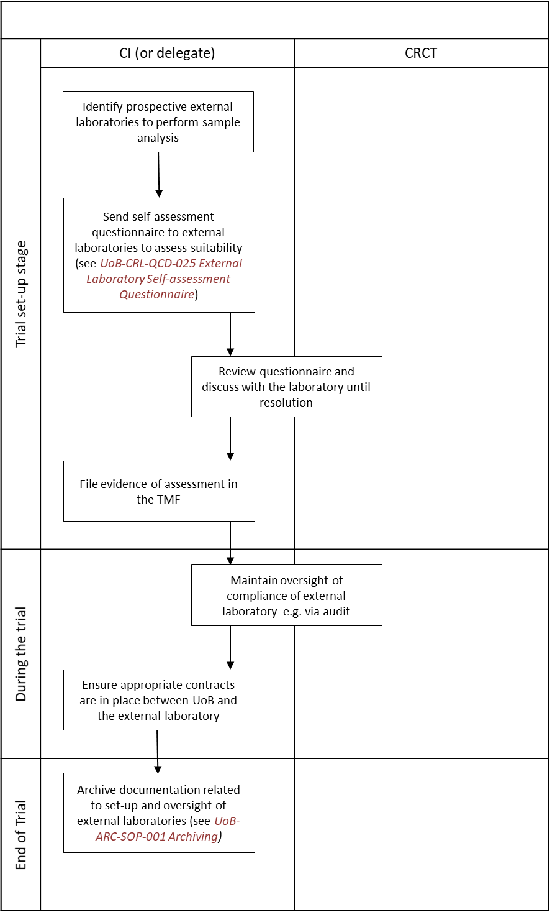

Procedure:
- The CI (or delegate) will identify the need for trial samples to be processed or analysed by an external laboratory.
- The CI (or delegate) will identify prospective laboratories that are able to perform the required processing or analysis of trial samples.
- The CI (or delegate) will contact the CRCT to confirm whether the laboratory has been previously assessed for suitability, using email address crct@contacts.bham.ac.uk.

Assessing a new external laboratory
- The CI (or delegate) will send the self-assessment questionnaire UoB-CRL-QCD-025 External Laboratory Self-Assessment Questionnaire (under development) to the laboratory’s management to determine whether the laboratory has appropriate processes in place to be capable of working to GCP in the laboratory standard.
- Once the completed questionnaire has been returned by the laboratory, the CRCT will review the questionnaire in collaboration with the CI (or delegate) to assess whether the laboratory has the appropriate processes in place to be capable of working to GCP in the laboratory standard.
- If there are any queries about the responses in the questionnaire, the CRCT will request clarification or further information from the laboratory and the questionnaire will be updated as appropriate.
- The CRCT will either:
- confirm with the CI (or delegate) via email that the laboratory has provided sufficient evidence to demonstrate that they could work to GCP in the laboratory standard and report the use of the external laboratory to HTOC, or
- if insufficient evidence is provided by the laboratory, or where there are any other concerns about the ability of the laboratory to meet the correct standard, the CRCT will conduct a vendor audit. This may be a co-audit with a CTU (see UoB-CPR-SOP-001 Compliance Review).
- If a vendor audit is required, the vendor audit report will be provided by CRCT to the CI (or delegate), the Research Governance Team (RGT) and the Human Tissue Oversight Committee (HTOC) and the laboratory.
- The CI (no delegation allowed) will decide, in collaboration with the RGT and the HTOC, whether to use the external laboratory for the processing or analysis of clinical trial samples.

Assessing a previously used external laboratory
- The CI (or delegate) will send the self-assessment questionnaire UoB-CRL-QCD-025 External Laboratory Self-Assessment Questionnaire (under development) previously completed by the laboratory to the laboratory’s management and request confirmation via email whether any of the information has changed.
- If the laboratory confirms that the information in the questionnaire is up to date, the CI (or delegate) will file the confirmation email and a copy of the completed self-assessment questionnaire in the trial master file (TMF) and inform the CRCT that a previously used external laboratory is going to be used.
- If the laboratory confirms that information has changed, points 3 to 7 of this SOP will be followed.

Once the assessment of the laboratory is complete
- Once suitability of the laboratory has been confirmed, the CI (or delegate) will file the completed questionnaire in the TMF, and vendor audit report if applicable.
- The CI (or delegate) in collaboration with the CRCT will maintain documented oversight of external laboratories throughout the trial to ensure compliance with GCP in the laboratory standard.
- The level of oversight required will be determined on a risk-based approach and documented in the trial-specific risk assessment.
- Oversight will be maintained by the inclusion of the trial in the CRCT compliance review programme, which may involve the trial being subject to an audit (see UoB-CPR-SOP-001 Compliance Review) for further information.
- Ahead of any sample processing or analysis by the external laboratory the CI (or delegate) will work with the UoB Contracts Team to arrange for the appropriate contract agreements to be put into place (see UoB-CRL-SOP-001 Laboratory Set-up and Management). Contracts will include, but not be limited to:
- details of material transfer agreement clauses if human tissue samples are being transferred to the external laboratory
- archiving requirements
- source-data requirements.
- The CI (or delegate) will archive all documentation related to the set-up and oversight of external laboratories along with the rest of the TMF at the end of the trial. See UoB-ARC-SOP-001 Archiving for further information.

List of expected outputs:
- Evidence of a completed self-assessment questionnaire for external laboratories.
- Evidence of documented oversight of external laboratories.
- Evidence of appropriate contractual agreements in place between UoB and external laboratories.
- If using a laboratory that has been previously assessed, evidence of email confirmation that no changes to the questionnaire are required, if applicable, and a copy of the completed questionnaire.

Related documents:
- UoB-ARC-SOP-001 Archiving
- UoB-CLN-CTM-QCD-002 Clinical Trial Task Delegation Log
- UoB-CRL-QCD-001 Setting up a Laboratory Master File
- UoB-CRL-QCD-004 Laboratory Contracts and Agreements Checklist
- UoB-CRL-QCD-005 Key Contacts
- UoB-CRL-QCD-025 External Laboratory Self-Assessment Questionnaire (under development)
- UoB-CRL-SOP-001 Laboratory Set Up and Management
- UoB-CRL-SOP-002 Laboratory Facilities
- UoB-CRL-SOP-003 Sample Management
- UoB-CRL-SOP-004 Laboratory Analysis
- UoB-CRL-SOP-005 Reportable Issues
- UoB-CRP-SOP-001 Compliance Review
Note the UoB QMS documents can be found on the CRCT website. Internal work instructions can be obtained from the CRCT (crct@contacts.bham.ac.uk) and/or from the RGT (researchgovernance@contacts.bham.ac.uk).

References and frameworks:
- Reflection paper for laboratories that perform the analyses or evaluation of clinical trial samples (2012), European Medical Agency: www.ema.europa.eu/docs/en_GB/document_library/Regulatory_and_procedural_guideline/2012/05/WC500127124.pdf
- The Human Tissue Act (2004): http://www.legislation.gov.uk/ukpga/2004/30/contents
- The Medicines for Human Use (Clinical Trials) Regulations 2004 and amendments: http://www.legislation.gov.uk/uksi/2004/1031/contents/made
- UoB Contracts team: https://intranet.birmingham.ac.uk/finance/rss/contracts/index.aspx

Abbreviations and definitions:
Term | Description
Audit | A systematic and independent examination of trial-related activities and documents to determine whether the evaluated trial-related activities were conducted, and the data were recorded, analysed and accurately reported according to the protocol, sponsor's standard operating procedures (SOPs), Good Clinical Practice (GCP), GCP in the Laboratory, HTA Research Licensing Standards, GMP and the applicable regulatory requirement(s).
Chief investigator (CI) | The person who takes overall responsibility for the design, conduct and reporting of a study if it is at one site; or if the study involves researchers at more than one site, the person who takes primary responsibility for the design, conduct and reporting of the study, whether that person is an investigator at any particular site.  Note that for CTIMPs the chief investigator must be an authorised health professional.
Clinical trial of an investigational medicinal product (CTIMP) | Any investigation in human subjects intended to discover or verify the clinical, pharmacological and/or other pharmacodynamic effects of one or more investigational medicinal product(s), and/or to identify any adverse reactions to one or more investigational medicinal product(s) and/or to study absorption, distribution, metabolism and excretion of one or more investigational medicinal product(s) with the object of ascertaining its (their) safety and/or efficacy.
Good Clinical Practice (GCP) | A set of internationally recognised ethical and scientific quality requirements that must be observed when designing, conducting, recording and reporting clinical research that involves the participation of human volunteers.
Human biomaterial | For CTIMPs: samples taken from a human being to be analysed for the purposes of that clinical trial. This may include both HTA ‘relevant’ and ‘non-relevant’ material.  For clinical studies and non-CTIMP trials: samples of human tissue obtained for analysis.
Laboratory | A facility that conducts manipulation, analysis or evaluation of samples collected as part of a clinical trial; such analysis or evaluation may include the generation of pharmacokinetic or pharmacodynamic data, safety data, primary efficacy data, histopathology data or data used to support any other stated primary or secondary end point.
Laboratory vendor audit | An inspection of an external, non-UoB laboratory vendor to confirm compliance with GCP in the Laboratory Standard, as defined in in the European Medical Agency’s Reflection paper for laboratories that perform the analyses or evaluation of clinical trial samples). An audit would be conducted prospectively, prior to the laboratory receiving any human biomaterial samples for a UoB-sponsored clinical trial.
TMF | Trial master file
UoB | University of Birmingham.
Vendor | Various types of external providers to whom a sponsor may delegate their functions e.g. contract research organisations, laboratories, consultants, freelancers/ contractors etc. They exclude research collaborators and clinical research sites.
See also the Glossary of Terms.

