

Clinical Research Oversight Committee (C-ROC)

Terms of Reference

Remit

The Clinical Research Oversight Committee (C-ROC) [formally knowns as the Clinical Trials Oversight Committee (CTOC)] is responsible for overseeing the activities undertaken by the University of Birmingham (UoB) in its role as a Sponsor, host institution or partner with other organisations for clinical research. It discharges this responsibility by coordinating the governance and monitoring of clinical research, and by contributing to the development of the University’s research strategy.

The C-ROC is specifically responsible for managing the development, implementation and maintenance of an effective support infrastructure for all clinical research, including clinical trials of investigational medicinal Products (CTIMPs) (including use of advanced therapies), clinical investigations of a medicial device, and trials conducted through the UoB’s UK Clinical Research Collaboration (UKCRC)-registered Clinical Trials Units (CTUs) and other interventional trials (e.g. surgical trials and non-CTIMP trials), and clinical research outside of a UoB CTU. In addition, the C-ROC provides oversight of any clinical research where a UoB Research Ethics Committee has stipulated that the research must be conducted to the UoB Principles of Good Clinical Practice (GCP) for Clinical Research (UoB-GCP-POL-001), or where the Research Ethics, Governance & Integrity Team (REGI) or Clinical Research Compliance Team (CRCT) has identified that an increased level of institutional oversight is required in line with the UoB Code of Practice for Research.

The Terms of Reference shall be reviewed every three years, and agreed by the Research Governance, Ethics & Integrity Committee.

Constitution and Membership

Chair
The C-ROC will be chaired by a UoB senior clinical academic with experience and detailed knowledge in the conduct of clinical trials, and who is only responsible for a small portfolio of UoB sponsored trials, if any.

The Chair is appointed for a three-year term by the Chair of the Research Governance, Ethics & Integrity Committee. The appointed may be renewable for another term (three years) with agreement by the Chair of the Research Governance, Ethics & Integrity Committee.

A UoB senior clinical academic(s) may be appointed as a C-ROC deputy Chair by the Chair in consultation with existing C-ROC members.

Membership
Membership of the C-ROC will include at least three UoB clinical academics with expertise in the design and conduct of clinical trials; one with experience of conducting trials independently of a CTU, and at least four other UoB academic or academic-related staff (ensuring, if not covered by aforementioned members, at least one representative from each of the UoB CTUs and the College of Life and Environmental Sciences (LES)) with collective expertise in trial governance, trial management, trial quality assurance, pharmacovigilance, investigational medicinal product (IMP) management and trial pharmacy. The Head of Research Governance and Integrity, the Clinical Research Compliance Manager and a representative from UoB Legal Services will also be core members of C-ROC.

Current members are defined in the Membership List (Word – 192 KB). The recruitment and appointment of new members will be determined by the Chair in consultation with existing C-ROC members following transparent recruitment processes as applicable. The membership list will be updated as and when required. Additional attendees, or expert input, may be identified/invited on an ad hoc basis at the discretion of the Chair and depending on the content of the meeting e.g. Senior Statistician, Insurance Officer or a lay member as a public-patient representative.

Secretariat
The Clinical Research Compliance Team (based in the College of Medicine and Health (CMH) Research Knowledge & Transfer (R&KT) Office) will provide secretarial support to ensure effective administration of the C-ROC.

Quorate
The C-ROC is quorate when there are members present with expertise in trial design, trial management, quality assurance and sponsor oversight, as well as the Chair or Deputy Chair and including at least two academic members (of whom at least two should be clinical).

Whenever issues are discussed that may cause a conflict of interest, or an appearance of conflict of interest, for the Chair, the Deputy Chair or delegate, as agreed by members present, will assume responsibility for the relevant section of the meeting.

Where required to deliver the remit of the C-ROC, formal working groups will be established to deliver specific activities, as agreed by C-ROC members.

Function of the Committee

- Oversight of the maintenance of the UoB clinical research quality management system (QMS):
The C-ROC has oversight of the maintenance of the UoB guidelines, standard operating procedures (SOPs) and policies relating to clinical research sponsored by the UoB. These documents will provide instructions to investigators on the UoB processes and procedures that ensure adherence to the relevant regulatory requirements and international standards for the conduct of clinical research and reflect best practice. These documents are developed and maintained by the CRCT.

- Oversight of the development and implementation of the UoB clinical research training programme:
The C-ROC has oversight of the development and delivery of a comprehensive clinical research training programme. This training programme will ensure all individuals taking on an identified role e.g. Chief Investigator, Trial Co-ordinator, in a UoB sponsored trial understand their role, the regulatory framework in which clinical research is undertaken and University’s procedures and policies for UoB sponsored clinical research.

- Oversight of sponsorship:
The C-ROC has oversight of the criteria used to assess whether UoB is prepared to take on the role of sponsor for a clinical trial/study and will advise on the procedures for approval of UoB sponsorship. The REGI and delegated authorised colleagues in the CTUs are responsible for formally notifying agreement of UoB sponsorship of clinical trials/studies and assessing any application for UoB (co-)sponsorship against these criteria.

The REGI will liaise with the C-ROC for guidance on specific trials/studies where the criteria are not fully met and/or where issues arise that may impact the ability of UoB to act as sponsor for the trial/study. The C-ROC will determine whether sponsorship by UoB can be provided and advise on additional requirements for sponsorship to be granted.

The C-ROC manages the approval and allocation of the UoB budget for the funding of clinical trials insurance premiums that are not covered by the standard UoB insurance policy.

- Oversight of UoB CTUs:
The C-ROC maintains oversight of the UoB CTUs’ systems set up to ensure the quality within the CTUs. For this, the CTUs will share their annual audit programme and QMS management plan at least annually with the C-ROC. The CTUs will also report on the management and delivery of UoB-sponsored trials, including recruitment in their trial portfolio every 6 months through a formal report. Finally, the CTUs will flag up any issues such as changes in resources that may impact on the quality of clinical trials conducted in the CTUs.

- Portfolio management and oversight:
The REGI will provide a report for every C-ROC meeting to enable committee members to monitor the number and risk of portfolio trials sponsored by UoB and studies for which C-ROC provides oversight. In addition, C-ROC will receive updates on recruitment issues with non-CTU-managed trials/studies and on relevant UoB research ethics and integrity activity such as trial transparency reporting.

- Oversight of compliance review:
During each meeting, the C-ROC will receive reports from the CRCT on any major risks to the UoB sponsored trials and studies (as applicable), trial/study participants and/or the organisation, arising from failure to comply with key legislative requirements and the actions that have been taken, or evidence of poor recruitment. The C-ROC will advise on whether further corrective action is required and review and approve the plan to prevent re-occurrence of further similar risks. If an issue cannot be resolved with support from the REGI or the C-ROC, this will be escalated through relevant reporting routes.

Compliance review programme for the UoB clinical research portfolio
The C-ROC will provide oversight for the CRCT-led programme of compliance review activities, to include the programme of audits, Sponsor Support Visits, and on-site monitoring activities (where applicable). In addition, the C-ROC reviews reports of audits conducted by the CRCT, including 6 monthly feedback on their review of a selection of the UoB CTUs’ on-site monitoring visit reports.

Serious breach reports, external audit reports and inspections
During each C-ROC meeting, the CTUs will provide feedback to the C-ROC of any serious breaches that have been reported. The UoB CTU will also provide a summary of all compliance reviews conducted/received and any significant findings noted in a 6-monthly report to the C-ROC.

Institutional regulatory inspections
The C-ROC will support the REGI, CRCT and the CTUs in their responsibility to effectively co-ordinate, conduct and respond to all relevant institutional regulatory inspections, particularly those undertaken by the MHRA. Resultant action plans and outcomes will be owned by the C-ROC who will be responsible for ensuring delivery within agreed timeframes and reporting if risks of potential non-compliance are anticipated; providing timely advice on necessary corrective action to ensure the University can fulfil its role as sponsor.

- Advisory:
Where requested, the C-ROC may provide advice to any UoB staff involved in clinical research not supported by a CTU . In addition, the C-ROC members will be able to direct any queries from Chief Investigators or trial/study team members to the appropriate body within the UoB, e.g. a UoB CTU, REGI or CRCT.

Meeting Frequency

The C-ROC will meet approximately 6 to 8 weeks or as required according to need, with a total of at least 6 meetings per year.

Reporting Lines

The Chair of the C-ROC will be a member of and report to the University Research Governance Ethics & Integrity Committee that is chaired by the Deputy Pro-Vice-Chancellor for Research Governance and Integrity. Where relevant there will be appropriate reporting within Colleges, as directed by relevant clinical research activity.

In the interest of complete transparency of processes, the C-ROC meeting minutes will be made available to the University RGEIC, the UoB Head of Internal Audit and the appropriate College-level committees (at time of writing this includes the CMH R&KT Executive Committee and the LES R&KT Committee).

See Figure 1 for the current UoB Research Governance Framework, and the UoB Clinical Research Quality Manual (UoB-CQM-POL-001) for further information.

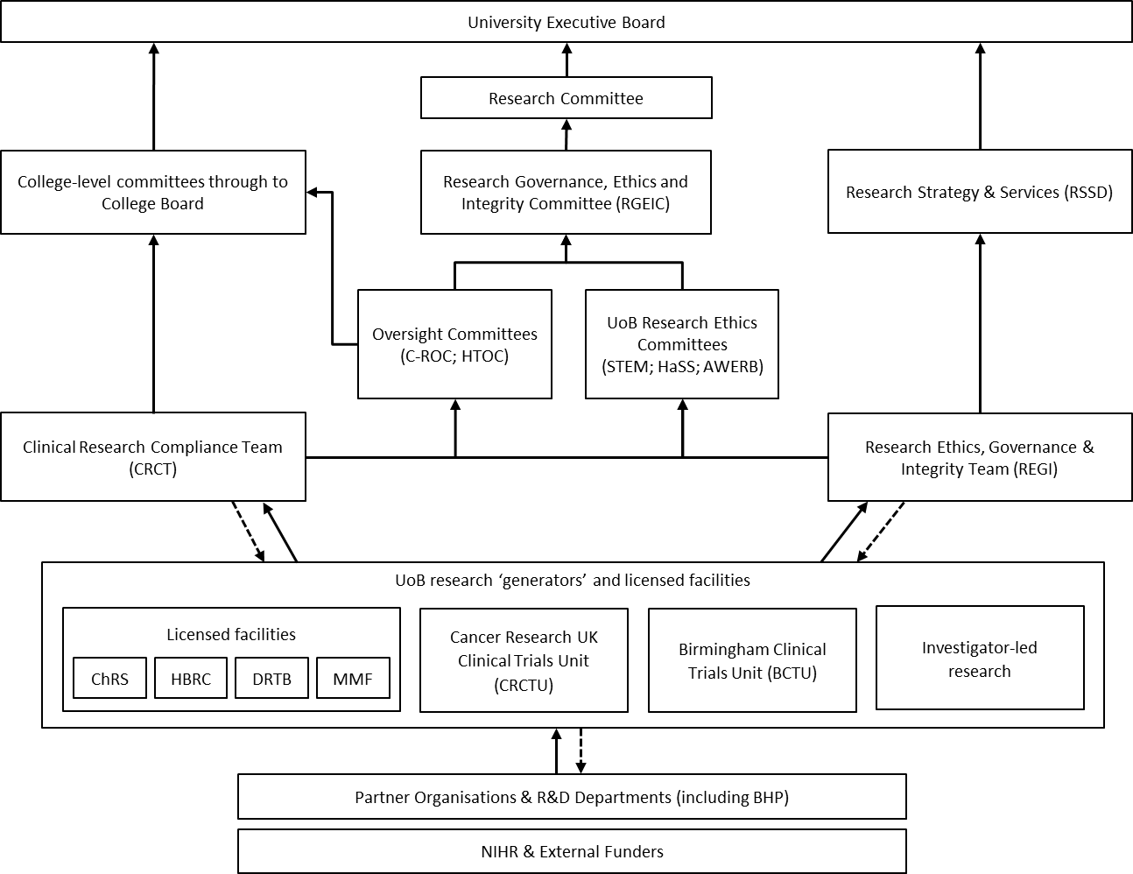

Figure 1. UoB Research Governance Framework. Solid line denotes reporting pathway, and dotted line denotes compliance review pathways. Abbreviations: AWERB, Animal Welfare and Ethical Review Body; BCTU, Birmingham Clinical Trials Unit; BHP, Birmingham Health Partners; ChRS, The Centre for Human Reproductive Science; CRCT, Clinical Research Compliance Team; CRTCU, Cancer Research UK Clinical Trials Unit; C-ROC, Clinical Research Oversight Committee; DRTB, Dental Research Tissue Bank; HaSS, Humanities and Social Sciences; HBRC, Human Biomaterials Resource Centre; HTOC, Human Tissue Oversight Committee; MMF, Medicines Manufacturing Facility; NIHR, National Institute for Health Research; R&D, Research and Development; REGI, Research Ethics, Governance & Integrity Team; RGEIC, Research Governance, Ethics & Integrity Committee; RSSD, Research Strategy & Services Division; STEM, Science, Technology, Engineering and Mathematics; UoB, University of Birmingham.

Document Status
Approved: by REGIC on 12 March 2026.

