

HUMAN TISSUE Oversight Committee (HTOC)

Terms of Reference

Remit

The Human Tissue Oversight Committee (HTOC) is responsible for overseeing all activities surrounding the use of human tissue at the University of Birmingham (UoB).

The Terms of Reference shall be reviewed annually and agreed by the Research Governance, Ethics & Integrity Committee (RGEIC).

Constitution and Membership

Chair
The HTOC will be chaired by a UoB senior academic who will usually have Designated Individual (DI) or Licence Holder experience with detailed knowledge of the conduct of human tissue activities.

The Chair is appointed for a three-year term by the UoB’s Human Tissue Authority (HTA) Licence Holder. The appointed may be renewable for up to another two terms (six years) with agreement by the Licence Holder.

Membership
Current members are defined in the Membership List (Word – 75 KB). The recruitment and appointment of new members will be determined by the Chair in consultation with existing HTOC members following transparent recruitment processes as applicable. The membership list will be updated as and when required.

Additional attendees, or expert input, may be identified/invited on an ad hoc basis at the discretion of the Chair, depending on the content of the meeting. The Licence Holder will receive the minutes from all Committee meetings and be updated by the Chair verbally after each meeting. The College of Life and Environmental Sciences (LES) Deputy Director of Operations and the Deputy Pro-Vice-Chancellor (Research Governance and Integrity) will receive meeting minutes and attend on an ad hoc basis, as required and according to need.

Secretariat
The Clinical Research Compliance Team (CRCT) (based in the College of Medicine and Health (CMH) Research Knowledge & Transfer (R&KT) Office) will provide secretarial support to ensure effective administration of the HTOC.

Quorate
The HTOC is quorate with the following members in attendance:
- the Chair (or a delegate selected from the current HTOC membership)
- at least two named DIs on the HTA licences held by the UoB (or a suitable delegate)
- a member of the Research Ethics, Governance & Integrity Team (REGI) (or a suitable delegate)
- a member of the (or a suitable delegate).

Any other member of the Committee may send a suitable delegate should they be unable to attend a meeting.

Whenever issues are discussed that may cause a conflict of interest, or an appearance of conflict of interest, the Chair or delegate, as agreed by members present, will assume responsibility for the relevant section of the meeting.

On occasion, formal working groups will be established to deliver specific activities under the remit of HTOC, as agreed by HTOC members.

Function of the Committee

The HTOC provides support for quality assurance and risk management processes in relation to activity carried out under the HTA licences held by the UoB (currently, as of January 2026), HTA research licence (Dental School) 12313, HTA research licence (Medical School) 12358 and HTA anatomy licence 12236).

The HTOC also provides support and oversight for the Medicines and Healthcare products Regulatory Agency (MHRA) Manufacturing and Importation Authorisation (Investigational Medicinal Products) (MIA(IMP)) Licence 21762 relating to the Medicines Manufacturing Facility (MMF), and the Human Fertilisation and Embryology Authority (HFEA) Research Licence (Centre #0209, Project R0173). The Licence Holder and Qualified Person (QP) named on the MIA(IMP) licence, and the Person Responsible and Licence Holder on the HFEA licence, are responsible for their own quality assurance and risk management processes of related activities under their licences but may seek support and advice from HTOC. The Licence Holder (for the MIA(IMP) licence) and the Person Responsible (for the HFEA licence) are expected to provide a report at each scheduled meeting to demonstrate compliance within their respective licensed areas.

The HTOC reviews compliance with the HTA standards for HTA licences, so that the DIs and named Persons Designated can be supported to fulfil their responsibilities and meet the conditions associated with licensed activities.

The UoB quality management system for clinical research is managed by the CRCT. The Committee will provide guidance to investigators on UoB processes and procedures that ensure adherence to the relevant regulatory requirements for the conduct of clinical research that involves the use of human tissue, or that need to be conducted in line with Good Clinical Practice (GCP) / Good Manufacturing Practice (GMP).

In extreme cases or persistent non-compliance, with support from the Heads of Colleges, Schools and Departments, the HTOC has the power to order disposal of human tissue, incorporation of tissue under an HTA licence, and to terminate activity relating to the analysis of clinical research samples within laboratories. The Committee is empowered to collect information in order to ensure that human tissues have been correctly managed and that laboratory GCP / GMP standards have been achieved (where appropriate), and to refer information to the Licence Holder representative, Heads of Colleges, Schools and Departments for further action.

The Committee supports the development and delivery of a comprehensive training programme for staff and students that work with human tissue. This training programme will ensure staff and students at the UoB are made aware of, and need to comply with, the statutory and regulatory requirements, as well as UoB guidance.

The HTOC will receive and review internal / external audit and other compliance reports (e.g. Sponsor Support Visit reports), or summaries thereof, and will support the inspection by regulatory bodies to ensure that any actions arising out of audits / inspections are implemented and completed in an appropriate and timely manner.

Meeting Frequency

The HTOC will meet quarterly at least and on an ad hoc basis, as required and according to need.

Reporting Lines

The Chair of the HTOC is a member of, and reports to, the University’s RGEIC. Where relevant, there will be appropriate reporting to other UoB College Boards e.g. through the College R&KT Executive Committee (Figure 1).

In the interest of complete transparency of processes, the HTOC meeting minutes will be made available to the CMH R&KT Executive Committee, the LES R&KT Committee, the University RGEIC and the UoB Head of Internal Audit.
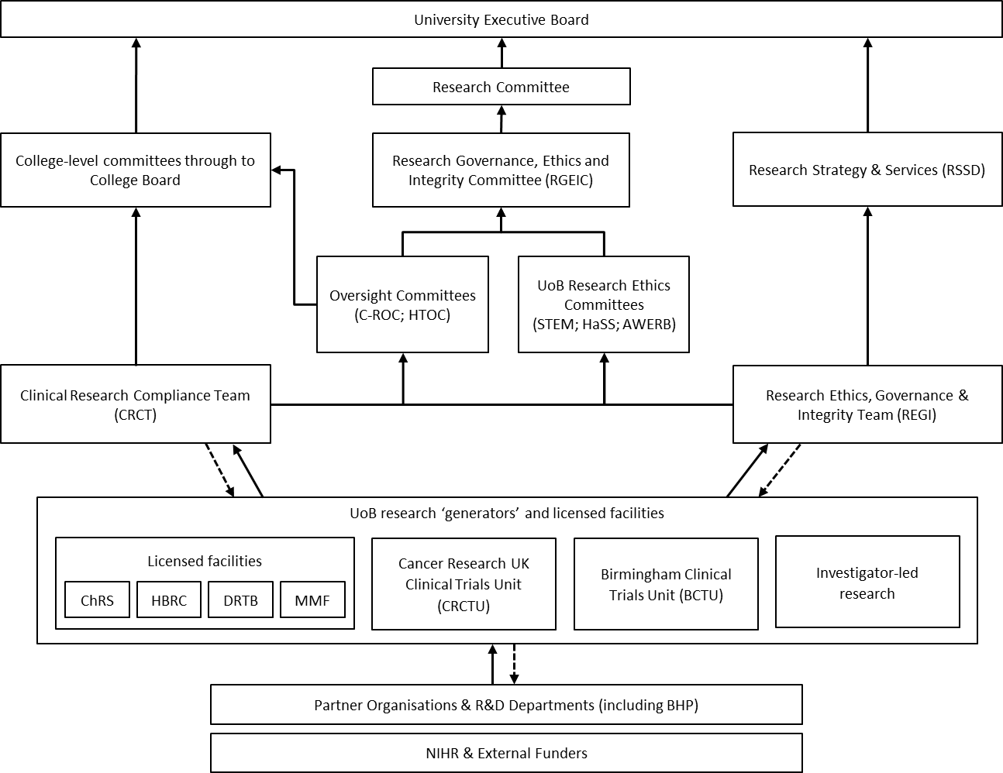

Figure 1. UoB Research Governance Framework. Solid line denotes reporting pathway and dotted lie denotes compliance review pathways. Abbreviations: AWERB, Animal Welfare and Ethical Review Body; BCTU, Birmingham Clinical Trials Unit; BHP, Birmingham Health Partners; ChRS, The Centre for Human Reproductive Science; CRCT, Clinical Research Compliance Team; CRTCU, Cancer Research UK Clinical Trials Unit; C-ROC, Clinical Research Oversight Committee; DRTB, Dental Research Tissue Bank; HaSS, Humanities and Social Sciences; HBRC, Human Biomaterials Resource Centre; HTOC, Human Tissue Oversight Committee; MMF, Medicines Manufacturing Facility; NIHR, National Institute for Health Research; R&D, Research and Development; REGI, Research Ethics, Governance & Integrity Team; RGEIC, Research Governance, Ethics & Integrity Committee; RSSD, Research Strategy & Services Division; STEM, Science, Technology, Engineering and Mathematics, University of Birmingham.

Document Status

Approved: by REGIC on 12 March 2026.

