

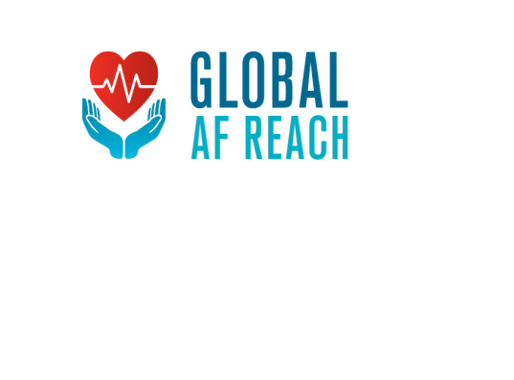

**NIHR Global Health Research Group on Atrial Fibrillation Management**

**GHR 17/63/121**

**Publication Policy – Draft v2**

Introduction

This policy aims to provide guidance for the Global Health Research Group on Atrial Fibrillation Management (Global AF Reach) for all publication issues relating to the dissemination of research findings related to the project.

The University of BirminghamCode of Practice for Research (1) states that

‘Publication is the dissemination of the outcomes of research in paper form and/or in other media, including electronic media. Publication may be taken to include, inter alia, books, chapters, articles, conference proceedings, reviews, patents, catalogues, compositions, the production of creative arts, theses, software, databases, museum exhibitions, web-sites, e-bulletins, press releases, media briefings or other events. The University encourages its Researchers to disseminate the findings of their research through appropriate and timely publication. Ethical considerations apply to the production of all categories of publication. The University expects Researchers to abide by the University’s core principles of openness, transparency and accountability and adopt appropriate ethical and professional standards and responsibilities in their publications

Authorship

The International Committee of Medial Journal Editors (ICMJE) (2) recommendations for the Conduct, Reporting, Editing and Publication of Scholarly Work in Medical Journals state that there are four criteria that need to be met for a person to be a designated author:

1. Substantial contributions to the conception or design of the work: or the acquisition, analysis, or interpretation of data for the work
2. Drafting the work or revising it critically for important intellectual content
3. Final approval of the version to be published
4. Agreement to be accountable for all aspects of the work in ensuring that questions related to the accuracy or integrity of any part of the work are appropriately investigated and resolved

Contributors can be defined as those who do not meet the four criteria but are involved with the planning of the project, carrying out work for the project and contributing to the reporting of results.

Global AF Reach Guidelines

The Co-Directors will identify all of the potential authors for each publication as early as possible, ideally when the potential publication is first discussed. This will be formally recorded as part of the Management Committee Meeting minutes. Any additions or changes will also be recorded here. Contributors will be identified prior to publication and also recorded in the minutes. Conflicts may be referred to ISAC if necessary for independent opinion.

It is the responsibility of the Co-Directors to appoint the **Corresponding Author** from the

group of authors for each publication. This person will have the responsibility for ensuring

that the following actions are carried out:

1. Communication with the journal during the process to include ethics approvals, clinical trials documentation (if required) confirming authors and conflicts of interest information
2. Being the point of contact for providing further information after publication

**Authorship** will be recorded in the following manner:

1. The main writing team will be listed as writing on behalf of ‘**The NIHR Global AF Reach Group’**
2. **The NIHR Global AF Reach Group** author list will include everyone who has contributed to the conduct of any study work package, and there is no limit to the number of people who can be included in the group
3. Prior to a publication, those who are to be the writing team will be agreed. The names of the author group should also to confirmed to ensure the correct names have been included for the publication concerned

The Group is reminded that the NIHR has included ‘Publicity, Publication and Branding as section 8 of the Research Contract (3). We are required to give the NIHR 14 days’ notice of any outputs or publicity from the project. For that reason, the Project Agreements between the University of Birmingham and each collaborating country include the following statement as clause 8.4:

*The University recognises that the Collaborating Institution may wish to publish in the form of certain papers, articles, books, pamphlets or published material which makes reference to or contains material arising from the Project. The Collaborating Institution agrees that the University’s written permission will be obtained before such publication or disclosure and pending such permission confidentiality shall be observed and the University will respond to such written requests within thirty days of receipt thereof. The Parties shall ensure that publications adhere to the Authorship and Publication Policy.*

Additionally, the following clauses should be observed:

*8.8 The Authority will ensure that any Queen's Printer and Controller of HMSO copyright publication arising from the Report carries the following statement:*

*"© Queen's Printer and Controller of HMSO 20xx [insert year of publication].*

*This work was produced by (name of author/organisation) under the terms of a commissioning contract issued by the Secretary of State for Health and Social Care".*

*8.10 The Contractor shall ensure that any publication of or resulting from research carried out under this Contract shall acknowledge, in any acknowledgement section, the Authority's financial support and carry a disclaimer as the Authority may require or in the absence of direction from the Authority a notice as follows:*

*"This research was commissioned by the National Institute for Health Research using Official Development Assistance (ODA) funding. The views expressed in this publication are those of the author(s) and not necessarily those of the NHS, the National Institute for Health Research or the Department of Health and Social Care."*

**References**

1. The University of Birmingham Code of Practice for Research, implementation date 29th March 2018
2. ICMJE Recommendations for the conduct, reporting, editing and publication of scholarly work in medical journals, updated December 2018
3. NIHR ODA standard research contract v2/18